**Program 1:**

#include<iostream>

using namespace std;

class students //single base class

{

protected: int roll_no;

public:

void get_roll(int a) {

roll_no=a;

}

void display() {

cout<<"Roll No = "<<roll_no<<endl;

}

};

class arts : public students //arts is derived from class base

{

protected: int h_marks;

public:

void history_marks(int b) {

h_marks=b;

cout<<"History Marks = "<<h_marks<<endl;

}

};

class engineering : public students //engineering is also derived from class base

{

protected: int m_marks;

public:

void maths_marks(int b) {

m_marks=b;

cout<<"Maths Marks = "<<m_marks<<endl;

}

};

class medical : public students //medical is also derived from class base

{

protected: int a_marks;

public:

void anatomy_marks(int c) {

a_marks=c;

cout<<"Anatomy Marks = "<<a_marks<<endl;

}

};

class mech : public engineering //mech is derived from class base engineering

{

protected: int t_marks;

public:

void thermodynamics_marks(int d) {

t_marks=d;

cout<<"Thermodynamics Marks = "<<t_marks<<endl;

}

};

class elec : public engineering //elec is also derived from class base engineering

{

protected: int e_marks;

public:

void circuit_marks(int e) {

e_marks=e;

cout<<"Circuit Marks = "<<e_marks<<endl;

}

};

class civil : public engineering //civil is also derived from class base engineering

{

protected: int c_marks;

public:

void construction_marks(int f) {

c_marks=f;

cout<<"Construction Marks = "<<c_marks<<endl;

}

};

int main()

{

arts s1;

medical s2;

mech s3;

elec s4;

civil s5;

s1.get_roll(21);

s2.get_roll(22);

s3.get_roll(23);

s4.get_roll(24);

s5.get_roll(25);

s1.history_marks(78);

s2.anatomy_marks(98);

s3.maths_marks(85);

s4.maths_marks(92);

s5.maths_marks(72);

s3.thermodynamics_marks(66);

s4.circuit_marks(58);

s5.construction_marks(99);

return 0;

}

**Output:**

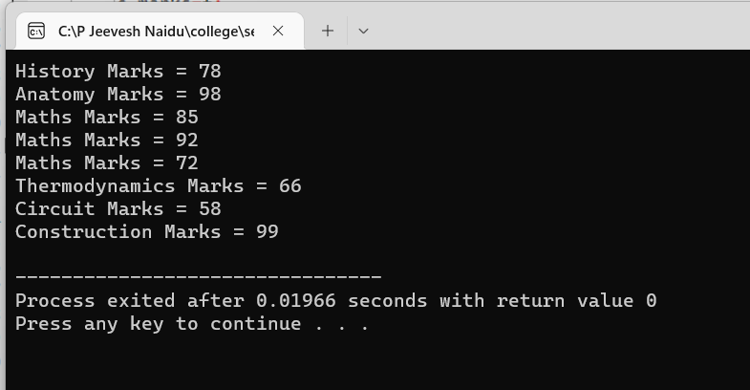

**Program 2:**

#include<iostream>

using namespace std;

class student {

int roll_no;

public:

void get_roll(int p) {

roll_no=p;

cout<<"Roll No = "<<roll_no<<endl;

}

};

class test: public virtual student {

protected:

int t1,t2;

public:

void get_tmarks(int q, int r) {

t1=q;

t2=r;

cout<<"Marks 1 = "<<t1<<endl<<"Marks 2 = "<<t2<<endl;

}

};

class sports: public virtual student {

protected:

int s;

public:

void get_smarks(int v) {

s=v;

cout<<"Sports Marks = "<<s<<endl;

}

};

class result: public test,public sports {

private:

int total;

public:

void display() {

total=t1+t2+s;

cout<<"Total Marks = "<<total<<endl;

}

};

int main() {

result r;

r.get_roll(10);

r.get_tmarks(100,92);

r.get_smarks(50);

r.display();

return 0;

}

**Output:**

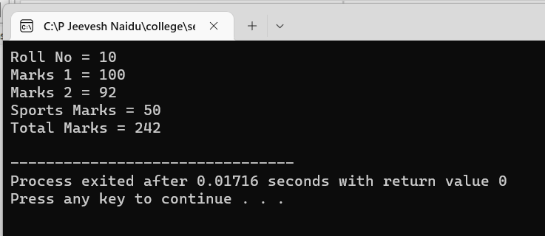

**Program 3:**

#include<iostream>

using namespace std;

class alpha {

int x;

public:

alpha(int i) {

x=i;

cout<<"Alpha Initialised "<<endl;

}

void show_x() {

cout<<x<<endl;

}

};

class beta {

float y;

public:

beta(float j) {

y=j;

cout<<"Beta initialised "<<endl;

}

void show_y() {

cout<<y<<endl;

}

};

class gamma: public beta, public alpha {

int m,n;

public:

gamma(int a, float b, int c, int d): alpha(a),beta(b) {

m=c;

n=d;

cout<<"Gamma initialised"<<endl;

}

void show_mn() {

cout<<m<<" and "<<n<<endl;

}

};

int main() {

gamma g(5,10.5,20,30);

g.show_x();

g.show_y();

g.show_mn();

return 0;

}

**Output:**

