**Program 1:**

#include<iostream>

using namespace std;

class Base {

public:

void display() { cout << "\n Display Base ";}

virtual void show() { cout << "\n Show Base ";}

};

class Derived : public Base {

public:

void display() { cout << "\n Display Derived";}

void show() { cout << "\n Show Derived \n";}

};

int main() {

Base B;

Derived D;

Base *bptr;

cout<<"\n bptr points to Base\n";

bptr=&B;

bptr->display(); // calls Base version

bptr->show(); // calls Base version

cout<<"\n\n bptr points to derived\n";

bptr=&D;

bptr->display(); // calls Base version

bptr->show(); // calls Derived version

return 0;

}

**Output:**

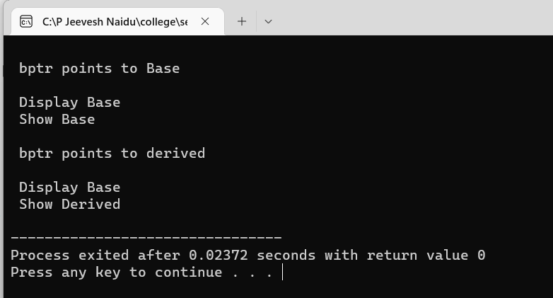

**Program 2:**

#include<iostream>

using namespace std;

class Media {

int x;

public:

void getmedia(int a) {

x=a;

}

virtual void display()=0;

};

class Book:public Media {

protected:

int y;

public:

void getbook(int b) {

y=b;

}

void display() {

cout<<"Total books - "<<y<<endl;

}

};

class Tape:public Media {

protected:

int z;

public:

void gettape(int b) {

z=b;

}

void display() {

cout<<"Total tapes - "<<z<<endl;

}

};

int main() {

Book b;

Tape t;

b.getbook(10);

t.gettape(20);

b.display();

t.display();

return 0;

}

**Output:**

