**Customer Churn Prediction**

|  |  |
| --- | --- |
| **Date** | **10-10-2023** |
| **Team ID** | **721** |
| **Project Name** | **Customer Churn Prediction** |

**Table of Contents**

|  |  |
| --- | --- |
| 1 | Introduction |
| 2 | Problem Statement |
| 3 | Design and Innovation Strategies |
| 3.1 | Data Collection and Feature Engineering |
| 3.2 | Data Pre-processing |
| 3.3 | Model Selection and Training |
| 3.4 | Geographic Analysis |
| 3.5 | Market Sentiment Analysis |
| 3.6 | Explainable AI (XAI) |
| 3.7 | Continuous Learning |
| 4 | Conclusion |

**1. Introduction**

The purpose of this document is to provide a detailed analysis of the design and innovation strategies for developing a Customer Churn Prediction model. Predicting customer churn is crucial for businesses looking to retain their customers and maintain profitability. This project aims to utilize innovative approaches to enhance the accuracy and effectiveness of churn prediction.

**2. Problem Statement**

Customer churn is a significant challenge for businesses across various industries. The central problem of this project is to build a model that accurately predicts customer churn and identifies the key factors influencing customer retention.

**3. Design and Innovation Strategies**

**3.1. Data Collection and Feature Engineering**

Innovation: Comprehensive Data Gathering

Utilize various data sources, including customer demographics, transaction history, and customer interactions, to collect comprehensive datasets.

Apply advanced data feature engineering techniques, such as customer segmentation, to extract meaningful insights from the data.

Create new features like customer lifetime value, customer satisfaction scores, and interaction frequency to improve churn prediction.

**3.2. Data Pre-processing**

Innovation: Natural Language Processing (NLP) for Feedback Analysis

Employ NLP techniques to analyse customer feedback and reviews.

Develop a custom NLP pipeline for sentiment analysis, topic modelling, and identifying specific customer concerns.

Handle missing data and outliers using innovative methods, such as imputation based on customer profiles and anomaly detection.

**3.3. Model Selection and Training**

Innovation: Advanced Machine Learning Models

Utilize a range of machine Learning algorithms, including Logistic Regression, Decision trees, Random Forest, and Support Vector Machines, for churn prediction.

Explore ensemble methods, such as Bagging and Boosting, to combine multiple models for improved accuracy.

Implement Deep Learning techniques, like Neural Networks, to capture complex patterns in customer behaviour.

**3.4. Customer Segmentation**

Innovation: Behavioural Clustering

Apply Unsupervised Learning techniques to segment customers based on their behaviour and characteristics.

Develop innovative Clustering algorithms that consider temporal patterns and transactional data for better segmentation.

Tailor retention strategies for each customer segment to increase effectiveness.

**3.5. Customer Engagement Analysis**

Innovation: Interaction History Analysis

Analyse historical customer interactions, including emails, calls, and website visits, to understand engagement patterns.

Implement innovative techniques like sequence analysis to identify customer touchpoints and their impact on churn.

Use Reinforcement Learning to optimize customer engagement strategies.

**3.6. Explainable AI (XAI)**

Innovation: Model Interpretability

Employ XAI techniques, such as SHAP values and LIME, to provide interpretable explanations for churn predictions.

Create a user-friendly dashboard with visual explanations to enhance decision-making for retention strategies.

**3.7. Continuous Learning**

Innovation: Real-time Model Updates

Establish a Continuous Learning framework that adapts to changing customer behaviours and market conditions.

Regularly retrain the model using new data and customer feedback.

Implement automated data pipelines for seamless data ingestion and model updates.

Note: In the diagram below, we've depicted the key components and interactions described in sections 3.1 to 3.7, offering a clear and concise overview of our solution architecture. This visualization simplifies the complex concepts and relationships discussed in those sections, making it easier for the reader to grasp the overall design and innovation strategies at a glance.

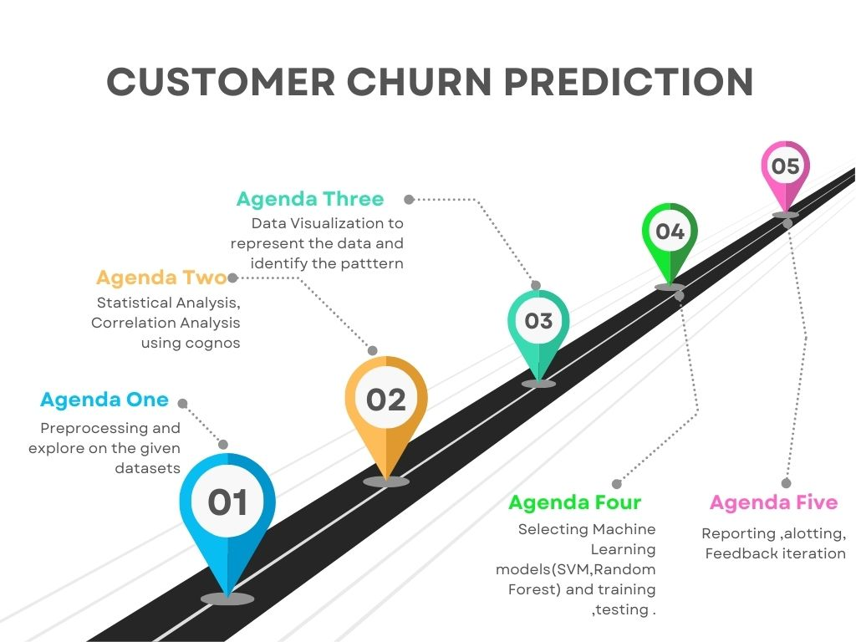

**4. Conclusion**

This Customer Churn Prediction project employs innovative strategies to address the challenge of predicting and reducing customer churn effectively. By leveraging comprehensive data collection, NLP for feedback analysis, advanced machine Learning models, customer segmentation, interaction history analysis, XAI, and Continuous Learning, this project aims to develop a robust churn prediction model. This model will not only help businesses reduce customer attrition but also advance the use of data analytics in customer retention strategies. Through cutting-edge technologies and techniques, we aim to provide a comprehensive and actionable solution for predicting and mitigating customer churn.