FULL TECHNICAL DOCUMENTATION

OBJECT TRACKING FOR ELDERLY AND LOCATION ASSISTANCE USING IR SENSORS INTEGRATED WITH ALEXA HOME ASSISTANT

Proposed by

Jeevith K

Introduction
In modern households, especially those with elderly individuals, the problem of misplaced everyday objects is common and often leads to stress, confusion, and loss of independence. Older adults may forget where they placed frequently used items such as keys, glasses, wallets, remote controls, medicine boxes, or small personal belongings. This can lead to frustration and, in some cases, mild anxiety if the item is essential for daily functioning. While technology has evolved significantly, many existing solutions—such as RFID tags, Bluetooth trackers, and GPS-based devices—require attaching a tag or operating within a limited range. These solutions are often impractical for elderly individuals who may forget to tag items or find such systems too complicated to operate.
To address these challenges, this project introduces a non-intrusive, always-on, tag-less object tracking system using Infrared (IR) sensors positioned in the four corners of a room or space. Unlike conventional tracking systems, this solution does not require the user to attach any device, sticker, or tag to the object. Instead, the system uses the presence-detection capability of IR sensors to map the movement of objects within a defined area. When an object enters a specific zone, the system detects its presence and updates the object’s last known location. The user can later ask, “Alexa, where is my object?” and the system retrieves the last detected zone and provides a voice-based response.
This innovative approach combines hardware sensing with smart-home integration through Alexa, enabling a seamless experience. The system is designed to operate 24/7, requiring minimal maintenance and offering real-time location assistance. The goal is to create a low-cost, reliable system that improves quality of life, especially for the elderly.

Problem Statement and Motivation
Elderly individuals often struggle with memory-related challenges, including misplacing personal belongings. Such forgetfulness may seem minor, but it can significantly impact daily activities. For example:
- Forgetting where medication is placed can affect health routines.
- Misplacing keys or wallets can create unnecessary stress.
- Searching for objects increases physical strain and reduces independence.
While caregivers can assist, relying on others for simple tasks can be discouraging for elderly individuals. Additionally, caregivers may not always be available.
Existing object-tracking technologies are either too complex, too expensive, or require behavioral changes (like attaching tags to items). Many elderly individuals find these methods inconvenient. Therefore, a hands-free, automatic, tag-less object detection system is far more practical.
The motivation behind this project is to create:
- A simple, affordable system for object tracking
- A non-intrusive method requiring no tags or additional devices
- A solution that integrates naturally into smart homes
- A continuous monitoring system that maintains an updated record of object locations
- A voice-controlled interface through Alexa that is easy for elderly users
This project is built with the vision of enhancing independence and reducing daily frustration through a practical, low-cost engineering solution.

System Overview
The system is built around four IR object detection sensors, strategically placed in the four corners of a room. Each sensor represents a zone. When an object enters the detection range of a sensor, the system identifies which zone the object is in and logs its presence.
At the core of the system are:
Hardware Components
- IR Sensors (4 units):
Detect the presence of objects entering their zone.
- Microcontroller (Arduino/Raspberry Pi/ESP):
Reads signals from the IR sensors and processes zone changes.
- Wi-Fi Integration Module (ESP32/ESP8266):
Connects the system to the internet for Alexa communication.
Software Components
- Microcontroller Firmware:
Handles sensor reading, zone mapping, and sending updates.
- Cloud Endpoint or Local Server:
Stores the last known zone of the object.
- Alexa Skill Integration:
Enables the user to ask Alexa for the object's location.
- Real-Time Update Logic:
Ensures the system reflects the most recent zone across the data pipeline.
This hierarchical architecture ensures efficient sensing, accurate mapping, and user-friendly retrieval through Alexa.

Workflow Architecture
The workflow of the system consists of multiple interconnected modules, each responsible for a specific function. The end-to-end architecture is designed to ensure real-time object detection and seamless user interaction. Below is an expanded, step-by-step breakdown.
Step 1: Continuous Sensor Monitoring
The IR sensors placed at the four corners constantly emits infrared light. When an object enters their detection zone, the reflected light is captured by the receiver. Each IR sensor represents a unique zone:
- Zone 1: Top-left corner
- Zone 2: Top-right corner
- Zone 3: Bottom-left corner
- Zone 4: Bottom-right corner
The microcontroller continuously polls the sensors in a loop, checking whether any zone has changed from "no object" to "object detected."
Step 2: Zone Detection and Identification
When a sensor detects an object, the microcontroller identifies which zone triggered the detection and assigns it as the object’s “current zone.” If multiple sensors detect the object simultaneously, the system prioritizes the sensor with the strongest signal or the first trigger.
Each detection is time-stamped to ensure accurate tracking and proper chronological ordering.
Step 3: Storing Last Known Location
The microcontroller sends zone information to a backend using HTTP or MQTT. This data includes:
- Zone number
- Timestamp
- Object detected state
- Room identifier
The backend stores the most recent zone in a database, ensuring persistent tracking even if the device restarts.
Step 4: Alexa Skill Integration
A custom Alexa skill is created with an intent such as “WhereIsObjectIntent.”
When the user asks:
“Alexa, where is my object?”
Alexa sends a request to the backend. The backend retrieves the last known zone and returns a text response indicating the location.
Step 5: Voice Response to the User
Depending on the detected zone, Alexa replies with something like:
- “Your object was last detected in the top-left corner of the room.”
- “The object is in zone three, near the bottom-left corner.”
- “It seems the object is not currently detected.”
This completes the loop, providing real-time guidance to the user in an easily accessible format.

Hardware Design
The hardware architecture forms the foundation of this project. The reliability of the system depends heavily on accurate sensor placement, stable wiring, and efficient power management. The IR sensors are placed in the four corners at a height appropriate for detecting objects placed on tables, shelves, or surfaces. Proper alignment is critical to ensure minimal interference and maximize detection accuracy.
IR Sensor Configuration
Each IR sensor is angled slightly inward to provide optimal coverage of the room’s center area. The detection range is configured to cover nearby objects but not wall reflections. To avoid cross-interference, each sensor operates at controlled sensitivity.
Microcontroller Role
The microcontroller handles all sensor readings. It must be fast enough to detect changes within milliseconds. Debouncing logic is implemented to filter out false positives caused by environmental factors like dust, light, or temperature.
Power Supply Setup
A 5V or 12V regulated power supply is used depending on the sensor type. Backup power may be added to ensure 24/7 operation even during outages.
Connectivity
The microcontroller communicates with the Alexa backend via Wi-Fi, requiring stable internet for real-time responses.

Software Architecture
The software layer forms the intelligence of the system. It includes firmware, backend logic, and Alexa integration.
Firmware Functionality
The firmware runs a continuous loop reading the IR sensor values. On detection, it constructs a JSON payload and transmits it to the server. Debouncing and noise filtering algorithms improve accuracy.
Backend Logic
A lightweight cloud server is deployed using Firebase, Node.js, or AWS Lambda. The server receives IR zone data and stores it. It exposes an API endpoint for the Alexa skill to retrieve the last known zone.
Alexa Skill Design
The Alexa skill includes:
- Invocation name
- User intents
- Intent schema
- Backend linkage
The response is dynamically generated based on the stored zone.

Block Diagram

The block diagram illustrates the overall architecture of the object-tracking system using IR sensors placed in the four corners of a room. Each sensor represents a detection zone and continuously monitors for the presence of objects. The detected signals are sent to the microcontroller (ESP32/ESP8266), which processes the input and transmits the updated zone information to a cloud backend via Wi-Fi.
The cloud server stores the last-seen location of the object, enabling real-time retrieval. When a user asks Alexa, “Where is my object?”, the Alexa skill queries the backend and provides a voice response based on the most recent sensor data. This diagram highlights the full system interaction between hardware, cloud infrastructure, and voice assistant integration.

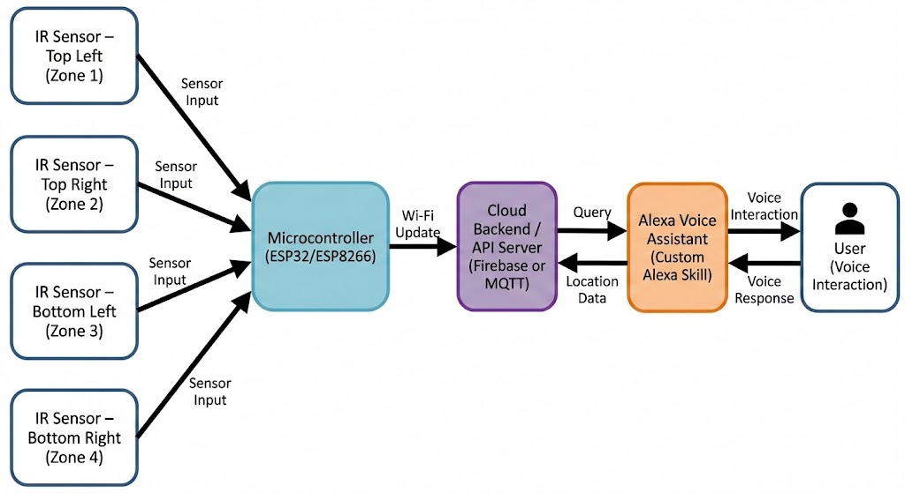

Circuit Diagram

This circuit diagram displays the physical wiring setup for the system. Four IR sensors are positioned around the ESP32/ESP8266 microcontroller, each connected to a dedicated GPIO pin for accurate zone detection. The sensors share a common power supply, with VCC connected to 3.3V (or 5V depending on sensor type) and a common ground.
The data output pin of each IR sensor is wired to a specific GPIO pin on the microcontroller (e.g., GPIO14, GPIO27, GPIO26, GPIO25). A power block shows the USB input supplying regulated voltage to the ESP module. This diagram clearly shows how all sensors and power components connect to form a functional object-detection system.

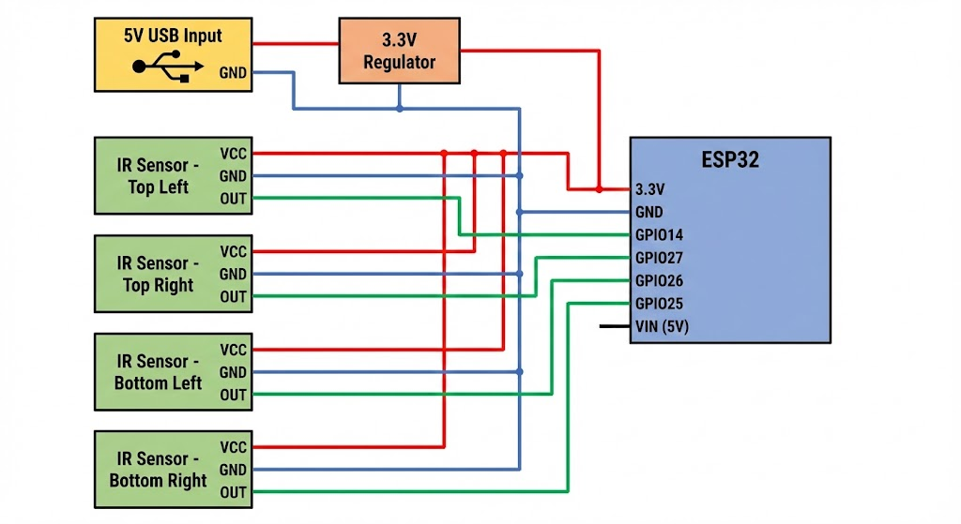

Workflow Diagram

The workflow diagram provides a step-by-step representation of how the system operates from detection to user interaction. When an object enters any of the room’s corner zones, the corresponding IR sensor detects its presence and alerts the microcontroller. The microcontroller identifies the zone, debounces noise, and updates the cloud server with a timestamp and zone number.
When the user asks Alexa for the object’s location, the Alexa skill retrieves the stored last-seen location from the cloud and provides a spoken response. This workflow diagram helps visualize how data flows between sensors, processing logic, cloud storage, and voice assistant to deliver a seamless user experience.

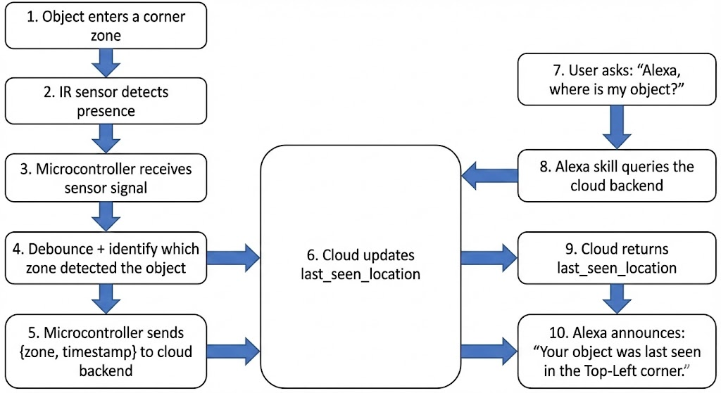

Real-Time Object Tracking Logic
The system uses a rule-based approach:
- If an object enters a zone → update the database
- If the object leaves and no sensors detect it → keep the last known location
- If the object is not detected for long periods → alert “object is not currently detected”
The system is passive and does not track continuous movement, but rather the last known zone since elderly users mainly need to recall where they last placed something.

Use Cases
Primary Use Case: Elderly Assistance
- Helps elderly individuals find commonly lost items
- Reduces dependency on caregivers
- Minimizes frustration and confusion
Secondary Use Cases
- Smart home automation
- Object tracking in storage areas
- Inventory tracking in small shops
- Monitoring item placement in offices

Overall Advantages of the Project
1. Early Warning System
- Provides instant alerts to people in affected areas before the disease spreads.
- Reduces risk by informing users not to use contaminated water.
2. Public Health Improvement
- Helps prevent major outbreaks by delivering real-time actionable information.
- Supports government and health departments in quick decision-making.
3. Automated Detection
- Continuously monitors water quality using sensors or data sources.
- Minimizes human error and saves time.
4. Scalable and Flexible
- Can be deployed for villages, towns, cities, and industries.
- Supports integration with IoT, cloud, mobile apps, and SMS gateways.
5. Cost-Effective
- Reduces costs related to treatment of outbreaks by preventing them early.
- Uses commonly available sensors and digital infrastructure.
6. Improved Community Awareness
- Increases public awareness about water safety, hygiene, and health.
7. Supports Government Missions
- Aligns with Smart City initiatives, Jal Jeevan Mission, and Digital India.

Overall Disadvantages / Limitations of the Project
1. Dependency on Sensor Accuracy
- Faulty or low-quality sensors may give false positives or false negatives.
2. Requires Internet Connectivity
- Rural or low-network areas may face delayed alerts.
3. Initial Deployment Cost
- Installing sensors at multiple water sources requires investment.
4. Data Security & Privacy Risks
- IoT systems may be vulnerable to hacking if not secured.
5. Maintenance Challenges
- Sensors require regular calibration and servicing.
- System failure could delay alerts and risk public health.
6. User Adoption
- People may ignore alerts if not aware of the system’s importance.
7. Integration Complexity
- Combining IoT, cloud, database, and SMS/notification systems requires technical expertise.

Future Scope
The current IoT-based object detection system using IR sensors and Alexa already supports tracking multiple objects simultaneously within the four corner zones. While this is a significant advantage, there are still several ways the system can be enhanced for better accuracy, usability, and intelligence

- AI-Based Object Identification
- Expanded Detection Zones
- Mobile App Integration
- Enhanced Alexa/Voice Features
- Edge and Cloud Intelligence
- Integration with Smart Home Devices
- Energy Efficiency and Autonomous Operation
- Security and Privacy Enhancements

Conclusion
The Object Detection and Location Assistance System using IR sensors and Alexa provides a practical, low-cost, and reliable solution for assisting elderly individuals who often misplace essential items. The project successfully demonstrates how simple IoT components—IR sensors, a microcontroller, and cloud connectivity—can work together to create a powerful 24/7 object-monitoring environment. By dividing the room into fixed detection zones and continuously tracking when an object enters or leaves each zone, the system provides real-time positional awareness without the need for attaching any tags or stickers to the objects.
Through Alexa integration, users can simply ask “Alexa, where is my item?” and receive an instant verbal response indicating which zone the item was last detected in. This voice-based interface makes the system especially helpful for senior citizens, visually impaired individuals, and people who struggle with memory lapses. The project proves that IoT and smart home technologies can offer meaningful assistance in daily life and improve independence and safety.
Although the system depends on sensor placement, environmental conditions, and zone accuracy, its advantages—hands-free usage, 24/7 tracking, low cost, and ease of integration—make it a promising foundation for more advanced future enhancements. With additional sensor fusion, AI-based object recognition, or mobile app integration, this system can evolve into a fully intelligent indoor object-tracking assistant.
Overall, this project showcases the power of IoT to deliver practical, human-centered solutions and highlights how smart home technologies can significantly improve the quality of life for elderly people.

