**Task 1**

<html>

    <body>

        <script>

            alert("Hello,World!;")

        </script>

    </body>

</html>

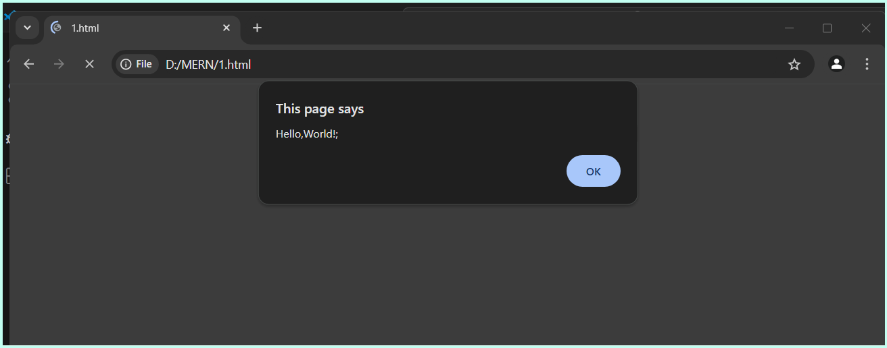

**Task 2**

let string="jeevitha";

console.log("string : "+string);

let number=17;

console.log("number : "+number);

let boolean=true;

console.log("boolean : "+boolean);

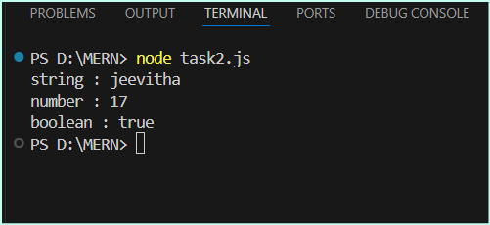

**Task 3**

let a=10 , b=10;

console.log("addition : "+(a+b));

console.log("subtraction : "+(a-b));

console.log("multiplication : "+(a*b));

console.log("division : "+(a/b));

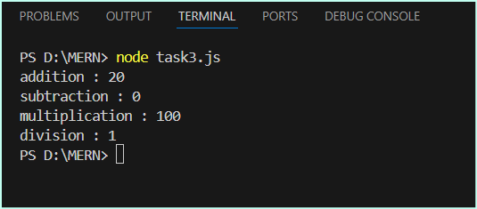

**Task 4**

let string1 = "javascript ";

let string2 = "mernstack";

console.log(string1+string2);

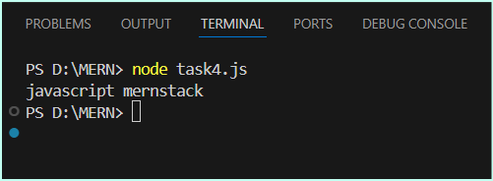

**Task 5**

let string="jeevitha";

console.log(typeof(string));

let number=17;

console.log(typeof(number));

let boolean=true;

console.log(typeof(boolean));

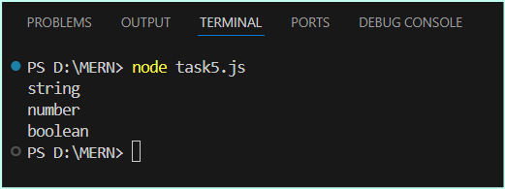

**Task 6**

// This is a single-line comment

let Age = 20; // This variable stores the age of a person

/*

This is a multi-line comment.

It explains more details about the code below.

*/

let Age = 5;

**Task 7**

console.log("jeevitha");

console.log("jeevitha")

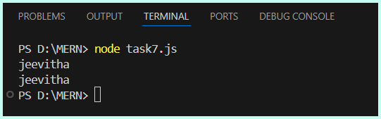

// Both lines will behave identically.

**Task 8**

for(let i=0;i&lt;2;i++){

    console.log(&quot;mern&quot;);

    for(let j=0;j&lt;3;j++){

        console.log(&quot;stack&quot;);

    }

}

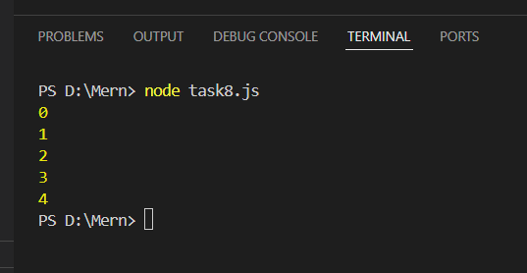

**Task 9**

let x=10,y=20,z=30;

console.log(x*y*z);

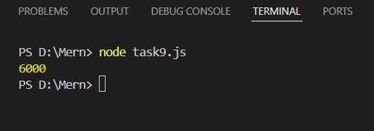

**Task 10**

<html>

    <head>

        <script>

            let string = "jeevitha";

            console.log(string);

        </script>

    </head>

    <body>

        <script>

            let string2="ece";

            console.log(string2)

        </script>

    </body>

</html>

// The first script runs first , second script runs after the page has started loading

**Task 11**

<html>

    <head>

        <body>

            <script>

                variable =10;

                console.log(variable);

            </script>

        </body>

    </head>

</html>

// without using “use strict”, variable is automatically created as global variable



**Task 12**

<html>

    <head>

        <body>

            <script>

“use strict”;

                variable =10;

                console.log(variable);

            </script>

        </body>

    </head>

</html>

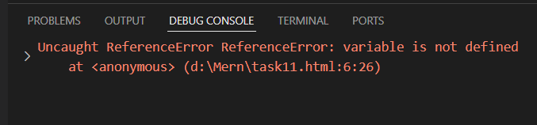

**Task 13**

<html>

    <head>

        <body>

            <script>

                "use strict";

                let variable =10;

                delete variable;

                console.log(variable);

            </script>

        </body>

    </head>

</html>

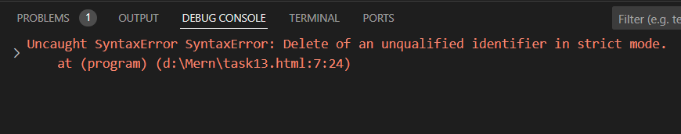

**Task 14**

// without using “use strict”, variable is automatically created as global variable

// without using “use strict”, JavaScript will throw a error variable because variable is not declared.

**Task 15**

<html>

    <head>

        <body>

            <script>

                "use strict";

                let if =10;

                console.log(if);

            </script>

        </body>

    </head>

</html>

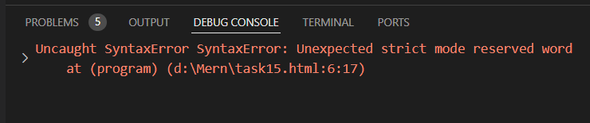

**Task 16**

let name="jeevitha";

var age = 20;

const DOB="07/02/2005";

console.log(name);

console.log(age);

console.log(DOB);

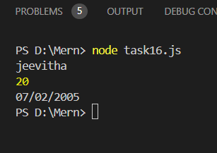

**Task 17**

const pi =22.7;

pi=23;

console.log(pi);

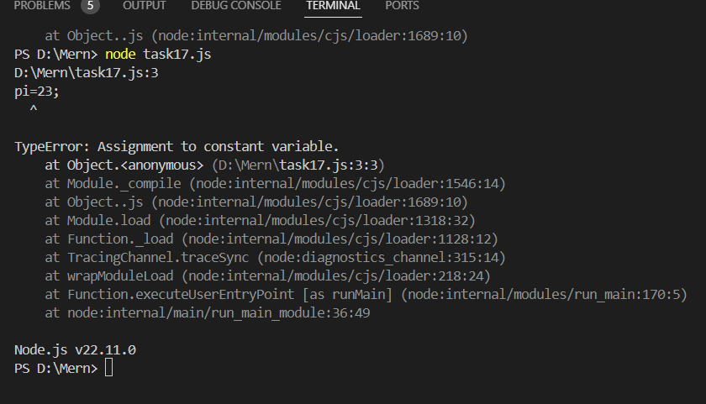

**Task 18**

let variable;

console.log(variable);

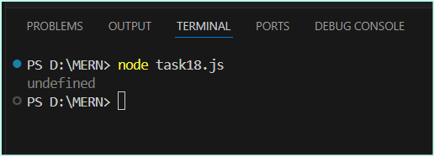

**Task 19**

let string="jeevitha";

console.log(typeof(string));

let number=17;

console.log(typeof(number));

let boolean=true;

console.log(typeof(boolean));

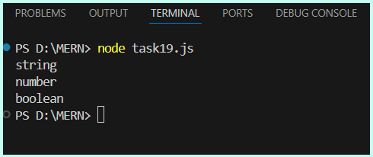

**Task 20**

let a="mern";

let b=a;

console.log(a);

console.log(b);

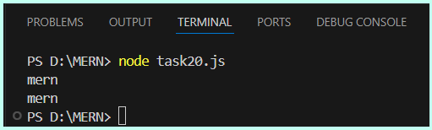

**Task 21**

let string="jeevitha";

let number=17;

let boolean=true;

let nul=null;

let  undefined;

let object={

    name:"jeevitha",

    age:20

};

console.log(string);

console.log(number);

console.log(boolean);

console.log(nul);

console.log(undefined);

console.log(object);

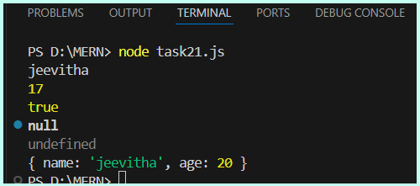

**Task 22**

let string="jeevitha";

console.log(typeof(string));

let number=17;

console.log(typeof(number));

let boolean=true;

console.log(typeof(boolean));

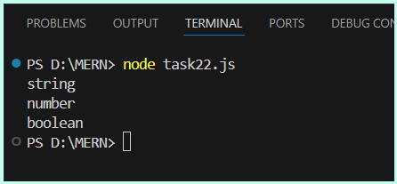

**Task 23**

let nul=Symbol("unique");

console.log(typeof nul);

console.log(nul);

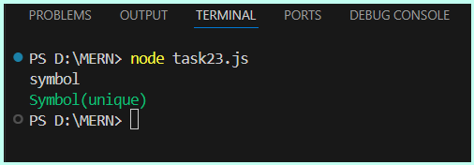

**Task 24**

let nul=null;

console.log(typeof nul);

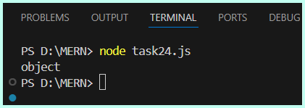

**Task 25**

var a = 5;

var a = 10; // No error because redeclaration of var is allowed

console.log(a); // Output: 10

let b = 15;

let b = 25; // Error because redeclaration of let is not allowed

**Task 26**

//implicit

let num="12"*5;

console.log(num);

//explicit

let num1="10";

let num2=Number(num1);

let ans=num2+18;

console.log(ans)

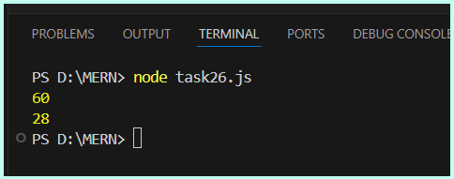

**Task 27**

let boolean=true;

console.log(String(boolean));

let string=""

console.log(Boolean(string));

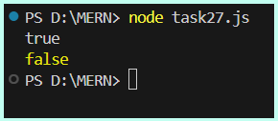

**Task 28**

let a=10 , b=10;

console.log("addition : "+(a+b));

console.log("subtraction : "+(a-b));

console.log("multiplication : "+(a*b));

console.log("division : "+(a/b));

console.log("modulus : "+(a%b));

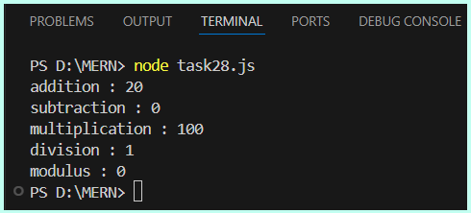

**Task 29**

let a=10;

console.log(a--);

a=20;

console.log(a++);

a=130;

console.log(--a);

a=109;

console.log(++a);

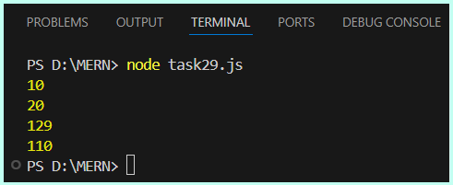

**Task 30**

let a = 10, b = 5, c = 2;

let result1 = a + b * c;

console.log(result1);

let result2 = (a + b) * c;

console.log( result2);

let result3 = a > b == b < c;

console.log(result3);

let result4 = a > b && b > c || c > a;

console.log(result4);

let result5 = -a * b;

console.log(result5);

let result6 = a + (b = c * 2);

console.log(result6);

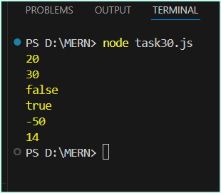

**Task 31**

let a=10,b=20;

console.log("a>b : "+(a>b));

console.log("a<b : "+(a<b));

console.log("a>=b : "+(a>=b));

console.log("a<=b : "+(a<=b));

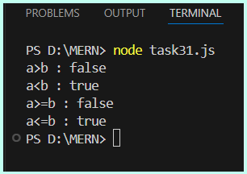

**Task 32**

// Equality (==)

console.log(5 == '5');

console.log(0 == false);

// Strict Equality (===)

console.log(5 === '5');

console.log(0 === false);

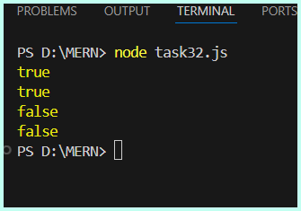

**Task 33**

// Lexicographical comparison

console.log("apple" > "banana");

console.log("grape" < "grapefruit");

console.log("Zoo" > "apple");

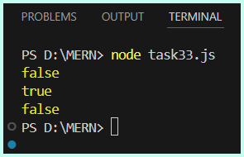

**Task 34**

// Inequality (!=) examples

console.log(5 != '5');

console.log(0 != false);

// Strict Inequality (!==) examples

console.log(5 !== '5');

console.log(0 !== false);

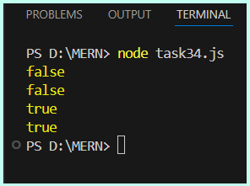

**Task 35**

console.log(null == undefined);

console.log(null === undefined);

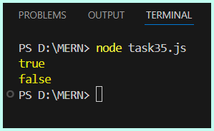

**Task 36**

let num = 7;

if(num%2==0){

    console.log("even");

}else{

    console.log("odd");

}

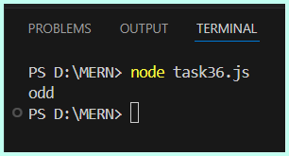

**Task 37**

let num = 7;

if(num==0){

    console.log("zero")

}

else if(num<0){

    console.log("negative")

}

else{

    console.log("positive")

}

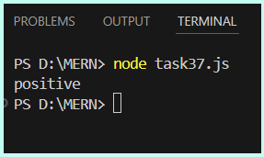

**Task 38**

let num=78;

console.log((num<0) ? "negative":"Positive");

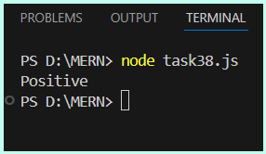

**Task 39**

let value;

console.log(value ? "Valid" : "Invalid");

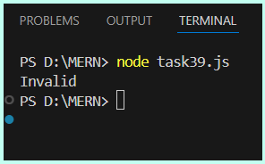

**Task 40**

let age = 18;

let status = age >= 18 ? "Adult" : "Minor";

console.log("Status:"+ status );

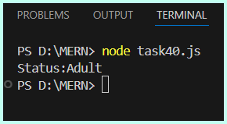

**Task 41**

console.log(true && true);

console.log(true && false);

console.log(false || true);

console.log(false || false);

console.log(!true);

console.log(!false);

// Combining multiple operators

console.log(true || false && false);

console.log(!(true && false));

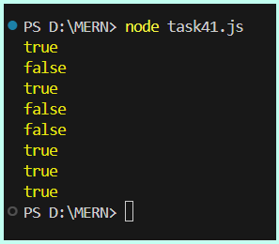

**Task 42**

let number = 15;

if (number >= 10 && number <= 20) {

  console.log(number);

} else {

  console.log(number );

}

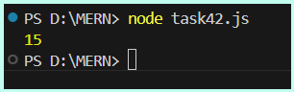

**Task43**

let isAvailable = true;

console.log(!isAvailable);

let isLoggedIn = false;

console.log(!isLoggedIn);

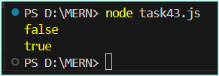

**Task 44**

console.log(false && console.log());

console.log(true && console.log());

console.log(true || console.log());

console.log(false || console.log());

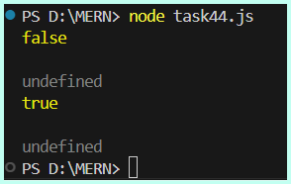

**Task 45**

console.log("Hello" && 42);

console.log(0 && "World");

console.log("Hello" || 42);

console.log(0 || "World");

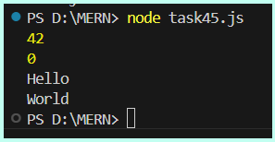

**Task 46**

function addNumbers(a, b) {

    return a + b;

  }

  console.log(addNumbers(5, 7));

  console.log(addNumbers(10, 20));

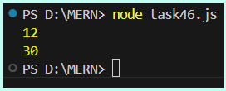

**Task 47**

function calculateRectangleArea(length, width) {

    return length * width;

  }

  console.log(calculateRectangleArea(5, 10));

  console.log(calculateRectangleArea(7, 3));

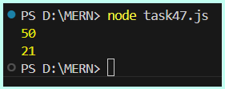

**Task 48**

function sayHello() {

    console.log("Hello, World!");

  }

  sayHello();

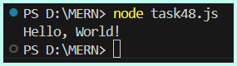

**Task 49**

function doNothing() {

  }

  console.log(doNothing());

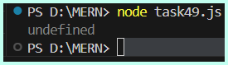

**Task 50**

function greet(name = "Jeevi", greeting = "ECE") {

    return `${greeting}, ${name}!`;

  }

  console.log(greet("Jeevitha", "Hi"));

  console.log(greet("GV"));

  console.log(greet());

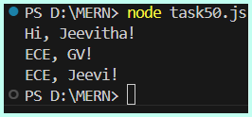

**Task 51**

const greet = (name) => `Hello, ${name}!`;

console.log(greet("Alice"));

console.log(greet("Bob"));

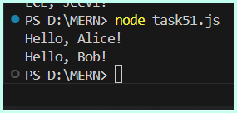

**Task 52**

const add = (a, b) => a + b;

console.log(add(5, 3));

console.log(add(10, 20));

console.log(add(-5, 15));

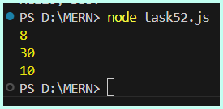

**Task 53**

const isEven = (num) => num % 2 === 0;

console.log(isEven(4));

console.log(isEven(7));

console.log(isEven(0));

console.log(isEven(-2));

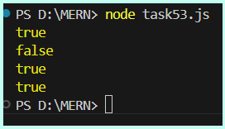

**Task 54**

const maxValue = (a, b) => {

    return a > b ? a : b;

  };

  console.log(maxValue(10, 20));

  console.log(maxValue(50, 30));

  console.log(maxValue(-5, -10));

  console.log(maxValue(7, 7));

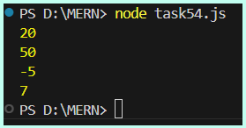

**Task 55**

const Object = {

    value: 10,

    multiply: function (num) {

      return this.value * num;

    },

    multiplyArrow: (num) => {

      return this.value * num;

    }

  };

  console.log(Object.multiply(2));

  console.log(Object.multiplyArrow(2));

