**REPLICA SETS CONCEPTS**

**NAME: JEEVITHA R**

**REGNO:23BAI1550**

**Start MongoDB instances (3 separate CMD windows):**

MKDIR DATA

CD DATA

MKDIR db0 db1 db2

"C:\Program Files\MongoDB\Server\8.0\bin\mongod.exe" --replSet myReplSet --dbpath C:\data\db0 --port 27017 --bind_ip localhost

"C:\Program Files\MongoDB\Server\8.0\bin\mongod.exe" --replSet myReplSet --dbpath C:\data\db1 --port 27018 --bind_ip localhost

"C:\Program Files\MongoDB\Server\8.0\bin\mongod.exe" --replSet myReplSet --dbpath C:\data\db2 --port 27019 --bind_ip localhost

**Connect to primary node:**

mongosh --port 27017

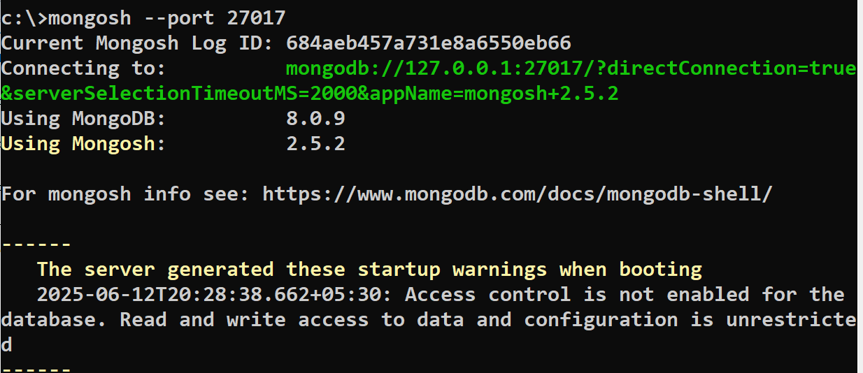

**Initiate the replica set:**

rs.initiate({

_id: "myReplSet",

members: [

{ _id: 0, host: "localhost:27017" },

{ _id: 1, host: "localhost:27018" },

{ _id: 2, host: "localhost:27019" }

]

})

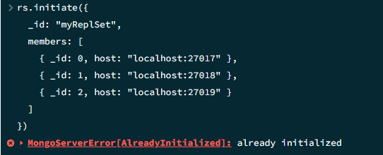

**Check replica set status: rs.status()**

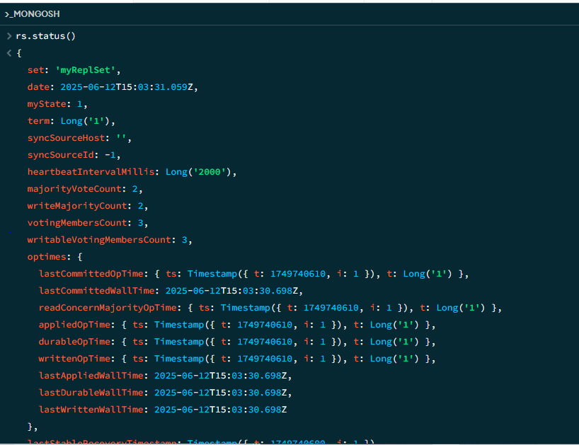

**Insert a test document:**

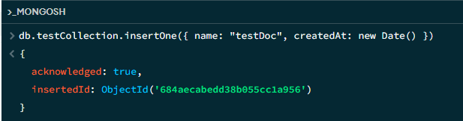

### ****Verify inserted document:****

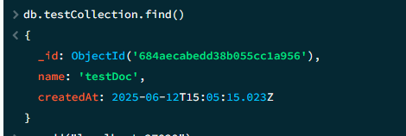

**Delete the test document:**

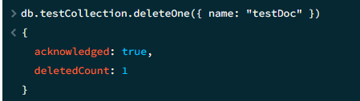

**Add a new member**

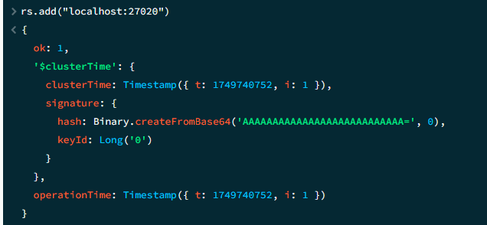

**Check if connected to primary (before adding members):**

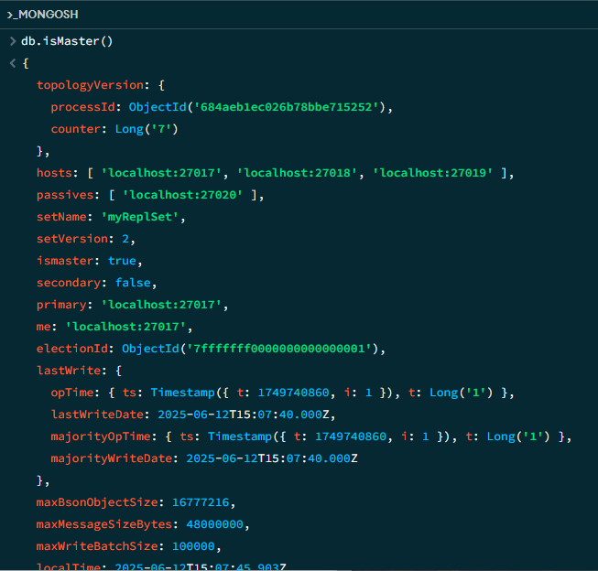

**Check replica set configuration:**

