**REPLICA SETS CONCEPTS**

**NAME: JEEVITHA R**

**REGNO:23BAI1550**

**Step 1: Create Directories**

mkdir C:\data\cfg1, C:\data\cfg2, C:\data\cfg3

mkdir C:\data\shard1_1, C:\data\shard1_2, C:\data\shard1_3

mkdir C:\data\shard2_1, C:\data\shard2_2, C:\data\shard2_3

mkdir C:\data\mongos

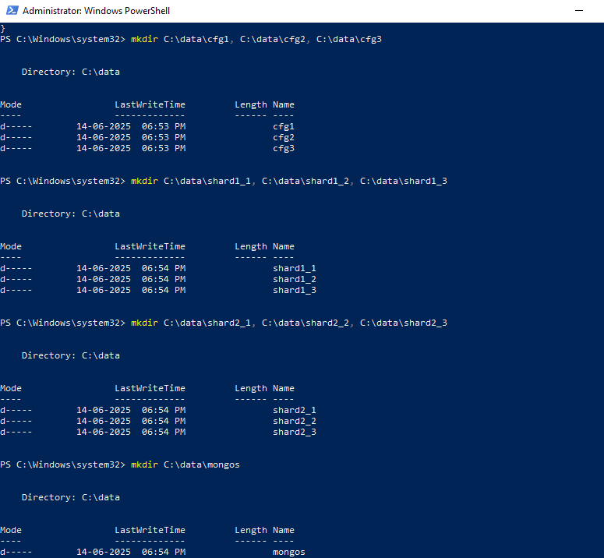

**Step 2: Start Config Server Replica Set (Run each in a separate PowerShell window):**

mongod --configsvr --replSet configReplSet --port 27019 --dbpath C:\data\cfg1 --bind_ip localhost

mongod --configsvr --replSet configReplSet --port 27020 --dbpath C:\data\cfg2 --bind_ip localhost

mongod --configsvr --replSet configReplSet --port 27021 --dbpath C:\data\cfg3 --bind_ip localhost

**3 POWER SHELLS:**

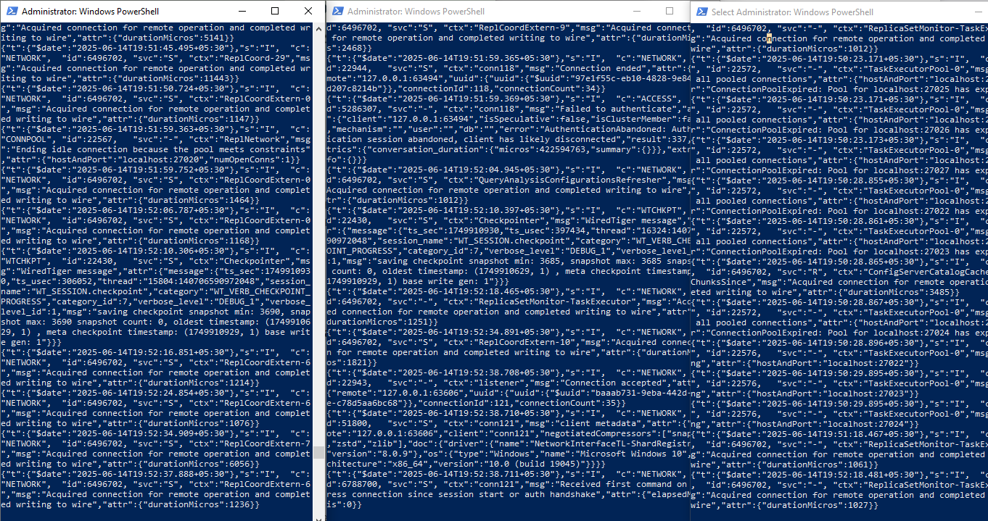

mongo --port 27019

rs.initiate({

_id: "configReplSet",

configsvr: true,

members: [

{ _id: 0, host: "localhost:27019" },

{ _id: 1, host: "localhost:27020" },

{ _id: 2, host: "localhost:27021" }

]

})

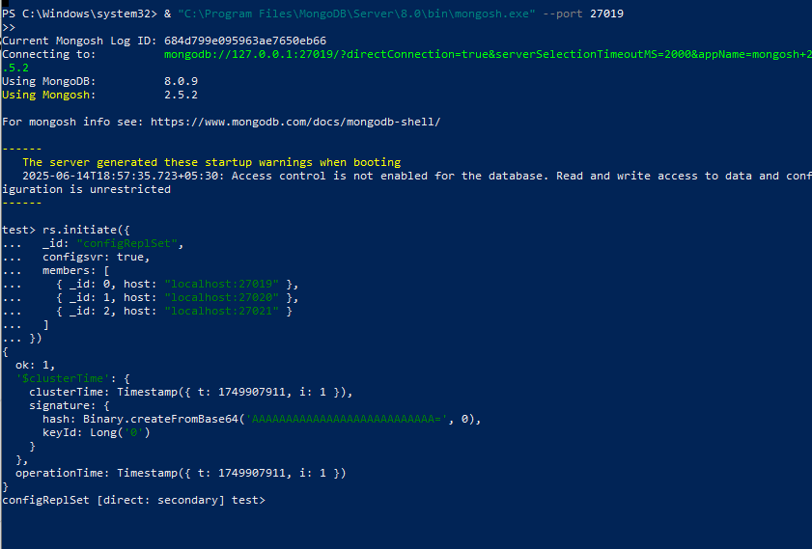

**Step 3: Start Shard Replica Sets**

**Shard 1 (3 nodes, separate PowerShell windows)::**

mongod --shardsvr --replSet shard1ReplSet --port 27022 --dbpath C:\data\shard1_1 --bind_ip localhost

mongod --shardsvr --replSet shard1ReplSet --port 27023 --dbpath C:\data\shard1_2 --bind_ip localhost

mongod --shardsvr --replSet shard1ReplSet --port 27024 --dbpath C:\data\shard1_3 --bind_ip localhost

**3 POWER SHELLS FOR SHARD 1:**

mongo --port 27022

rs.initiate({

_id: "shard1ReplSet",

members: [

{ _id: 0, host: "localhost:27022" },

{ _id: 1, host: "localhost:27023" },

{ _id: 2, host: "localhost:27024" }

]

})

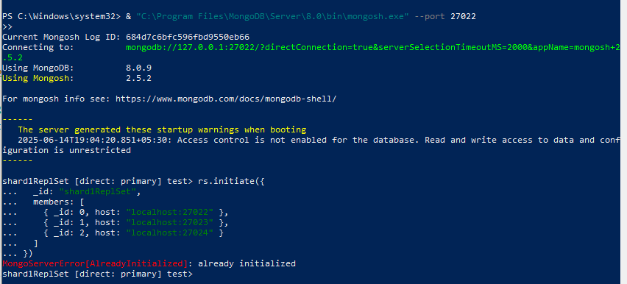

**Shard 2 (3 nodes, separate PowerShell windows):**

mongod --shardsvr --replSet shard2ReplSet --port 27025 --dbpath C:\data\shard2_1 --bind_ip localhost

mongod --shardsvr --replSet shard2ReplSet --port 27026 --dbpath C:\data\shard2_2 --bind_ip localhost

mongod --shardsvr --replSet shard2ReplSet --port 27027 --dbpath C:\data\shard2_3 --bind_ip localhost

**3 POWER SHELLS FOR SHARD 2:**



mongo --port 27025

rs.initiate({

_id: "shard2ReplSet",

members: [

{ _id: 0, host: "localhost:27025" },

{ _id: 1, host: "localhost:27026" },

{ _id: 2, host: "localhost:27027" }

]

})

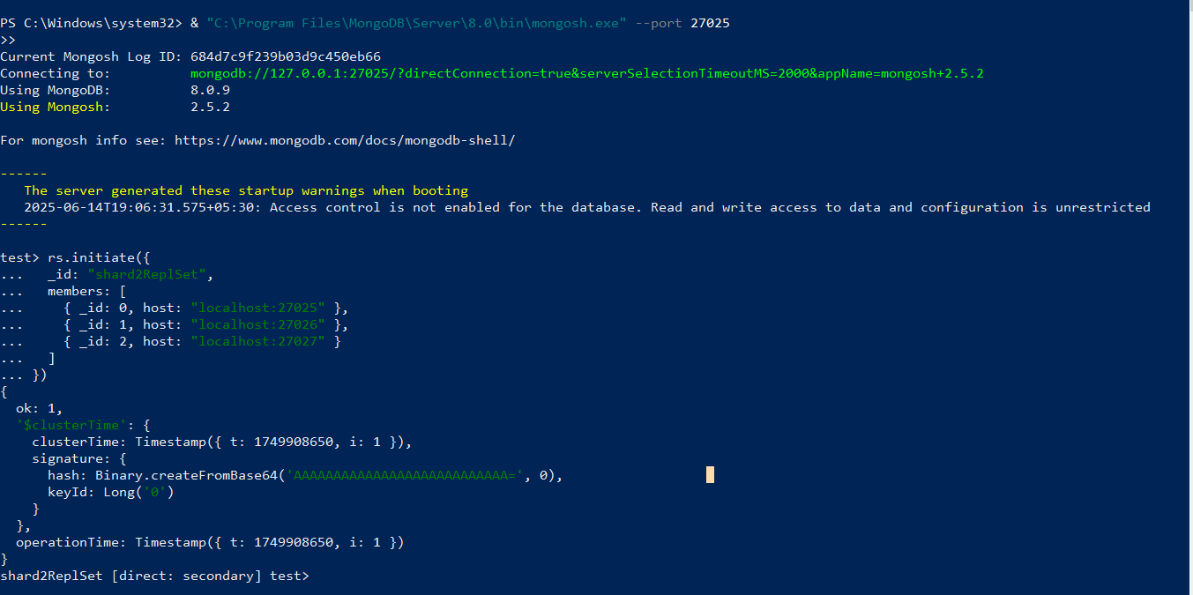**Step 4: Start Mongos Query Router powershell**

mongos --configdb configReplSet/localhost:27019,localhost:27020,localhost:27021 --port 27018 --bind_ip localhost

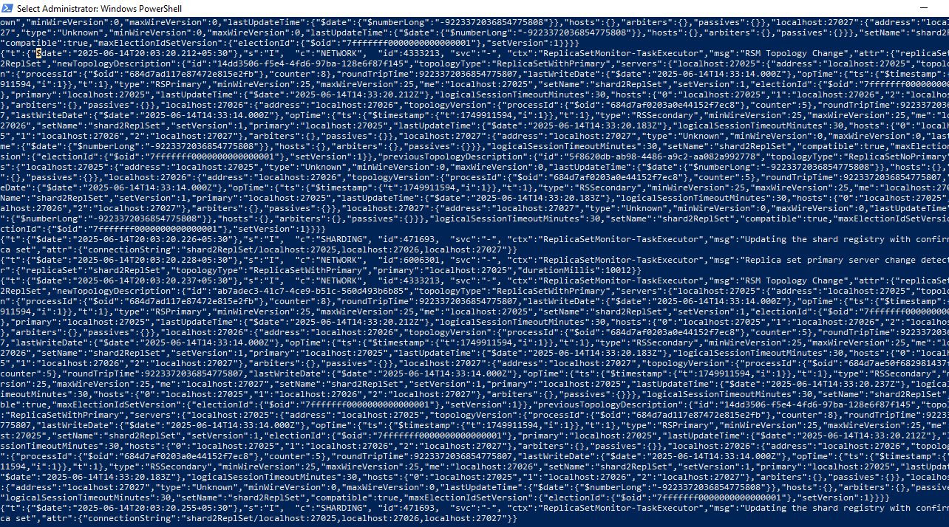

**Step 5: Configure Sharding:**

mongo --port 27018

sh.addShard("shard1ReplSet/localhost:27022,localhost:27023,localhost:27024")

sh.addShard("shard2ReplSet/localhost:27025,localhost:27026,localhost:27027")

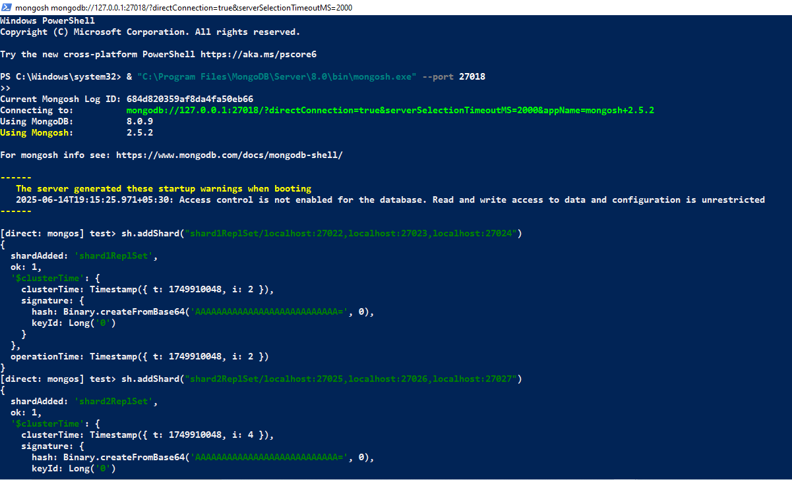

**Step 6: Enable Sharding for Database and Collection:**

sh.enableSharding("testDB")

sh.shardCollection("testDB.testCollection", { "_id": "hashed" })

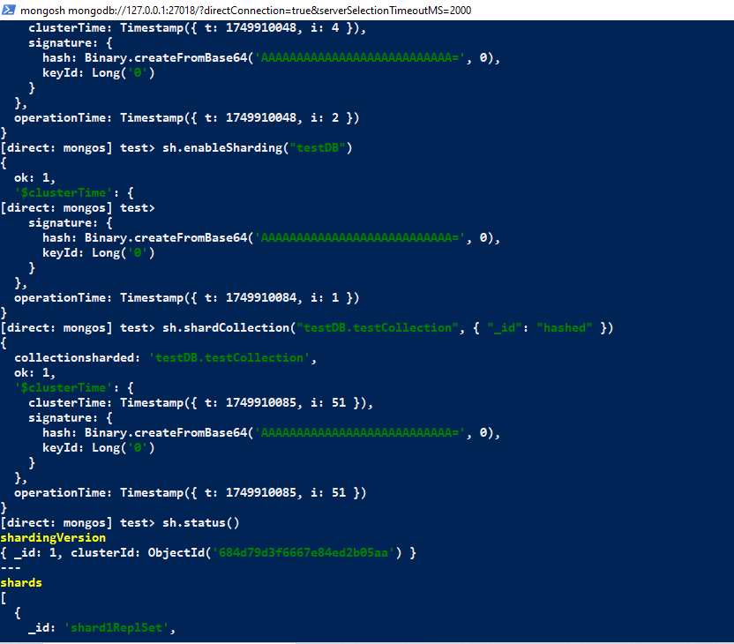

**Step 7: Verify Sharding Status sh.status()**

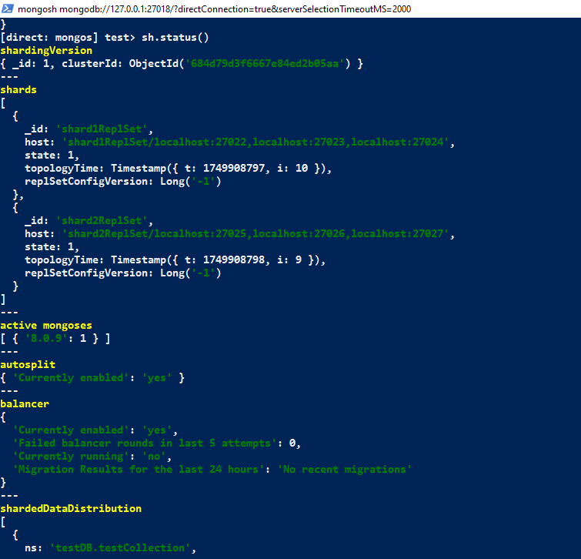

**Connection String for MongoDB Compass or Clients**

use testDB

let bulkDocs = [];

for (let i = 0; i < 10000; i++) {

bulkDocs.push({

userId: i,

data: "Sample data " + i,

timestamp: new Date()

});

}

db.testCollection.insertMany(bulkDocs);

db.testCollection.getShardDistribution();

db.testCollection.deleteMany({})

