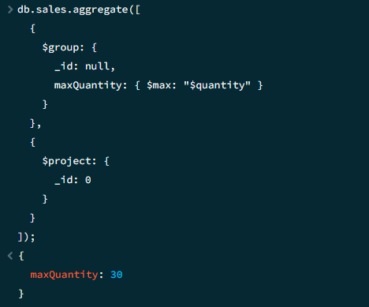

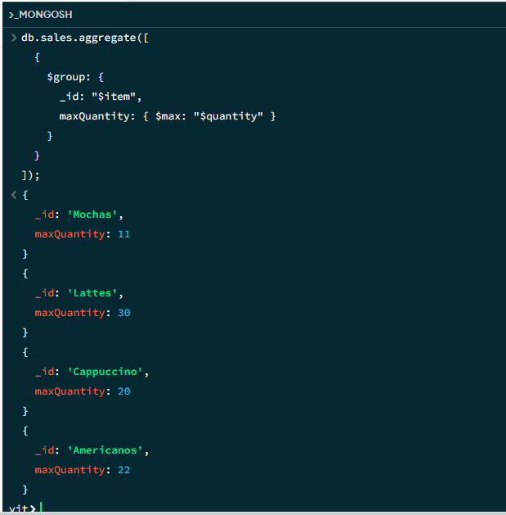

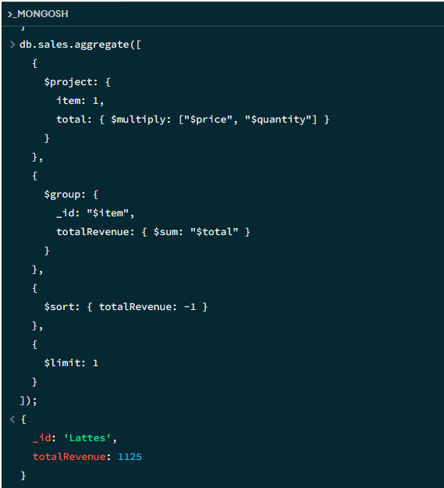

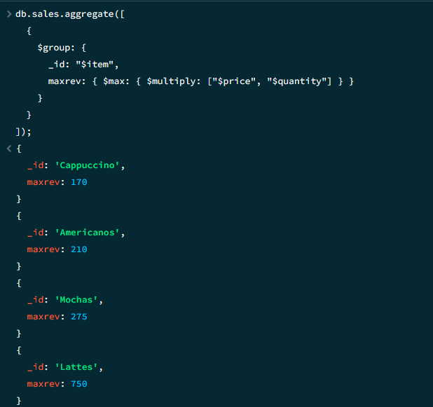

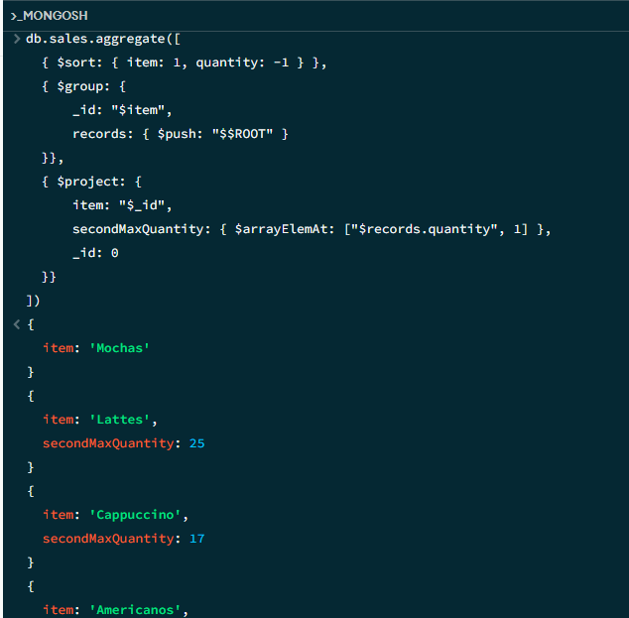

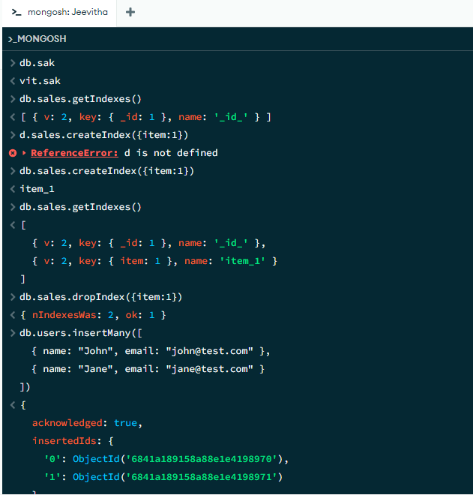

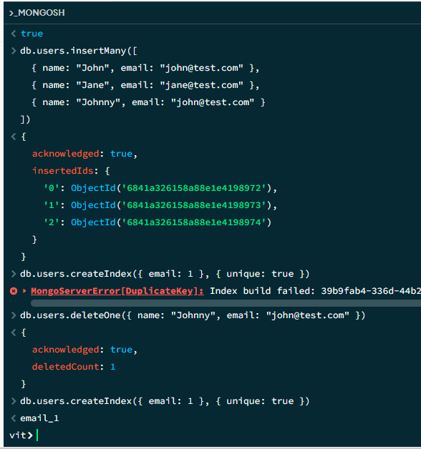

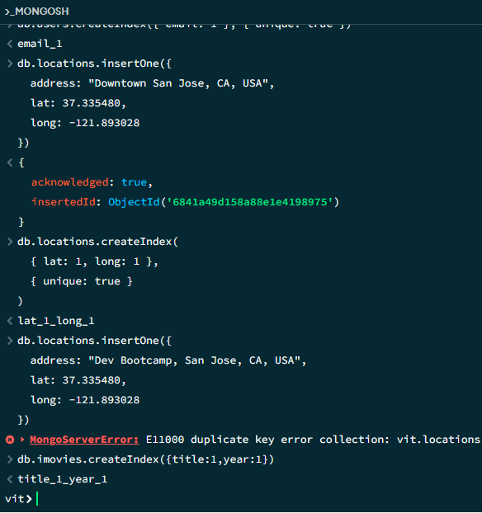

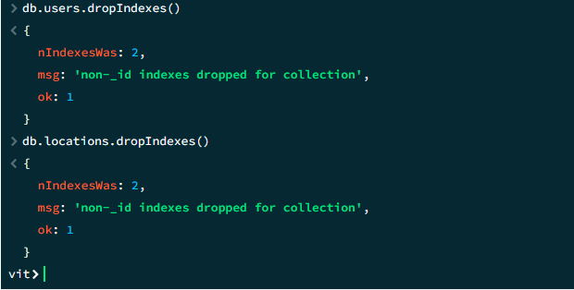

**ECLIPSE MONGODB CONNECTION CODE**

**package** connection;

**import** com.mongodb.MongoClient;

**import** com.mongodb.MongoCredential;

**import** com.mongodb.client.MongoDatabase;

**public** **class** MongoDB {

**public** **static** **void** main(String[] args) {

**try** {

MongoClient db

= **new** MongoClient("localhost", 27017);

MongoCredential credential;

credential

= MongoCredential

.*createCredential*(

"GFGUser", "mongoDb",

"password".toCharArray());

System.***out***.println(

"Successfully Connected"

+ " to the database");

MongoDatabase database

= db.getDatabase("mongoDb");

System.***out***.println("Credentials are: "

+ credential);

}

**catch** (Exception e) {

System.***out***.println(

"Connection establishment failed");

System.***out***.println(e);

}

}

}