Software Project – 2
Blockchain-Enabled Security and Integrity in Cloud Computing

BY
JEEVITHA. S
BP231029

Under the Guidance of
Asst.Prof. Dr. S. Anthony Philomen Raj M.C.A, Ph. D.


PG DEPARTMENT OF COMPUTER APPLICATION
SACRED HEART COLLEGE (AUTONOMOUS)
TIRUPATTUR-635 601
April 2025

BONAFIDE CERTIFICATE
This is to certify that the project work entitled “Blockchain-Enabled Security and Integrity in Cloud Computing” is submitted to Department of Computer Applications (PG), Sacred Heart College (Autonomous), Tirupattur by JEEVITHA. S [BP231029] for the partial fulfilment for the award of a degree in Master of Computer Applications is a project work carried out under my guidance and supervision.

Signature of the HOD Signature of the Guide

Submitted for Viva –Voce examination held on: ______________________

Examiner 1 Examiner 2

Department of Computer Applications (PG)
SACRED HEART COLLEGE (Autonomous)
Tirupattur- 635 601, Tirupattur District, Tamil Nadu

CERTIFICATE OF ORIGINALITY

(Plagiarism Tested)

It is certified that the MCA project title: Blockchain-Enabled Security and Integrity in Cloud Computing by JEEVITHA. S (BP231029) has been examined by us and we undertake the following:
- blockchain, data is distributed across a network of nodes, enhancing resilience and availability.The project work has not presented any others as their own and has taken steps to ensure the ethical and academic integrity of their work
- such as finance, healthcare, and supply chain management. It ensures that data remains trustworthy and verifiable, reducing the risk of fraud and manipulation.

Place: Tirupattur

Date:

Asst. Prof. DR. S. Anthony Philomen Raj Dr. A. George Louis Raja
Project Guide Head of the Department






ACKNOWLEGEMENT
I thank God Almighty for the blessings and grace by which I was able to complete this project work successfully. I sincerely thank my parents, unless and my relatives for their continuous support, love and blessings for me to attain many achievements.

I take this opportunity to express my gratitude to those who helped me and led me to complete this project work. I offer my humble gratitude to Rev. Dr. D. Maria Antony Raj Principal, Sacred Heart College (Autonomous), Tirupattur for permitting me to do my project work. I would like to thank the Director, HR and the entire team at Strydo Technologies for the guidance they provided to me to complete this project successfully.

I express my deep gratitude to Dr. S. Sagayaraj Director, Department of Computer Applications (PG), Sacred Heart College (Autonomous), Tirupattur.

I would like to thank Dr. A. George Louis Raja Head, Department of Computer Applications (PG), Sacred Heart College (Autonomous) Tirupattur for providing the necessary arrangements for me to do my project work and training at Strydo Technologies

My sincere thanks to DR. S. Anthony Philomen Raj internship Guide, who has guided me throughout my project work, I am grateful to him for his encouragement, guidance and assistance towards my project work.

JEEVITHA. S
(BP231029)
TABLE OF CONTENTS
CHAPTER NO. | TITLE | PAGE NO.
 | ABSTRACT | 10
1. | CHAPTER 1 : INTRODUCTION  - GENERAL  - OBJECTIVE  - EXISTING SYSTEM  1.3.1EXISTINGSYSTEM DISADVANTAGES  1.3.2 LITERATURE SURVEY  1.4 PROPOSED SYSTEM  1.4.1 PROPOSED SYSTEM ADVANTAGES | 11-17
2. | CHAPTER 2 :PROJECT DESCRIPTION  2.1 GENERAL AND METHODOLOGIES  2.2 MODULES  2.2.1 MODULE DISCRIPTIONS | 18-19
3. | CHAPTER 3 : REQUIREMENTS  3.1 GENERAL  3.2 HARDWARE REQUIREMENTS  3.3 SOFTWARE REQUIREMENTS | 20
4. | CHAPTER 4 : SYSTEM DESIGN  4.1 GENERAL  4.1.1 USE CASE DIAGRAM  4.1.2 CLASS DIAGRAM  4.1.3 OBJECT DIAGRAM  4.1.4 STATE DIAGRAM  4.1.5 ACTIVITY DIAGRAM  4.1.6 SEQUENCE DIAGRAM  4.1.7 COLLABORATION DIAGRAM  4.1.8 COMPONENT DIAGRAM  4.1.9 DATA FLOW DIAGRAM  4.1.10 E-R DIAGRAM  4.1.11 SYSTEM ARCHITECHTURE | 21-26
5. | CHAPTER 5 :SOFTWARE SPECIFICATION  5.1 GENERAL  5.2 FRAMEWORKS  5.2.1 SPRING BOOT FRAMEWORK  5.2.2 REACT JS FRAMEWORK | 27
6. | CHAPTER 6 : IMPLEMENTATION  6.1 GENERAL  6.2 IMPLEMENTATION | 28
7. | CHAPTER 7 : SNAPSHOTS  7.1 GENERAL  7.2 VARIOUS SNAPSHOTS  7.3 SOURCE CODE | 29-52
8. | CHAPTER 8 : SOFTWARE TESTING  8.1 GENERAL  8.2 DEVELOPING METHODOLOGIES  8.3 TYPES OF TESTING | 53-54
9. | CHAPTER 9 :  APPLICATIONS AND FUTURE ENHANCEMENT  9.1 GENERAL  9.2 FUTURE ENHANCEMENTS | 55
10 | CHAPTER 10 :  10.1 CONCLUSION  10.2 REFERENCES | 56

CHAPTER - 1
ABSTRACT
The widespread usage of cloud computing has brought about new opportunities and severe security issues. This research is aimed at solving the significant problem of data security in cloud computing systems. Conventional security techniques, such as encryption, are typically not adequate to preserve data confidentiality in cloud environments. This paper discusses a new model that incorporates blockchain technology for confidentiality, authentication, and integrity of data in cloud computing. With the incorporation of blockchain in cloud computing infrastructure, this proposed solution attempts to resolve confidentiality, authentication, and integrity of data issues. This research study investigates the feasibility of implementing blockchain-based strategies for securing APIs and network interfaces, minimizing malicious traffic attacks, accidental disclosures, and breach of service agreements. The study also solves the issue of multi-tenancy problems that are hazardous for data confidentiality and integrity in multi-tenancy cloud platforms. The primary goal of this research is to ensure a safe and trusted computing environment for consumers of cloud computing services, and this gives confidence and trust in cloud-based services. In resolving significant issues in data security and confidentiality, this research facilitates the increasing adoption and growth of cloud computing services

INTRODUCTION
The rapid development of cloud computing has brought along various benefits such as cost savings, scalability, and flexibility, which have rendered it an essential service for businesses and individuals. With organizations moving their business and data to the cloud, they are tapping into these benefits to boost productivity and streamline processes. Cloud computing allows users to remotely access resources and services from anywhere across the globe, making collaboration and innovation easier. The trend has, however, brought along new challenges, primarily security and privacy of the massive amounts of sensitive data stored and processed in cloud platforms.
Conventional data protection mechanisms such as encryption, firewalls, and access controls have been common in protecting data within cloud computing. While these mechanisms offer some form of protection, they are generally not adequate in addressing the specific weaknesses present in cloud computing. The multi-tenant model of cloud computing, where many users use the same infrastructure, makes data leakage and unauthorized access more common. In addition, the absence of centralized control over data storage and processing challenges the enforcement of security policies. These weaknesses highlight the necessity for new solutions augmenting data security in cloud computing.
Blockchain technology has been a potential solution to security and privacy in cloud computing. With a decentralized, tamper-resistant ledger, blockchain technology has the potential to provide higher data integrity, transparency, and authentication. The inherent features of blockchain, such as tamper resistance and the ability to securely store transactions without the intervention of intermediaries, are most suitable to the nature of cloud environments. As blockchain technology is decentralized, cloud service users can gain higher control over their data, minimizing the risk of data storage in a single point and establishing trust in the cloud.

OBJECTIVE
The primary objective of the given project is to design and deploy a blockchain-based system that enhances data security and privacy within cloud computing systems. The project seeks to address major challenges such as data confidentiality, authentication, integrity, and multi-tenancy issues through the application of the decentralized and immutable nature of blockchain. Through the application of blockchain technology within cloud infrastructures, the project seeks to offer a more secure and reliable platform for the storage of sensitive information, APIs protection, and trusted interactions among users and cloud services. In the long term, the project seeks to encourage more confidence and trust in cloud computing by offering strong security features that counter threats from malicious attacks and unintended or unauthorized intrusions.

EXISTING SYSTEM
Existing systems for Blockchain Enabled Security and Integrity in Cloud Computing primarily focus on reducing storage redundancy by identifying and removing duplicate files. These systems typically operate by comparing file hashes or using content-based identifiers to detect duplicates. However, most existing solutions fail to handle encrypted data securely, as they require access to the file content for comparison, which compromises data privacy. Additionally, many systems do not address the issue of protecting ownership in scenarios where similar files are involved, potentially allowing one user to falsely claim ownership of another’s media. Moreover, existing systems often lack fine-grained access control, leading to potential security risks in terms of unauthorized data access. While some approaches attempt to enable secure deduplication over encrypted data, they generally rely on trusted third parties or introduce significant computational overhead, making them impractical for large-scale applications.
DISADVANTAGES
1. Lack of Support for Encrypted Data: Most systems require access to file content for deduplication, which poses privacy risks when the data is encrypted. This compromises the confidentiality of users' files stored in the cloud.
2. Ownership Protection Issues: Existing systems often do not address the risk of one distributor falsely claiming ownership of another's media file, particularly when similar files are involved, leading to potential intellectual property disputes.
3. Limited Access Control: Many systems do not provide fine-grained access control mechanisms, which could result in unauthorized access to sensitive or private media content.
4. High Computational Overhead: Deduplication over encrypted data typically introduces significant computational complexity, which can lead to high processing costs and reduced efficiency, making it impractical for large-scale or real-time use.
5. Inability to Handle Similar Data: Most systems only focus on exact duplicate detection and fail to effectively handle visually or functionally similar files, which is a common scenario in media sharing applications.
6. Dependence on Trusted Third Parties: Some systems rely on trusted third parties to perform deduplication, which introduces potential security risks and trust issues, especially in decentralized cloud environments.
7. Inadequate Scalability: Existing solutions may not scale efficiently when dealing with massive amounts of media data or when many users are involved, leading to performance bottlenecks and increased costs.

SCOPE OF THE PROJECT
The objective of the Blockchain Enabled Security and Integrity in Cloud Computing project is to create a secure deduplication system for media sharing in the cloud that will maximize storage efficiency by identifying and removing duplicate and near-duplicate media files. The system will employ sophisticated similarity detection algorithms to handle various types of media, such as images, videos, and audio. Security is a critical feature, with robust encryption and privacy-preserving measures ensuring that user data is kept confidential during deduplication. The solution will be integrated into existing cloud infrastructures seamlessly, with scalability and high speed to handle large-scale data storage. The system will be optimized for rapid processing with minimal computation time while maintaining the integrity and accessibility of media files. The project will also focus on user experience, with easy-to-use interfaces for managing deduplicated content.

PURPOSE OF THE PROJECT
The goal of the Blockchain Enabled Security and Integrity in Cloud Computing project is to develop a secure and efficient deduplication system for cloud media sharing services that optimizes storage and preserves data privacy. The system addresses the issue of identifying and eliminating duplicate and near-duplicate media files like images, videos, and audio, which have a probability of being stored on different devices or cloud storage accounts. With the help of advanced similarity detection mechanisms, SIMLESS can handle exact and fuzzy duplicates, thus avoiding the duplicate storage cost. The project employs strong encryption techniques to preserve the security and confidentiality of users' data during the process of deduplication. The project also targets scalability, making the system perform well in high-scale cloud environments. Lastly, the goal of SIMLESS is to allow cloud users to enjoy a more secure, cost-efficient, and efficient way of handling their media content.

LITERATURE SURVEY
TITLE: Support Vector Classifier for Precise Autism Spectrum Disorder Prediction with Federated Learning (SVCFL)
YEAR: 2023
AUTHOR: A. Daliri, A. Mohammadifar et al.
DESCRIPTION:
This research proposes a new method of Autism Spectrum Disorder (ASD) prediction using a Support Vector Classifier (SVC) and Federated Learning (FL). Federated Learning allows the model to be trained on decentralized data sources without sharing sensitive personal information, maintaining privacy and security. This is critical in healthcare, where confidentiality of patient data is essential. The application of SVC allows for the classification of ASD accurately by examining patterns in medical data, enhancing early diagnosis and intervention.
In addition, the use of Federated Learning guarantees the model can leverage different datasets without storing them in a central location and making them insecure. This process not only protects user privacy but also prevents the risk of data breaches or unauthorized use. The study confirms the use of FL in medical AI can reduce issues such as data isolation and privacy concerns. With the application of this model, medical professionals can accurately predict ASD risk in a manner that is compliant with data privacy laws, offering a new and secure method to improve the accuracy of diagnosis in a privacy-friendly manner.
TITLE: DeepASDPred: a deep learning approach based on CNN-LSTM for classifying Autism Spectrum Disorders risk RNAs
YEAR: 2023
AUTHOR: Guijie Li et al.
DESCRIPTION
In this, the authors present DeepASDPred, a deep learning approach combining Convolutional Neural Networks (CNN) and Long Short-Term Memory (LSTM) networks for RNA sequence prediction associated with Autism Spectrum Disorders (ASD). CNNs are suitable for extracting spatial features from genomic data, and LSTM networks are suitable for handling sequential data, so the combined model is a suitable one for the intricate task of RNA sequence prediction. The combination of CNN and LSTM improves the accuracy of RNA marker identification associated with ASD, providing a promising early diagnostic and risk-prediction tool. The paper highlights the increasing importance of artificial intelligence, and specifically deep learning, in the development of genetic studies and precision medicine. The capacity of DeepASDPred to process genetic information at a deeper level makes it possible to identify biomarkers related to ASD more accurately, which can translate to tailored interventions and treatments. The model is a major advance in the application of deep learning to genetic studies, giving a comprehensive insight into the genetic aetiology of ASD. Researchers can make diagnostic potential stronger and potentially detect people at greater genetic risk for ASD more accurately using this technology.

PROPOSED SYSTEM
The suggested system, Blockchain Enabled Security and Integrity in Cloud Computing, is a secure deduplication system for redundant media files in cloud storage. It allows the cloud to deduplicate encrypted content without violating privacy, ownership, or security. Blockchain Enabled Security and Integrity in Cloud Computing provides distributors with the ability to specify a distance threshold while uploading media content, such that deduplication will only take place when a similar file, according to a predefined similarity metric, already exists on the cloud. This approach maintains the confidentiality of the content by enabling deduplication among encrypted files without exposing their content. Blockchain Enabled Security and Integrity in Cloud Computing also includes fine-grained access control to enable only legitimate users to access the media, and it prevents any distributor from illegally claiming ownership of a file by similar file tags. The system is made to balance security, efficiency, and usability, offering an extensible solution for storage redundancy reduction over cloud-based media sharing.
ADVANTAGES
1. Secure Deduplication on Encrypted Data: Blockchain Enabled Security and Integrity in Cloud Computing performs deduplication over encrypted media files, ensuring data confidentiality is maintained while optimizing storage without exposing sensitive content to the cloud provider.
2. Distance-Based Deduplication: The system allows distributors to set a distance threshold when uploading files, ensuring that deduplication only occurs for files that are sufficiently similar, avoiding unnecessary removal of non-duplicate content.
3. Ownership Protection: Blockchain Enabled Security and Integrity in Cloud Computing prevents unauthorized distributors from falsely claiming ownership of media files, even if the files are similar to others already stored in the cloud, protecting intellectual property rights.
4. Fine-Grained Access Control: The system enables precise access control, ensuring that only authorized consumers can access or modify the media files, addressing concerns about unauthorized data access.
5. Efficient Storage Use: By removing redundancy among similar files, Blockchain Enabled Security and Integrity in Cloud Computing significantly reduces the storage requirements in cloud environments, leading to cost savings and improved cloud resource utilization.
6. Scalability and Practicality: The system is designed to handle large-scale media sharing, with minimal impact on computational and communication costs, making it feasible for real-world applications with many users and large datasets.
7. Data Privacy: By enabling secure deduplication without revealing file contents, Blockchain Enabled Security and Integrity in Cloud Computing ensures that the privacy of media data is preserved even when stored in the cloud.
8. Protection Against Collusion: The system's architecture prevents collusion between distributors to falsely claim ownership of media files, ensuring fair use and preventing fraud.
9. No Dependence on Trusted Third Parties: Unlike some existing systems, Blockchain Enabled Security and Integrity in Cloud Computing does not rely on trusted third parties for deduplication, reducing trust and security concerns associated with such intermediaries.

CHAPTER -2
METHODOLOGIES
Software project development methodologies are essential in guiding the development and implementation processes towards maximum effectiveness and efficiency. Traditional methodologies like Waterfall follow a sequential, linear process, in which each stage of the project—requirements collection, design, implementation, and testing—is completed before moving to the next one. The Waterfall methodology is rigid, and it is not easy to introduce changes once the project has been initiated. However, modern methodologies like Agile follow a flexible and iterative process. The iterative process supports early delivery of functional modules, encourages teamwork, and enhances responsiveness to changing needs. Agile's incremental development and responsiveness features make it very effective in managing the dynamic requirements of hostel management systems, so that the end product is closely aligned with user requirements and business needs.
AGILE METHODOLOGY
Agile techniques, Agile divides projects into smaller, workable pieces known as iterations or sprints, each producing a working component of the entire system. Teams can build and improve the product in incremental steps with feedback from stakeholders at every point. Agile promotes a problem-solving setup where team members collaborate with users in close proximity.
Steps Involved:
- Sprint Planning: Break the project down into smaller tasks, with clear goals for each iteration (e.g., implementing smart contracts, creating a user login system).
- Design & Development: Develop the system in iterations, each focused on a specific set of features (e.g., a sprint focused on student registration, another focused on certificate verification).
- User Feedback: After each sprint, gather feedback from users (e.g., academic institutions, students) to ensure that the system aligns with their needs.
Advantages:
- Highly flexible and adaptive to changing requirements.
- Frequent, incremental updates allow for faster delivery of usable features.
- Continuous user involvement ensures alignment with user needs.
MODULES
- Admin Module
- DataOwner Module
- DataUser Module
Admin Module
The Admin Module is responsible for overseeing the overall management of the Blockchain Enabled Security and Integrity in Cloud Computing platform. It serves as the control center for managing both users and data providers. Admins have the authority to create, modify, and delete user accounts, as well as assign roles and permissions. They can also manage data providers by reviewing and approving the files they upload to the cloud system. When users request access to a specific file, the admin reviews the request and grants or denies access based on the user's rights and the file's availability. The admin module also monitors system performance, ensures security compliance, and handles administrative tasks such as data backups and auditing. The module ensures that proper access control and data security policies are enforced throughout the platform.
DataOwner Module
The DataOwner Module is designed for individuals or organizations that contribute data (such as media files) to the cloud platform. Data owner are responsible for uploading, managing, and maintaining files in the system. This module allows data providers to add new files, organize existing files, and update or delete their contributions as necessary. It also enables them to view which files have been accessed or requested by users. Data owner may categorize their media content to make it easier for users to find relevant files. The module also ensures that data is uploaded securely, with encryption and deduplication processes in place to protect against unauthorized access and optimize storage.

DataUser Module:
The Data User Module is designed for individuals who interact with the cloud platform to request or access media files uploaded by data providers. Users can browse available files, search for specific media, and submit requests for access to particular files they wish to download or view. Upon making a request, the system will send it to the admin for approval. Users also have the option to track the status of their file requests. Once granted access by the admin, users can download or view the requested files. The user module provides an intuitive interface for file interaction and ensures that all file requests and downloads are logged for tracking and auditing purposes. User access is controlled based on the permissions granted by the admin to maintain security and proper use of shared media.
Summary of Role Interaction:
- Admin Module: Manages both users and data providers, grants or denies access requests for files, and ensures security and system oversight.
- DataOwner Module: Responsible for uploading, organizing, and managing the media files available for sharing on the platform.
- DataUser Module: Allows users to browse, request, and access files based on the admin's approval.

CHAPTER - 3
SOFTWARE REQUIREMENTS
The software requirements document is the specification of the system. It should include both a definition and a specification of requirements. It is a set of what the system should do rather than how it should do it. The software requirements provide a basis for creating the software requirements specification. It is useful in estimating cost, planning team activities, performing tasks and tracking the team’s and tracking the team’s progress throughout the development activity.
FRONT END : HTML, CSS, REACT JS, BOOTSTRAP
BACK END : SPRINGBOOT
DATABASE : MY SQL
CLOUD SERVICE : AMAZON WEB SERVICE

CHAPTER – 4
DESIGN ENGINEERING
Design Engineering addresses the different UML [Unified Modeling language] diagrams for the project implementation. Design is a significant engineering depiction of an object that needs to be constructed. Software design is an activity by which the requirements are mapped into representation of the software. Design is where quality is achieved in software engineering. Design is the way to accurately translate customer requirements into finished product.
USE CASE :
Data owner can register, log in, and upload files to the cloud after encrypting them using symmetric keys for secure storage. They can also manage their uploaded files, including updating or deleting them. Users, after registering and logging in, browse available files, request access to specific files, and, upon approval from the Admin, download the files. The Admin manages user and Data Owner accounts, approves or denies file access requests, and monitors the overall system activity to ensure security. The system integrates encryption for data protection, access control for file requests, and deduplication techniques to optimize cloud storage, ensuring both data security and efficient resource management.
DIAGRAM
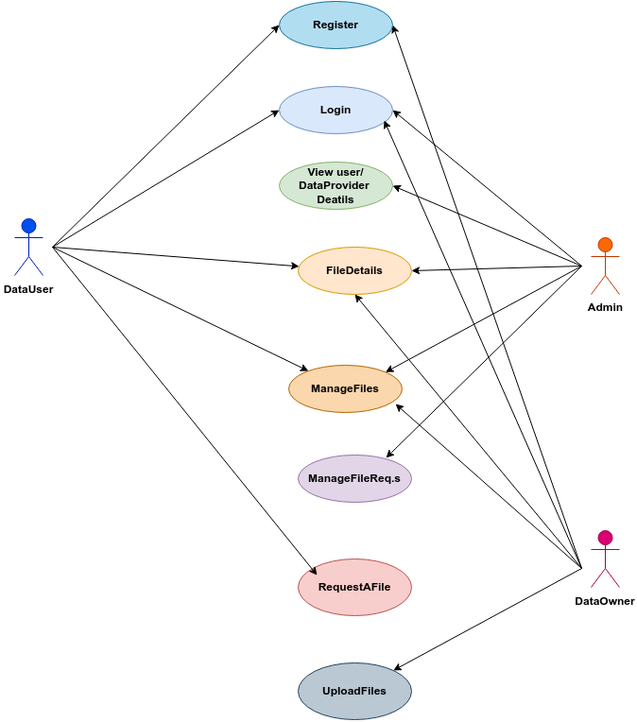

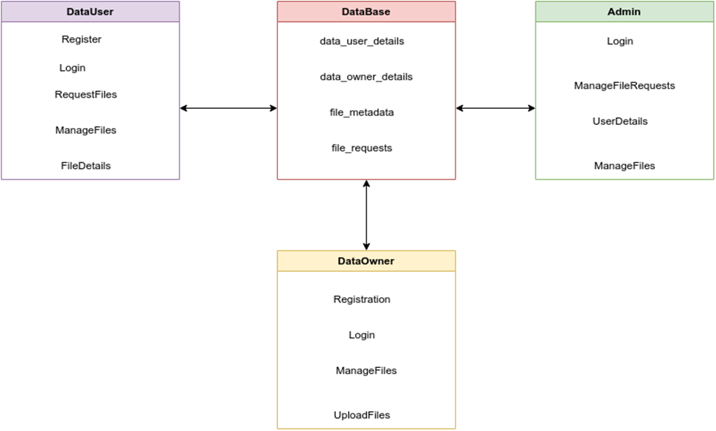

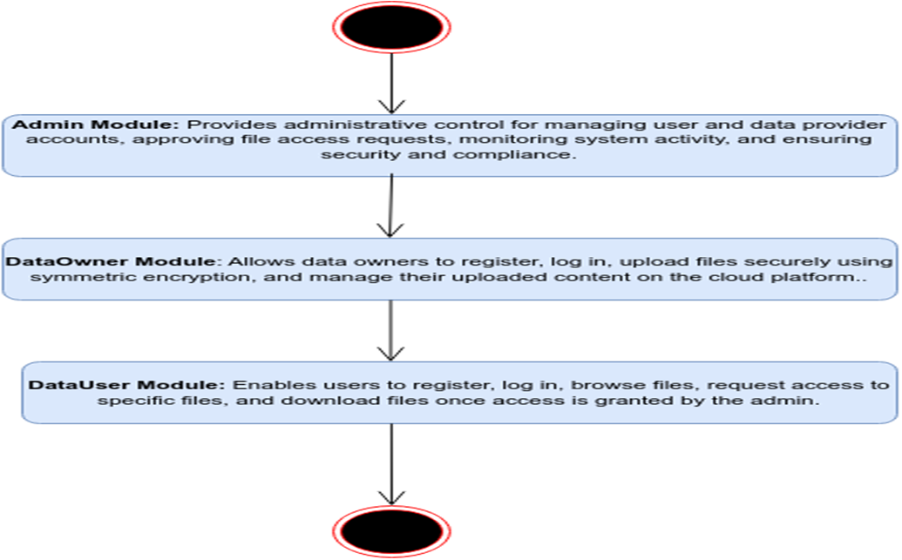

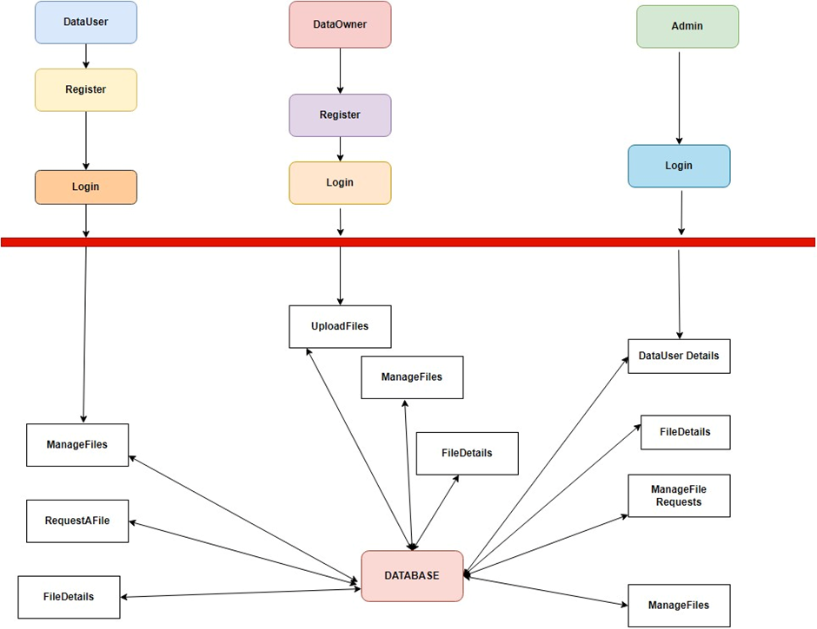
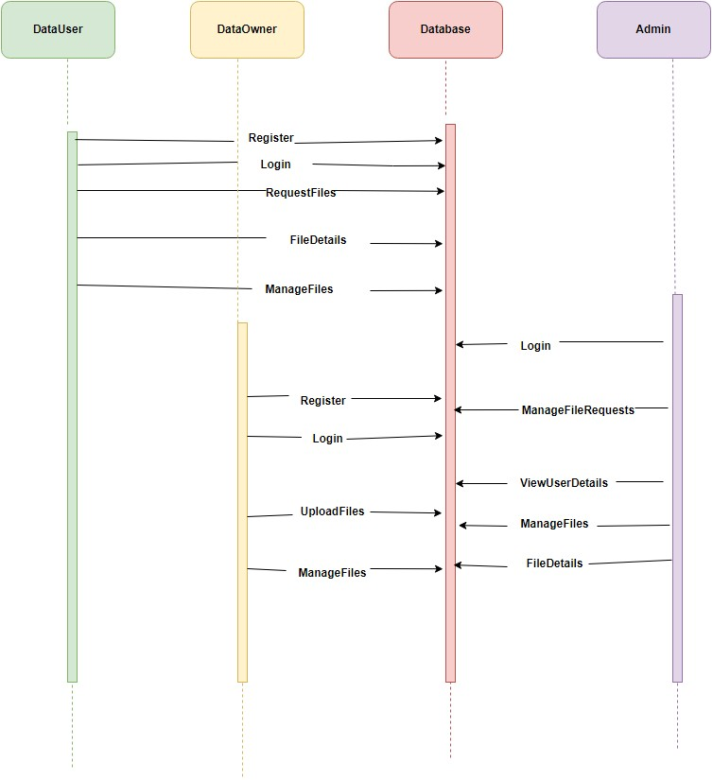
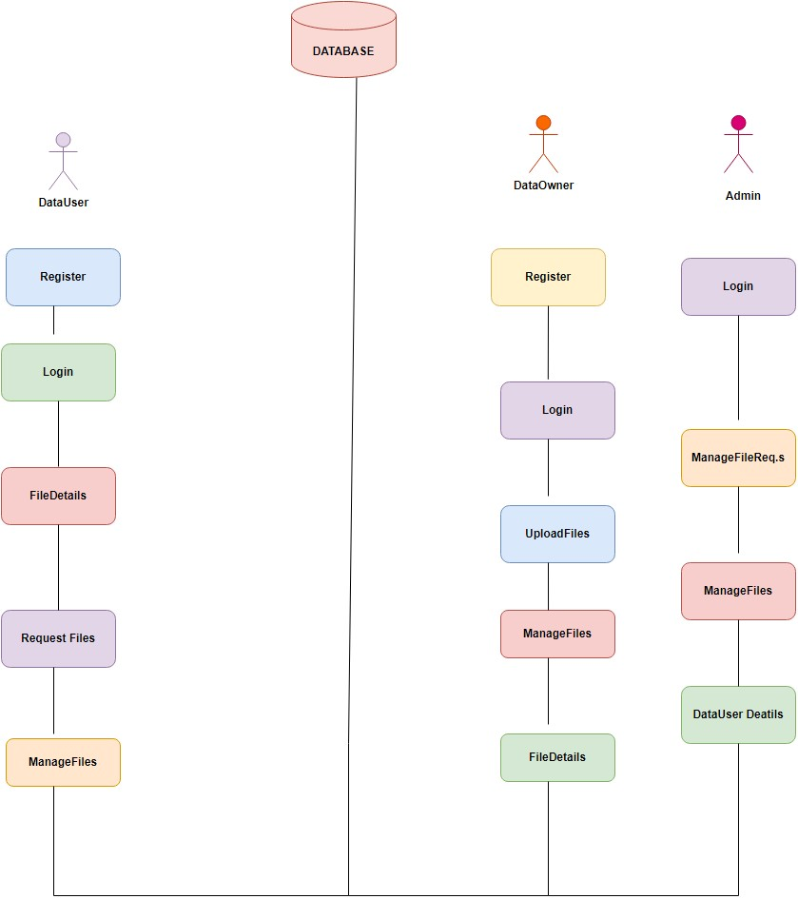
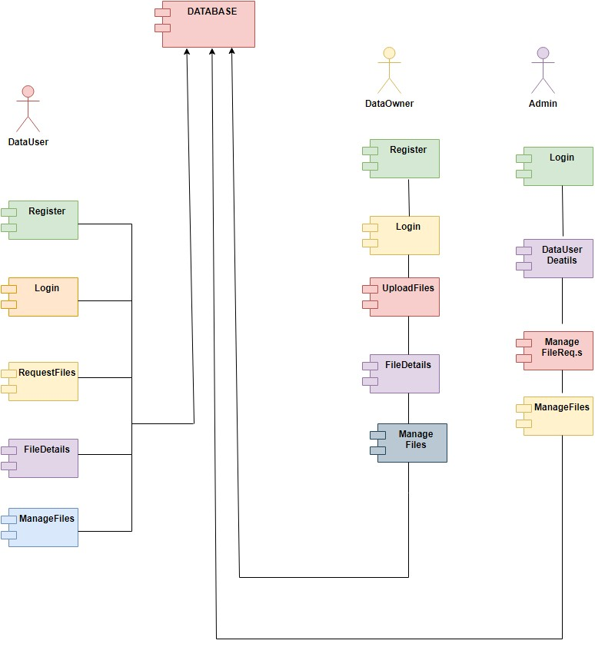
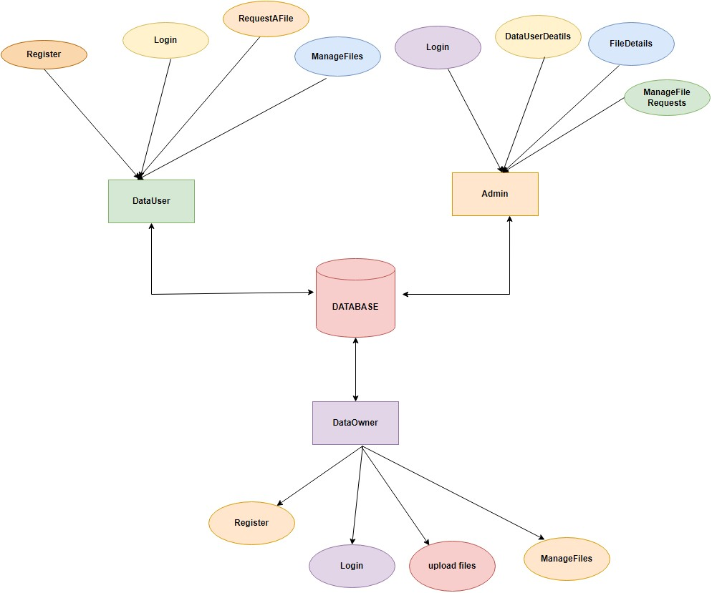
CHAPTER - 5
DEVELOPMENT TOOLS
SPRING BOOT FRAMEWORK
Spring Boot is an extension of the Spring Framework designed to simplify the development of stand-alone, production-grade Spring-based applications. By offering a set of pre-configured defaults and reducing the need for boilerplate code, Spring Boot makes it easier to create and deploy Java applications with minimal setup. One of its standout features is auto-configuration, which automatically configures Spring's infrastructure based on the libraries available in the classpath. This allows developers to concentrate on coding business logic instead of working with a lot of configuration. Also, Spring Boot applications can be executed on embedded servers such as Tomcat, Jetty, or Undertow without the need for a standalone application server.
Spring Boot also offers an assortment of "starters," which are premixed collections of dependencies for frequently used functionalities like web development, data access, and security. The starters facilitate dependency management and save time that would otherwise have been spent creating a new project. Another principal feature is Spring Boot Actuator, which introduces production-ready aspects like monitoring, metrics, and health checks into the application and aids developers in keeping the reliability and performance of the application on track. Spring Boot is especially suited for creating RESTful APIs and microservices, and hence it is widely used to create scalable, enterprise-level applications. Its methodology not only speeds up development but also makes sure that applications follow best practices and standards.

REACT JS FRAMEWORK
React is a robust JavaScript library created by Facebook for constructing user interfaces, especially for single-page applications (SPAs). Its component-based structure enables developers to construct encapsulated components that control their own state and can be combined to form intricate UIs. This modular design encourages reusability and maintainability since components can be simply updated or swapped out without impacting the whole application. React employs a virtual DOM to achieve improved rendering performance by re-rendering only those components that changed, as opposed to re-rendering the complete UI.
The adoption of JSX (JavaScript XML) by React makes it easy for developers to compose HTML-like syntax in JavaScript, which helps keep the coding process intuitive as well as have a code organization consistent with the UI intended display pattern. Adding React Hooks that facilitate the ability to utilize state and other aspects of React inside functional components provides for easier UIs that respond interactively. React's declarative paradigm simplifies understanding and maintaining the UI from the application state. It easily supports different back-end services and APIs, enabling developers to create dynamic and interactive applications that provide a seamless user experience

CHAPTER - 6
IMPLEMENTATION
In this we use the coding segment through eclipse. The following are the coding's that are utilized in order to produce the domain module for Cloud Computing. Here the suggested techniques are applied in the coding.

CHAPTER - 7
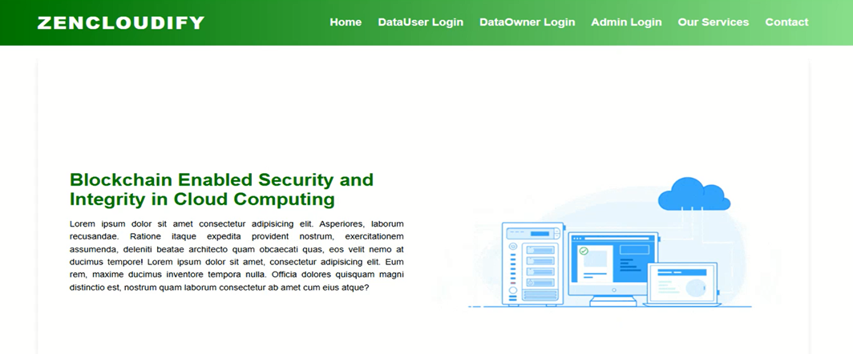
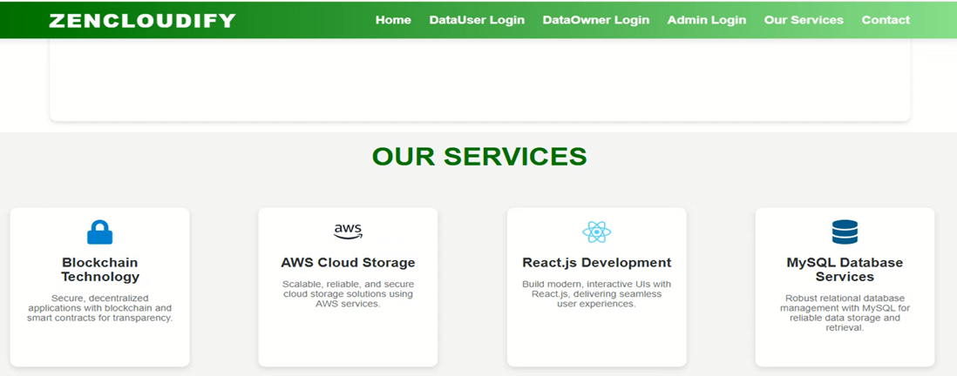


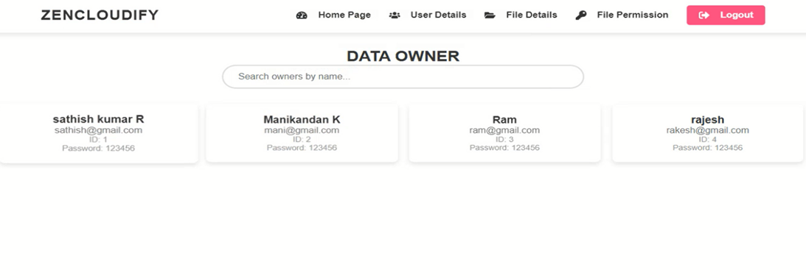
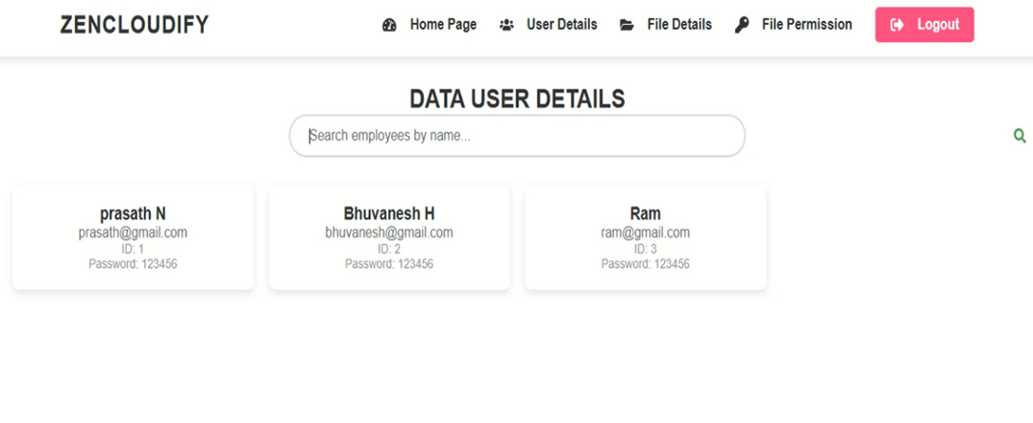
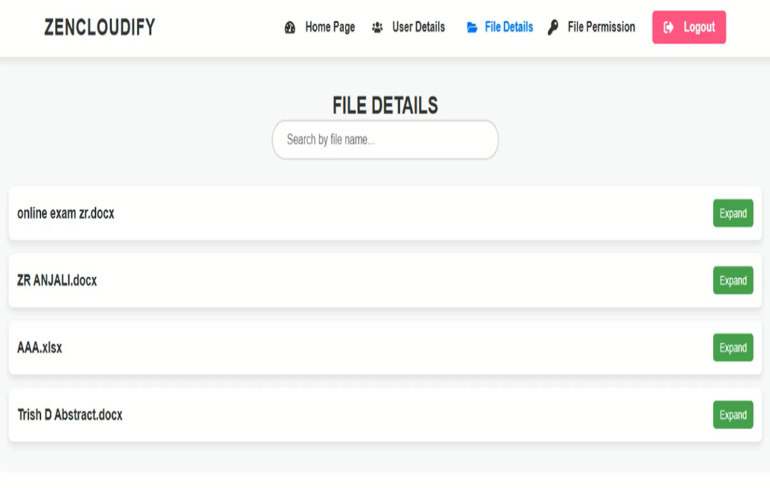

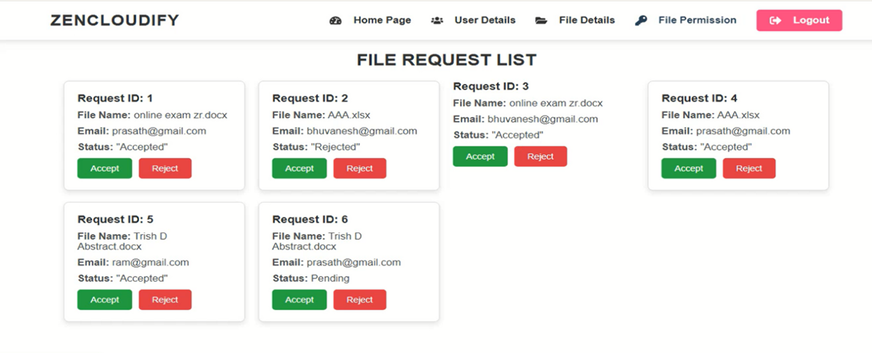
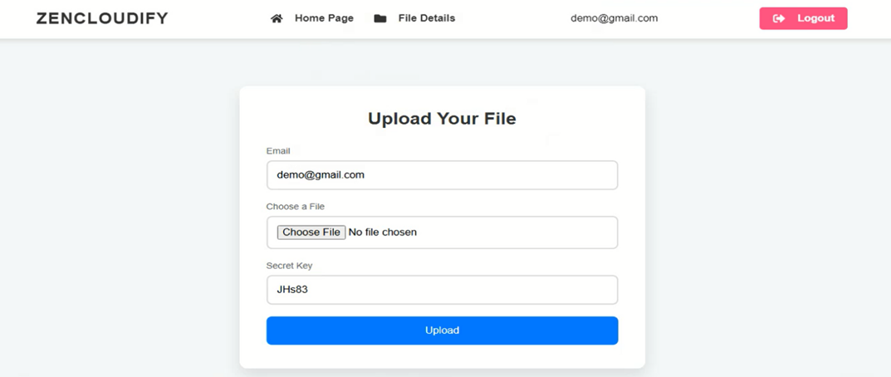
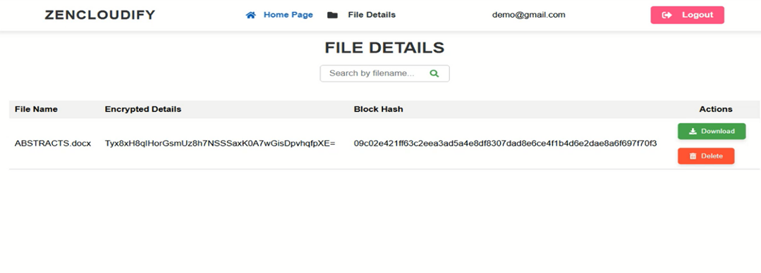

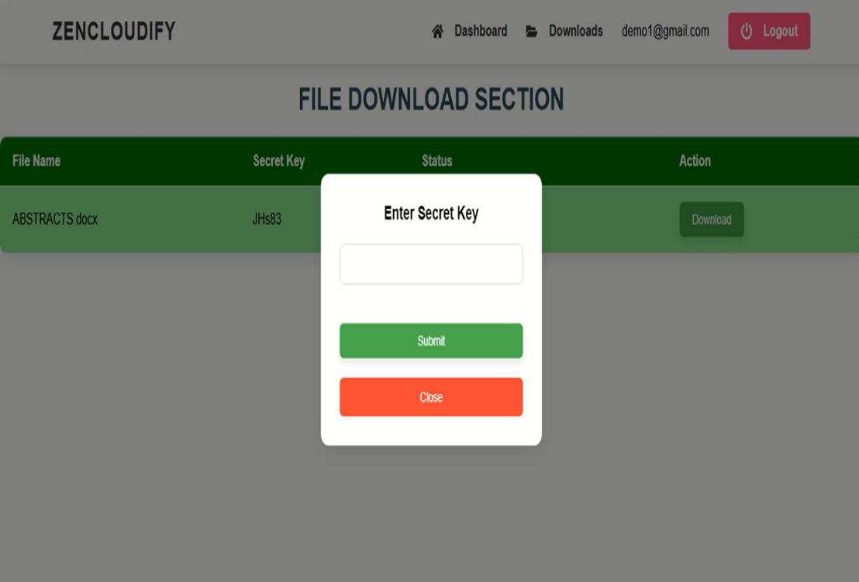

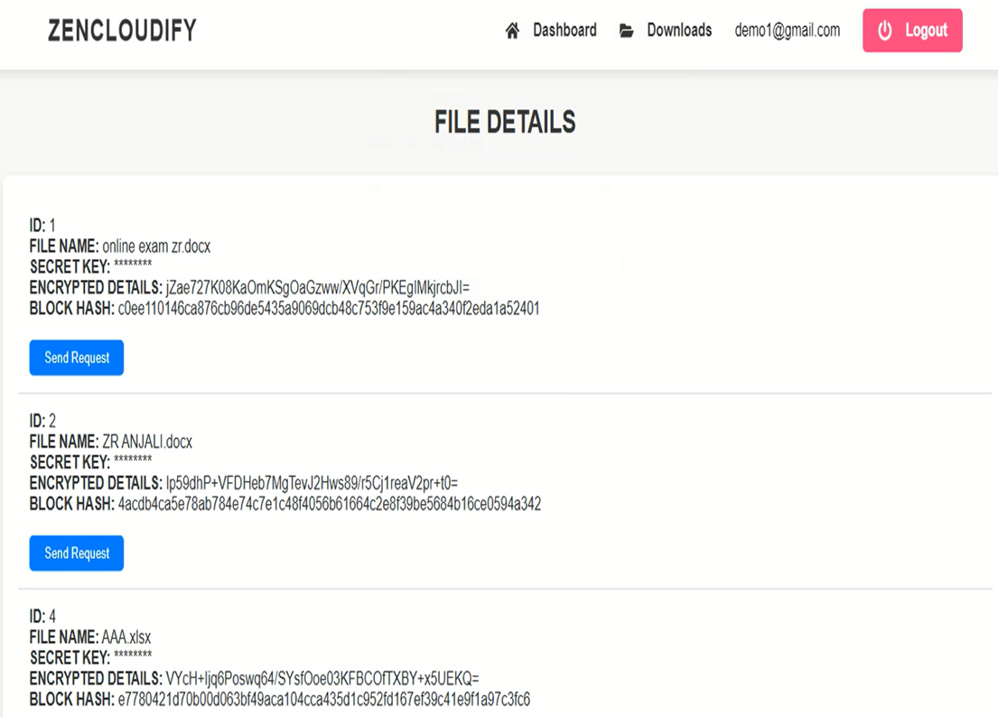
SOURCE CODE
CloudifyApplication.java
package com.example.demo;

import org.springframework.boot.SpringApplication;
import org.springframework.boot.autoconfigure.SpringBootApplication;

@SpringBootApplication
public class CloudifyApplication {

public static void main(String[] args) {
SpringApplication.run(CloudifyApplication.class, args);
}

}

Application.properties
spring.application.name=Cloudify
spring.datasource.url=jdbc:mysql://localhost:3306/cloudinfra?allowPublicKeyRetrieval=true&useSSL=false
spring.datasource.username=root
spring.datasource.password=3307
spring.datasource.driverClassName=com.mysql.cj.jdbc.Driver
spring.jpa.database-platform=org.hibernate.dialect.MySQL8Dialect
spring.jpa.hibernate.ddl-auto=update
server.port=6900

UserController.java
package com.example.demo.Controlers;

import java.util.List;
import java.util.Map;

import org.springframework.beans.factory.annotation.Autowired;
import org.springframework.http.ResponseEntity;
import org.springframework.web.bind.annotation.CrossOrigin;
import org.springframework.web.bind.annotation.GetMapping;
import org.springframework.web.bind.annotation.PostMapping;
import org.springframework.web.bind.annotation.RequestBody;
import org.springframework.web.bind.annotation.RequestMapping;
import org.springframework.web.bind.annotation.RestController;

import com.example.demo.Entites.User;
import com.example.demo.Repos.UsersRepo;

@RestController
@CrossOrigin("*")
@RequestMapping("/api/user")
public class UserController {

@Autowired

private UsersRepo dataUserRepository;

@PostMapping("/register")
public ResponseEntity<String> registerDataUser(@RequestBody User dataUser) {

// Check if username already exists

User existingUserByUsername = dataUserRepository.findByName(dataUser.getName());
if (existingUserByUsername != null) {
return ResponseEntity.badRequest().body("Username already exists");
}

// Check if email already exists

User existingUserByEmail = dataUserRepository.findByEmail(dataUser.getEmail());
if (existingUserByEmail != null) {
return ResponseEntity.badRequest().body("Email already exists");
}

dataUserRepository.save(dataUser);
return ResponseEntity.ok("Registration successful");
}

@PostMapping("/login")
public ResponseEntity<String> loginDataUser(@RequestBody Map<String, String> credentials) {

String email = credentials.get("email");

String password = credentials.get("password");

User dataUser = dataUserRepository.findByEmail(email);

if (dataUser == null || !dataUser.getPassword().equals(password)) {
return ResponseEntity.badRequest().body("Invalid credentials");
}

return ResponseEntity.ok("Login successful");
}

@GetMapping("/all")
public ResponseEntity<List<User>> getAllDataUsers() {

List<User> allUsers = dataUserRepository.findAll();

return ResponseEntity.ok(allUsers);
}

}

OwnerController.java
package com.example.demo.Controlers;

import java.util.List;
import java.util.Map;

import org.springframework.beans.factory.annotation.Autowired;
import org.springframework.http.ResponseEntity;
import org.springframework.web.bind.annotation.CrossOrigin;
import org.springframework.web.bind.annotation.GetMapping;
import org.springframework.web.bind.annotation.PostMapping;
import org.springframework.web.bind.annotation.RequestBody;
import org.springframework.web.bind.annotation.RequestMapping;
import org.springframework.web.bind.annotation.RestController;

import com.example.demo.Entites.Owner;
import com.example.demo.Repos.OwnerRepo;

@RestController
@CrossOrigin("*")
@RequestMapping("/api/owner")
public class OwnerController {

@Autowired
private OwnerRepo dataOwnerRepository;

@PostMapping("/register")
public ResponseEntity<String> registerDataOwner(@RequestBody Owner dataOwner) {

// Check if username already exists

Owner existingUserByUsername = dataOwnerRepository.findByName(dataOwner.getName());
if (existingUserByUsername != null) {
return ResponseEntity.badRequest().body("Username already exists");
}

// Check if email already exists
Owner existingUserByEmail = dataOwnerRepository.findByEmail(dataOwner.getEmail());
if (existingUserByEmail != null) {
return ResponseEntity.badRequest().body("Email already exists");
}

dataOwnerRepository.save(dataOwner);
return ResponseEntity.ok("Registration successful");
}

@PostMapping("/login")
public ResponseEntity<String> loginDataOwner(@RequestBody Map<String, String> credentials) {

String email = credentials.get("email");

String password = credentials.get("password");

Owner dataOwner = dataOwnerRepository.findByEmail(email);

if (dataOwner == null || !dataOwner.getPassword().equals(password)) {
return ResponseEntity.badRequest().body("Invalid credentials");
}

return ResponseEntity.ok("Login successful");
}

@GetMapping("/all")
public ResponseEntity<List<Owner>> getAllDataOwners() {
List<Owner> allOwners = dataOwnerRepository.findAll();
return ResponseEntity.ok(allOwners);
}

}
FileController.java
package com.example.demo.Controlers;

import java.io.IOException;
import java.io.InputStream;
import java.util.List;

import org.springframework.beans.factory.annotation.Autowired;
import org.springframework.core.io.InputStreamResource;
import org.springframework.http.HttpHeaders;
import org.springframework.http.HttpStatus;
import org.springframework.http.MediaType;
import org.springframework.http.ResponseEntity;
import org.springframework.web.bind.annotation.CrossOrigin;
import org.springframework.web.bind.annotation.DeleteMapping;
import org.springframework.web.bind.annotation.GetMapping;
import org.springframework.web.bind.annotation.PathVariable;
import org.springframework.web.bind.annotation.PostMapping;
import org.springframework.web.bind.annotation.RequestMapping;
import org.springframework.web.bind.annotation.RequestParam;
import org.springframework.web.bind.annotation.RestController;
import org.springframework.web.multipart.MultipartFile;

import com.example.demo.Repos.FileMetaDataRepo;

@CrossOrigin("*")
@RestController
@RequestMapping("/files")
public class FileController {
@Autowired
private S3Service s3Service;

@Autowired
private FileMetadataService fileMetadataService;

@PostMapping("/upload")
public ResponseEntity<String> uploadFile(
@RequestParam("file") MultipartFile file,
@RequestParam("email") String email,
@RequestParam("secretKey") String secretKey) throws IOException {

return s3Service.uploadFile(file, email, secretKey);
}

@GetMapping("/filesByEmail/{email}")
public ResponseEntity<?> getFilesByEmail(@PathVariable String email) {
try {
return ResponseEntity.ok(fileMetadataService.getFilesByEmail(email));
} catch (Exception e) {
return ResponseEntity.status(HttpStatus.INTERNAL_SERVER_ERROR)
.body("Error fetching files: " + e.getMessage());
}
}

@DeleteMapping("/delete/{fileId}")
public ResponseEntity<String> deleteFile(@PathVariable Long fileId) {
try {
fileMetadataService.deleteFile(fileId);
return ResponseEntity.ok("File deleted successfully");
} catch (Exception e) {
return ResponseEntity.status(HttpStatus.INTERNAL_SERVER_ERROR)
.body("Failed to delete file: " + e.getMessage());
}
}

@GetMapping("/download/{fileName}")
public ResponseEntity<InputStreamResource> downloadFile(@PathVariable String fileName) {
try {
// Retrieve the file from S3
InputStream fileInputStream = s3Service.downloadFile(fileName);
if (fileInputStream == null) {
return ResponseEntity.status(HttpStatus.NOT_FOUND)
.body(null);
}
InputStreamResource resource = new InputStreamResource(fileInputStream);

// Set up the response
return ResponseEntity.ok()
.contentType(MediaType.APPLICATION_OCTET_STREAM)
.header(HttpHeaders.CONTENT_DISPOSITION, "attachment; filename=\"" + fileName + "\"")
.body(resource);
} catch (Exception e) {
return ResponseEntity.status(HttpStatus.INTERNAL_SERVER_ERROR)
.body(null);
}
}

@Autowired
private FileMetaDataRepo fileMetadataRepository; // Injecting the repository directly

// New method to get all file metadata
@GetMapping("/all")
public ResponseEntity<List<com.example.demo.Entites.FileMetadata>> getAllFiles() {
try {
List<com.example.demo.Entites.FileMetadata> allFiles = fileMetadataRepository.findAll();
return ResponseEntity.ok(allFiles);
} catch (Exception e) {
return ResponseEntity.status(HttpStatus.INTERNAL_SERVER_ERROR)
.body(null);
}
}
}
FileRequestController.java
package com.example.demo.Controlers;

import org.springframework.beans.factory.annotation.Autowired;
import org.springframework.http.ResponseEntity;
import org.springframework.web.bind.annotation.*;

import com.example.demo.Entites.FileRequest;
import com.example.demo.Repos.FilerequestDataRepo;

import java.util.List;
@CrossOrigin("*")
@RestController
@RequestMapping("/api/requests")
public class FileRequestController {

@Autowired
private FilerequestDataRepo repository;

@PostMapping
public ResponseEntity<FileRequest> createRequest(@RequestBody FileRequest fileRequest) {
fileRequest.setStatus("Pending"); // Set initial status
FileRequest savedRequest = repository.save(fileRequest);
return ResponseEntity.ok(savedRequest);
}

// New method to get all file requests
@GetMapping
public ResponseEntity<List<FileRequest>> getAllRequests() {
List<FileRequest> requests = repository.findAll();
return ResponseEntity.ok(requests);
}

// New method to update the status of a file request by ID
@PutMapping("/{id}")
public ResponseEntity<FileRequest> updateRequestStatus(@PathVariable Long id, @RequestBody String newStatus) {
return repository.findById(id)
.map(request -> {
request.setStatus(newStatus); // Update the status
FileRequest updatedRequest = repository.save(request);
return ResponseEntity.ok(updatedRequest);
})
.orElse(ResponseEntity.notFound().build());
}

// New method to get file requests by email
@GetMapping("/byEmail")
public ResponseEntity<List<FileRequest>> getRequestsByEmail(@RequestParam String email) {
List<FileRequest> requests = repository.findByEmail(email);
return ResponseEntity.ok(requests);
}
}
Service.java
package com.example.demo.Controlers;

import com.amazonaws.services.s3.AmazonS3;
import com.amazonaws.services.s3.model.S3ObjectInputStream;
import com.example.demo.Entites.FileMetadata;
import com.example.demo.Repos.FileMetaDataRepo;
import org.slf4j.Logger;
import org.slf4j.LoggerFactory;
import org.springframework.beans.factory.annotation.Autowired;
import org.springframework.http.HttpStatus;
import org.springframework.http.ResponseEntity;
import org.springframework.stereotype.Service;
import org.springframework.web.multipart.MultipartFile;

import java.io.ByteArrayInputStream;
import java.io.IOException;
import java.io.InputStream;
import java.security.Key;
import java.security.MessageDigest;
import java.util.Base64;
import java.util.List;

@Service
public class S3Service {

private static final Logger logger = LoggerFactory.getLogger(S3Service.class);

@Autowired
private AmazonS3 s3Client;

@Autowired
private FileMetaDataRepo fileMetadataRepository;

private String bucketName = "databuckets12"; // Replace with your bucket name

// Generate SHA-256 hash for the file
private String generateSHA256Hash(byte[] fileBytes) throws Exception {
MessageDigest digest = MessageDigest.getInstance("SHA-256");
byte[] hashBytes = digest.digest(fileBytes);
return bytesToHex(hashBytes); // Convert the byte array to hex string
}

// Convert byte array to hex string (for SHA-256 hash)
private String bytesToHex(byte[] bytes) {
StringBuilder hexString = new StringBuilder();
for (byte b : bytes) {
hexString.append(String.format("%02x", b));
}
return hexString.toString();
}

// Check if the file with the same name already exists for the given email
private boolean isFileAlreadyExists(String filename, String email) {
// Search for existing files by email and filename
List<FileMetadata> existingFiles = fileMetadataRepository.findByEmail(email);
for (FileMetadata fileMetadata : existingFiles) {
if (fileMetadata.getFileName().equals(filename)) {
return true; // Found a file with the same name
}
}
return false; // No duplicate found
}

// Upload file to S3 and store metadata
public ResponseEntity<String> uploadFile(MultipartFile file, String email, String secretKey) {
try {
String filename = file.getOriginalFilename();

// Check if the file with the same name already exists for the given email
if (isFileAlreadyExists(filename, email)) {
// Return HTTP 400 (Bad Request) with a message indicating the file already exists
return new ResponseEntity<>("Duplicate file: A file with the same name already exists.", HttpStatus.BAD_REQUEST);
}

// Convert file to bytes
byte[] fileBytes = file.getBytes();

// Generate SHA-256 hash for the file (block hash)
String fileHash = generateSHA256Hash(fileBytes);

// Encrypt the file with AES before uploading
Key aesKeySpec = EncryptionUtils.createKey(secretKey, "AES");
byte[] encryptedBytes = EncryptionUtils.encryptData(fileBytes, aesKeySpec);

// Upload the encrypted file to S3
try (InputStream encryptedStream = new ByteArrayInputStream(encryptedBytes)) {
s3Client.putObject(bucketName, filename, encryptedStream, null);
}

// Save the file metadata including the block hash
String encryptedKeyStore = EncryptionUtils.encodeKey(aesKeySpec);

FileMetadata fileMetadata = new FileMetadata(filename, email, secretKey, encryptedKeyStore, fileHash);
fileMetadataRepository.save(fileMetadata); // Save block hash in metadata

// Return HTTP 200 OK with success message
return new ResponseEntity<>("File uploaded successfully.", HttpStatus.OK);

} catch (Exception e) {
// Log the error and return HTTP 500 (Internal Server Error)
logger.error("Error during file upload: ", e);
return new ResponseEntity<>("Error during file upload: " + e.getMessage(), HttpStatus.INTERNAL_SERVER_ERROR);
}
}

// Download the file from S3
public ByteArrayInputStream downloadFile(String filename) {
try {
// Download the file from S3
S3ObjectInputStream s3InputStream = s3Client.getObject(bucketName, filename).getObjectContent();
byte[] encryptedBytes = s3InputStream.readAllBytes();
s3InputStream.close();

// Retrieve the AES key for decryption
FileMetadata fileMetadata = fileMetadataRepository.findByFileName(filename);
if (fileMetadata == null) {
throw new IllegalArgumentException("File metadata not found");
}
Key aesKeySpec = EncryptionUtils.createKey(fileMetadata.getSecretKey(), "AES");

// Decrypt the file using AES
byte[] decryptedBytes = EncryptionUtils.decryptData(encryptedBytes, aesKeySpec);

return new ByteArrayInputStream(decryptedBytes);
} catch (Exception e) {
logger.error("Error during decryption/download: ", e);
return null;
}
}

// Method to calculate the SHA-256 hash of the file
private String calculateFileHash(InputStream fileInputStream) throws Exception {
MessageDigest digest = MessageDigest.getInstance("SHA-256");
byte[] byteArray = fileInputStream.readAllBytes();
byte[] hashBytes = digest.digest(byteArray);
return Base64.getEncoder().encodeToString(hashBytes); // Base64 encoding of the hash
}

}

Run the source sode
VS code : npm run dev
http://localhost:5173/

CHAPTER - 8
SOFTWARE TESTING
In this work, we derive achievability schemes and outer bounds for the secure network coding scenario, with edges experiencing packet erasures and public channel state feedback accessible to both Eve and the legitimate network. Secure network coding relies on the assumption that the error-free network channels are provided by the underlying network channels; therefore, if our channels are error-introducing, we must first encode using a channel code to fix errors, and then we construct security upon the resulting error-free network. We demonstrate that by using erasures and feedback, we can achieve secrecy rates in certain cases several times higher than the alternative of independent channel-error-correction followed by secure network coding; and we establish outer bounds and optimality of our proposed schemes in some special cases.
DEVELOPING METHODOLOGIES
The testing process is started by creating a thorough plan to test the overall functionality and special features on a range of platform combinations. Strict quality control measures are employed.
The process checks that the application is bug-free and satisfies requirements outlined in the system requirements document. The points below are those that were taken into consideration when creating the framework from creating testing methodologies.
TYPE OF TESTING
Unit testing
Unit testing is the process of creating test cases that ensure that the internal program logic works correctly, and that program input yield correct outputs. All decision branches and internal code flow need to be checked. It is the testing of individual software units of the application.it is performed after finishing an individual unit prior to integration. This is a structural test, which is based on its build and is intrusive. Unit tests conduct simple tests at component level and test a given business process, application, and/or system configuration. Unit tests confirm that every distinct path of a business process executes correctly to the documented specifications and has well-defined inputs and expected outcomes.
Functional test
Functional tests deliver systematic demonstrations that functions tested are accessible as indicated by the business and technical specifications, system documentation, and user guides.
Functional testing revolves around the following items:
Valid Input : recognized classes of valid input should be accepted.
Invalid Input : found classes of invalid input should be rejected.
Functions : found functions should be tested.
Output : identified classes of application outputs must be exercised.
Systems/ Procedures: interfacing systems or procedures must be invoked.
System Test
System testing confirms that the complete integrated software system satisfies requirements. It checks a configuration to validate known and expected results. One example of system testing is the configuration oriented system integration test. System testing is process description and flow based, with focus on pre-driven process links and integration points.
Performance Test
The Performance test makes sure that the output be generated within the time constraints, and the time consumed by the system for compiling, providing response to the users and request being sent to the system for to get the results.
Integration Testing
Software integration testing is incremental integration testing of two or more integrated software components on one platform to generate failures due to interface defects.
The integration test is to verify that components or software applications, i.e. components within a software system or – one level higher – software applications at the company level – behave without error.
Acceptance Testing
User Acceptance Testing is an important phase of any project and involves a lot of end user participation. It also verifies that the system fulfills the functional requirements
Acceptance testing for Data Synchronization:
¬ The Acknowledgements will be sent to the Sender Node once the Packets are reached at the Destination Node
¬ The Route add operation is performed only when there is a Route request pending
¬ The Status of node information is automatically completed in the Cache Updation process
Construct the test plan
Any project can be segmented into units which can be executed further for finer processing. Then there is a testing plan for every one of this unit executed. Unit testing assists to identify the probable bugs in the single component, so the faulty component can be identified and can be corrected from errors

CHAPTER - 9
APPLICATION
The Blockchain Enabled Security and Integrity in Cloud Computing project seeks to solve cloud storage challenges through a secure, efficient, and scalable solution for media file sharing. The system focuses on deduplication so that only new media files are stored, minimizing storage overhead and enhancing efficiency. Data owners can upload files, which are encrypted and saved to the cloud. Users can have access to individual files requested, and the cloud administrator authorizes these requests, allowing access in accordance with access control rules. The system employs a key-based encryption system to protect data and secure it against unwanted access. Through the integration of file deduplication, encryption, and controlled access, this system increases security for data, decreases storage expenses, and enhances general user experience in cloud-based media sharing systems. This method is especially beneficial for use in media sharing, online storage services, and secure cloud data management.

FUTURE ENHANCEMENT
Possible future improvements for this project would involve the use of sophisticated machine learning algorithms to make deduplication and file similarity identification more effective. With AI, the system can automatically recognize and group similar files even if they have minimal differences, e.g., variations in format or resolution, further maximizing storage. Moreover, adoption of a decentralized storage strategy through the use of blockchain technology may enhance data integrity and transparency by providing an immutable log of file access and updates. The user interface may also be enhanced by introducing a recommendation mechanism that suggests similar files based on user behavior and preferences. To enhance security, multi-factor authentication (MFA) and advanced encryption mechanisms like homomorphic encryption might be implemented, keeping the data secure even when being processed. Finally, the system might be extended to support multimedia files other than conventional ones, like 3D models or VR material, making it more versatile in a wide range of industries like entertainment, healthcare, and research. These improvements would help to make the system more stable, best UI.

CHAPTER - 10
CONCLUSION
In summary, Blockchain Enabled Security and Integrity in Cloud Computing presents an innovative solution for secure efficient deduplication of similar encrypted media files in cloud-based media sharing platforms. Through the ability of media distributors to restrict access to their media and specify a similarity threshold at which deduplication takes place, Blockchain Enabled Security and Integrity in Cloud Computing makes sure that privacy as well as storage efficiency is achieved. The fuzzy proof-of-work (PoW) implementation of the system effectively wards off false claims of ownership while upholding data integrity. Through serious theoretical security proofs and actual practice on AlibabaCloud OSS, Blockchain Enabled Security and Integrity in Cloud Computing showcases the ability to extend cloud media sharing by minimizing the cost of storage, enhancing management of files, and protecting privacy of data. The overall assessment findings validate the efficacy and practicability of Blockchain Enabled Security and Integrity in Cloud Computing in actual implementation, opening the door to its use in media distribution systems with high security and scalability demands.

REFERENCES
1. Daliri, A. Mohammadifar et al., "Accurate Autism Spectrum Disorder Prediction using Support Vector Classifier based on Federated Learning (SVCFL)", 2023.
2. Guijie Li et al., "DeepASDPred: a CNN-LSTM-based deep learning method for Autism spectrum disorders risk RNA identification", 2023.
3. Z. Sherkatghanad, M. Akhondzadeh, S. Salari et al., "Automated detection of autism spectrum disorder using a convolutional neural network", 2020.
4. S. Jayarathna, Y. Jayawardana, M. Jaime and S. Thapaliya, "Electroencephalogram (EEG) for delineating objective measure of autism spectrum disorder", 2019.
5. R. Asaoka, H. Murata, A. Iwase and M. Araie, "Detecting glaucoma progression with deep learning", 2019.
6. A. Mozo, B. Ordozgoiti and S. Gómez-Canaval, "Forecasting short-term data center network traffic load with convolutional neural networks", 2018.
7. T. T. A. Dinh et al., "Blockchain: A decentralized solution to data management and sharing", 2017.
8. F. N. Iandola, S. Han, M. W. Moskewicz, K. Ashraf, W. J. Dally and K. Keutzer, "SqueezeNet: AlexNet-level accuracy with 50x fewer parameters", 2016.
9. F. Grassmann, J. Mengelkamp, C. Brandl, S. Harsch, M. E. Zimmermann, B. Linkohr, et al., "A deep learning algorithm for prediction of age-related eye disease study severity scale for age-related macular degeneration from color fundus photography", Ophthalmology, vol. 125, no. 9, pp. 1410-1420, 2018.
10. P. Burlina, K. D. Pacheco, N. Joshi, D. E. Freund, N. M. Bressler and R. Jorge, "Use of deep learning for detailed severity characterization and estimation of 5-year risk among patients with age-related macular degeneration", JAMA Ophthalmology, vol. 135, no. 6, pp. 603-610, 2017

