INTERNSHIP REPORT

A report submitted in partial fulfilment of the requirements for the Award of Degree of
PG. Diploma in Data Science

By
JEEVITHA. S
Reg. No. BD241062

Under Supervision of
Mr. SAKTHI S,
Senior Technical Trainer,
Strydo Technologies India Private Limited, Vellore.
[Duration: 17nd Dec, 2024 to 12nd Mar, 2025]


DEPARTMENT OF COMPUTER APPLICATIONS (PG)
SACRED HEART COLLEGE (AUTONOMOUS), TIRUPATTUR Dt. 635601

APRIL 2025

DEPARTMENT OF COMPUTER APPLICATIONS(PG)
SACRED HEART COLLEGE (AUTONOMOUS) TIRUPATTUR


CERTIFICATE
This is to certify that the “Internship report” submitted by JEEVITHA. S (Reg. No.: BD241062) is work done by him and submitted during APRIL 2025, in partial fulfilment of the requirements for the award of the degree of PG. DIPLOMA IN DATA SCIENCE, at Strydo Technologies India Private Limited, Vellore.

Department Internship Coordinator Internship Internal Guide
Dr. THOMAS IMMANUEL V Mr. Veeraragavan
Assistant professor, Assistant professor,
Department of Computer Application (PG) Department of Computer Application (PG)

.

Dr. George Louis Raja A
Head of the Department
Department of Computer Application (PG)

Submitted for the Viva-Voce Examination held on ……………...……………

Examiner-1 Examiner-2
ACKNOWLEGEMENT
I thank God Almighty for the blessings and grace by which I was able to complete this project work successfully. I sincerely thank my parents, unless and my relatives for their continuous support, love and blessings for me to attain many achievements.

I take this opportunity to express my gratitude to those who helped me and led me to complete this project work. I offer my humble gratitude to Rev. Dr. D. Maria Antony Raj Principal, Sacred Heart College (Autonomous), Tirupattur for permitting me to do my project work. I would like to thank the Director, HR and the entire team at Strydo Technologies for the guidance they provided to me to complete this project successfully.

I express my deep gratitude to Dr. S. Sagayaraj Director, Department of Computer Applications (PG), Sacred Heart College (Autonomous), Tirupattur.

I would like to thank Dr. A. George Louis Raja Head, Department of Computer Applications (PG), Sacred Heart College (Autonomous) Tirupattur for providing the necessary arrangements for me to do my project work and training at Strydo Technologies

My sincere thanks to Mr. Veeraragavan internship Guide, who has guided me throughout my project work, I am grateful to him for his encouragement, guidance and assistance towards my project work.

JEEVITHA. S
(BP231029)

No | Table Content | Page No
1 | Abstract | 5
2 | Internship Objectives | 6
3 | Overview of Internship Activities (Weekly Report) | 7
4 | Introduction | 11
5 | System Analysis | 16
6 | Technology Study | 17
7 | User Screenshots (GUI Screens) | 18
8 | Coding | 19
9 | Conclusion | 22
10 | Bibliography | 23

ABSTRACT – 1
The widespread usage of cloud computing has brought about new opportunities and severe security issues. This research is aimed at solving the significant problem of data security in cloud computing systems. Conventional security techniques, such as encryption, are typically not adequate to preserve data confidentiality in cloud environments. This paper discusses a new model that incorporates blockchain technology for confidentiality, authentication, and integrity of data in cloud computing. With the incorporation of blockchain in cloud computing infrastructure, this proposed solution attempts to resolve confidentiality, authentication, and integrity of data issues. This research study investigates the feasibility of implementing blockchain-based strategies for securing APIs and network interfaces, minimizing malicious traffic attacks, accidental disclosures, and breach of service agreements. The study also solves the issue of multi-tenancy problems that are hazardous for data confidentiality and integrity in multi-tenancy cloud platforms. The primary goal of this research is to ensure a safe and trusted computing environment for consumers of cloud computing services, and this gives confidence and trust in cloud-based services. In resolving significant issues in data security and confidentiality, this research facilitates the increasing adoption and growth of cloud computing services

OBJECTIVE – 2
The primary objective of the given project is to design and deploy a blockchain-based system that enhances data security and privacy within cloud computing systems. The project seeks to address major challenges such as data confidentiality, authentication, integrity, and multi-tenancy issues through the application of the decentralized and immutable nature of blockchain. Through the application of blockchain technology within cloud infrastructures, the project seeks to offer a more secure and reliable platform for the storage of sensitive information, APIs protection, and trusted interactions among users and cloud services. In the long term, the project seeks to encourage more confidence and trust in cloud computing by offering strong security features that counter threats from malicious attacks and unintended or unauthorized intrusions.

OVERVIEW OF INTERNSHIP ACTIVITIES - 3

S. No | Title | Description | Date
1. | Reporting to the company | Going to the company | 22/12/2024
2. | Choosing the Project  Title | Confirmation of the title of the project with the guides | 23/12/2024
3. | Requirements Document | Completing the User Requirement and System Requirement  Documents | 28/12/2024
4. | Design Document | Finalizing and Completing the Design Document | 29/12/2024
5. | UI Design | Completing the UI Design for the project | 31/12/2024
6. | Database Design | Creating and Completing the  Database Design for the project | 02/01/2025
7. | Project Implementation | Implementation of the project and deployment are completed. | 20/02/2025
8. | Testing | After implementation, the testing process of the project is completed. | 24/02/2025
9. | Documentation | Completing the Project Documentation | 28/02/2025
10 | First Review | First Review of the Project | 07/03/2025

OUR SERVICES:
Strydo Technologies continuously strives to provide high-quality products and services to customers that enable interactive communication between their business and audiences. STRYDO TECHNOLOGIES has a typical client base from small to Fortune 30 Companies and offers a one-stop solution for all types of technology services. Our experts specialize in Mobile Application Development Companies in Vellore and Tirupati, Android OS App Development, Mobile App Development Companies in Vellore and Tirupati, Top Mobile app development Companies, Mobile app developers, Mobile App Development Company in Vellore and Tirupati Android Application Development Companies in Bangalore, OS Application Development Companies in Bangalore, Hybrid Mobile App Development Company in Vellore and Tirupati, Best Mobile App

Development Company in Vellore and Tirupati, Android App Development Company, Mobile Application App Development Company, Mobile Application Development, Web Design and Development, E-commerce Website Development across various latest technology platforms and always keen on updating with new trends arising in the industry
- UI/UX Design
Strydo specializes in crafting intuitive and engaging user interfaces and experiences that captivate and retain users. Our UI/UX design services focus on user- centric design principles, ensuring seamless navigation, visual appeal, and optimal usability. By leveraging the latest design trends and tools, we help organizations enhance user satisfaction, drive engagement, and achieve their business goals through visually stunning and functionally superior digital products.
- Mobile Application & Development
We empower businesses to reach their mobile audience with innovative and high- performance mobile applications. Our expert developers create custom mobile solutions tailored to your unique needs, whether for iOS, Android, or cross-platform development. From concept to deployment, we ensure that your mobile app is secure, scalable, and delivers an exceptional user experience, helping you stay competitive in the ever-evolving mobile landscape.
- Digital Marketing
Strydo offers comprehensive digital marketing services designed to boost your online presence and drive measurable results. Our strategies encompass search engine optimization (SEO), pay-per-click (PPC) advertising, social media marketing, content marketing, and email campaigns. By leveraging data-driven insights, we help you reach your target audience, increase brand visibility, and achieve higher conversion rates, ultimately maximizing your return on investment.
- Cloud Migration
Our cloud migration services enable organizations to transition their IT infrastructure and applications to the cloud seamlessly. We provide end-to-end migration solutions, including assessment, planning, execution, and optimization, ensuring minimal
disruption to your operations. By migrating to the cloud, businesses can benefit from enhanced scalability, cost efficiency, and improved performance, positioning themselves for future growth and innovation.
- Embedded Systems
We specialize in the design and development of embedded systems tailored to meet the specific needs of various industries. Our expertise spans hardware design, firmware development, and software integration, ensuring robust and reliable embedded solutions. Whether for IoT devices, industrial automation, or consumer electronics, our embedded systems services deliver high-performance, low-power solutions that drive innovation and efficiency.
- Web Hosting & Maintenance
Strydo provides reliable and secure web hosting solutions to ensure your website is always accessible and performing optimally. Our hosting services include scalable infrastructure, robust security measures, and regular backups to safeguard your data. Additionally, our maintenance services encompass ongoing updates, performance monitoring, and technical support, ensuring your website remains up-to-date, secure, and aligned with your evolving business needs.

Introduction - 4
The rapid development of cloud computing has brought along various benefits such as cost savings, scalability, and flexibility, which have rendered it an essential service for businesses and individuals. With organizations moving their business and data to the cloud, they are tapping into these benefits to boost productivity and streamline processes. Cloud computing allows users to remotely access resources and services from anywhere across the globe, making collaboration and innovation easier. The trend has, however, brought along new challenges, primarily security and privacy of the massive amounts of sensitive data stored and processed in cloud platforms.
Conventional data protection mechanisms such as encryption, firewalls, and access controls have been common in protecting data within cloud computing. While these mechanisms offer some form of protection, they are generally not adequate in addressing the specific weaknesses present in cloud computing. The multi-tenant model of cloud computing, where many users use the same infrastructure, makes data leakage and unauthorized access more common. In addition, the absence of centralized control over data storage and processing challenges the enforcement of security policies. These weaknesses highlight the necessity for new solutions augmenting data security in cloud computing.
Blockchain technology has been a potential solution to security and privacy in cloud computing. With a decentralized, tamper-resistant ledger, blockchain technology has the potential to provide higher data integrity, transparency, and authentication. The inherent features of blockchain, such as tamper resistance and the ability to securely store transactions without the intervention of intermediaries, are most suitable to the nature of cloud environments. As blockchain technology is decentralized, cloud service users can gain higher control over their data, minimizing the risk of data storage in a single point and establishing trust in the cloud.

EXISTING SYSTEM
Existing systems for Blockchain Enabled Security and Integrity in Cloud Computing primarily focus on reducing storage redundancy by identifying and removing duplicate files. These systems typically operate by comparing file hashes or using content-based identifiers to detect duplicates. However, most existing solutions fail to handle encrypted data securely, as they require access to the file content for comparison, which compromises data privacy. Additionally, many systems do not address the issue of protecting ownership in scenarios where similar files are involved, potentially allowing one user to falsely claim ownership of another’s media. Moreover, existing systems often lack fine-grained access control, leading to potential security risks in terms of unauthorized data access. While some approaches attempt to enable secure deduplication over encrypted data, they generally rely on trusted third parties or introduce significant computational overhead, making them impractical for large-scale applications.
DISADVANTAGES
1. Lack of Support for Encrypted Data: Most systems require access to file content for deduplication, which poses privacy risks when the data is encrypted. This compromises the confidentiality of users' files stored in the cloud.
2. Ownership Protection Issues: Existing systems often do not address the risk of one distributor falsely claiming ownership of another's media file, particularly when similar files are involved, leading to potential intellectual property disputes.
3. Limited Access Control: Many systems do not provide fine-grained access control mechanisms, which could result in unauthorized access to sensitive or private media content.
4. High Computational Overhead: Deduplication over encrypted data typically introduces significant computational complexity, which can lead to high processing costs and reduced efficiency, making it impractical for large-scale or real-time use.
5. Inability to Handle Similar Data: Most systems only focus on exact duplicate detection and fail to effectively handle visually or functionally similar files, which is a common scenario in media sharing applications.
6. Dependence on Trusted Third Parties: Some systems rely on trusted third parties to perform deduplication, which introduces potential security risks and trust issues, especially in decentralized cloud environments.
7. Inadequate Scalability: Existing solutions may not scale efficiently when dealing with massive amounts of media data or when many users are involved, leading to performance bottlenecks and increased costs.

SCOPE OF THE PROJECT
The objective of the Blockchain Enabled Security and Integrity in Cloud Computing project is to create a secure deduplication system for media sharing in the cloud that will maximize storage efficiency by identifying and removing duplicate and near-duplicate media files. The system will employ sophisticated similarity detection algorithms to handle various types of media, such as images, videos, and audio. Security is a critical feature, with robust encryption and privacy-preserving measures ensuring that user data is kept confidential during deduplication. The solution will be integrated into existing cloud infrastructures seamlessly, with scalability and high speed to handle large-scale data storage. The system will be optimized for rapid processing with minimal computation time while maintaining the integrity and accessibility of media files. The project will also focus on user experience, with easy-to-use interfaces for managing deduplicated content.

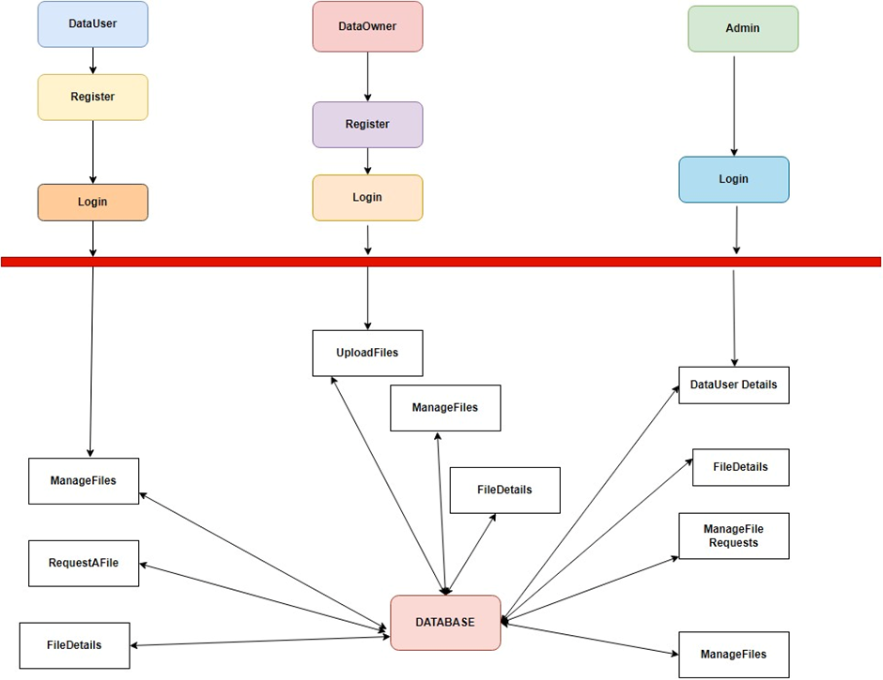

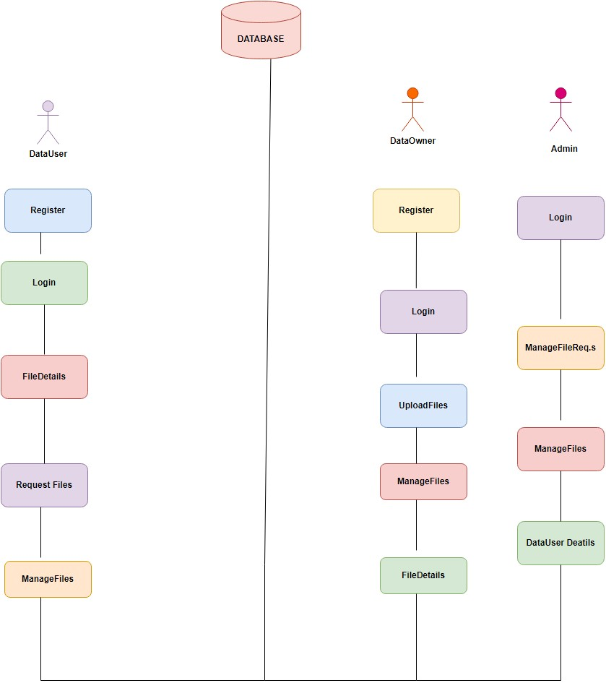

SYSTEM ANALYSIS – 5
Spring Boot is an extension of the Spring Framework designed to simplify the development of stand-alone, production-grade Spring-based applications. By offering a set of pre-configured defaults and reducing the need for boilerplate code, Spring Boot makes it easier to create and deploy Java applications with minimal setup. One of its standout features is auto-configuration, which automatically configures Spring's infrastructure based on the libraries available in the classpath. This allows developers to concentrate on coding business logic instead of working with a lot of configuration. Also, Spring Boot applications can be executed on embedded servers such as Tomcat, Jetty, or Undertow without the need for a standalone application server.
Spring Boot also offers an assortment of "starters," which are premixed collections of dependencies for frequently used functionalities like web development, data access, and security. The starters facilitate dependency management and save time that would otherwise have been spent creating a new project. Another principal feature is Spring Boot Actuator, which introduces production-ready aspects like monitoring, metrics, and health checks into the application and aids developers in keeping the reliability and performance of the application on track. Spring Boot is especially suited for creating RESTful APIs and microservices, and hence it is widely used to create scalable, enterprise-level applications. Its methodology not only speeds up development but also makes sure that applications follow best practices and standards.

REACT JS FRAMEWORK
React is a robust JavaScript library created by Facebook for constructing user interfaces, especially for single-page applications (SPAs). Its component-based structure enables developers to construct encapsulated components that control their own state and can be combined to form intricate UIs. This modular design encourages reusability and maintainability since components can be simply updated or swapped out without impacting the whole application. React employs a virtual DOM to achieve improved rendering performance by re-rendering only those components that changed, as opposed to re-rendering the complete UI.
The adoption of JSX (JavaScript XML) by React makes it easy for developers to compose HTML-like syntax in JavaScript, which helps keep the coding process intuitive as well as have a code organization consistent with the UI intended display pattern. Adding React Hooks that facilitate the ability to utilize state and other aspects of React inside functional components provides for easier UIs that respond interactively. React's declarative paradigm simplifies understanding and maintaining the UI from the application state. It easily supports different back-end services and APIs, enabling developers to create dynamic and interactive applications that provide a seamless user experience

TECHNOLOGY STUDY - 6
SOFTWARE REQUIREMENTS
The software requirements document is the specification of the system. It should include both a definition and a specification of requirements. It is a set of what the system should do rather than how it should do it. The software requirements provide a basis for creating the software requirements specification. It is useful in estimating cost, planning team activities, performing tasks and tracking the team’s and tracking the team’s progress throughout the development activity.
FRONT END : HTML, CSS, REACT JS, BOOTSTRAP
BACK END : SPRINGBOOT
DATABASE : MY SQL
CLOUD SERVICE : AMAZON WEB SERVICE

User Screenshots (GUI Screens) - 7
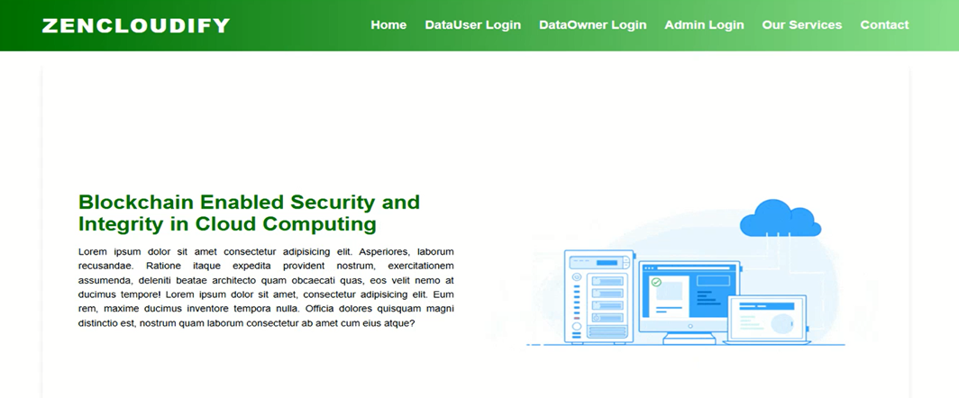
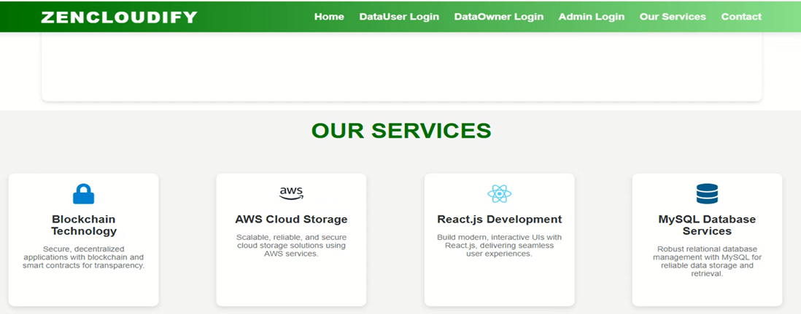


Coding – 8
CloudifyApplication.java
package com.example.demo;

import org.springframework.boot.SpringApplication;
import org.springframework.boot.autoconfigure.SpringBootApplication;

@SpringBootApplication
public class CloudifyApplication {

public static void main(String[] args) {
SpringApplication.run(CloudifyApplication.class, args);
}

}

Application.properties
spring.application.name=Cloudify
spring.datasource.url=jdbc:mysql://localhost:3306/cloudinfra?allowPublicKeyRetrieval=true&useSSL=false
spring.datasource.username=root
spring.datasource.password=3307
spring.datasource.driverClassName=com.mysql.cj.jdbc.Driver
spring.jpa.database-platform=org.hibernate.dialect.MySQL8Dialect
spring.jpa.hibernate.ddl-auto=update
server.port=6900

UserController.java
package com.example.demo.Controlers;

import java.util.List;
import java.util.Map;

import org.springframework.beans.factory.annotation.Autowired;
import org.springframework.http.ResponseEntity;
import org.springframework.web.bind.annotation.CrossOrigin;
import org.springframework.web.bind.annotation.GetMapping;
import org.springframework.web.bind.annotation.PostMapping;
import org.springframework.web.bind.annotation.RequestBody;
import org.springframework.web.bind.annotation.RequestMapping;
import org.springframework.web.bind.annotation.RestController;

import com.example.demo.Entites.User;
import com.example.demo.Repos.UsersRepo;

@RestController
@CrossOrigin("*")
@RequestMapping("/api/user")
public class UserController {

@Autowired

private UsersRepo dataUserRepository;

@PostMapping("/register")
public ResponseEntity<String> registerDataUser(@RequestBody User dataUser) {

// Check if username already exists

User existingUserByUsername = dataUserRepository.findByName(dataUser.getName());
if (existingUserByUsername != null) {
return ResponseEntity.badRequest().body("Username already exists");
}

// Check if email already exists

User existingUserByEmail = dataUserRepository.findByEmail(dataUser.getEmail());
if (existingUserByEmail != null) {
return ResponseEntity.badRequest().body("Email already exists");
}

dataUserRepository.save(dataUser);
return ResponseEntity.ok("Registration successful");
}

@PostMapping("/login")
public ResponseEntity<String> loginDataUser(@RequestBody Map<String, String> credentials) {
String email = credentials.get("email");
String password = credentials.get("password");
User dataUser = dataUserRepository.findByEmail(email);

if (dataUser == null || !dataUser.getPassword().equals(password)) {
return ResponseEntity.badRequest().body("Invalid credentials");
}
return ResponseEntity.ok("Login successful");
}
@GetMapping("/all")
public ResponseEntity<List<User>> getAllDataUsers() {
List<User> allUsers = dataUserRepository.findAll();

return ResponseEntity.ok(allUsers);
}

}
Conclusion - 9
In summary, Blockchain Enabled Security and Integrity in Cloud Computing presents an innovative solution for secure efficient deduplication of similar encrypted media files in cloud-based media sharing platforms. Through the ability of media distributors to restrict access to their media and specify a similarity threshold at which deduplication takes place, Blockchain Enabled Security and Integrity in Cloud Computing makes sure that privacy as well as storage efficiency is achieved. The fuzzy proof-of-work (PoW) implementation of the system effectively wards off false claims of ownership while upholding data integrity. Through serious theoretical security proofs and actual practice on AlibabaCloud OSS, Blockchain Enabled Security and Integrity in Cloud Computing showcases the ability to extend cloud media sharing by minimizing the cost of storage, enhancing management of files, and protecting privacy of data. The overall assessment findings validate the efficacy and practicability of Blockchain Enabled Security and Integrity in Cloud Computing in actual implementation, opening the door to its use in media distribution systems with high security and scalability demands.

Biography - 10
1. Daliri, A. Mohammadifar et al., "Accurate Autism Spectrum Disorder Prediction using Support Vector Classifier based on Federated Learning (SVCFL)", 2023.
2. Guijie Li et al., "DeepASDPred: a CNN-LSTM-based deep learning method for Autism spectrum disorders risk RNA identification", 2023.
3. Z. Sherkatghanad, M. Akhondzadeh, S. Salari et al., "Automated detection of autism spectrum disorder using a convolutional neural network", 2020.
4. S. Jayarathna, Y. Jayawardana, M. Jaime and S. Thapaliya, "Electroencephalogram (EEG) for delineating objective measure of autism spectrum disorder", 2019.
5. R. Asaoka, H. Murata, A. Iwase and M. Araie, "Detecting glaucoma progression with deep learning", 2019.
6. A. Mozo, B. Ordozgoiti and S. Gómez-Canaval, "Forecasting short-term data center network traffic load with convolutional neural networks", 2018.
7. T. T. A. Dinh et al., "Blockchain: A decentralized solution to data management and sharing", 2017.
8. F. N. Iandola, S. Han, M. W. Moskewicz, K. Ashraf, W. J. Dally and K. Keutzer, "SqueezeNet: AlexNet-level accuracy with 50x fewer parameters", 2016.
9. F. Grassmann, J. Mengelkamp, C. Brandl, S. Harsch, M. E. Zimmermann, B. Linkohr, et al., "A deep learning algorithm for prediction of age-related eye disease study severity scale for age-related macular degeneration from color fundus photography", Ophthalmology, vol. 125, no. 9, pp. 1410-1420, 2018.
10. P. Burlina, K. D. Pacheco, N. Joshi, D. E. Freund, N. M. Bressler and R. Jorge, "Use of deep learning for detailed severity characterization and estimation of 5-year risk among patients with age-related macular degeneration", JAMA Ophthalmology, vol. 135, no. 6, pp. 603-610, 2017

