hive
create table movie(movie_id int,movie_name varchar(30),year_of_release int,rating float,duration int) row format delimited fields terminated by ',';
load data local inpath '/home/jeevitha/Downloads/movies dataset for pig (2).txt' into table movie;
select * from movie;

A)select* from movie where year_of_release >=1950 and year_of_release<=1960;
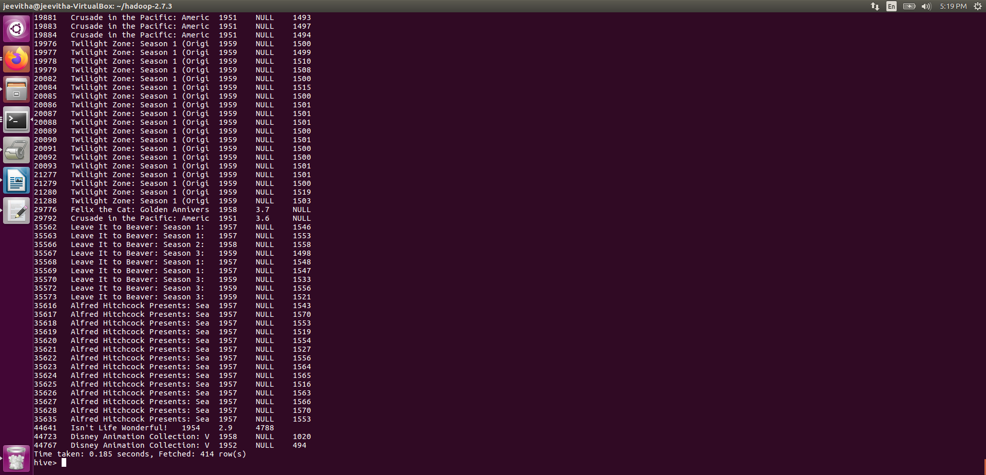
B)select count(movie_name) from movie where rating>4;

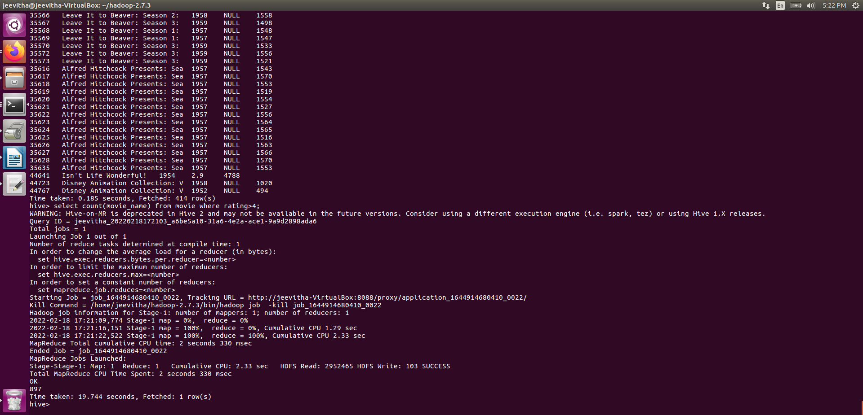
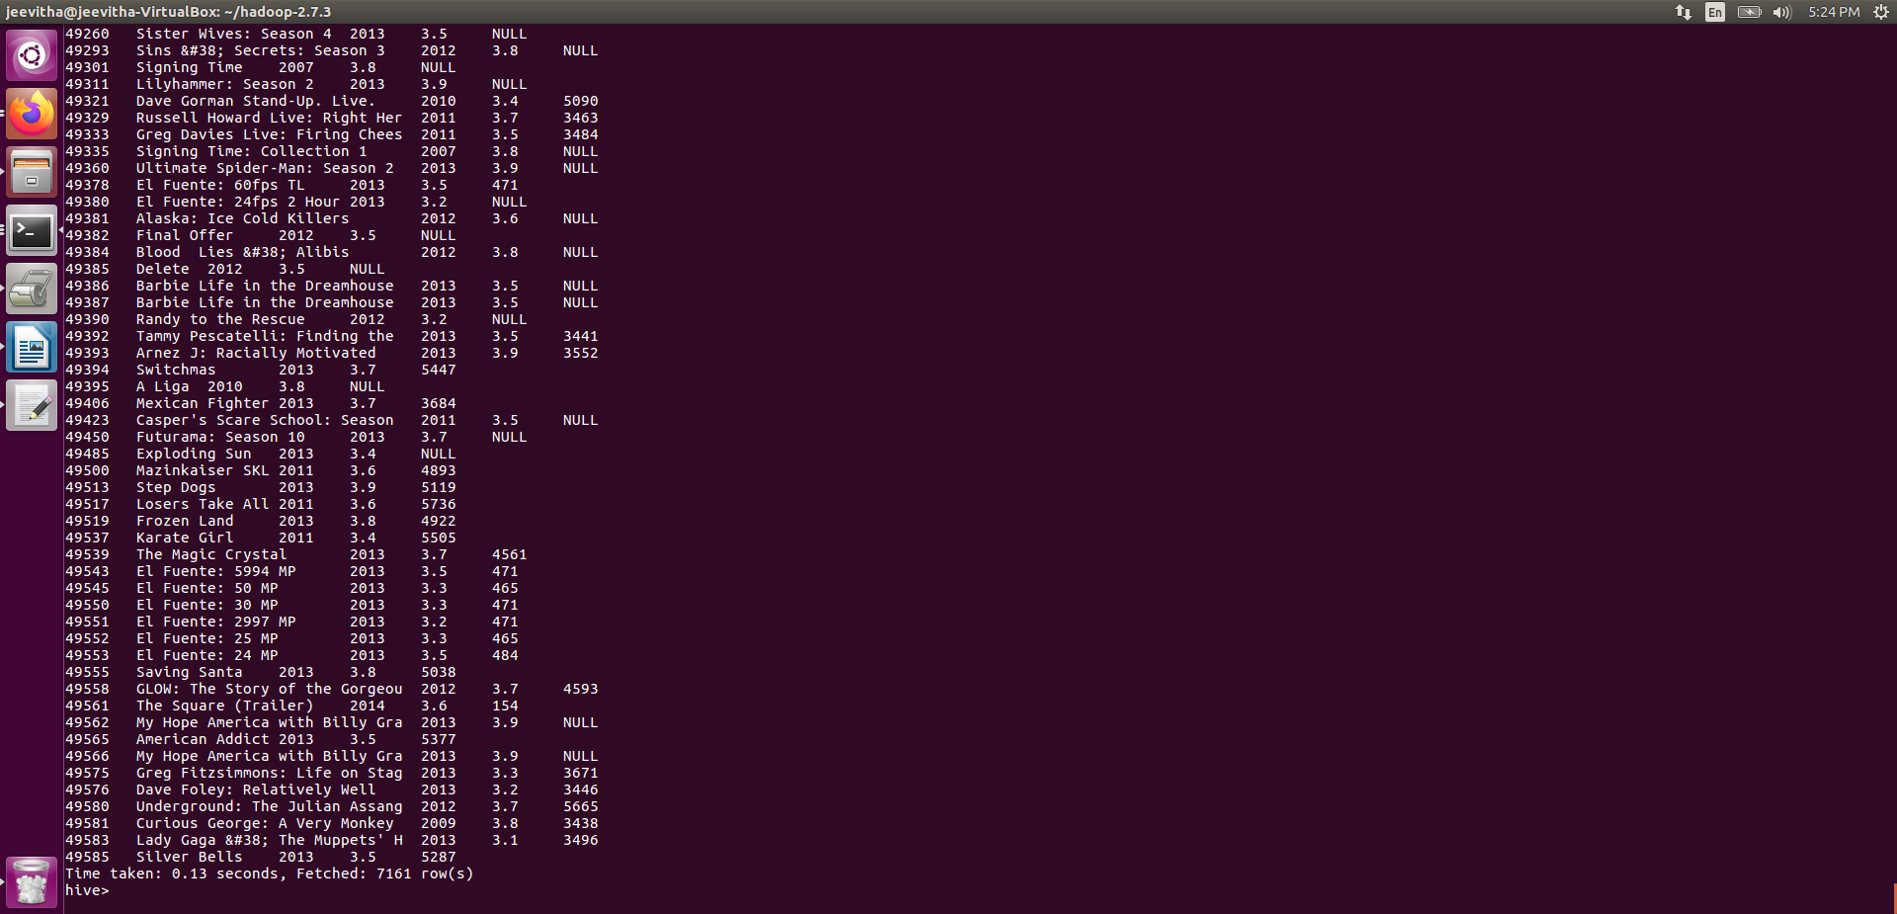
C)select * from movie where rating>3.0 and rating<4.0;

D)select count(movie_id) from movie where duration>7200;

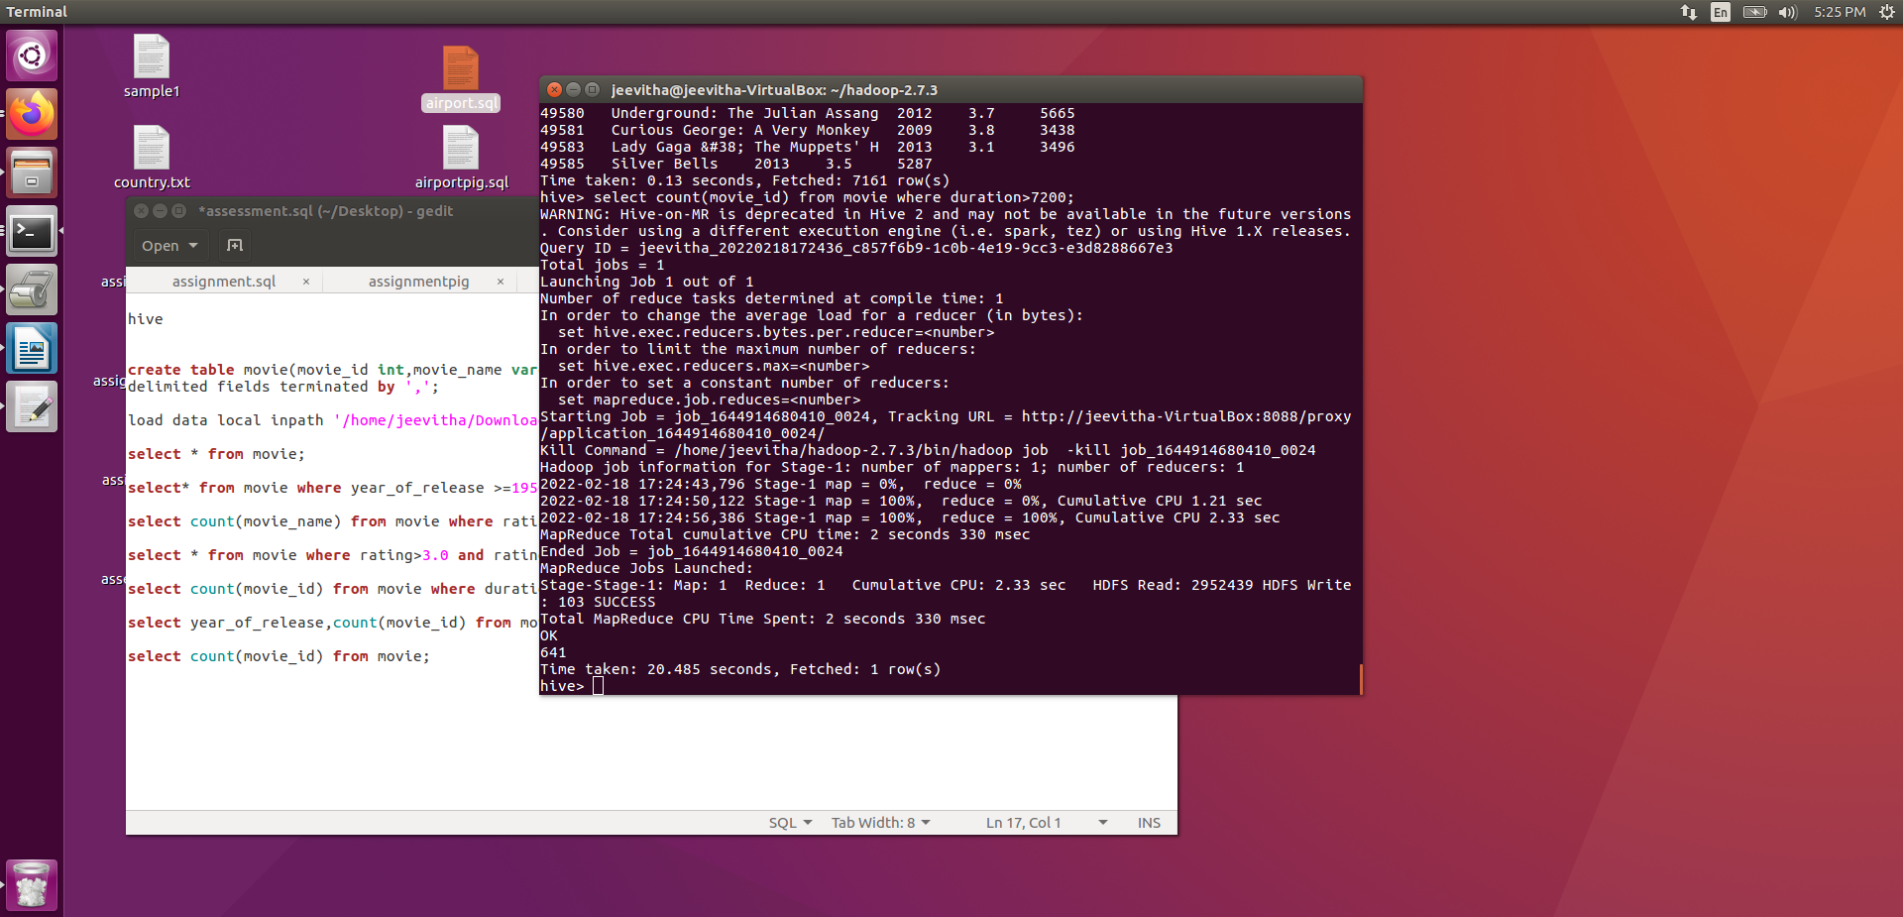
E)select year_of_release,count(movie_id) from movie group by year_of_release;
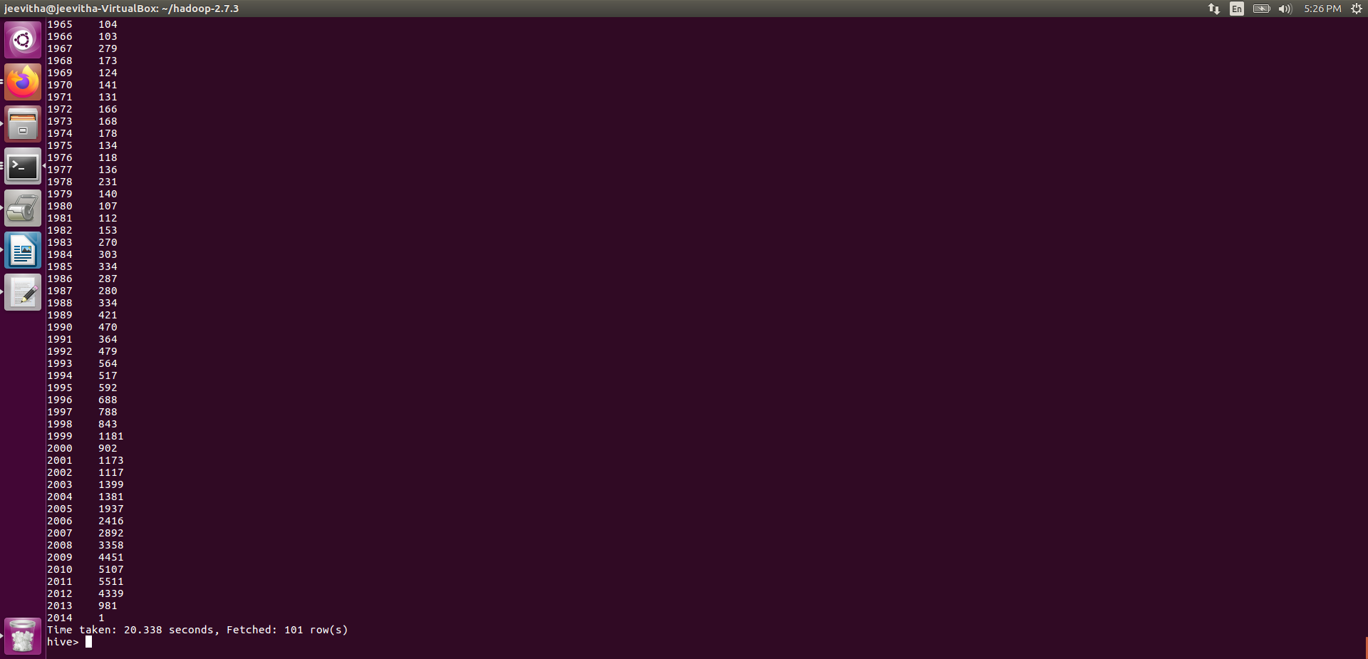
F)select count(movie_id) from movie;
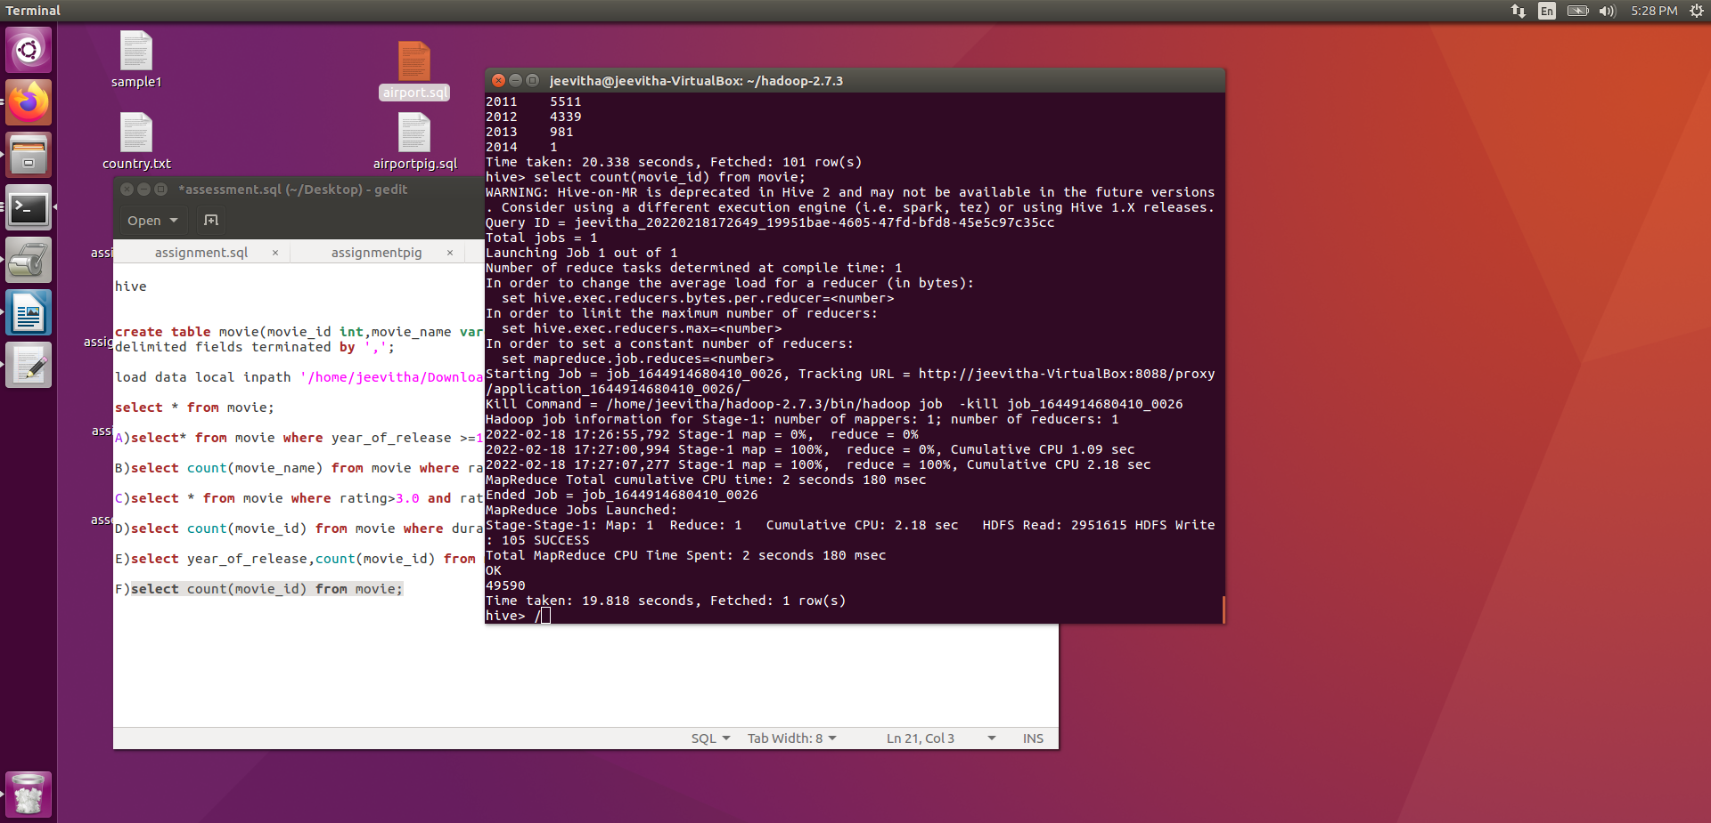

pig
cd hadoop-2.7.3
source ~/.bashrc_profile
bin/hdfs dfs -mkdir /assessment
bin/hdfs dfs -put /home/jeevitha/Downloads/movies dataset for pig (2).txt/assessment
pig

Cinema = load '/assessment/movies dataset for pig (2).txt' USING PigStorage(',') as (movie_id:int, movie_name:chararray, yol:int, rating:double, duration:int);

describe Cinema;
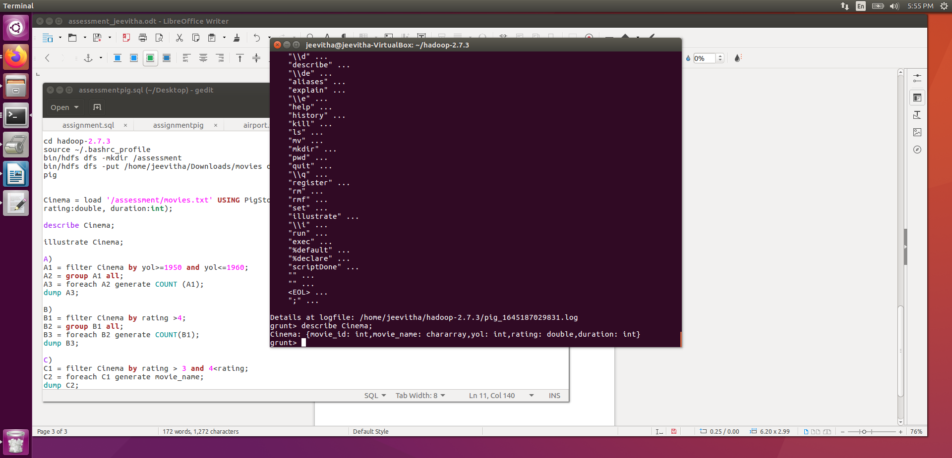
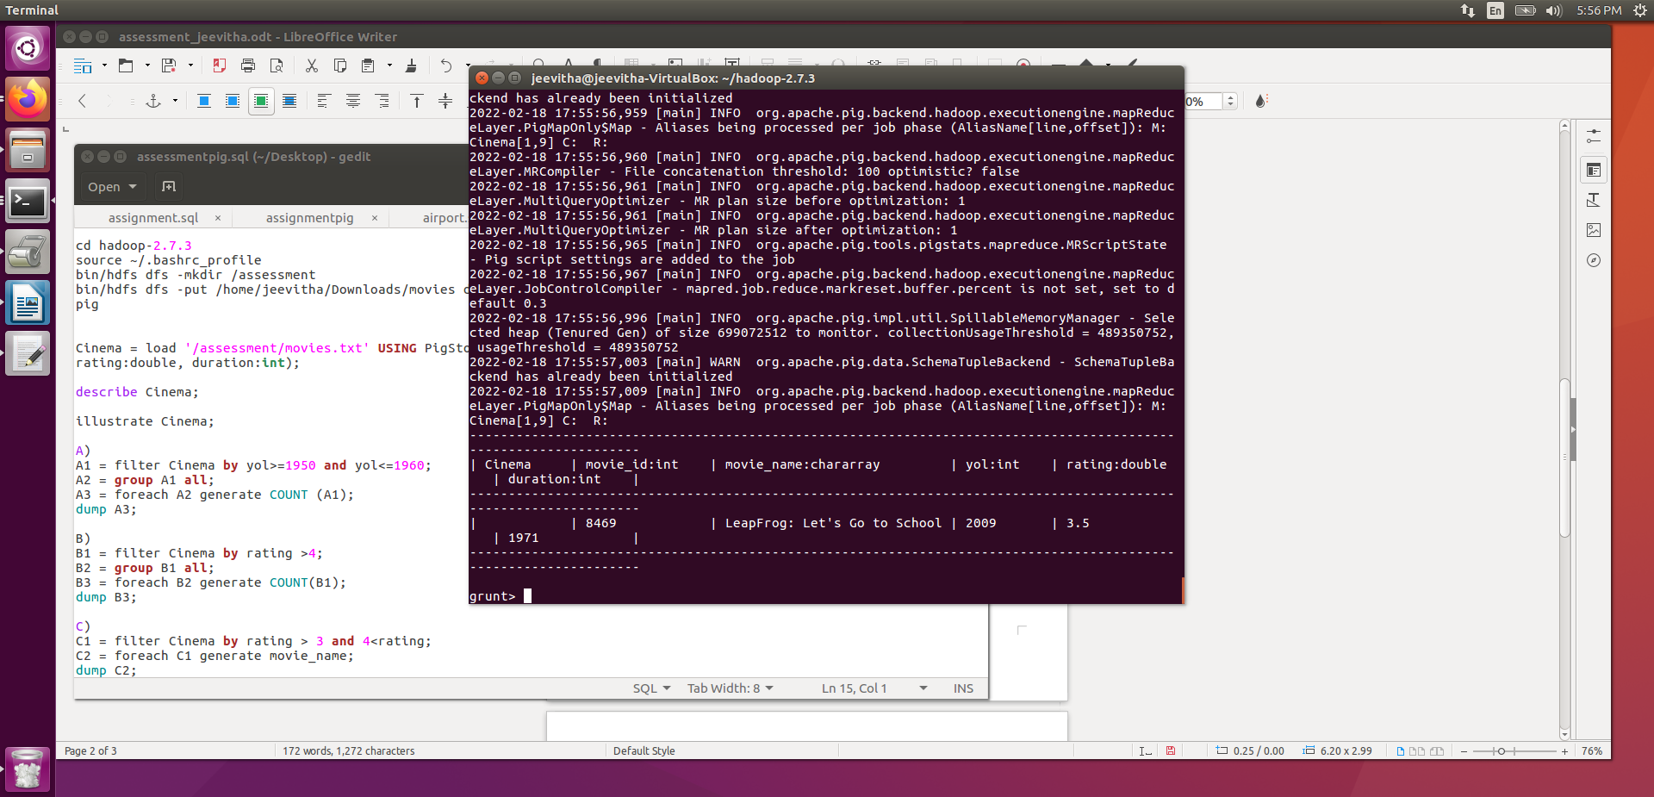
illustrate Cinema;

A)A1 = filter Cinema by yol>=1950 and yol<=1960;
A2 = group A1 all;
A3 = foreach A2 generate COUNT (A1);
dump A3;
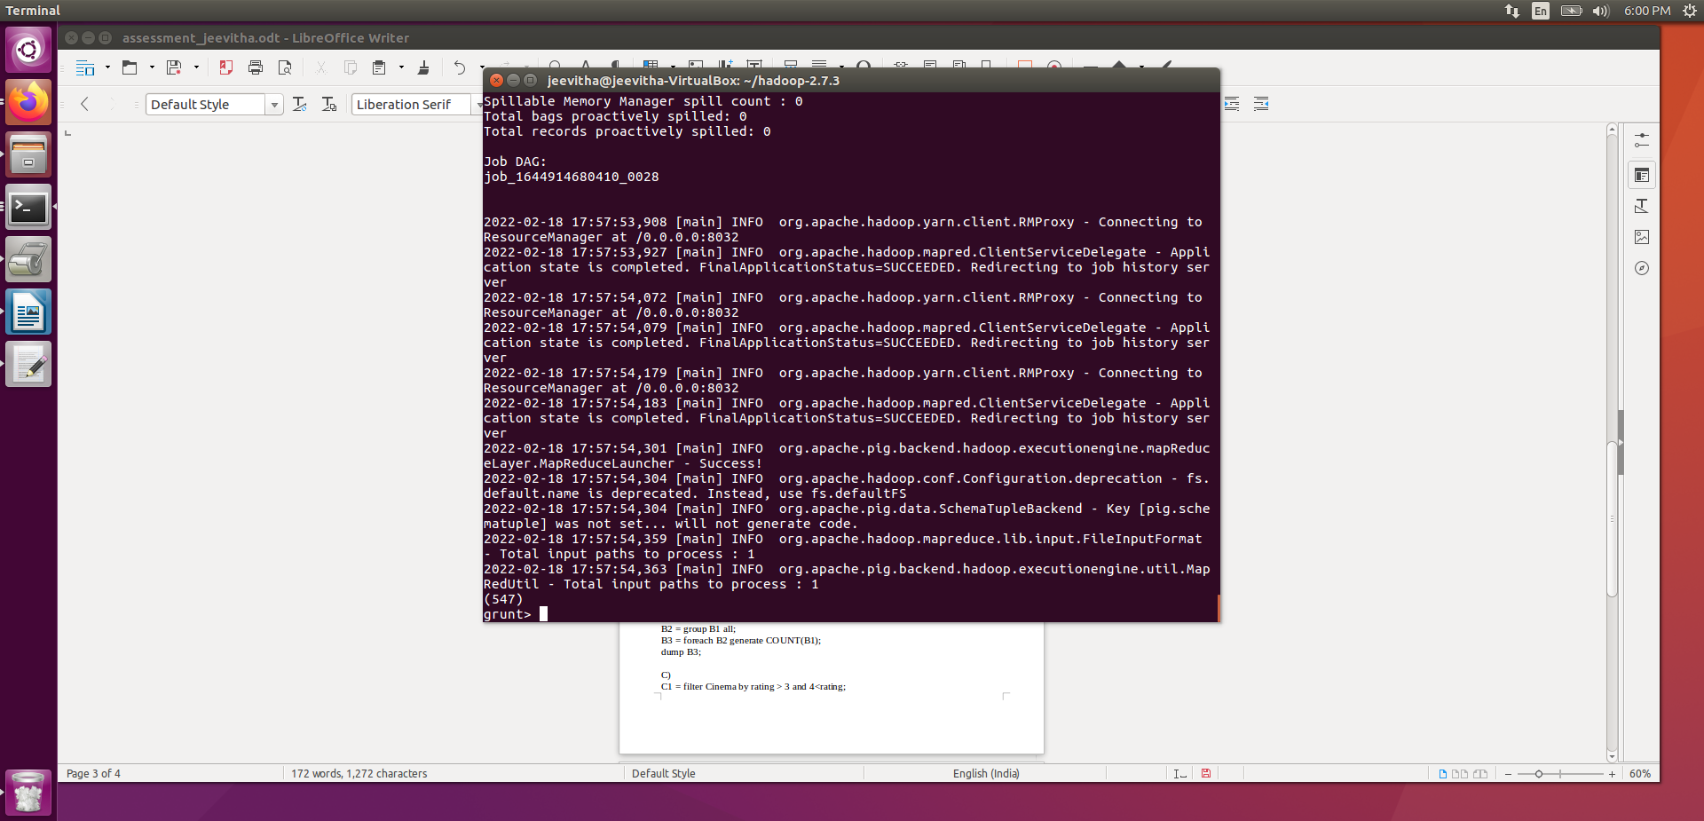

B)B1 = filter Cinema by rating >4;
B2 = group B1 all;
B3 = foreach B2 generate COUNT(B1);
dump B3;
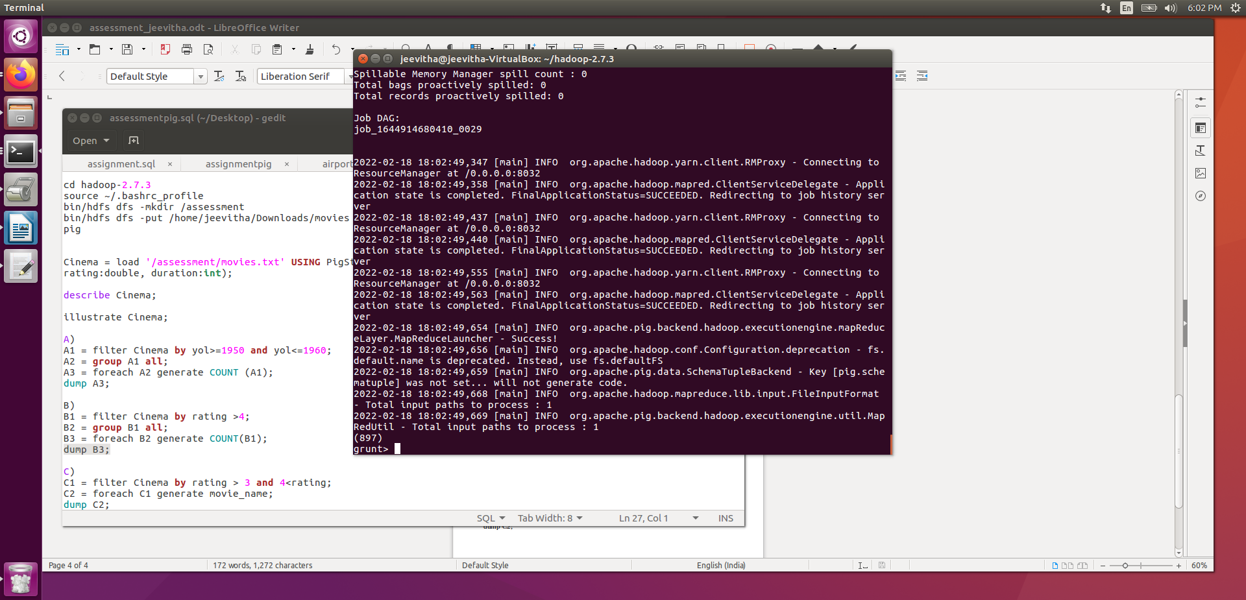

C)C1 = filter Cinema by rating > 3 and 4<rating;
C2 = foreach C1 generate movie_name;
dump C2;

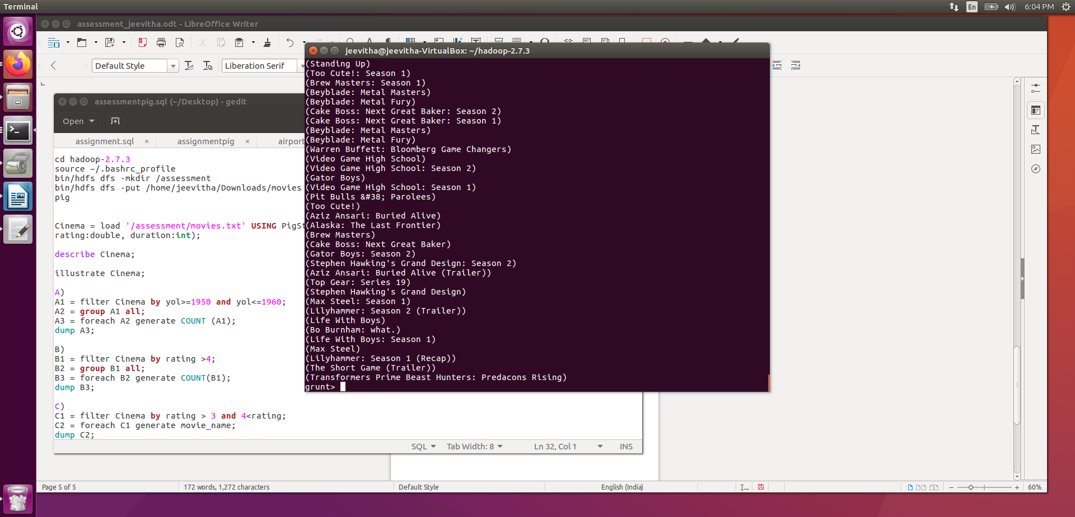
D)D1 = filter Cinema by duration&gt;7200;
D2 = group D1 all;
D3 = foreach D2 generate COUNT(D1);
dump D3;

E)E1 = foreach Cinema generate yol;
E2 = group E1 by yol;
E3 = foreach E2 generate group, COUNT(E1) as Movies;
dump E3;

F)F1 = group Cinema all;
F2 = foreach F1 generate COUNT(Cinema);
dump F2;

