11. In a class of Grade 3, Mathematics Teacher asked for the Acronym PEMDAS ?. All of them are thinking for a while. A smart kid of the class Kishore of the class says it is Parentheses, Exponentiation, Multiplication, Division, Addition, Subtraction. Can you write a C Program to help the students to understand about the operator precedence parsing for an expression containing more than one operator, the order of evaluation depends on the order of operations.

PROGRAM:
#include <stdio.h>
int main() {
int result;
int a = 10, b = 2, c = 3;
result = a + b * c;
printf("Expression : a + b * c\n");
printf("According to PEMDAS: Multiplication before Addition\n");
printf("Result = %d\n", result);
return 0;
}

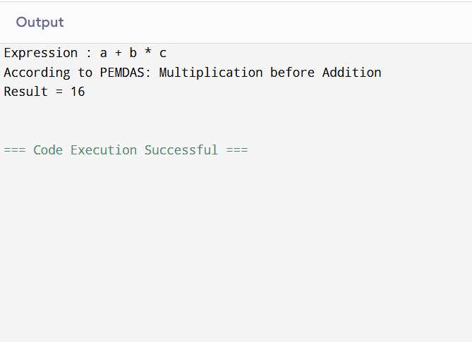
OUTPUT:

