SIMATS ENGINEERING
ASSESSMENT TOOL 1: Experiments

COURSE NAME: COMPUTER VISION with Open CV
COURSE CODE: DAS02

COURSE OUTCOME COVERED

CO3: Analyze and extract image features using detection and matching techniques for effective image representation and comparison. (BTL 4)

Assessment Tool Weightage: 40%

Instructions: Perform the experiment using the laboratory performance rubric Understanding of Concepts, Experimental Design, Use of Tools, Analysis of Results, Documentation.

1. Preprocessing Impact Analysis

Design and perform an experiment to study the impact of preprocessing techniques such as noise removal and normalization on image quality and feature detection. Explain the theoretical concepts behind preprocessing methods and justify the selection of techniques used. Implement the preprocessing process using suitable software/tools, document the workflow and outputs systematically, and analyze how preprocessing influences feature detection accuracy and reliability.

2. Image Representation Study

Conduct an experiment to convert a given image into grayscale and binary representations. Explain the significance of different image representations in computer vision applications. Design the conversion procedure using appropriate tools, document the generated outputs clearly, and analyze how image representation affects edge detection and feature extraction performance.

3. Edge Detection Comparison

Design an experiment to compare Sobel and Canny edge detection techniques on the same input image. Explain the underlying concepts and operational principles of both methods. Apply the techniques using suitable tools/software, document the detected edges systematically, and analyze the comparative effectiveness of each method for different image conditions and applications.

4. Harris Corner Detection Analysis

Perform Harris corner detection on images containing varying textures and patterns. Explain the concept of corner detection and its importance in computer vision tasks. Use appropriate parameters and tools to execute the experiment, document the detected corner points clearly, and analyze the distribution, accuracy, and significance of the detected corners.

5. Effect of Noise on Corner Detection

Design an experiment to study the effect of noise on Harris corner detection performance. Explain the purpose of introducing noise and its influence on image features. Add noise systematically, perform corner detection using suitable tools, document observations for original and noisy images, and analyze the impact of noise along with possible improvement techniques.

6. Hough Transform for Shape Detection

Conduct an experiment using the Hough Transform to detect lines or circles in an image. Explain the principles and significance of the Hough Transform in shape detection. Execute the detection process using appropriate tools, record the detected shapes and their parameters, and analyze the detection accuracy under different image conditions.

7. Feature Matching using SIFT

Perform feature extraction and matching between two images using the SIFT algorithm. Explain the concept of feature matching and scale-invariant features. Use suitable software/tools to extract and match features, document the matching key points systematically, and analyze the robustness of SIFT under variations in scale, rotation, and illumination.

8. PCA for Feature Reduction

Design and implement an experiment using Principal Component Analysis (PCA) for dimensionality reduction of extracted image features. Explain the importance of feature reduction in machine learning and computer vision applications. Apply PCA using appropriate tools, document the feature dimensions before and after reduction, and analyze its impact on computational efficiency and feature representation quality.

9. Preprocessing vs Feature Extraction

Conduct a comparative study of feature extraction performed with and without preprocessing. Explain the relationship between preprocessing and feature extraction performance. Execute both approaches using suitable tools, document the observations systematically, and analyze the differences in feature quality, detection accuracy, and overall system performance.

10. Integrated Feature Detection Pipeline

Design and implement a complete image processing pipeline consisting of preprocessing, edge detection, and feature extraction stages. Explain the purpose and workflow of the integrated pipeline. Execute each stage systematically using appropriate tools, document intermediate and final outputs clearly, and analyze the contribution and importance of each stage in achieving accurate feature detection results.

Code of Conduct:

I M Jeevitha (192424257) (Name / Reg No) certify that this submission is my original work and that I have adhered to the guidelines specified for this assessment.
I understand that any violation of academic integrity rules will result in disciplinary action.

Signature of the student: Jeevitha

RUBRICS FOR CALCULATION:

Criteria | Weightage (%) | Level 4 (Exemplary) | Level 3 (Proficient) | Level 2 (Developing) | Level 1 (Beginning)
Understanding of Concepts | 25 | Demonstrates thorough understanding and effectively integrates multiple concepts/technologies | Good understanding with proper integration of most concepts | Basic understanding; limited or partial integration | Poor understanding; unable to integrate concepts
Experimental Design | 30 | Well-planned, systematic implementation with optimal solution | Correct implementation with minor issues | Basic implementation with errors or inefficiencies | Incorrect or incomplete implementation
Use of Tools | 20 | Effective and advanced use of tools/technologies with proper configuration | Appropriate use of tools with correct execution | Limited or inconsistent use of tools | Incorrect or minimal use of tools
Analysis of Results | 15 | Insightful analysis with accurate interpretation and validation of results | Good analysis with reasonable interpretation | Basic analysis with limited insights | Poor or incorrect analysis of results
Documentation | 10 | Clear, well-structured documentation with diagrams, code, and results | Organized documentation with necessary details | Basic documentation with missing details | Poor or incomplete documentation

Experiment 1: Preprocessing Impact Analysis Aim
To study the impact of noise removal and normalization on image quality and feature detection.

Requirements
- Python
- OpenCV
- NumPy
- Matplotlib
- Input image

Procedure
- Read the input image.
- Convert it to grayscale.
- Add noise to the image.
- Remove noise using Gaussian Blur.
- Normalize the image.
- Apply Canny edge detection before and after preprocessing.
- Compare the results.

Code
import cv2
import numpy as np
import matplotlib.pyplot as plt img = cv2.imread("image.jpg")
gray = cv2.cvtColor(img, cv2.COLOR_BGR2GRAY) # Add noise
noise = np.random.normal(0, 25, gray.shape)
noisy = np.clip(gray + noise, 0, 255).astype(np.uint8)

# Noise removal
filtered = cv2.GaussianBlur(noisy, (5, 5), 0) # Normalization
normalized = cv2.normalize(filtered, None, 0, 255, cv2.NORM_MINMAX) # Edge detection
edges_before = cv2.Canny(noisy, 100, 200)
edges_after = cv2.Canny(normalized, 100, 200)
plt.figure(figsize=(10, 6))
plt.subplot(2, 2, 1) plt.imshow(gray, cmap="gray") plt.title("Original") plt.axis("off")
plt.subplot(2, 2, 2) plt.imshow(noisy, cmap="gray") plt.title("Noisy")
plt.axis("off") plt.subplot(2, 2, 3)
plt.imshow(edges_before, cmap="gray") plt.title("Before Preprocessing") plt.axis("off")
plt.subplot(2, 2, 4) plt.imshow(edges_after, cmap="gray") plt.title("After Preprocessing") plt.axis("off")
plt.show()

Output
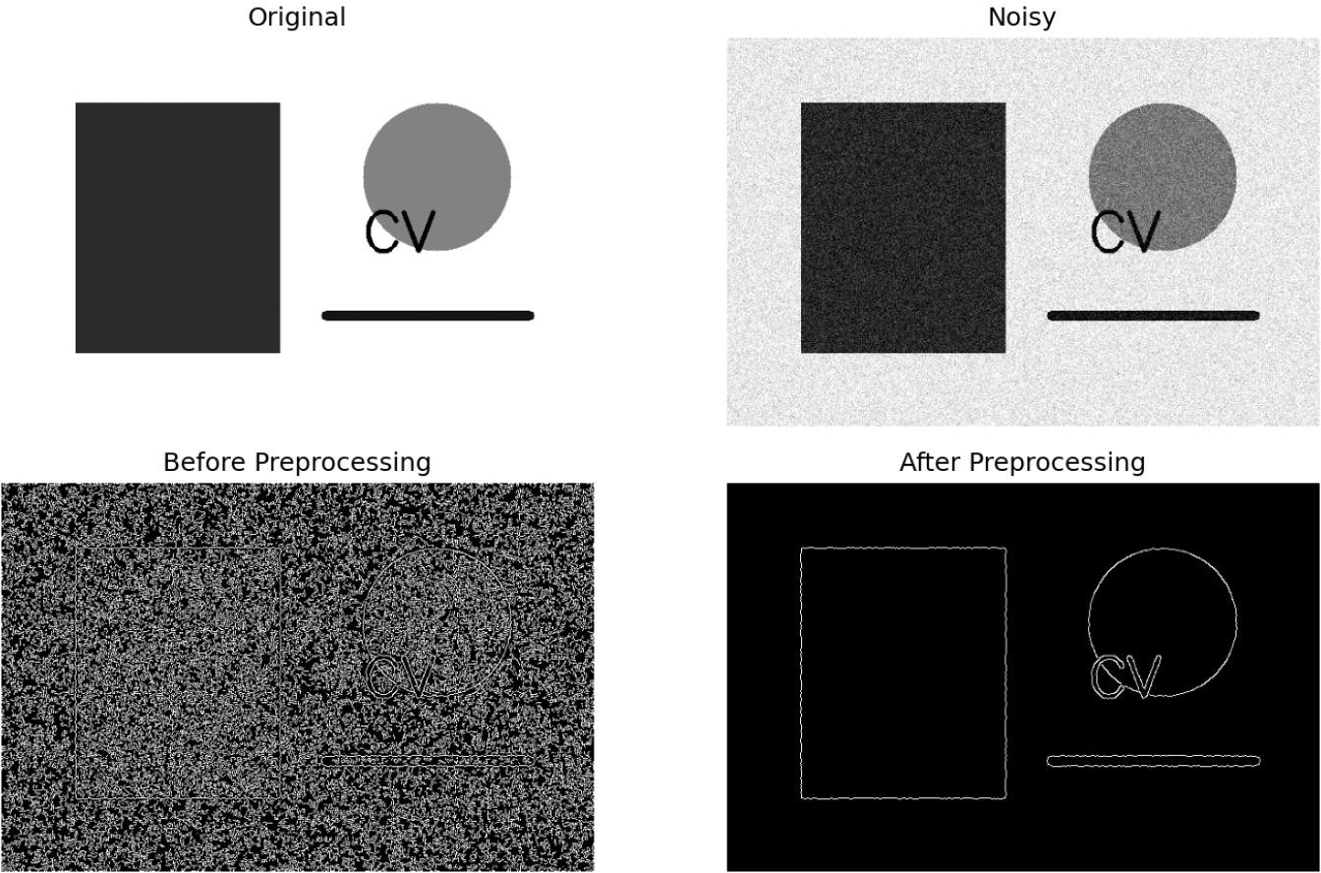

Result
The preprocessing techniques successfully reduced noise and produced cleaner and more reliable edge detection results

Experiment 2: Image Representation Study Aim
To convert an image into grayscale and binary representations and study their effect on edge detection and feature extraction.

Requirements
- Python
- OpenCV
- Matplotlib
- Input image

Procedure
- Read the input image.
- Convert the image into grayscale.
- Convert the grayscale image into binary using thresholding.
- Apply edge detection to both representations.
- Display and compare the results.

Code
import cv2
import matplotlib.pyplot as plt

img = cv2.imread("image.jpg")

# Convert to grayscale
gray = cv2.cvtColor(img, cv2.COLOR_BGR2GRAY)

# Convert to binary
_, binary = cv2.threshold(gray, 127, 255, cv2.THRESH_BINARY)

# Edge detection
gray_edges = cv2.Canny(gray, 100, 200)
binary_edges = cv2.Canny(binary, 100, 200)

# Display plt.figure(figsize=(10, 6))

plt.subplot(2, 2, 1)
plt.imshow(cv2.cvtColor(img, cv2.COLOR_BGR2RGB)) plt.title("Original")
plt.axis("off")

plt.subplot(2, 2, 2) plt.imshow(gray, cmap="gray") plt.title("Grayscale") plt.axis("off")

plt.subplot(2, 2, 3) plt.imshow(binary, cmap="gray") plt.title("Binary")
plt.axis("off")

plt.subplot(2, 2, 4) plt.imshow(gray_edges, cmap="gray") plt.title("Edge Detection") plt.axis("off")

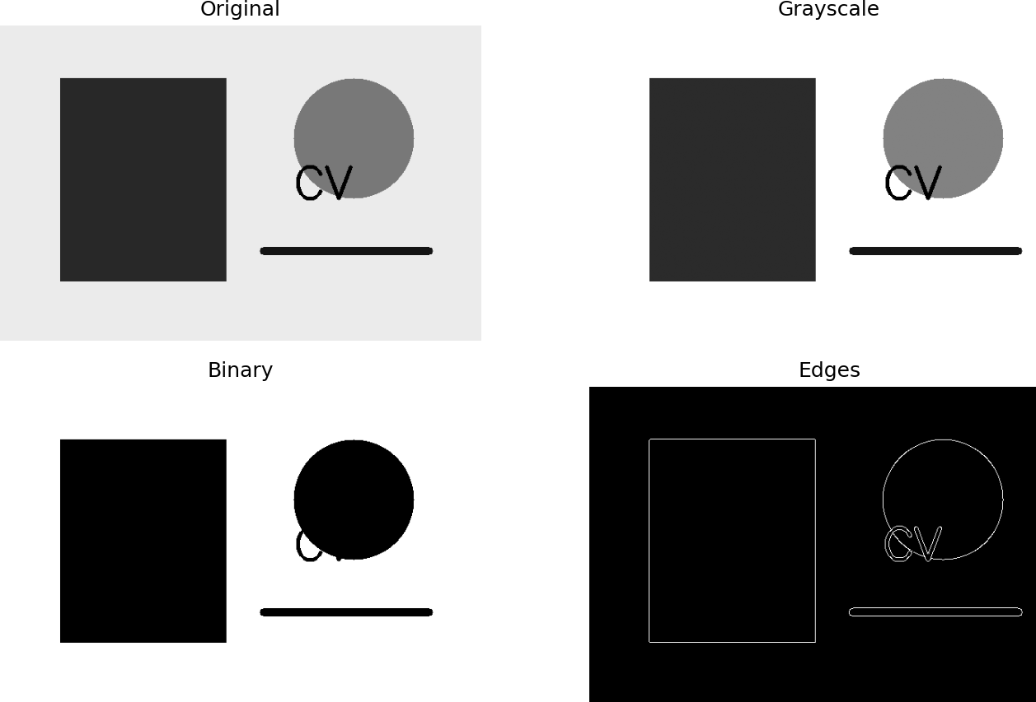
plt.tight_layout() plt.show() Output

Result
The image was successfully converted into grayscale and binary representations. Grayscale preserves intensity information, while binary represents the image using two intensity levels, making it useful for segmentation and shape analysis

Experiment 3: Edge Detection Comparison Aim
To compare Sobel and Canny edge detection techniques on the same image.

Requirements
- Python
- OpenCV
- Matplotlib
- Input image

Procedure
- Read the input image.
- Convert it to grayscale.
- Apply Sobel edge detection.
- Apply Canny edge detection.
- Display and compare the results.

Code
import cv2
import matplotlib.pyplot as plt

img = cv2.imread("image.jpg")
gray = cv2.cvtColor(img, cv2.COLOR_BGR2GRAY)

# Sobel edge detection
sobel_x = cv2.Sobel(gray, cv2.CV_64F, 1, 0, ksize=3) sobel_y = cv2.Sobel(gray, cv2.CV_64F, 0, 1, ksize=3) sobel = cv2.magnitude(sobel_x, sobel_y)

# Canny edge detection

canny = cv2.Canny(gray, 100, 200)

# Display plt.figure(figsize=(10, 5))

plt.subplot(1, 2, 1) plt.imshow(sobel, cmap="gray") plt.title("Sobel Edge Detection") plt.axis("off")

plt.subplot(1, 2, 2) plt.imshow(canny, cmap="gray") plt.title("Canny Edge Detection") plt.axis("off")

plt.tight_layout() plt.show() Output
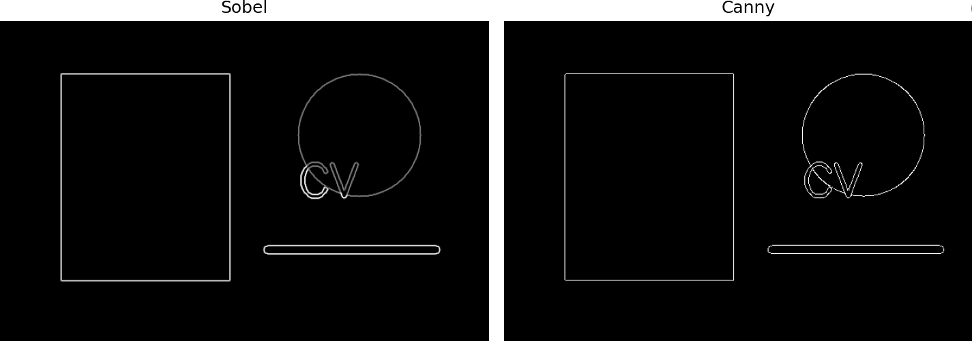

Result
Sobel and Canny edge detection were successfully applied. Canny generally produces cleaner and more precise edges, while Sobel is simpler and useful for detecting intensity gradients.

Experiment 4: Harris Corner Detection Aim
To perform Harris corner detection on an image and analyze the detected corner points.

Requirements
- Python
- OpenCV
- NumPy
- Matplotlib
- Input image

Procedure
- Read the input image.
- Convert it to grayscale.
- Apply Harris Corner Detection.
- Mark the detected corner points.
- Display the output image.

Code
import cv2
import numpy as np
import matplotlib.pyplot as plt

img = cv2.imread("image.jpg")
gray = cv2.cvtColor(img, cv2.COLOR_BGR2GRAY)

# Harris corner detection gray = np.float32(gray)
corners = cv2.cornerHarris(gray, 2, 3, 0.04)

# Mark corners
img[corners > 0.01 * corners.max()] = [0, 0, 255]

# Display
plt.imshow(cv2.cvtColor(img, cv2.COLOR_BGR2RGB)) plt.title("Harris Corner Detection")
plt.axis("off") plt.show() Output
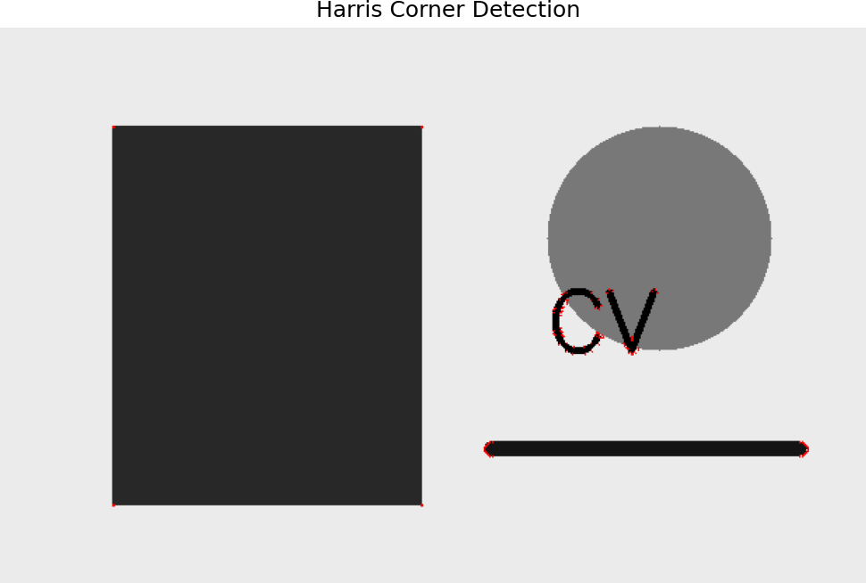

Result
Harris Corner Detection was successfully performed, and the corner points of the image were detected and highlighted.

Experiment 5: Hough Transform for Shape Detection Aim
To detect lines or circles in an image using the Hough Transform.

Requirements
- Python
- OpenCV
- Matplotlib
- Input image

Procedure
- Read the input image.
- Convert it to grayscale.
- Apply edge detection.
- Apply Hough Line Transform.
- Detect and draw the lines.
- Display the output.

Code
import cv2
import numpy as np
import matplotlib.pyplot as plt

img = cv2.imread("image.jpg")
gray = cv2.cvtColor(img, cv2.COLOR_BGR2GRAY)

# Edge detection
edges = cv2.Canny(gray, 50, 150)

# Hough Line Transform

lines = cv2.HoughLinesP( edges, 1, np.pi / 180, threshold=100, minLineLength=50, maxLineGap=10
)

# Draw detected lines if lines is not None:
for line in lines:
x1, y1, x2, y2 = line[0]
cv2.line(img, (x1, y1), (x2, y2), (0, 0, 255), 2)

# Display
plt.imshow(cv2.cvtColor(img, cv2.COLOR_BGR2RGB)) plt.title("Hough Line Detection")
plt.axis("off") plt.show()

Output
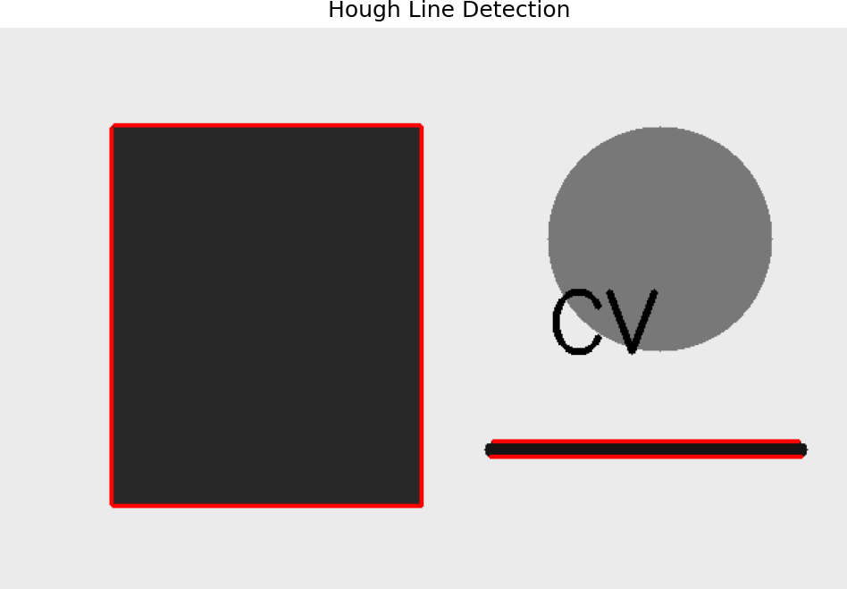

Result
The Hough Transform was successfully used to detect and highlight lines present in the input image.

Experiment 6: Feature Matching using SIFT Aim
To perform feature extraction and matching between two images using the SIFT algorithm. Requirements
- Python
- OpenCV
- Matplotlib
- Two input images

Procedure
- Read two images.
- Convert both images to grayscale.
- Create a SIFT detector.
- Detect keypoints and descriptors.
- Match the descriptors using a Brute-Force matcher.
- Display the matched features.

Code
import cv2
import matplotlib.pyplot as plt

img1 = cv2.imread("image1.jpg") img2 = cv2.imread("image2.jpg")

gray1 = cv2.cvtColor(img1, cv2.COLOR_BGR2GRAY) gray2 = cv2.cvtColor(img2, cv2.COLOR_BGR2GRAY)

# Create SIFT detector sift = cv2.SIFT_create()

# Detect keypoints and descriptors
kp1, des1 = sift.detectAndCompute(gray1, None) kp2, des2 = sift.detectAndCompute(gray2, None)

# Brute-Force matcher bf = cv2.BFMatcher()
matches = bf.knnMatch(des1, des2, k=2)

# Apply ratio test good_matches = []

for m, n in matches:
if m.distance < 0.75 * n.distance: good_matches.append(m)

# Draw matches
result = cv2.drawMatches( img1, kp1,
img2, kp2, good_matches, None,
flags=cv2.DrawMatchesFlags_NOT_DRAW_SINGLE_POINTS
)

plt.figure(figsize=(12, 6))
plt.imshow(cv2.cvtColor(result, cv2.COLOR_BGR2RGB)) plt.title("SIFT Feature Matching")

plt.axis("off") plt.show() Output

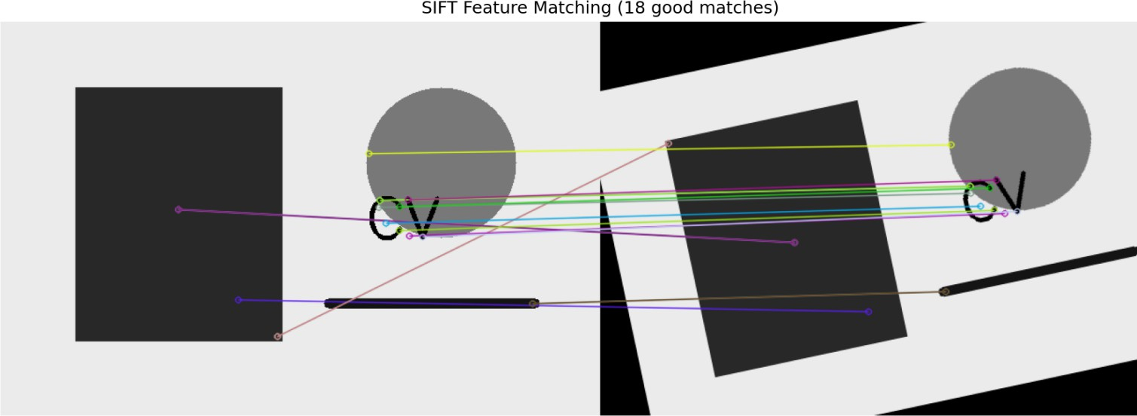

Result
SIFT feature extraction and matching were successfully performed between two images. The matching keypoints were detected and displayed.

Experiment 7: Effect of Smoothing on Edge Detection Aim
To study the effect of smoothing techniques on edge detection by reducing noise and improving edge continuity.

Requirements
- Python
- OpenCV
- Matplotlib
- Input image

Procedure
- Read the input image.
- Convert it to grayscale.
- Apply Gaussian smoothing.
- Apply Canny edge detection before and after smoothing.
- Compare the results.

Code
import cv2
import matplotlib.pyplot as plt

img = cv2.imread("image.jpg")
gray = cv2.cvtColor(img, cv2.COLOR_BGR2GRAY)

# Edge detection before smoothing edges_before = cv2.Canny(gray, 100, 200)

# Apply Gaussian smoothing
smooth = cv2.GaussianBlur(gray, (5, 5), 0)

# Edge detection after smoothing edges_after = cv2.Canny(smooth, 100, 200)

# Display results plt.figure(figsize=(10, 5))

plt.subplot(1, 2, 1) plt.imshow(edges_before, cmap="gray") plt.title("Before Smoothing") plt.axis("off")

plt.subplot(1, 2, 2) plt.imshow(edges_after, cmap="gray") plt.title("After Smoothing") plt.axis("off")

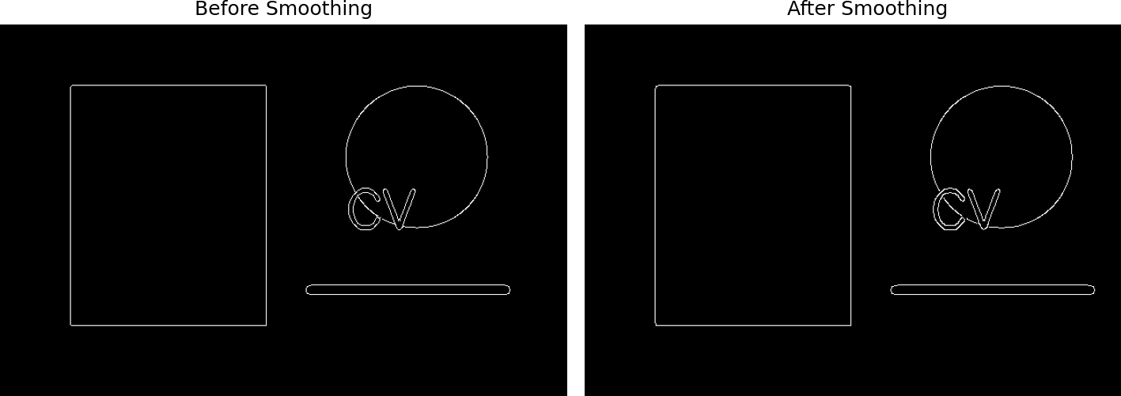
plt.tight_layout() plt.show() Output

Result
Smoothing successfully reduced image noise and produced cleaner and more continuous edges during edge detection.

Experiment 8: Prewitt vs Sobel Comparison Aim
To compare Prewitt and Sobel edge detection operators on the same image.

Requirements
- Python
- OpenCV
- NumPy
- Matplotlib
- Input image

Procedure
- Read the input image.
- Convert it to grayscale.
- Apply the Prewitt operator.
- Apply the Sobel operator.
- Display and compare the detected edges.

Code
import cv2
import numpy as np
import matplotlib.pyplot as plt

img = cv2.imread("image.jpg")
gray = cv2.cvtColor(img, cv2.COLOR_BGR2GRAY)

# Prewitt kernels
prewitt_x = np.array([[-1, 0, 1],
[-1, 0, 1],
[-1, 0, 1]])

prewitt_y = np.array([[-1, -1, -1],
[0, 0, 0],
[1, 1, 1]])

px = cv2.filter2D(gray, cv2.CV_64F, prewitt_x) py = cv2.filter2D(gray, cv2.CV_64F, prewitt_y)

prewitt = cv2.magnitude(px, py)

# Sobel
sx = cv2.Sobel(gray, cv2.CV_64F, 1, 0, ksize=3) sy = cv2.Sobel(gray, cv2.CV_64F, 0, 1, ksize=3)

sobel = cv2.magnitude(sx, sy)

# Display plt.figure(figsize=(10, 5))

plt.subplot(1, 2, 1) plt.imshow(prewitt, cmap="gray") plt.title("Prewitt")
plt.axis("off")

plt.subplot(1, 2, 2) plt.imshow(sobel, cmap="gray") plt.title("Sobel")

plt.axis("off")

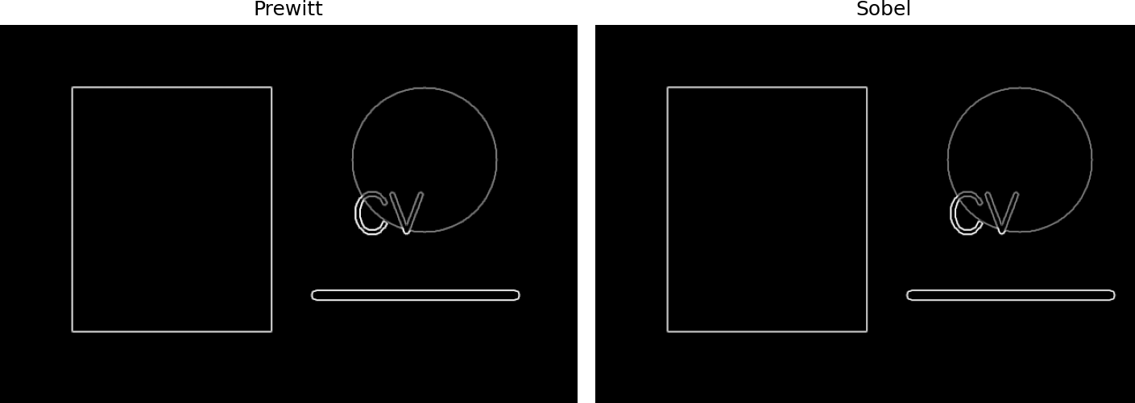
plt.tight_layout() plt.show() Output

Result
Prewitt and Sobel edge detection were successfully performed. Both methods detected image boundaries, with Sobel generally providing stronger and smoother edge detection.

Experiment 9: Threshold Effect in Edge Detection Aim
To study the effect of different threshold values on edge detection quality. Requirements
- Python
- OpenCV
- Matplotlib
- Input image

Procedure
- Read the input image.
- Convert it to grayscale.
- Apply Canny edge detection with different threshold values.
- Display and compare the results.
- Analyze the effect of threshold values on edge detection.

Code
import cv2
import matplotlib.pyplot as plt

img = cv2.imread("image.jpg")
gray = cv2.cvtColor(img, cv2.COLOR_BGR2GRAY)

edges1 = cv2.Canny(gray, 50, 100)
edges2 = cv2.Canny(gray, 100, 200)
edges3 = cv2.Canny(gray, 150, 300)

plt.figure(figsize=(12, 4))

plt.subplot(1, 3, 1) plt.imshow(edges1, cmap="gray") plt.title("Threshold: 50-100") plt.axis("off")

plt.subplot(1, 3, 2) plt.imshow(edges2, cmap="gray") plt.title("Threshold: 100-200") plt.axis("off")

plt.subplot(1, 3, 3) plt.imshow(edges3, cmap="gray") plt.title("Threshold: 150-300") plt.axis("off")

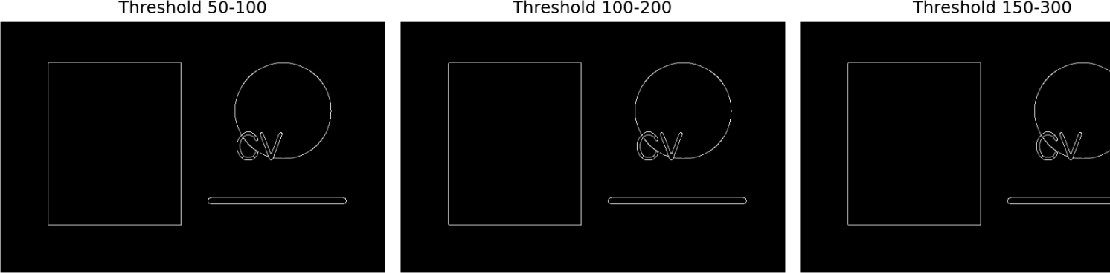
plt.tight_layout() plt.show() Output

Result
Different threshold values produced different edge detection results. Lower thresholds detect more edges, while higher thresholds reduce weak and unwanted edges.

Experiment 10: Noise Removal Comparison Aim
To compare different noise removal techniques and analyze their effectiveness in preserving image details.

Requirements
- Python
- OpenCV
- Matplotlib
- Input image

Procedure
- Read the input image.
- Add noise to the image.
- Apply Gaussian, Median, and Bilateral filters.
- Display the filtered images.
- Compare the noise reduction and image details.

Code
import cv2
import numpy as np
import matplotlib.pyplot as plt

img = cv2.imread("image.jpg")
gray = cv2.cvtColor(img, cv2.COLOR_BGR2GRAY)

# Add noise
noise = np.random.normal(0, 25, gray.shape)
noisy = np.clip(gray + noise, 0, 255).astype(np.uint8)

# Noise removal
gaussian = cv2.GaussianBlur(noisy, (5, 5), 0) median = cv2.medianBlur(noisy, 5)
bilateral = cv2.bilateralFilter(noisy, 9, 75, 75)

# Display plt.figure(figsize=(12, 6))

plt.subplot(2, 2, 1) plt.imshow(noisy, cmap="gray") plt.title("Noisy Image") plt.axis("off")

plt.subplot(2, 2, 2) plt.imshow(gaussian, cmap="gray") plt.title("Gaussian Filter") plt.axis("off")

plt.subplot(2, 2, 3) plt.imshow(median, cmap="gray") plt.title("Median Filter") plt.axis("off")

plt.subplot(2, 2, 4) plt.imshow(bilateral, cmap="gray") plt.title("Bilateral Filter") plt.axis("off")

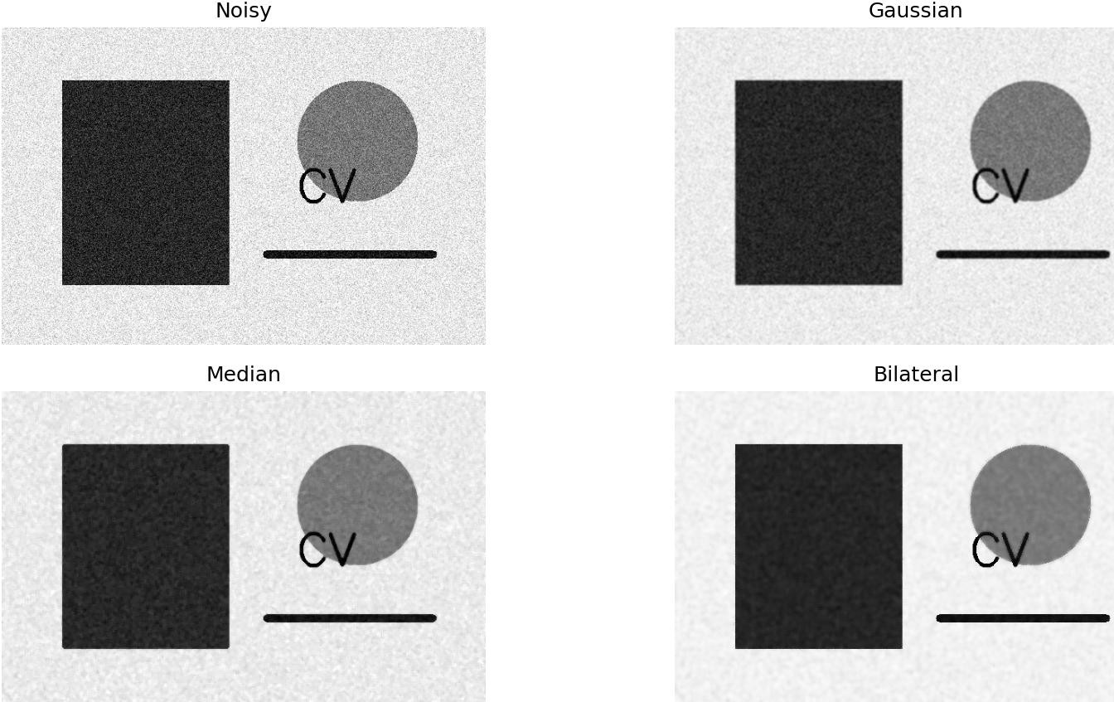
plt.tight_layout() plt.show() Output

Result
Different noise removal filters were successfully applied. The filters reduced image noise while attempting to preserve important image details.

