SIMATS ENGINEERING (SAVEETHA SCHOOL OF ENGINEERING)
Department of Computer Science and Engineering
ASSESSMENT TOOL 2- INTREPRETATION
TASK (3 Questions)

Course Code: | DSA0607 | Course Title: | Data Handling and Visualization
CO Assessed: | CO2 – Precision (BL3) | Assessment: | Assessment Tool 2 – Intrepretation
Weightage: | 40% of CIA | Total Marks: | 50 (5 Questions × 10 Marks)
CO2 Statement: | Apply appropriate visualization methods to represent distributions, proportions, and relationships in data.(BL3)
Student Name: | M Jeevitha | Reg. No.: | 192424257
Section / Batch: | 2024/D | Date: | 04.08.2026
Code of Conduct
I B Akshaya(192424336) (Name / Reg No) certify that this submission is my original work and that I have adhered to the guidelines specified for this assessment. I understand that any violation of academic integrity rules will result in disciplinary action.

Signature of the Student: M Jeevitha
Instructions
- This test contains 5 questions, each carrying 10 marks. Total: 50 Marks.
- No negative marking. Unanswered questions carry zero marks.
- No calculators or electronic devices permitted.
- Duration: 60 minutes.

Section / Topic | Focus | Q Nos | Marks
Categorical Data Visualization | Comparing category-wise revenue, proportions, and seasonal trends using bar, grouped, and stacked charts | 1 | 10
Distribution Analysis | Understanding defect distribution and variability using histograms, boxplots, and violin plots | 2 | 10
Relationship Visualization | Exploring relationships between variables using scatter plots, heatmaps, and multivariate techniques | 3 | 10
Geospatial & Temporal Visualization | Analyzing delivery performance using maps, time-series plots, and heatmaps | 4 | 10
Distribution Comparison | Comparing patient data distributions using ridgeline plots, density plots, and boxplots | 5 | 10
GRAND TOTAL: |  | 50 Marks

- An e-commerce company is analyzing the purchase amounts of 10,000 customers during a festive sale. Most customers spent between ₹500 and
₹2,000, while a small number of customers made purchases above ₹25,000. The company wants to understand customer spending behavior, identify high-value customers, and determine whether the spending distribution follows a normal pattern. How would you use ECDF, histograms, and Q-Q plots to analyze the spending data, and what insights could be derived from the results?
# Customer Spending Analysis
set.seed(123)

# Normal customer spending
normal_spending <- runif(9950, min = 500, max = 2000)

# High-value customer spending (outliers)
premium_spending <- runif(50, min = 25000, max = 40000)

# Combine data
spending <- c(normal_spending, premium_spending)

# Display 3 plots together
par(mfrow = c(1, 3))
#Histogram
hist(
spending,
breaks = 40,
col = "lightblue",
border = "black",
main = "Histogram of Customer Spending",
xlab = "Purchase Amount (₹)",
ylab = "Number of Customers"
)
# ECDF Plot
plot(
ecdf(spending),
main = "ECDF of Customer Spending",
xlab = "Purchase Amount (₹)",
ylab = "Cumulative Probability",
col = "blue",
lwd = 2
)

grid()

# Q-Q Ploqqnorm(
spending,
main = "Q-Q Plot of Customer Spending",
pch = 19,
col = "darkgreen"
)

qqline(
spending,
col = "red",
lwd = 2
)

# Reset plotting layout
par(mfrow = c(1, 1)

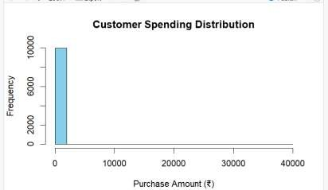
OUTPUT:

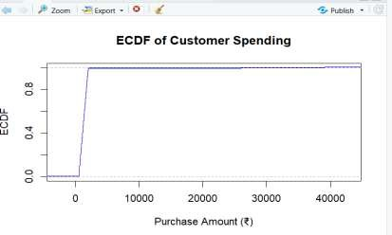

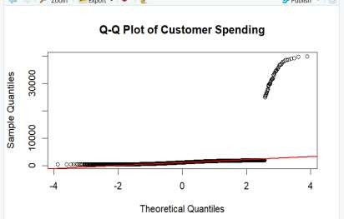

- A hospital is comparing patient waiting times in two departments: Emergency Care and General Consultation. The management wants to determine whether waiting times in both departments follow similar distributions and whether one department experiences significantly longer delays. Explain how Q-Q plots, boxplots, and density plots can be used to compare the two datasets and evaluate distributional differences.
Code:
# Hospital Waiting Time Analysis

# Sample waiting time data (in minutes)
Emergency <- c(18, 22, 28, 32, 38, 42, 48, 55, 65, 75)
General <- c(12, 16, 21, 24, 27, 30, 33, 36, 40, 45)

# Display plots in one row
par(mfrow = c(1, 3))

# --------------------------
# Box Plot
# --------------------------
boxplot(
Emergency,
General,
names = c("Emergency", "General"),
main = "Hospital Waiting Time",
ylab = "Waiting Time (Minutes)",
col = c("tomato", "lightblue"),
border = "black"
)

# --------------------------
# Density Plot
# --------------------------
plot(
density(Emergency),
main = "Density of Waiting Time",
xlab = "Waiting Time (Minutes)",
col = "darkred",
lwd = 2
)

lines(
density(General),
col = "darkblue",
lwd = 2
)

legend(
"topright",
legend = c("Emergency", "General"),
col = c("darkred", "darkblue"),
lwd = 2,
bty = "n"
)

# --------------------------
# Q-Q Plot
# --------------------------
qqplot(
Emergency,
General,
main = "Q-Q Plot",
xlab = "Emergency Waiting Time",
ylab = "General Waiting Time",
pch = 19,
col = "purple"
)

abline(
a = 0,
b = 1,
col = "red",
lwd = 2,
lty = 2
)

# Reset layout
par(mfrow = c(1, 1))
Output:
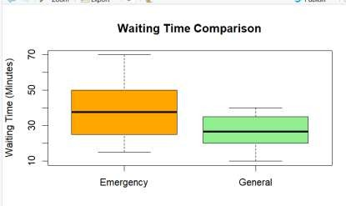
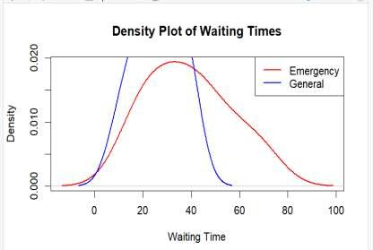

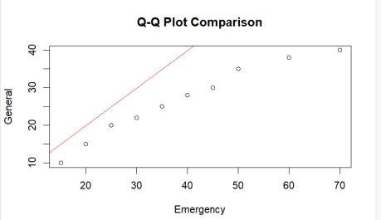

- A digital marketing team wants to present the number of likes received by five social media campaigns: 2,000, 5,000, 8,000, 15,000, and 30,000 likes. One analyst suggests using a 3D exploded pie chart, while another recommends a horizontal bar chart. Discuss how each visualization may influence audience perception and identify the most effective method for accurately comparing campaign performance. What design principles should be followed to avoid misleading interpretations?

Code:

# Social Media Campaign Likes Analysis

# Campaign names
Campaign <- c("Ad1", "Ad2", "Ad3", "Ad4", "Ad5")

# Number of likes
Likes <- c(2500, 6500, 9500, 18000, 35000)

# Horizontal Bar Chart
barplot(
Likes,
names.arg = Campaign,
horiz = TRUE,
col = c("lightgreen", "gold", "skyblue", "orange", "violet"),
border = "darkblue",
main = "Social Media Campaign Likes",
xlab = "Number of Likes",
las = 1
)

OUTPUT:
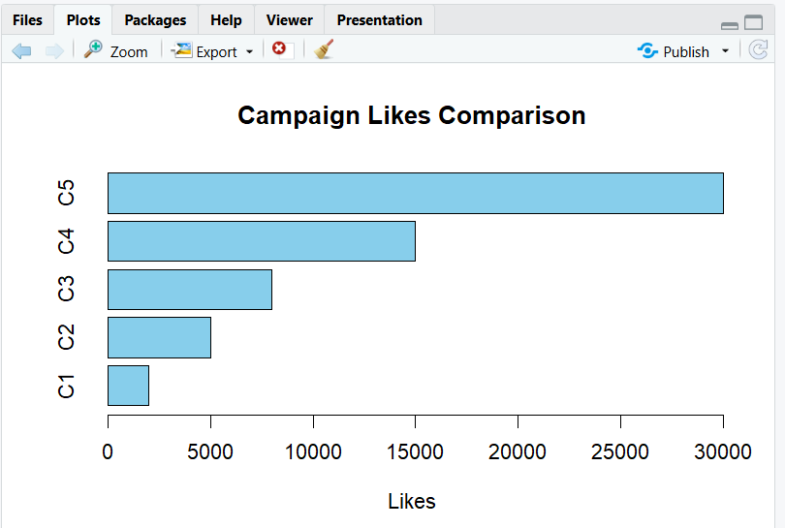

Rubrics for Calculation
Criteria | Weight age | Level 4 – Exemplary | Level 3 – Proficient | Level 2 – Developing | Level 1 – Beginning | Marks
Understandi ng of Industry Problem | 20% | Comprehensive understanding of real-world problem and constraints | Good understanding with minor gaps in requirements | Basic understanding; some requirements unclear | Poor understanding; misinterprets problem context
Application of Engineering Concepts | 25% | Applies advanced and relevant concepts effectively to solve the problem | Applies appropriate concepts with minor errors | Limited application of concepts | Incorrect or no application of concepts
Solution Design | 25% | Innovative, practical, and feasible solution aligned with industry standards | Logical and feasible solution with minor gaps | Basic solution with limited feasibility | Unclear or impractical solution
Use of Tools | 15% | Effective use of modern tools, technologies, and real data | Appropriate use of tools with correct implementatio n | Limited or inconsistent use of tools | Minimal or incorrect use of tools
Analysis | 10% | Thorough analysis with validated results and performance evaluation | Good analysis with reasonable validation | Basic analysis with limited validation | Poor or no analysis

Faculty In-charge | Course Coordinator | Head of Department
Signature: | Signature: | Signature:
Date: | Date: | Date:

