1) Jenkins Installation

**Required Files**

- jenkins.war file to run Jenkins on local host (local machine)

Steps to follow:

1.

Go to the link and download the war file



2.



[https://jenkins.io/downloa](https://jenkins.io/download/)

[d](https://jenkins.io/download/)



[/](https://jenkins.io/download/)

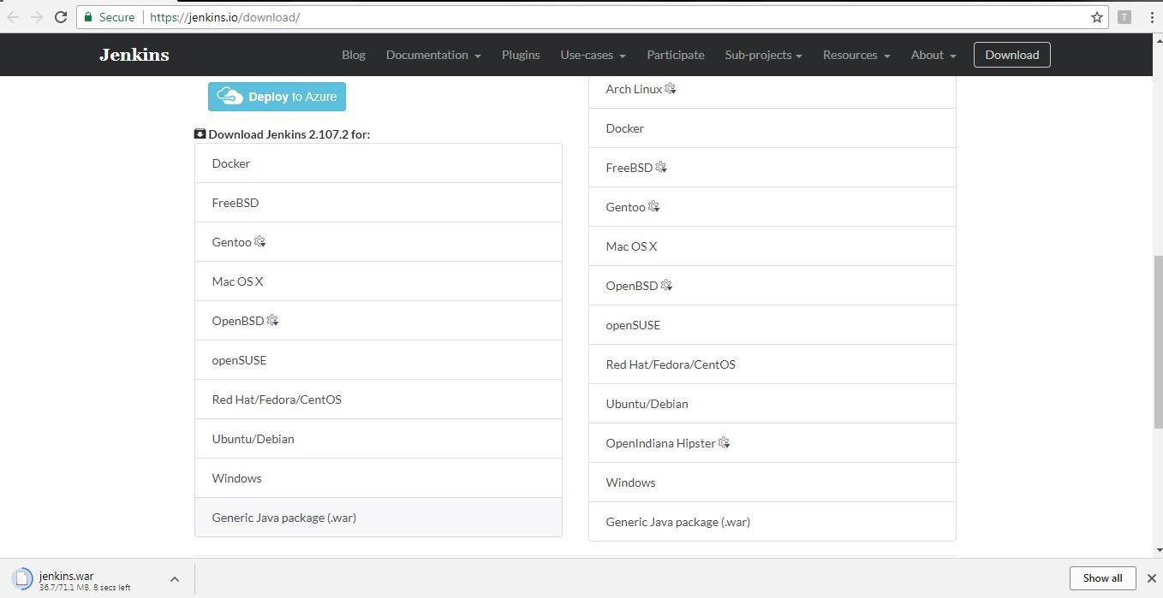

**Or** also can be downloaded directly by clicking the below link  [http://mirrors.jenkins.io/warstable/latest/jenkins.war](http://mirrors.jenkins.io/war-stable/latest/jenkins.war)

1. After downloading the war file, navigate to the downloaded folder and start command prompt (by typing **cmd** in the address bar)

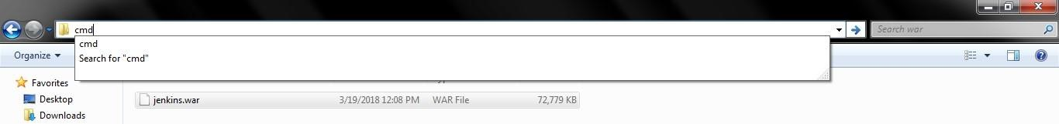

Type: **java –jar jenkins.war**

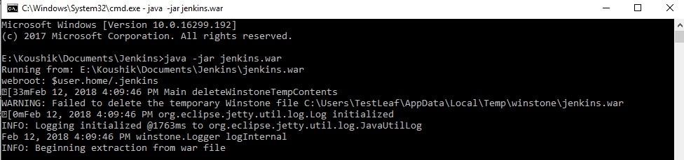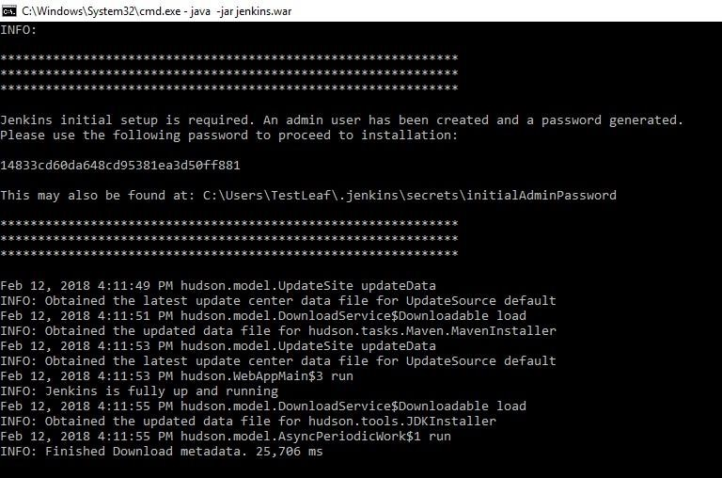

1. Open Chrome browser
2. Type the url - **localhost:8080** and type the password shown in the console

(Copy & paste the password) – *Highlighted in yellow color on the above snap*

1. Click Continue

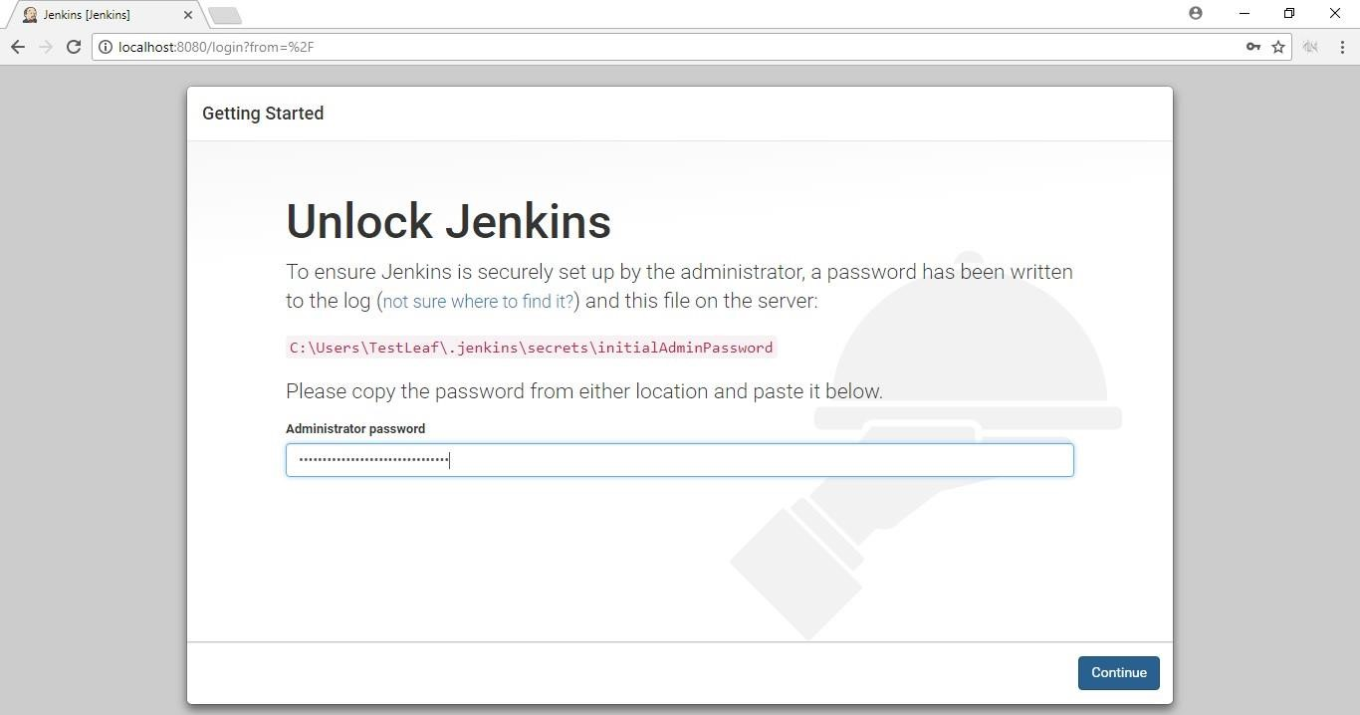

7.



Click Install Suggested plugins

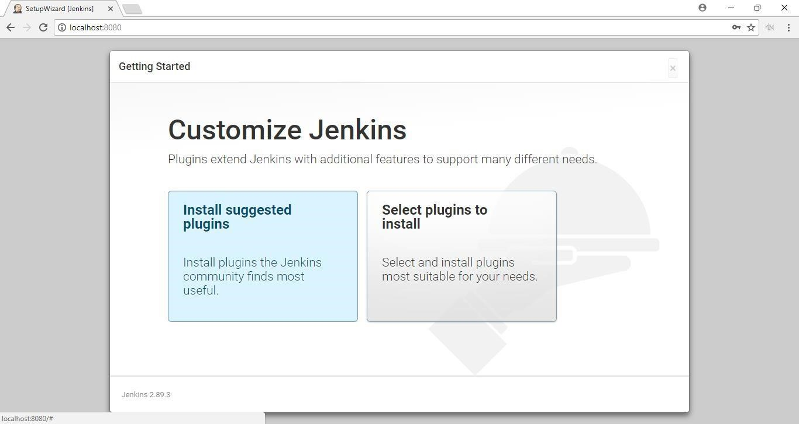

Installation of plugins will take some time, depending upon the internet connectivity speed

*(If you are not able to see the page, check the index page for solution)Top of the Document*

Once plugins are installed successfully,

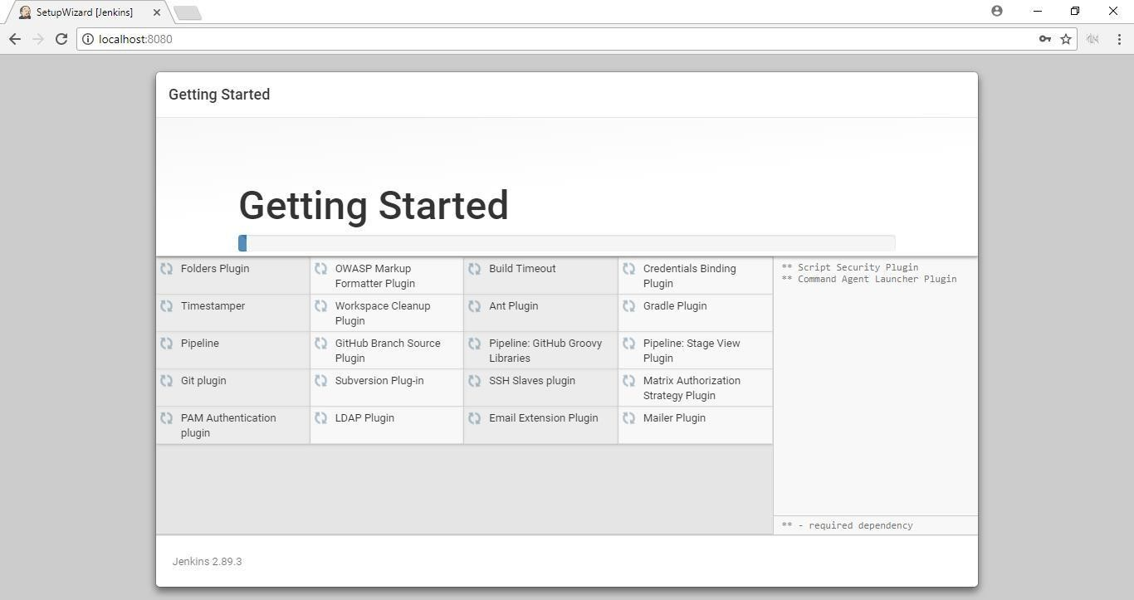

8.



Click

Continue as admin

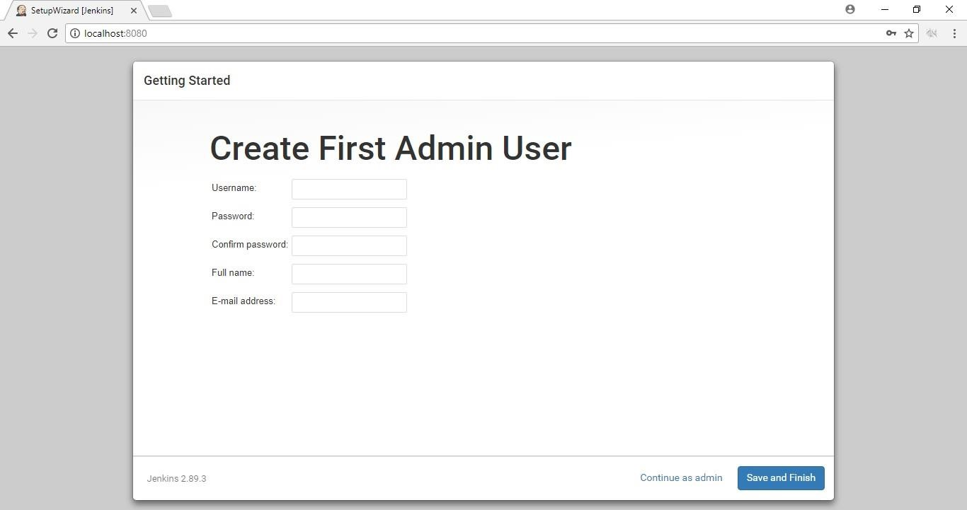

9. Click Save and Finish



10.



Click Start using Jenkins

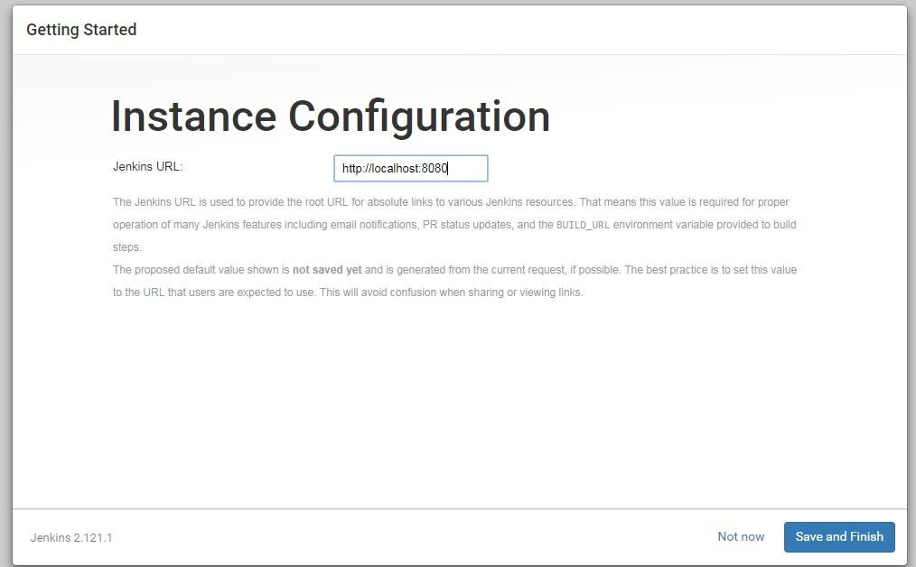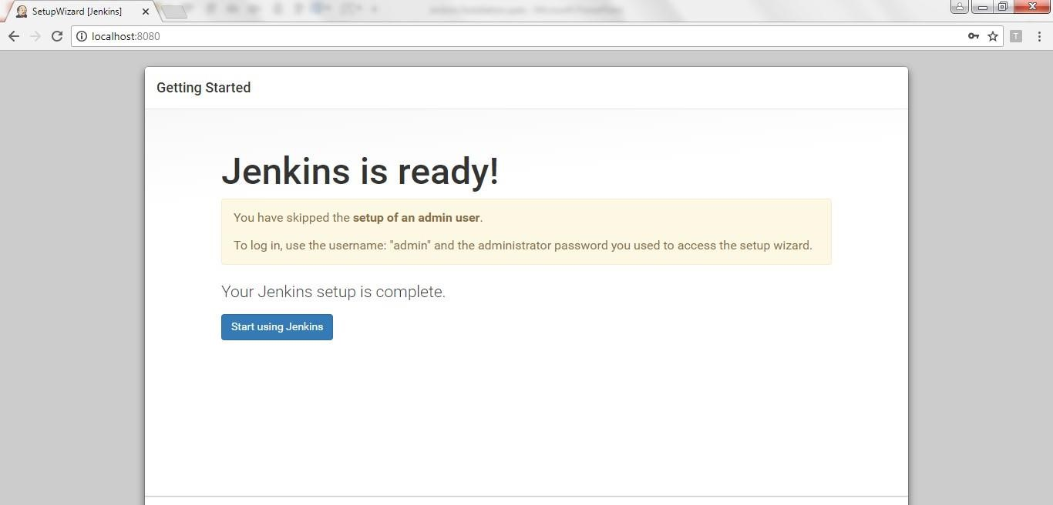

**Note:** If the command prompt is closed Jenkins will not run.

Complete the installation fully, if stops in between you will face issues **Note: Username:** admin **Password:**

**Password can be found in the location C:\Users\(user name)\.jenkins\secrets\initialAdminPassword -> Right click the file and open with notepad**

# Common Issues

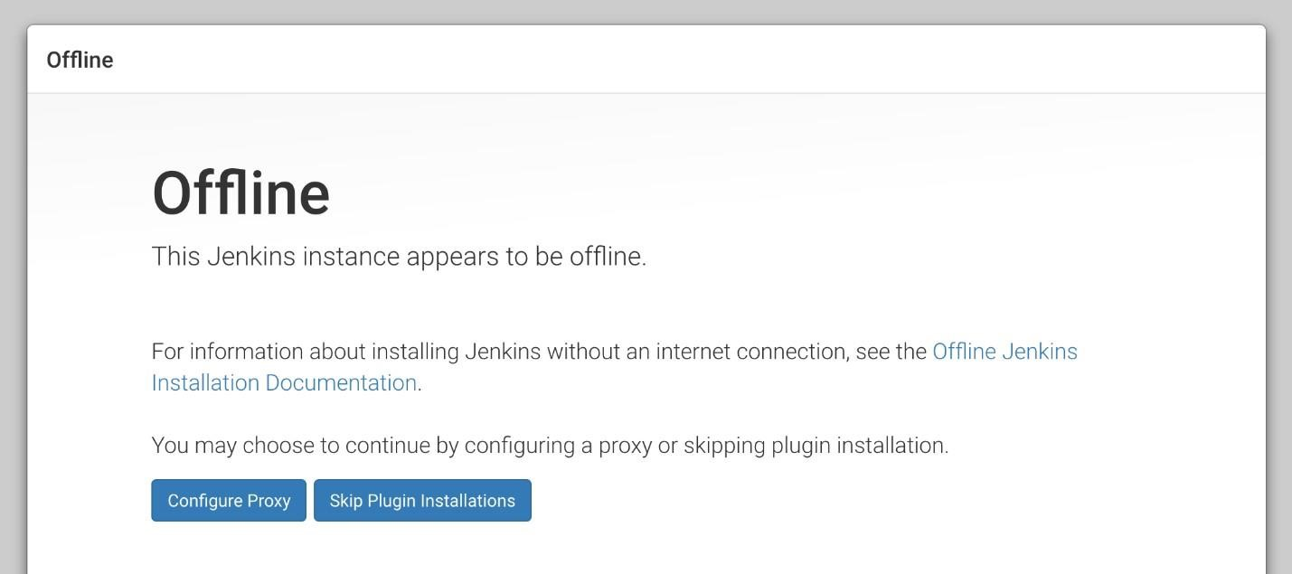

Solution:

1. Close Jenkins console (Close the cmd prompt)
2. Close Browser
3. Go to C drive -> Users -> your username -> .jenkins
4. In that folder right click on the file **hudson.model.UpdateCenter.xml** and open with notepad

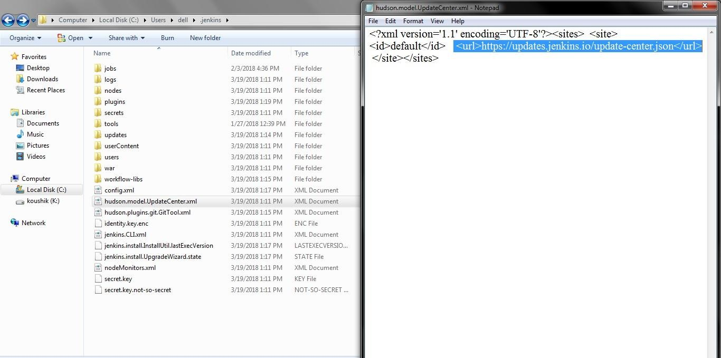

Edit the URL to

<url>[http://updates.jenkins.io/update-center.json</url>](http://updates.jenkins.io/update-center.json%3c/url) *(https to http)*

**Save the file and close**. Start the installation again from **step 3**

# Password

If you run Jenkins second time it won’t show password in the console.

To get the password, follow the instruction.

**Username:** admin **Password:**

**password can be found in the location C:\Users\(user name)\.jenkins\secrets\initialAdminPassword -> Right click the file and open with notepad**