***CHAPTER 1***

# INTRODUCTION

**Automatic Number Plate Recognition (ANPR)** is a technology used to detect and read vehicle license plates. It involves two main steps: detecting the position of the number plate and using Optical Character Recognition (OCR) to identify the text on the plate.

ANPR is widely used in traffic management, law enforcement, and toll collection. Recent advancements in deep learning have improved ANPR systems accuracy and reliability. EasyOCR, an open-source OCR library, is a powerful tool that leverages deep learning for precise text recognition, making it a suitable choice for ANPR applications.

## 1.1 OBJECTIVES

### 1. Accurate License Plate Detection and Recognition

* Achieve High Detection Accuracy : Ensure the system can accurately detect license plates in diverse conditions, including varying light levels, weather conditions, and different angles.
* Achieve High Recognition Accuracy : Utilize EasyOCR to accurately recognize and convert characters on license plates to machine-readable text, handling different fonts, sizes, and languages.

### 2. Real-Time Processing

* Enable Real-Time Operation: Design the system to process images and recognize license plates in real-time to support immediate decision-making and actions.
* Minimize Latency: Optimize the system to reduce latency in detection and recognition processes, ensuring timely data availability.

### 3. Integration with Existing Infrastructure

* Seamless Integration: Design the system to integrate seamlessly with existing traffic management, law enforcement, and parking management systems.

**Department Of Computer Science and Engineering, SGBIT, Belagavi**

* API and Database Compatibility: Provide APIs for data exchange and ensure compatibility with various databases and third-party applications.

### 4. Cost-Effectiveness

* Optimize Costs: Design the system to be cost-effective, reducing the need for expensive hardware and leveraging open-source software like EasyOCR.
* Affordable Maintenance: Ensure that the system is easy to maintain and update, minimizing long-term operational costs

### 5. Enhanced Traffic Management and Law Enforcement

* Support Traffic Management: Use ANPR data to optimize traffic flow, reduce congestion, and manage traffic lights more effectively.
* Aid Law Enforcement: Provide law enforcement agencies with tools to track and identify suspect vehicles, enhance public safety, and enforce traffic laws.

***CHAPTER 2***

# LITERATURE SURVEY

## 2.1 Year: 2024

**Title** : Number plate recognition using opencv

**Author/s**: R Roopa Chandrika , K Vanitha , Aafiya Thahaseen,TR Mahesh , R chandramma , Vikram Neerugatti

**Methodology:** Number plate recognition with OpenCV is a practical application of computer vision that combines image preprocessing, object detection, and character recognition to automate vehicle identification.

**Remarks:** To recognize number plates using OpenCV, first preprocess the image by converting it to grayscale and applying noise reduction. Then, detect and extract the plate region using edge and contour detection, segment the characters, and finally apply Optical Character Recognition (OCR) to read the plate text.

## 2.2 Year: 2023

**Title :** An Automatic Framework for Number Plate Detection using OCR and Deep Learning Approach

**Author/s:** Yash Shambharkar , Shailaja Alagrama , Kanhaiya Sharma , Om Mishra , Deepak Parashar

**Methodology:** The use of automatic number plate detection devices in safety, commercial, and security has increased over the past few years. Number plate detection using computer vision is used to provide fast and accurate detection and recognition.

**Remarks:** The proposed system evaluates the car image from a given dataset. The most crucial factor in solving deep learning problems has an accurate dataset that is unbiased, because of which it produces inaccurate or skewed outcomes. It is necessary to ensure no similarities between the items in the dataset other than the characteristic of interest.

## 2.3 Year: 2022

**Title :** Automatic number plate recognition (ANPR) in smart cities: A systematic review on technological advancements and application cases

**Author/s:** Junqing Tang , Li Wan , Jennifer Schooling , Shufen Wei

**Methodology:** ANPR is an image processing technology that can capture images of vehicles and from the images extract information of their number (license) plates, and translate them into machine-readable formats, such as text string, which can then be processed and indexed into a database

**Remarks:** Technical challenges of automatic number plate recognition (ANPR) technology have been studied from different aspects (Zheng et al., 2007). Generally speaking, technological advancements manifest in the constant pursuit of higher accuracy and speed of recognition.

## 2.4 Year: 2021

**Title :** Automatic Fetching of Vehicle details using ANPR Camera

**Author/s:** Ankit Kumar, Sayon Samadar, Rupam Saha , Sukanya Roy, Swagata Bhatarcharya

**Methodology:** The process of ANPR starts with identifying a registration plate of the vehicle. It involves the algorithms used which are able to identify the rectangular area of the registration plate from an original picture. This is achieved through video cameras capturing images that are analyzed using Optical Character Recognition (OCR), which scans each group of pixels within the images and estimates whether or not it could be a letter and replaces the pixels with the ASCII* code for the letter.

**Remarks**: the key advantages of ANPR cameras is their ability to automate and expedite the process of capturing vehicle information. This technology eliminates the need for manual data entry, reducing human error and saving time and resources.

***CHAPTER 3***

# SYSTEM REQUIREMENTS AND SPECIFICATIONS

## 3.1 SCOPE OF THE PROJECT

**Application Areas :**

* **Traffic Management:** Monitor and manage traffic flow, detect violations such as speeding or illegal parking, and optimize traffic light timings.
* **Law Enforcement:** Identify stolen vehicles, track suspect vehicles, and enhance public safety by integrating ANPR with police databases.
* **Toll Collection:** Automate toll collection processes by accurately recognizing license plates at toll booths, reducing manual intervention.
* **Parking Management:** Facilitate automated entry and exit in parking facilities, manage parking spaces, and enforce parking regulations.

## 3.2 SOFTWARE REQUIREMENTS

* **Operating System :** Windows or macOS (suitable for development and testing)
* **Programming Languages :** Python (primary language for implementing detection and OCR using EasyOCR)
* **Libraries :** OpenCV: For image processing and computer vision tasks

▪ EasyOCR: For Optical Character Recognition

* **IDE:** Visual Studio Code, PyCharm, or Jupyter Notebook

## 3.3 HARDWARE REQUIREMENTS

* **Processor:** Intel i5 or higher
* **RAM:** 8 GB or higher
* **Storage:** 500 GB HDD or SSD
* **Camera:** HD webcam or equivalent for capturing images

***CHAPTER 4***

# SYSTEM ANALYSIS

## 4.1 EXISTING SYSTEM

Traditional ANPR systems have been employed for years, leveraging a combination of hardware and software components. These systems typically include high-resolution cameras, illumination devices, and specialized software for image processing and OCR.

### Key Components

Image Acquisition: High-resolution cameras capture images or videos of vehicles. These cameras are often equipped with infrared illumination to enhance visibility in low-light conditions.

Plate Detection: Image processing algorithms or machine learning models detect the location of the license plate within the captured image.

Character Segmentation: Once the plate is detected, the characters are segmented individually to prepare for recognition.

Optical Character Recognition (OCR): OCR algorithms convert the segmented characters into machine-readable text.

Data Processing and Storage: The recognized text is processed, matched against databases if necessary, and stored for further analysis.

**Limitations of Existing systems :**

* Environmental Dependence: Traditional ANPR systems can struggle in varying lighting conditions, adverse weather, and with images of poor quality due to motion blur or low resolution.
* Fixed Positioning: Many systems require fixed camera installations, limiting their flexibility and making them unsuitable for mobile or rapidly changing environments.
* Character Variability: Variations in font, size, and plate design can affect the accuracy of OCR, particularly with non-standard or damaged plates.

***CHAPTER 5***

# PROPOSED METHODOLOGY

**5.1 PROPOSED SYSTEM WORK FLOW DIAGRAM :**

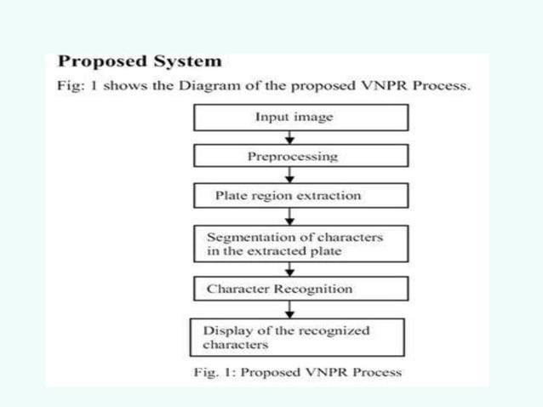

**5.2 DATA FLOW DIAGRAM :**

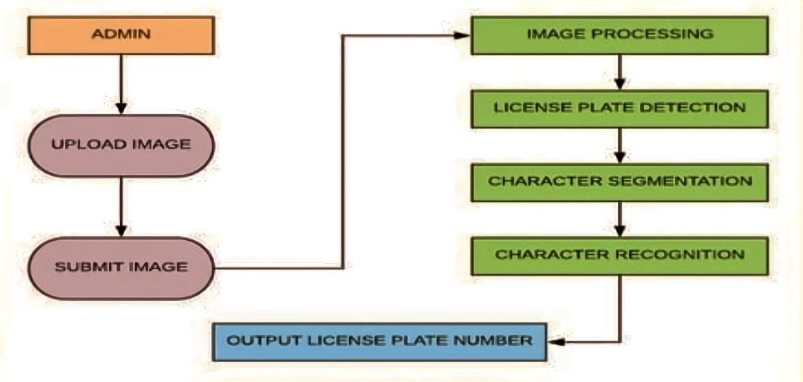

**5. 3 STEPS FOLLOWED IN PROPOSED SYSTEM :**

## 1. Image Acquisition

High-resolution cameras capture images or video frames of vehicles. These cameras are strategically positioned to maximize visibility and minimize obstructions. Infrared illumination may be used to enhance image quality in low-light conditions.

## 2. Preprocessing

The captured images undergo preprocessing to improve their quality and make the detection and recognition steps more effective. Preprocessing techniques may include:

* **Grayscale Conversion:** Converting the image to grayscale to reduce computational complexity.
* **Noise Reduction:** Applying filters to remove noise and enhance important features.
* **Contrast Enhancement:** Adjusting the contrast to make the license plate more distinguishable.

## 3. Plate Detection

Using image processing algorithms or deep learning models, the system detects the position of the license plate within the image. Common methods include:

* **Edge Detection:** Identifying edges to locate rectangular regions that resemble license plates.
* **Object Detection Models:** Utilizing pre-trained models like YOLO (You Only Look Once) and localize the license plate.

## 4. Character Segmentation

Once the license plate is detected, the next step is to segment the individual characters. This involves:

* **Binarization:** Converting the detected license plate region to a binary image to differentiate characters from the background.
* **Character Isolation:** Identifying and isolating each character for individual recognition.

## 5. Optical Character Recognition (OCR) with EasyOCR

* **EasyOCR**, a deep learning-based OCR library, is employed to recognize the segmented characters. The steps involved are:
* **Character Recognition:** EasyOCR processes each segmented character to convert it into machine-readable text.
* **Post-Processing:** Refining the recognized text to correct common OCR errors and enhance accuracy.

## 6. Data Processing and Storage

The recognized license plate text is processed for various applications, such as matching against a database, calculating tolls, or generating alerts for law enforcement. The data is then stored in a structured format for future retrieval and analysis.

## 7. Deployment and Integration

The final system is deployed in the target environment, such as highways, parking lots, or urban streets. It is integrated with existing infrastructure and databases for real-time operation and monitoring.

***CHAPTER 6***

# RESULTS AND SNAPSHOTS WITH CODE

**Number_Plate.py ( main file )**

import cv2

import pytesseract

pytesseract.pytesseract.tesseract_cmd = r'C:\Program Files\Tesseract-OCR\tesseract.exe'

# Read the image file

image = cv2.imread('jeo.jpeg')

cv2.imshow("jeo",image)

# Convert to Grayscale Image

gray_image = cv2.cvtColor(image, cv2.COLOR_BGR2GRAY)

#Canny Edge Detection

canny_edge = cv2.Canny(gray_image, 170, 200)

# Find contours based on Edges

contours, new  = cv2.findContours(canny_edge.copy(), cv2.RETR_LIST, cv2.CHAIN_APPROX_SIMPLE)

contours=sorted(contours, key = cv2.contourArea, reverse = True)[:30]

# Initialize license Plate contour and x,y,w,h coordinates

contour_with_license_plate = None

license_plate = None

x = None

y = None

w = None

h = None

for contour in contours:

        perimeter = cv2.arcLength(contour, True)

        approx = cv2.approxPolyDP(contour, 0.01 * perimeter, True)

        if len(approx) == 4:     #see whether it is a Rect

            contour_with_license_plate = approx

            x, y, w, h = cv2.boundingRect(contour)

            license_plate = gray_image[y:y + h, x:x + w]

            break

(thresh, license_plate) = cv2.threshold(license_plate, 127, 255, cv2.THRESH_BINARY)

cv2.imshow("plate",license_plate)

# Removing Noise from the detected image, before sending to Tesseract

license_plate = cv2.bilateralFilter(license_plate, 11, 17, 17)

(thresh, license_plate) = cv2.threshold(license_plate, 150, 180, cv2.THRESH_BINARY)

text = pytesseract.image_to_string(license_plate)

image = cv2.rectangle(image, (x,y), (x+w,y+h), (0,0,255), 3)

image = cv2.putText(image, text, (x-100,y-20), cv2.FONT_HERSHEY_SIMPLEX, 1, (0,255,0), 2, cv2.LINE_AA)

print("License Plate :", text)

cv2.imshow("License Plate Detection",image)

cv2.waitKey(0)

## EXPECTED RESULTS

### Step 1 : Image Acquisition and Detection

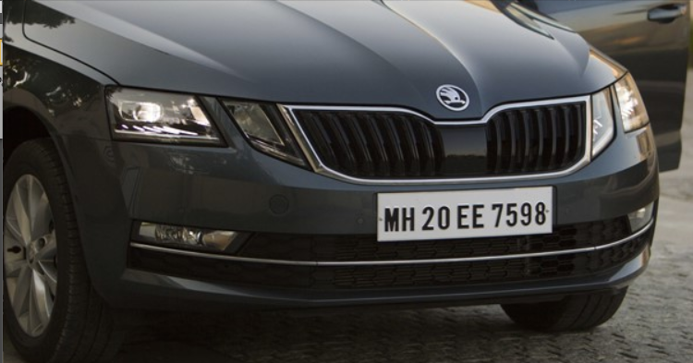

### Step 2 : Image preprocessing and Contour image formation

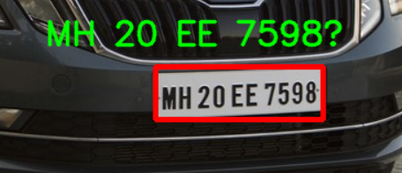

### Step 3 : Using OCR extract text from contour image



### Step 4 : Storing the extracted text output into Excel file or any Database



# FUTURE ADVANCEMENTS IN ANPR SYSTEM

## Integration with IoT and Smart Infrastructure

* IoT Integration: Integrate ANPR systems with Internet of Things (IoT) devices for enhanced data collection and processing capabilities.
* Smart Traffic Management: Incorporate ANPR data into smart traffic management systems to optimize traffic flow and reduce congestion.

## Enhanced Image Processing

* Adaptive Illumination: Implement adaptive illumination techniques to improve image quality under varying lighting conditions.
* Advanced Noise Reduction: Develop more sophisticated noise reduction algorithms to handle extreme weather conditions, such as heavy rain or fog.
* Multi-Angle Recognition: Enhance the system to accurately detect and recognize plates from various angles, not just front or rear views.

## Enhanced Data Analytics

* Predictive Analytics: Utilize ANPR data for predictive analytics to forecast traffic patterns, identify trends, and enhance urban planning.
* Machine Learning Insights: Apply machine learning techniques to analyze ANPR data for insights into vehicle usage, peak traffic times, and law enforcement patterns.

# REFERENCES

1. https://pypi.org/project/opencv-python
2. Invention Journal of Research Technology in Engineering & Management (IJRTEM) ISSN: 2455- 3689 www.ijrtem.com Volume 2 Issue 1 ǁ January. 2018 ǁ PP 11-16.
3. R. R. Palekar, S. U. Parab, D. P. Parikh and V. N. Kamble, "Real time license plate detection using openCV and tesseract," 2017 International Conference on Communication and Signal

Processing (ICCSP), Chennai, India, 2017, pp. 2111-2115, doi:

10.1109/ICCSP.2017.8286778.

1. W. Riaz, A. Azeem, G. Chenqiang, Z. Yuxi Saifullah and W. Khalid, "YOLO Based Recognition Method for Automatic License Plate Recognition", 2020 IEEE International

Conference on Advances in Electrical Engineering and Computer Applications (AEECA)*,* pp. 87-90, Aug 2020

1. https://youtu.be/ltpnWBBT7NI?si=S506KzgTXytd2C_M