ASSIGNMENT – 1
1. Write HTML code to do the following tasks:
- Change the title of the page to “Internet and Web Technology Lab”.
- Display the heading “Web Technology Basics” using an <h1> tag.
- Add at least two paragraphs describing the importance of web development.
- Create a hyperlink with the display text “Read More” to go to:
https://en.wikipedia.org/wiki/Internet
- Create another link to open Google in a new tab.
- Insert an image of your choice into the webpage and control its height and width using attributes.

<!DOCTYPE html>
<html>
<head>
<meta charset="UTF-8">
<meta name="viewport" content="width=device-width, initial-scale=1.0">
<title>Internet and Web Technologies Lab</title>
</head>
<body>
<h1>Web Technology Basics</h1>
<p>
Web development is important because it helps in creating websites and web applications
that are accessible to users across the world. It enables information sharing, online
services, and digital communication.
</p>

<p>
With the growth of the internet, web development plays a vital role in business,
education, and entertainment by providing interactive and user-friendly platforms.
</p>

<p>To know more, click the link below</p>
<a href="https://en.wikipedia.org/wiki/Internet">Read More</a>
<br><br>

<p>For deep research use Google search engine</p>
<a href="https://www.google.com" target="_blank">Open Google</a>
<br><br>

<p>Image of Sri Mandir in the evening</p>
<img src="PURI_JAGANATHA_TEMPLE,_PURI,_ORISSA,_INDIA,_ASIA.jpg"
alt="Sri Jagannath Temple"
width="200"
height="300">
</body>
</html>
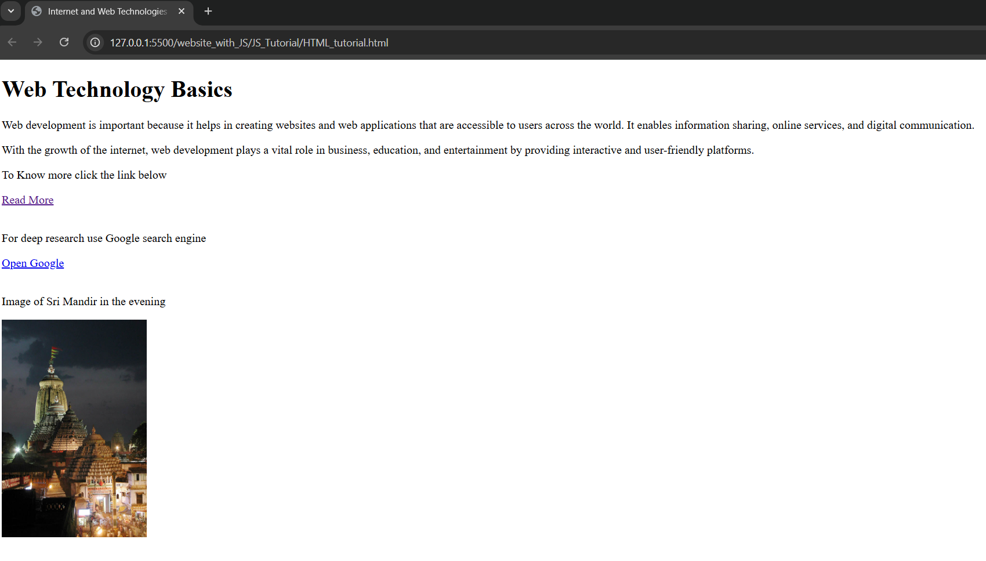

2. Write HTML code to generate the lists:
- Create an unordered list of at least five web browsers.
- Create an ordered list of at least five popular programming languages.
- Create a nested list showing:
- Frontend Technologies (HTML, CSS, JavaScript)
- Backend Technologies (Java, Python, PHP)

<!DOCTYPE html>
<html>
<head>
<meta charset="UTF-8">
<meta name="viewport" content="width=device-width, initial-scale=1.0">
<title>Internet and Web Technologies Lab</title>
</head>
<body>
<h3>Unordered List of Web Browsers</h3>
<ul>
<li>Google Chrome</li>
<li>Mozilla Firefox</li>
<li>Microsoft Edge</li>
<li>Safari</li>
<li>Opera</li>
</ul>

<h3>Ordered List of Programming Languages</h3>
<ol>
<li>Python</li>
<li>Java</li>
<li>C</li>
<li>JavaScript</li>
<li>C++</li>
</ol>

<h3>Nested List of Technologies</h3>
<ul>
<li>Frontend Technologies
<ul>
<li>HTML</li>
<li>CSS</li>
<li>JavaScript</li>
</ul>
</li>
<li>Backend Technologies
<ul>
<li>Java</li>
<li>Python</li>
<li>PHP</li>
</ul>
</li>
</ul>
</body>
</html>

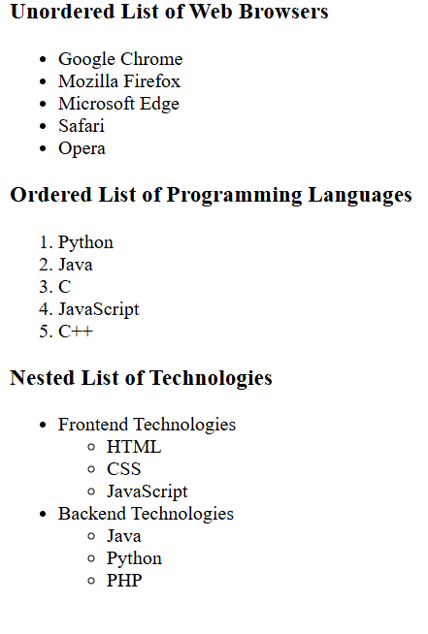

3. Write an HTML snippet to display the following text using proper formatting tags:
- Display the sentence “Internet and Web Technology” in bold.
- Display the word “HTML” in italic.
- Display the phrase “Core Concepts” with an underline.
- Write the formula for the square of a binomial:
(A + B)² = A² + B² + 2AB
- Write the chemical formula for water as: H₂O

<!DOCTYPE html>
<html>
<head>
<meta charset="UTF-8">
<meta name="viewport" content="width=device-width, initial-scale=1.0">
<title>Internet and Web Technologies Lab</title>
</head>
<body>
<h2>Q3. Formatting Tags</h2>

<p><b>Internet and Web Technology</b></p>
<p><i>HTML</i></p>
<p><u>Core Concepts</u></p>

<p>
(A + B)<sup>2</sup> = A<sup>2</sup> + B<sup>2</sup> + 2AB
</p>

<p>
Chemical formula of water: H<sub>2</sub>O
</p>
</body>
</html>

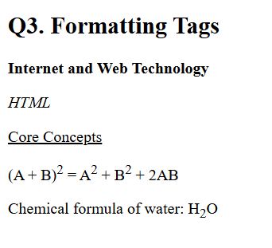

4. Create a navigation menu at the top with 3 links:
- Basic Tags
- Lists
- Formatting Tags
Clicking each link should scroll to the respective section (use bookmarks / anchor tags).

<!DOCTYPE html>
<html>
<head>
<title>Navigation Menu Example</title>
</head>
<body>

<!-- Navigation Menu -->
<h2>Navigation Menu</h2>
<a href="#basic">Basic Tags</a> |
<a href="#lists">Lists</a> |
<a href="#formatting">Formatting Tags</a>

<hr>

<!-- Basic Tags Section -->
<h2 id="basic">Basic Tags</h2>
<p>
This section contains information about basic HTML tags such as
headings, paragraphs, links, and images.
</p>

<hr>

<!-- Lists Section -->
<h2 id="lists">Lists</h2>
<p>
This section explains ordered lists, unordered lists, and nested lists in HTML.
</p>

<hr>

<!-- Formatting Tags Section -->
<h2 id="formatting">Formatting Tags</h2>
<p>
This section covers formatting tags like bold, italic, underline,
superscript, and subscript.
</p>

</body>
</html>

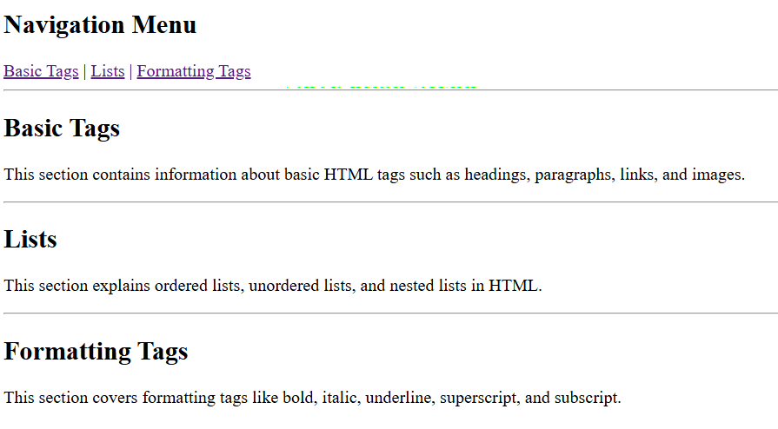

5. Download icons of LinkedIn and GitHub and add them to your page such that clicking on them takes you to your respective profiles.
<!DOCTYPE html>
<html>
<head>
<title>Navigation Menu Example</title>
</head>
<body>

<h2>Q5. Social Media Icons</h2>

<a href="https://www.linkedin.com/in/jeeya-verma-424a1228a/" target="_blank">
<img src="https://cdn-icons-png.flaticon.com/512/174/174857.png"
alt="LinkedIn"
width="100"
height="100"
style="margin-right: 10px;">
</a>

<a href="https://github.com/JeeyaVerma" target="_blank">
<img src="https://cdn-icons-png.flaticon.com/512/25/25231.png"
alt="GitHub"
width="100"
height="100">
</a>

</body>
</html>
