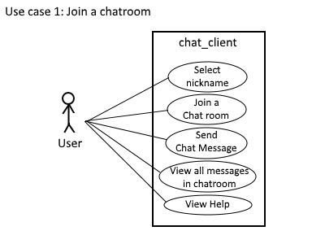

|  |  |  |  |
| --- | --- | --- | --- |
| Use Case ID: | 1 | | |
| Use Case Name: | Join a chatroom | | |
| Created By: | David Benepe | Last Updated By: | David Benepe |
| Date Created: | 10/10/17 | Date Last Updated: | 10/10/17 |
| Actors: | User | | |
| Description: | The user shall use a currently not-in-use nickname and join an existing chatroom, where they will be able to chat with everyone in it. | | |
| Preconditions: | A chatroom already exists. | | |
| Postconditions: | The nickname that the user will use is no longer available if they are online. | | |
| Normal Flow: | 1. The user shall request a nickname to use as their identity. 2. The user will then join one or more of the existing chatrooms. 3. The user can then chat with anyone in the chatroom until they exit the program. | | |
| Alternative Flows: | * If a nickname is already taken, then one or more underscores will be added to their requested nickname. | | |
| Exceptions: | N/A | | |
| Includes: | N/A | | |
| Priority: | High | | |
| Frequency of Use: | As needed | | |
| Business Rules: | N/A | | |
| Special Requirements: | Linux PC | | |
| Assumptions: | The server and client programs are both running without any issues. | | |

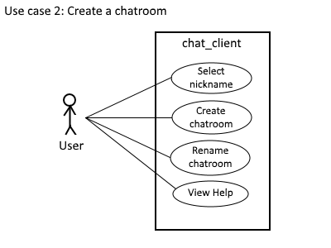

|  |  |  |  |
| --- | --- | --- | --- |
| Use Case ID: | 2 | | |
| Use Case Name: | Create a chatroom | | |
| Created By: | David Benepe | Last Updated By: | David Benepe |
| Date Created: | 10/10/17 | Date Last Updated: | 10/17/17 |
| Actors: | User | | |
| Description: | The user will create a new chatroom. | | |
| Preconditions: | N/A | | |
| Postconditions: | A new chatroom will be available for anyone to enter. | | |
| Normal Flow: | 1. The user enters the server with a unique nickname. 2. The user clicks on the “Create a room” button and will then enter a unique name for the chat room. 3. A new chatroom is created and is added to the list of chatrooms. | | |
| Alternative Flows: | * If the user enters a room name that is already exists, then they will be prompted to enter another name. | | |
| Exceptions: | N/A | | |
| Includes: | N/A | | |
| Priority: | High | | |
| Frequency of Use: | As needed | | |
| Business Rules: | N/A | | |
| Special Requirements: | Linux PC | | |
| Assumptions: | The server and client programs are both running without any issues. | | |