User Interface Sketch

1. Server Main Page (i.e. its going to be in shell)

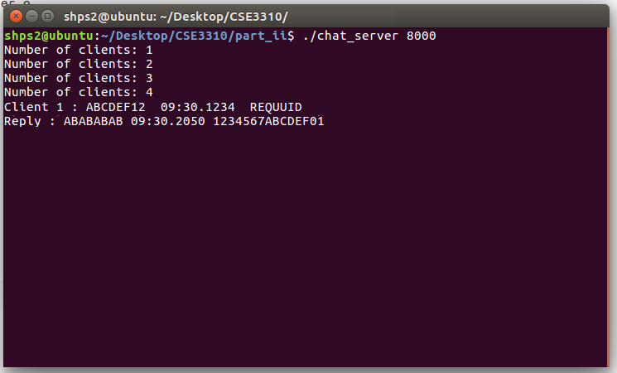

1. Client Main Page

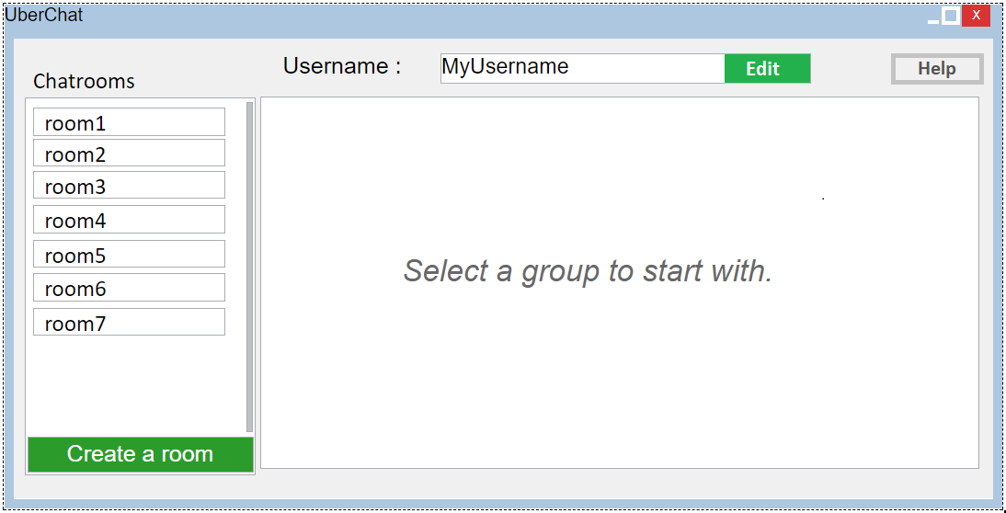

1. Client Login/Username Select

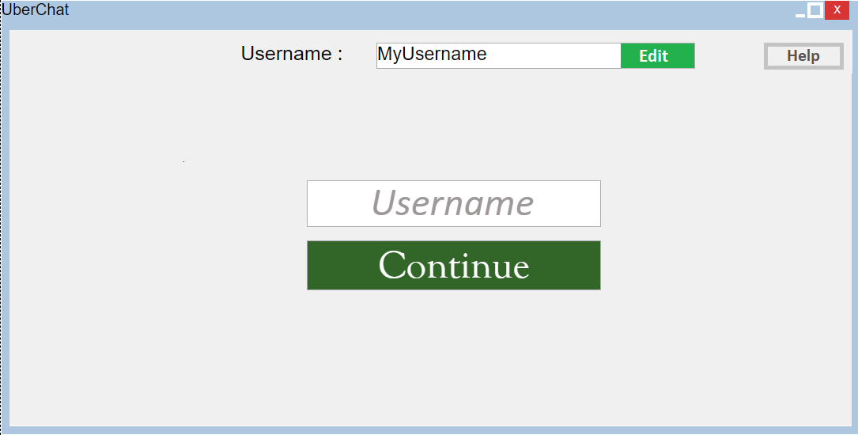

1. Client Room Select

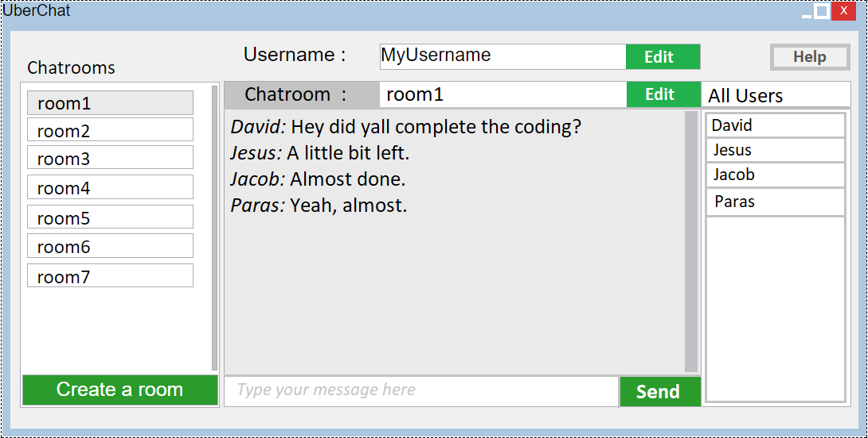

1. Client Help

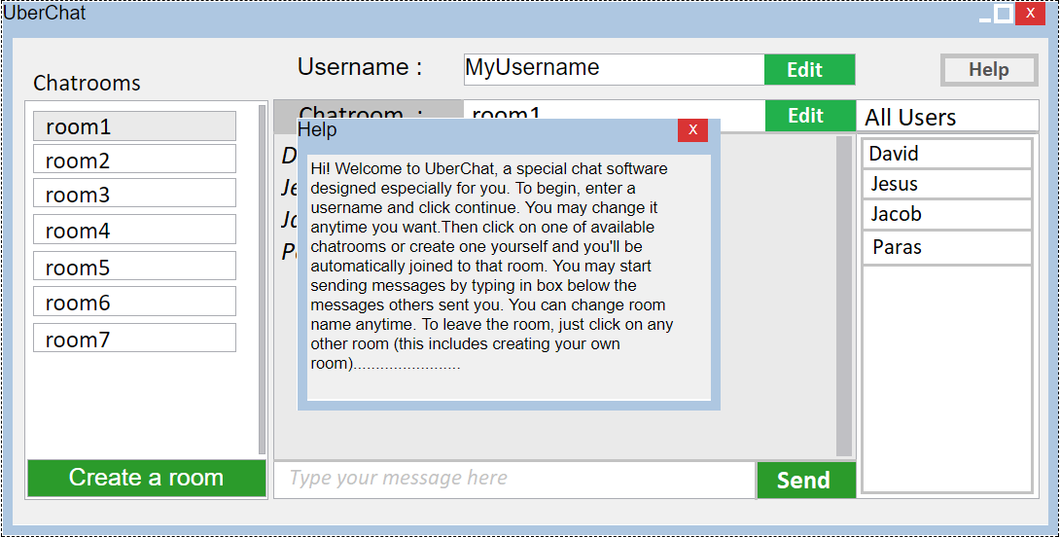

System Models

1. Context Model

<<system>>  
Server

<<system>>  
UberChat

<<system>>  
Client

Fig: Context Diagram of UberChat

1. Class Model

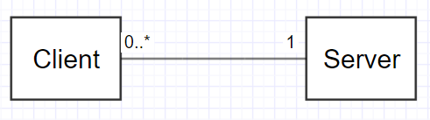

Fig: Class Model Diagram of UberChat

1. Sequence Model

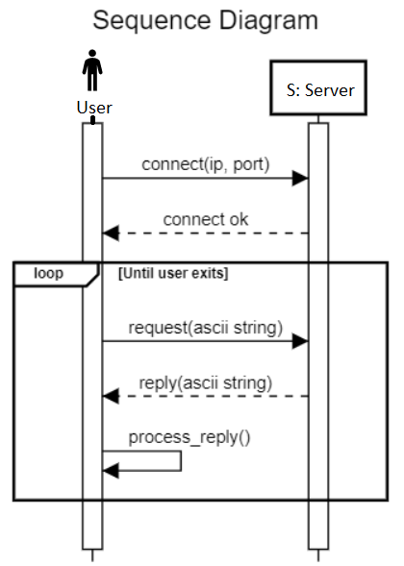

Fig: Sequence Model Diagram of UberChat

* request(string) can be anything from selecting/changing username, selecting/creating/changing chatroom, request for messages updates (uploads and downloads), etc. that a client sends to server.

* reply(string) can be anything like validating username, updating messages, etc. that server gives to client.

* process_reply() is a tool that says what to do with the response from the server such as printing out the new messages.

1. Use Case Model

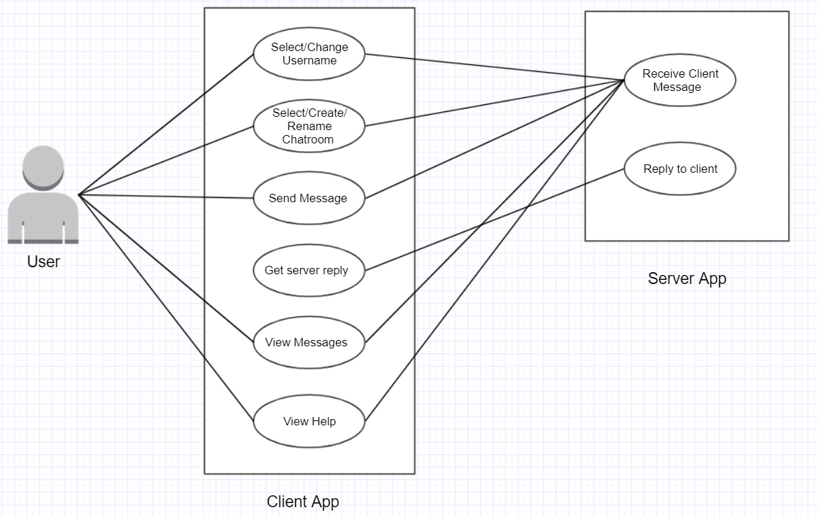

Fig: Use-Case Diagram of UberChat