Project-3 (Mail)
JMC Jupiter Mining Corp Mail Client
CS50 Web Programming in Python & Javascript. Project-3

Design

Dataflow Diagrams

Author: | Jef McDonald Ralston
Date: | 28-Aug-2023

Scope

This document describes the design of the Client for the Project-3 JMC Mail Client

Overview

This is a mail client which is uses a Django/Python backend server on a SQLite databse with an API for a Javascript to send and view emails between registered users of the App. The App is designed using the Yourdon Software Systems Analysis and Design Methodology (SSADM) and the diagrams were created using DrawIO.

Level 0: Context DFD

The top level design describes the fundamental components of the App. Before we get into verifying the requirements specification, lets take a brief moment to look at the design behind the mail client.

The app breaks down into two main areas
The part that handles the User Interface.
The part that handles fetching data from the server via the Mail API

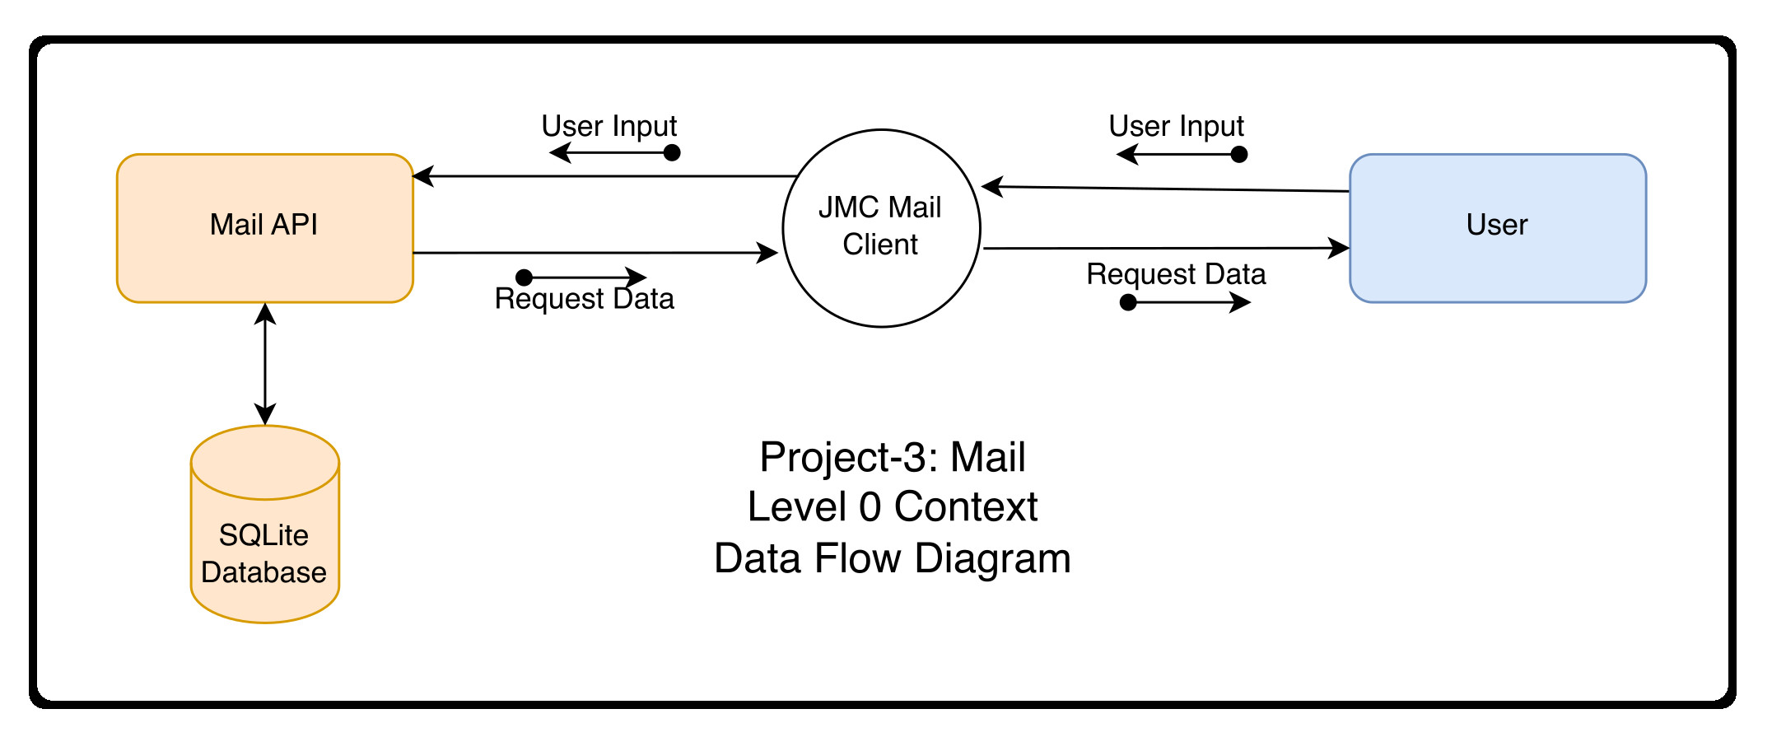

Level 1: Top Level DFD

The application has Three main processes. Send Mail, View Email and Mailbox, These will capture user input and fetch data from the API and then present it to the user via the Web Browser’s User Interface.

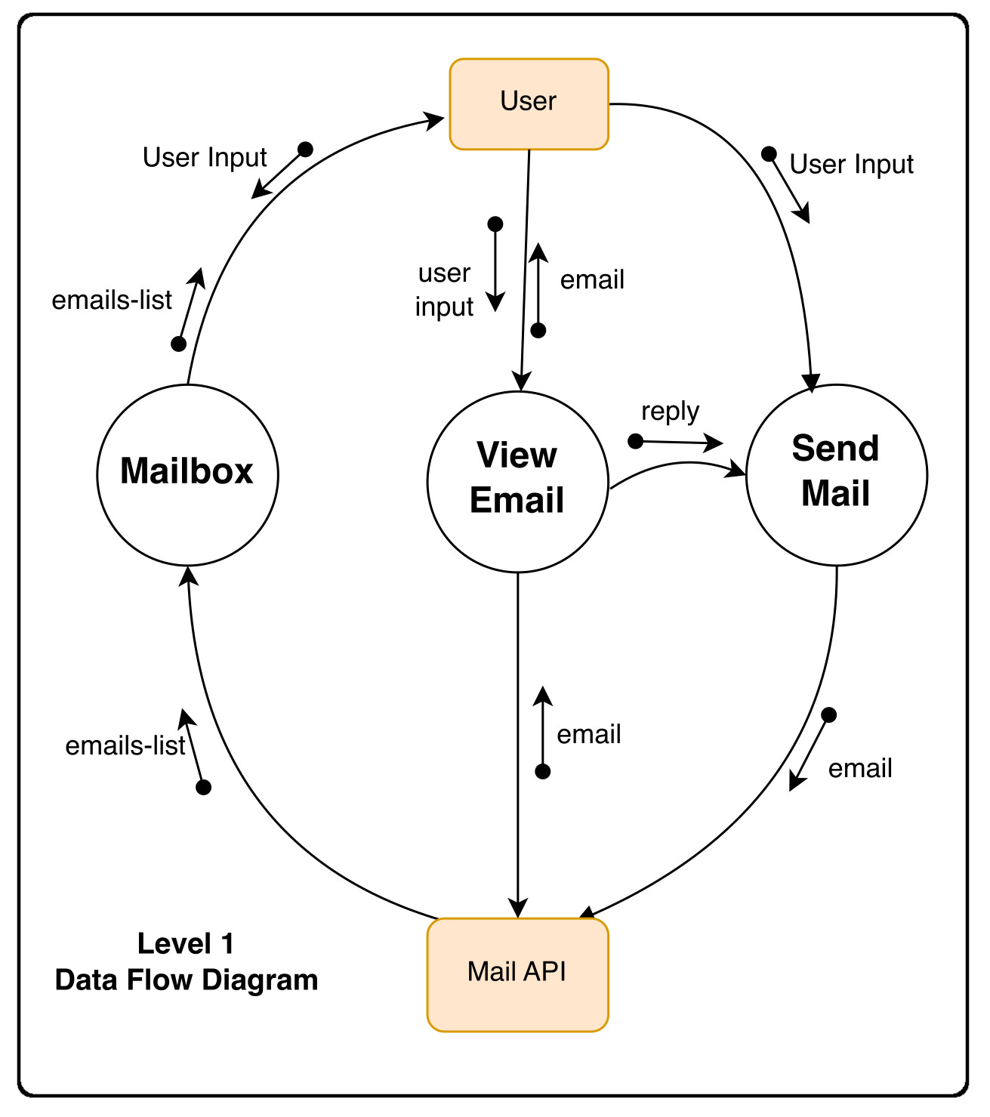

- Send Mail
Allows a User to send another registered user of the Application
- Mailbox
This will allow a user to see all the emails they have, either in their inbox, sent emails or archive emails
- View Mail
When a user clicks on a message in the emails list they will be able to read the contents of the email

Mailbox:
When a user visits their Inbox, Sent mailbox, or Archive, load the appropriate mailbox.

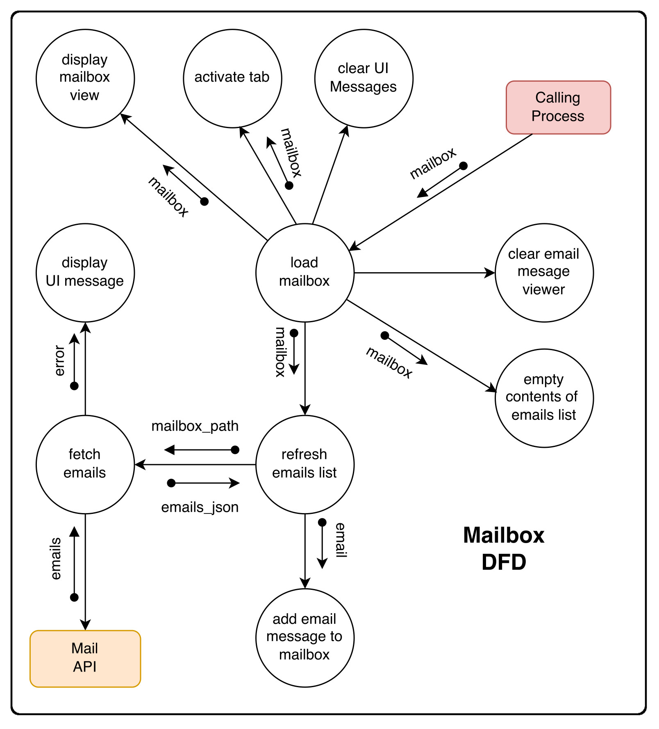

- Make a GET request to /emails/<mailbox> to request the emails for a particular mailbox.
- When a mailbox is visited, the application will query the API for the emails in that mailbox.
- When a mailbox is visited, the name of the mailbox should appear at the top of the page
- Each email should then be rendered in its own box (e.g. as a <div> with a border) that displays who the email is from, what the subject line is, and the timestamp of the email.
- If the email is unread, it should appear with a white background. If the email has been read, it should appear with a gray background.

View Message
When a user clicks on an email, the user should be taken to a view where they see the content of that email.
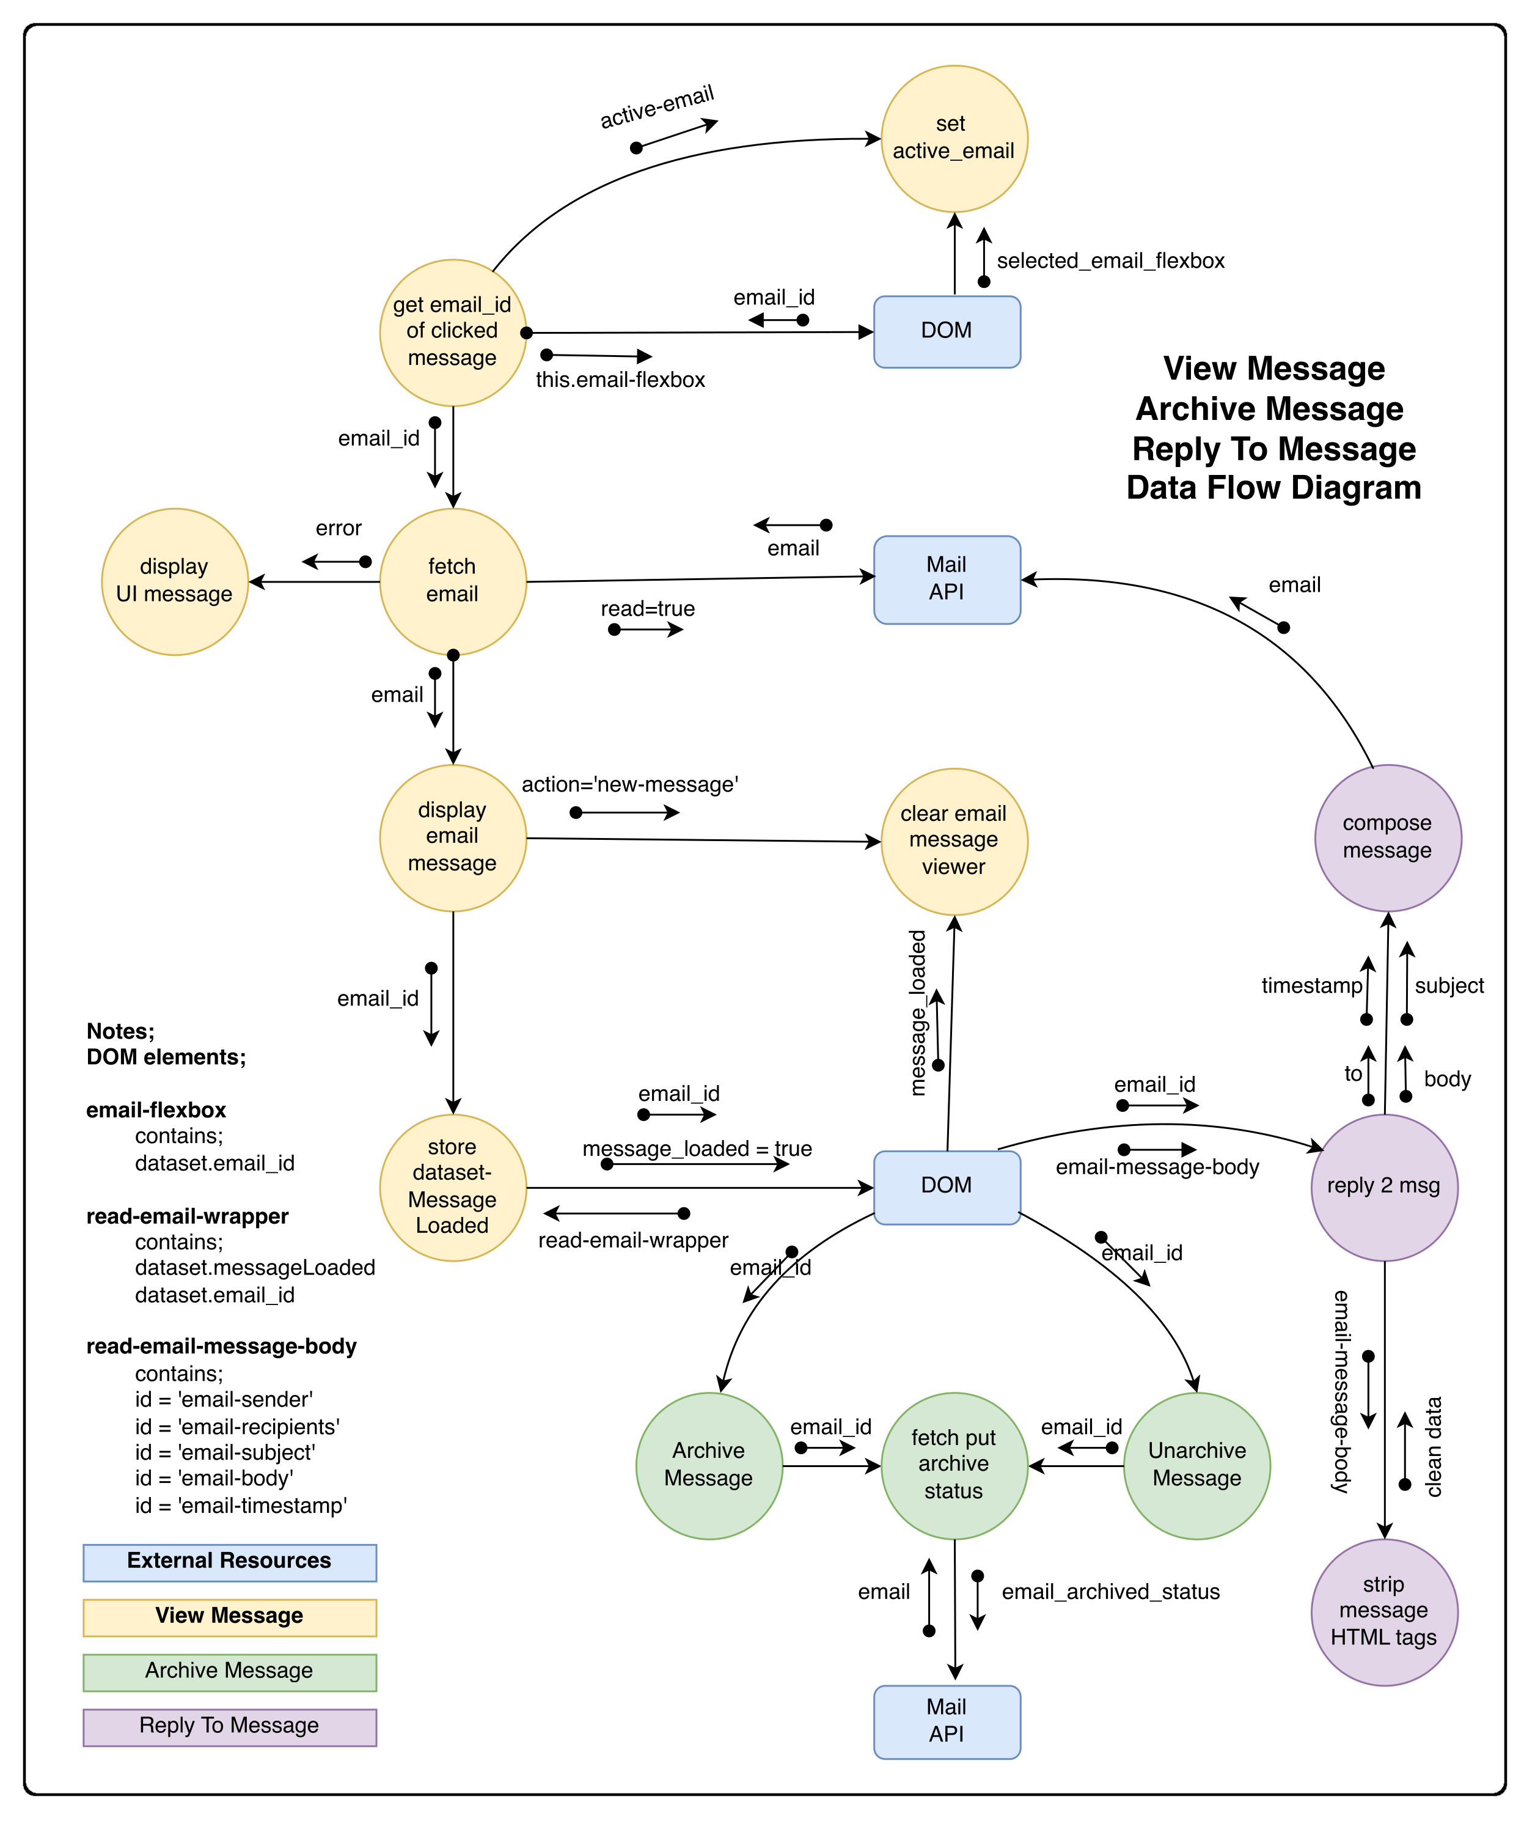

Essentially from the viewpoint of the Data, there are two external sources to to store and retrieve information. The first is the Mail API and the other is the DOM.

The DOM is storing application state data thats used by the app in the following elements

class = ‘email-list-name’
contains;
mailbox_name
This is the element containing the name of the Mailbox

class = ‘email-flexbox’
contains;
email_id
This is the individual element containing each list item in the mailbox. It has an attribute dataset which hoilds the email_id

class= ‘read-email-wrapper’
contains;
dataset-messageLoaded
dataset-email_id
This is the element that containst the all the elements that make up an email message. It contains two datasets. One to store a flag that indicates that a message is loaded or not and a dataset that contains the email_id of the current message being viewed.

class = ‘read-email-message-body’
contains;
id = 'email-sender'
id = 'email=recipients'
id = 'email-subject'
id = 'email-body'
id = ‘email-timestamp’
These are the elements within ‘read-email-message-body’ that thold the data fetched from the API and contain the email data.

- Make a GET request to /emails/<email_id> to request the email.
- Your application should show the email’s sender, recipients, subject, timestamp, and body.
- You’ll likely want to add an additional div to inbox.html (in addition to emails-view and compose-view) for displaying the email. Be sure to update your code to hide and show the right views when navigation options are clicked.
- Once the email has been clicked on, you should mark the email as read. Recall that you can send a PUT request to /emails/<email_id> to update whether an email is read or not.

Send Mail
When a user submits the email composition form, use JavaScript code to actually send the email.
- Use a POST request to the API /emails path, passing in values for recipients, subject, and body.
- Once the email has been sent, load the user’s sent mailbox.
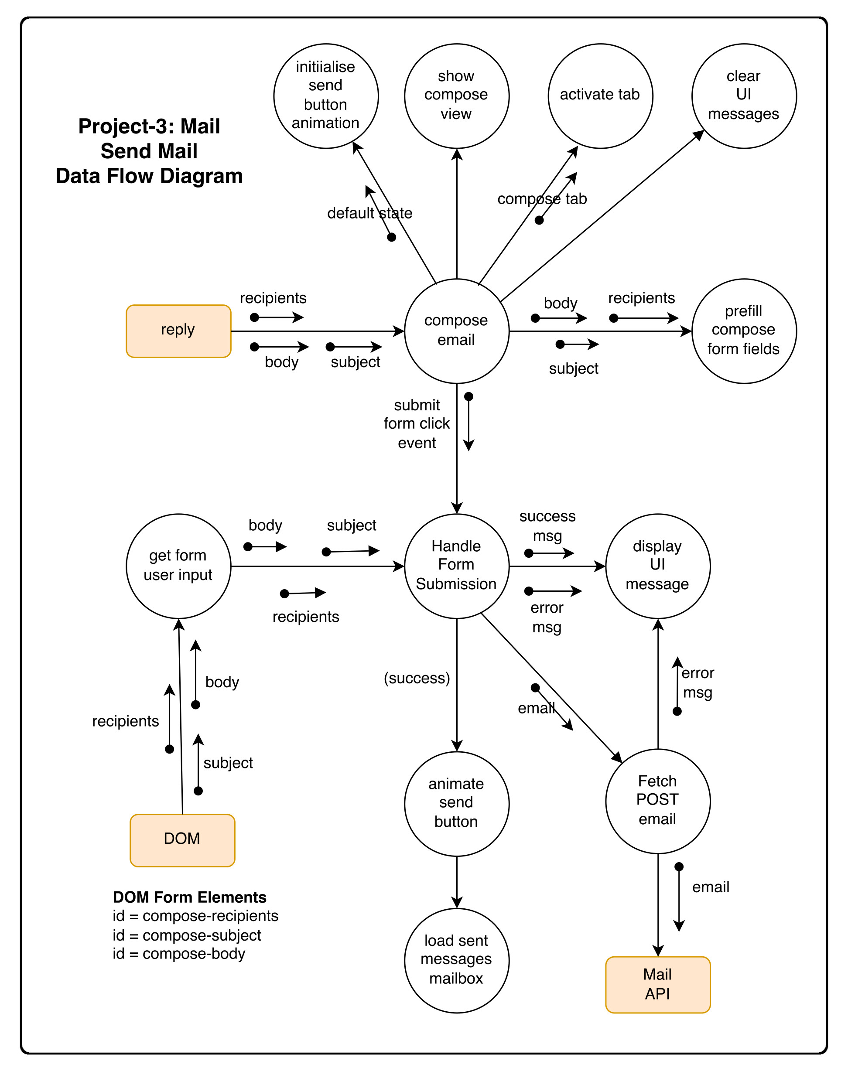
Appendix I

