Project-3 (Mail)
JMC Jupiter Mining Corp Mail Client
CS50 Web Programming in Python & Javascript. Project-3

Pseudo code

&
Flowcharts

Author: Jef McDonald Ralston
Date: 28-Aug-2023

Scope

This document describes the pseudocode for the processes identified in the DFD Design Documention

Top Level Main:
INPUT : None
RETURN : Null

Main top level controls the Applications Three main functions, Send Mail, Mailbox and View Email

IF DOMContentLoaded THEN
when user clicks inbox Mailbox load_mailbox(‘inbox’)
when user clicks sent Mailbox load_mailbox(‘sent’)
when user clicks archive Mailbox load_mailbox(‘archive’)

when user clicks compose tab Send Mail compose_email()

when user clicks View Email read_message()
when user clicks View Email reply button call reply_2_msg()
when user clicks View Email archive button call archive()
when user clicks View Email unarchive button call unarchive()
when user clicks View Email refresh email list button call refresh_email_list()

By default, When page loads call load_mailbox(‘inbox’)
every 5 minutes refresh_email_list()
ENDIF

MAILBOX

load_mailbox(mailbox)
Process: Mailbox:
INPUT : Mailbox type: string
Values: ‘inbox’ | ‘sent’ | ‘archive’
RETURN : Null
Fetches the contents of the mailbox from the API and displays it on the User Interface
Prepares email message viewer to view a new message
FUNCTION load_mailbox(mailbox)
BEGIN
clear_UI_message()
clear_email_message_viewer()
activate_tab(mailbox_name)
display_mailbox_view(mailbox)
refresh_emails_list()
END

refresh_email_list()
Process: Mailbox
INPUT: mailbox_name type: string
RETURN : Null
AJAX function that fetches a new list from the API with the latest emails in it for the given mailbox

FUNCTION refresh_email_list()
BEGIN
mailbox = get_mailbox_name()
empty_contents_of-emails_list()
mailbox_API_path = ‘emails/’ + mailbox_name
FETCH emails from mailbox_API_path
IF no emails in mailbox_API_path THEN
add_email_message_to_mailbox(Null, ‘mailbox empty’)
ENDIF
FOR all emails
IF email status = read THEN
message_style = Read messages have a white background
ELSE
message_style = Unread messages have a grey background
ENDIF
add_email_message_to_mailbox(email, message_style)
ENDFOR
IF FETCH error
display_UI_message(error)
END

Load Mailbox and Refresh Emails List Flowchart

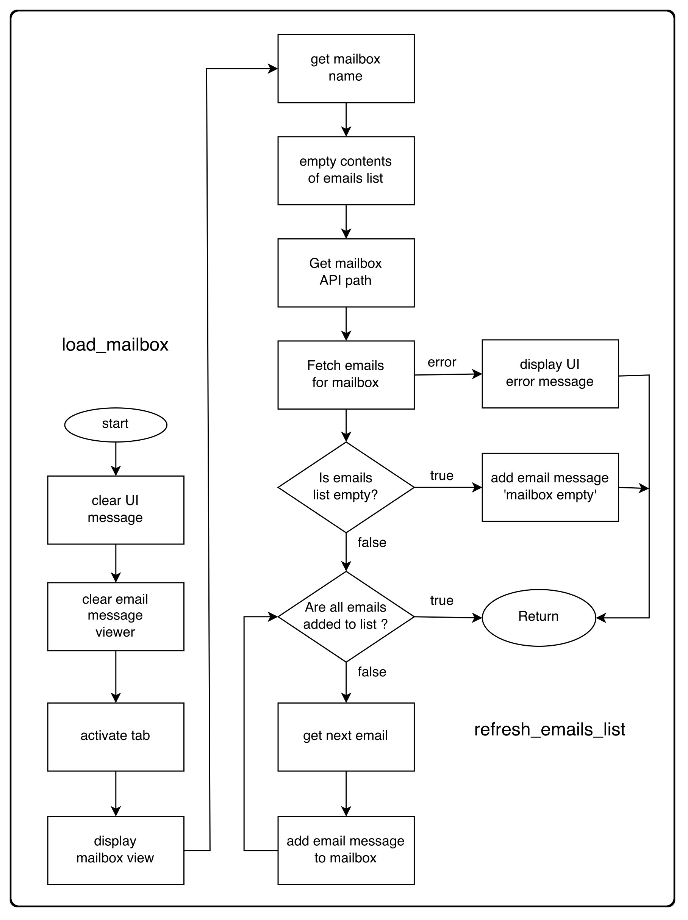

add_email_message_to_mailbox(email, message_style)
Process: Mailbox
INPUT : email: type Javascript Object
message_style: type string
RETURN : Null

Add a new HTML DOM structure containing the email details to the emails list.
The DOM element that contains the emails list has class=’emails-list-wrapper’

The dataset ‘data-email-id=email.id’ is added to each new email list item element so that each email in the list can be identified and looked up when it is clicked. This will enable the message to be searched for on the API.

The list is created inside the DOM element with the class=’email-list-wrapper’

FUNCTION add_email_message_to_mailbox(email)
BEGIN

IF email.sender is from empty mailbox messageTHEN
email CSS style class = ‘email-list-item-unread
ELSE
IF email.read = true THEN
email CSS style class = ‘email-list-item-read
ELSE
email CSS style class = ‘email-list-item-unread
ENDIF
ENDIF

Select the element containing the emails list. (element with class=’emails-list-wrapper’)
new_email_row =
‘
<div class='email_class’ data-email_id=email.id>
<div class = 'email-sender'>
email.sender_name
</div>
<div class='email-subject'>
email.subject
</div>
<div class = 'email-timestamp'>
email.timestamp
</div>
</div>
‘
Insert new_email_row into email_list_wrapper

IF email.sender != Null THEN
add event listener to the element that triggers ‘read_message’ when clicked
ENDIF
RETURN
END

display_mailbox_view(mailbox)
Process: Compose Mail, Load Mailbox:
INPUT : message: type: string
RETURN : Null
Displays the #emails-view with a page title

FUNCTION display_mailbox_view(mailbox)
BEGIN
show mailbox view
hide compose view
set page title = mailbox
RETURN
END

display_UI_message(message)
Process: Compose Mail, Load Mailbox:
INPUT : message: type: string
RETURN : Null
Displays a message to the User
FUNCTION display_UI_message()
BEGIN
find DOM element that displays UI Messages #debug-messages
set the inner HTML = message
RETURN
END

get_mailbox_name()
Process:Malbox, refresh_email_list
INPUT: None
RETURN: Null
returns the name of the mailbox currently being viewed by the user

FUNCTION get_mailbox_name()
BEGIN
find DOM element containing the mailbox title
RETURN the inner text of this elememt
END

activate_tab(tab)
Process: Compose Mail, Load Mailbox
INPUT : tab: type: string
RETURN : Null
Sets the active tab and styles it so that it indicates that its active
FUNCTION activate_tab(tab)
BEGIN
find current element with class==’active-tab’
remove the ‘active-tab’ class to deactivate it

find element with id==tab
add the ‘active-tab’ class
RETURN
END

empty_contents_of_emails_list(mailbox)
Process: Mailbox → refresh_email_list
sets the contents of the mailbox to Null
FUNCTION empty_mailbox()
BEGIN
find DOM element containing the emails list
set the contents to Null
RETURN
END

clear_UI_messages(element)
Process: Compose Mail, Load Mailbox
INPUT : element: type: DOM Element #debug-messages
RETURN : Null
clears the contents of the element used for displaying application messages to the user
FUNCTION clear_UI_message(element)
BEGIN
set inner HTML of UI-message element to Null
RETURN
END

clear_email_message_viewer(action)
Calling Process: Load Message:
INPUT : action: type: string,
values: ‘close-message’ | ‘new-message’ | ‘reset-default’
RETURN : NULL
Summary: This function prepares the element used for displaying the contents of the email. The element will be presented differently and have different options available to the user depending on the permutations of the parameters ‘mailbox’ and ‘action’
The element used to display the email message has class name ‘email-message-body’

FUNCTION clear_email_message_viewer(mailbox_name, action)
BEGIN
select element with class=’email-message-body’
clear contents of the ‘email-message-body’ element and set to Null
IF action == ‘reset-default’ OR action == ‘close-message’ THEN
Hide reply button
Hide archive button
Hide unarchive button
Find email in email-list with ‘active-email’ class set
remove active-email class from it
Show JMC Logo in email-message-body element
ELSEIF action = ‘new-message’
IF mailbox == ‘inbox’ THEN
Show Reply Button
Show Archive Button
Hide Unarchive Button
ELSEIF mailbox == ‘archive’ THEN
Show Reply Button
Hide Archive Button
Show Unarchive Button
ELSEIF mailbox == ‘sent’ THEN
Show Reply Button
Hide Archive Button
Show Unarchive Button
ENDIF
Hide JMC Logo
ENDIF
END

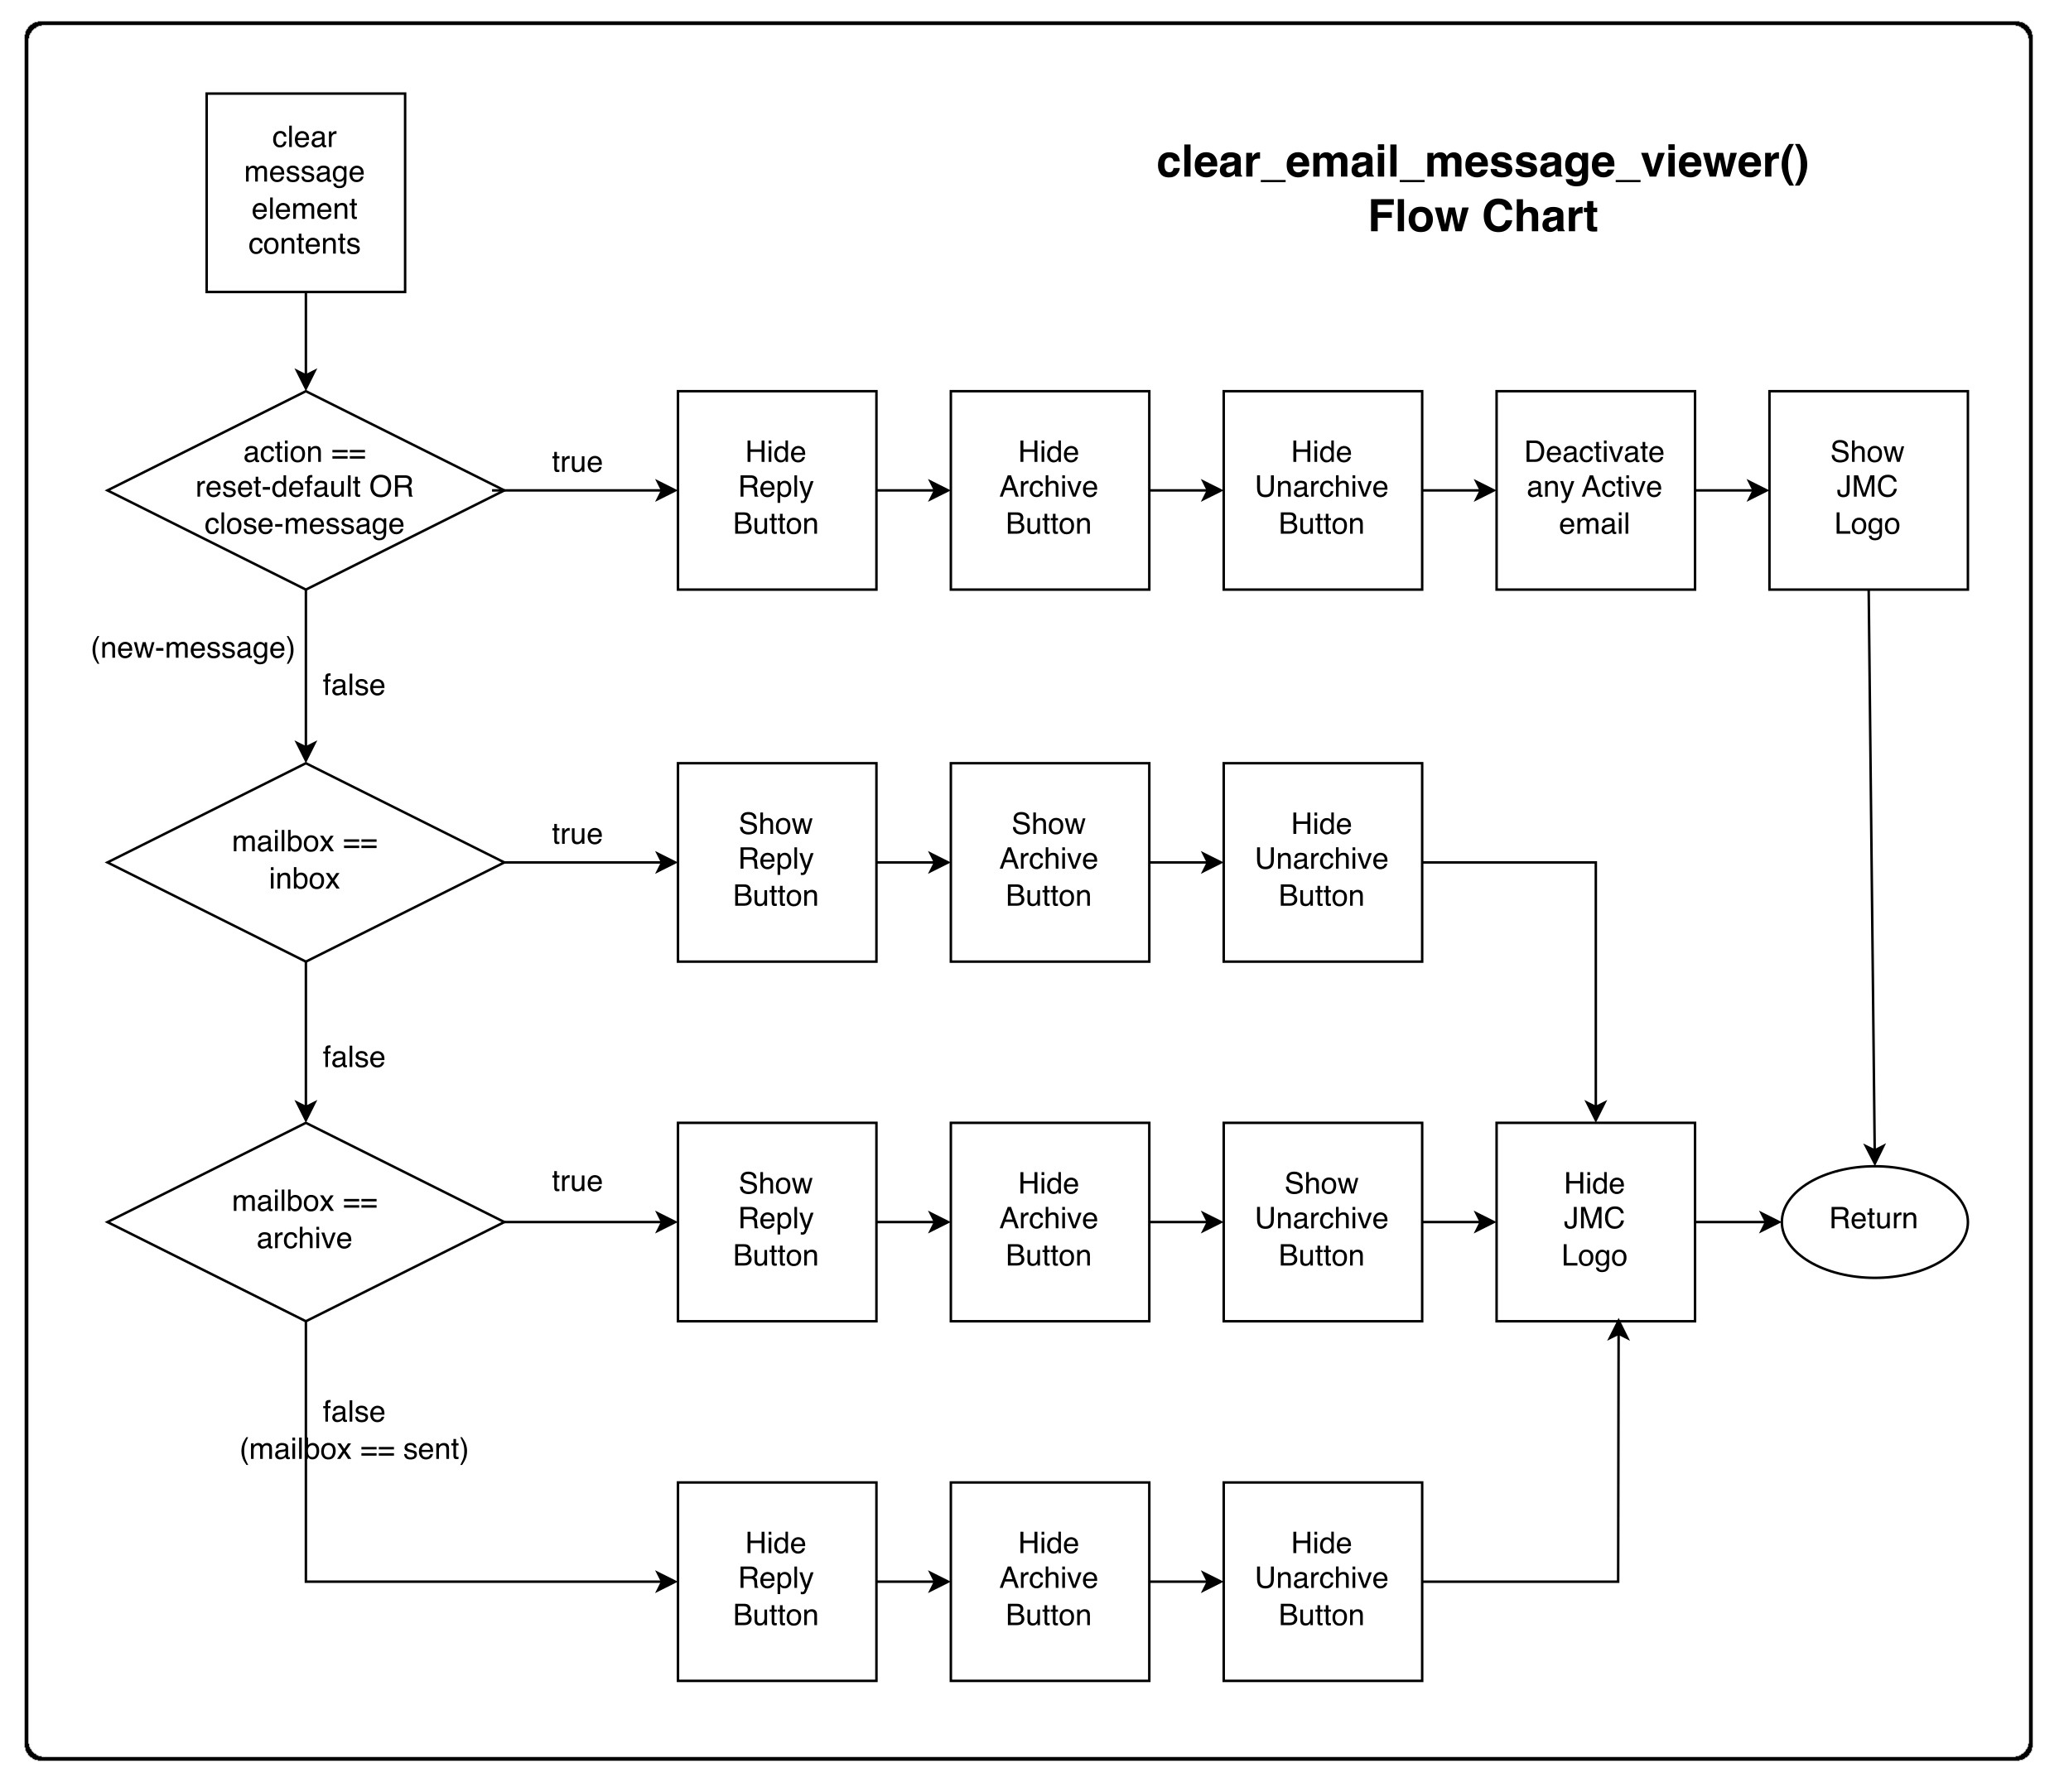

Send Mail

compose_email(to, subject, body)
Process Compose Mail:
INPUT : to: type string
subject: type string
body: type string
RETURN : Null

invoke a fetch on the API emails: path and POST user input to send a message

FUNCTION compose_email(to, subject, body)
BEGIN
clear_UI_Messages()
activate_tab(tab) Set Active Tab to Compose
Display Compose Mailbox tab
Hide emails-view
Show compose-view
Prefill Fill compose form fields with values in the paramaters, to, subject, body
initialise send button animation to paused state

Handle Form Submission
IF Compose Form Submit buttom clicked THEN
get form user input, subject, recipients and message body
POST form data to the Mail API
clear user interface message
IF Message POST == Success THEN
display UI message = Success
animate send button
load_mailbox of Sent Messages
ELSE
display UI message = Error
END
END

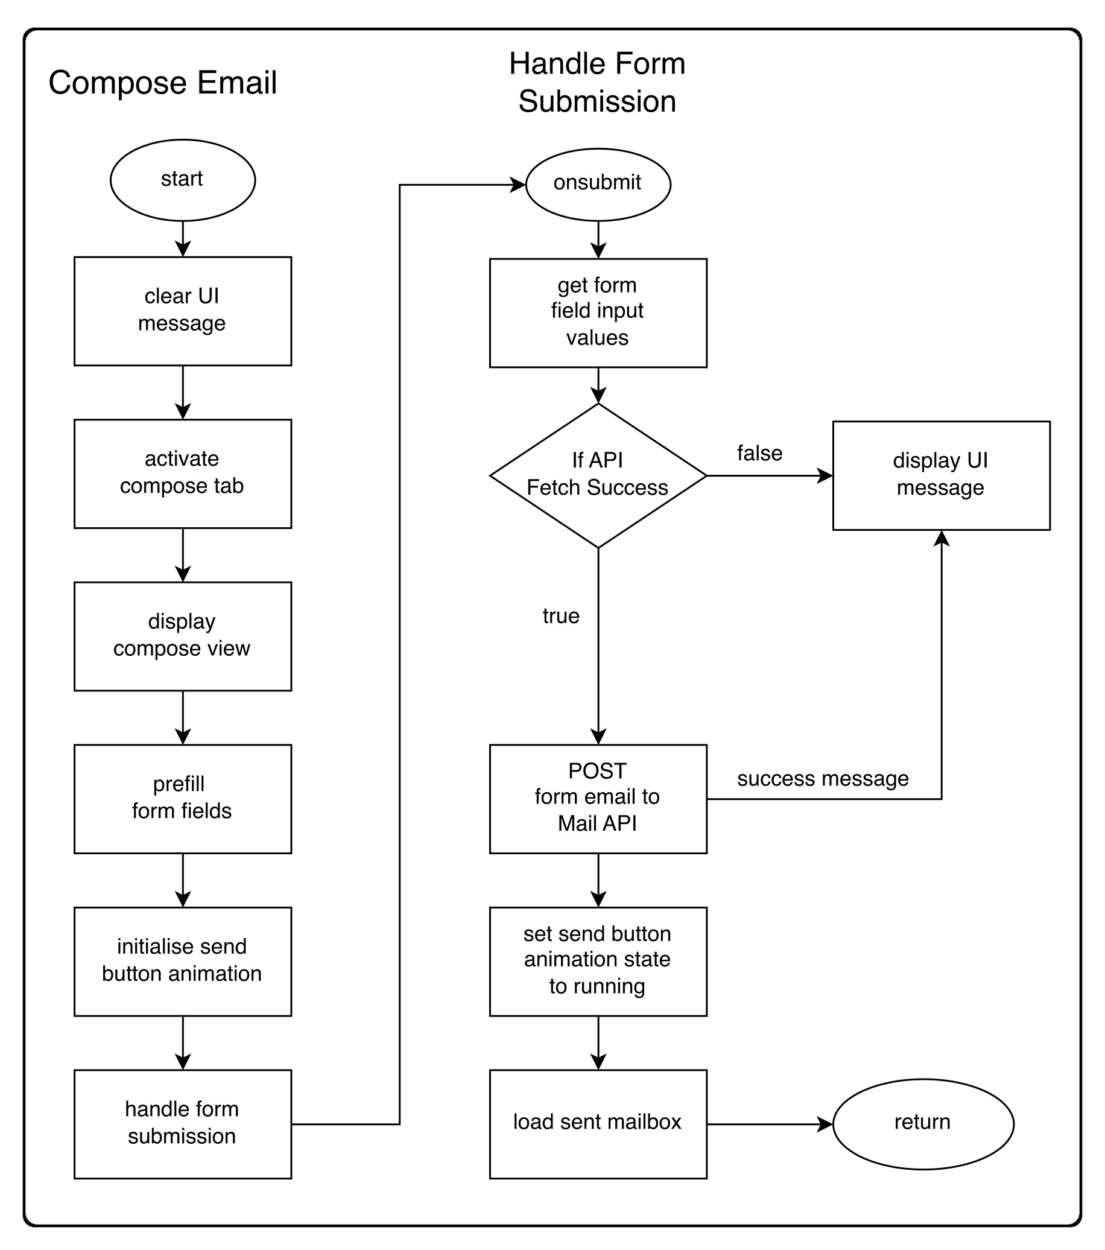

View Email

read_message()
Process: View Email
INPUT : this: type: eventHandler click event
RETURN : Null
Opens a en emails contents when it is clicked on and displays its contents
FUNCTION read_message(this)
BEGIN
clear UI messages
get email Id of clicked email message
set clicked email to active-email
FETCH GET email THEN
IF email has been read === false THEN
FETCH PUT email.email_id THEN
email.read = true
CATCH
ENDIF
IF message viewer element closed THEN
open message viewer
ENDIF
display_message
CATCH error
display UI message(error)
RETURN

display_email_message(email)
Process: View Email
INPUT : email: type: json
RETURN : Null
displays the email message in DOM
FUNCTION display_email_message(email)
BEGIN
IF message viewer is closed THEN
open message
ENDIF
clear_message_viewer(‘new_message’)
create message html
insert html into DOM element ‘email-message-body’
On element ‘email-message-wrapper’ set dataset message-loaded = ‘true’
On element ‘email-message-wrapper’ set dataset email-id = email.email_id
RETURN

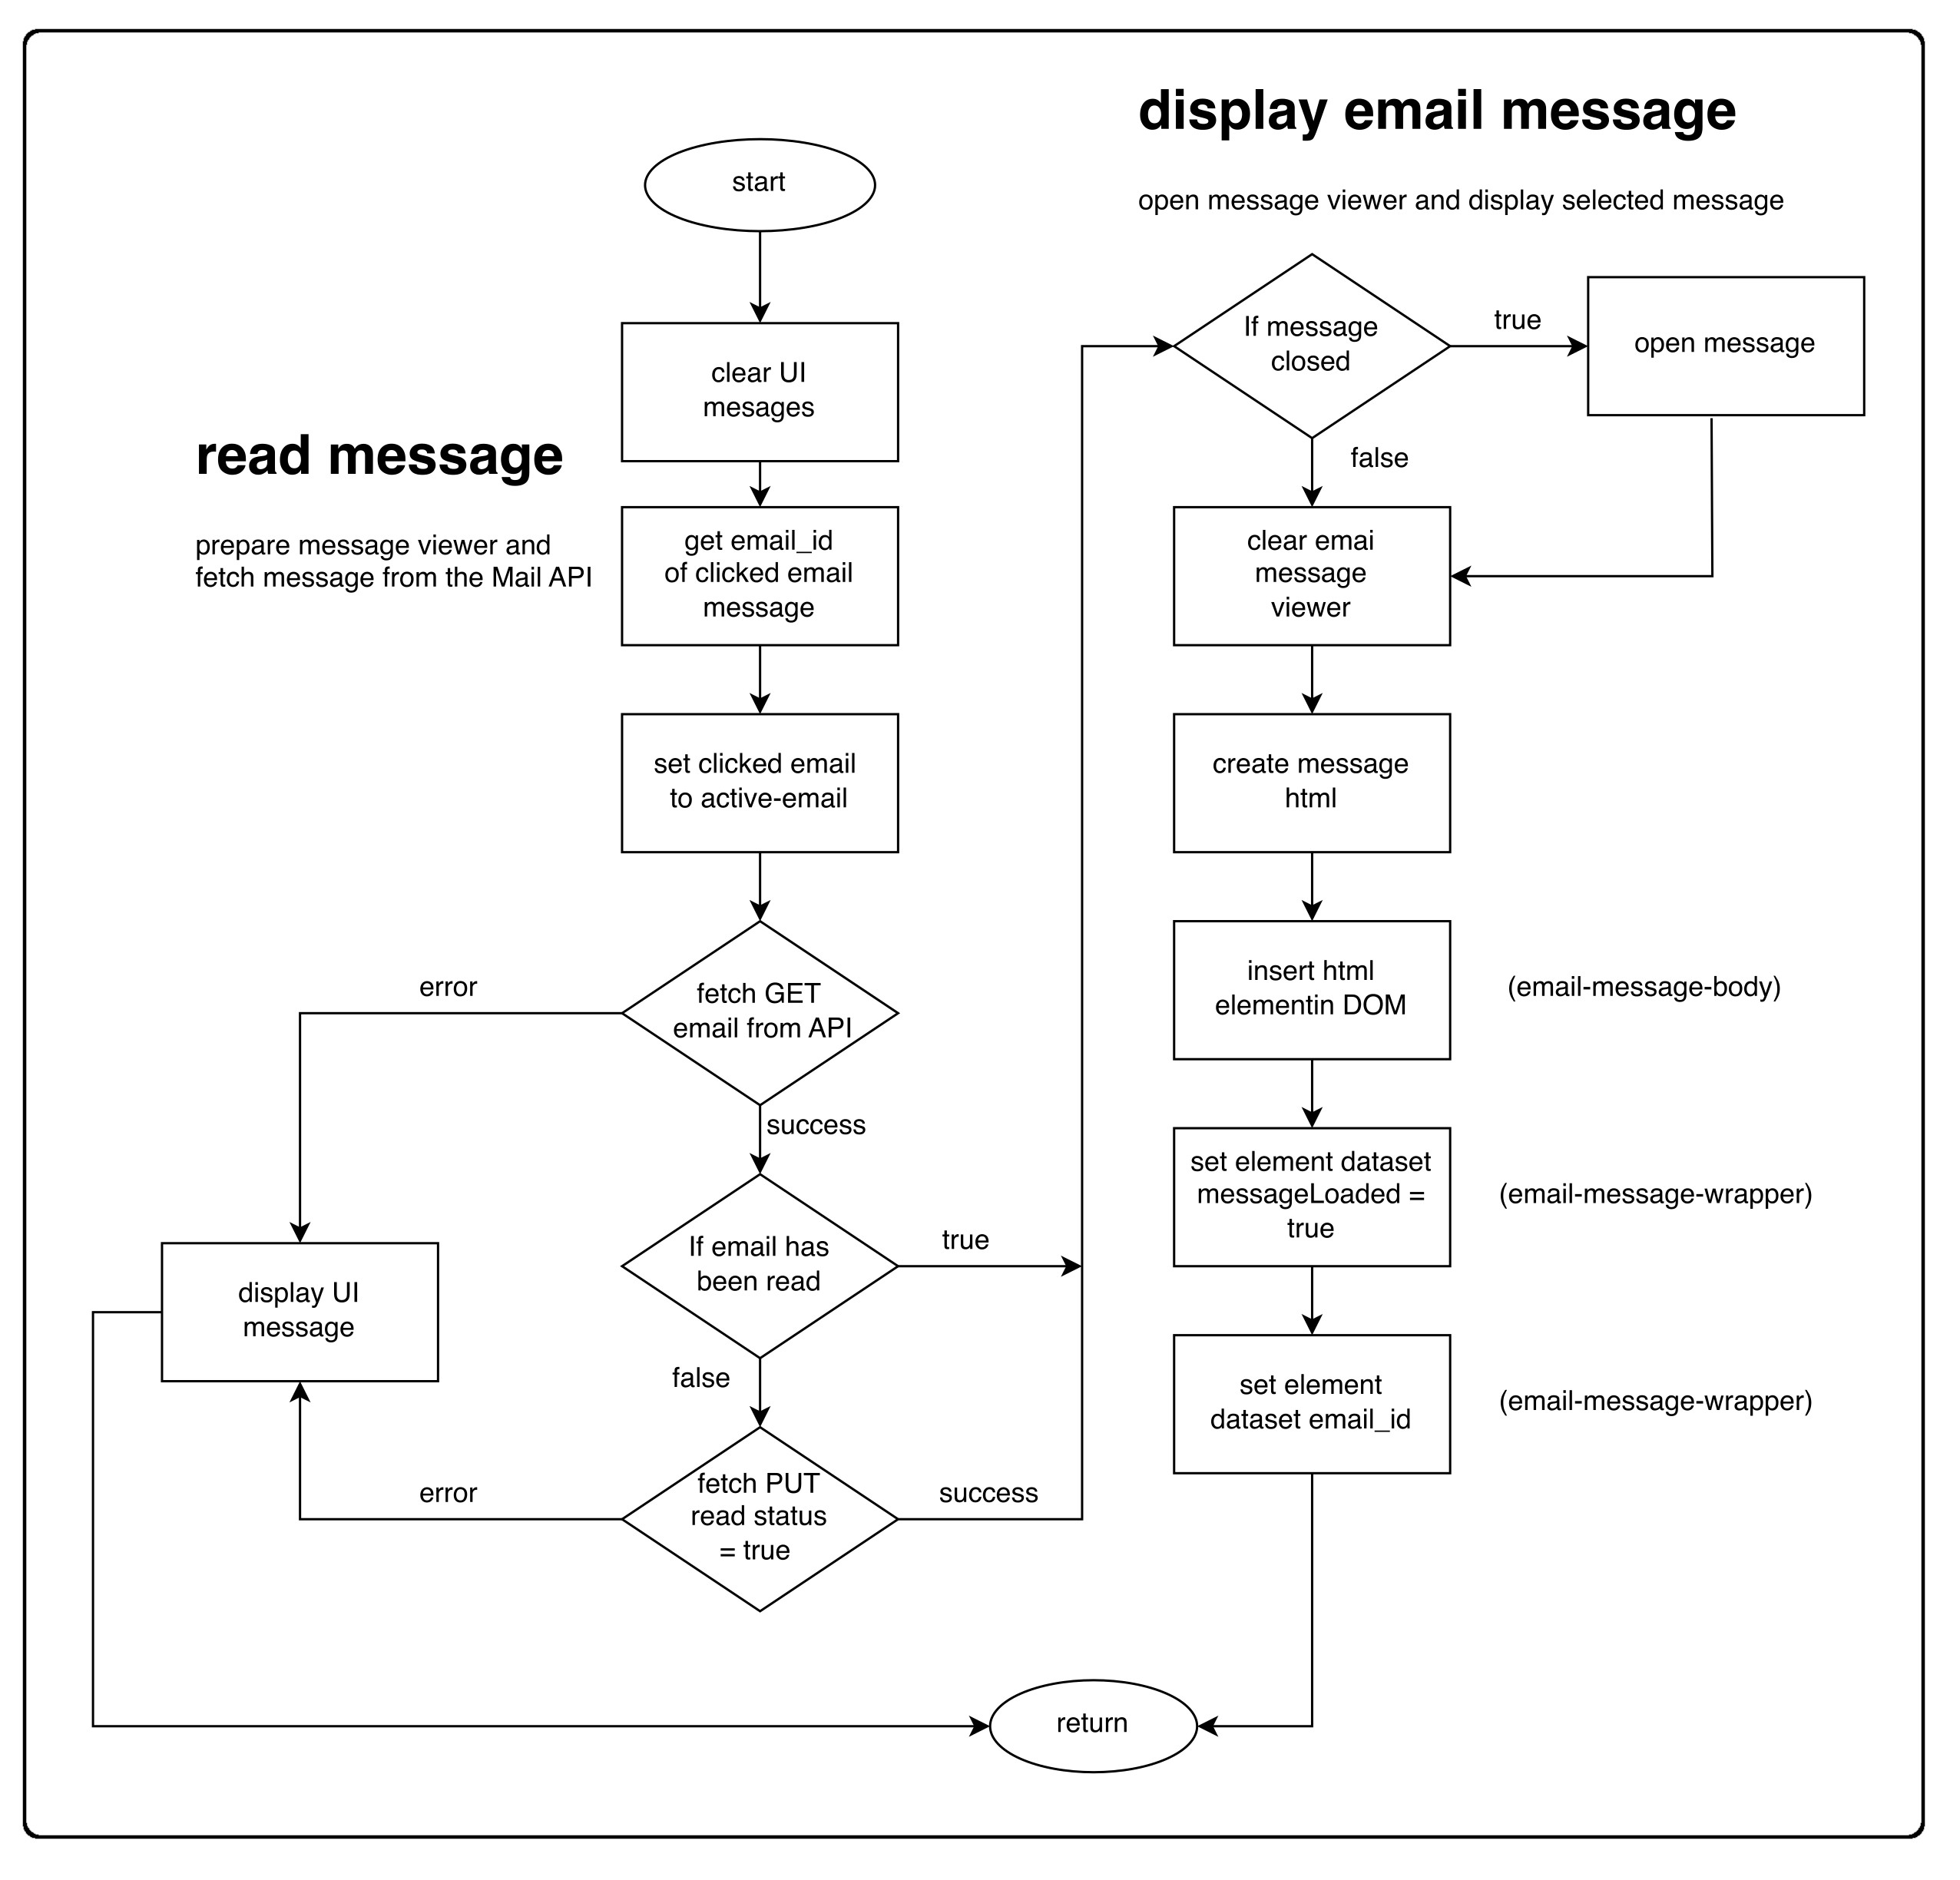

archive_msg()
Process: Compose Mail, Load Mailbox
INPUT : None:
RETURN : Null
Sets the archive status of the message loaded in the mail viewer
FUNCTION archive_msg()
BEGIN
fetch the currently viewed message and PUT the archives status to true
display UI message ‘Message Archived’
refresh emails list after short timeout
clear email message viewer to default settings
RETURN

unarchive_msg()
Process: Compose Mail, Load Mailbox
INPUT : None:
RETURN : Null
Sets the archive status of the message loaded in the mail viewer
FUNCTION unarchive_msg()
BEGIN
fetch the currently viewed message and PUT the archives status to false
display UI message ‘Message Unarchived’
refresh emails list after short timeout
clear email message viewer to default settings
RETURN

fetch_put_archive_status(email_archived_status)
Process: Compose Mail, Load Mailbox
INPUT : email_archived_status: type: boolean
RETURN : Null
Fetches laoded message and Sets the archive status
FUNCTION fetch_put_archive_status()
BEGIN
get email_id from the read-email-wrapper element
FETCH email_id from API THEN
PUT archived = email_archived_status
CATCH error
display UI error “Error setting archived status”
ENDFETCH
RETURN
END

reply_2_messsage(event)
Process: View Email
INPUT : event: type: DOM event
RETURN : Null
replys to the currently viewed message
FUNCTION reply_2_message(event)
BEGIN
get loaded message
clean loaded message of html formatting
call compose_mail with the cleaned message data
RETURN

test(p)
Process: Compose Mail, Load Mailbox
INPUT : p: type: string
RETURN : Null
Sets the active tab and styles it so that it indicates that its active
FUNCTION test(p)
BEGIN
find current element with class==’active-tab’
remove the ‘active-tab’ class to deactivate it

find element with id==tab
add the ‘active-tab’ class
RETURN

Process | Pseudo Code | Flowchart
activate_tab(tab) | Yes | No
clear_UI_messages(element) | Yes | No
display_mailbox(message) | Yes | No
clear_email_message_viewer(mailbox_name, action) | Yes | Yes
load_mailbox(mailbox) | Yes | Yes
refresh_emails_list(mailbox) | Yes | No

APPENDIX II

NOTES on AJAX: Asynchronous Javascript And XML
The format of the asynchronous fetch calls to the mail API is thus;

fetch("/emails", The Django url path
{ The fetch init attributes. A request method and a body
method:"POST",
body: JSON.stringify({"subject": msg_subject,
"recipients": msg_recipients,
"body": msg_body
})
}
)
At first, the fetch appears to invoke the /emails path with a javascript object
containing two key:value pairs. method:value and body:value

However, the django /emails paths dont care for a javascript object. They are;

path("emails", views.compose, name="compose"),
path("emails/<int:email_id>", views.email, name="email"),
path("emails/<str:mailbox>", views.mailbox, name="mailbox"),

The path can be called with either no parameter a string or an int

Q: So what is going on with the javascript object being passed?
How is that working?

A: It so happens that the second parameter to the fetch is called the 'init' options
These control the fetch operation and provide context to the request which can be accessed through the Django request object on the server side.
eg checking request.method == 'POST', 'GET', 'PUT' or 'DELETE'

Its not a parameter to the URL like typing something in the URL path

There are many Fetch init options

https:developer.mozilla.org/en-US/docs/Web/API/fetch
https:developer.mozilla.org/en-US/docs/Web/API/Fetch_API/Using_Fetch

So the /emails url path is being invoked with no parameter.
This then loads the views.compose function which can access the JSON object Posted in the fetch
though accessing the request, ie request.body
This can then be converted into a python dictionary and its contents become usable

The python loads function takes a JSON object and converts it into a python Dictionary

Python loads
https:www.geeksforgeeks.org/json-loads-in-python/
data = json.loads(request.body)

