**E.T Invasion**

Document date: 3/8/2020

Name: Aniq and Napa

Contents

General Overview:

1. Game Statement
2. Game Genre
3. Overview
4. Target audience
5. Platform

Details:

1. Gameplay
2. Characters
3. Game Mechanics
4. Progression
5. Win and Lose
6. Player component
7. Artstyle

Other aspects:

1. Story and Mission details
2. Project plan
3. Flowchart
4. Assets
5. Reference

General Overview

Game statement:

The game is about top down space invaders with the modern take of the classic. With added stages and different varieties.

Game genre:

Shooter

Overview:

The year 2XXX. An extra-terrestrial living beings invaded. Mankind is almost wiped out, until they created a special prototype to combat the invaders.

Target audience:

Teenagers ranged 15-18

Platform:

PC

Details

Gameplay:

The gameplay is similar to classic space invaders. But without the defense. Each stage progress. There will be boss battle and it will have large pool of health for the player to defeat.

The features were moving freely

Characters:

Prototype Ship

Generic E.T enemy #1

Generic E.T enemy #2

Generic E.T enemy #3

Game Mechanics:

Instead having a defense. There will no defense. Because of the player’s high performance, dodging will be the main mechanics. (Player)

Enemies will have special abilities for shooting at the player which giving the player a hard time

Progression:

Kill certain amount of enemy and the boss will spawn.

Killing the boss will proceed to next level.

Each level raises a difficulty.

Player component:

Player attack and upgrades:

Player basic shoots, each level completed will get a permanent upgrade. Player will have a simple health bar.

Enemy attack and upgrades:

Each enemy will attack differently, depending on which enemy player faced. Enemy will get difficulty as the level progress.

Artstyle:

Artstyle is going to be low poly. PS1 era graphics.

Other aspects:

Story missions and details:

The earth has created a prototype ship to combat the space invaders. First level is the departure, city base to fight off the invasion. Second level is to desert is where the progression and fight around the desert. Final level is where the player face a final assault on the forest.

Project plan:

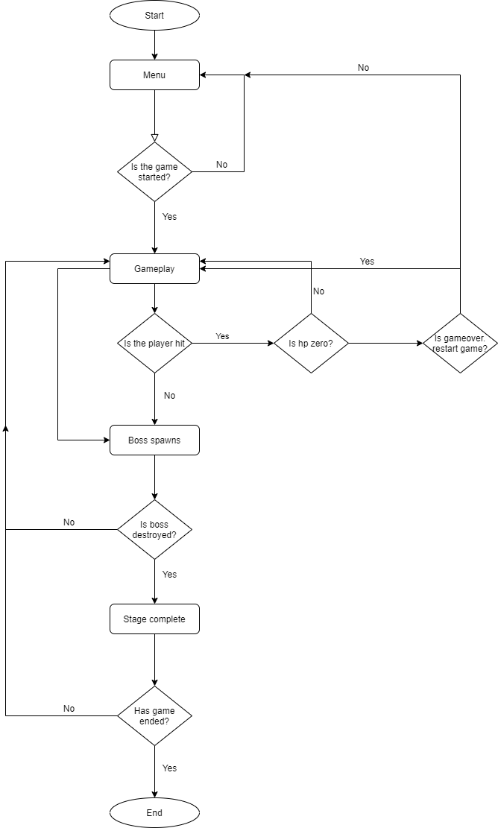Flowchart:

Assets:

Asset list

1. Space ship

* Link: <https://assetstore.unity.com/packages/3d/galactic-heroes-cartoon-spaceship-70188>

1. Low poly Desert

* Link: <https://assetstore.unity.com/packages/3d/environments/landscapes/lowpoly-environment-pack-99479>

1. Low poly Forest

* Link: <https://assetstore.unity.com/packages/3d/environments/landscapes/low-poly-simple-nature-pack-162153>

1. Low poly city

* Link: <https://assetstore.unity.com/packages/3d/environments/roadways/low-poly-road-pack-67288>

Reference: