WPL Project Report
BookVault
Done by Jeff Jacob Jaison
Guided by Mr. Ajay Antony Joseph

ABSTRACT
BookVault is a comprehensive web-based platform designed to simplify library management, integrating lending services, marketplace features, user interactions, and fines calculation. Built on Laravel 12, BookVault provides a dynamic environment for members to borrow books, submit e-books, and buy or sell personal books. Librarians and Administrators ensure a seamless ecosystem with role-based moderation. This modern project enhances operational efficiency in book distribution and digital cataloging.

1. INTRODUCTION
BookVault is a robust application developed using the latest Laravel framework. It provides users with an integrated collection of both library lending services and a peer-to-peer marketplace. Members can view available books, track their borrow history, resolve their fines, and participate in community sales. With careful validation and security layers, BookVault ensures high-level data integrity and scalable architecture in managing digital and physical books.

2. SYSTEM ANALYSIS

2.1 Module Description
1. Book Management: Enables Librarians to moderate books, modify stocks, and categorize digital submissions.
2. Lending Management: Users can request books and track return dates. The system deducts stock on lending and restores it upon return.
3. Fine Management: Calculates penalties dynamically if a user exceeds the lending deadline.
4. Marketplace: Allows members to list personal books for sale and others to purchase them.
5. Role Management: Secures access through specific roles (Member, Librarian, Admin).

2.2 Actors and Roles
Admin: Has ultimate control over the platform's settings, users, and overall operations.
Librarian: Focuses on moderating book collections, approving e-book submissions, and managing the market listings.
Member (User): The central consumer who borrows books, pays fines, lists items for sale, and makes purchases.

3. SYSTEM DESIGN

3.1 Use Case Model
Use Case Diagram (Premium):
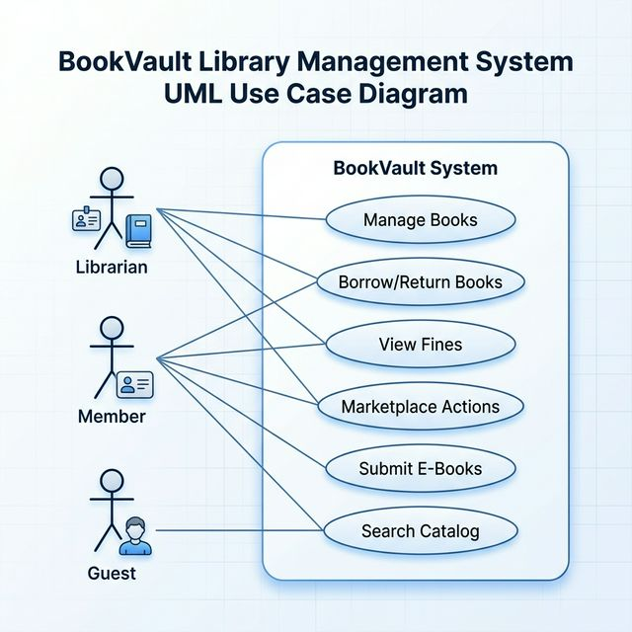
Use Case Diagram (Wireframe):
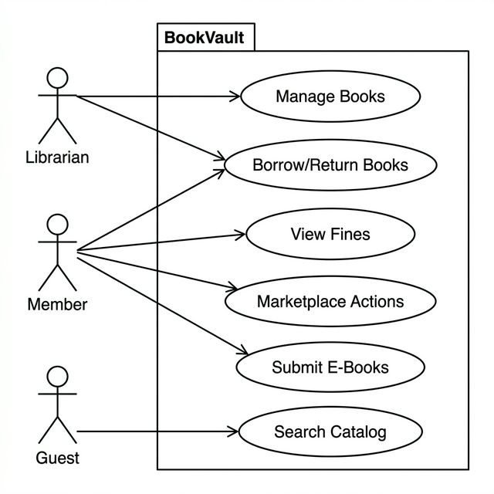
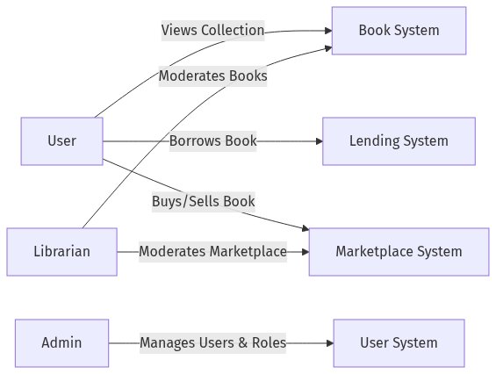

3.2 Sequence Diagrams
User Login:
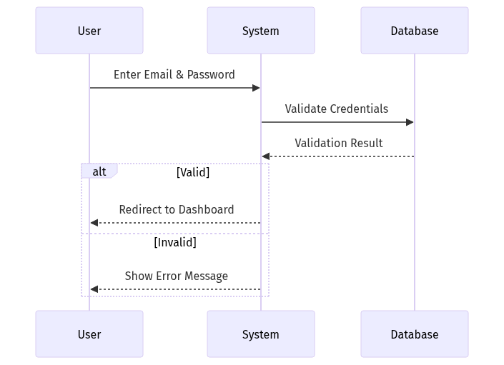
Book Lending:
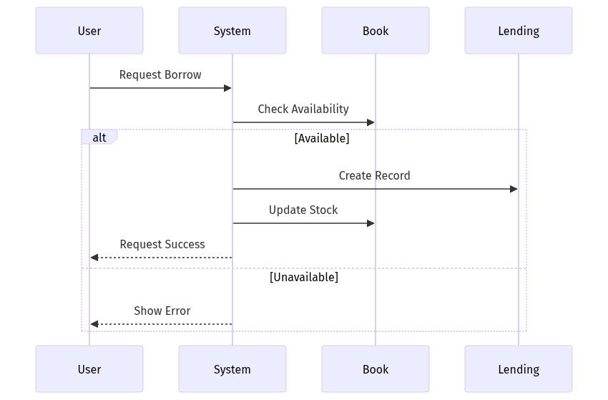

3.3 Entity Relationship Diagram
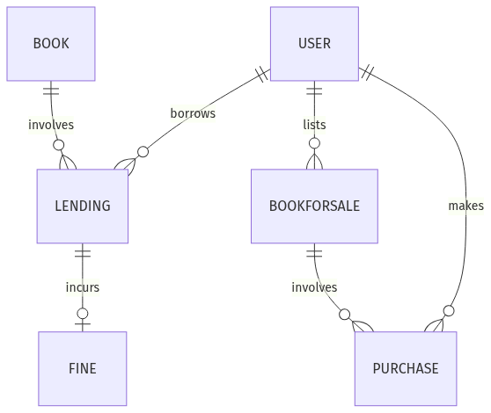

3.4 Class Diagram
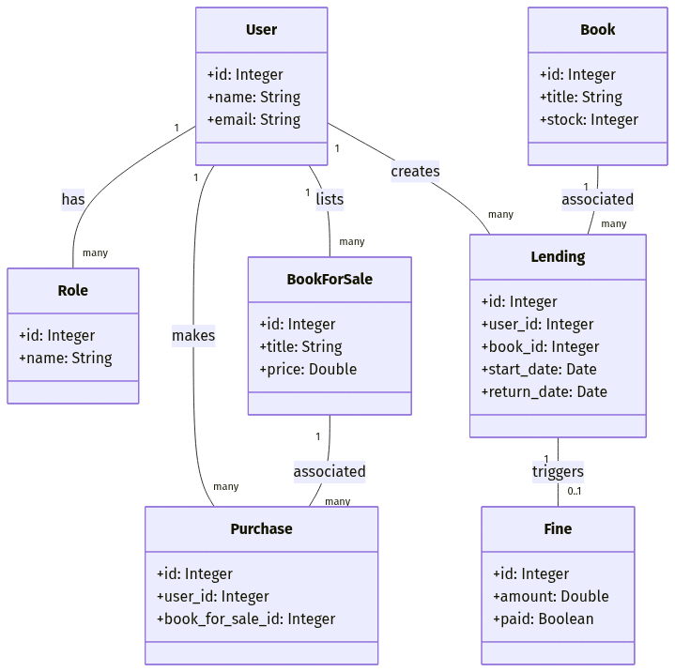

Database Tables Summary
The BookVault system is built upon a relational database schema comprising 8 core tables, each serving a specific role in the library and marketplace ecosystem.

3.5 Data Dictionary
Table Name | Purpose / Description
roles | Manages user authorization levels (e.g., Librarian, Member).
users | Stores user account information and virtual wallet balances.
books | Central catalog for library-owned physical and digital books.
lendings | Tracks the borrowing lifecycle of physical library assets.
fines | Manages monetary penalties for late book returns.
book_for_sales | Facilitates the peer-to-peer marketplace listings.
purchases | Records financial transactions for marketplace items.
wishlists | Allows users to bookmark library or marketplace items.

Table 3.1: Users Table
Table 3.2: Books Table
Table 3.3: Lendings Table
Table 3.4: Fines Table
Table 3.5: BookForSales Table
Table 3.6: Wishlists Table
Table 3.7: Roles Table
Table 3.8: Purchases Table

4. SYSTEM ARCHITECTURE & DATABASE DESIGN

Column Name | Data Type | Description
id | BigInt, AI | Primary Key
user_id | BigInt | Foreign Key (Buyer)
book_id | BigInt | Foreign Key (Book)
amount_paid | Decimal(8,2) | Total paid amount
commission_earned | Decimal(8,2) | Platform fee earned
created_at | Timestamp | Record creation time
updated_at | Timestamp | Record modification time

Column Name | Data Type | Description
id | BigInt, AI | Primary Key
name | Varchar(255) | Role name (Unique)
created_at | Timestamp | Record creation time
updated_at | Timestamp | Record modification time

Column Name | Data Type | Description
id | BigInt, AI | Primary Key
user_id | BigInt | Foreign Key (Users)
book_id | BigInt | Foreign Key (Books)
book_for_sale_id | BigInt | Foreign Key (Marketplace)
created_at | Timestamp | Record creation time
updated_at | Timestamp | Record modification time

Column Name | Data Type | Description
id | BigInt, AI | Primary Key
user_id | BigInt | Foreign Key (Seller)
title | Varchar(255) | Book title for sale
author | Varchar(255) | Book author
price | Decimal(8,2) | Selling price
description | Text | Item description
condition | Varchar(255) | Item condition
status | Varchar(255) | Moderation status
created_at | Timestamp | Record creation time
updated_at | Timestamp | Record modification time

Column Name | Data Type | Description
id | BigInt, AI | Primary Key
lending_id | BigInt | Foreign Key (Lendings)
user_id | BigInt | Foreign Key (Users)
amount | Decimal(8,2) | Penalty amount
paid | Boolean | Status of payment
created_at | Timestamp | Record creation time
updated_at | Timestamp | Record modification time

Column Name | Data Type | Description
id | BigInt, AI | Primary Key
user_id | BigInt | Foreign Key (Users)
book_id | BigInt | Foreign Key (Books)
issued_at | Timestamp | Time of issuance
due_date | Timestamp | Deadline for return
returned_at | Timestamp | Actual return time
status | Varchar(255) | Borrowing status
created_at | Timestamp | Record creation time
updated_at | Timestamp | Record modification time

Column Name | Data Type | Description
id | BigInt, AI | Primary Key
title | Varchar(255) | Title of the book
author | Varchar(255) | Author of the book
isbn | Varchar(255) | Unique ISBN
published_year | Integer | Year of publication
quantity | Integer | Total stock (Lendable)
available_qty | Integer | Current available stock
description | Text | Book overview
cover_image | Varchar(255) | Path to cover image
created_at | Timestamp | Record creation time
updated_at | Timestamp | Record modification time

Column Name | Data Type | Description
id | BigInt, AI | Primary Key
name | Varchar(255) | User's full name
email | Varchar(255) | Unique email address
balance | Decimal(10,2) | User's wallet balance
password | Varchar(255) | Hashed password
role_id | BigInt | Foreign Key (Roles)
created_at | Timestamp | Record creation time
updated_at | Timestamp | Record modification time
The application relies on a modern MVC architecture provided by the Laravel framework. The backend logic securely connects to the PostgreSQL/MySQL database through Laravel's highly optimized Eloquent ORM. The frontend leverages Tailwind CSS / Bootstrap along with Vue/Inertia.js for seamless view rendering without continuous page reloads.

4.1 Table Design
1. Users Table: Central identity tracker, housing fields like: ID, Name, Email, Password, Role_ID.
2. Books Table: Core entity for library stock, containing: Title, ISBN, Author, Base Stock, Approved status.
3. Lendings Table: Logs active or resolved borrows, featuring tracking tokens: User_ID, Book_ID, Borrow_Date, Return_Deadline.
4. Fines Table: Calculated values linking specific Lendings to overdue amounts, storing boolean resolution states.
5. BookForSale and Purchases: Facilitator of the integrated P2P sales mechanics, linking multiple Users to specific items and price tags.

5. CONCLUSION
BookVault streamlines advanced library and reading processes, making book lending, selling, and tracking much easier and far more efficient. Through the use of modern development paradigms built on the Laravel framework, the platform remains highly reliable, expandable, and accessible.

