WPL Project Report
BookVault
Done by Jeff Jacob Jaison
Guided by Mr. Ajay Antony Joseph

ABSTRACT
BookVault is a comprehensive web-based platform designed to simplify library management, integrating lending services, marketplace features, user interactions, and fines calculation. Built on Laravel 12, BookVault provides a dynamic environment for members to borrow books, submit e-books, and buy or sell personal books. Librarians ensure a seamless ecosystem with role-based moderation. This modern project enhances operational efficiency in book distribution and digital cataloging.

1. INTRODUCTION
BookVault is a robust application developed using the latest Laravel framework. It provides users with an integrated collection of both library lending services and a peer-to-peer marketplace. Members can view available books, track their borrow history, resolve their fines, and participate in community sales. With careful validation and security layers, BookVault ensures high-level data integrity and scalable architecture in managing digital and physical books.

2. SYSTEM ANALYSIS

2.1 Module Description
6. Wishlist: Allows members to save books for later preview and access.
5. Role Management: Secures access through specific roles (Member, Librarian).

2.2 Actors and Roles
Librarian: Has ultimate control over the platform's settings, moderating book collections, approving e-book submissions, and managing market listings.

3. SYSTEM DESIGN

3.1 Use Case Model
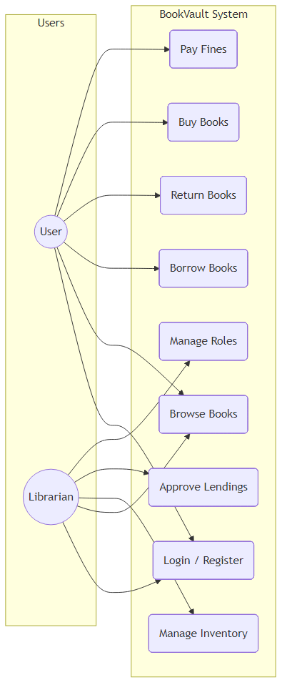
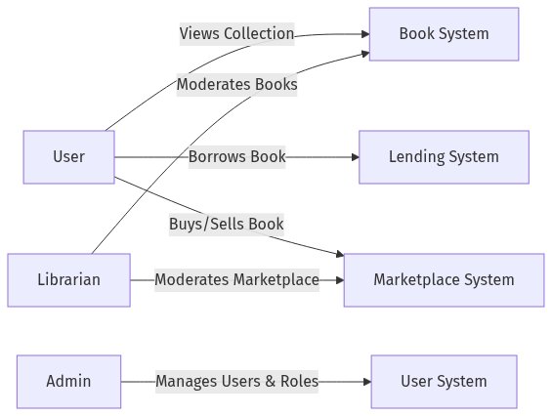

3.2 Sequence Diagrams
User Login:
Buying Sequence:
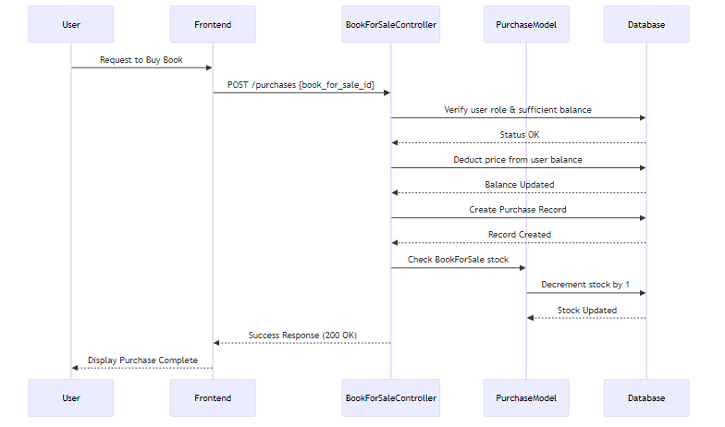
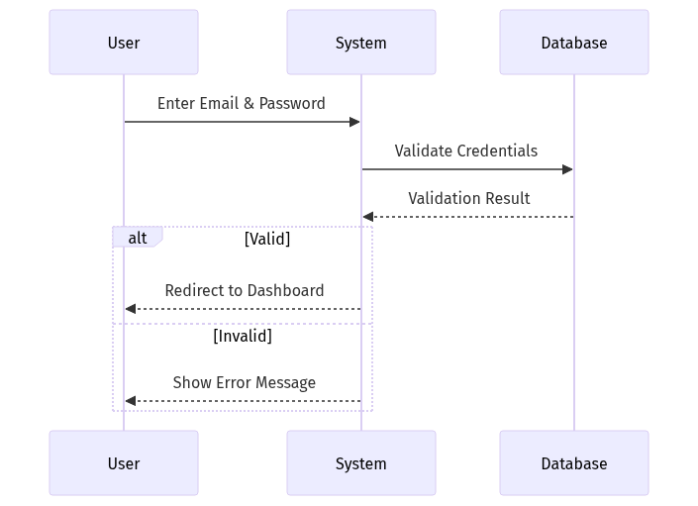
Book Lending:
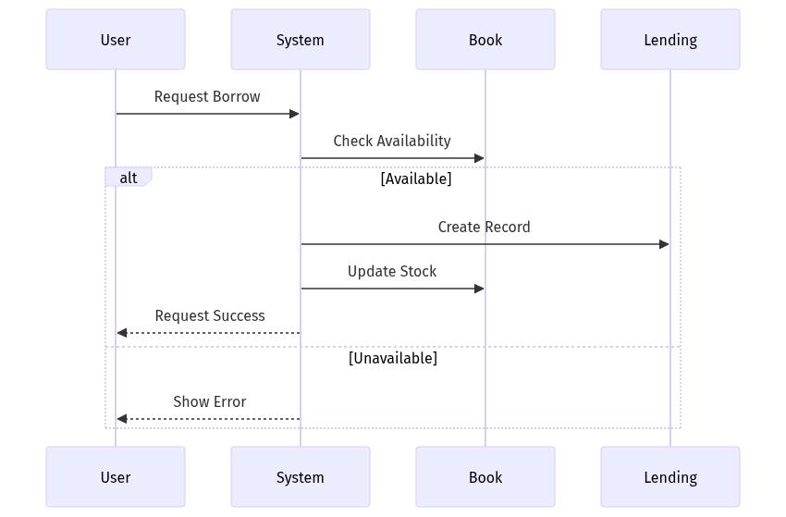

3.3 Entity Relationship Diagram
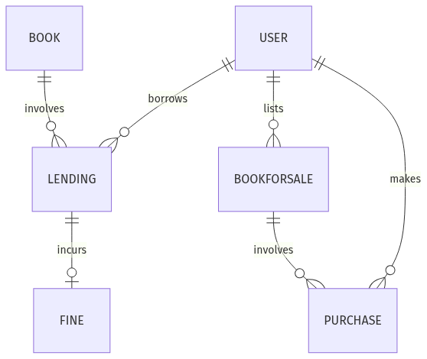

3.4 Class Diagram
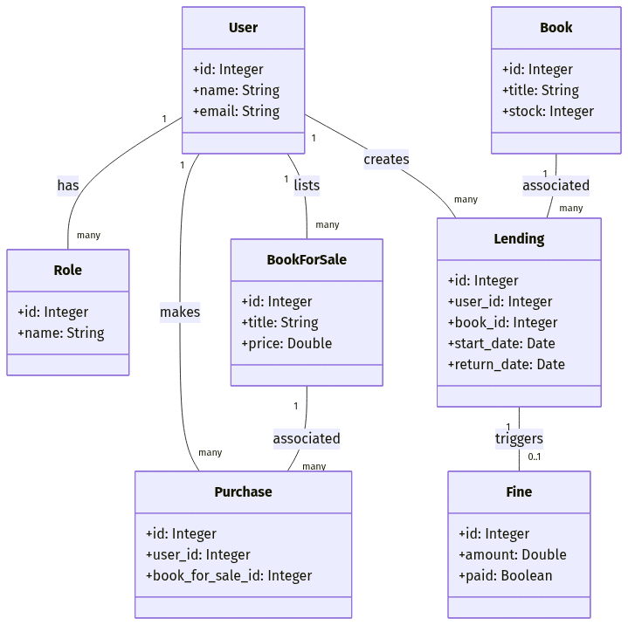

3.5 UI Previews
6. Wishlists Table: Stores user bookmarked items.
Collection Page:
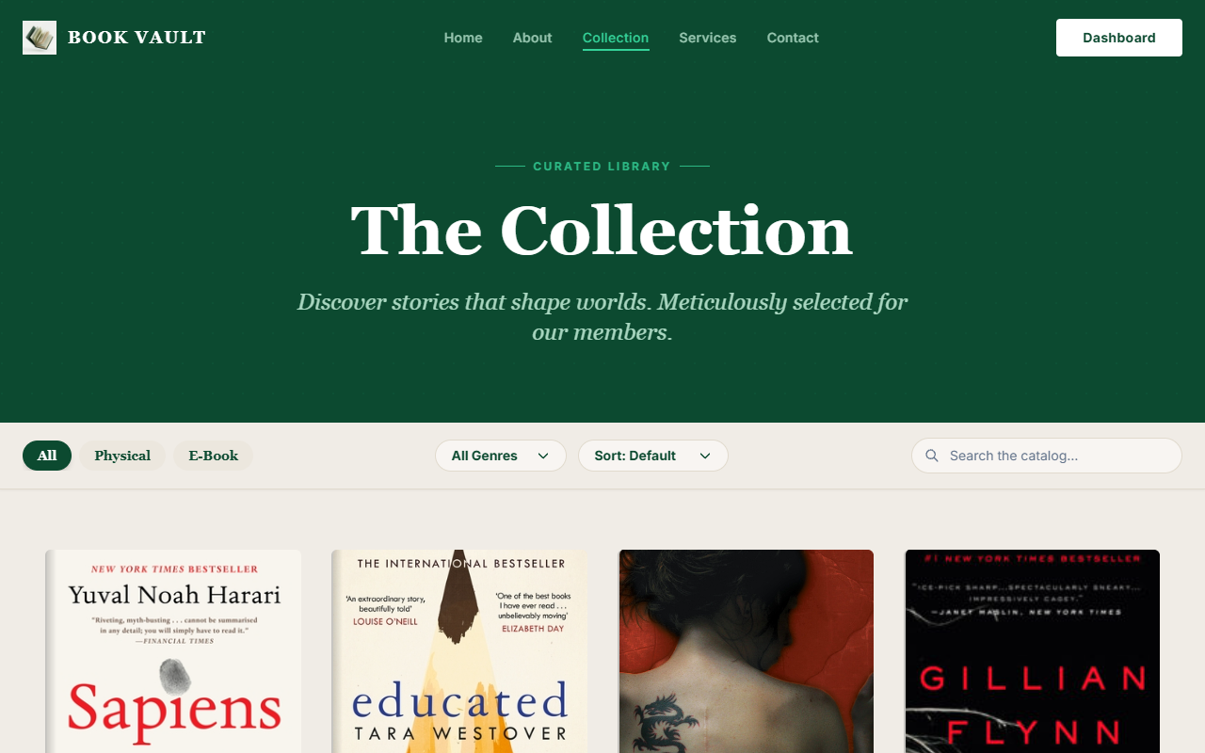
Book Preview Modal:

Wishlist Page:
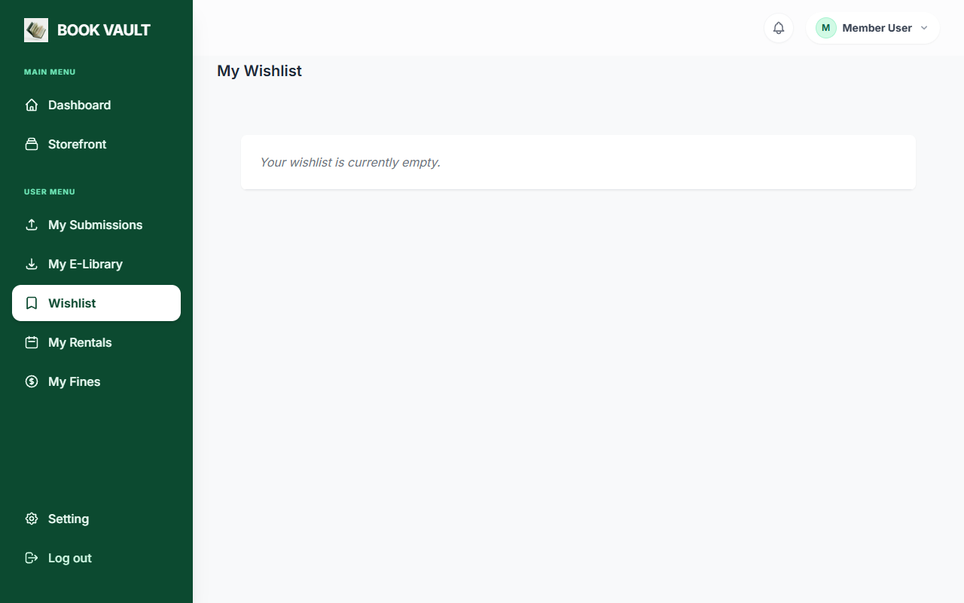

4. SYSTEM ARCHITECTURE & DATABASE DESIGN
The application relies on a modern MVC architecture provided by the Laravel framework. The backend logic securely connects to the PostgreSQL/MySQL database through Laravel's highly optimized Eloquent ORM. The frontend leverages Tailwind CSS / Bootstrap along with Vue/Inertia.js for seamless view rendering without continuous page reloads.

4.1 Table Design
1. Users Table: Central identity tracker, housing fields like: ID, Name, Email, Password, Role_ID.
2. Books Table: Core entity for library stock, containing: Title, ISBN, Author, Base Stock, Approved status.
3. Lendings Table: Logs active or resolved borrows, featuring tracking tokens: User_ID, Book_ID, Borrow_Date, Return_Deadline.
4. Fines Table: Calculated values linking specific Lendings to overdue amounts, storing boolean resolution states.
5. BookForSale and Purchases: Facilitator of the integrated P2P sales mechanics, linking multiple Users to specific items and price tags.

5. CONCLUSION
BookVault streamlines advanced library and reading processes, making book lending, selling, and tracking much easier and far more efficient. Through the use of modern development paradigms built on the Laravel framework, the platform remains highly reliable, expandable, and accessible.

