RAJAGIRI COLLEGE OF SOCIAL SCIENCES
(AUTONOMOUS) KALAMASSERY



Department of Computer Science

Web Programming Project Report
BikeMS: Bike Rental & Management System

Done by Anunay Brini
Reg No: 24118007

Under the guidance of
Ajay Antony Joseph
2024-2028

RAJAGIRI COLLEGE OF SOCIAL SCIENCES
(AUTONOMOUS) KALAMASSERY CERTIFICATE


BikeMS: Bike Rental & Management System
Certified that this is the bonafide record of project work done by

ANUNAY Reg No: 24118007
During the academic year 2024-2028, in partial fulfillment of requirements for award of the degree,

Bachelor in Computer Science
Rajagiri College of Social Sciences(Autonomous)

Faculty Guide Head of the Department
Prof. Bindiya M Varghese

Project Coordinator External Examiner

ACKNOWLEDGEMENT

With heartfelt gratitude, I extend my deepest thanks to the Almighty for His unwavering graceand blessings that have made this journey possible. May His guidance continue to illuminatemy path in the years ahead.

I am immensely thankful to Dr.Bindiya M Varghese, Dean, Department of Computer Science and Mr. Ajay Antony Joseph, Faculty Guide, for their invaluable guidance and timely advice, which played a pivotal role in shaping this project. Their guidance, constant supervision, and provision of essential information were instrumental in the successful completion of the Project.

I extend my profound thanks to all the professors in the department and the entire staff at RCSS for their unwavering support and inspiration throughout my academic journey. My sincere appreciation goes to my beloved parents, whose guidance has been a beacon in every step of my path.

I am also grateful to my friends and individuals who generously shared their expertise and assistance, contributing significantly to the fulfillment of this endeavor.

Anunay Brini

ABSTRACT

BikeMS is a comprehensive web-based Bike Rental and Management System developed using the Laravel PHP framework. The primary objective of the system is to digitize and stream- line the workflow of bike rental agencies while providing an intuitive, seamless reservation experience for customers.
The system features robust authentication, personalized client dashboards, and modular interfaces for Administrators, Staff, and Customers. Customers can browse available bikes, view dynamic pricing plans, and make online reservations. To enhance the user experience, BikeMS integrates an advanced tracking simulation using the Leaflet Routing Machine and OSRM (Open Source Routing Machine) API, allowing users to visually track their rented bike’s delivery route in real-time.
Furthermore, the platform incorporates a Sentiment Analysis and Review module. Cus- tomers can leave emoji-based feedback after unlocking a bike, and administrators have access to detailed sentiment reports via graphical charts and Excel exports. By combining an elegant Tailwind CSS-driven user interface with powerful back-end features, BikeMS ensures efficient inventory management, transparent pricing, and improved customer satisfaction in the bike rental domain.

CONTENTS
ACKNOWLEDGEMENT i

ABSTRACT ii
- INTRODUCTION 1
- SUPPORTING LITERATURE 2
  - Overview 2
  - Review of Technologies 2
  - Proposed Enhancements 2
- SYSTEM ANALYSIS 3
  - Module Description 3
  - Business Rules 3
  - Feasibility Analysis 4
    - Technical Feasibility 4
    - Economical Feasibility 4
    - Operational Feasibility 4
  - System Environment 4
    - Software Environment 4
    - Hardware Environment 4
- SYSTEM DESIGN 5
  - Architecture Overview 5
  - Database Design 5
  - User Interface Design 5
    - Customer Interface 5
    - Admin/Staff Dashboard 7
  - Integration of External APIs 9
  - Workflow Diagram 10
  - Entity-Relationship (ER) Diagram 11
- TESTING 12
  - Unit Testing 12
  - Integration Testing 12
  - User Acceptance and UI Testing 12
- DEPLOYMENT 13
  - Local Deployment 13
  - Production Deployment 13
- GIT HISTORY 14
  - Commit Practices 14
  - Branching Strategy 14
- CONCLUSION 15
- APPENDIX 16
  - Tools and Libraries Used 16
  - Important API Endpoints 16

INTRODUCTION

The advent of the internet has significantly revolutionized how typical businesses operate, open- ing the pathway for online services spanning a multitude of domains. Bike rentals represent a crucial part of the modern urban mobility ecosystem, providing an eco-friendly, cost-effective, and practical solution for commuting and tourism. Traditionally, renting a bike required manual paperwork, phone calls, and physical visits to agencies to check availability.
The ”BikeMS” project aims to modernize this workflow through a full-stack, comprehen- sive web application built with the robust PHP framework, Laravel. It provides a cohesive online platform tailored to solve the inconveniences of conventional bike renting. The platform bridges the gap between administrators, operational staff, and customers.
Through BikeMS, customers can effortlessly browse inventory, select bikes categorized by type, and reserve them using flexible pricing tiers (Hourly, Daily, Weekly). This eliminates the friction associated with verifying bike availability. Moreover, the project introduces real-time engagement features such as the integration of tracking simulation using the Leaflet API and OSRM demo servers. This innovative touch allows customers to visualize the location and route of a dispatched bike.
To bridge consumer feedback into actionable metrics, the system also features an Emoji- based Sentiment Analysis module. Customers can express their satisfaction through intuitive emoji choices, and the backend aggregates this data to present graphical reports and Excel data exports for the administration.
Ultimately, BikeMS simplifies inventory tracking for admins while offering an interactive and reliable user experience for the customers.

SUPPORTING LITERATURE

Overview
The study of existing systems highlights several operational gaps in traditional bike rental and transportation workflows. Many current solutions manage reservations via isolated spread- sheets lacking a unified customer-facing portal, or they possess monolithic web architectures without interactive features.

Review of Technologies
- Laravel Framework: Known for its elegant syntax and MVC architecture, Laravel has proven to be an excellent backend choice for dynamic web applications. Its Eloquent ORM enables robust database manipulation.
- Tailwind CSS: A utility-first CSS framework that allows rapid UI creation without leav- ing the HTML (or Blade) structure. It ensures the application is fully responsive out-of- the-box.

- Leaflet routing machine: Open-source JavaScript libraries map rendering and routing. By leveraging OpenStreetMap data and the OSRM backend network, Leaflet allows com- plex route visualization and delivery simulation, enriching the user experience signifi- cantly.

Proposed Enhancements
While basic CRUD (Create, Read, Update, Delete) applications suffice for simple renting op- erations, BikeMS includes modern analytical elements such as Sentiment Reporting. A dash- board that aggregates customer reviews using visual emojis directly maps qualitative reviews into quantitative metrics for management analysis.

SYSTEM ANALYSIS

Module Description
The ”BikeMS” project is divided into distinct functional modules catering to the specific needs of administrators, operational staff, and customers.

- Authentication & Authorization: Handles secure login, registration, and password re- covery. It distinguishes users according to their roles (Admin, Staff, Customer), routing them to appropriately permitted dashboard areas upon login.
- Inventory & Bike Management: Administrators and staff can perform CRUD opera- tions on bike entries. Features include uploading bike pictures, setting rental prices, and tracking current availability status.
- Booking & Reservation: Allows end-users to view active pricing plans securely, pick dates for rental, and confirm bookings. It automatically alters the status of the bike in the registry to prevent double-booking.
- Customer Verification: Requires customers to upload a valid DL (Driving License) image for verification before unlocking and renting a bike, maintaining safety protocols.
- Review & Sentiment Analysis: After completing a rental or during unlocking, cus- tomers can rate the service using emojis. Background processes score and tally these reviews, presenting a Sentiment Analysis graph on the admin dashboard with the option to export the sentiment report via Excel.
- Tracking Simulation Module: Customers can open a real-time tracking interface show- ing a simulation of a delivery driver or the bike routing to a destination. Powered by Leaflet Routing Machine and an OSRM backend, it visually interpolates map coordi- nates to mimic active movement.

Business Rules
- Security & Access: Users must be registered and authenticated to book a bike. Staff cannot access administrative configurations.
- Rentals: A single user may rent multiple bikes, but a single bike cannot hold concurrent reservations on overlapping dates.
- Verification: A booking cannot activate into an ”in-use” status without proper approval and DL image submission.
- Review Limitations: Only users with an active or completed booking log can submit a review. Sentiments are constrained to specific emoji selections mapped to internal ratings (e.g., Happy, Neutral, Sad).

Feasibility Analysis

Technical Feasibility
The Laravel framework, built on robust PHP, coupled with PostgreSQL makes the project highly feasible from a technical standpoint. Standard frontend assets like HTML, Blade Tem- plates, JavaScript (for map routing) and Tailwind CSS are well-supported across all modern browsers.

Economical Feasibility
The system leverages open-source infrastructures (PHP, Laravel, PostgreSQL, OpenStreetMap). There is no dependency on expensive proprietary mapping APIs, making it highly economical.

Operational Feasibility
By automating bookings, payments (future), and inventory, BikeMS seamlessly bridges oper- ational gaps. The interactive UI ensures swift onboarding for staff with minimal training, and the sentiment reports aid the administration in rapid decision-making.

System Environment

Software Environment
Framework: Laravel 11.x
Frontend: Blade Templates, Tailwind CSS, Alpine.js Mapping/Routing: Leaflet JS, Leaflet Routing Machine, OSRM API Database Engine: PostgreSQL (via local installation or container) Languages: PHP 8.2+, JavaScript, HTML/CSS
Version Control: Git / GitHub

Hardware Environment
Processor: Modern Multi-core CPU (Intel i5/Ryzen 5 or better)
Memory: Minimum 8 GB RAM
Storage: SSD preferred for fast local development
Operating System: Windows 11 / Linux / macOS

SYSTEM DESIGN

Architecture Overview
The project follows the standard Model-View-Controller (MVC) architectural pattern enforced by the Laravel framework.
- Model: Eloquent classes mapping to PostgreSQL database tables (Bike, User, Booking, Review).

- View: Blade template files structuring the UI, powered by Tailwind CSS.
- Controller: PHP scripts receiving HTTP requests, interacting with Models, and passing data down to the Views.

Database Design
The system architecture includes several interconnected schemas utilizing Foreign Keys for referential integrity.
- Users Table: Stores authentication details and roles.
- Bikes Table: Contains attributes such as model name, registration plate, status, and im- age paths.
- Bookings Table: Links a User ID to a Bike ID, documenting timestamps, status, and attached documents (like DL images).
- Reviews Table: Links a User ID to predefined sentiment ratings corresponding to an emoji.

User Interface Design
An emphasis was placed on creating an immersive, clean, and responsive interface.

Customer Interface
The customer dashboard features dynamic views outlining active plans, recent bookings, and a dedicated interface to track route simulations. It relies on crisp typography, generous whites- pace (rounded image containers with soft shadows), and interactive hover elements.

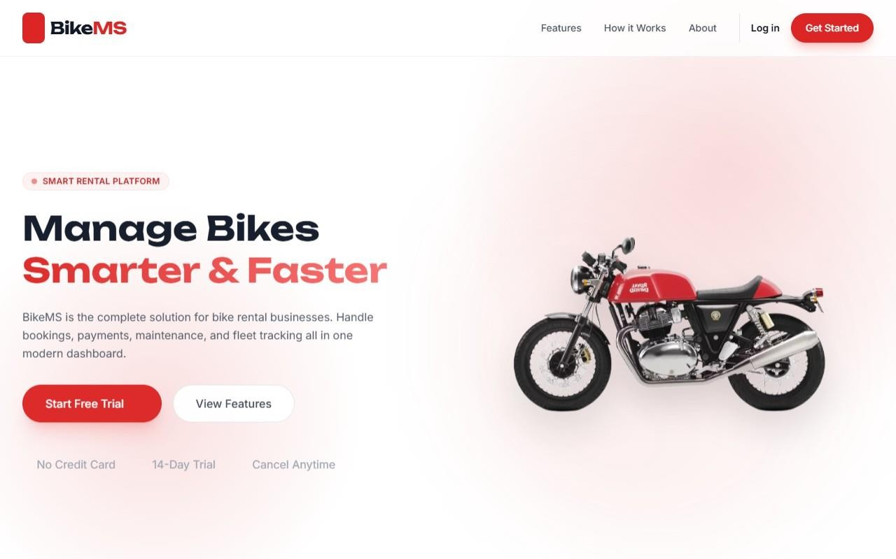
Figure 4.1: BikeMS Landing Page

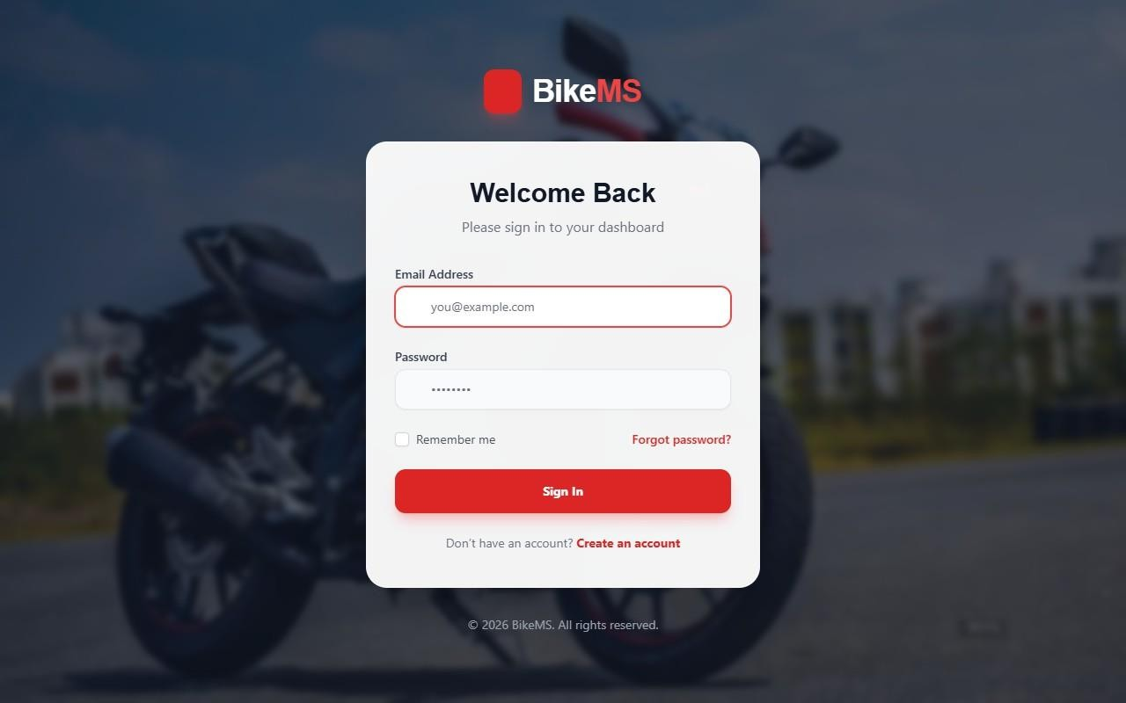

Figure 4.2: User Login Interface

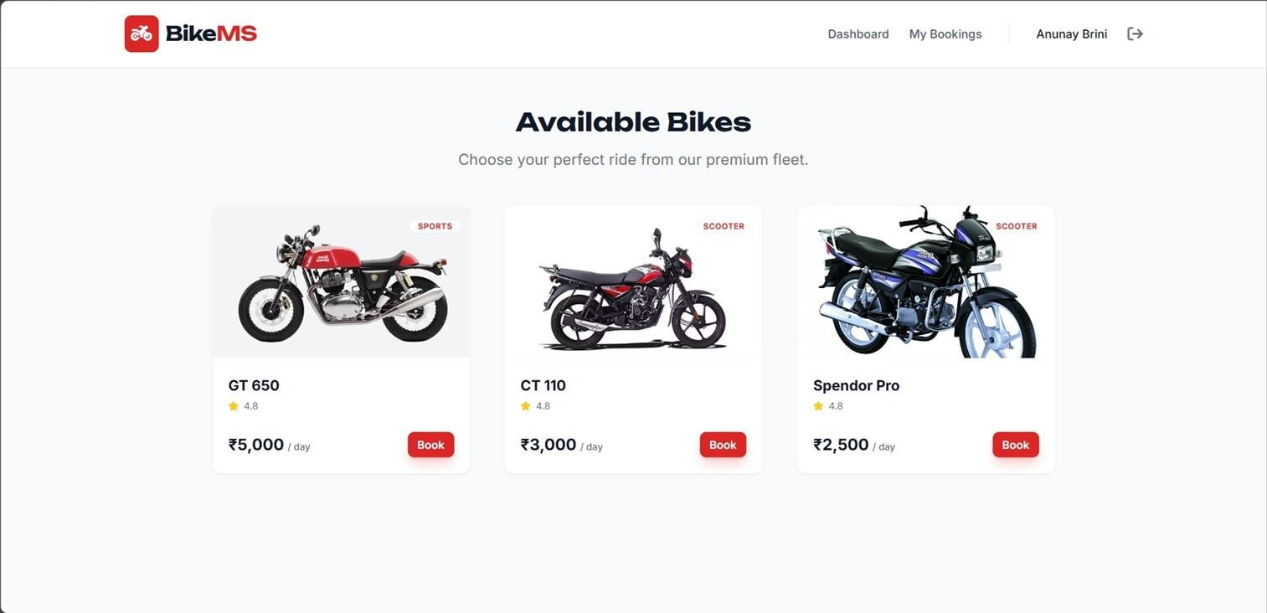
Figure 4.3: Bikes Browsing and Rental Interface

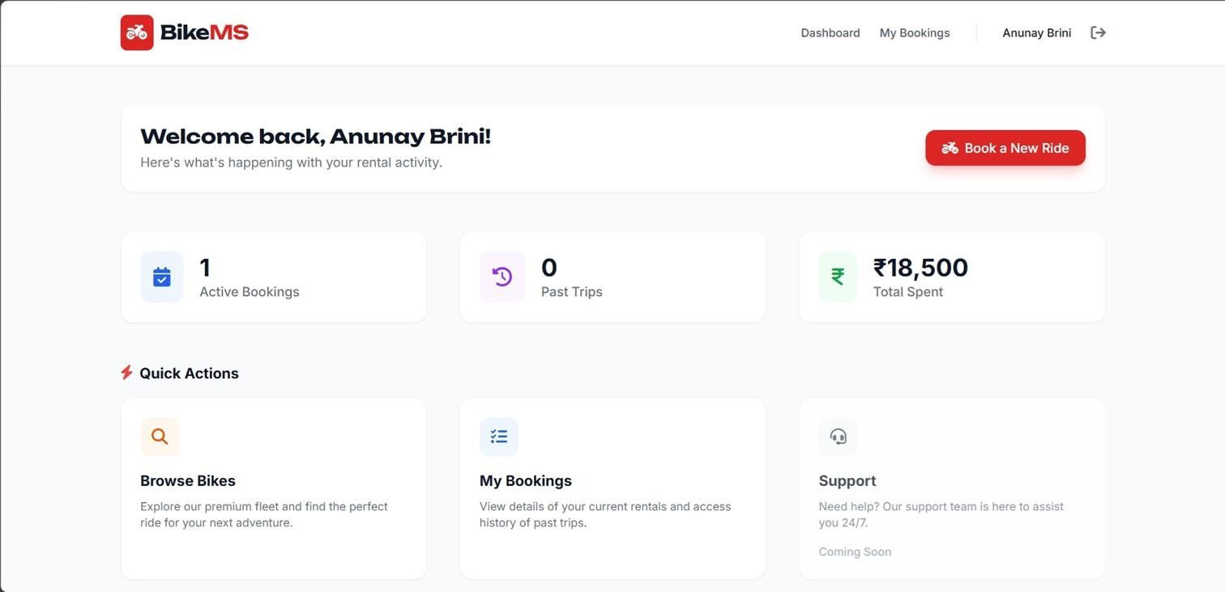
Figure 4.4: Customer Dashboard

Admin/Staff Dashboard
The internal portal favors utility, featuring data tables for handling large lists of bikes and reservations. Graphical components, like the Sentiment Analysis pie charts or line graphs, provide a visually cohesive summary of organizational health.

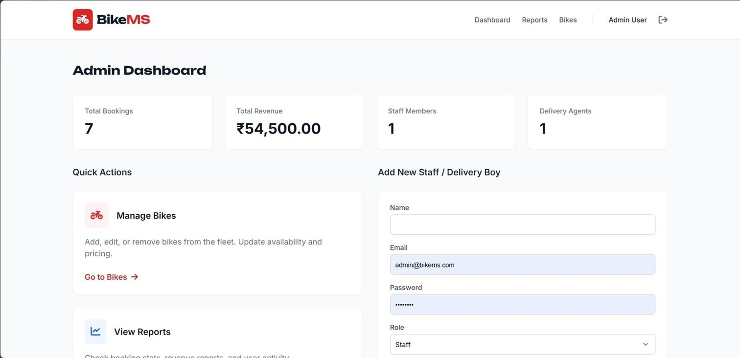
Figure 4.5: Admin Dashboard and Overview

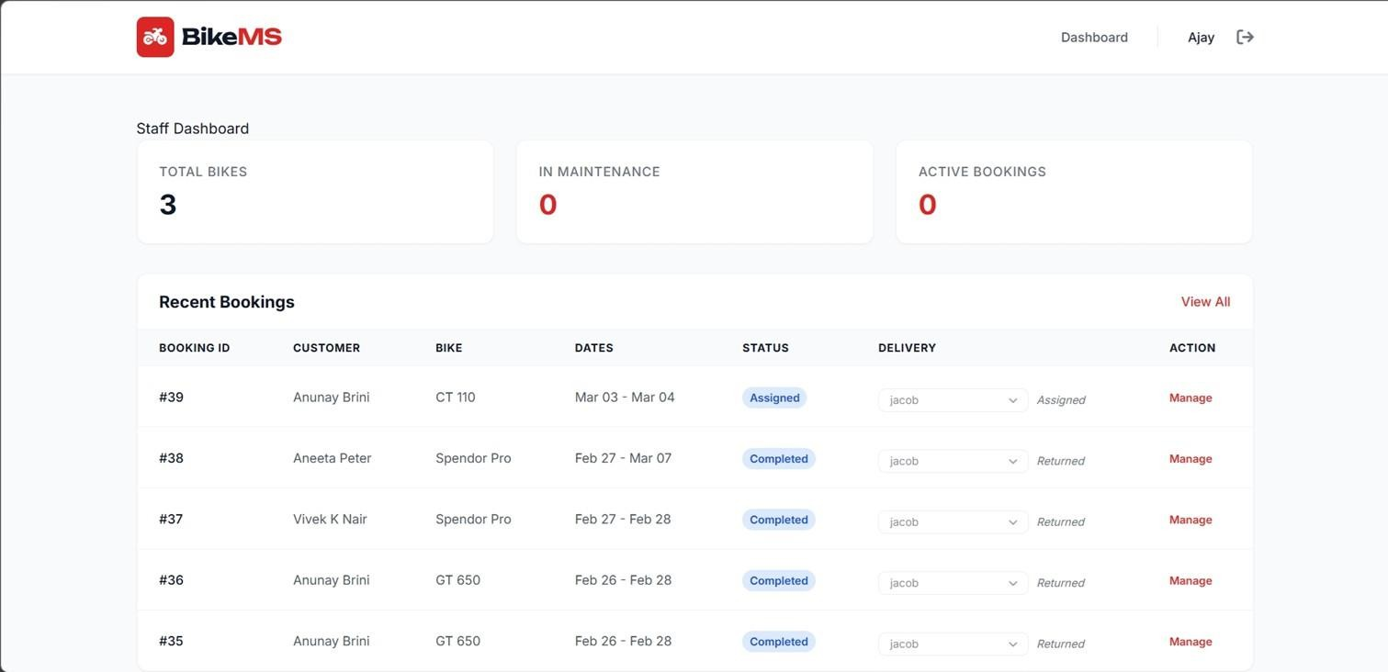
Figure 4.6: Staff Booking Management Portal

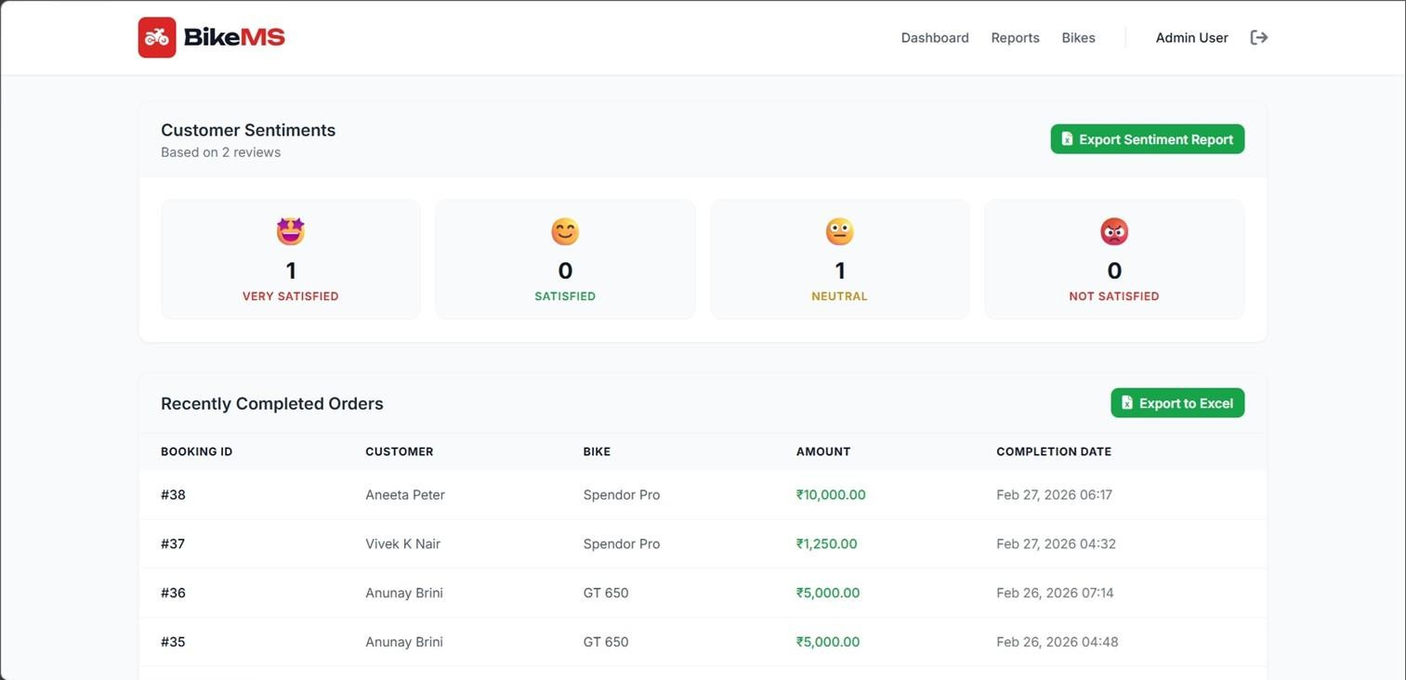
Figure 4.7: Emoji Sentiment Analysis Reporting

Integration of External APIs
For the Tracking Simulation, the system utilizes Leaflet map rendering. Polylines and routes are calculated dynamically by initiating a request to the OSRM (Open Source Routing Ma- chine) demo server API. The response JSON contains waypoints, interpolating the coordinate geometry to render a simulated ”driver” marker moving over time across the generated map layer.

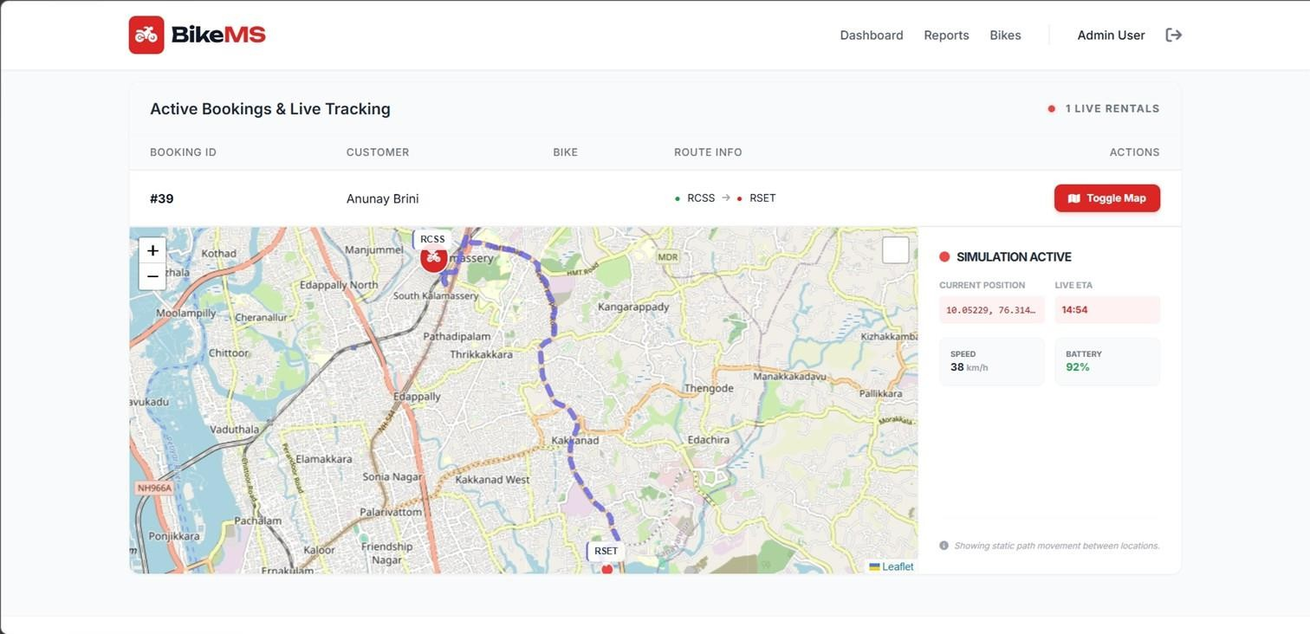
Figure 4.8: Real-Time Bike Route Tracking Simulation

  - Workflow Diagram
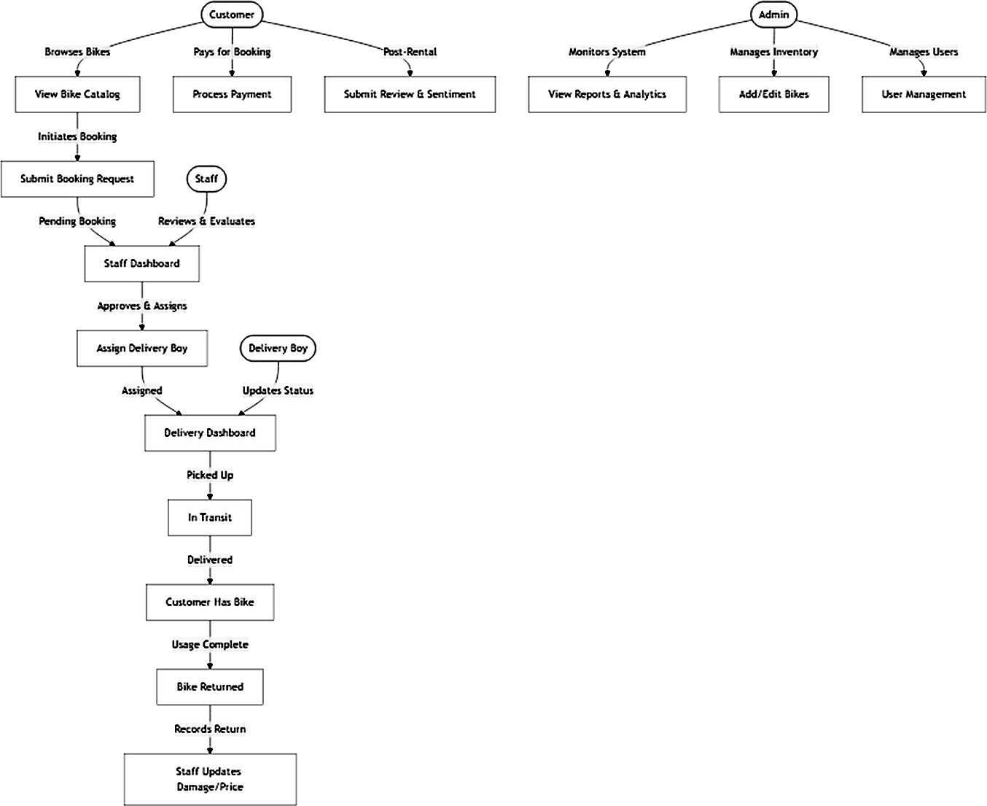

  - Entity-Relationship (ER) Diagram
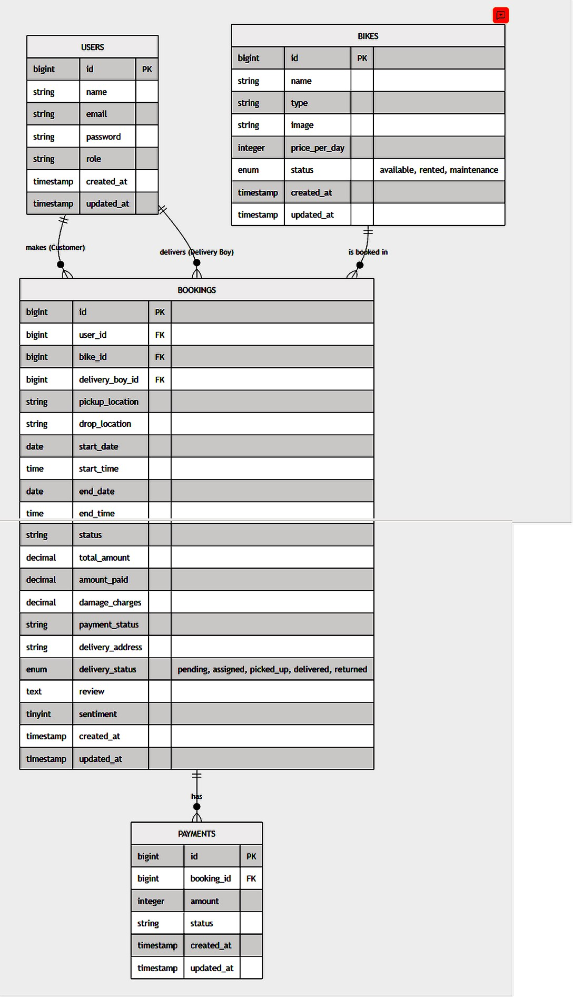

TESTING

Testing is a cornerstone of software development, ensuring system reliability, performance, and usability. Given the complex nature of a full-stack platform like BikeMS, an extensive testing strategy was implemented.

Unit Testing
Unit tests verify individual components in isolation.

- Model Testing: Validated the Bike, User, and Booking Eloquent models to ensure relationships, foreign keys, and accessors work as intended.
- Controller Testing: Routes like the Customer Booking form and Staff Dashboard up- dates were tested for valid HTTP response codes (e.g., 200 OK, 302 Redirect).

Integration Testing
Integration testing evaluates how different modules interact.

- Database Integration: Assessed if creating a Booking properly checks the availability status of a Bike before committing the transaction.
- API Integration (OSRM): Simulated responses from the external OSRM demo server to guarantee the Tracking Module fails gracefully with an intuitive error message in case of API timeouts.

User Acceptance and UI Testing
The front end, designed with Tailwind CSS, was tested across multiple viewports (Mobile, Tablet, Desktop) to ensure the interface dynamically scales without breaking elements. Manual tests included the user flow of logging in, selecting a bike, uploading a dummy DL image, and checking the real-time tracker.

DEPLOYMENT

Deployment involves hosting the project on an accessible server for production usage.

Local Deployment
During development, the generic php artisan serve command provides a robust local- ized server environment. Using standalone PHP bundled with PostgreSQL satisfies backend prerequisites.

Steps involved:
- Clone the repository using Git.

- Run composer install to fetch PHP dependencies.
- Configure the .env file with the respective PostgreSQL credentials.

- Run php artisan migrate and php artisan db:seed to generate and pop- ulate schemas.
- Execute npm install and npm run build (or dev) to compile Tailwind CSS as- sets.

Production Deployment

For full public deployment, standard VPS or Managed Hosting solutions (such as Forge or cPanel-based environments) support Laravel and PostgreSQL. Utilizing an SSL certificate guar- antees HTTPS security, maintaining encryption for login endpoints and preventing sensitive data (DL uploads) interception.

GIT HISTORY

Git serves as the core version control system for BikeMS, facilitating parallel development, backtracking, and feature iteration without damaging the main stabilizing branch.

Commit Practices
Semantic commit messages (e.g., feat: add sentiment export, fix: resolve map timeout) were utilized to ensure an organized timeline. Commits were chunked based on the modification of specific modules rather than sweeping undocumented changes.

Branching Strategy
Development spanned across multiple feature branches, enabling isolated sandboxing for risky features such as the integration of the Leaflet Routing Machine. Upon stability checks, these individual branches were merged back onto the main timeline.

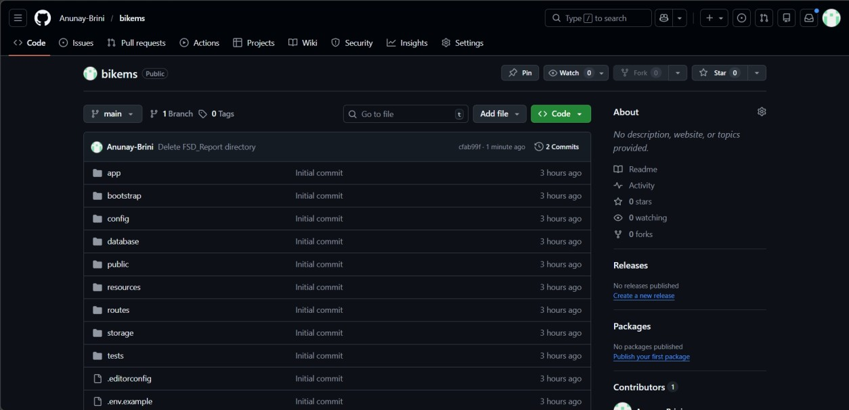

CONCLUSION

The BikeMS platform successfully modernizes the traditional model of bike renting through the synergy of web technologies. Employing the MVC structure of Laravel ensured code maintain- ability, security, and scalability. Customer friction is drastically minimized via instantaneous booking capabilities and dynamic pricing plans.

Additionally, by capitalizing on advanced sentiment reporting and visual map route sim- ulations powered by Leaflet, BikeMS is elevated from a barebones CRUD platform into an engaging web application that provides substantial analytical value to its administrators. It stands as a comprehensive solution ready to accommodate the evolving demands of urban bike rentals.

APPENDIX

Tools and Libraries Used

- Laravel 11.x: The primary PHP framework.
- Tailwind CSS: The CSS utility library used for rapid responsive design.
- Leaflet: JavaScript library for interactive maps.
- Leaflet Routing Machine: A plugin to add routing to the map.

- PostgreSQL: RDBMS for user credentials and records.

Important API Endpoints

- OSRM Routing API: https://router.project-osrm.org/route/v1/driving/

- Used extensively for generating waypoints and computing optimal delivery driver route simulations.

