Android Mobile Automation Setup
Document ID: ASP-DRSYS
Author(s): Rajesh K
Table of Contents

1. Install mobile device driver 1
2. Install Android SDK 2
3. Install Appium 4
4. Create AVD 5
5. Profile settings for Appium and Android 6
I. Profile Settings for Appium : 6
II. Profile settings for Android Emulator : 7
III. Profile settings for Android Device : 9
6. Wireless connection using ABD ……………………………………………………………………………..…17
I. Connect using Wi-Fi network : 17

Install mobile device driver
Installing Mobile Device Driver (for Samsung) on windows : -
- Download Samsung-Usb-Driver-v1.5.49.0.exe from http://androidxda.com/download-samsung-usb-drivers
- Enable USB debugging on the mobile and then connect the mobile to the system and it should install the driver software and open a new window for the mobile connected
- Ensure that the connected device is listed in Device Manager
Note: download the driver based on the mobile model used

Also install Intel HAXM (haxm-windows_r04.zip (1.0.8) from https://software.intel.com/en-us/android/articles/intel-hardware-accelerated-execution-manager ) to work with Android AVD

Install Android SDK
Pre-requisites :
- Install JDK in your machine. (java version "1.8.0_11")
Follow the below steps :
- Download Android Studio from http://developer.android.com/sdk/installing/studio.html and run the application - “android-studio-bundle-135.1245622-windows.exe”
(As the studio plugins consumes more memory, it is safe to install the software in the drive having more memory space)
- After installation set the path for Android Studio
  - create an environment variable ‘JAVA_HOME ‘ with value ‘C:\Program Files\Java\jdk1.8.0_11’
  - ensure that the path variable also has the value ‘C:\Program Files\Java\jdk1.8.0_11\bin’
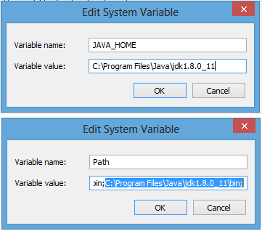
  - create an environment variable ‘ANDROID_HOME’ with value
‘/path/to/Android/android-studio/sdk’ and ensure that the ANDROID_HOME is added to path variable
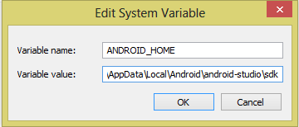
- Now launch the Android Studio application
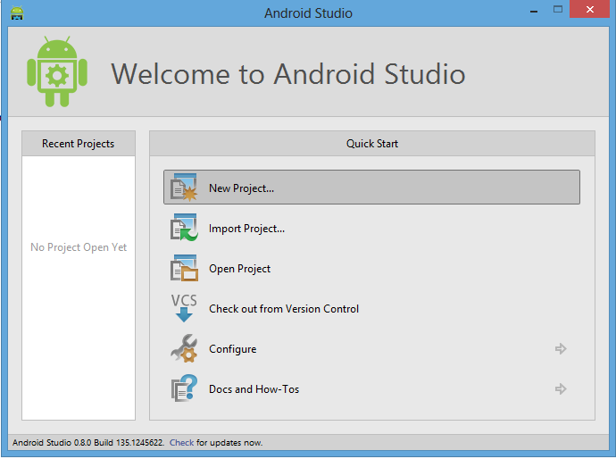

Install Appium
Pre-requisite: -
- Download .net framework 4.5 from http://www.microsoft.com/en-in/download/ (under menu Products/Microsoft .Net Framework)
- Install the downloaded set-up file
Note : .net framework 4.5 is bundled with Windows 8 operating systems and hence no need to install .net 4.5 separately
Installing appium on windows : -
- Download the latest Appium zip file (AppiumForWindows-1.1.0.0.zip) from https://bitbucket.org/appium/appium.app/downloads/
- Unzip the file under “C:\Appium” directory
- Now, run the Appium application (having the Appium logo as icon) inside the unzipped file and it should show a window like this
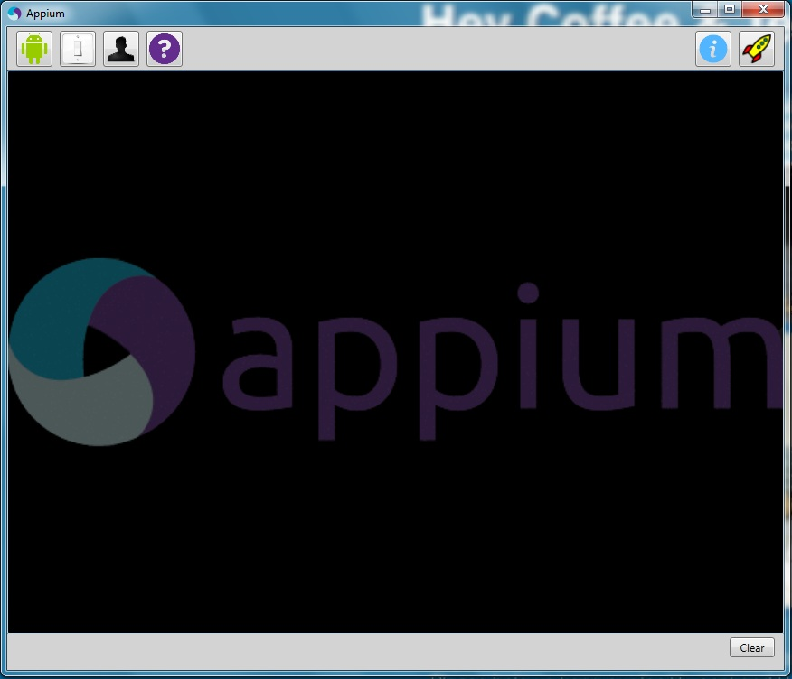

Create AVD
Follow the below steps : -
- Launch Android Studio
- Go to Tools >> Android >> SDK Manager and select the required Android version(s) and install them
- To create a new AVD go to Tools >> Android >> AVD Manager , click “Create” button to create a new AVD profile, fill the required fields
- Select the created AVD profile and click “Start” button to launch the AVD
- The AVD can also be launched from command line :
  - Go to “..\android-studio\sdk\platform-tools” in command prompt and type “emulator –avd emulator_name”
  - This will launch the AVD and type “adb devices” to list the emulators launched
  - If the current emulator is not listed, then type “adb kill-server” and “adb start-server” then type “adb devices”, it should list the currently running emulators
- To install an app in emulator then go to “..\android-studio\sdk\platform-tools” in command prompt and type “adb install path/to/apk_file.apk”

Profile settings for Appium and Android
- Profile Settings for Appium :
- Launch Appium
- Click “Android Settings” button (with image of Android logo)
- Under Capabilities section set Platform name to “Android”, Automation name to “Appium” and Platform version to the required Android version
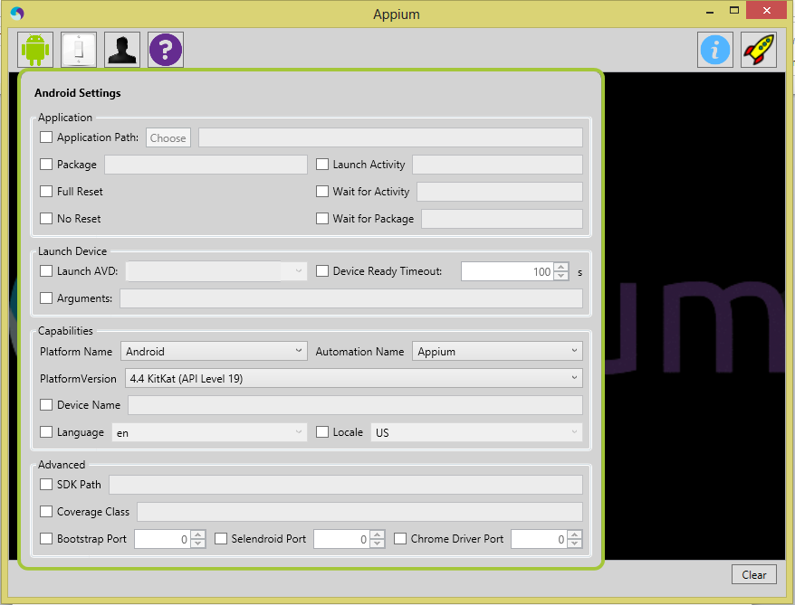
- Click “General settings” button (with image of Switch like)
- Under Server section set Server Address to “127.0.0.1” and Port to “4723”
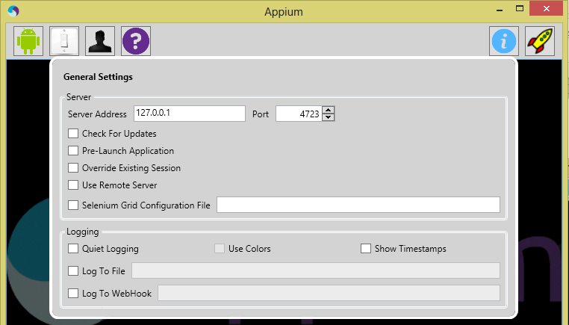
- That’s all. Click the launch button (with image of rocket) to start the appium server and again click it to stop it.
- This should be the appium server log
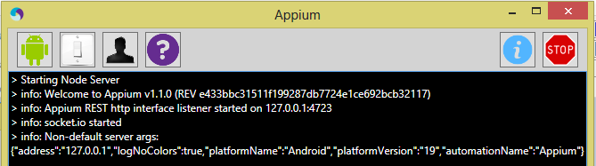

- Profile settings for Android Emulator :

- Launch the emulator
- Go to Settings >> More >> Mobiles networks >> Access Point Names >> click the Option displayed (Telkila) and give only the proxy details and Save it
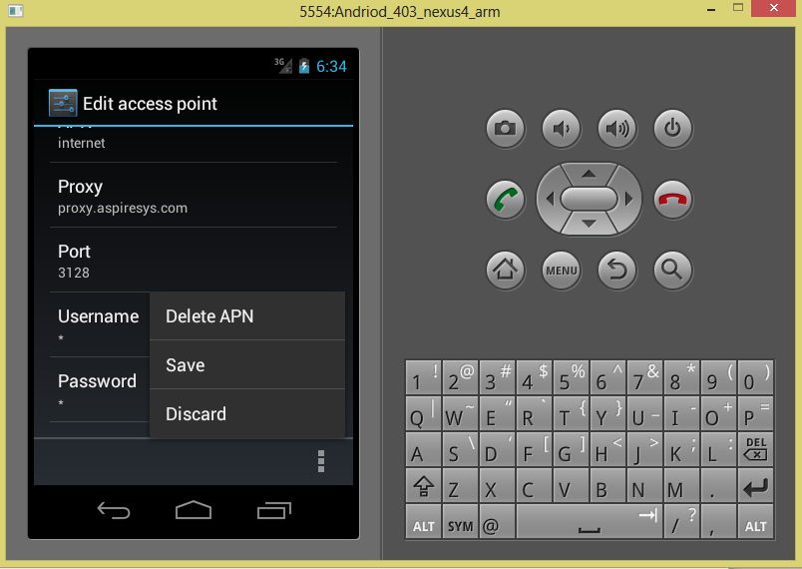
- Go to Settings >> Developer options and enable “USB debugging”
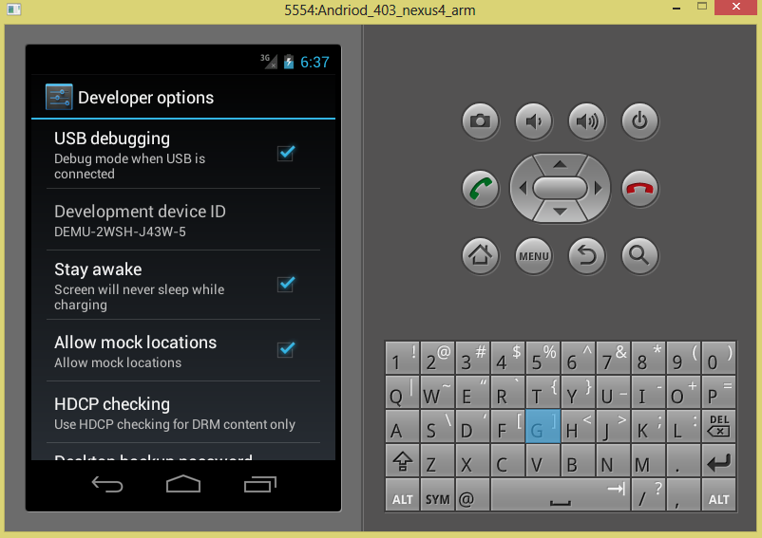

- Profile settings for Android Device :

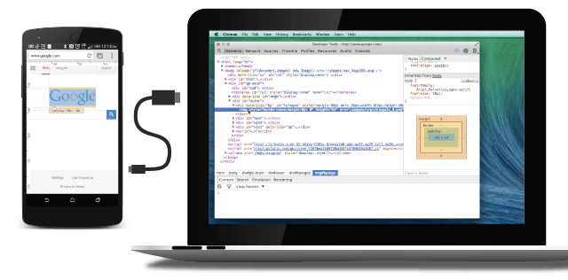
- Chrome 32 or later installed on your development machine.
- A USB cable to connect your Android device.
- For browser debugging: Android 4.0+ and Chrome for Android.
- For app debugging: Android 4.4+ and a WebView configured for debugging.

Note: Remote debugging requires your version of desktop Chrome to be newer than the version of Chrome for Android on your device. For best results, use Chrome Canary (Mac/Windows) or the Chrome Dev channelrelease (Linux) on desktop
Follow these instructions to set up your Android device for remote debugging.
Enable USB debugging

On your Android device, select Settings > Developer options.
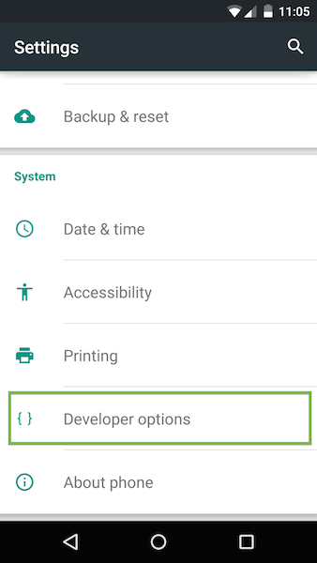
Developer options on the Settings page.
Note: On Android 4.2 and later, the developer options are hidden by default. To enable the developer options, select Settings > About phoneand tap Build number seven times.
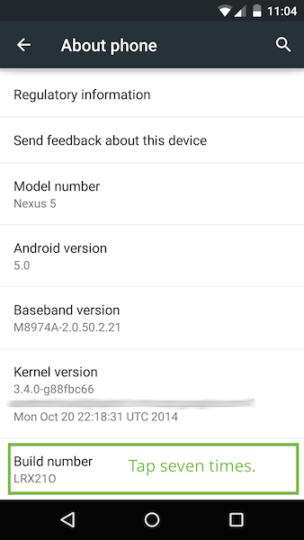

In Developer options, select the USB debugging checkbox:
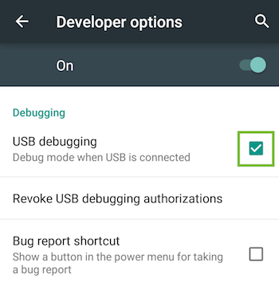
An alert prompts you to allow USB debugging. Tap OK.
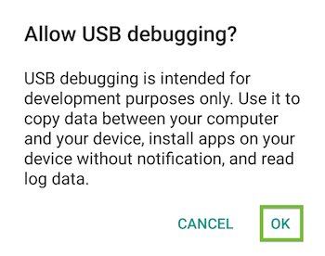
Connecting device to PC
Connect the Android device to your development machine using a USB cable.
Note : If you are developing on Windows, install the appropriate USB driver for your device. See OEM USB Drivers on the Android Developers' site.
After setting up remote debugging on Android, discover your device in Chrome.On your desktop Chrome browser, navigate to chrome://inspect. Confirm that Discover USB devices is checked:
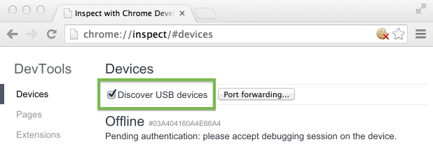Tip: You can also get to chrome://inspect by selecting Chrome menu > More tools > Inspect Devices.
On your device, an alert prompts you to allow USB debugging from your computer. Tap OK.
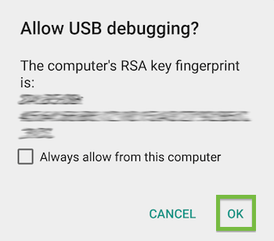
Tip: To skip this alert in the future, check Always allow from this computer.
The message USB debugging connected displays in the device's notification drawer.

On your computer, the chrome://inspect page displays every connected device, along with its open tabs and debug-enabled WebViews.
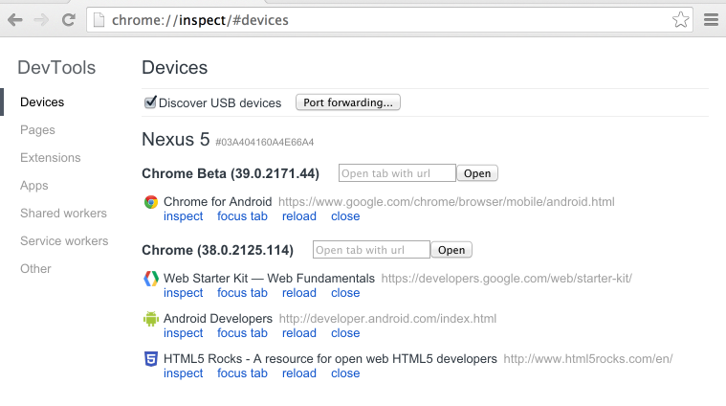Viewing connected devices from the chrome://inspect page.
From the chrome://inspect page, you can launch DevTools and debug your remote browser tabs.

To start debugging, click inspect below the browser tab you want to debug.
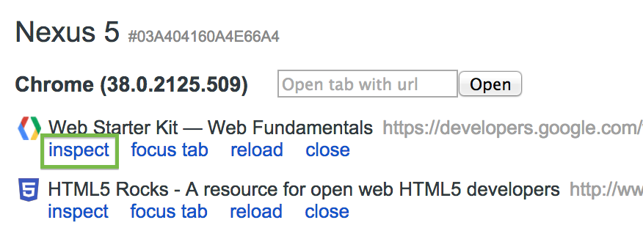
A new instance of Chrome DevTools launches on your computer. From this instance, you can interact with the selected browser tab on your device in real time.
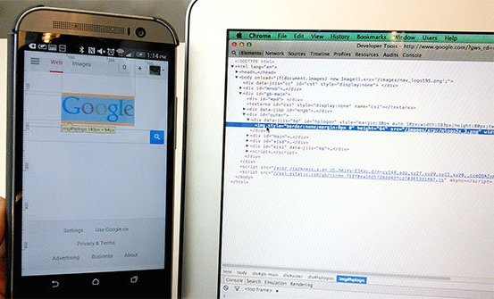
Debug a web page on your Android phone from your laptop using Chrome DevTools.
For example, you can use DevTools to inspect web page elements on your device:
- When you mouse over an element in the Elements panel, DevTools highlights the element on your device.
- You can also click the Inspect Element icon in DevTools and tap your device screen. DevTools highlights the tapped element in the Elements panel.
- You can do the same with Android emulator. Launch the emulator and go to chrome://inspect/#devices in your chrome browser and it will list the emulator launched
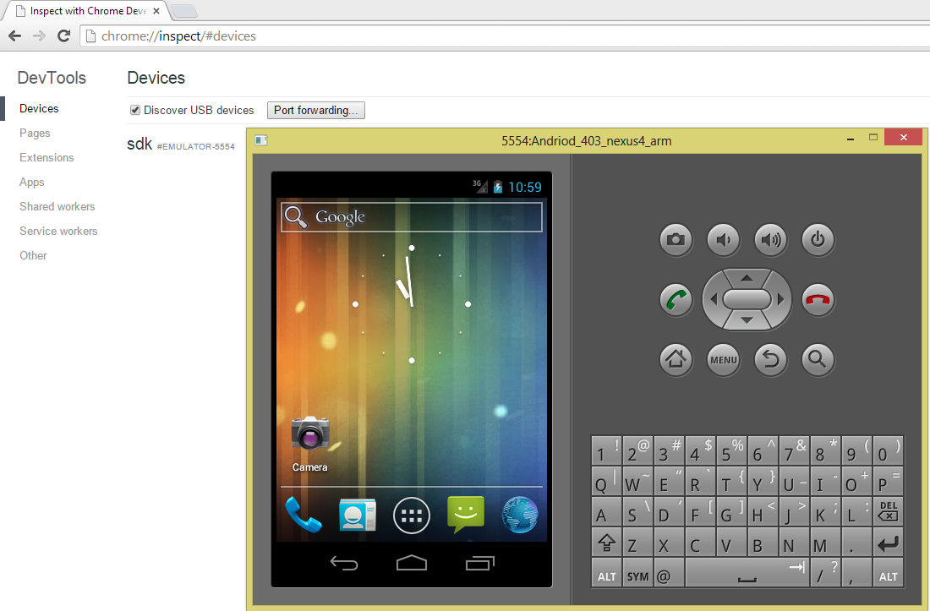
- Now you can launch the browser in emulator and inspect the web page
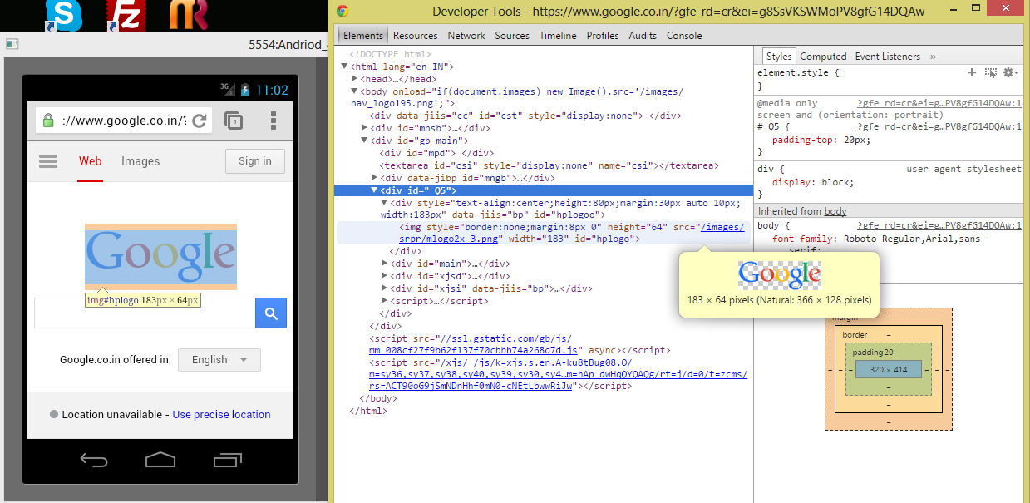

Wireless connection using ABD
    - Connect using Wi-Fi network :

- Connect Android device and adb host computer to a common Wi-Fi network accessible to both
- Connect the device with USB cable to PC
- Open command prompt type
adb devices
it should list the device connected to PC
- Now to set ABD to the TCP/IP port for remote connection, type in prompt :
adb tcpip 5555
- Disconnect the device from PC
- Now connect your device to ADB by typing this command :
adb connect xxx.xxx.xxx.xxx
(IP address of the device, which will present in Settings>About phone)
- Now in command prompt you should see the result like :
* daemon not running. starting it now on port 5037 *
* daemon started successfully *
connected to xxx.xxx.xxx.xxx:5555
- To disconnect device from TCP/IP port:
adb disconnect xxx.xxx.xxx.xxx

