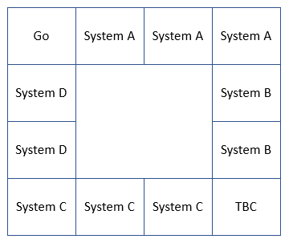Systems

A = Exploration Ground Systems

1. Launch Pad 39B
2. Vehicle Assembly Building (VAB)
3. Young-Crippen Firing Room 1

B = Space Launch Systems (SLS)

1. RS-25 Engines
2. Boosters

C = Orion

1. Service Module
2. Crew Module
3. Launch Abort System

D = Landing Equipment

1. Lunar Landers
2. Artemis Generation Spacesuits

**Game Rules Artemis Lite – From requirements**

* 2-4 players
* If one player quits or bankrupt game ends
* Players start at “Go” – Kennedy Space Centre OR Cape Canavaeral Space force Station
* Players take turns to roll the dice and move the num squares that they rolle
* 2 6 sided dice
* When a player lands on a square they have option to buy the square – if they do not it is offered to the other players
* If already owned the player must pay rent unless the square owner agrees not to charge
* A player must own the whole system to develop a square
* Rent increases the more developed a square is
* If one player goes bankrupt or quits all players quit
* When game ends show final state of play – show all developments and player funds – no need to convert properties / developments into equivalent funds
* If all developments are completed then it announces the path ahead for Artemis project
* *Display the successful outcome dynamically asa sequenceof headlines: e.g. in2021[...], then in 2022 [...]until finally asuccessful landing is achieved,withcongratulations all round! Also give the final state of play that made it possible –* use thread.sleep to output one by one

**Additional**

* Players can land on “Chance square” = randomly generates message that can increase or decrease player funds

**Game Rule Design Suggestions – set all amounts as protected constants in board class**

Starting fund = 2000?

*Elements*

Price per square = System A = least costly to buy =>B=>C=> System D = most costly

Make price to buy and rent the same?

System A = 50?

System B = 100?

System C = 150?

System D = 200?

Rent per square = 100?

Price per Development = 50?

Rent price increase per development= 50?

*Go Square*

Rename as Kennedy Space Centre OR Cape Canavaeral Space force Station

Pass go amount= 200?

*Chance Square*

Chance Square Name = NASA Marshall’s Update? – from NASA site….

Chance Square amount = +/- 200?

Chance Message Examples

“Your lead engineer is ill – You must pay 250 to hire a replacement”

“Foreign actors have hacked your network! Pay 250 to repair”

“The President has reduced your project funding by 250 to fund…..”

“A storm has cause damage to the launch site - pay 250 repair!”

“Your engineers have had a breakthrough and saved you 250!”

“You’ve received a donation from a mystery billionaire of 250!”

“Russia have made a breakthrough - the president increases you funding by 250 to keep up!”