Replicate Experiment

Table of contents

## Introduction

Statistical process control (SPC) is the use of statistical methods to monitor and control the quality of processes. Though the tools were initially developed and used for manufacturing, they have found applications in many other areas where outcomes can be measured and quality is valued, including scientific laboratories. Some of the most common SPC tools include Run Charts, Control Charts, Experimental Design, and Replicate Experiment.

The Replicate-Experiment(Eastwood et al. 2006) is based on Bland-Altman difference analysis(Bland and Altman 1986) between two sets of measurements and is used to assess either **repeatability** or **reproducibility**. These terms have specific meanings in SPC. **Repeatability** is the ability to produce comparable results within a group of conditions (e.g. people, instruments, reagents, …), while **reproducibility** refers to the ability to replicate results across different conditions (e.g. between two assayers or pieces of equipment). Initially repeatability should be demonstrated by having a scientist test the same set of samples with 2 independently prepared sets of working reagents/cells (note: these experiments can be performed at the same time or on different days) on the same set of equipment. Once repeatability has been established, reproducibility can be determined between different assayers, pieces of equipment, or lots of reagents or cells.

## Rationale

Replicate-Experiment studies(Iversen et al. 2004) are used to formally evaluate the *within-run* assay variability and formally compare a new assay to the existing (old) assay. They also allow a preliminary assessment of the *overall* or *between-run* assay variability, but two runs are not enough to adequately assess overall variability. Post-Production monitoring, such as Retrospective MSR(Haas et al. 2004) analysis and Control Charts(Beck et al. 2004) are used to formally evaluate the overall variability in the assay. Note that the Replicate-Experiment study is a diagnostic and decision tool used to establish that the assay is ready to go into production by showing that the endpoints of the assay are repeatable over a range of values. It is not intended as a substitute for post-production monitoring or to provide an estimate of the overall Minimum Significant Ratio (MSR).

It may seem counter-intuitive to call the differences between two independent assay runs as *within-run* variability. However, the terminology results from how assay runs are defined. Experimental variation is categorized into two distinct components: *between-run* and *within-run* sources. Consider the following examples:

* If there is variation in the concentrations of buffer components between 2 runs, then the assay results could be affected. However, assuming that the same buffer is used with all compounds within one run, each compound will be equally affected and so the difference will only show up when comparing one run to another run, i.e. in two runs, one run will appear higher on average than the other run. This variation is called *between-run* variation.
* If the concentration of a compound in the stock plate varies from the target concentration then all wells where that compound is used will be affected. However, wells used to test other compounds will be unaffected. This type of variation is called *within-run* as the source of variation affects different compounds in the same run differently.
* Some sources of variability affect both within- and between-run variation. For example, if assay cells are plated and then incubated for 24-72 hours to achieve a target cell density taking into account the doubling time of the cells. If the doubling time equals the incubation time, and the target density is 30,000 cells/well, then 15,000 cells/well are plated. But even if exactly 15,000 cells are placed in each well there won’t be exactly 30,000 cells in each well after 24 hours. Some will be lower and some will be higher than the target. These differences are *within-run* as not all wells are equally affected. But also suppose in a particular run only 13,000 cells are initially plated. Then the wells will on average have fewer than 30,000 cells after 24 hours, and since all cells are affected this is *between-run* variation. Thus cell density has both *within*- and *between*-run sources of variation.

The total variation is the sum of both sources of variation. When comparing two compounds across runs, one must take into account both the *within-run* and *between-run* sources of variation. But when comparing two compounds in the same run, one must only take into account the *within-run* sources, since, by definition, the *between-run* sources affect both compounds equally.

In a Replicate-Experiment study the *between-run* sources of variation cause one run to be on average higher than the other run. However, it would be very unlikely that the difference between the two runs were exactly the same for every compound in the study. These individual compound “differences from the average difference” are caused by the *within-run* sources of variation. The higher the within-run variability the greater the individual compound variation in the assay runs.

**The analysis approach used in the Replicate-Experiment study is to estimate and factor out between-run variability, and then estimate the magnitude of within-run variability.**

## Experimental Procedure

The Replicate-Experiment is intended to be easy to execute with a modest resource commitment. Most executions can be performed with 2-4 assay plates. It is most commonly run in the potency mode, though it can be run in efficacy mode to gain a better understanding of assay variability across the dynamic range of the assay or facilitate the interpretation of screening results.

The potency mode is ideally run with 20-30 active compounds with a broad range of potencies and the potencies should be well spaced across the range of potencies. If this number of active compounds is not available, then it can be run with a smaller set of compounds in replicate, with each replicate treated as an independent sample (e.g. 5 compounds with 5 seperate replicate dilutions).

In the efficacy mode, it is particularly important to have samples where the activity spans the dynamic range of the assay. Often the variability of measurements will not be constant across the dynamic range of the assay. For this reason, efficacy studies should not be conducted with random screening plates, since most compounds will be inactive and could skew the assessment. It may be simpler to use a small number of active compounds in a. dilution series, as if for a potency determination, but treat each dilution as an independent sample for the efficacy analysis. This will ensure that the data cover the entire dynamic range of the assay with just a few compounds.

Initially **repeatability** should be demonstrated with identical compounds tested with 2 independently prepared sets of reagents/cells. Once **repeatability** has been demonstrated for a protocol, it is ready for routine testing. The assay should be monitored to ensure it behaves as validated. This can include any or all of the following methods:

* Control charting reference compound(s)(Beck et al. 2004).
* Retrospective MSR studies(Haas et al. 2004).
* periodic retests if the samples used in previous replicate experiments to compare to previous data(Eastwood et al. 2006).

The replicate experiment is also used to validate minor assay changes such as new assayers, equipment substitutions, or changes to lots of reagents or cells. In this case the data from identical samples is compared in the current and new formats. Historical data can be used for the current format, as long as it comes from a single experiment.

## Data Analysis

The statistical analysis assumes that any measurement errors are normally distributed. While this is true for efficacy data, potency data is log-normal. This means that potency data must first be transformed to their log10 values before the analysis. After that transformation the analysis methods are the same:

1. For each pair of compound measurements, calculate the mean = (meas1 + meas2)/2 and the difference = (meas1 - meas2). *Note when these values are transformed back to the linear scale for potency data they will generate the geometric mean and the ratio, since log(meas1) - log(meas2) = log(meas1/meas2).*
2. Calculate the mean () and standard deviation (sd) for the set of the difference values.
3. Calculate the difference limits Where n is the number of compounds tested. This is the 95% confidence interval for the mean difference.
4. Calculate limits of agreement Most of the individual compound differences (~95%) should fall within these limits.
5. Samples outside the agreement limits are flagged as outliers. Since these values are 2sd outliers, it is expected that 5% of the data to be flagged if the data follow a normal distribution. This is not a flag for automatically excluding data.
6. Calculate the Minimum Significant Difference This is the minimum difference between two compounds that is statistically significant.
7. For potency data all statistics are transformed back to linear scale and differences become ratios (e.g. Minimum Significant Ratio ).

## Interpretation

The replicate experiment is based on two assumptions:

1. The variability in the measurements of all the samples is equivalent.
2. The variability is normally distributed.

|  |
| --- |
| Figure 1: Difference Distribution for Replicate Experiment |

Figure 1 illustrates that distribution of difference values along with the associated analysis statistics. The difference limits are derived from the standard error of the mean (SEM) and represent a 95% CI around the mean difference. If the difference limits include 0, then there is no discernible systematic bias between the first and second measurement. **Note: As the number of samples increases, a few samples may fall outside the LSA due to random variation, especially if they are just outside of the LSA. If outliers are to be excluded, start with the most extreme differences. Only obvious outliers or those with an assignable cause should be removed.**

### Variability of Data Sets

The two most common types of data reported from *in vitro* bioassays are efficacy and potency. Understanding the variability of these data types is essential for the interpretation of replicate experiment results

#### Efficacy

**Efficacy** measures the magnitude of an **effect** at a given concentration and is usually what is directly measured in an assay well. The variability is efficacy measurements is normally distributed at given concentration, though this variability may change across the dynamic range of the assay. There are two primary factors that can contribute to this. The first is the detection method. For example fluorescence intensity often exhibit a constant coefficient of variation (cv) across the dynamic range, while the variability of ratiometric fluorescence polarization measurements is more constant. Second the sigmoidal nature of most dose response curves means that the variability of individual efficacy measurements will be greatest around the inflection point in the curve, due to the effect that small differences in sample concentration can exhibit. While it is difficult to predict the overall effect in advance, the replicate experiment with samples across the full dynamic range of the assay should indicate whether the data can be treated as a single population or should be divided into more discrete populations (e.g. inactive, moderately active, highly active).

#### Potency Data

**Potency** data are the **concentration** of a substance which elicits a specified efficacy. These are generated by fitting concentration response curves to the Hill equation (Y vs log(X)) to determine the binding constant and slope. While AC50 values are used for the examples, any potency measurement (Ki, LD80, etc.) can be used.

Potency values generally follow a log-normal distribution(Elassaiss-Schaap and Duisters 2020). In other words, log transformed potency values are normally distributed. Potency values are determined from the efficacy plotted at log(concentration), which is often represented as an x-axis with a log scale. Therefore when doing a statistical analysis, which assumes the data are normally distributed, the analysis must be done on log transformed data.

|  |
| --- |
| Figure 2: Potency data is log-Normal. |

A simulated data set of 10,000 potency measurements of compound with a potency of 100 nM was used to illustrate some of the properties of log-normal data. Figure 2 shows several views of the data distribution. Panel A represents the original data values plotted on a linear axis. Panel B is the log10 transformed potency data and exhibits the expected normal distribution centered on 2 (log10(100) = 2). Panel C is. the original data plotted with log10 transformed axis which now appears to be normally distributed. Transforming the axis spacing for log-normal data facilitates visualization of the variability in the data. The true potency of 100 is the geometric mean of the data set and would represent the median in the distribution of the original data. Note that the peak of the original data is less than the geometric mean, since the data is right skewed. Similarly this skew will result in arithmetic means do not represent the midpoint of the distribution.

This log-normal data distribution means that the data analysis must be performed on log(Potency) data as described in Section 1.4. This ensures that the differences will be normally distributed as shown in Figure 1. These are then converted back to the linear scale for reporting, so differences are transformed to ratios and a difference of 0 becomes a ratio of 1. These transformed values are also log-normal so the axis scales are log transformed for graphing. **Note: If potency has already been transformed into a log scale (eg. pKa or log(IC50) it can be analyzed in the** [**Replicate-Experiment web tool**](https://agm.ncats.nih.gov/app/) **with the Efficacy setting.**

### Bland-Altman Plot

The Replicate-Experiment has two primary assumptions. The first assumption it that the differences between each pair of measurements should be random and normally distributed. Additionally, the mean difference for the set of paired measurements should be 0 (or 1 for ratios), if the measured values are equivalent.Bland-Altman plots (Bland and Altman 1986) can be used to examine both the assumptions in the replicate experiment. In this plot, the x-axis is the mean of the measurement with the measurement difference on the y-axis.

|  |
| --- |
| Figure 3: Bland-Altman Plots |

Figure 3 illustrates this. Panel A shows a simulated data set with the y-axis is scaled in units of standard deviation similar to Figure 1 with the same color scheme. The data points show the mean and difference values for each measured pair. Panel B shows the same data with the observed differences on the y-axis. The x-axis spreads the data across the dynamic range of the measurements, so it’s possible to visualize if the variation is distributed equally across this range. The difference values should cluster near 0 on the y-axis with fewer points as you increase the distance from 0. Panel B shows a more conventional representation. There is a reference line for 0 as well as lines to indicate the mean difference, the difference limits, and the limits of statistical agreement. About half of the data points should be in either side of the mean difference line.

While the standard Bland-Altman plot is appropriate for efficacy data or log transformed potency data, it must be modified to display potency data in the original concentration units. The x-axis is log transformed and the ratio of the two measurements is plotted on the y-axis (see Section 1.5.1.2).

### Correlation plot

Correlation plots directly comparing the measurement values for each sample between the 2 experiments are also useful.

|  |
| --- |
| Figure 4: Correlation plot. |

Figure 4 shows the correlation between the two experiments using Spearman’s method. This linear correlation is appropriate for efficacy data and log transformed potency data. To view potency data in the original concentration units, both the x-axis and y-axis should be log transformed to see a linear correlation.

## Examples

All examples created with [Replicate Experiment web tool](https://agm.ncats.nih.gov/app/), which also adds sample labels to any data outside of the Agreement Limits.

### Efficacy - Constant SD

Efficacy measurements can be made with raw data from a detector or data which has been normalized (e.g. % Activity) using plate controls. Normalized data is preferred, since it provides biological context and facilitates comparisons across the lifetime of an assay. ***Note all the example data sets are % activity, where the vehicle control is set to 0.***

Generally efficacy experiments can be performed with a single plate of samples tested twice. Even a 96-well plate with control wells will provide enough samples for a good statistical analysis. This data set represents 320 samples tested in 2 independent experiments.

|  |  |  |  |  |  |  |  |  |  |  |  |  |  |  |  |  |  |  |  |  |  |
| --- | --- | --- | --- | --- | --- | --- | --- | --- | --- | --- | --- | --- | --- | --- | --- | --- | --- | --- | --- | --- | --- |
| Table 1: Sample efficacy data.  Table 1: Uploaded Data   | Sample | Exp1 | Exp2 | | --- | --- | --- | | 7032194 | 115.044632 | 118.490663 | | 2451491 | -7.202141 | 1.521088 | | 1771761 | 35.259537 | 44.730147 | | 2769859 | 20.962247 | 23.343282 | | 3779070 | 106.162994 | 108.951022 | | 7853477 | -7.261590 | -19.891421 | |

Table 1 shows the data from the first 6 samples. The data is simply the sample identifiers (numeric or character) and the measured activity values for the 2 experiments.

|  |  |  |  |  |  |  |  |  |  |  |  |  |  |  |  |  |  |  |  |  |  |  |  |  |  |  |  |  |  |  |  |  |  |  |  |  |  |  |  |  |  |  |
| --- | --- | --- | --- | --- | --- | --- | --- | --- | --- | --- | --- | --- | --- | --- | --- | --- | --- | --- | --- | --- | --- | --- | --- | --- | --- | --- | --- | --- | --- | --- | --- | --- | --- | --- | --- | --- | --- | --- | --- | --- | --- | --- |
| Table 2: Calculated Replicate Experiment Data.  Table 1: Calculated Data   | Sample | Meas1 | Meas2 | MeasMean | MeasDiff | Class | | --- | --- | --- | --- | --- | --- | | 7032194 | 1.15 × 10^2 | 1.18 × 10^2 | 1.17 × 10^2 | -3.45 | NA | | 2451491 | -7.20 | 1.52 | -2.84 | -8.72 | NA | | 1771761 | 3.53 × 10^1 | 4.47 × 10^1 | 4.00 × 10^1 | -9.47 | NA | | 2769859 | 2.10 × 10^1 | 2.33 × 10^1 | 2.22 × 10^1 | -2.38 | NA | | 3779070 | 1.06 × 10^2 | 1.09 × 10^2 | 1.08 × 10^2 | -2.79 | NA | | 7853477 | -7.26 | -1.99 × 10^1 | -1.36 × 10^1 | 1.26 × 10^1 | NA | |

Once the data have been uploaded, the replicate experiment calculations are displayed. This data now includes the Mean and Difference values as well as Class, in addition to the original data. The Class column is used to identify flagged samples that fall outside the agreement limits. This table is fully sortable in the web tool. ***Note. While the input data may contain any number of digits after the decimal point and are used for the analysis and download. Calculated values and statistics are displayed to 3 significant digits.***(Dahlin et al. 2004)

|  |
| --- |
| Figure 5: Mean-Difference plot of efficacy data. |

The Bland-Altman plot shows that the variation is consistent across the range of measured values with most of the difference values close to 0. The statistics in the plot are based on the distribution in Figure 1.

|  |  |  |  |  |  |  |  |  |  |  |  |  |  |  |
| --- | --- | --- | --- | --- | --- | --- | --- | --- | --- | --- | --- | --- | --- | --- |
| Table 3: Efficacy Replicate Experiment Statistics  Table 1: Efficacy Stats   | n | MeanDiff | MSD | Upper Difference Limit | Lower Difference Limit | Upper Agreement Limit | Lower Agreement Limit | | --- | --- | --- | --- | --- | --- | --- | | 320 | -1.80 × 10^-3 | 2.11 × 10^1 | 1.16 | -1.16 | 2.08 × 10^1 | -2.08 × 10^1 | |

The statistics for the Bland-Altman plot are shown in @tbl-effStats.

There are 18 samples with differences outside of the agreement limits (95% CI) which are flagged and labelled in the report graphs. This is close to the expected value of 16 for 320 samples. The MSD is 21.1 and recall that MSD equals 2 standard deviations. It appears that all of the data are within about 3 standard deviations, so none of the flagged samples appear to be obvious outliers.

|  |
| --- |
| Figure 6: Efficacy Correlation plot. |

Figure 6 is a correlation plot of the two data sets with a unity reference line and Spearman’s correlation coefficient. The data should overlay the equality reference line.

The calculated data, plots, and statistics can be downloaded for documentation and future reference.

### Constant CV

Often the variability in efficacy data varies across the dynamic range of an assay and is better represented by the CV. Unfortunately this violates a primary assumption in the analysis, making the replicate-experiment less useful. This is illustrated in the following example, where the the CV is 10% across the assay range.

|  |
| --- |
| Figure 7: Mean Difference plot for an assay with 10% CV. |

Figure 7 shows the variability increasing as the efficacy values increase. This occurs in signal increase assays, where the raw data values for the vehicle controls are smaller than those for active samples. The pattern would be reversed for a signal decrease assay.

|  |  |  |  |  |  |  |  |  |  |  |  |  |  |  |
| --- | --- | --- | --- | --- | --- | --- | --- | --- | --- | --- | --- | --- | --- | --- |
| Table 4: Efficacy(constant cv) Replicate Experiment Statistics  Table 1: Efficacy Stats   | n | MeanDiff | MSD | Upper Difference Limit | Lower Difference Limit | Upper Agreement Limit | Lower Agreement Limit | | --- | --- | --- | --- | --- | --- | --- | | 320 | -1.05 × 10^-1 | 1.82 × 10^1 | 8.96 × 10^-1 | -1.11 | 1.78 × 10^1 | -1.80 × 10^1 | |

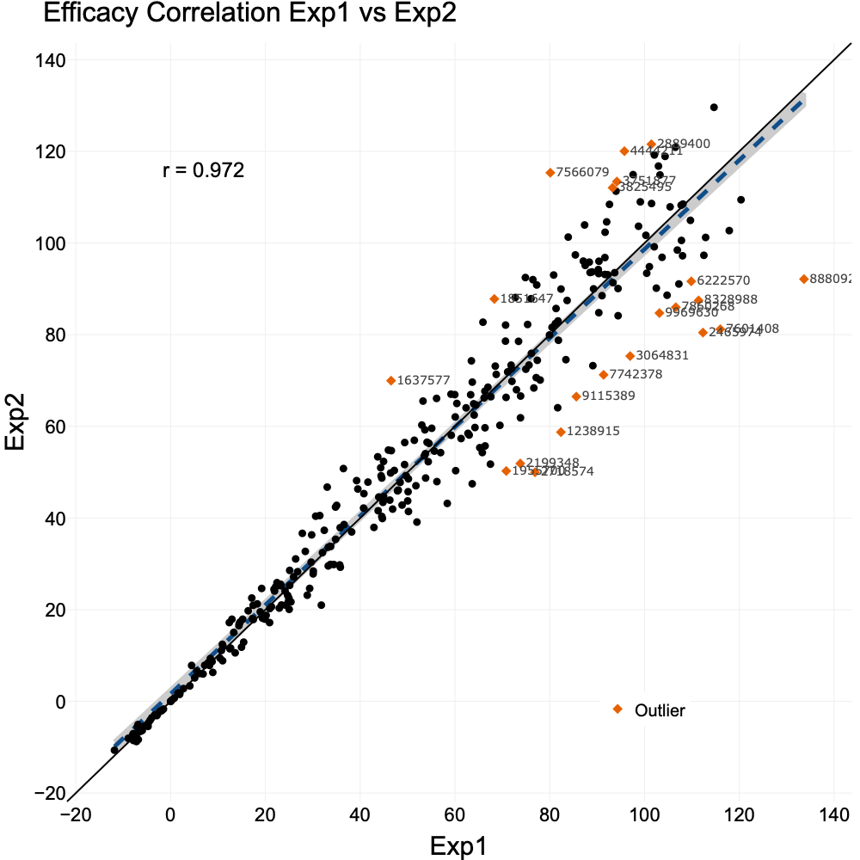

Correlation plot for an assay with 10% CV.

The same pattern is observed in the correlation plot with the spread between experiments increasing as the efficacy increases.

Assays which show this behavior should not use the replicate experiment as a general measurement of uncertainty in the assay. However Replicate-Experiments with the vehicle and active controls analyzed separately can be useful to document that the assay is repeatable and helping to define limits for activity. In fact, the numerator in the Z’ equation(Zhang, Chung, and Oldenburg 1999) is the difference between the Limits of Agreement for the two controls.

## Potency

Below are the first 6 samples from an example experiment with 32 total samples. The data is simply the sample identifiers (numeric or character) and the measured potency values for the 2 experiments. This is all that is needed to upload for analysis.

|  |  |  |  |  |  |  |  |  |  |  |  |  |  |  |  |  |  |  |  |  |  |
| --- | --- | --- | --- | --- | --- | --- | --- | --- | --- | --- | --- | --- | --- | --- | --- | --- | --- | --- | --- | --- | --- |
| Table 5: Sample Potency data.  Table 1: Uploaded Data   | Sample | Exp1 | Exp2 | | --- | --- | --- | | 2455167 | 883.59032115 | 531.29130588 | | 2225318 | 0.33218715 | 1.03798254 | | 4625166 | 2.16832037 | 2.15084190 | | 9852359 | 2.55900969 | 2.06438777 | | 2107695 | 146.93978930 | 214.71751251 | | 7465843 | 0.07546636 | 0.08069902 | |

The data analysis is similar to that used with efficacy data, except that the potency values must first be transformed to their log10 values, so the variability will have a normal distribution for the statistical analysis. Then the means and differences for the pairs of log10(Potency) values are determined along with the associated statistics as described in #sec-data_analysis.

|  |  |  |  |  |  |  |  |  |  |  |  |  |  |  |  |  |  |  |  |  |  |  |  |  |  |  |  |  |  |  |  |  |  |  |  |
| --- | --- | --- | --- | --- | --- | --- | --- | --- | --- | --- | --- | --- | --- | --- | --- | --- | --- | --- | --- | --- | --- | --- | --- | --- | --- | --- | --- | --- | --- | --- | --- | --- | --- | --- | --- |
| Table 6: Calculated Replicate Experiment Data.  Table 1: Calculated Data   | Sample | Exp1 | Exp2 | Geometric Mean | Ratio | | --- | --- | --- | --- | --- | | 2455167 | 8.84 × 10^2 | 5.31 × 10^2 | 6.85 × 10^2 | 1.66 | | 2225318 | 3.32 × 10^-1 | 1.04 | 5.87 × 10^-1 | 3.20 × 10^-1 | | 4625166 | 2.17 | 2.15 | 2.16 | 1.01 | | 9852359 | 2.56 | 2.06 | 2.30 | 1.24 | | 2107695 | 1.47 × 10^2 | 2.15 × 10^2 | 1.78 × 10^2 | 6.84 × 10^-1 | | 7465843 | 7.55 × 10^-2 | 8.07 × 10^-2 | 7.80 × 10^-2 | 9.35 × 10^-1 | |

Once the data have been uploaded, the replicate experiment calculations are displayed. This data now includes the Geometric Mean and Ratio values as well as Class, in addition to the original data. The GeoMean is the geometric mean of the potency values and the Ratio is the transformation of the difference from the statistical analysis. Recall that , so the difference between 2 log values becomes a ratio, when anti-logged. Similarly the mean of logs becomes a geometric mean when anti-logged. The Class column is used to identify flagged samples that fall outside the agreement limits. This table is fully sortable in the web tool. ***Note. While the input data may contain any number of digits after the decimal point and are used for the analysis and download. Calculated values and statistics are displayed to 3 significant digits.***(Dahlin et al. 2004)

|  |
| --- |
| Figure 8: Mean-Ratio plot of potency data. |

The Bland-Altman plot for potency data uses the geometric mean value of each data pair on the x-axis with the ratio between the potencies is represented on the y-axis. Both axes are plotted on the log scale, as described in Section 1.5.1.2. The data points are centered around 1 with about half of the data on either side of the center. The variability also is evenly distributed across the range of x values

|  |  |  |  |  |  |  |  |  |  |  |  |  |  |  |
| --- | --- | --- | --- | --- | --- | --- | --- | --- | --- | --- | --- | --- | --- | --- |
| Table 7: Potency Replicate Experiment Statistics  Table 1: Potency Stats   | n | MeanRatio | MSR | Upper Ratio Limit | Lower Ratio Limit | Upper Agreement Limit | Lower Agreement Limit | | --- | --- | --- | --- | --- | --- | --- | | 32 | 1.06 | 2.53 | 1.25 | 8.98 × 10^-1 | 2.73 | 4.13 × 10^-1 | |

The corresponding statistics are shown in Table 7. There is only a single labelled sample in the Bland-Altman plot, which is consistent with a data set of this size. The ratio for this sample, while outside of the ratio limits, is close and thus not an obvious outlier.

|  |
| --- |
| Figure 9: Potency Correlation plot. |

Figure 9 is a correlation plot of the two data sets with a unity reference line and the Spearman correlation. The data should overlay the equality reference line.

The calculated data, plots, and statistics can be downloaded for documentation and future reference.

### Too Few Samples

Early in a project, it may be a struggle to identify a sufficient number of validated, active samples to perform a replicate experiment. Here is an example where there are only 5 unique samples. Unfortunately this low sample number does not provide enough statistical power to obtain a good estimate of the assays variability, so the Ratio limits and MSR can appear to be greater than their true values.

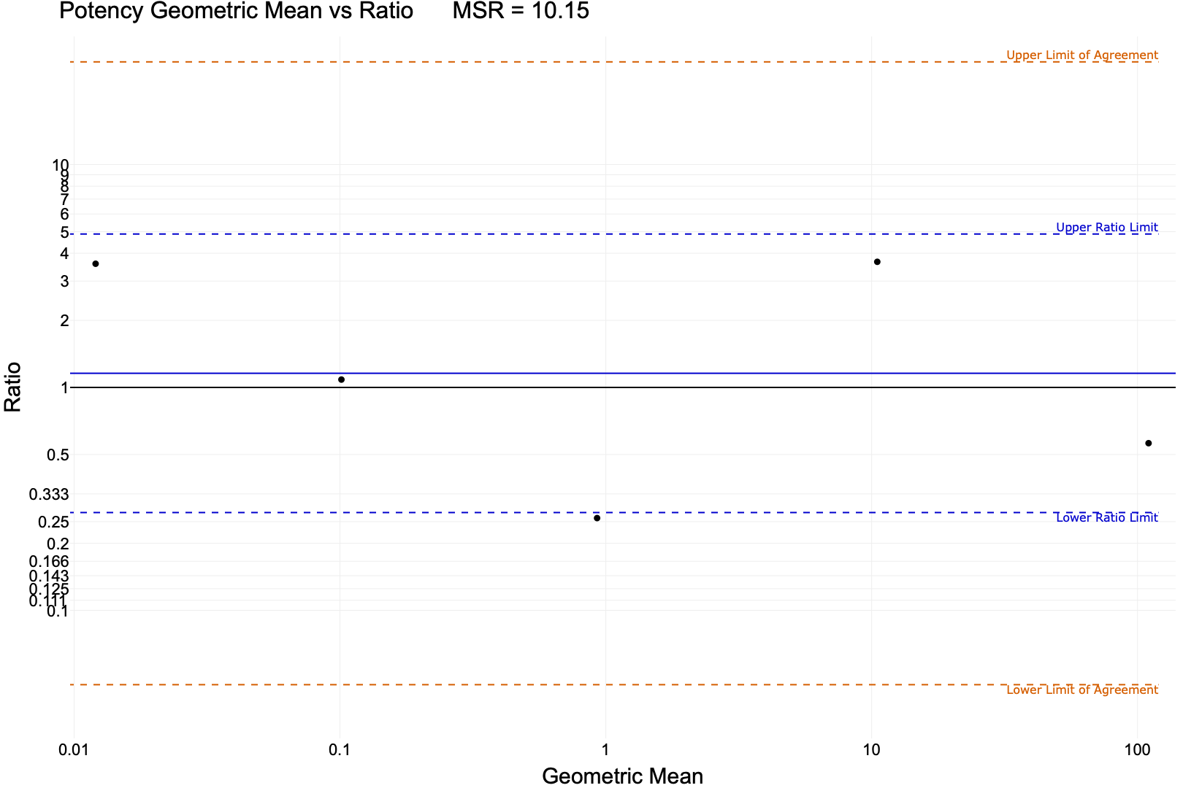

Mean Ratio plot.

|  |  |  |  |  |  |  |  |  |  |  |  |  |  |  |
| --- | --- | --- | --- | --- | --- | --- | --- | --- | --- | --- | --- | --- | --- | --- |
| Table 8: Replicate Experiment Statistics  Table 1: Potency Stats   | n | MeanRatio | MSR | Upper Ratio Limit | Lower Ratio Limit | Upper Agreement Limit | Lower Agreement Limit | | --- | --- | --- | --- | --- | --- | --- | | 5 | 1.16 | 1.01 × 10^1 | 4.88 | 2.75 × 10^-1 | 2.89 × 10^1 | 4.64 × 10^-2 | |

Table 8 shows the associated statistics. While the MSR appears to be high we also see that n is only 5, so there is probably not enough data to provide a good estimate of the MSR.

|  |
| --- |
| Figure 10: Correlation Plot |

Fortunately there is a simple solution to this problem. Each sample can be replicated multiple times on the plates and the replicate dose response curves analyzed as if they were from different samples. Ideally, these replicate samples should be prepared as if they were unique compounds with their own dilution series. In this example, the 5 unique samples were each replicated 6 times (e.g. sample 1 becomes 1A, 1B, 1C …). This produces 30 pairs of potency values for the analysis

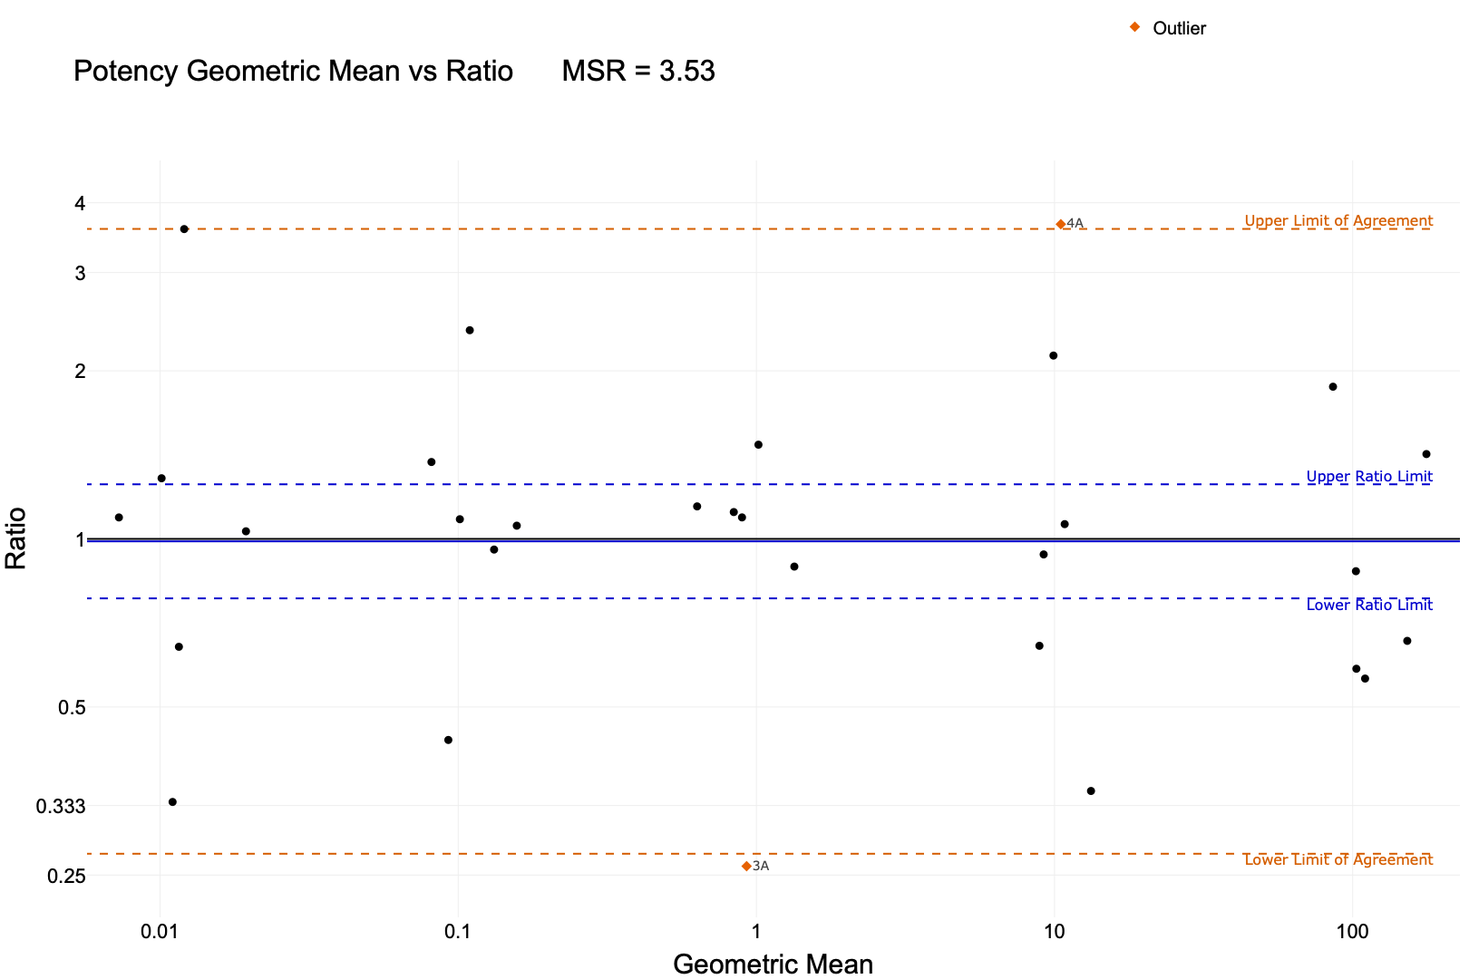

Replicated samples Mean Ratio plot,

The Bland-Altman plot now shows 5 clusters of difference values corresponding to the 5 replicated samples.

|  |  |  |  |  |  |  |  |  |  |  |  |  |  |  |
| --- | --- | --- | --- | --- | --- | --- | --- | --- | --- | --- | --- | --- | --- | --- |
| Table 9: Replicate Experiment Statistics  Table 1: Potency Stats   | n | MeanRatio | MSR | Upper Ratio Limit | Lower Ratio Limit | Upper Agreement Limit | Lower Agreement Limit | | --- | --- | --- | --- | --- | --- | --- | | 30 | 9.90 × 10^-1 | 3.53 | 1.25 | 7.83 × 10^-1 | 3.59 | 2.73 × 10^-1 | |

Table 9 shows a much lower MSR.

|  |
| --- |
| Figure 11: Replicated samples correlation plot, |

While it is easy to identify the clusters due to the sample replication in the graphs, the improvement in statistical power from n=30 instead of n = 5 provides a much better estimate of the true assay variability. Both the MSR and the ratio limits are significantly lower.

### Systematic Difference between Runs (change example to larger difference)

When the mean ratio line is displaced from the ratio = 1 reference line, this may be an indication of a systematic difference between the two experiments. However if the reference line is within the ratio limits, this could simply be random variation, or due to a cause with a very small effect. If the reference line is outside of the ratio limits, this can indicate a systematic difference which should be investigated.

|  |  |  |  |  |  |  |  |  |  |  |  |  |  |  |
| --- | --- | --- | --- | --- | --- | --- | --- | --- | --- | --- | --- | --- | --- | --- |
| Table 10: Replicate Experiment Statistics  Table 1: Potency Stats   | n | MeanRatio | MSR | Upper Ratio Limit | Lower Ratio Limit | Upper Agreement Limit | Lower Agreement Limit | | --- | --- | --- | --- | --- | --- | --- | | 32 | 7.97 × 10^-1 | 2.77 | 9.58 × 10^-1 | 6.63 × 10^-1 | 2.26 | 2.82 × 10^-1 | |

|  |
| --- |
| Figure 12: Systematic error Correlation plot. |

Table 10 shows that the expected ratio of 1 is not within the ratio limits.

Here we can see an example where the reference line lies outside of the ratio limits. The correlation line is also slightly different from the unity line.

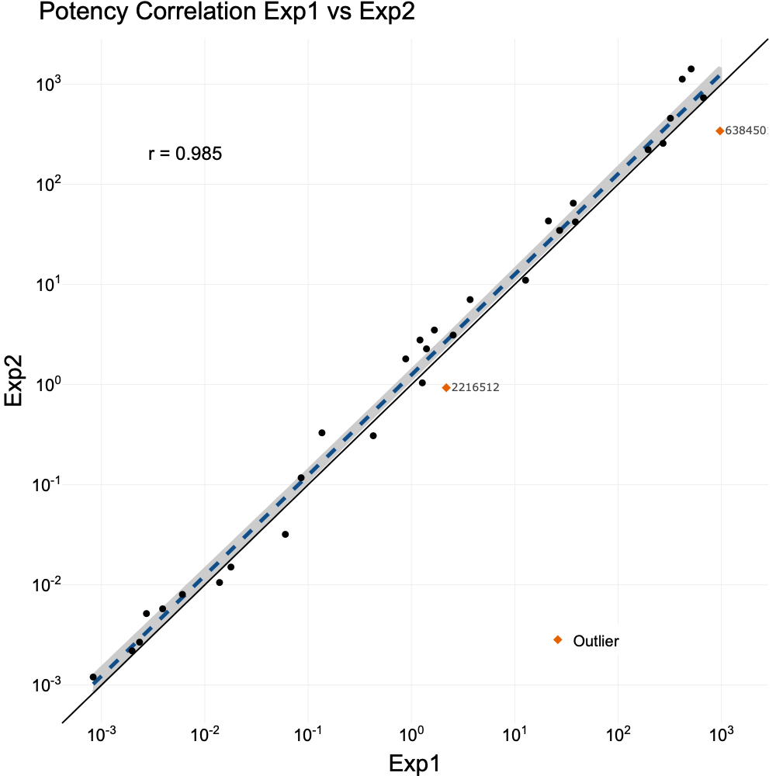

Common causes can include any of the following:

1. Differences in the samples between experiments (e.g. sample lots, or solubilizations).
2. Reagents or cells used in the assay.
3. Equipment changes.
4. Environmental changes (e.g. temperature).
5. Personnel

If a cause is identified, it should me mitigated (if possible) and the replicate experiment repeated. Sometimes a cause may be identified which includes historical data that can’t be changed. If this happens, it may be significant enough to require retesting of key compounds to assess the impact.

Beck, Benoit, Yun-Fei Chen, Walthere Dere, Viswanath Devanarayan, Brian J. Eastwood, Mark W. Farmen, Stephen J. Iturria, et al. 2004. “Assay Operations for SAR Support.” In, edited by Sarine Markossian, Abigail Grossman, Michelle Arkin, Douglas Auld, Chris Austin, Jonathan Baell, Kyle Brimacombe, et al. Bethesda (MD): Eli Lilly & Company; the National Center for Advancing Translational Sciences. <http://www.ncbi.nlm.nih.gov/books/NBK91994/>.

Bland, J. M., and D. G. Altman. 1986. “Statistical methods for assessing agreement between two methods of clinical measurement.” *Lancet (London, England)* 1 (8476): 307–10.

Dahlin, Jayme L., G. Sitta Sittampalam, Nathan P. Coussens, Viswanath Devanarayan, Jeffrey R. Weidner, Philip W. Iversen, Joseph V. Haas, et al. 2004. “Basic Guidelines for Reporting Non-Clinical Data.” In, edited by Sarine Markossian, Abigail Grossman, Michelle Arkin, Douglas Auld, Chris Austin, Jonathan Baell, Kyle Brimacombe, et al. Bethesda (MD): Eli Lilly & Company; the National Center for Advancing Translational Sciences. <http://www.ncbi.nlm.nih.gov/books/NBK550206/>.

Eastwood, Brian J., Mark W. Farmen, Philip W. Iversen, Trelia J. Craft, Jeffrey K. Smallwood, Kim E. Garbison, Neil W. Delapp, and Gerald F. Smith. 2006. “The Minimum Significant Ratio: A Statistical Parameter to Characterize the Reproducibility of Potency Estimates from Concentration-Response Assays and Estimation by Replicate-Experiment Studies.” *SLAS Discovery* 11 (3): 253–61. <https://doi.org/10.1177/1087057105285611>.

Elassaiss-Schaap, Jeroen, and Kevin Duisters. 2020. “Variability in the Log Domain and Limitations to Its Approximation by the Normal Distribution.” *CPT: pharmacometrics & systems pharmacology* 9 (5): 245–57. <https://doi.org/10.1002/psp4.12507>.

Haas, Joseph V., Brian J. Eastwood, Philip W. Iversen, Viswanath Devanarayan, and Jeffrey R. Weidner. 2004. “Minimum Significant Ratio A Statistic to Assess Assay Variability.” In, edited by Sarine Markossian, Abigail Grossman, Kyle Brimacombe, Michelle Arkin, Douglas Auld, Chris Austin, Jonathan Baell, et al. Bethesda (MD): Eli Lilly & Company; the National Center for Advancing Translational Sciences. <http://www.ncbi.nlm.nih.gov/books/NBK169432/>.

Iversen, Philip W., Benoit Beck, Yun-Fei Chen, Walthere Dere, Viswanath Devanarayan, Brian J. Eastwood, Mark W. Farmen, et al. 2004. “HTS Assay Validation.” In, edited by Sarine Markossian, Abigail Grossman, Kyle Brimacombe, Michelle Arkin, Douglas Auld, Chris Austin, Jonathan Baell, et al. Bethesda (MD): Eli Lilly & Company; the National Center for Advancing Translational Sciences. <http://www.ncbi.nlm.nih.gov/books/NBK83783/>.

Zhang, Ji-Hu, Thomas D. Y. Chung, and Kevin R. Oldenburg. 1999. “A Simple Statistical Parameter for Use in Evaluation and Validation of High Throughput Screening Assays.” *SLAS Discovery* 4 (2): 67–73. <https://doi.org/10.1177/108705719900400206>.