TS8W Ultrasonic Water Meter User Manual

Table of Contents

1.Product Introduction

2.Product Information

3.Wireless Communication Specifications

4.Installation Instructions

5.Warranty Terms

1.Product Introduction
The TS8W Ultrasonic Water Meter is a high-precision electronic water meter. It utilizes the ultrasonic time-of-flight principle to continuously measure, record, and display the water volume flowing through the sensor. This meter meets the stringent requirements of water utility management for accurate water consumption measurement. The TS14W is compatible with IoT transmission technologies, offering customizable solutions for diverse user needs. It is widely applied for water measurement in residential, apartment, and commercial settings.
The TS8W Ultrasonic Water Meter provides data on flow rate, volume, date, and medium temperature. Its LCD interface cyclically displays cumulative flow and instantaneous flow. Using a magnetic trigger, users can switch between P1 to P3 interfaces to view information such as meter address, battery voltage, and historical usage.

2.Product Information
2.1.Product Features
- No moving parts in the measurement mechanism, eliminating wear.
- Supports 9-digit LCD display,minimum measurement unit is "L".
- High measurement accuracy (R630/R400/R250 options available).
- Supports vertical, horizontal, or inclined installation angles (H/V).
- Supports reverse flow detection.
- Supports non-full pipe detection.
- Supports leakage reporting.
- Low pressure loss (ΔP40).
- IP68 high protection rating, adaptable to various harsh installation environments.
- Supports remote meter reading via:
- Wired transmission (RS-485 Modbus, M-Bus, Pulse)
- Wireless transmission (LoRaWAN, W-MBus, Cat.1, LoRaWAN+W-MBus)
- Battery service life exceeding 12 years.

2.2.Nameplate Identification
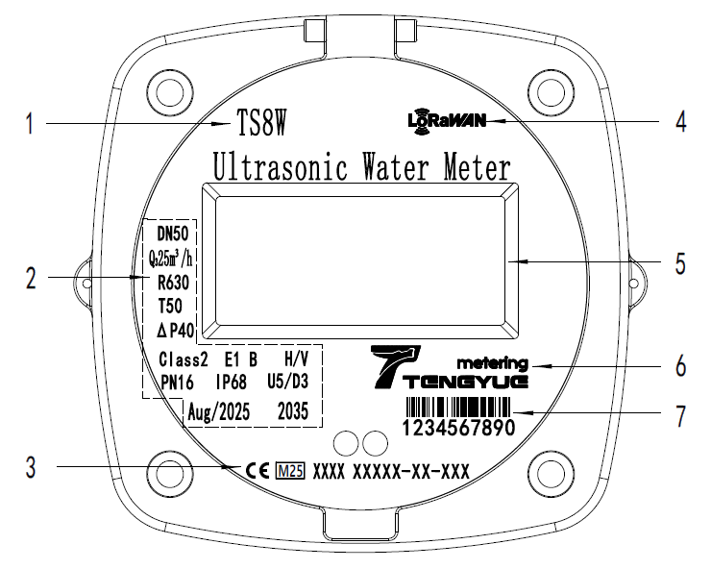
- Product model
- Product Parameter Area
- Certification Mark
- Communication method
- LCD Display Area
- Manufacturer's Logo
- Water Meter ID（S/N）

No. | Parameter | Details
 | DN50 | Nominal Diameter (DN50 ~ DN400)
 | R400 | Q3/Q1 (R250, R400, R630 selectable)
 | T50 | Temperature Class (T30, T50 selectable)
 | PN16 | Pressure Class(Nylon material PN10, brass material PN16)
 | Aug/2025 | Manufacturing Date (Month Year)
 | Q₃ 25m³/h | Permanent Flow Rate
 | 2035 | Service Life (>12 years)
 | U5/D3 | Flow Profile Sensitivity Class
 | IP68 | Protection Class
 | H/V | Installation Method
 | Class 2 | Accuracy Class
 | E1 | Electromagnetic Environment Class
 | B | Ambient Environment Class
 | ΔP40 | Pressure Loss Class

2.3.LCD Interface Identification
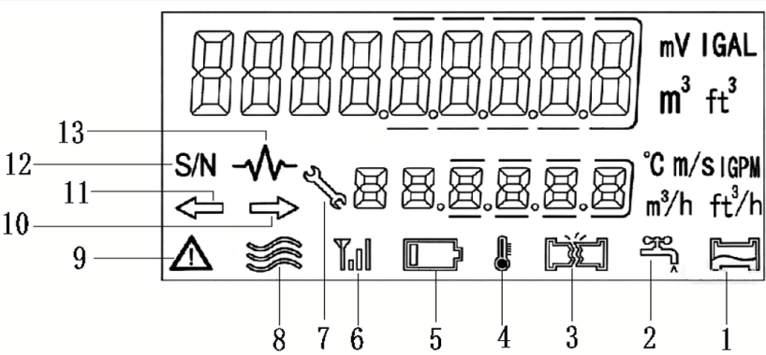
- Non-Full Pipe Alarm
- Drip/Leak Alarm
- Burst Pipe Alarm
- Temperature Indicator
- Low Battery Alarm
- Wireless Signal Strength
- Manufacturer Mode
- Flow Status Indicator
- Fault/Alarm Indicator
- Forward Flow Indicator
- Reverse Flow Indicator
- Meter Address (S/N)
- Transducer Amplitude
2.4.Operation Method
Swipe the magnetic tool directly over the magnetic trigger sensor area to cycle through the LCD display interfaces in sequence.
Quickly swipe the magnetic tool over the magnetic trigger sensor area. When the display interface starts blinking, keep the magnetic tool held over the sensor area to switch between the P1 to P4 interfaces.
Display Interface Description
Classification | No. | LCD Display | Display Instructions
P1 | 1 | 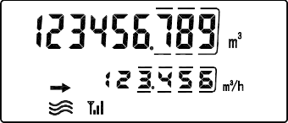 | Positive Cumulative Flow
 |  |  | Positive Instantaneous Flow
 | 2 | 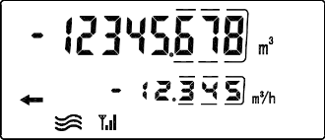 | Reverse Cumulative Flow
 |  |  | Reverse Instantaneous Flow
 | 3 | 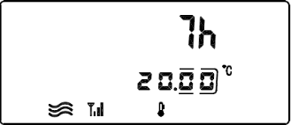 | Cumulative Operating Time
 |  |  | Medium Temperature
 | 4 | 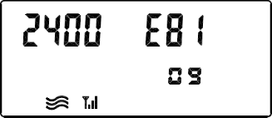 | Baud Rate Parity
 |  |  | Modbus Address
 | 5 | 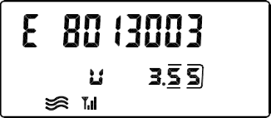 | Firmware Version
 |  |  | Battery Voltage
 | 6 | 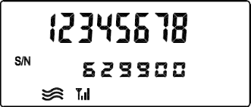 | Meter Address
 |  |  | Manufacturer Code
P2 | 7 | 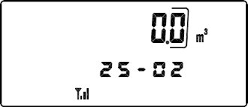 | Historical Cumulative Volume
 |  |  | Historical Month
 | 8 | 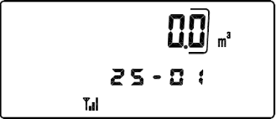 | Historical Cumulative Volume
 |  |  | Historical Month
 | 9 | 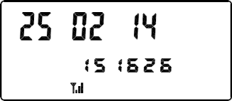 | Data Available for 36 Months (Query)
 |  |  | Current Meter Date
 | 10 | 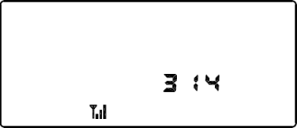 | Current Meter Time
P3 | 11 | 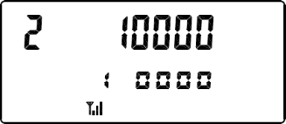 | Dynamic Parameters
 |  |  | Calibration Factor
 | 12 | 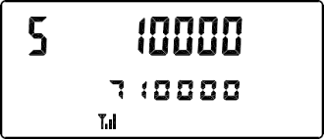 | Commonly Used 3-Segment Factor
 |  |  | Calibration Factor
 | 13 | 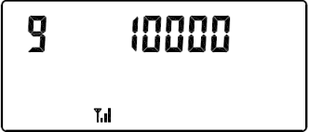 | Commonly Used 3-Segment Factor
 | 14 | 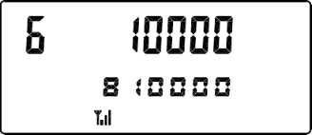
 |  |  | Calibration Factor
 | 15 | 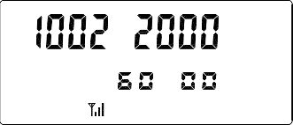 | Commonly Used 3-Segment Factor
 |  |  | Status Flag
P4 | 16 | 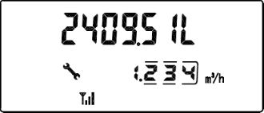 | Calibrated Positive Cumulative Flow
 |  |  | Positive Instantaneous Flow
 | 17 | 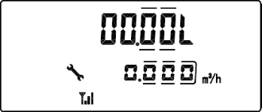 | Single Calibration Positive Flow
 |  |  | Positive Instantaneous Flow
 | 18 | 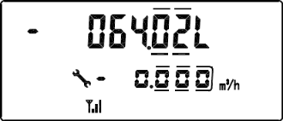 | Calibrated Reverse Cumulative Flow
 |  |  | Reverse Instantaneous Flow
 | 19 | 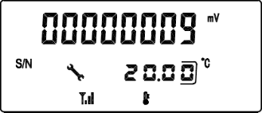 | Transducer Signal Strength
 |  |  | Medium Temperature
 | 20 | 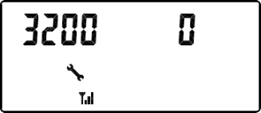 | Calibration Dynamic Parameters
 | 21 | 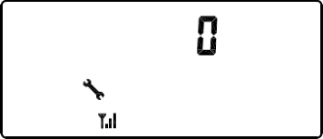 | Calibration Dynamic Parameters
 | 22 | 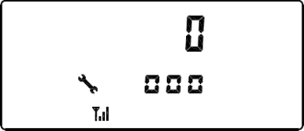 | Calibration Dynamic Parameters

3.Wireless Communication Specifications
 | Description
Mode | RS-485 | LoRaWAN | Cat.1 | NB-IoT
Frequency Band | 9600bps | EU863-870 US902-928 AU915-928 | 1880MHz-1900MHz | B3/B5/B8
Transmit Power | - | Max. 20 dBm | Max. 33 dBm | Max. 23 dBm
Effective Range | 800m | 1 - 3 km (open environment) | - | -
Protocol | Modbus | LoRaWAN v1.0.3 | 3GPP | 3GPP
Communication Mode | Half-Duplex | Class A | - | LwM2M/NITZ/PING/TCP/UDP
Power Supply | 12-24V DC | 3.6V DC | 3.6V DC | 3.6V DC
Upload Interval | Real-time | 12 / 24 h | 24 h | 24h
Corresponding Mode | Answering | Timed | Timed | Timed
4.Installation Instructions
4.1. Specification parameters
Model（DN） |  | 50 | 65 | 80 | 100 | 125 | 150 | 200 | 250 | 300
Material |  | Ductile iron
L mm |  | 200 | 200 | 225 | 250 | 250 | 300 | 350 | 450 | 500
D mm |  | 170 | 185 | 200 | 220 | 250 | 285 | 340 | 405 | 460
H mm |  | 215 | 220 | 235 | 255 | 285 | 335 | 405 | 490 | 550
Flange | Flange  Diameter | 170 | 185 | 200 | 220 | 250 | 285 | 340 | 405 | 460
 | Bolt Circle  Diameter | 125 | 145 | 160 | 180 | 210 | 240 | 295 | 355 | 410
 | Bolt Size—M | 4-M16 | 4-M16 | 8-M16 | 8-M16 | 8-M16 | 8-M20 | 12-M20 | 12-M24 | 12-M24
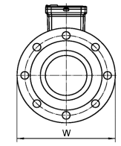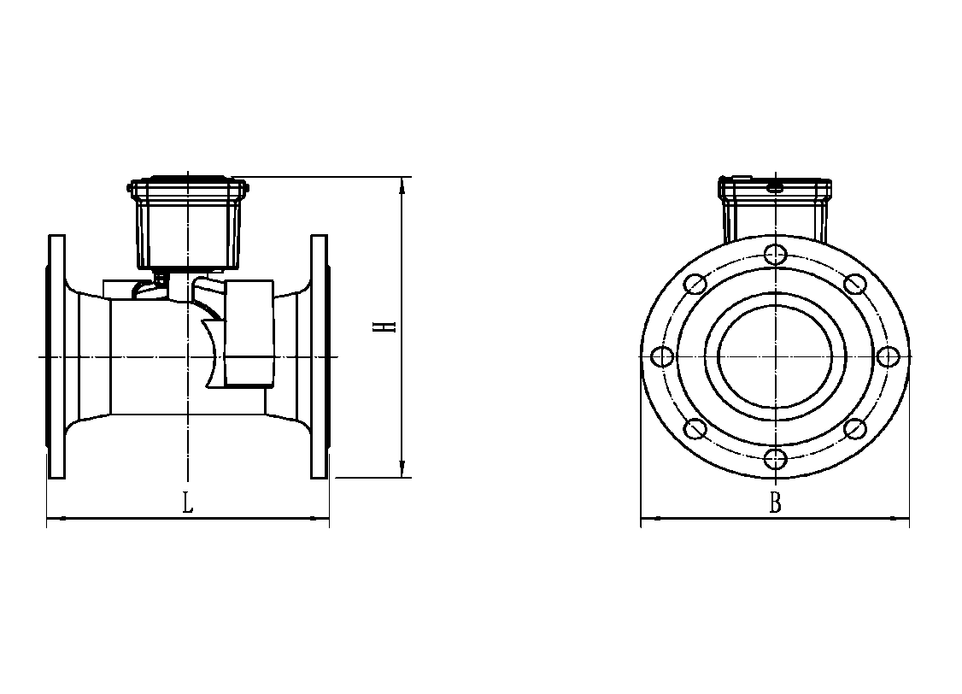
4.2. Product Installation Method
Installation Steps
Install the PTFE gasket inside the connection pipe.
Connect the water meter to the connection pipes according to the flow direction indicated on the meter. Tighten the connection nuts (maximum torque should not exceed 30 N·m).
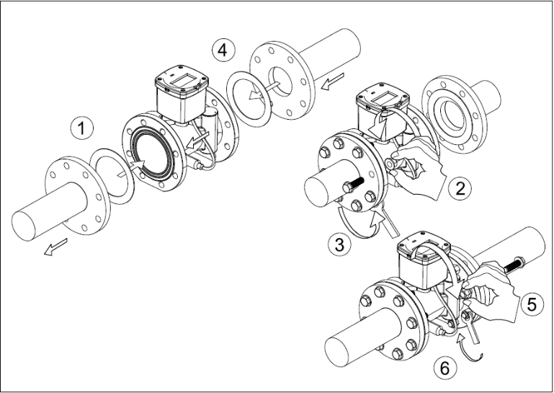
Open the inlet valve and the outlet valve in sequence (water pressure should be less than 1.6 MPa).
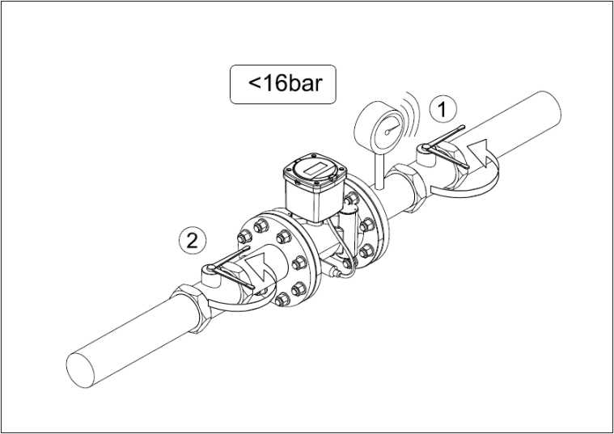
Installation Notes
- The arrow on the meter body must align with the water flow direction.
- Do not install the water meter at a position lower than the pipeline outlet or in areas prone to air accumulation, as this may prevent accurate measurement.
- Ensure the ultrasonic water meter is properly aligned before tightening the connecting pipes.
- The medium temperature range is 0.1°C to 90°C. If the temperature falls below 0°C, close the inlet valve and drain all medium from the pipeline.
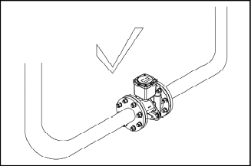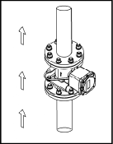
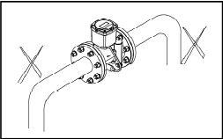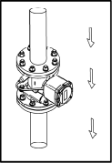
Meter Removal Procedure
1. Close the inlet valve.
2. Drain the medium from the pipeline until internal pressure is completely released.
3. Close the outlet valve.
4. Loosen the fixing bolts of the outlet and inlet connection flanges in sequence.
5. Remove the water meter from the pipeline (handle with care during removal).
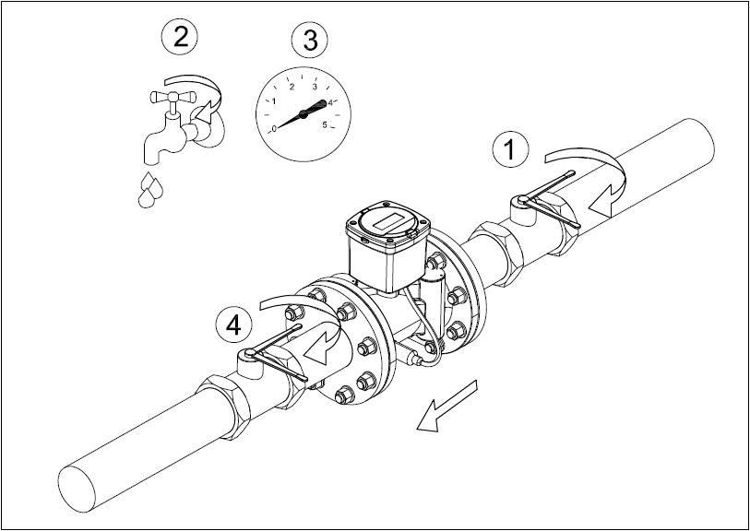
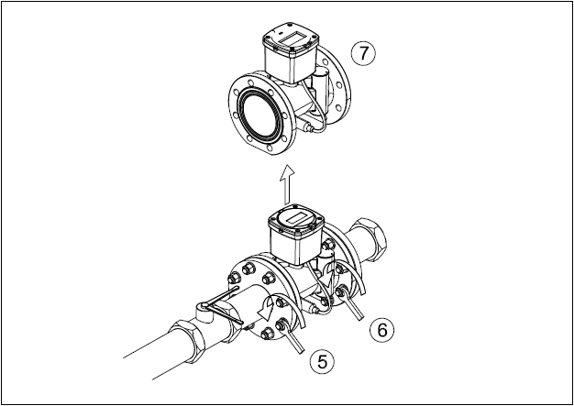

Installation Precautions
The use of thread lock adhesive or other sealants on the connection threads is strictly prohibited.
The meter must not be installed in a pipeline section where air bubbles can accumulate.
After installation is complete, bleed the pipeline to remove any air before putting the meter into service.
Ensure the connecting pipelines are properly aligned.
4.3. Periodic Inspection
Every 6 months: Clean the pre-meter filter and check for leaks.
Every 2 years: Verify measurement accuracy (this can be done by sending the meter to a relevant metrology department or by comparison using a portable ultrasonic flow meter).

4.4. Important Notes (Refer to other product documentation for content on daily maintenance, transport, and storage)
Please read this user manual carefully before using the meter to ensure correct operation.
The meter must be used as specified. The company shall not be liable for damage to persons, animals, or property caused by improper installation, maintenance, or use.
After unpacking, ensure the product is intact and undamaged. If you suspect product damage, contact your distributor immediately.
Necessary frost protection measures must be applied to the meter before installation and use.
Before installing the meter, thoroughly flush the system pipelines to remove debris such as hemp fibers, sand, or gravel from the branch pipes, as these can cause meter failure.
The lengths of straight pipe required before and after the meter should be implemented according to the Flow Profile Sensitivity Class marked on the meter.
5. Warranty Terms
The TS8W Ultrasonic Water Meter is covered by a free warranty for one year on the entire unit from the date of shipment, with lifetime maintenance provided. However, damage resulting from the following circumstances is not covered under warranty:
If the tamper-evident seals on any components of the meter are broken or damaged.
If there is evidence of human tampering or vandalism on any components of the meter.
If the meter's components have been exposed to excessive sunlight, flooding, freezing, or chemical contamination.
If the flow sensor is damaged due to failure to clean the pipeline before installation or excessive impurities within the pipeline.
If there are signs of human tampering with the sensor leads.
Failures or damages caused by failure to select an appropriate product model for the application.

Note: The battery within the ultrasonic water meter must be replaced by authorized personnel. Users are not permitted to replace the battery themselves. Please contact the manufacturer directly if a low battery voltage condition occurs.

All rights reserved for the final interpretation of this user manual belong to Lianyungang Tengyue Electronic Technology Co., Ltd.

