Test case 1:

Word: bank

Sentence: the bank can guarantee deposits will eventually cover future tuition costs because it invests in adjustable-rate mortgage securities.

Code result:

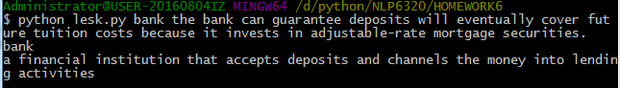

Positive case

Test case 2:

Word: activity

Sentence: The traditions and activities that take place in celebration of the Day of the Dead are not universal, often varying from town to town.

Code Result:

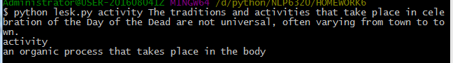

Positive case

Test case 3:

Word: spirit

Sentence: During Day of the Dead festivities, food is both eaten by living people and given to the spirits of their departed ancestors.

Code result:

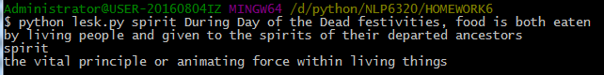

This is a negative case that the program fails to output the correct sense of the input *spirit* in the input sentence.

The correct sense of *spirit* in the input sentence is:

any incorporeal supernatural being that can become visible (or audible) to human beings.