**WEC**

Wavelet Equalizer Calculator

Program Design:

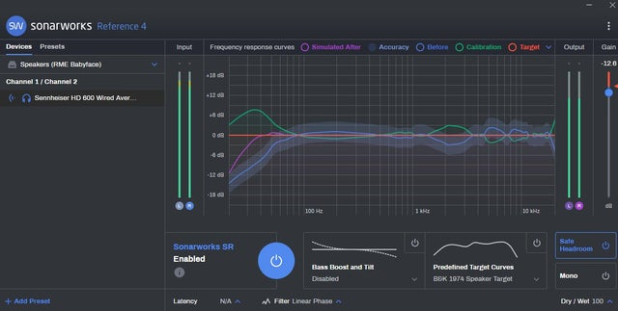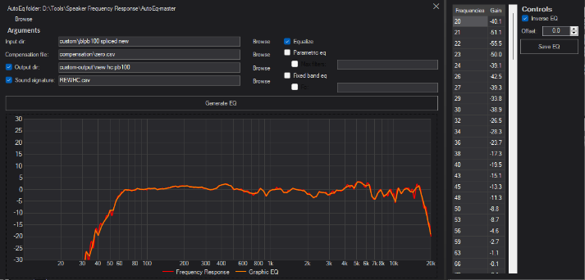

**Calculation**

1. Normalize Frequency Response @1khz to 0db and set to limit values if FR is > or < maximum and minimum constraints (+/- 30db) respectively.
   1. Initialize function with array and 1khz value.
   2. Create an array to store normalized frequency response
   3. Create a for loop to loop each and every frequency to normalize to 0db according to the 1khz value
   4. Logical statement inside for loop to determine if the constraint value goes farther than the constraints, set to constraint value and store in NFR.
   5. Else set normalized value and set to NFR.
   6. Return array
2. Interpolate Target Response and compensate FR for Target Response
   1. Initialize function array with inputs: targetResponse, targetResponseFrequencies, frequencyResponse, frequencyResponseFrequencies.
   2. Create an array to store compensated frequency response.
   3. Create a for loop to loop through the frequency response input array.
   4. If tRF is equal to fRF, compensate and store to CFR.
   5. If tRF is not equals to fRF, determine the nearest left and right frequency in fRF and use linear log equation to interpolate target response, compensate and store the value to CFR.
   6. Return compensated array.
3. Calculate GEQ Response
   1. Initialize function array with inputs: frequencyResponse and frequencyResponseFrequencies, geqFrequencies.
   2. Create and array to store GEQ Response
   3. Create a for loop to loop through the geqFrequencies.
   4. If geqF is equal to fRF, GEQ Response value to FR.
   5. Else if gecF is not equal to fRF, interpolate to determine gecF db value using linear log equation and store the value in GEQ Response.
   6. Return GEQ Response.

**UI Animations**

Note: Use exponential ease out for the animations

For Graph:

1. Get values of decibel level
2. If finished is not equal to true
3. Use for loop to loop through each decibel value
4. If an animated list value is equal to a decibel level value, increment true values by one.
5. If true values are equal to the number of frequencies present in the list, set finished to true.

**UI Functions**

1. Button to set or change the Target Response
2. Button to show GEQ values in another window
3. Clickable Label to set locations like source file, output folder and file name, target response file path
4. 3-step equalization process: Read source file, align target response (show panel to normalize at set frequency), Generate EQ (Show save path, file name, button for eq values)