Network Analysis of English Word Transformations: Structural Patterns and Implications for ESL Learning
Jeff Paller (21677646)¹, Brendan James (31927486)¹, Nathan Jacinto (62151279)¹, and Amey Karmarkar (57577843)¹
¹Department of Computer Science, University of British Columbia Okanagan, Kelowna BC V1V 1V7, Canada
Jeffrey.paller02@gmail.com
Abstract. Understanding the structural relationships between words is crucial for advancing natural language processing, computational linguistics, and language education, particularly in ESL contexts. While Levenshtein distance effectively measures word similarities, traditional approaches often examine words in isolation, missing broader patterns in language structure. This study investigates how English words connect through single-character transformations by analyzing a network of the 10,000 most common English words, aiming to reveal patterns that could inform language learning and computational applications. Using network analysis, we constructed graphs where words or word parts (characters) form nodes and single-character transformations create edges, applying centrality measures and community detection algorithms to uncover structural patterns. The analysis revealed a distinct core-periphery structure with single characters forming highly connected hubs (up to 68 connections), while identifying 4,806 communities with varying characteristics across transformation types. Key findings include a mean path length of 5.7 steps between connected words, and distinct patterns in community formation across substitution, addition, and deletion transformations. These results suggest natural pathways for vocabulary acquisition, with implications for ESL education and computational linguistics. The identified network structure provides a framework for organizing vocabulary instruction that aligns with the inherent structure of English word relationships.
Keywords: Network Analysis, Levenshtein Distance, Word Transformations, Language Structure, ESL Learning.
- Introduction
The relationships between words and characters reveal essential patterns in language, ranging from structural variations to phonetic similarities. Understanding these connections is fundamental to fields such as natural language processing (NLP), linguistics, and language education. In NLP, analyzing word/character relationships supports algorithms that improve language models, enabling more sophisticated spell-checking, text prediction, and even automated language instruction (Zhao, Chunchun, & Sahni, 2019). Additionally, linguistic research benefits from examining how words relate through slight spelling or phonetic changes, offering insights into morphological patterns and common language structures (Yap et al., 2010). This study explores English word transformations to enhance understanding of word similarity in language processing, especially for ESL contexts.
To quantify word relationships, this study uses Levenshtein distance, a metric that measures similarity by counting the minimum number of single-character edits required to change one word into another (Soukoreff & MacKenzie, 2001). Levenshtein distance highlights words that are close in both spelling (orthographic structure) and, often, phonetic structure due to the similar yet distinct spelling. By categorizing these edits as edges and words/characters as nodes using a network-based approach, this study reveals structural relationships among common English words. This approach holds potential benefits for ESL learning and phonology by identifying clusters of similar words/characters that may aid learners in understanding pronunciation, spelling variations, and language structure.
This study visualizes word similarity by constructing an undirected network where each node represents a word or part of a word (i.e., character(s)), and each edge signifies a single-character transformation. This network approach provides a holistic view of word/character relationships, where words or word parts differing by one edit form direct connections, creating clusters that reflect natural groupings within the lexicon. Centrality measures within this network, such as degree and betweenness centralities are applied to identify structurally significant words and word parts (characters). Degree centrality reveals highly connected words/characters, often representing morphologically flexible terms or foundational elements in language clusters; conversely, words/characters with low degree centrality may highlight unique phonetic or orthographic features.
Betweenness centrality measures how often a word or character(s) serve as a "bridge" between clusters, potentially representing transitional morphemes or phonetic elements critical to language structure. High-betweenness words/characters connect different groups within the lexicon, whereas low-betweenness words/characters are more isolated.
Examining these centrality measures uncovers insights into phonetic similarities, morphological relationships, and orthographic roles within the lexicon. These findings can be applied to language-learning tools that emphasize central and bridging words, which may be used to improve language comprehension or enhance phonetic pattern recognition algorithms. Overall, conducting a network-based analysis provides a structured view of word similarity, contributing both to linguistic theory and practical language applications.
- Literature Review
  - Levenshtein Distance in NLP and Linguistics
The study of word or character relationships and similarities is foundational to fields such as natural language processing (NLP), linguistics, and language education. Understanding these relationships enables researchers to uncover patterns that support applications in spell-checking, text prediction, language modeling, and language instruction (Zhao & Sahni, 2019). At the heart of these analyses is the ability to accurately measure word similarity, which has significant implications for enhancing algorithms and systems in NLP. Levenshtein distance, also known as edit distance, is a key metric in this domain, measuring similarity by counting the minimum number of single-character edits—insertions, deletions, or substitutions—required to transform one word into another (Soukoreff & MacKenzie, 2001). This simple yet powerful metric provides a straightforward way to capture structural similarities between words and characters, and it has been widely adopted as a basis for exploring both orthographic and phonetic relationships in language. Moreover, its utility across multiple applications highlights the flexibility and adaptability of Levenshtein distance as a core metric in linguistic research and computational models.
  - Applications of Levenshtein Distance in Phonology and Sociolinguistics
Beyond NLP applications, Levenshtein distance supports linguistic research by providing insights into both orthographic and phonological similarities among words and characters. For example, Yap et al. (2010) created a comprehensive database that includes orthographic and phonological Levenshtein distances for Malaysian words, enabling analyses that explore how words with minor spelling or phonetic variations form clusters in the lexicon. This aligns with the concept that small differences in spelling often correlate with phonetic similarity, making Levenshtein distance a valuable tool for investigating morphological and phonological relationships. Additionally, Dautriche et al. (2017) examined how word forms tend to cluster more than expected by chance, providing evidence that certain structures in language are more than purely random patterns, reflecting deep-seated linguistic phenomena.
Levenshtein distance applications extend into areas like dialectology and sociolinguistics, where it is used to quantify and compare language variation across different regions and social groups. Studies, such as those by Lind-Combs et al. (2023), have shown that Levenshtein distance can capture accent variation by identifying how subtle pronunciation differences affect perception. This perspective is particularly useful in second-language acquisition and speech recognition technologies, where minor phonetic differences influence comprehension and learning. Levenshtein distance thus serves as a bridge between phonetic theory and practical applications, providing a structured way to quantify variations that are otherwise challenging to categorize.
  - Advancements and Limitations of Levenshtein Distance
While Levenshtein distance is traditionally used for pairwise comparisons between words and characters, recent advancements have expanded its application to network-based analyses, providing a broader perspective on word relationships. By representing words/characters as nodes and single-character transformations as edges, researchers can construct networks that reveal complex relational patterns. Allassonnière-Tang, Wan, and Lee (2024) utilized this approach to examine semantic and phonological distances in word association tasks, suggesting that network analyses of word transformations can reveal clustering and connectivity patterns that are not visible through simple pairwise comparison alone. Similarly, Schepens, Dijkstra, and Grootjen (2012) demonstrated the effectiveness of network-based approaches by analyzing cognates across European languages, showing how Levenshtein distance can be used to map relationships in multilingual contexts.
However, despite its broad applications, Levenshtein distance has limitations in capturing deep genealogical relationships within languages. Greenhill (2011) highlighted that while Levenshtein distance is effective in measuring orthographic and phonological similarity, it falls short in identifying historical and evolutionary language patterns due to its focus on surface-level differences. This shortcoming is significant for studies aiming to understand language genealogy, as Levenshtein distance cannot account for semantic drift and morphological changes over time.
Interestingly, Levenshtein distance has also been applied in non-human linguistic contexts, such as studying humpback whale vocalizations. Garland et al. (2012) demonstrated its usefulness in identifying distinct “accents” among whale songs, where differences in the ordered patterns of sounds or "syllables" within the whale songs eventually reached a point that indicated regional differences. This application highlights the versatility of Levenshtein distance in identifying structural variations that can be used to explain phonological morphologies, whether across human languages or animal communication. Together, these studies illustrate that while Levenshtein distance is adaptable, its applications must be carefully calibrated to the nuances of the data being analyzed.
- Methodology
The purpose of this study is to investigate structural patterns in English word relationships through network analysis, focusing on common single-character transformations among frequently used English words. By examining addition, deletion, and substitution transformations, we aim to uncover patterns that can aid in understanding language structure, with applications for English as a Second Language (ESL) learning and computational linguistics. Our methodology involves building a network of word relationships, computing centrality measures, and analyzing community structures, all aimed at revealing meaningful linguistic patterns.
  - Data Gathering
This study employed a dataset of the 10,000 most used English words, sourced from the Corpus of Contemporary American English (COCA). This dataset was selected to establish a solid foundation for analyzing word transformation patterns, while also ensuring its relevance to frequently used vocabulary. The data was processed to create networks representing word relationships through single-character transformations. Furthermore, duplicates and non-alphabetic characters were removed from the dataset to ensure that each word appeared as a unique node in the network.
  - Network Construction
To build the networks, we computed pairwise Levenshtein distances between each word/character in the dataset, producing an initial adjacency matrix where entries were set to 1 only if the distance was exactly one, indicating a single-character transformation. This matrix became the basis for our main network, where nodes represent individual words or word parts (character combinations), and edges indicate a transformation involving the addition, deletion, or substitution of one character. In addition to this main network, we created three distinct sub-networks based on each transformation type. This categorization allowed for a deeper exploration of linguistic relationships, revealing nuanced differences in word connectivity based on the type of transformation.
  - Analysis of Community Structure
The nodes in each network represent unique word/character combinations, such as “at,” “c,” “em,” or “me,” while edges indicate a single-character transformation that captures phonological and orthographic similarities. This structure facilitated the examination of local connectivity, word clusters, and the overall reach of transformation pathways. Community structure was analyzed using the Louvain algorithm, which groups words and character combinations into communities based on their transformation density. Community sizes were summarized across each network to reveal clustering patterns by transformation type, and additional analysis focused on the largest community within the main network to explore local structure in greater detail.
  - Centrality Metrics and Cluster Analysis
We computed several centrality metrics to understand the role of each word/character within the network. Degree centrality identified frequently connected words and characters, acting as transformation hubs, while betweenness centrality highlighted those words and characters bridging different network areas, serving as linguistic pivot points. Clustering coefficients, both global and local, offered insights into the density of connections, helping us identify tightly connected clusters representing phonologically or orthographically similar words and characters. These coefficients are particularly useful for identifying clusters where certain phonological features may be concentrated, suggesting groups of words with related linguistic properties.
  - Path Analysis
Path analysis added another dimension by examining the shortest and longest transformation paths within the network, providing insight into the diversity and reach of connections. By calculating these paths, we assessed the flexibility and diversity of the network’s connectivity, with path length statistics such as mean and standard deviation offering a quantitative overview of the network’s reach.
  - Sub-Network Community Analysis
Finally, each sub-network (addition, deletion, and substitution) was analyzed for community structure individually. Since the properties of each transformation type may uniquely contribute to language patterns, community size and density metrics were computed within each sub-network to capture clustering tendencies. This approach allowed us to understand how specific transformations influence the formation of similar words and character combinations, enhancing our insights into language structure patterns that are relevant to ESL learning contexts.
- Results
  - Full Network Structure and Centrality Metrics
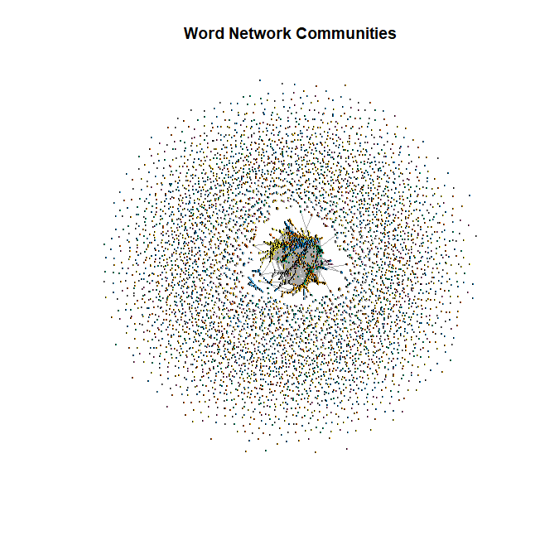
Fig. 1. Full Network Communities
The word transformation network contained 9,894 words with 39,756 direct connections and a network density of 0.000406. Degree centrality calculations identified the top 10 highest degree nodes with 'a', 'c', and 's' each having 68 connections, followed by 'm' with 67 connections, 'r' with 66 connections, 'at' and 'p' with 65 connections each, and 'e' and 't' with 64 connections each, while 'd' showed 62 connections. The analysis found 3,639 words with zero-degree centrality, including common English words such as "about," "information," and "search."
Betweenness centrality measurements revealed "late" with the highest value (199,231.63), followed by "later" (166,022.26), "lat" (112,197.14), "latter" (108,329.94), and "lan" (100,751.55). Additional high-betweenness words included "care" (92,541.36), "matter" (88,739.94), "master" (80,634.94), "ran" (80,221.90), and "ae" (75,005.01). The analysis identified 6,575 words with zero betweenness centrality, including words like "about," "search," "information," and "which."
  - Path Length Distribution in Full Network
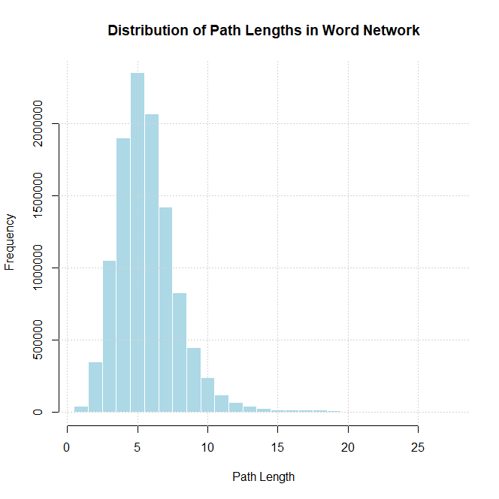
Fig. 2. Path Length Distribution in Full Network
The path analysis revealed a minimum path length of 1 and a maximum length of 27, with a mean path length of 5.7 and median of 5 (standard deviation: 2.24). The most common path length was 5 at a frequency of over 200,000. The longest identified path traversed from "reality" to “thoughts”:

reality → realty → really → rally → sally → silly → billy → bill → ball → mall → male → mate → late → later → latter → matter → master → faster → foster → roster → router → route → rouge → rough → tough → though → thought → thoughts.
  - Clustering Coefficients
The network's clustering analysis showed a global clustering coefficient of 0.3859 and an average local clustering coefficient of 0.341. The analysis identified 6,115 NA clustering coefficients and 460 words with perfect clustering (coefficient = 1). Perfect clustering examples included: "just" (connected to "must" and "dust"), and "two" (connected to "to" and "too").
  - Substitution, Deletion, and Addition Sub-Community Findings
The substitution community’s analysis revealed 625 communities with a mean size of 6.42 and median size of 2. These communities showed a standard deviation of 27.97, with the largest community containing 372 words, totaling 4,015 words across all substitution communities.
Deletion communities totaled 582, showing a mean size of 4.01 and median size of 2. These communities demonstrated a standard deviation of 8, with the largest deletion community containing 75 words. The total word count across deletion communities was 2,334.
Addition-based communities numbered 1,267, with a mean size of 3.54 and median size of 2. The standard deviation was 12.58, and the largest addition community contained 232 words. The total word count across addition communities reached 4,479.
  - Largest Community Analysis
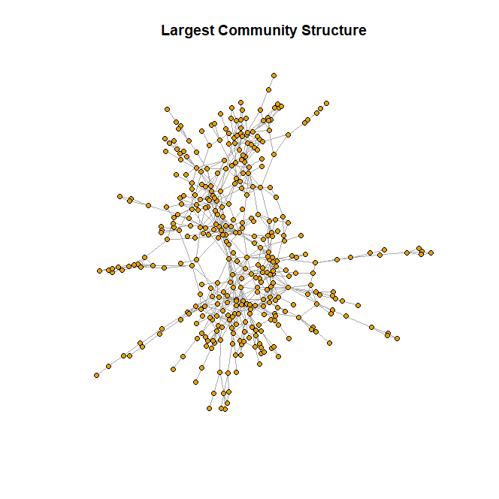
Fig. 3. Largest Community Structure
The largest community analysis revealed 383 words with 802 connections and a density of 0.011. Within this community, the mean degree was 4.19 with a median of 3, ranging from a minimum degree of 1 to a maximum of 14. The community showed a diameter of 16. Word length analysis revealed a mean length of 4.7, median length of 5, and mode length of 5. The highest degree words in this community were "hose" with 14 connections, "cold" with 13 connections, and several words with 12 connections including "come," "hold," "core," and "rose." Betweenness analysis of this community showed a mean of 973.68, median of 381, and maximum of 12,311.56. Additionally, many word lengths within this community were found to be 4-5 characters in length.
- Discussion
  - Structural and Centrality Patterns in English Vocabulary
The full network analysis reveals a core-periphery structure within English vocabulary, where short words and single characters form a dense core surrounded by an outer ring of less-connected, longer words. This structural pattern (Fig. 1) supports the idea that foundational vocabulary relies on high-degree centrality nodes, such as 'a', 'c', and 's', which facilitate connectivity. The significance of these core elements in vocabulary development suggests they should be prioritized in ESL programs to enhance connectivity in learners’ vocabulary, which they usually are as people begin with the alphabet when learning a language.
Contrastingly, words like “information” and “search,” which have zero-degree centrality, represent more isolated vocabulary. These isolated words could guide vocabulary acquisition pathways by emphasizing foundational words or characters/word parts initially and then progressing to more specialized vocabulary.
  - Connectivity Across Vocabulary Clusters
Betweenness centrality highlights critical bridge words, such as “late,” “later,” and “latter,” which connect diverse network regions and act as pivotal transformation hubs. Words with high betweenness bridge different communities, whereas zero-betweenness words like “which” and “only” appear isolated (which is perhaps why unsurprisingly “late,” “later,” and “latter” were involved in our longest path analysis). These results draw attention to the idea that emphasizing high betweenness words in vocabulary teaching could aid learners by showing that certain words sound like many others, and as a result, require extra attention to ensure proper enunciation, and therefore, communication of the chosen high betweenness word.
  - Path Lengths and Vocabulary Reach
Path length analysis (Fig. 2) suggests an optimal transformation range for English words, with common paths around 5 to 6 steps. The skewed distribution, with paths extending up to 27 steps, illustrates that while most words transform into others in short steps, some require complex transformations. ESL instruction could benefit here by sequencing vocabulary based on shorter paths before progressing to more distant terms, allowing for shorter morphological phonetics to develop before moving to more advanced combinations that are required for larger words.
  - Clustering Insights and Vocabulary Groupings
The clustering analysis identified trimodal clustering coefficients, which suggest three main vocabulary types: isolated words, partially clustered words, and fully clustered words forming transformation triangles (e.g., “just” linked to “must” and “dust”). By identifying these clusters, educators can group related words with similar phonological or morphological features, aiding in deciding which groupings of words to teach at a time when applying structured vocabulary learning.
  - Transformation Type Patterns
Each transformation type revealed unique patterns: substitution communities form compact groups (mean size 6.42), addition transformations create more fragmented clusters (mean size 3.54), and deletion-based communities show closer phonetic or semantic ties (mean size 4.01). These distinctions offer a targeted approach to vocabulary building, with substitution supporting morphological understanding by showing minor changes in word structure, and addition fostering vocabulary expansion by connecting a base word to a broader range of related terms. Deletion-based clusters, which retain close phonetic or semantic similarities as they breakdown to word parts (characters) from words, can aid in phonological learning and help learners recognize subtle differences across similar words as they’re deconstructed.
  - Dense Community Structure in High-Connectivity Words
The largest community (Fig. 3) demonstrates a dense, star-like topology, with 383 words connected by 802 edges and a notably higher community density of 0.011 compared to the full network. This community is characterized by medium-length words, with a mean word length of 4.7 characters, suggesting that such words could serve as central anchors in vocabulary teaching due to their structural versatility. Central hubs in this community include words like "hose" and "cold," with the highest degree of 14 and 13 connections, respectively, indicating that these words are pivotal within the community and connect multiple clusters of other words.
Betweenness centrality metrics further underscore the structural significance of specific words within this community. The mean betweenness centrality is 973.68, with the highest observed betweenness of 12,311.56. This suggests that certain words act as critical connectors across different subclusters, facilitating transitions within the community. Words with high betweenness not only enhance local connectivity but also serve as pathways for vocabulary expansion across the network. Teaching strategies could focus on these high-betweenness words as they offer broader access to related vocabulary, aiding in the retention of interconnected word groups. This community structure highlights the potential for targeted vocabulary instruction using high-connectivity words to enhance language learning and retention.
  - Implications for Language Learning and Further Research
This network-based analysis sheds light on English lexicon structures, suggesting natural vocabulary groupings beneficial for language learning. The clustering and transformation patterns observed provide a scaffolded approach to vocabulary acquisition. However, focusing solely on single-character transformations excludes broader linguistic relationships. Expanding this framework to include multi-character transformations and semantic analysis could yield deeper insights. Comparative studies across languages would also reveal whether these structural patterns are unique to English, enhancing the utility of this approach in global ESL contexts.
  - Challenges and Methodological Adjustments
In our initial proposal, we aimed to analyze the entire SOWPODS word list to explore the full structure of the English language. However, we encountered significant computational limitations due to the vast number of word pairs required for Levenshtein distance calculations, which was impractical with our available resources. To overcome this, we adjusted our methodology by focusing on the 10,000 most frequently used English words instead. This subset allowed us to manage computational demands while still providing meaningful insights relevant to ESL learners.
Another challenge we faced was the original plan to identify the longest simple path between words, which was intended to reveal extended connectivity across nodes in the network. However, we discovered that this problem is NP-Hard, making it computationally infeasible given the dataset size and available resources. This realization led us to shift our focus toward more computationally tractable analyses, such as shortest paths and centrality measures, which still provided significant insights into the structural patterns of the lexicon.
These deviations impacted our ability to study certain rare words and non-trivial subgraphs or explore inefficient paths that visit many nodes. However, by concentrating on commonly used vocabulary and emphasizing computationally feasible metrics, our findings remain highly applicable to language learning applications. If we were to repeat this study, we might employ advanced computational techniques or distributed computing resources to overcome these limitations. Despite these adjustments, our results contribute valuable perspectives on word transformations and their implications for ESL education
- Conclusion
This study applied network analysis to English vocabulary, examining 10,000 of the most common words using Levenshtein distance to uncover structural relationships that inform both ESL learning and computational linguistics. By focusing on single-character transformations, we identified key patterns through degree centrality, betweenness, clustering coefficients, and community structures, offering insights into vocabulary organization.
Our findings revealed a core-periphery network structure, where single characters and short words serve as highly connected hubs, underscoring their foundational role in English vocabulary. Patterns in path lengths (mean of 5.7) and bridge words, such as the "late" to "latter" transformation, highlight natural pathways for vocabulary expansion. Additionally, the distinctions among substitution, addition, and deletion transformations suggest unique clustering behaviors that enhance our understanding of word formation.
These insights carry implications for language education, particularly ESL, where teaching sequences could leverage highly connected words and transformation clusters to optimize learning. Bridge words and community structures identified in the network offer promising directions for vocabulary acquisition strategies aligned with natural language structure.
While valuable, this study is limited by its focus on single-character transformations and lack of semantic analysis. Future research could broaden the scope with multi-character transformations, semantic analysis, and cross-linguistic comparisons to deepen our understanding of vocabulary relationships. Applying these findings to ESL methodologies and computational models could further validate and extend their impact.

References
- Allassonnière-Tang, M., Wan, I.-P., Lee, C.: Semantic and phonological distances in free word association tasks. In: Chinese Lexical Semantics, CLSW 2023. LNCS, vol. 14515, pp. 91-100. Springer (2024). [Access Article]
- Dautriche, I., Mahowald, K., Gibson, E., Christophe, A., Piantadosi, S.T.: Words cluster phonetically beyond phonotactic regularities. Cognition 163, 128-145 (2017). [Access Article]
- Garland, E.C., Lilley, M.S., Goldizen, A.W., Rekdahl, M.L., Garrigue, C., Noad, M.J.: Improved versions of the Levenshtein distance method for comparing sequence information in animals' vocalisations. Behaviour 149(13-14), 1413-1441 (2012). [Access Article]
- Greenhill, S.J.: Levenshtein distances fail to identify language relationships accurately. Computational Linguistics 37(4), 1-10 (2011). [Access Article]
- Lind-Combs, H.C., Bent, T., Holt, R.F., Clopper, C.G., Brown, E.: Comparing Levenshtein distance and dynamic time warping in predicting listeners' judgments of accent distance. Speech Communication 155, 102987 (2023). [Access Article]
- Schepens, J., Dijkstra, T., Grootjen, F.: Distributions of cognates in Europe as based on Levenshtein distance. Bilingualism: Language and Cognition 15(S1), 157-166 (2012). [Access Article]
- Soukoreff, R.W., MacKenzie, I.S.: Measuring errors in text entry tasks: An application of the Levenshtein string distance statistic. In: Proceedings of the SIGCHI Conference on Human Factors in Computing Systems, pp. 319-320. ACM (2001). [Access Article]
- Yap, M.J., Rickard Liow, S.J., Jalil, S.B., Faizal, S.S.: The Malay Lexicon Project: A database of lexical statistics for 9,592 words. Behavior Research Methods 42, 992-1003 (2010). [Access Article]
- Zhao, C., Sahni, S.: String correction using the Damerau-Levenshtein distance. BMC Bioinformatics 20(11), 277 (2019). [Access Article]
- GitHub Repository: https://github.com/Jeff1999/English-Word-Levenshtein-Distance-Analysis).

