User Interface prototype:

**The UI is for caregiver and we have the assumption that there is no machine learning component involved in this stage. First window the equipment is successfully connected, the main window will show up.**

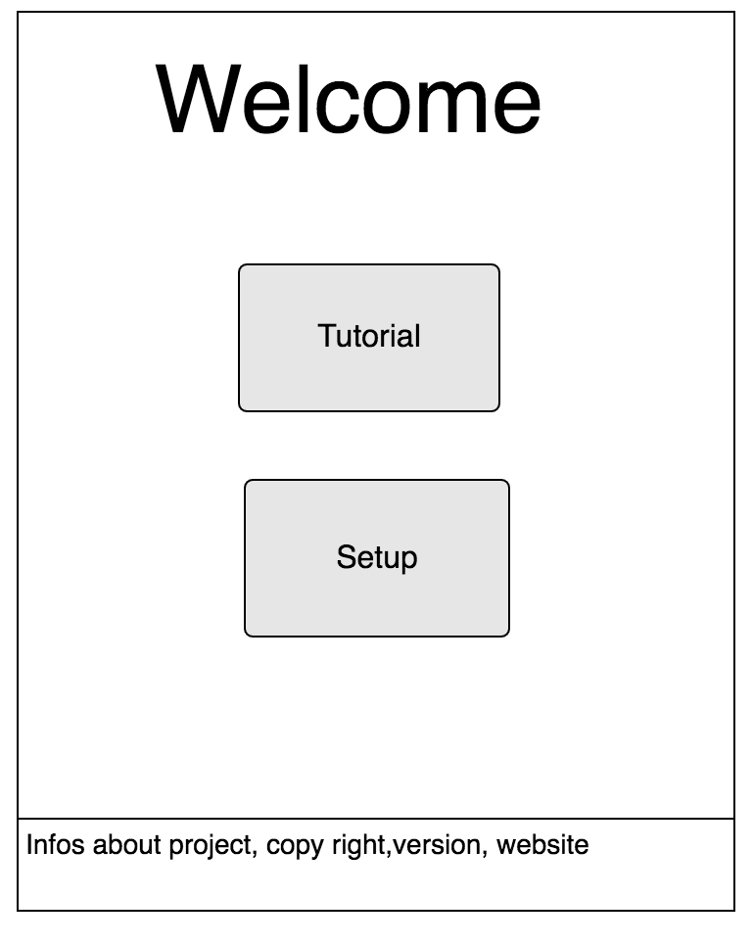

**A Start button should be added below the setup button.**

**If the tutorial button is clicked,**

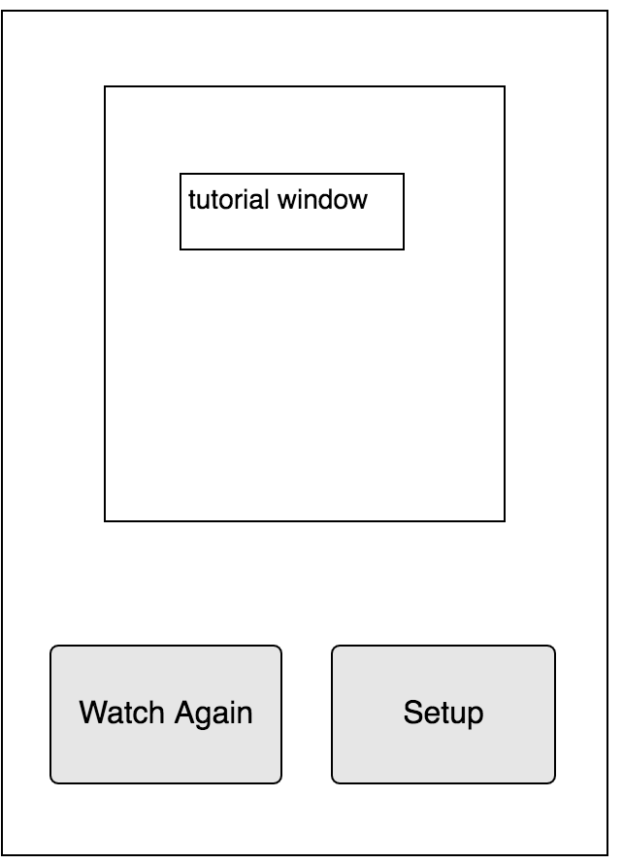

**A “go back to main page” button should be added next to setup button.**

**The tutorial should contain instruction and examples to help the caregiver navigate the equipment.**

**If Setup button is clicked.**

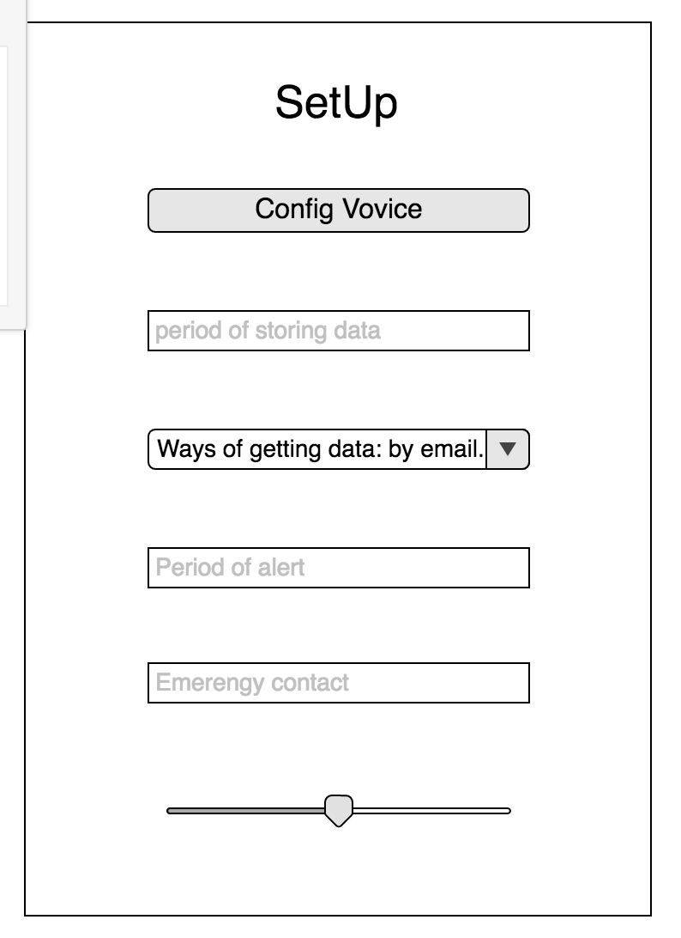

**Caregiver can setup the period of data storage, emergency contact phone number, methods to store and receive data (send data via email, store data in csv file….)**

**Period of alert set a interval: if the patient does not show up on the video for a certain amount of time, then the program send alert to the caregiver.**

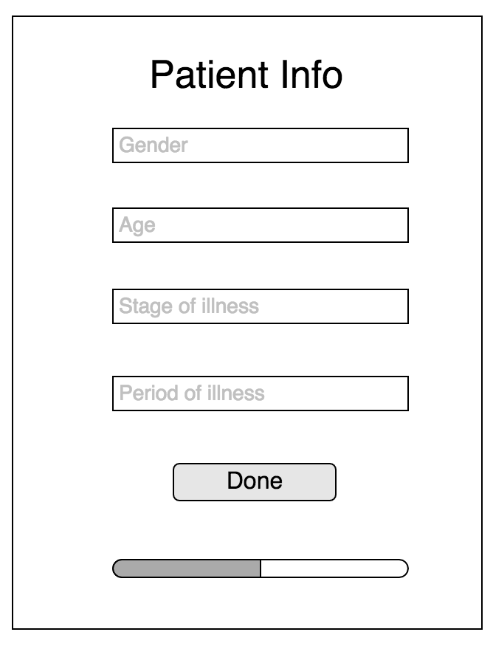

**Then the caregiver can put into infos of the patients. By clicking the button done, the caregiver should be redirected to main page.**

**If at the setup stage, the caregiver wants to config voice source, **

**Then he can click “config voice” button.**

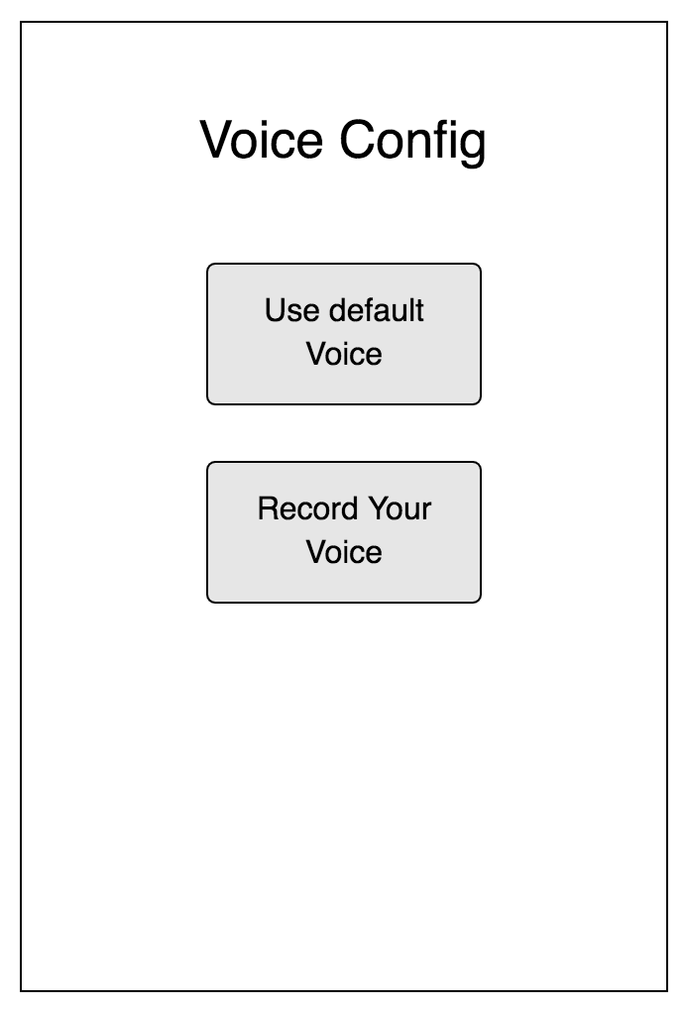

**A go back button should be added below the button “Record your voice”.**

**On main page,**



**if the caregiver press start, the window should pop up:**

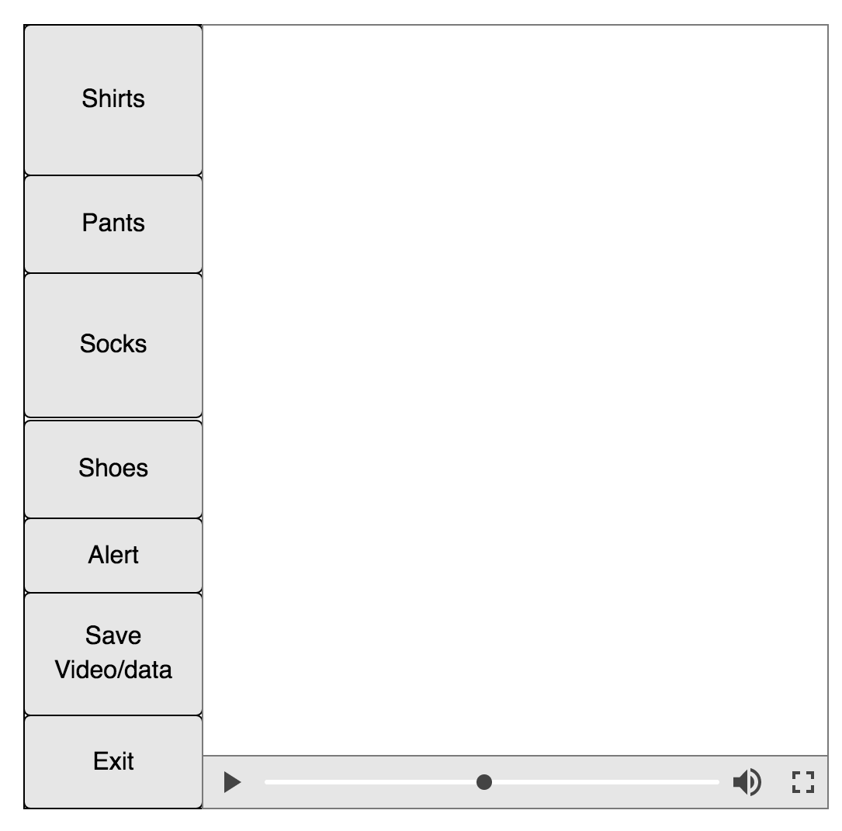

**Technical level:  
Nodejs covers server-side implement and Nodejs can call python script to achieve the following functionality of interface. A framework called Qt5 can handle interface implement. We can use some external library to build the voice into our program (easy task).**

**The priority of interface is the instruction window. **