**QUIZ: Objects**

Link to the quiz: [Quiz: Objects | Watch and Code](https://watchandcode.com/courses/350615/lectures/23007760)

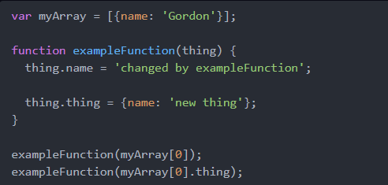

After the code above runs, which of the following statements will be true? (select at least one)

1. At some point, myArray will have a length of 2.
   1. False – 100%.
   2. The array still has one value.
2. At some point, myArray[0].thing.name will be equal to 'new thing'.
   1. True – 100%.
   2. In the first call to exampleFunction, myArray[0].thing.name will be will be equal to 'new thing'.
3. After the code runs, myArray[0].thing.thing.name will be equal to 'new thing'.
   1. True – 100%.
   2. Ran console.log(myArray[0].thing.thing.name) and the value is ‘new thing’.
4. None of the above.
   1. False – 100%.
   2. There exist a correct answer (number 3).