**Quiz: Visibility**

Link to the quiz: [Quiz: Visibility | Watch and Code](https://watchandcode.com/courses/350615/lectures/22948071)

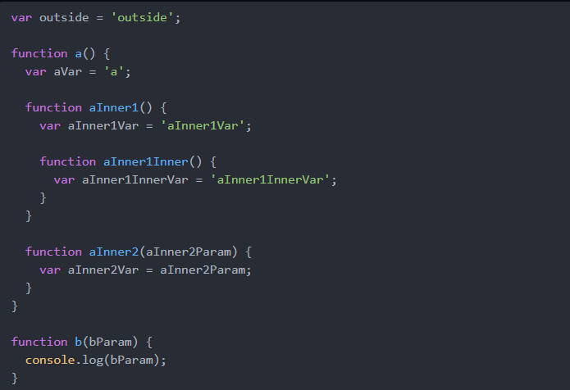

Which of the following statements are true? Select 1 or more.

1. a is visible to b
   1. True - 99%, a can be called by function b.
2. b and bParam are visible to a
   1. False - 99%.
   2. b can be called by function a, but the parameter bParam is outside the scope of a.
3. aInner1InnerVar is only visible to aInner1Inner and aInner1
   1. False - 99%.
   2. aInner1Innervar is also visible to a.
4. aInner1InnerVar is visible to aInner1Inner
   1. True - 99%.
   2. The variable aInner1InnerVar is located inside the function aInner1Inner.
5. aVar is visible to aInner2
   1. True - 99%.
   2. The variable is visible to the function aInner2.
6. aInner1Var is visible to aInner2
   1. False - 99%.
   2. aInner1Var is not visible.
7. aInner2Param is visible to aInner1.
   1. False - 99%.
   2. aInner1Var is not visible.
8. None of the above.
   1. False – 100%.
   2. There are true answers.