**Quiz: weirdToggleAll**

Link to the quiz: [Quiz: weirdToggleAll | Watch and Code](https://watchandcode.com/courses/350615/lectures/23090550)

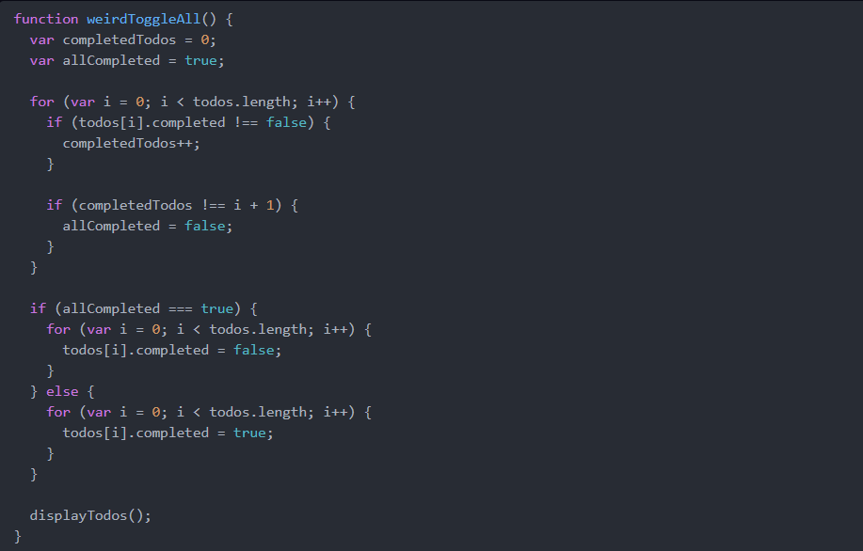

In this section, we wrote a toggleAll function. If we replaced toggleAll with weirdToggleAll, would our app still work the same as before?

1. Yes
   1. True 100%
   2. The functionality of the function will not change. Unless the function call is toggleAll, then it will not work.
2. No
   1. False 100%
   2. The name is only changed, not the functionality.