ABSTRACT
Background: Spinal infection requires etiological identification after clinical and imaging suspicion, but conventional culture often has limited yield because of low organism burden, prior antimicrobial exposure, and slow-growing or fastidious pathogens.
Methods: We conducted a retrospective study consecutively enrolling patients with clinically suspected spinal infection between July 2019 and November 2025. Patients who accepted metagenomic next-generation sequencing (mNGS) were included in this analysis. In total, this analysis included 820 records from 779 patients. Spinal infection was diagnosed using a clinical standard 1incorporating clinical suspicion, compatible imaging and supportive pathological, microbiological, operative or treatment-response evidence. Clinically interpreted mNGS reports were compared with conventional culture at patient and specimen-record levels.
Results: Final clinical adjudication classified 592 of 779 patients into the spinal infection cohort, contributing 628 infection-cohort records; 187 patients were classified as non-infection controls. In infection-cohort records, mNGS identified clinically relevant organisms in 462 of 628 records (73.6%), whereas culture was positive in 291 of 568 records with interpretable culture (51.2%). In the same-sample comparison set, mNGS positivity exceeded culture positivity (417 of 568 versus 291 of 568; exact McNemar P < 0.001). The added yield was concentrated in culture-negative records: mNGS identified clinically relevant organisms in 192 of 277 culture-negative records (69.3%). The largest detection gains were observed for Mycobacterium tuberculosis complex and fungi.
Conclusions: In this consecutive retrospective cohort, mNGS provided pathogen- and context-dependent culture-complementary etiological yield in spinal infection, especially for culture-negative, mycobacterial, fungal and other fastidious infections. The findings support targeted interpretation of clinically reported mNGS rather than unqualified replacement of culture.
Keywords: spinal infection; metagenomic next-generation sequencing; etiological yield; conventional culture; pathogen-stratified detection; culture-negative infection

INTRODUCTION
Spinal infection can involve the vertebral body, intervertebral disc, epidural space or paraspinal tissues, and delayed diagnosis can cause neurological injury, prolonged antimicrobial exposure, repeated procedures and persistent disability. Once clinical and imaging findings raise suspicion, management depends on pathogen identification rather than disease recognition alone.^{1,2}
Conventional culture remains necessary because it can recover viable organisms and provide antimicrobial susceptibility data, but its yield is constrained by low organism burden, prior antibiotics, slow growth and specimen quality.³⁻⁵ These constraints are especially relevant in percutaneous spinal sampling and in tuberculosis, Brucella, fungal, anaerobic and other fastidious infections.^{2,6,7}
mNGS has repeatedly produced higher pathogen-detection rates than culture in spinal infection cohorts.^{1,8,9} However, the field now needs more than proof of higher positivity. Recent syntheses highlight the need for larger consecutive cohorts, transparent disease adjudication, same-sample mNGS-culture matrices, non-infection comparators and pathogen-specific interpretation.^{10,11}
To address this gap, we evaluated clinically reported spinal-specimen mNGS and conventional culture in a consecutive retrospective cohort of 779 patients with suspected spinal infection. We asked whether mNGS added etiological information beyond culture, and whether this added yield differed across culture-negative disease, pathogen classes, antibiotic exposure and sampling approach.

RESULTS

Study flow and baseline characteristics
Between July 2019 and November 2025, all consecutive eligible spinal-specimen mNGS records from patients with clinically suspected spinal infection were included, yielding 820 records from 779 patients. Inclusion preceded clinical adjudication and was not conditioned on mNGS result, culture result, pathogen class, sampling approach, antibiotic exposure or final diagnosis (Fig. 1). Final adjudication classified 592 patients (76.0%) into the spinal infection cohort, contributing 628 specimen records for the primary record-level analyses; 187 patients (24.0%) were classified as non-infection controls. Among the 628 infection-cohort records, median age was 59.0 years (IQR, 49.0-67.0), 390 records (62.1%) were from male patients and 289 (46.0%) were from rural residents (Table 1). Pain was documented in 601 records (95.7%), neurological symptoms in 363 (57.8%) and activity limitation in 498 (79.3%). Median symptom duration before sampling was 105 days (IQR, 30-365), and median hospital stay was 10 days (IQR, 7-16). Prior antibiotic exposure was recorded in 214 records (34.1%), 568 records (90.4%) had interpretable conventional culture, and sampling was predominantly percutaneous (509 records, 81.1%). Full supporting distributions are provided in the supplementary tables.

Overall etiological detection yield of mNGS and culture
To compare etiological detection yield, we first summarized infection-cohort records and then tested the same-sample subset in which both mNGS and culture were interpretable. Among the 628 infection-cohort records, mNGS identified clinically relevant organisms in 462 records (73.6%). Culture was positive in 291 of 568 records with interpretable culture (51.2%). Patient-level detection was directionally consistent: among culture-evaluable patients, mNGS detected clinically relevant organisms more often than culture (75.8% versus 53.5%). In the 568-record same-sample comparison set, mNGS was positive in 417 records (73.4%) and culture was positive in 291 records (51.2%; exact McNemar P < 0.001; Fig. 2 and Table 2). Non-infection control summaries are provided in Supplementary Table 7 rather than treated as prospective blinded diagnostic-accuracy endpoints.

Discordant mNGS-culture results and culture-negative pathogen detection
Same-sample discordance located the added yield of mNGS mainly in culture-negative infection records. Among the 568 records with both tests available, both methods were positive in 225 records and both were negative in 85 records. Discordance was strongly asymmetric: 192 records were mNGS-positive/culture-negative, compared with 66 mNGS-negative/culture-positive records (exact McNemar P < 0.001). Among the 277 culture-negative records, mNGS identified clinically relevant organisms in 192 (69.3%). These detections included MTBC in 79 records, Gram-positive bacteria in 60, Gram-negative bacteria in 41, Brucella in 10 and fungi in 9; mixed-infection records could contribute to more than one pathogen class. The reverse discordant group was retained as a culture-only signal and is summarized in Supplementary Table 8 (Fig. 3 and Table 2).

Pathogen-stratified detection gain of mNGS over culture
Pathogen-stratified analyses showed that the detection gain of mNGS was concentrated in pathogen classes where culture is expected to be weakest. Among records with interpretable culture, the largest absolute gain was observed for MTBC: mNGS detected 89 of 97 records (91.8%), whereas culture detected 1 of 97 (1.0%; +90.7 percentage points). Fungi showed a 75.0-point gain (19 of 20 records, 95.0%, versus 4 of 20 records, 20.0%). Gains were also substantial for Gram-negative bacteria (107 of 124 records, 86.3%, versus 53 of 124 records, 42.7%; +43.5 points) and Brucella (40 of 44 records, 90.9%, versus 25 of 44 records, 56.8%; +34.1 points). In contrast, the gain was small for Gram-positive bacteria (185 of 243 records, 76.1%, versus 178 of 243 records, 73.3%; +2.9 points). These proportions are detection rates within adjudicated pathogen classes rather than independent analytic sensitivity estimates. Detection-pattern analysis further showed that MTBC was predominantly mNGS-only (88 records), whereas both-method detection was more frequent for Brucella (23 records) and Gram-positive bacteria (124 records; Fig. 4 and Table 3).

Detection across antibiotic exposure and sampling approach
Clinical-context analyses tested whether the mNGS detection-yield advantage persisted in settings that commonly weaken culture. In records with both tests available, mNGS detected 281 of 383 records (73.4%) without prior antibiotics and culture detected 202 of 383 records (52.7%; exact McNemar P < 0.001). With prior antibiotic exposure, mNGS detected 136 of 185 records (73.5%) and culture detected 89 of 185 records (48.1%; exact McNemar P < 0.001). By sampling approach, the gain was larger in percutaneous records (342 of 466, 73.4%, versus 228 of 466, 48.9%; exact McNemar P < 0.001) than in open-surgery records (75 of 102, 73.5%, versus 63 of 102, 61.8%; exact McNemar P = 0.111). First-record and patient-level sensitivity checks gave the same directional conclusion, making repeated sampling an unlikely sole explanation for the record-level difference (Fig. 5 and Supplementary Table 7).

DISCUSSION
The principal finding is that mNGS adds pathogen information in spinal infection, but the gain is context-specific rather than uniform. Its clearest value was recovery of clinically relevant organisms from culture-negative infection records and improved detection in pathogen classes that are difficult for conventional culture. This pattern was supported by same-sample test comparisons, pathogen-stratified analyses and clinically relevant sampling contexts.
These findings align with prior spinal infection studies reporting higher mNGS yield than culture.^{1,3,5} They are also consistent with recent systematic reviews and meta-analyses.^{10,13} The main advance here is not another unmatched positivity comparison; it is the combination of a large suspected-patient denominator, consecutive inclusion, explicit separation of the infection cohort from non-infection controls and same-sample test analyses. That design makes the result less vulnerable to case-mix and culture-availability artifacts that can inflate apparent diagnostic value.
Pathogen stratification shows where mNGS is most credible and clinically useful. The largest gains occurred for MTBC, fungal infections, Brucella and Gram-negative bacteria, supporting mNGS as a culture-complementary tool when slow-growing, fastidious or antibiotic-suppressed pathogens are suspected.¹⁴⁻¹⁶ Prior reports have similarly emphasized rare, fastidious and polymicrobial detections that are difficult to capture with culture alone.^{17,18} The small gain for Gram-positive bacteria, together with culture-positive/mNGS-negative records, is the strongest argument against replacing culture with mNGS.¹¹ Culture remains necessary for viable isolates, susceptibility testing and confirmation of common pyogenic bacteria.
The clinical-context analyses point in the same direction. mNGS retained similar detection rates regardless of prior antibiotic exposure, while the absolute gain over culture remained meaningful.^{3,4,7} The larger gain in percutaneous specimens is also biologically and clinically plausible: minimally invasive sampling is common in spinal infection, but culture recovery can be limited by organism burden and specimen constraints.^{2,5,6}
Two features of the data require careful interpretation. First, non-infection control metrics are post-adjudication summaries because controls were retrospectively identified, had limited covariate completeness and were not prospectively sampled under the same protocol. Second, mNGS positivity was adjudicated as clinical relevance, not raw sequence presence. This is appropriate for retrospective clinical data, but it can make apparent specificity stronger than it would be under a prospective blinded reference standard.^{8,19} The result should therefore be read as performance after clinical interpretation, not as evidence that raw mNGS output is inherently free of false-positive signals.
The main limitations are those expected from a retrospective diagnostic study.^{10,13} Consecutive inclusion reduced result-driven selection within the mNGS-tested population, but it did not eliminate real-world ordering, referral, sampling or culture-availability bias. The analytic workbook records the final composite diagnosis but does not independently encode every imaging, operative and treatment-response component needed to reconstruct the reference standard de novo. In addition, mNGS was analyzed as the clinically reported result; raw read-count thresholds, background-subtraction procedures and negative-control performance were not available for reanalysis. Treatment modification and hard clinical outcomes were also outside the present analysis, although prior studies have examined mNGS-guided management.^{9,17,20} Prospective studies with blinded adjudication, predefined interpretation rules and treatment-impact endpoints are needed.
In conclusion, clinically interpreted mNGS provided substantial pathogen- and context-dependent etiological yield in spinal infection, especially in culture-negative records and for MTBC, fungi, Brucella and Gram-negative bacteria. The defensible clinical message is targeted use with clinical adjudication, while culture remains necessary for viable isolates, antimicrobial susceptibility testing and confirmation of common pyogenic bacteria.

METHODS

Study design and participants
We performed a retrospective diagnostic-yield study of consecutive spinal-specimen mNGS records from patients with clinically suspected spinal infection at Nanfang Hospital between July 2019 and November 2025. Eligible records were identified from the institutional mNGS/laboratory database and included every spinal specimen submitted for mNGS during the study period from a patient with clinical suspicion of spinal infection. Consecutive inclusion was defined as inclusion irrespective of mNGS result, culture result, pathogen class, sampling approach, antibiotic exposure or final adjudicated infection status. Records without interpretable culture remained in the overall mNGS and disease-adjudication dataset but were excluded from same-sample mNGS-culture comparisons. Patient identity was deduplicated into study UIDs using name, sex, province, residence and age, with attention to admission-date effects on age. The final dataset contained 820 specimen records from 779 suspected patients. Reporting was aligned with STARD principles where applicable to a retrospective report-level diagnostic-yield analysis.

Clinical reference standard for spinal infection
Confirmed spinal infection required clinical suspicion, compatible MRI or CT findings and at least one supporting criterion. Clinical suspicion included spinal pain, fever or chills, abnormal inflammatory markers, neurological symptoms or related presentations. Imaging support included vertebral osteomyelitis, discitis, epidural abscess, paraspinal abscess or related infectious changes. Supporting evidence included infectious, suppurative or granulomatous histopathology; clinically relevant culture or conventional microbiological positivity; purulence or infected tissue observed during puncture or surgery; or improvement in symptoms, CRP, ESR, imaging or follow-up outcome after antimicrobial therapy. Tumour, degenerative disease, aseptic inflammation and postoperative noninfectious changes were classified as non-spinal infection when infection was not supported. The curated analytic workbook records final adjudicated infection status and selected supporting fields; Supplementary Table 9 provides a patient-level audit trace and identifies reference-standard components that were not separately encoded.

Diagnostic tests and positivity definitions
The analyzed mNGS and culture results were the clinically reported results recorded in the source database. mNGS was considered positive when the report listed an organism adjudicated as clinically relevant to the spinal infection syndrome. Organisms judged inconsistent with the clinical syndrome or annotated as contaminants were not counted as clinically relevant positives. Conventional culture was considered positive when an interpretable culture result yielded a clinically relevant pathogen. Blank, uninterpretable, coded zero and no-result culture entries were excluded from same-sample mNGS-culture comparisons. Raw mNGS read-count thresholds, negative-control handling, background-subtraction rules, sequencing-platform metadata and laboratory-level quality-control files were not available in the analytic dataset; the analysis therefore evaluates clinically interpreted mNGS reports rather than independently reprocessed raw sequencing output.

Analysis units
We used patient-level analyses for suspected-patient detection summaries and post-adjudication control summaries within the available adjudicated dataset. Because non-infection records had limited covariate completeness and were not prospectively sampled controls, specificity, positive predictive value and accuracy were not treated as primary independent diagnostic-accuracy endpoints. We used record-level analyses for infection-cohort specimens, same-sample mNGS-culture comparisons, pathogen-spectrum analyses, culture-negative rescue and clinical-context subgroup analyses. This separation was prespecified because some patients contributed more than one spinal specimen record.

Pathogen grouping
Adjudicated pathogens were grouped as Gram-positive bacteria, Gram-negative bacteria, MTBC, Brucella and fungi. Mixed infections were retained, so one record could contribute to more than one pathogen class. Final pathogen class could be informed by clinical adjudication and available microbiological evidence, including clinically reported mNGS or culture findings. Pathogen-class proportions were therefore interpreted as descriptive detection rates within adjudicated classes, not as analytic sensitivity estimates independent of the tests used for adjudication.

Statistical analysis
Continuous variables were summarized as median and interquartile range. Categorical variables were summarized as number and percentage. Detection proportions and post-adjudication diagnostic summaries were reported with Wilson 95% confidence intervals in the tables. Same-sample mNGS-culture positivity was compared using the exact McNemar test. Analyses were performed from the curated analytic dataset using prespecified Python scripts (Python 3.12.13, pandas 3.0.1 and NumPy 2.3.5), with exact-test and Wilson interval calculations implemented in the project analysis files.

Ethics and data availability
This retrospective study was approved by the institutional ethics committee under approval number NFEC-2024-539. The research dataset contains patient privacy information and cannot be publicly shared. De-identified data may be available from the corresponding author on reasonable request, subject to institutional approval.

ACKNOWLEDGEMENTS
This research was funded in part by National Natural Science Foundation of China grants 82402889 (ZC), Guangdong Basic and Applied Basic Research Foundation grant 2023A1515110749 (ZC), and Research Fund of Nanfang Hospital, Southern Medical University, grant 2023B002 (ZC).

AUTHOR CONTRIBUTIONS
Conceptualization: JS, ZC
Methodology: JS, ZC, XL, XA, XW
Investigation: ZC, XL, RZ, YW, XW
Visualization: ZC, XL
Funding acquisition: ZC, ZZ
Project administration: JS, ZC
Supervision: JS, ZZ, DQ, MZ
Writing original draft: ZC, XL, JS

REFERENCES
1. Zhang Y, Chen J, Yi X, et al. Evaluation of the metagenomic next-generation sequencing performance in pathogenic detection in patients with spinal infection. Front Cell Infect Microbiol 2022;12:967584. (In eng). DOI: 10.3389/fcimb.2022.967584.
2. Liu S, Xiang Y, Liu P, et al. Application of metagenomic next-generation sequencing in the precise and rapid diagnosis of spinal infections. Diagn Microbiol Infect Dis 2026;114(2):117165. (In eng). DOI: 10.1016/j.diagmicrobio.2025.117165.
3. Huang H, Shi J, Zheng M, et al. Pathogen detection in suspected spinal infection: metagenomic next-generation sequencing versus culture. Eur Spine J 2023;32(12):4220-4228. (In eng). DOI: 10.1007/s00586-023-07707-3.
4. Zhang QC, Li J, Zhang QY, et al. Influence factors of metagenomic next-generation sequencing negative results in diagnosed patients with spinal infection. Diagn Microbiol Infect Dis 2024;109(3):116278. (In eng). DOI: 10.1016/j.diagmicrobio.2024.116278.
5. Lv H, Liao S, Shi Z, et al. Application of metagenomic next-generation sequencing for rapid molecular identification in spinal infection diagnosis. Front Cell Infect Microbiol 2024;14:1382635. (In eng). DOI: 10.3389/fcimb.2024.1382635.
6. Li Z, Zhang Q, Lian X, et al. Value of metagenomic next-generation sequencing in the diagnosis of native pyogenic spinal infections: a multicenter, retrospective observational study. Spine J 2025;25(4):640-648. (In eng). DOI: 10.1016/j.spinee.2024.11.004.
7. Shi T, Lin Y, Zheng X, et al. Metagenomic next-generation sequencing for the clinical identification of spinal infection-associated pathogens. Front Cell Infect Microbiol 2024;14:1437665. (In eng). DOI: 10.3389/fcimb.2024.1437665.
8. Xu L, Zhou Z, Wang Y, Song C, Tan H. Improved accuracy of etiological diagnosis of spinal infection by metagenomic next-generation sequencing. Front Cell Infect Microbiol 2022;12:929701. (In eng). DOI: 10.3389/fcimb.2022.929701.
9. Wang C, Hu J, Gu Y, Wang X, Chen Y, Yuan W. Application of next-generation metagenomic sequencing in the diagnosis and treatment of acute spinal infections. Heliyon 2023;9(3):e13951. (In eng). DOI: 10.1016/j.heliyon.2023.e13951.
10. Ibrahim O, Aboushaala R, Ahmed N, et al. The diagnostic value of metagenomic next-generation sequencing versus traditional microbiological testing in native pyogenic spinal infections: A systematic review and meta-analysis. N Am Spine Soc J 2026;25:100840. (In eng). DOI: 10.1016/j.xnsj.2025.100840.
11. Li YC, Liu YX, Li L, Wang H, Zhao ZR, Yao ZY. Metagenomic next-generation sequencing (mNGS) versus tissue culture technique (TCT) in diagnosis of spinal infection: a systematic review and meta-analysis. Sci Rep 2025;15(1):20926. (In eng). DOI: 10.1038/s41598-025-06759-3.
12. Zhang B, Wang L, Wang J, Qi D, Zhang N. Comparative diagnostic performance of metagenomic next-generation sequencing and conventional microbial culture in spinal infections: a systematic review and meta-analysis. Front Cell Infect Microbiol 2026;16:1689254. (In eng). DOI: 10.3389/fcimb.2026.1689254.
13. Zhu Z, Miao X. Research progress of metagenomic next-generation sequencing in infectious diseases of the spine: a systematic review. Ther Adv Infect Dis 2026;13:20499361251412789. (In eng). DOI: 10.1177/20499361251412789.
14. Cheng H, Wu H, Tan N, et al. Diagnostic Efficacy of Metagenomic Next-Generation Sequencing in Patients with Spinal Infections: A Retrospective Study. Infect Drug Resist 2023;16:7613-7620. (In eng). DOI: 10.2147/idr.S435466.
15. Yin C, Cong Y, Wang H, et al. Pathogenic Detection by Metagenomic Next-generation Sequencing in Spinal Infections. Spine (Phila Pa 1976) 2025;50(4):E70-e75. (In eng). DOI: 10.1097/brs.0000000000005148.
16. Ali KA, He LX, Gao F, et al. Pathogen Detection in Spinal Infections: Next-Generation Sequencing Versus Conventional Microbiological Methods. Curr Med Sci 2025;45(2):331-340. (In eng). DOI: 10.1007/s11596-025-00040-4.
17. Chen J, Liu Y, Huang S, et al. Spinal Infections? mNGS Combined with Microculture and Pathology for Answers. Infect Drug Resist 2024;17:3025-3034. (In eng). DOI: 10.2147/idr.S466738.
18. Li C, Zhu J, Wang Y, Jiang W, Lin Y. Metagenomic NGS reveals determinants of polymicrobial spinal infection pathogenesis. Sci Rep 2025;15(1):13959. (In eng). DOI: 10.1038/s41598-025-99283-3.
19. Lin W, Xie F, Li X, et al. Diagnostic performance of metagenomic next-generation sequencing and conventional microbial culture for spinal infection: a retrospective comparative study. Eur Spine J 2023;32(12):4238-4245. (In eng). DOI: 10.1007/s00586-023-07928-6.
20. Qi M, Du Y, Guan J, et al. The clinical management and efficacy of metagenomic next-generation sequencing in patients with pyogenic spinal infection: a single-center cohort study. J Orthop Surg Res 2024;19(1):716. (In eng). DOI: 10.1186/s13018-024-05188-8.

Figure Legends
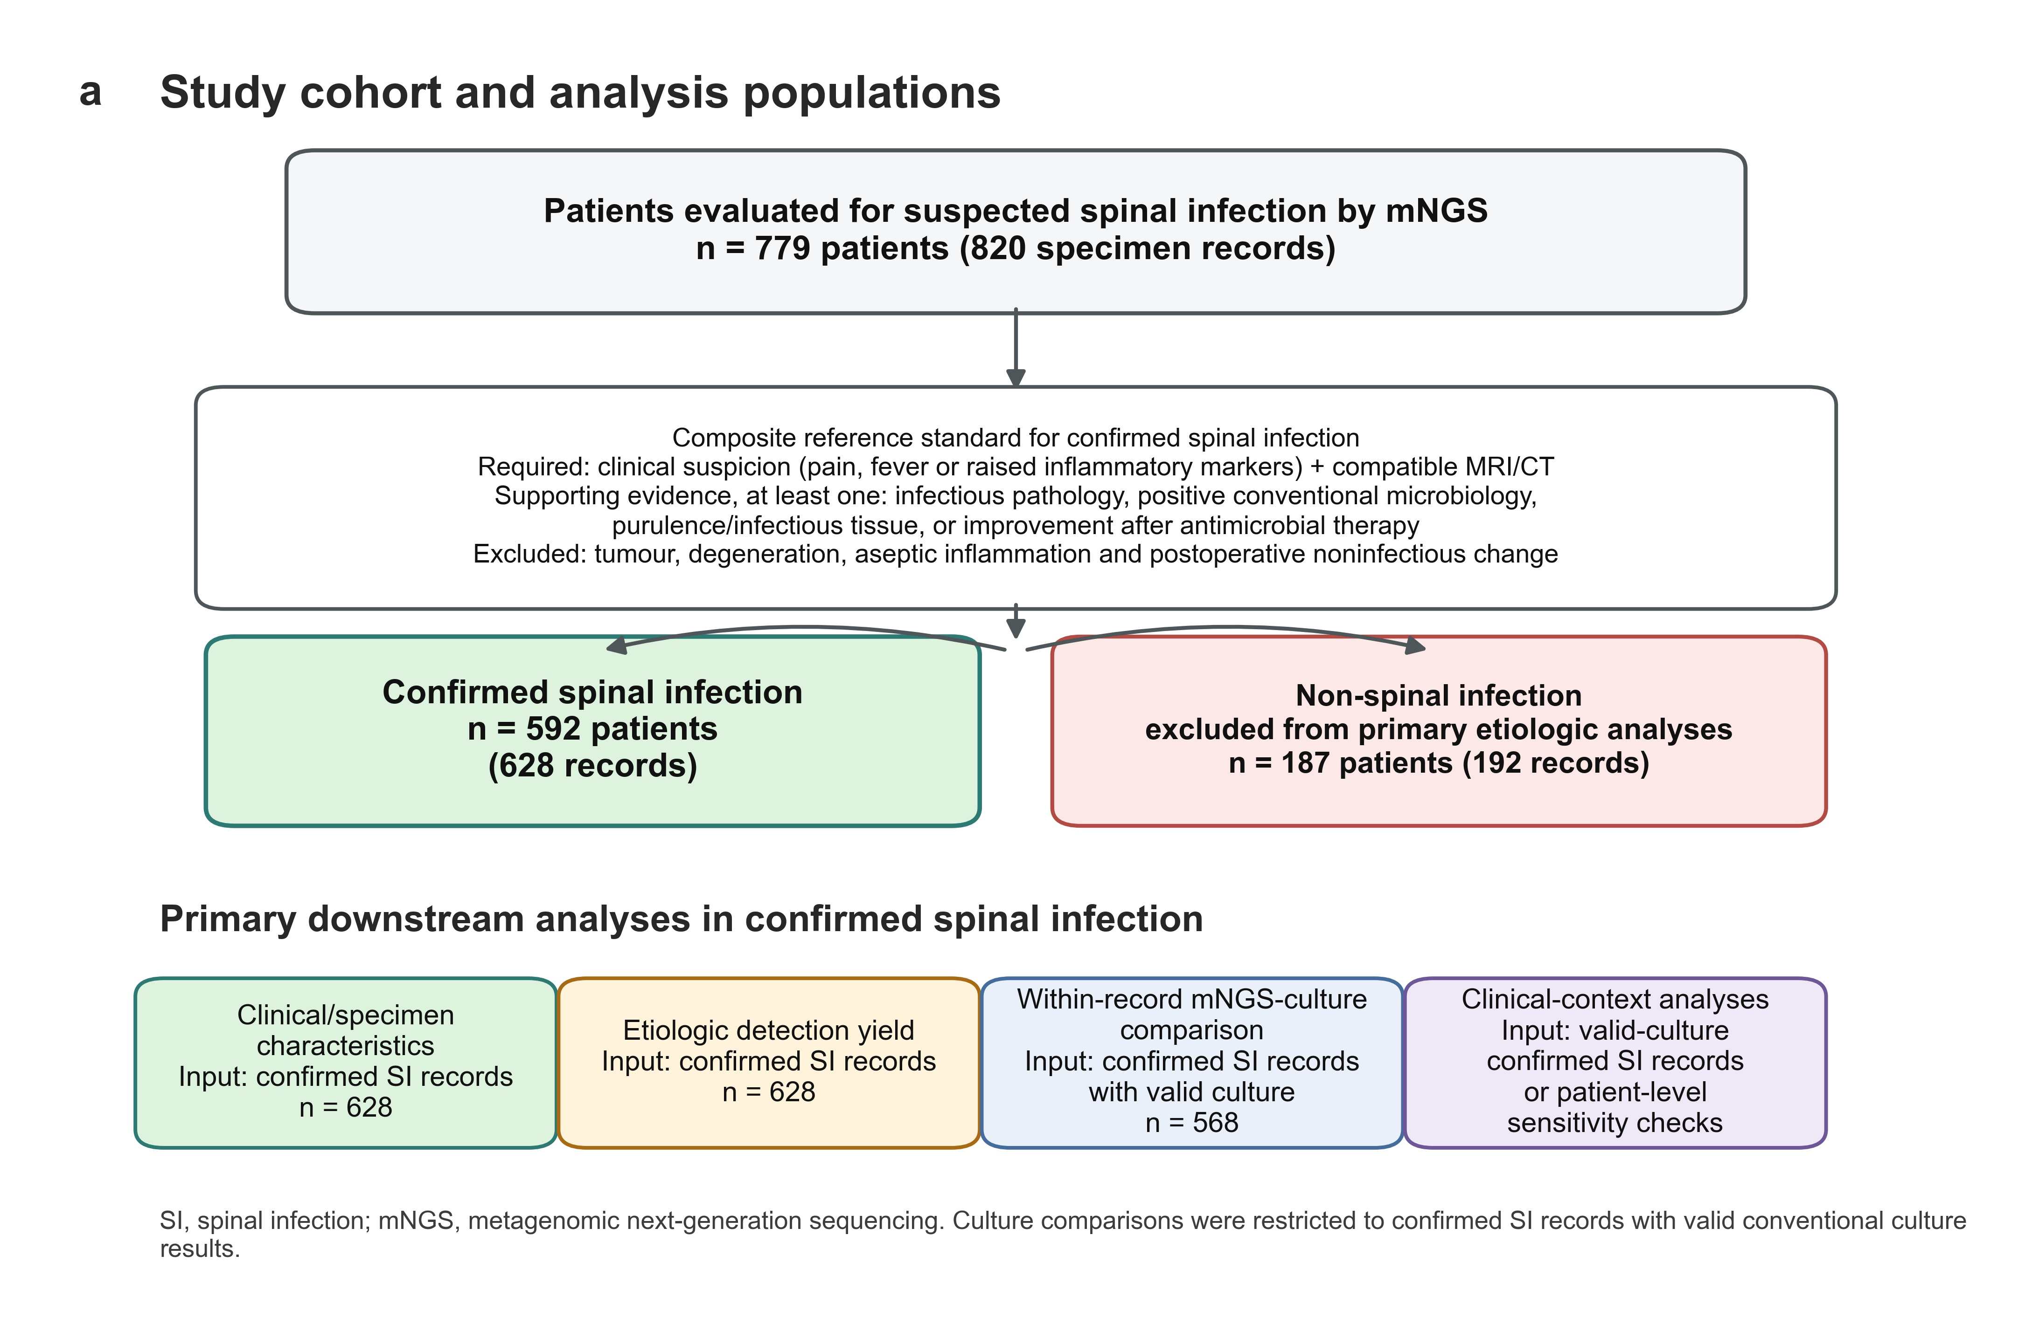
Fig. 1. Study flow and analysis populations. The flowchart shows consecutive inclusion of all eligible spinal-specimen mNGS records during the study period, the 820 records from 779 suspected patients, classification into the spinal infection cohort and non-infection controls, and the main downstream analysis modules. Inclusion was performed before adjudication and was not based on mNGS result, culture status, pathogen class, sampling approach, antibiotic exposure or final diagnosis. The spinal infection reference standard required clinical suspicion, compatible MRI or CT findings and at least one supportive pathological, microbiological, operative or treatment-response criterion after exclusion of noninfectious mimics.

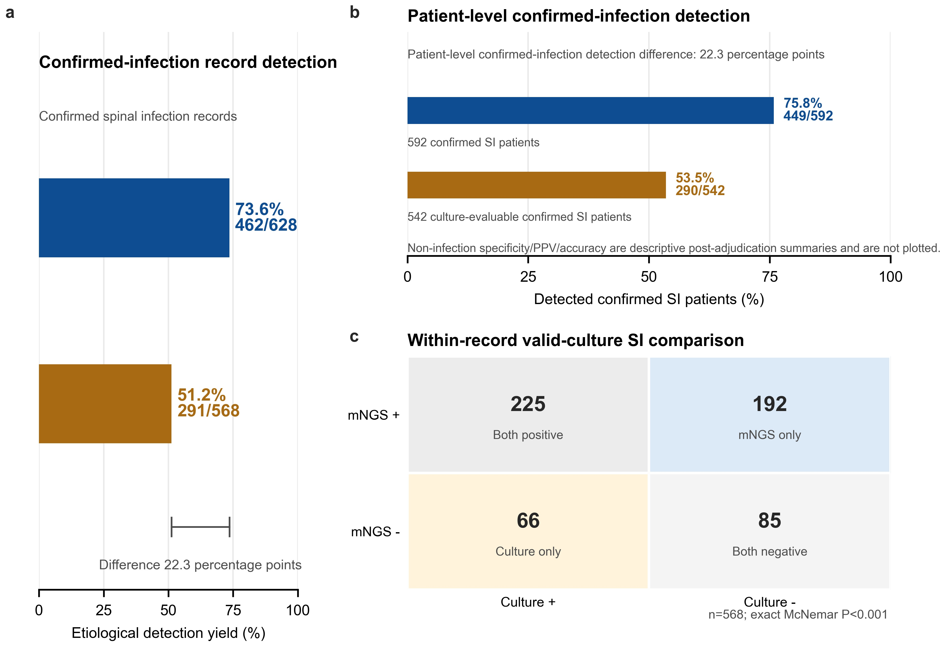
Fig. 2. Primary etiological detection-yield comparison of mNGS and conventional culture. The figure summarizes record-level pathogen detection, patient-level pathogen detection and the same-sample mNGS-culture comparison. Post-adjudication non-infection control summaries are provided in Supplementary Table 7 rather than plotted as primary endpoints.

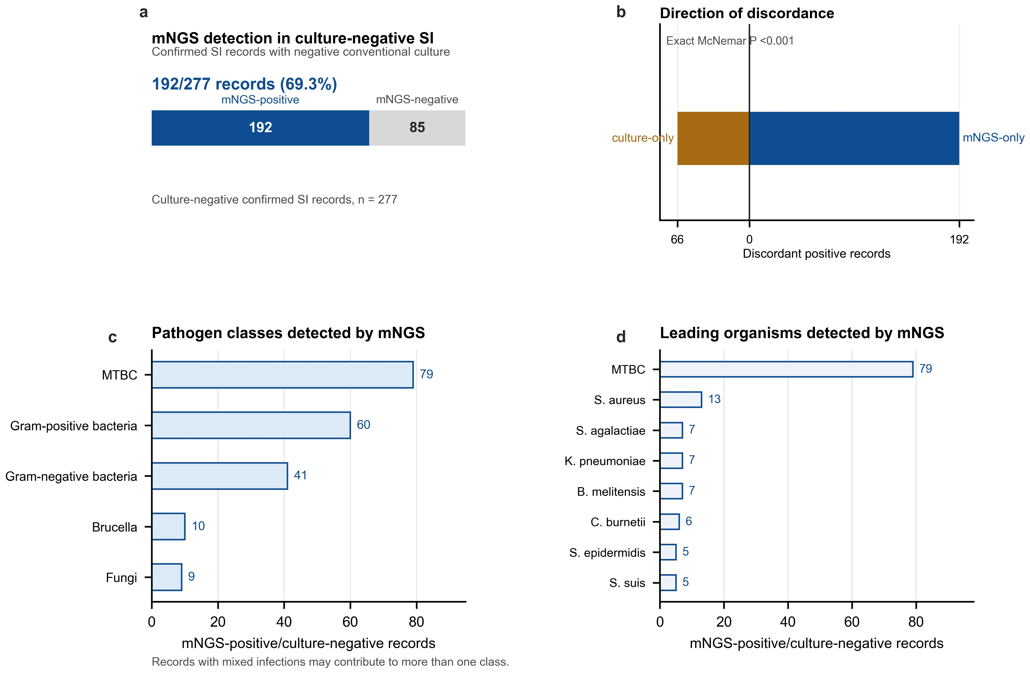
Fig. 3. Discordant mNGS-culture results and culture-negative pathogen detection. The figure shows the same-sample 2 by 2 matrix, the asymmetric discordance favouring mNGS-positive/culture-negative records and the pathogen classes identified by mNGS in culture-negative records. Mixed-infection records could contribute to more than one pathogen class.

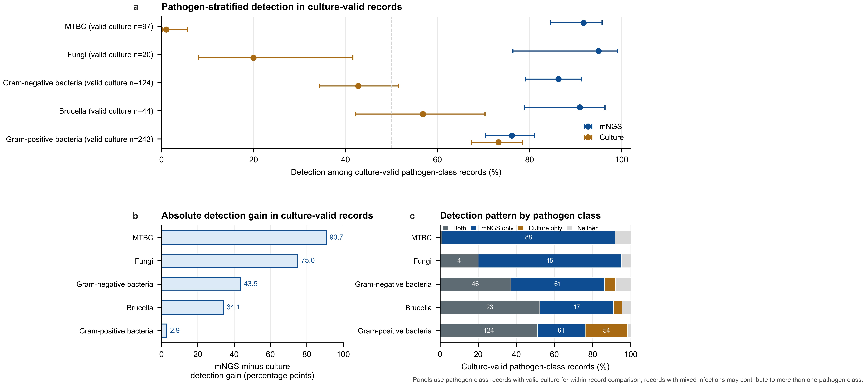
Fig. 4. Pathogen-stratified detection within adjudicated pathogen classes. The figure compares mNGS and culture detection for Gram-positive bacteria, Gram-negative bacteria, MTBC, Brucella and fungi, and summarizes detection-pattern composition by pathogen class. Mixed-infection records could contribute to more than one pathogen class.

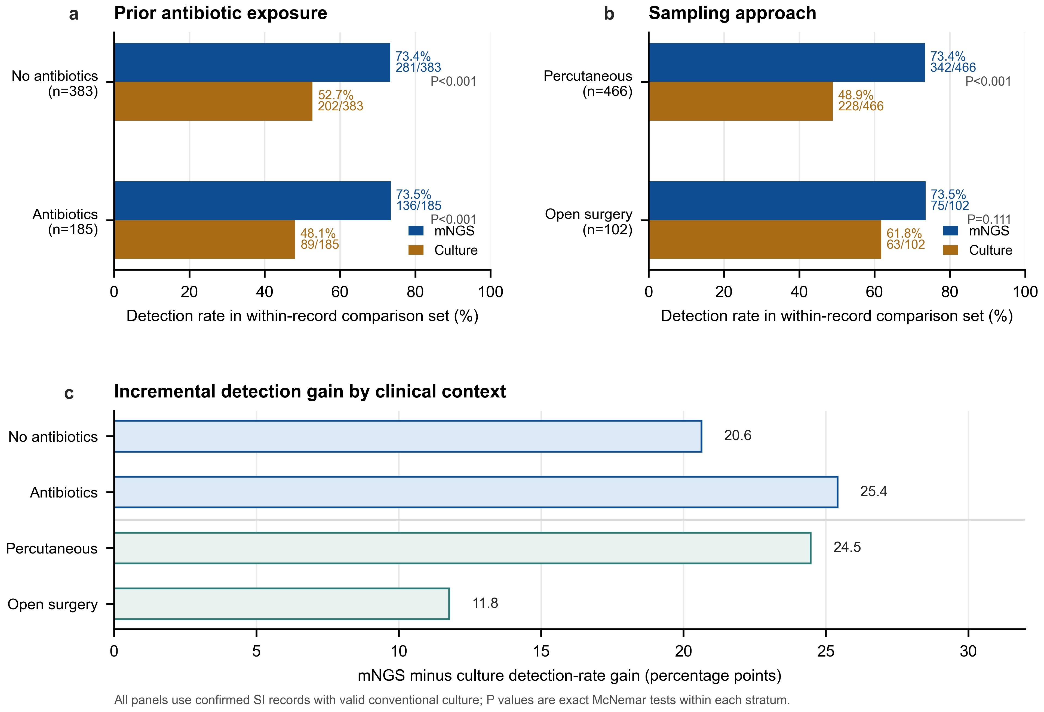
Fig. 5. Detection across antibiotic exposure and sampling approach. The figure compares mNGS and culture detection rates within antibiotic-exposure strata and sampling approaches among records with both tests available, and shows absolute mNGS-culture gains.

