Example assumptions:

- Please send us the setting of tango parameters to capture images from a camera using trigger signals on the fly. Please provide us example codes in C# or C++. By using Tango dll and API.
Customer uses Sentech camera which accepts hardware trigger input from Tango desktop controller.
Customer setting the stage pattern as 10 x 10 matrix in X and Y plane. Hence passes 100 points one by one in a series to move the stage. At present they move the stage and capture the image then move to next point. This way they scan the total area.
- Customer wants to program the tango controller such a way that, it sends trigger signal automatically to camera through Aux IO when stage moves from one point to next point, exactly at the midway between the points.
- Or else. They move the stage from one point to another point and will set exact no. trigger pulses at equal interval within this travel. So that they can take no of snapshots from camera and stitch the snapshots to create an accurate montage at high speed.
- Can you please send us example program in C# or C++ for the option 1 to 3. It will help the customer to integrate Tango with motorised stage and his application.

Introduction to Trigger
Best tool to understand Tango trigger output section is using our tool SwitchBoard at least for the very first steps and to get familiar with. In splash screen „Connect“ select check box „Show protocol window“ to follow Tango low level communication.
The menu „Commands“/„Trigger“ gives an overview about actual selected Trigger mode and all available configuration parameter.

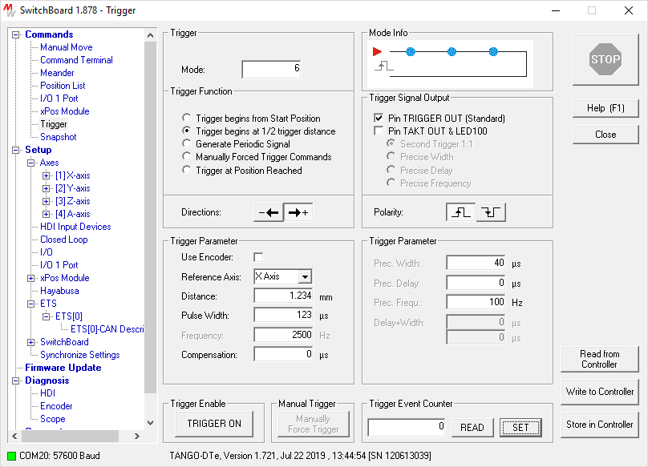
=> Before altering any settings make sure button „TRIGGER ON“ is not pressed.

From your given requirements one would select best:
- group box „Trigger“
  - Radio button „Trigger begins at ½ trigger distance“
  - maybe both direction buttons in case of moving meander (consider backlash)
- group box „Trigger Signal Output“
  - Select check box „Pin TRIGGER OUT“ (Standard)
    - Hint: If LED100 is connected, you may consider to select other trigger mode. This is more precise and will flash LED light while camera shutter is open.
  - Select polarity button (depend on required camera trigger input signal)
- group box „Trigger Parameter“
  - Select check box „Use Encoder“ in case of application given precision requirements
  - Pull down menu „Reference Axis“ to select trigger source
  - Text field „Distance“ to specify the required trigger distance
  - Text field „Pulse Width“ (depend on required camera trigger input signal)
  - Text field “Compensation” may without compensation. Thus 0 µs is o.k.
- group box „Trigger Event Counter“
  - May set to zero occasionally to proof if Tango has sent expected number of trigger pulses.

Trigger Low Level Commands
The open window “Tango Controller Protocol” traces all communication to and from the Tango. After selection of above or similar trigger data finally press button „TRIGGER ON“ to send all required low level trigger commands. Refer Tango Instruction Set reference manual for detailed explanation.

08:47:40.066 OUT: !trigo 1[CR]
08:47:40.068 OUT: ?err[CR]
08:47:40.068 IN : 0[CR]
08:47:40.071 OUT: !triga x[CR]
08:47:40.071 OUT: ?err[CR]
08:47:40.072 IN : 0[CR]
08:47:40.074 OUT: !trigm 6[CR]
08:47:40.076 OUT: ?err[CR]
08:47:40.076 IN : 0[CR]
08:47:40.078 OUT: !trigs 123[CR]
08:47:40.080 OUT: ?err[CR]
08:47:40.080 IN : 0[CR]
08:47:40.082 OUT: !trigd 1.234[CR]
08:47:40.084 OUT: ?err[CR]
08:47:40.084 IN : 0[CR]
08:47:40.088 OUT: !trigf 2500.000000[CR]
08:47:40.090 OUT: ?err[CR]
08:47:40.091 IN : 0[CR]
08:47:40.094 OUT: !trigenc 0[CR]
08:47:40.096 OUT: ?err[CR]
08:47:40.097 IN : 0[CR]
08:47:40.100 OUT: !trigcomp 0[CR]
08:47:40.102 OUT: ?err[CR]
08:47:40.103 IN : 0[CR]
08:47:40.106 OUT: !trigbdelay 0.000[CR]
08:47:40.108 OUT: ?err[CR]
08:47:40.109 IN : 0[CR]
08:47:40.112 OUT: !trigbwidth 40.000[CR]
08:47:40.114 OUT: ?err[CR]
08:47:40.115 IN : 0[CR]
08:47:40.118 OUT: !trigbf 100.000[CR]
08:47:40.122 OUT: ?err[CR]
08:47:40.123 IN : 0[CR]
08:47:40.126 OUT: !trigcount 0[CR]
08:47:40.127 OUT: ?err[CR]
08:47:40.129 IN : 0[CR]
08:47:40.132 OUT: !trig 1[CR]
08:47:40.136 OUT: ?err[CR]
08:47:40.140 IN : 0[CR]

Using DLL Trigger Functions
Following DLL functions give same functionality as above low level example.

LSX_SetTriggerPar (iLSID, FALSE);
LSX_SetTriggerOutput (iLSID, 1);
LSX_SetTriggerPar (iLSID, 1, 6, 123, 1.2345);
LSX_SetTriggerEncoder (iLSID, 0);
LSX_SetTriggerCompensation (iLSID, 0);
LSX_Set2ndTriggerDelay (iLSID, 0.0):
LSX_Set2ndTriggerWidth (iLSID, 40.0);
LSX_Set2ndTriggerFrequency (iLSID, 100.0);
LSX_SetTriggerCount (iLSID, 0);
LSX_SetTriggerPar(iLSID, TRUE);

Combination of Trigger with simple Meander
You may use the SwitchBoard menu „Commands“/”Meander” in combination with trigger.

=> Before selecting any meander parameter, make sure button „TRIGGER ON“ is not pressed.

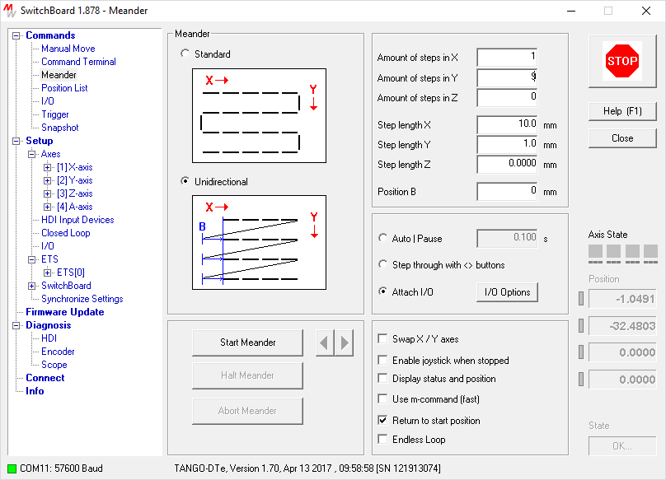
Move XY stage to area of interest.

Pressing “Start Meander” will scan an area of 10mm by 10mm in 10 unidirectional scan lines. “In the fly” is done, because X axis moves 10mm in one step without stopping after each 1mm.
Y axis moves 1mm in 9 steps (10 X lines).

Now press “TRIGGER ON” at the start point of the 10x10 area and “Start Meander”.
After “Return to start position” the group box “Trigger Event Counter” should return the expected number of 100 trigger pulses after pressing “READ”. Please refer low level command ?trigcount or DLL function LSX_GetTriggerLevel(int lLSID, int *plValue) for any further details.

Sample C# Program

