An Analysis Of Washington State School Districts That Ran A School Bond In 2020

Table of Contents
Summary: Large (Greater than 10,000 students) School Districts 3
Summary: Small (Fewer than 10,000 Students) School Districts 4
Aberdeen School District 5
District Advertised Cost 5
Actual Cost Determined From This Analysis 5
Arlington School District 6
District Advertised Cost 6
Actual Cost Determined From This Analysis 6
Bellevue School District 7
District Advertised Cost 7
Actual Cost Determined From This Analysis 7
Burlington Edison School District 8
District Advertised Cost 8
Actual Cost Determined From This Analysis 8
Castle Rock School District 9
District Advertised Cost 9
Actual Cost Determined From This Analysis 10
Eatonville School District 11
District Advertised Cost 11
Actual Cost Determined From This Analysis 11
Edmonds School District 12
District Advertised Cost 12
Actual Cost Determined From This Analysis 12
Elma School District 13
District Advertised Cost 13
Actual Cost Determined From This Analysis 13
Entiat School District 14
District Advertised Cost 14
Actual Cost Determined From This Analysis 14
Everett School District 15
District Advertised Cost 15
Actual Cost Determined From This Analysis 15
Kittitas School District 16
District Advertised Cost 16
Actual Cost Determined From This Analysis 16
Mukilteo School District 17
District Advertised Cost 17
Actual Cost Determined From This Analysis 17
North Thurston School District 18
District Advertised Cost 18
Actual Cost Determined From This Analysis 19
Oakville School District 20
District Advertised Cost 20
Actual Cost Determined From This Analysis 20
Pullman School District 21
District Advertised Cost 21
Actual Cost Determined From This Analysis 21
Ridgefield School District 22
District Advertised Cost 22
Actual Cost Determined From This Analysis 22
Riverview School District 23
District Advertised Cost 23
Actual Cost Determined From This Analysis 23
Rochester School District 24
District Advertised Cost 24
Actual Cost Determined From This Analysis 24
Snohomish School District 25
District Advertised Cost 25
Actual Cost Determined From This Analysis 25
Sumner School District 26
District Advertised Cost 26
Actual Cost Determined From This Analysis 27
Tacoma School District 28
District Advertised Cost 28
Actual Cost Determined From This Analysis 28

Summary: Large (Greater than 10,000 students) School Districts
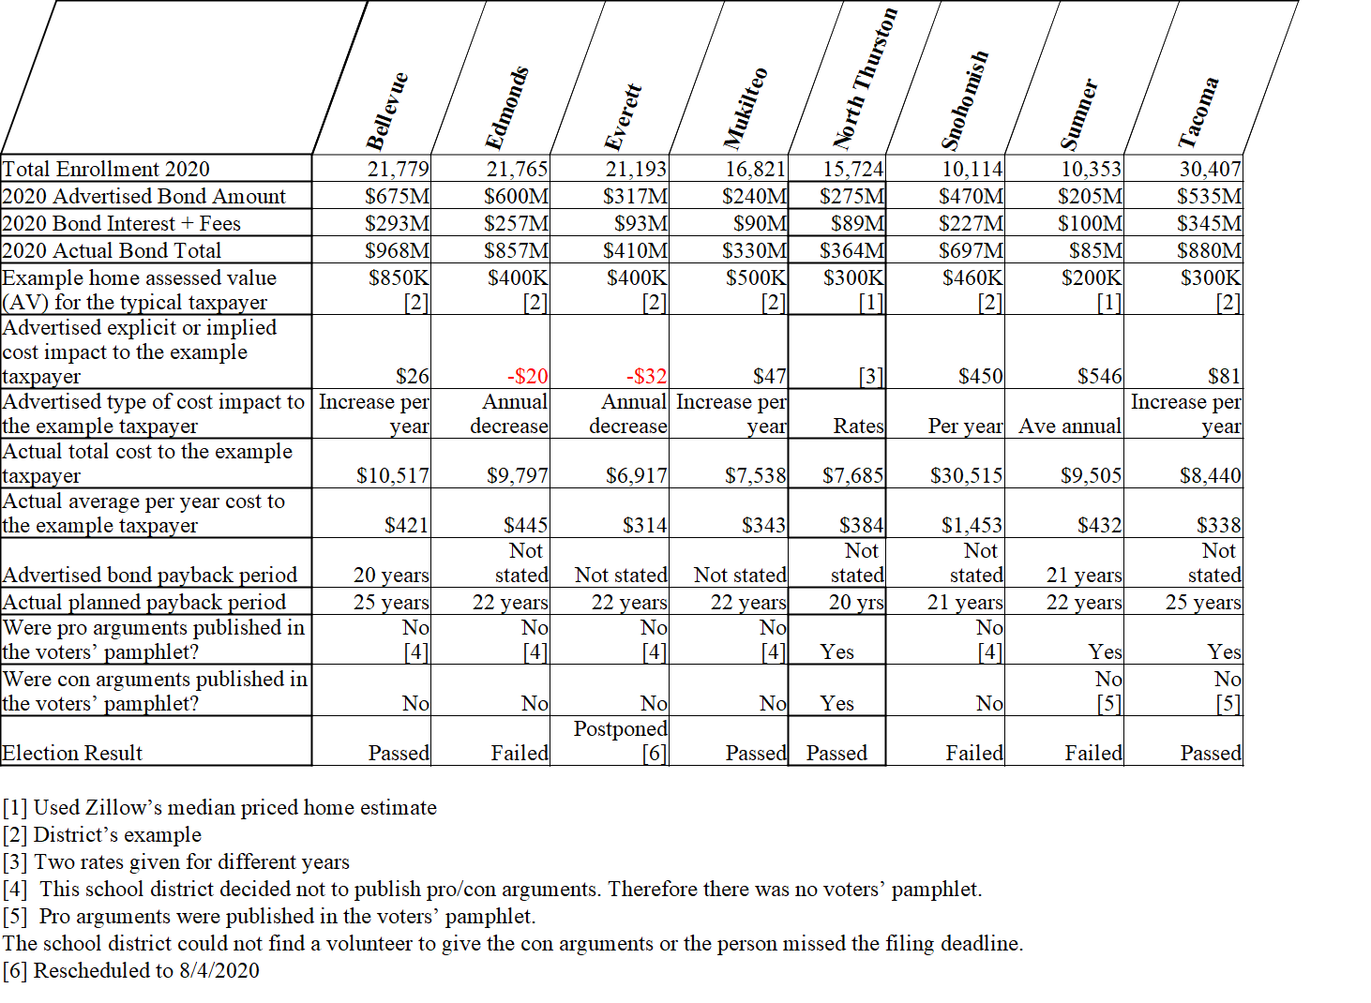

Summary: Small (Fewer than 10,000 Students) School Districts
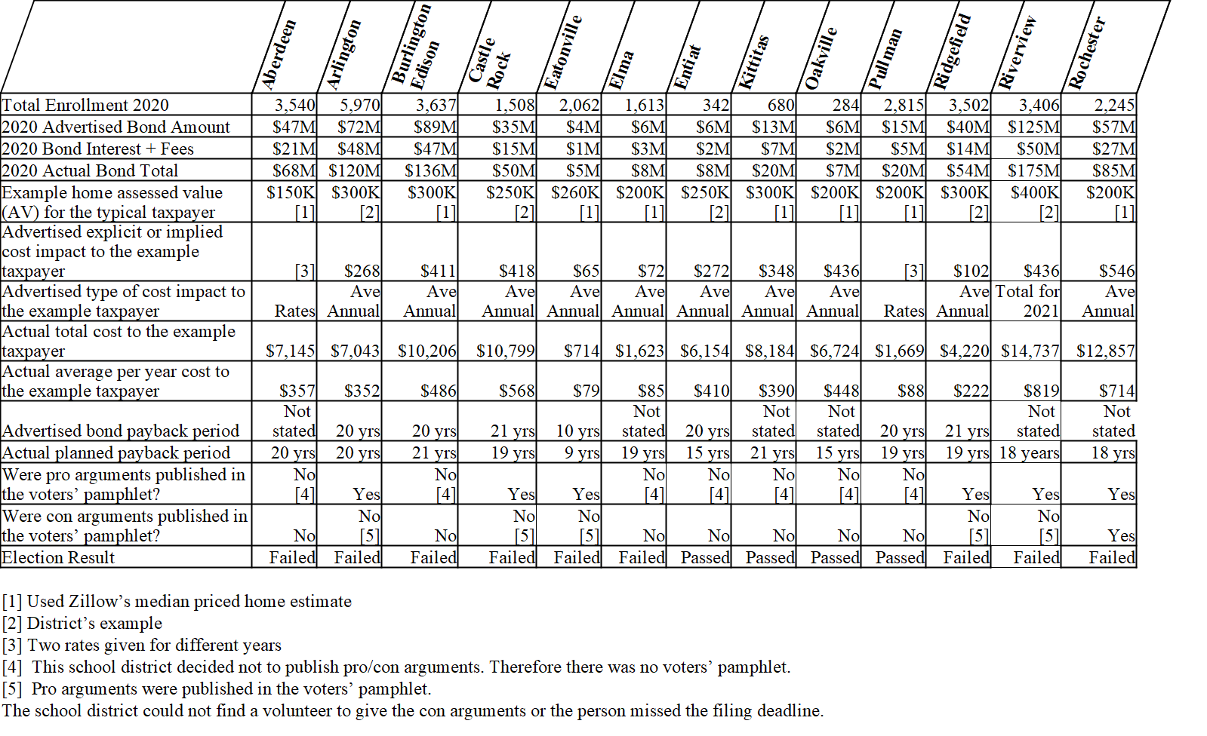

Aberdeen School District

District Advertised Cost
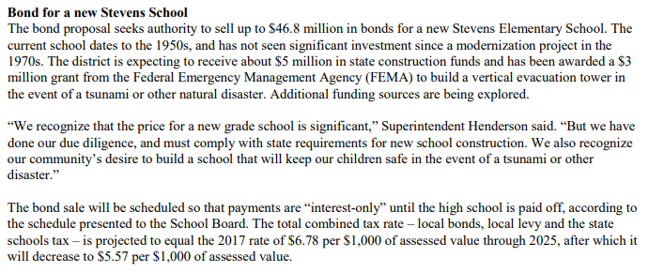

Actual Cost Determined From This Analysis
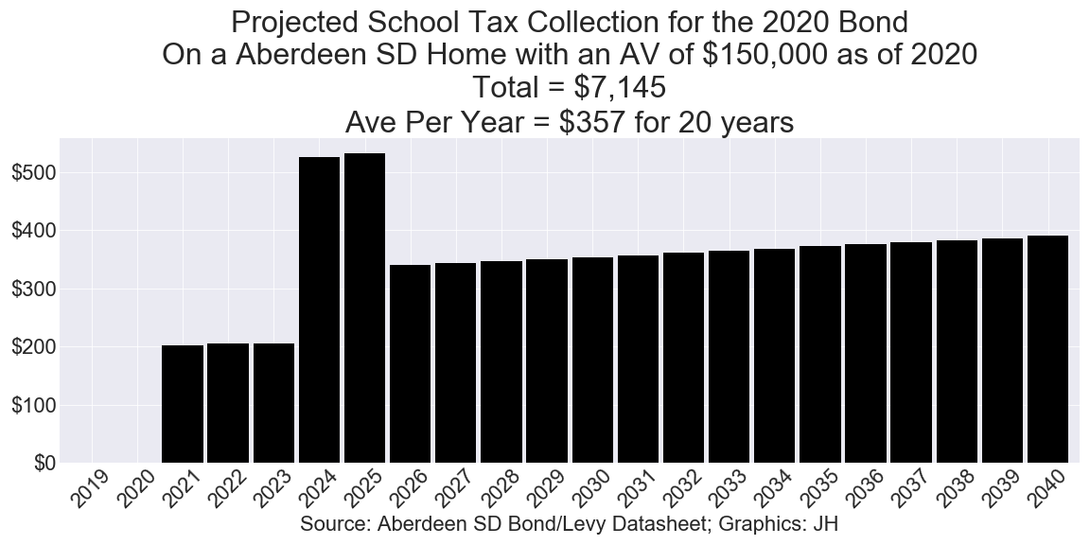

Arlington School District

District Advertised Cost
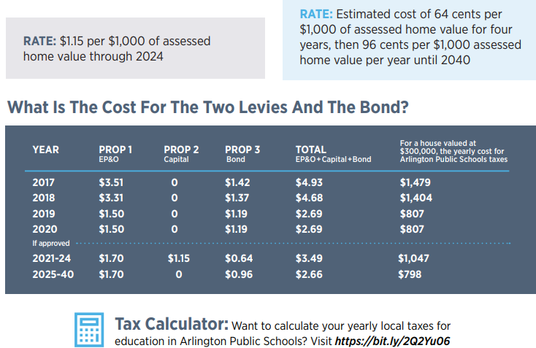

Actual Cost Determined From This Analysis
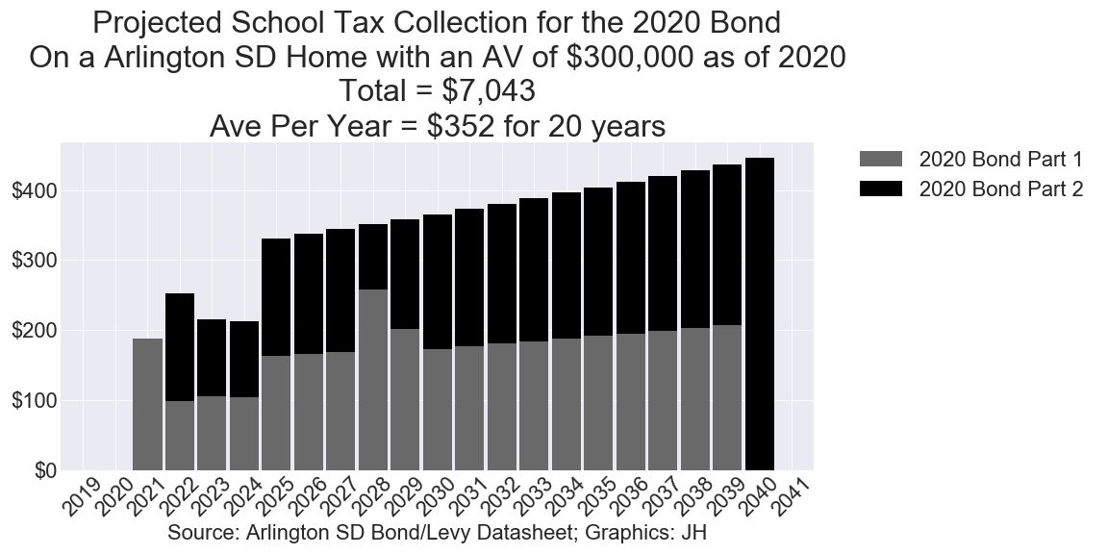

Bellevue School District

District Advertised Cost
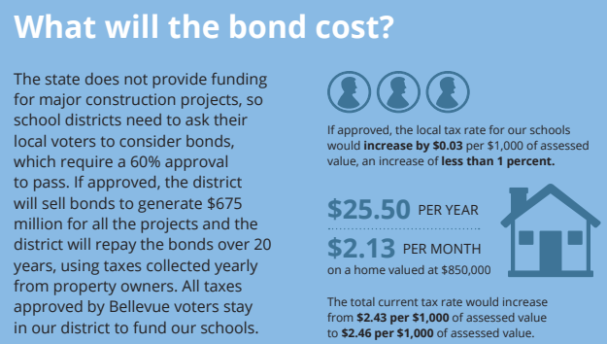

Actual Cost Determined From This Analysis
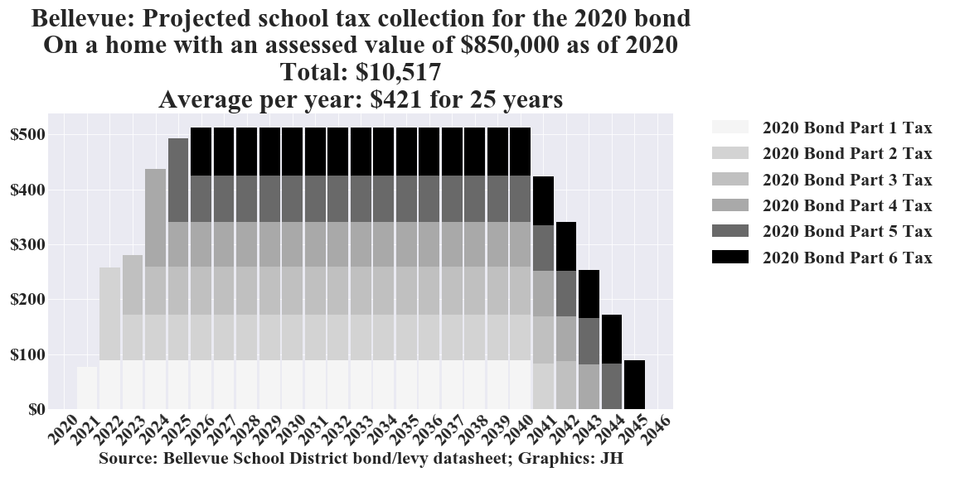

Burlington Edison School District

District Advertised Cost
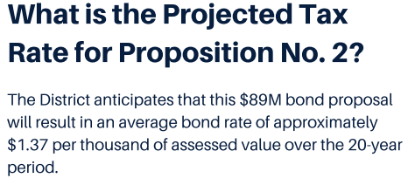

Actual Cost Determined From This Analysis
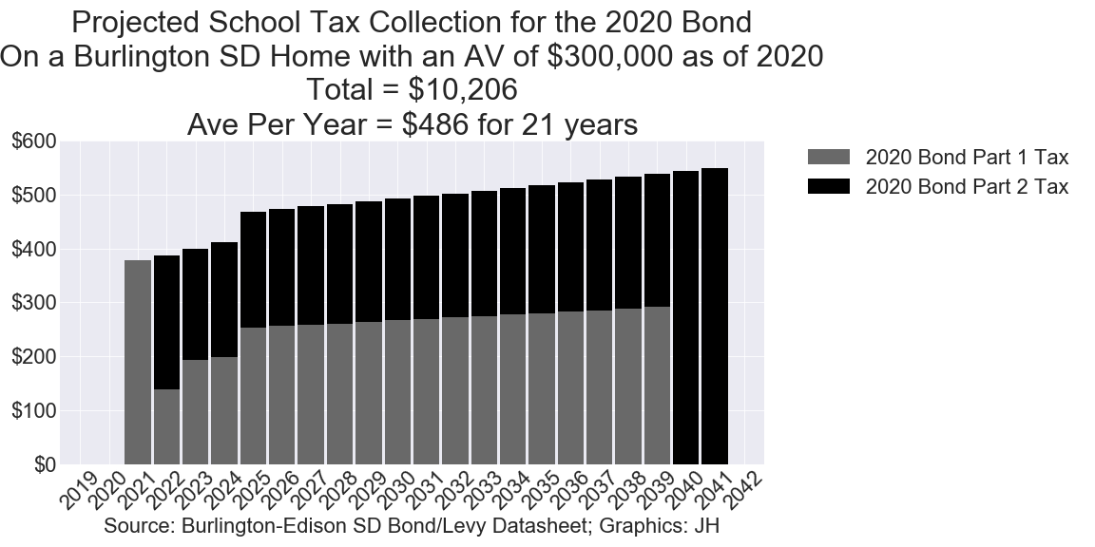

Castle Rock School District

District Advertised Cost
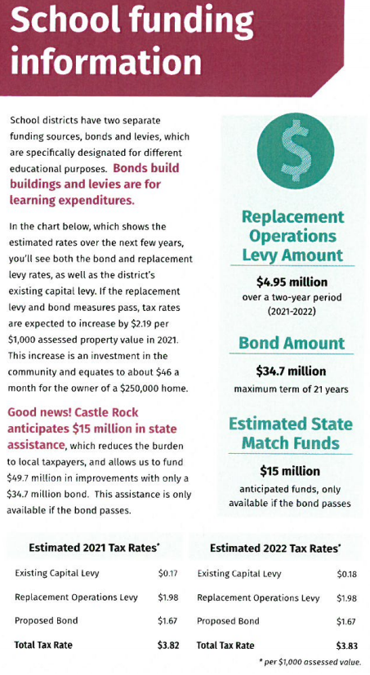

Actual Cost Determined From This Analysis
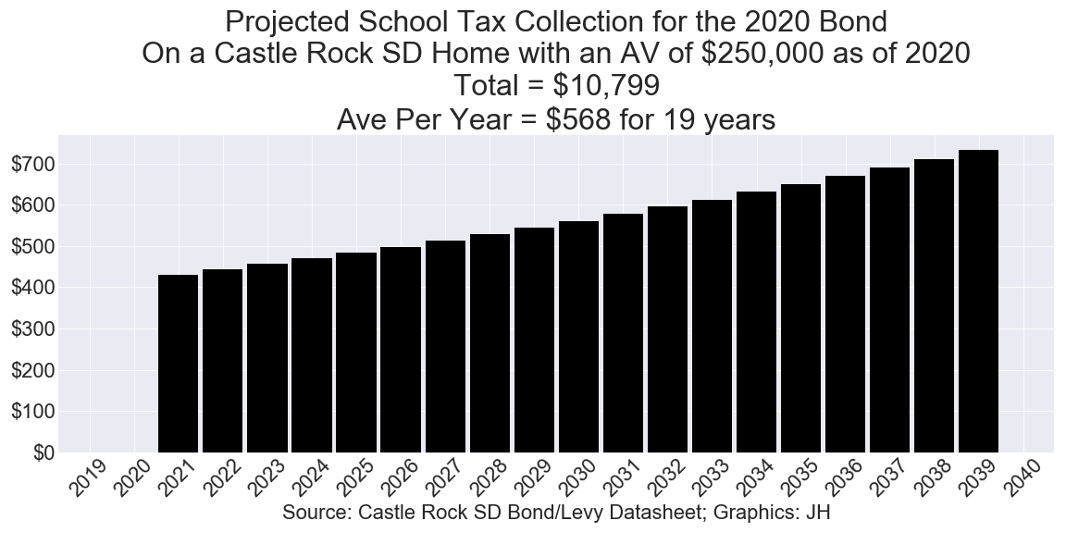

Eatonville School District

District Advertised Cost

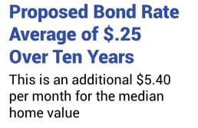

Actual Cost Determined From This Analysis

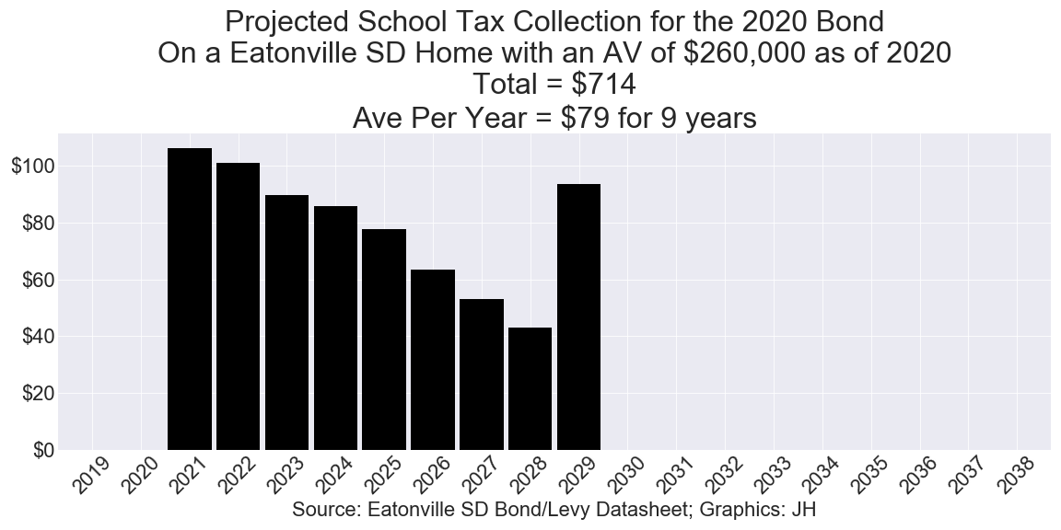

Edmonds School District

District Advertised Cost
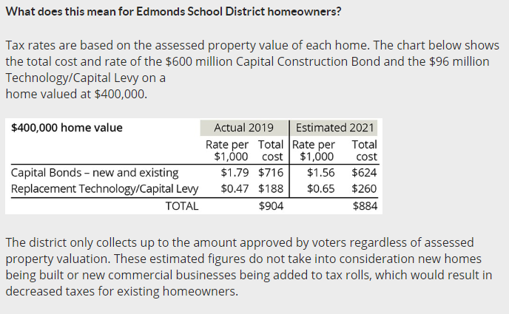

Actual Cost Determined From This Analysis

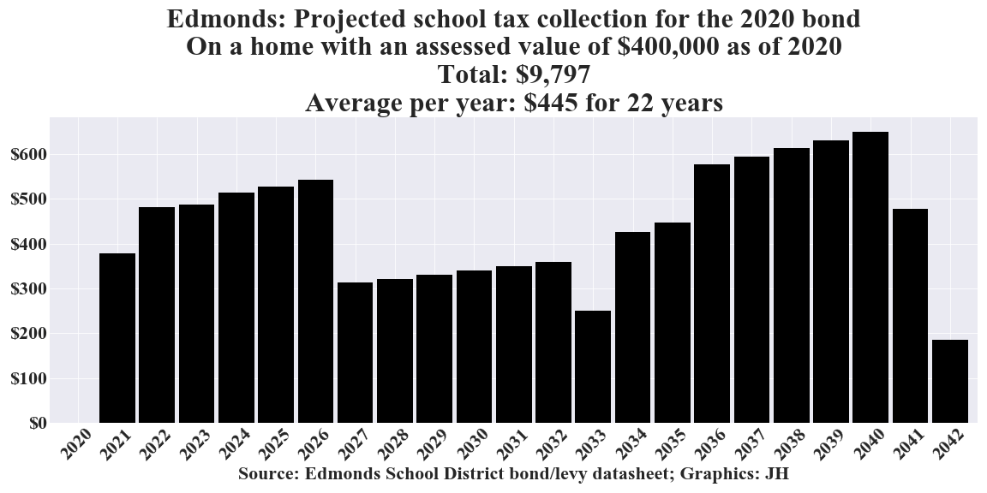

Elma School District

District Advertised Cost
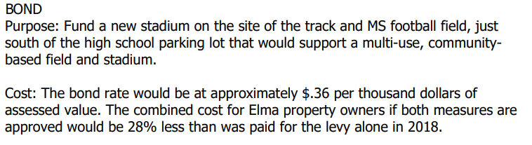

Actual Cost Determined From This Analysis
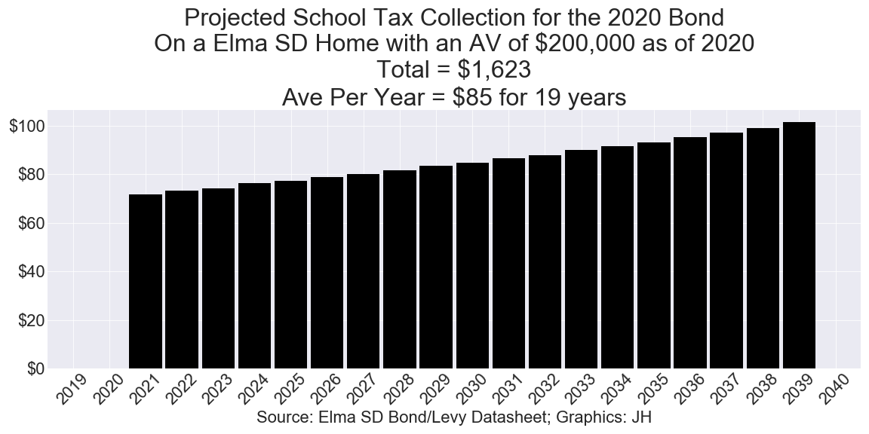

Entiat School District

District Advertised Cost
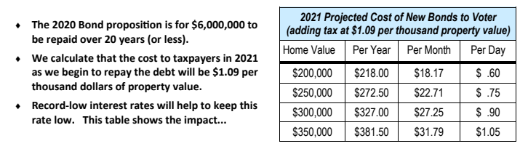

Actual Cost Determined From This Analysis
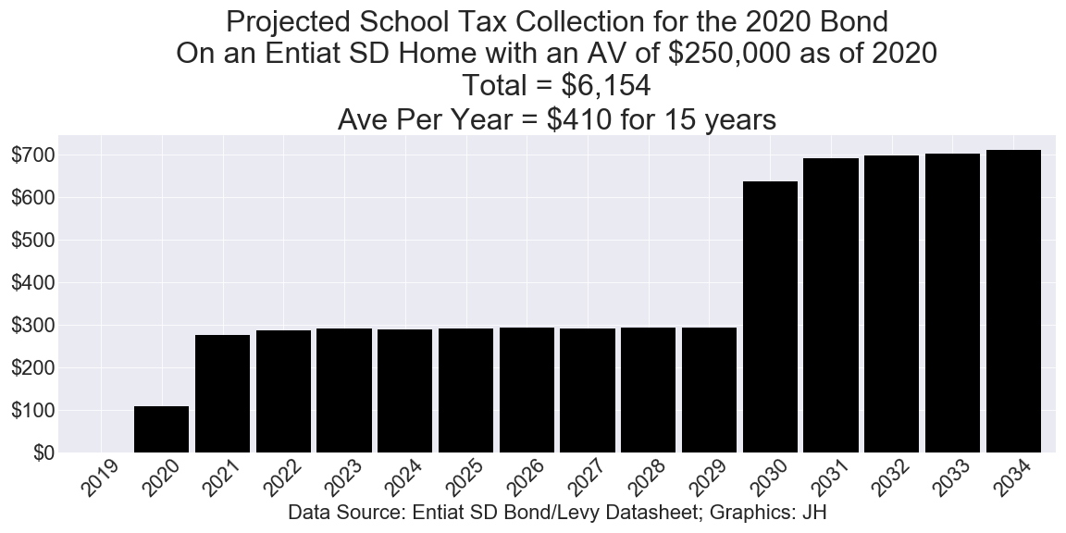

Everett School District

District Advertised Cost
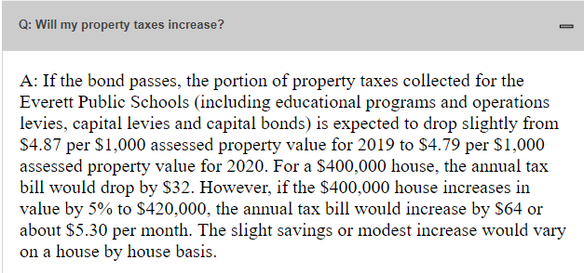

Actual Cost Determined From This Analysis
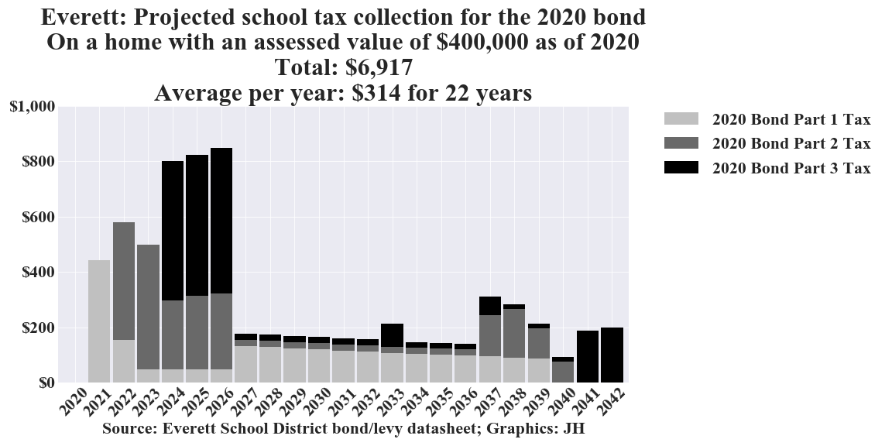

Kittitas School District

District Advertised Cost
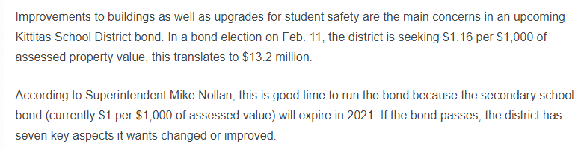

Actual Cost Determined From This Analysis
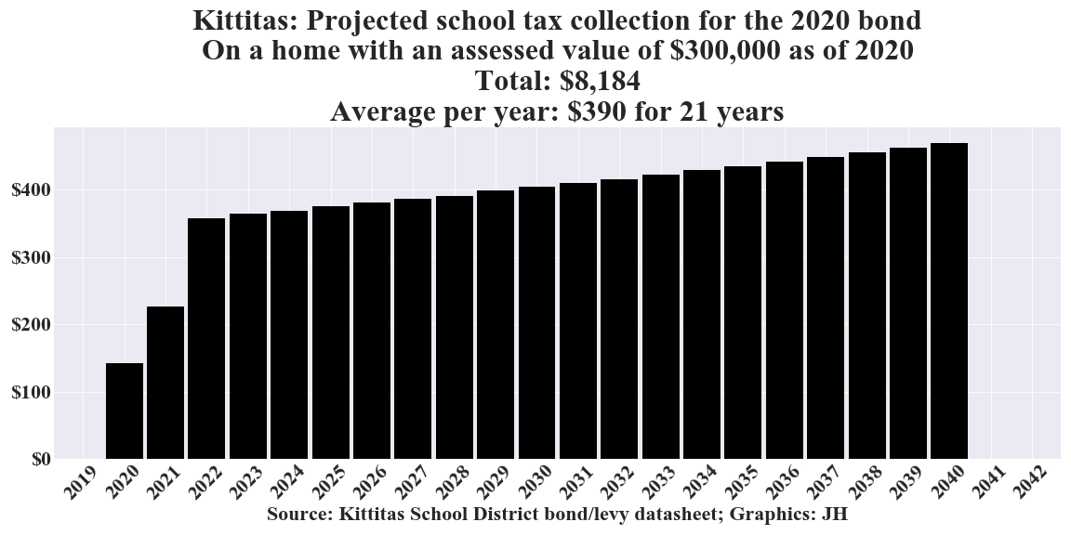

Mukilteo School District

District Advertised Cost
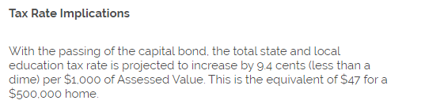

Actual Cost Determined From This Analysis
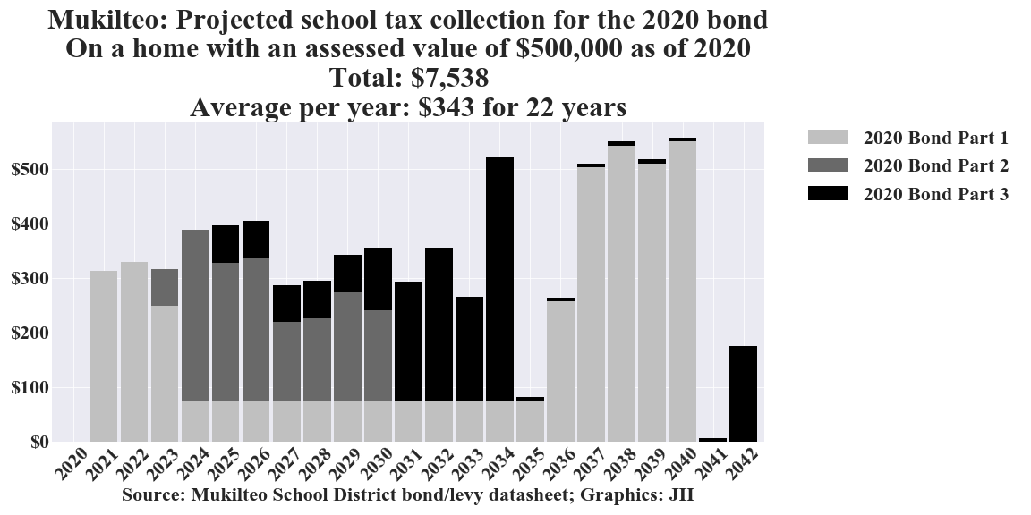

North Thurston School District

District Advertised Cost
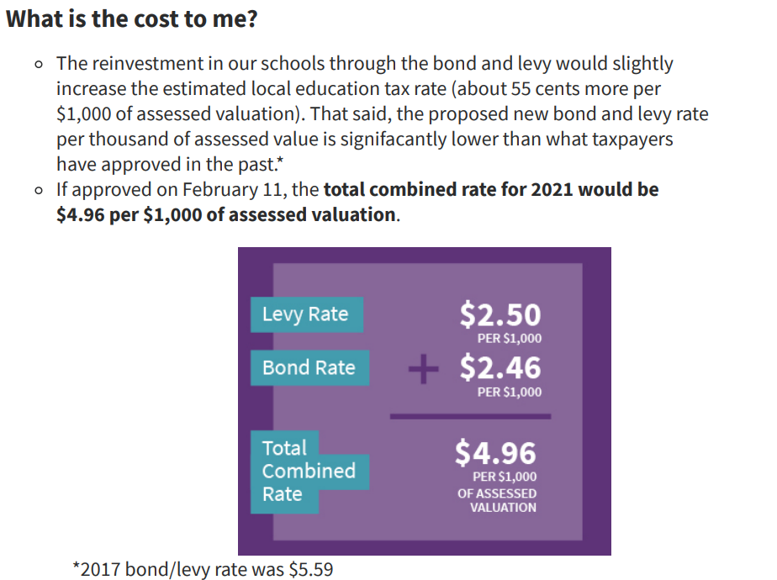

Actual Cost Determined From This Analysis
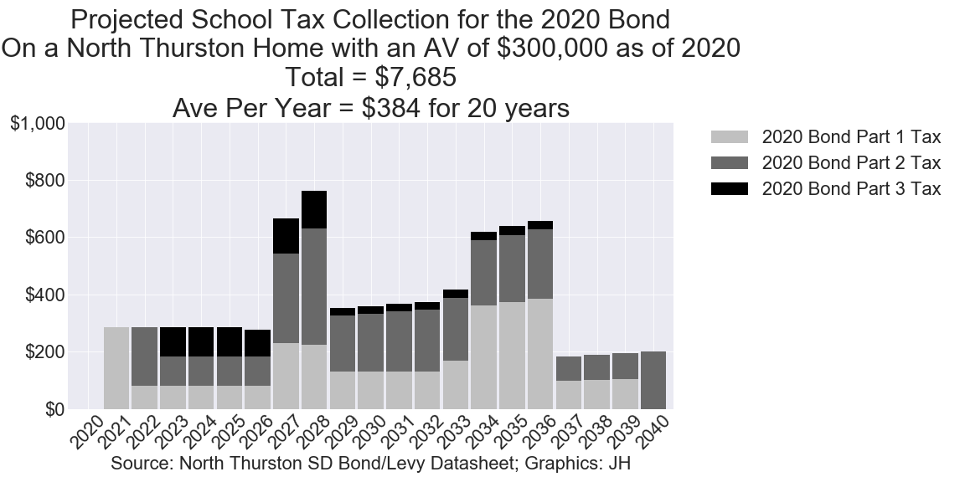

Oakville School District

District Advertised Cost
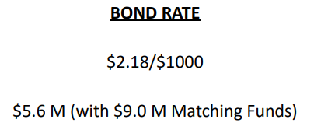

Actual Cost Determined From This Analysis

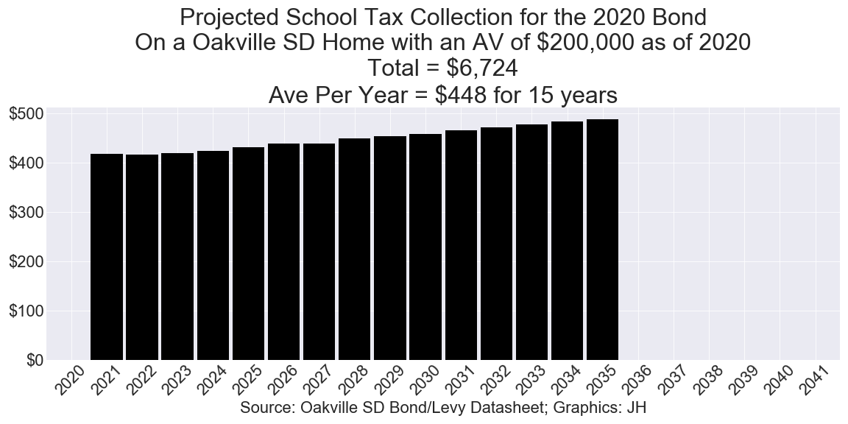

Pullman School District

District Advertised Cost
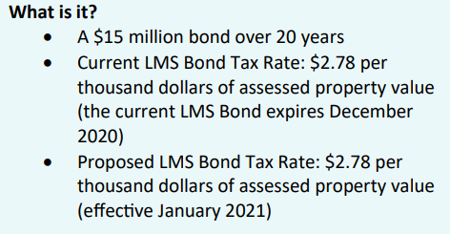

Actual Cost Determined From This Analysis
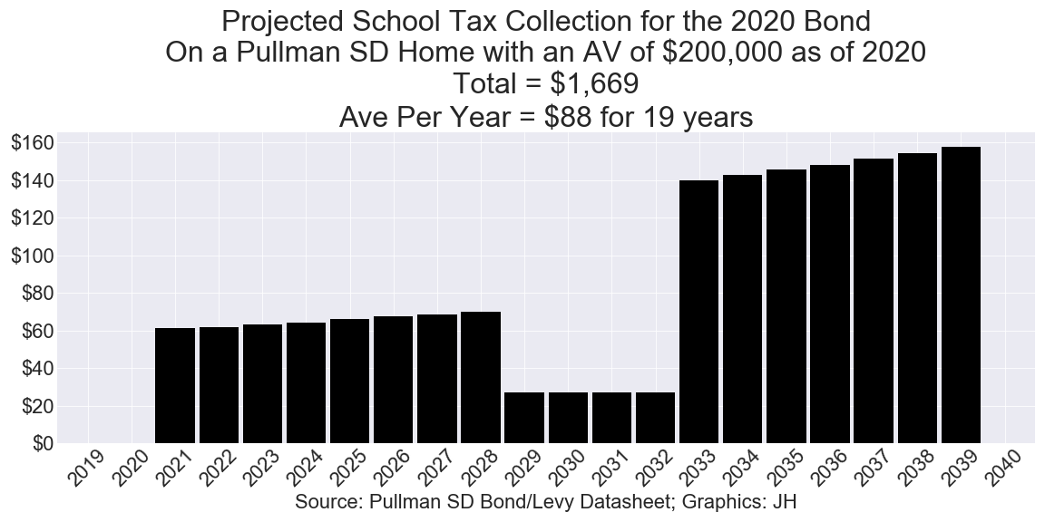

Ridgefield School District

District Advertised Cost
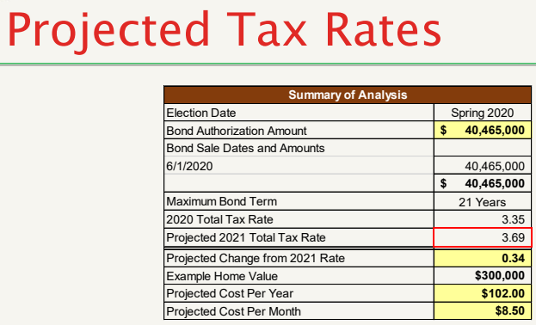

Actual Cost Determined From This Analysis
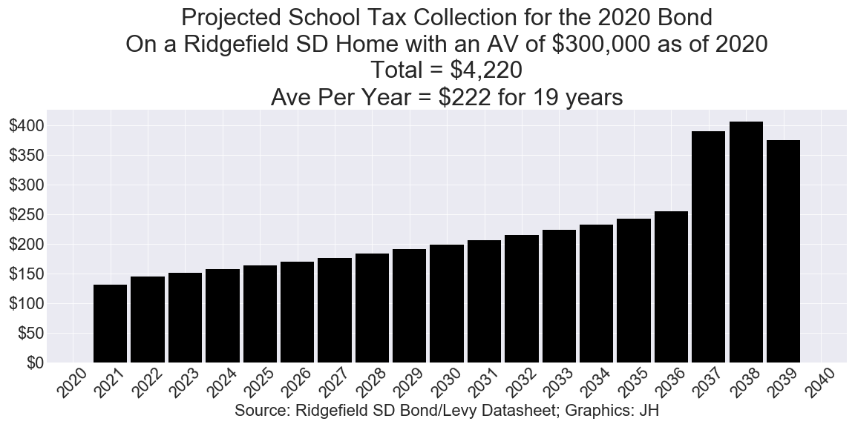

Riverview School District

District Advertised Cost
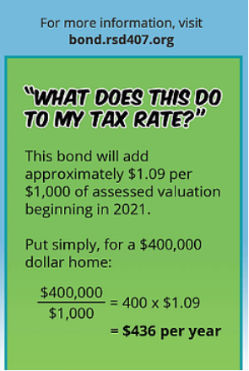

Actual Cost Determined From This Analysis
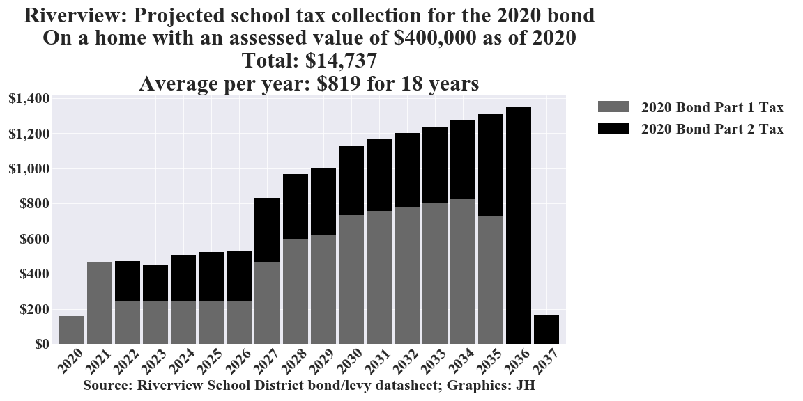

Rochester School District

District Advertised Cost
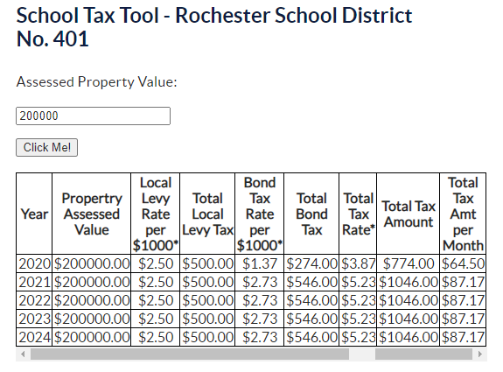

Actual Cost Determined From This Analysis
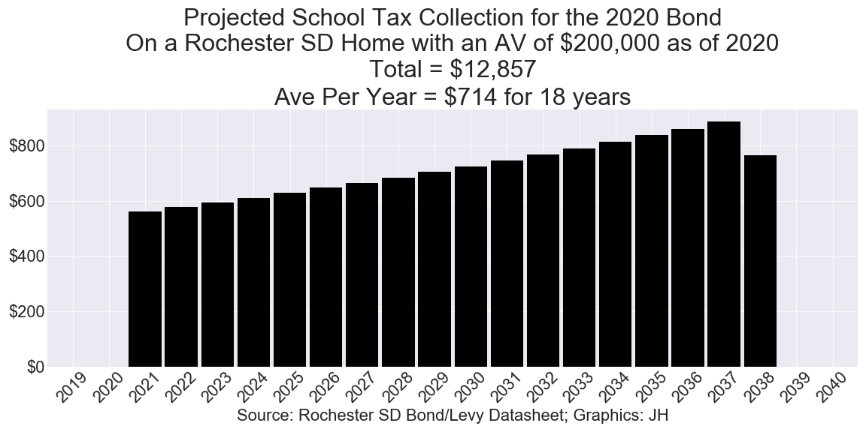

Snohomish School District

District Advertised Cost
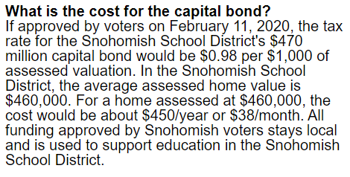

Actual Cost Determined From This Analysis
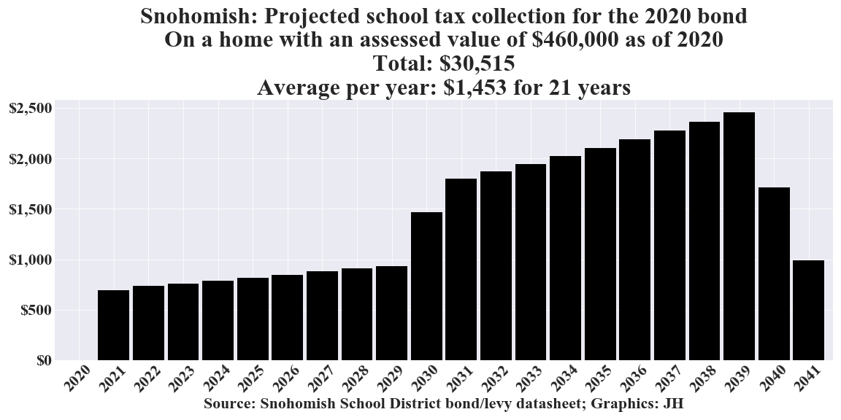

Sumner School District

District Advertised Cost


Actual Cost Determined From This Analysis
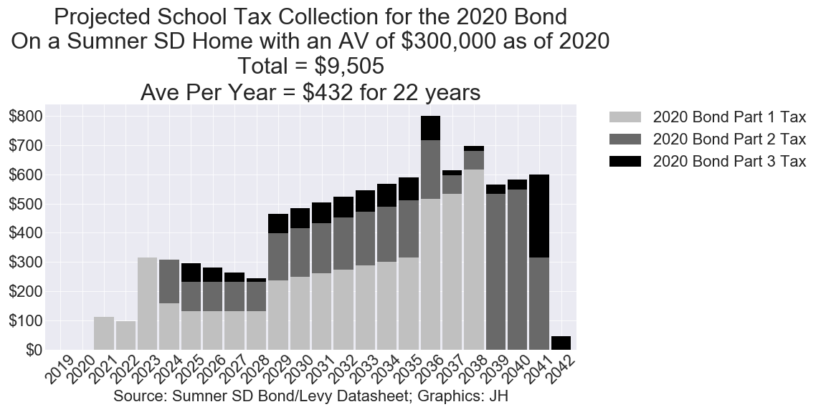

Tacoma School District

District Advertised Cost

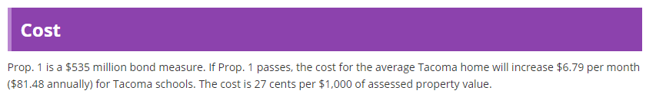
Actual Cost Determined From This Analysis


