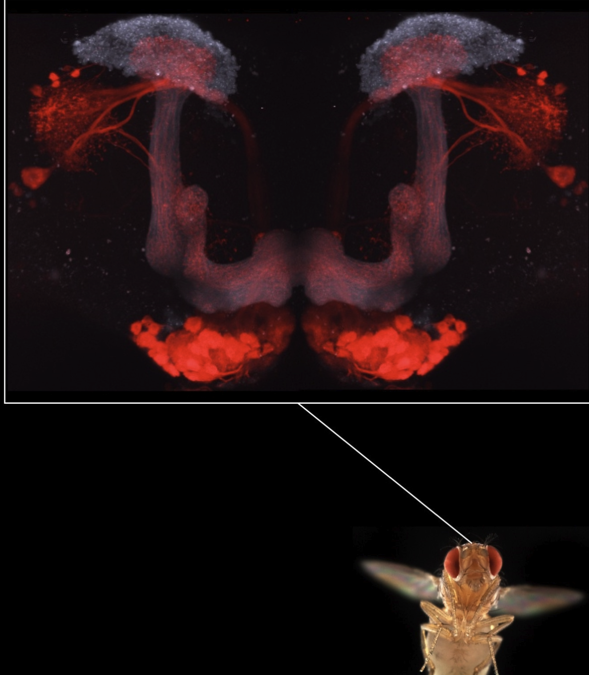
Mushroom body from slightly dorsal view in overall fly. There are some red signals at the bottom and side that’s not specific to mushroom bodies.
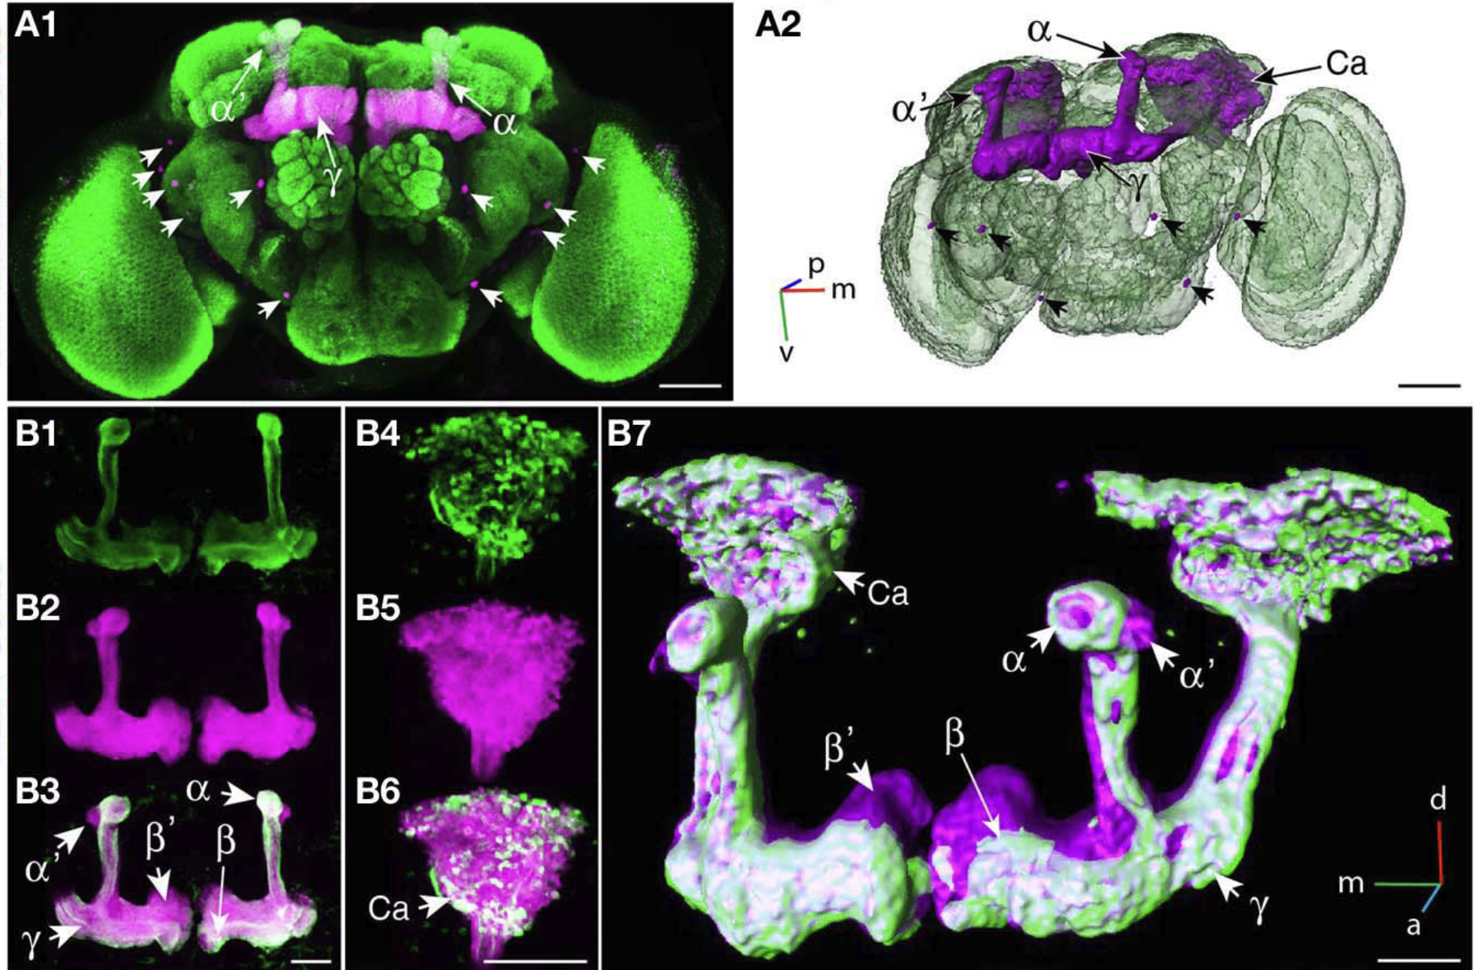
Confocal images and 3D reconstruction of mushroom body. There are lobes, cell bodies and calyx, especially in the 3D reconstruction image (A2 and B7) in purple. For this teaching material, we will focus on the lobes as distant synapse-dense regions, and not focus on calyx.

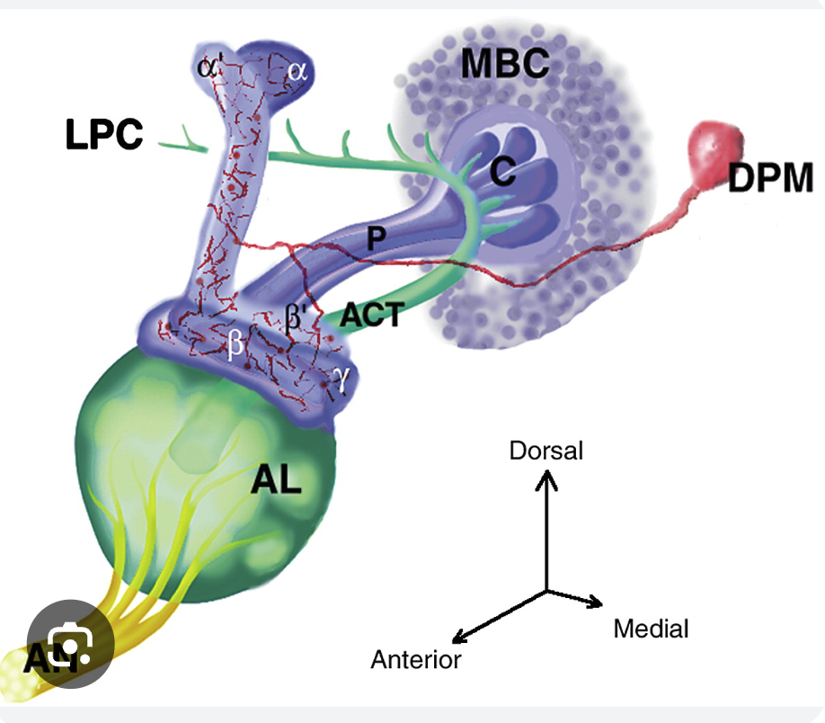
Illustration of mushroom body shape (blue). AL, DPM and other neurons will be ignored. The cell bodies of the kenyon are visible as smaller circular symbols.

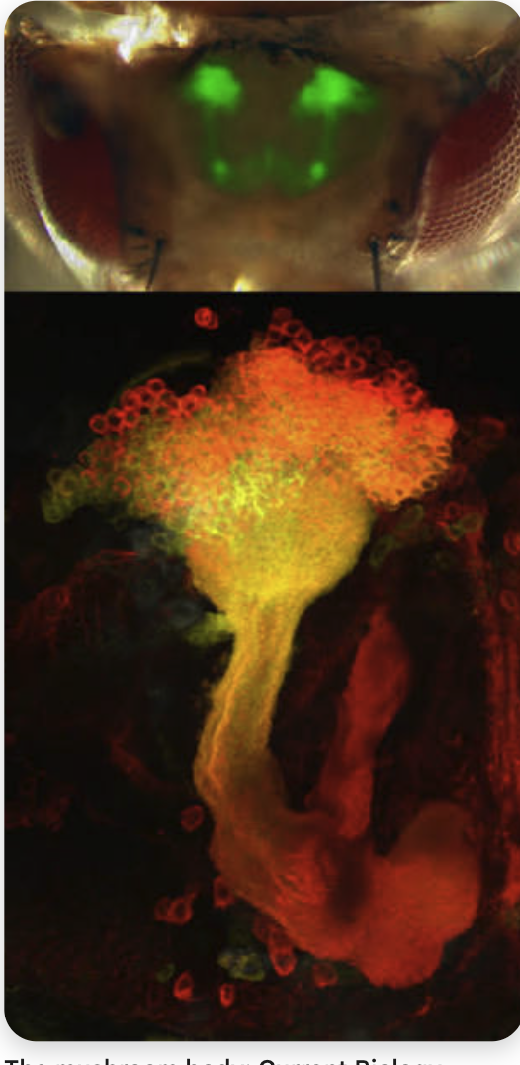
Nice image of mushroom body anatomy (green) shown literally superimposed on top of fly head.


Nice visual of how mushroom bodies look 2D max intensity projected in respect to the drosophila brain.

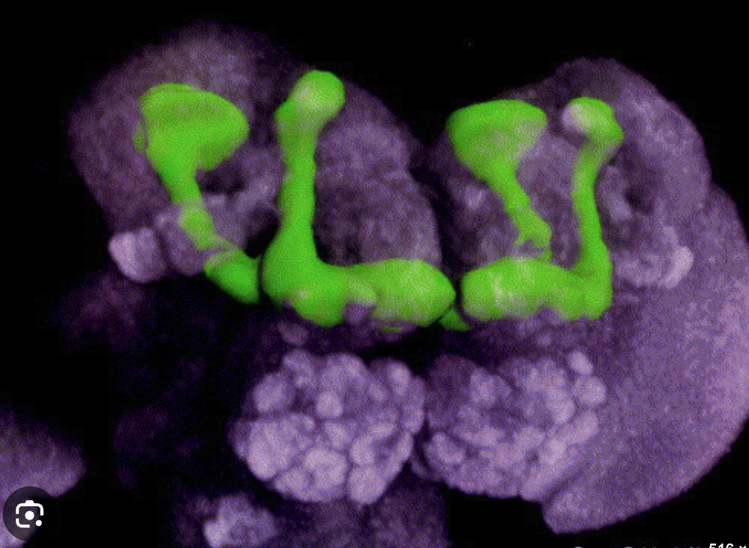
Slight side view of the mushroom body (in green) but only the axons, synapses are shown, the kenyon cell bodies are not shown in green.

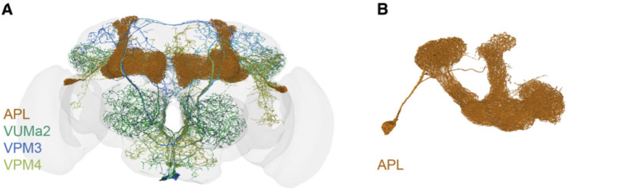

Nice illustration of mushroom body (in brown) probably from the EM reconstruction.

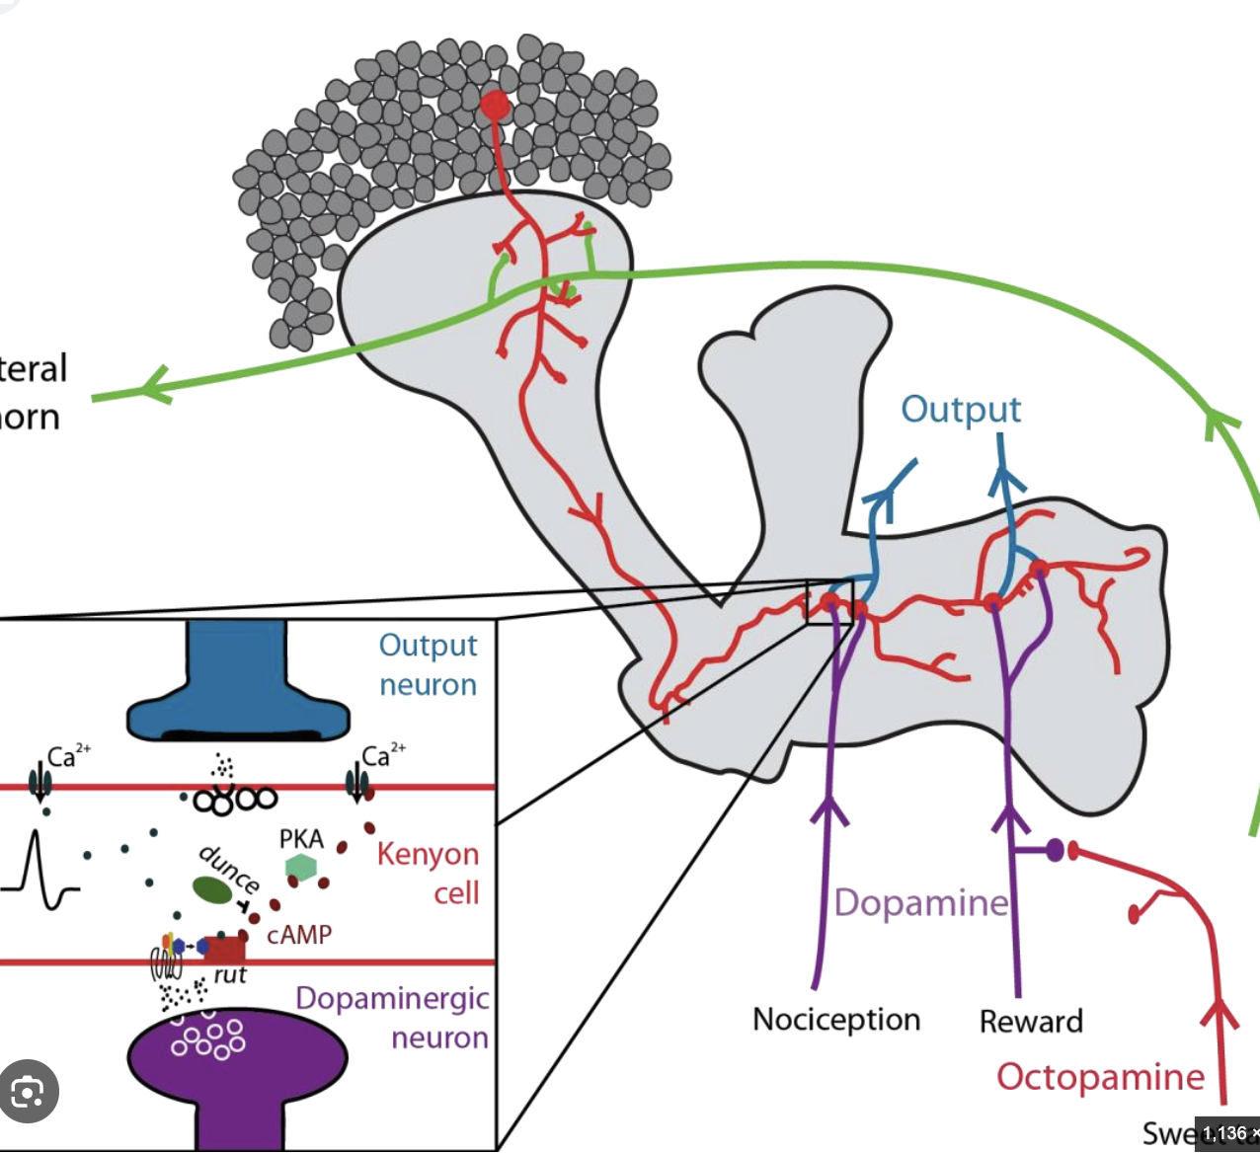
This shows how 1 kenyon cell might be arranged within the mushroom body cluster. We will focus on the grouped cell bodies and grouped axons, synapse lobes for the app.

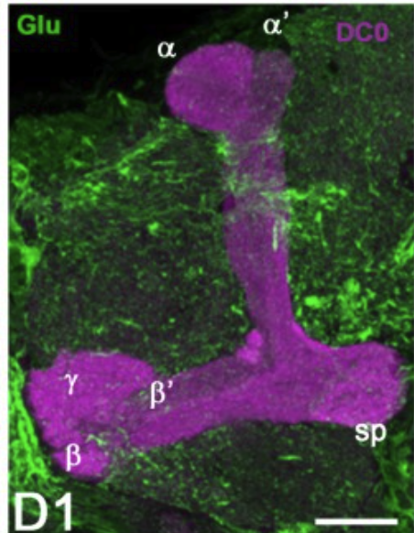
zoom in focus into the lobe (purple, 2D max projected).

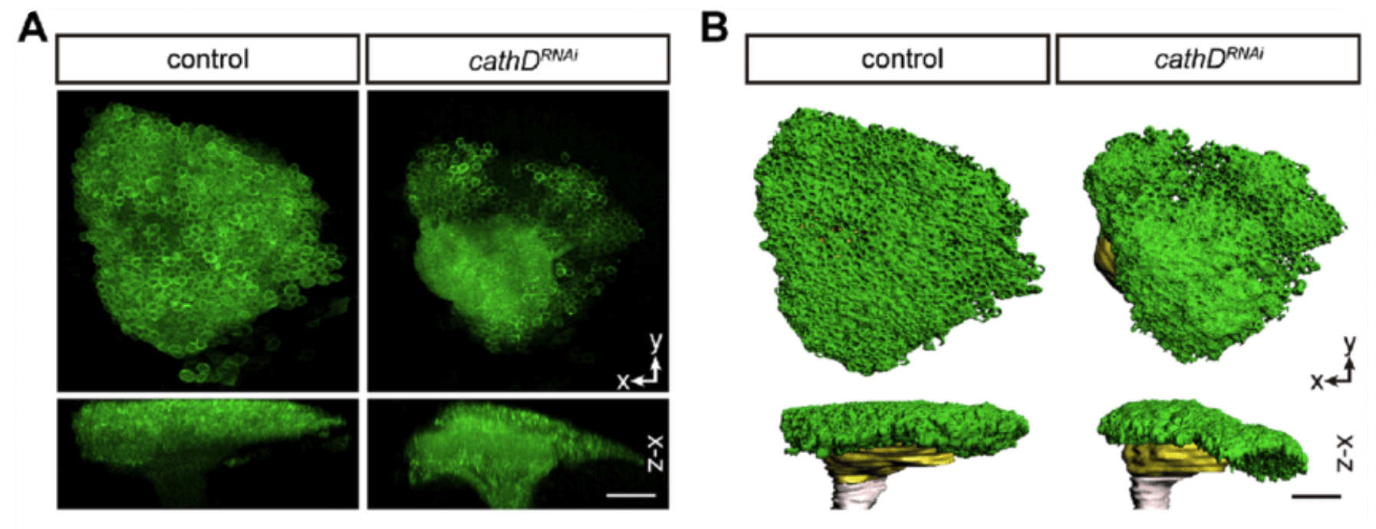
Confocal images of how zoomed in kenyon cell bodies look. As you can see, there are many cell bodies here that are clustered.

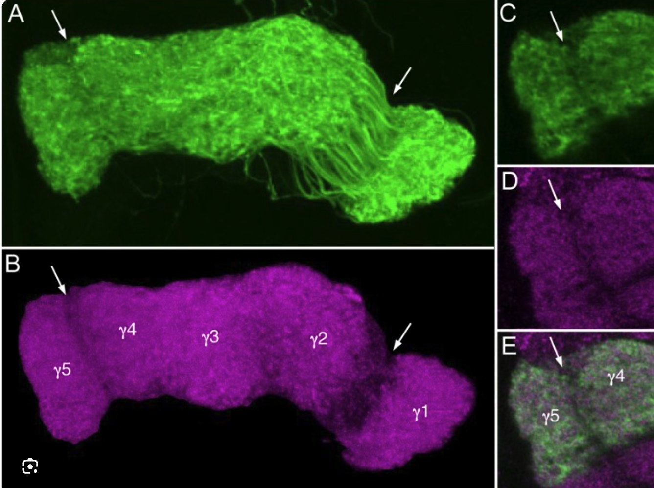
Zoom in view of one of the terminal lobes (in green and purple). The green shows very nice texture of membrane signal that should be reflected in the simulated microscopy.

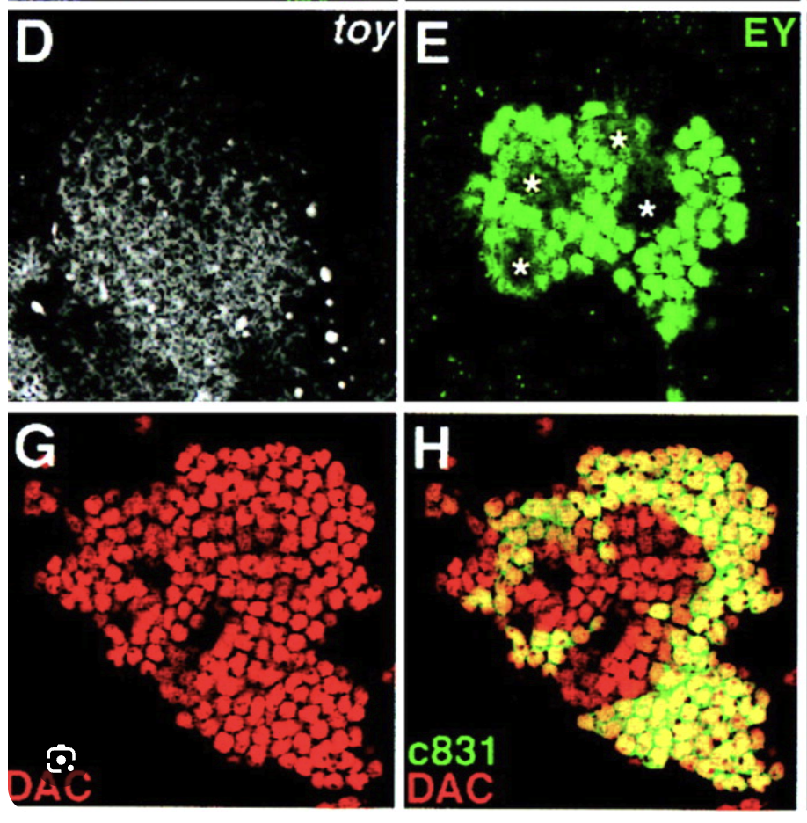This is how dapi stain would look like when zoomed in to kenyon cells. Cluster of many KC cell bodies that all project to the same direction.

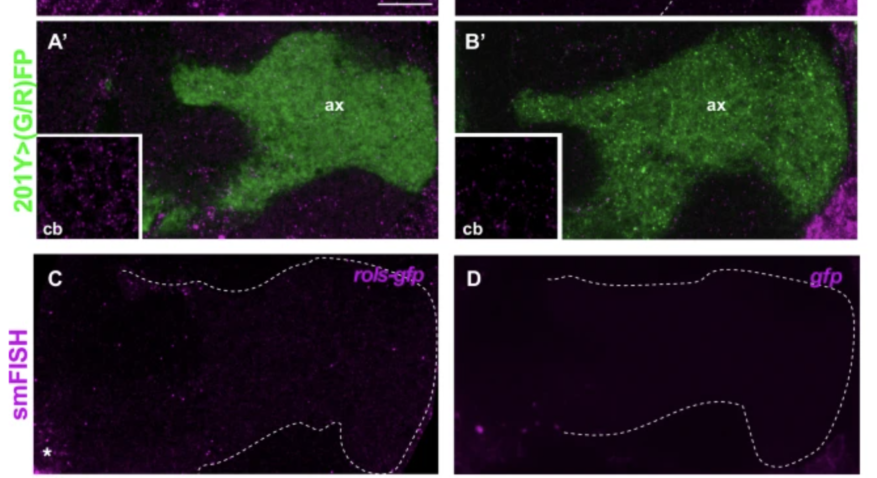
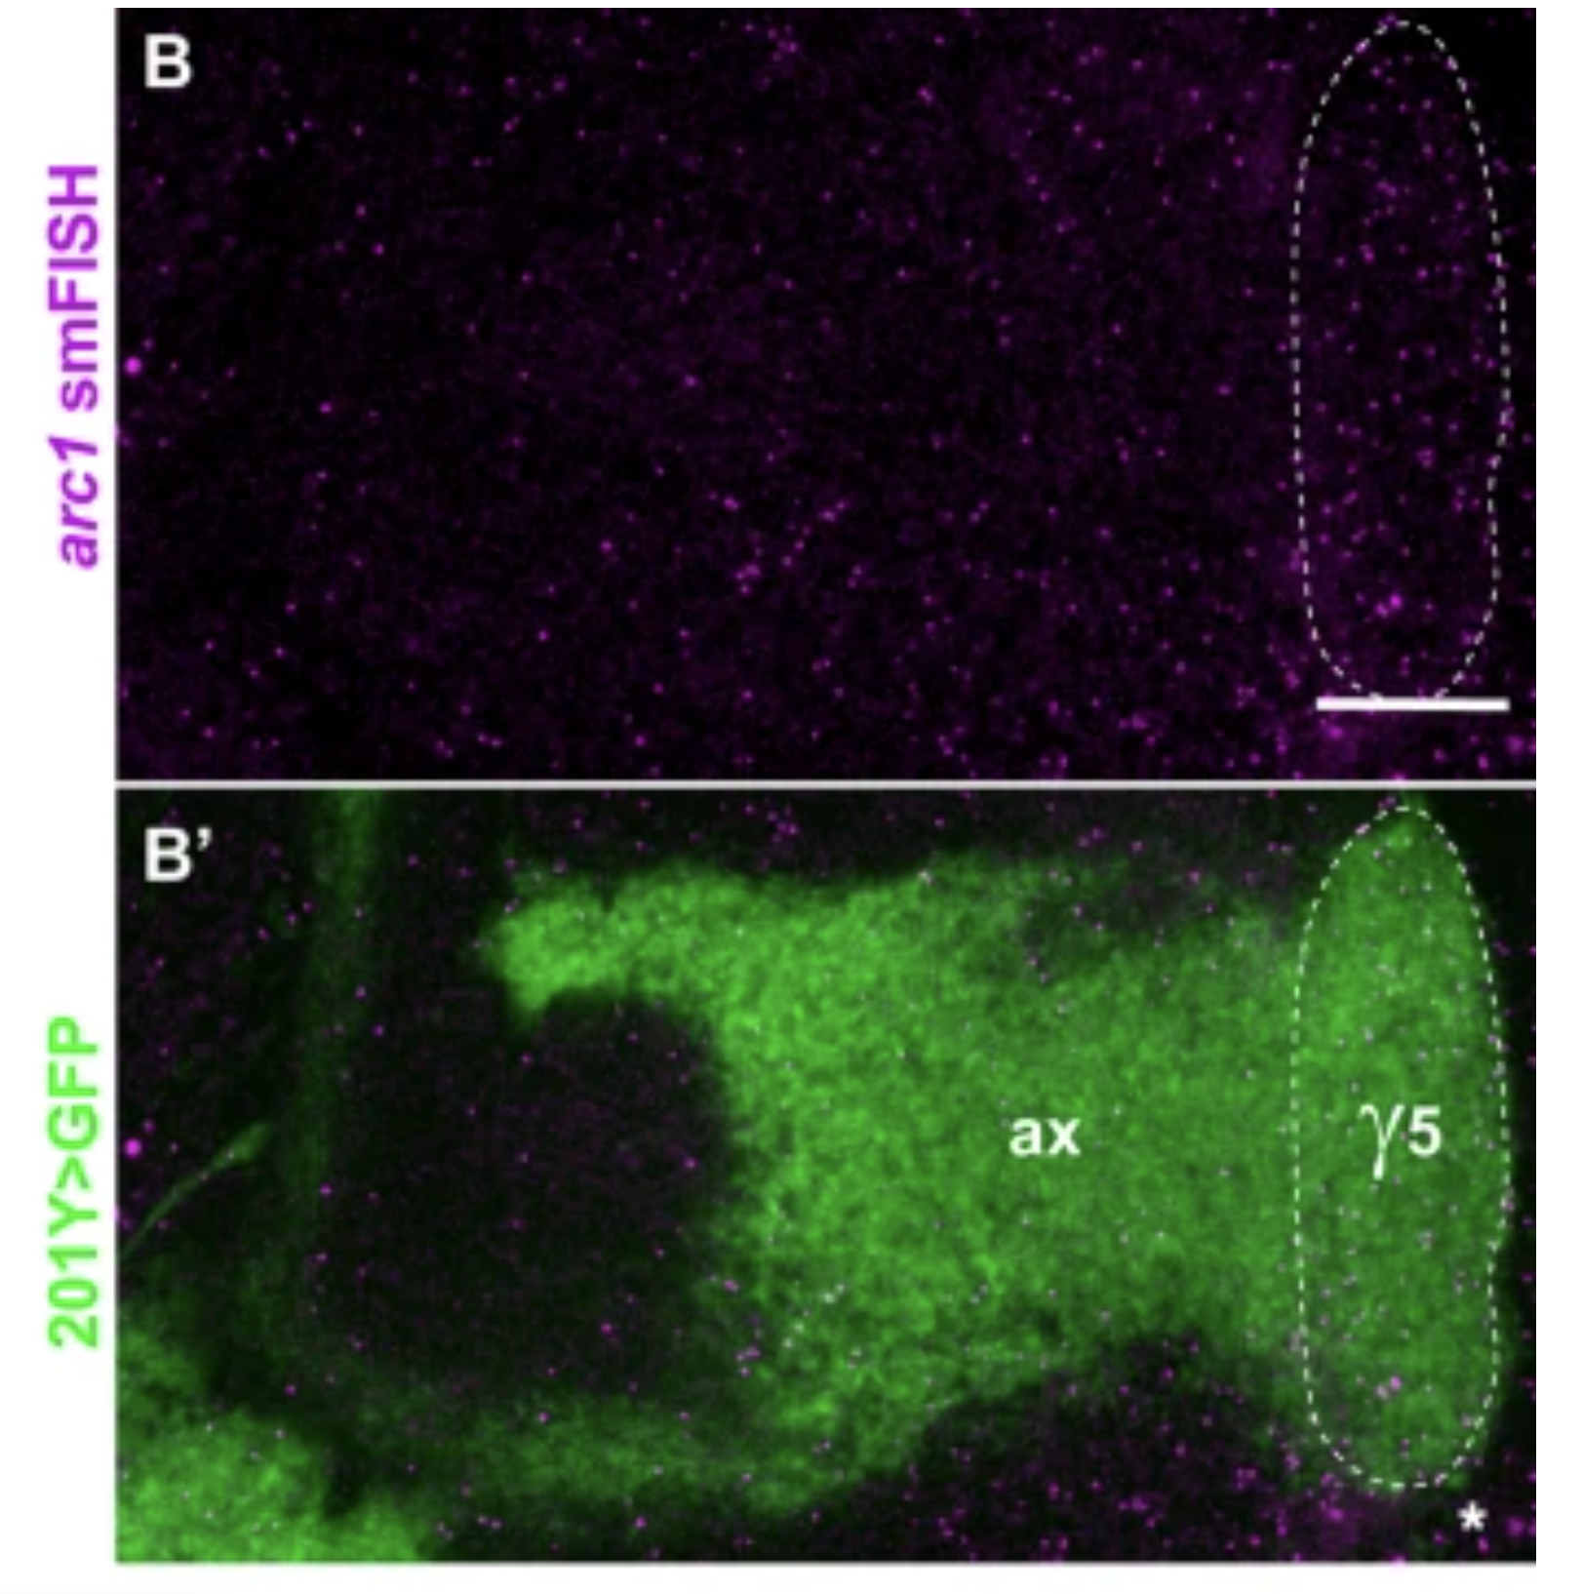
Lobe smFISH examples. Obviously the magenta image is very dim and not may RNA molecules in this case, so it will have to be distinct and brighter in the simulation.

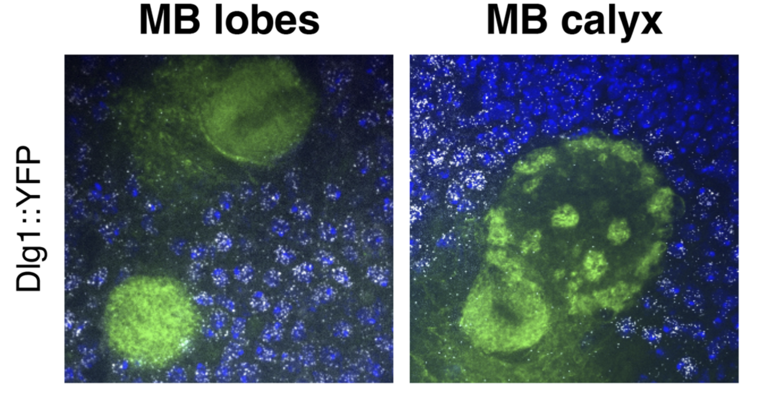
Not a great eample since spots are outside the MB (note we will only draw MB and none of the non-MB neurons) but it’s a good reference to see how smFISH spots look like in dense cell bodies.

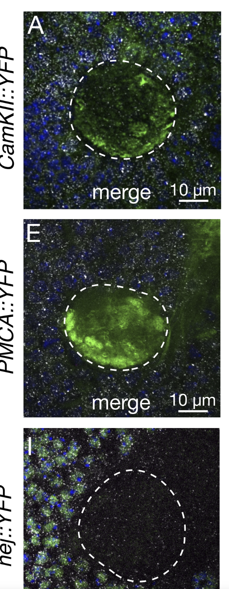
These smFISH images are a bit too real, so the simulated smFISH spots should be distinct, bright, perhaps bigger than it actually is in reality with respect to anatomy size. It should roughly look similar to the Pdf neuron simulation example.

