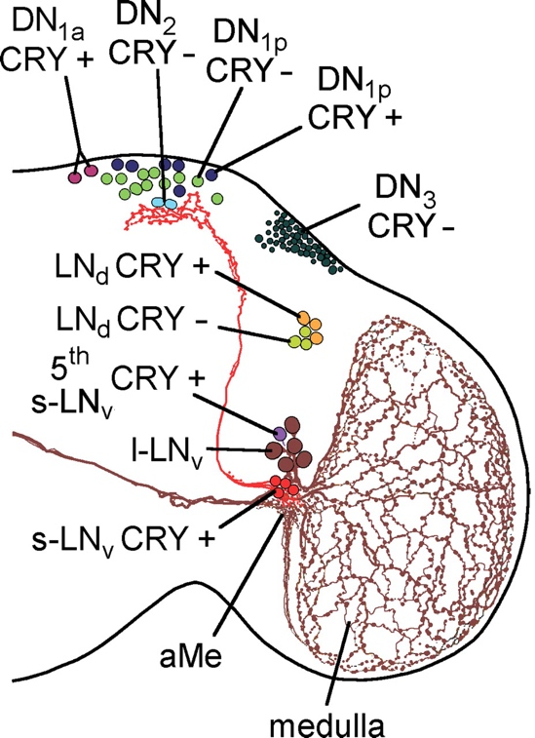
Show only the red s-LNv CRY ones (just call it Pdf neurons). Cell bodies are at the bottom, axonal projection towards the top side of the brain.

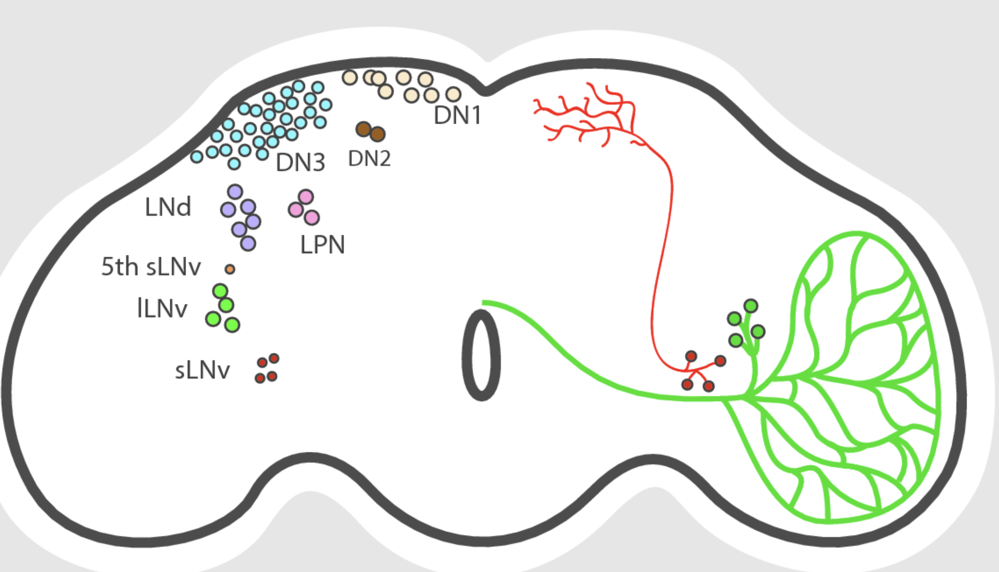
Again s-LNv neurons in red. Schematic in relation to the adult drosophila brain.
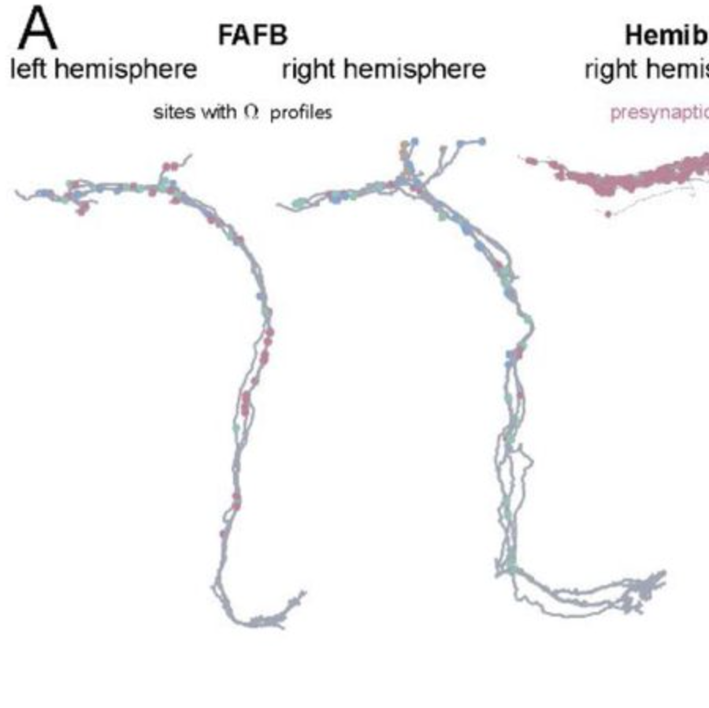
EM reconstructions.

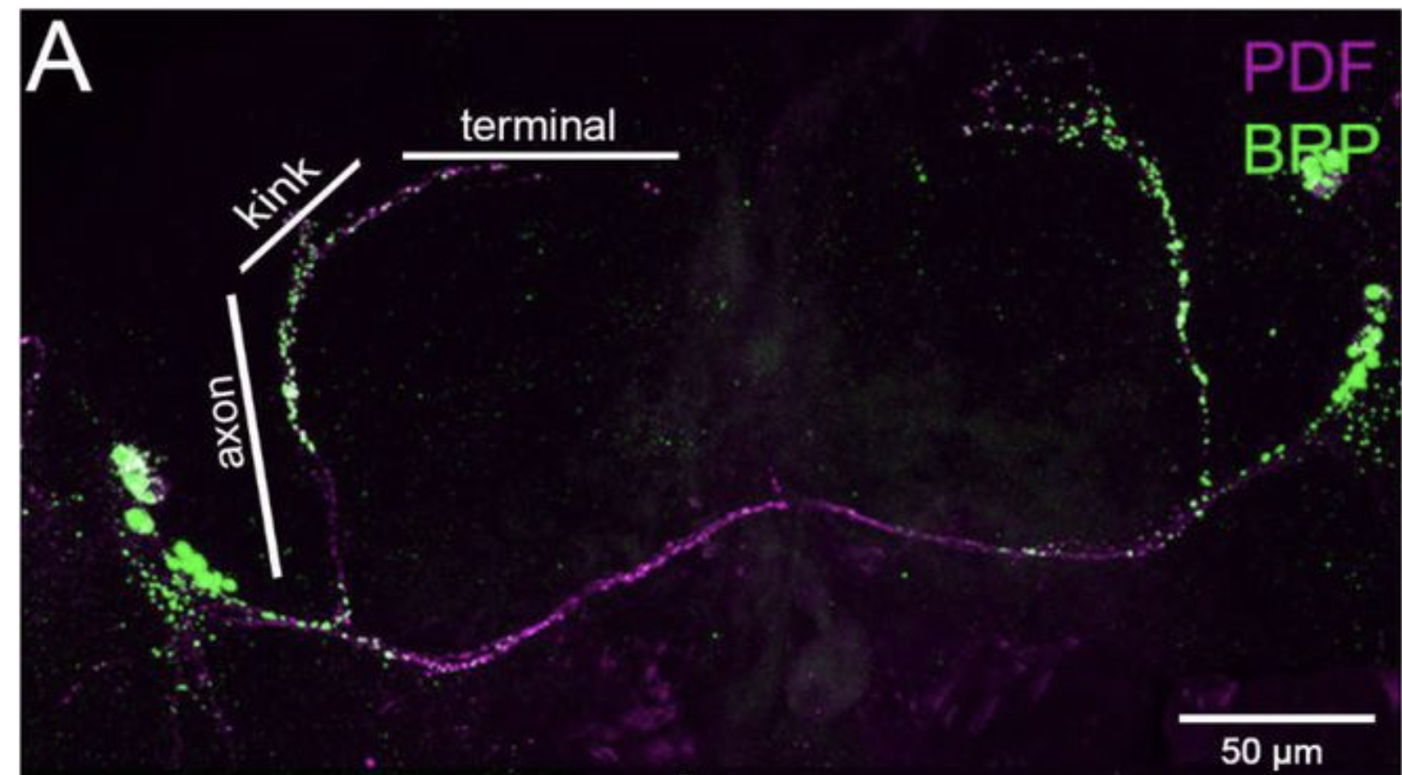
How it looks under low magnification confocal microscope (purple magenta). Ignore the neurites passing through the commissures through to the other hemisphere, only implement the axons projecting towards the top.
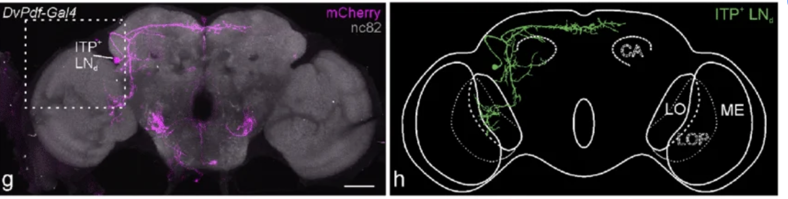
These are different neurons in magenta/green, but I like the schematic of the adult brain here in the right. The scale bar is 50 µm.
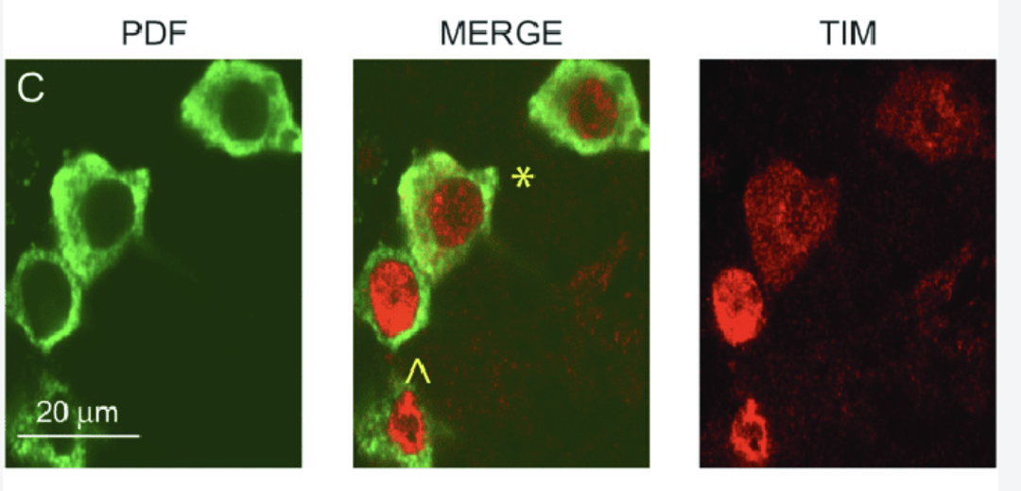
This is a zoom in confocal image of s-LNv cell bodies. The whole cytoplasm is filled with Pdf peptide in green. DAPI nucleus is not shown here but TIM (a transcription factor in red) nicely demarcates nuclear boundaries.
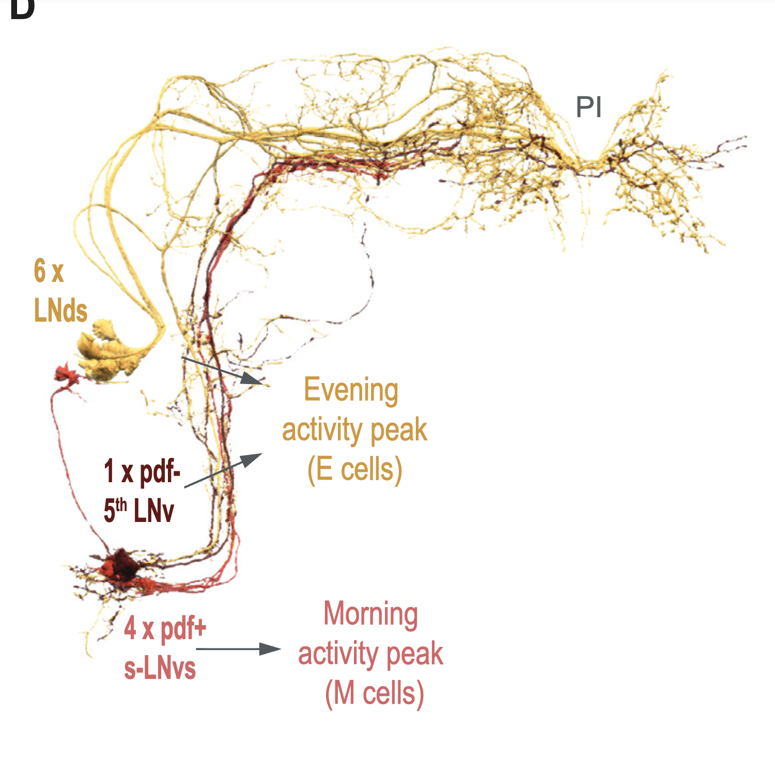
EM reconstruction of s-LNvs (in red). The simulation should show 4 cell bodies.
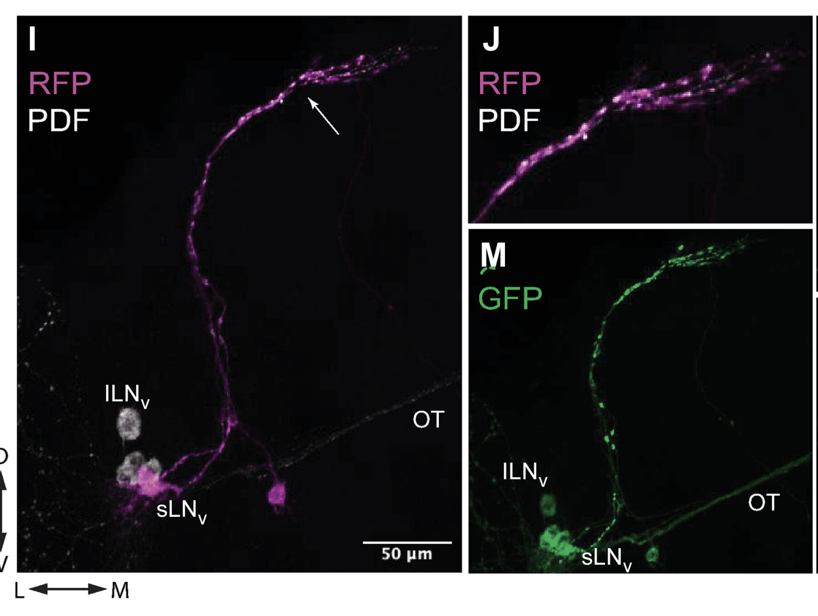Another confocal image showing the axons (red and green) sprouting out of the cell bodies, then projecting towards the dorsal side where the synapses are.
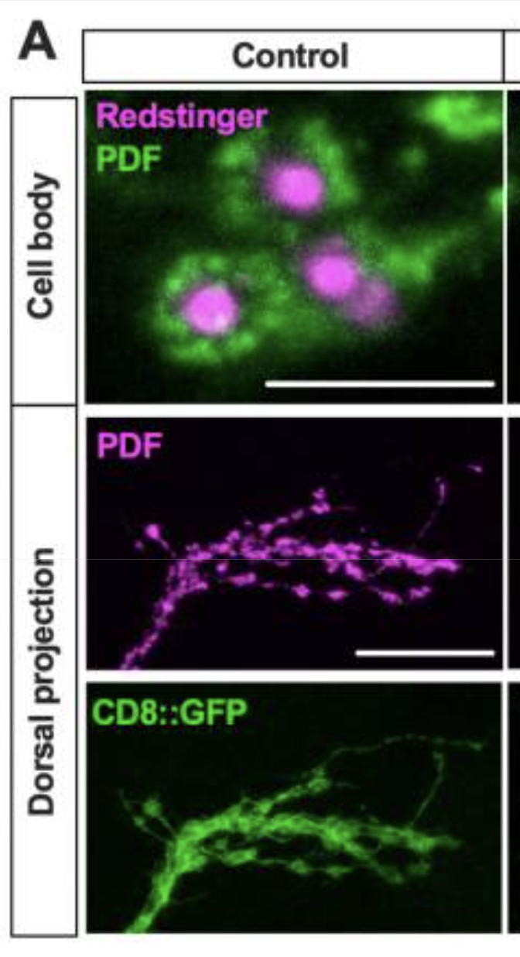
This is a nice depiction of zoomed-in view of Pdf dorsal projections with synapses. The CD8::GFP nicely shows synaptic boutons and terminal neurite structures. Cell bodies are also show in the top panel, but it’s not very high quality. Top panel scale bar is 10 µm. Middle and bottom panel scale bars 20 µm (dorsal projections).
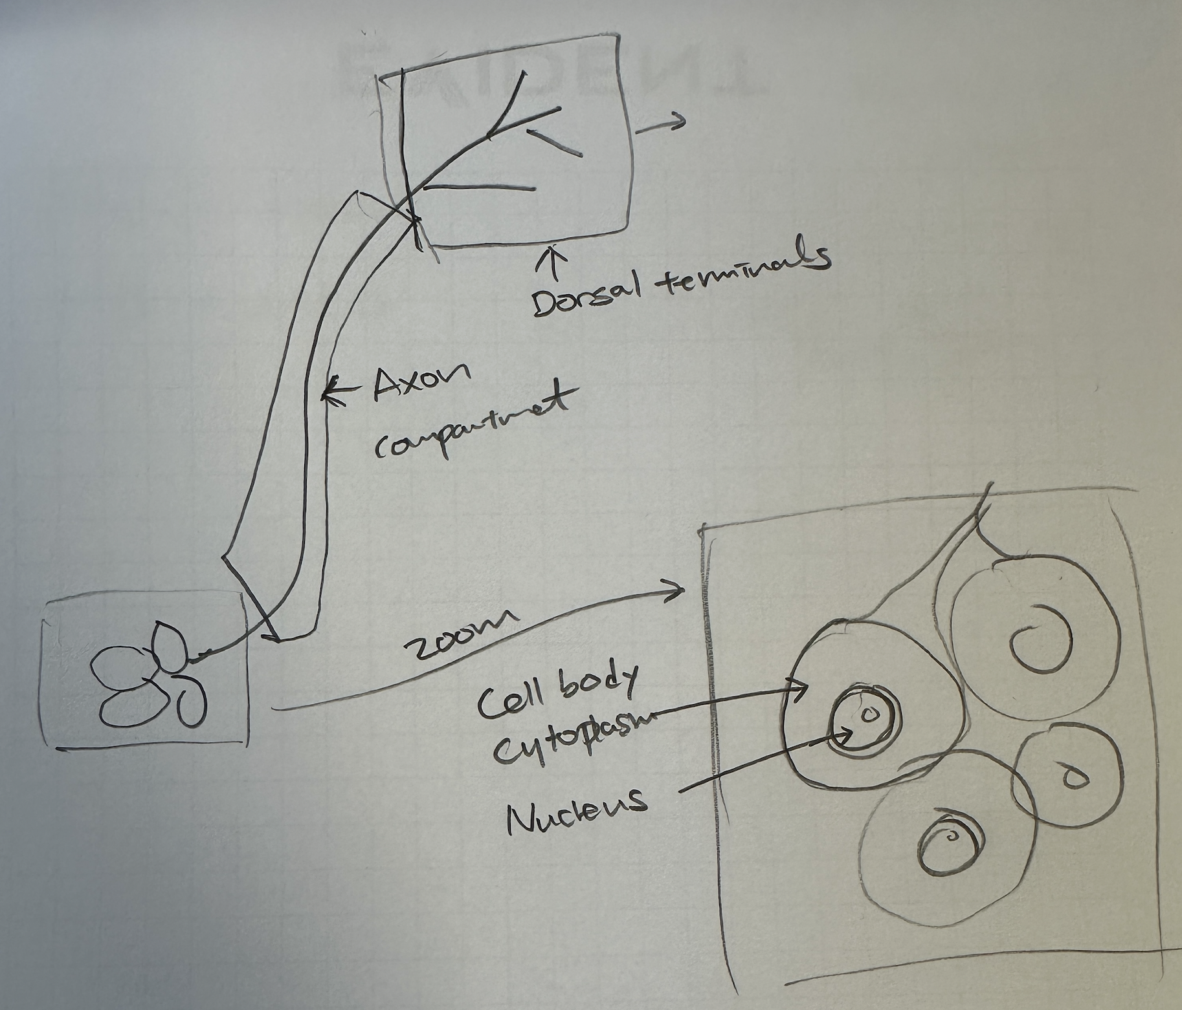
Annotated Pdf neuron compartments.

