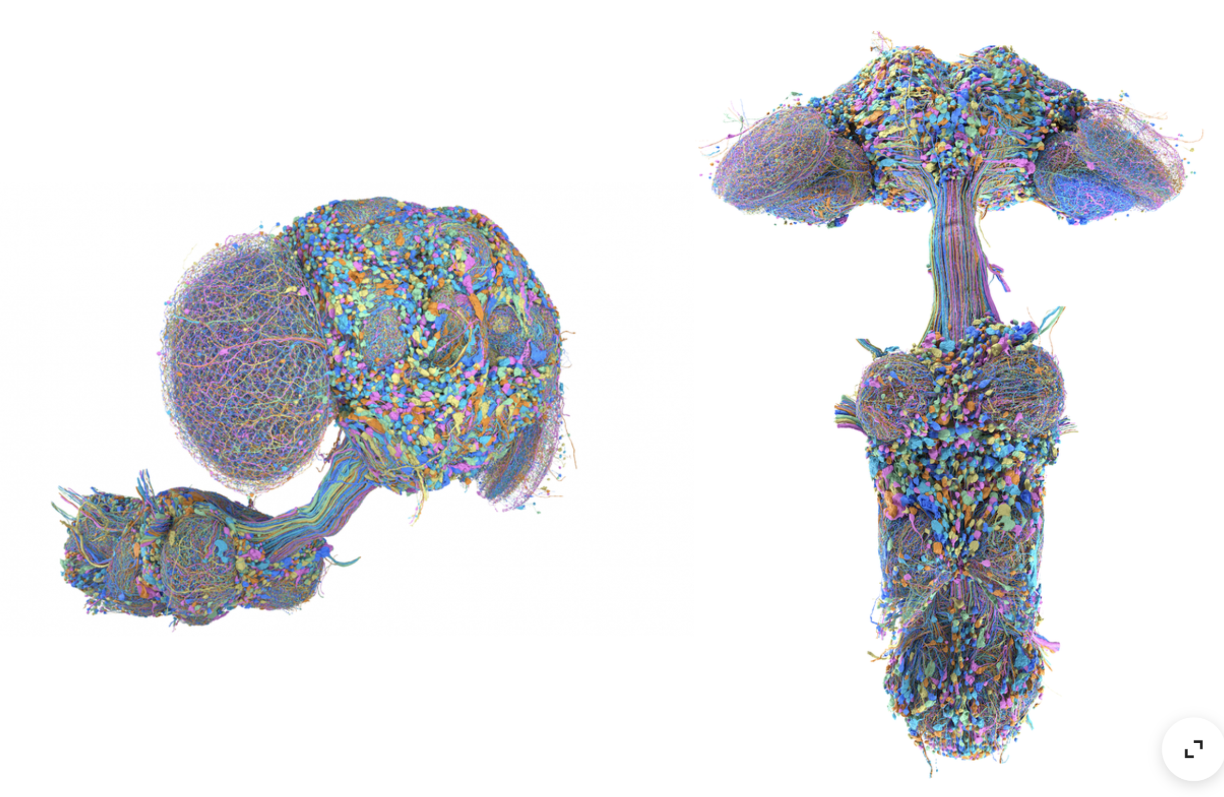
Janelia connectomics of male fruit fly showing the orientation of the VNC connectome in relation to the central brain. This should be useful to position the VNC in the fly diagram in the anatomy section. Note the neurite bundles coming out of the VNC. Those would correspond to MN bundles.

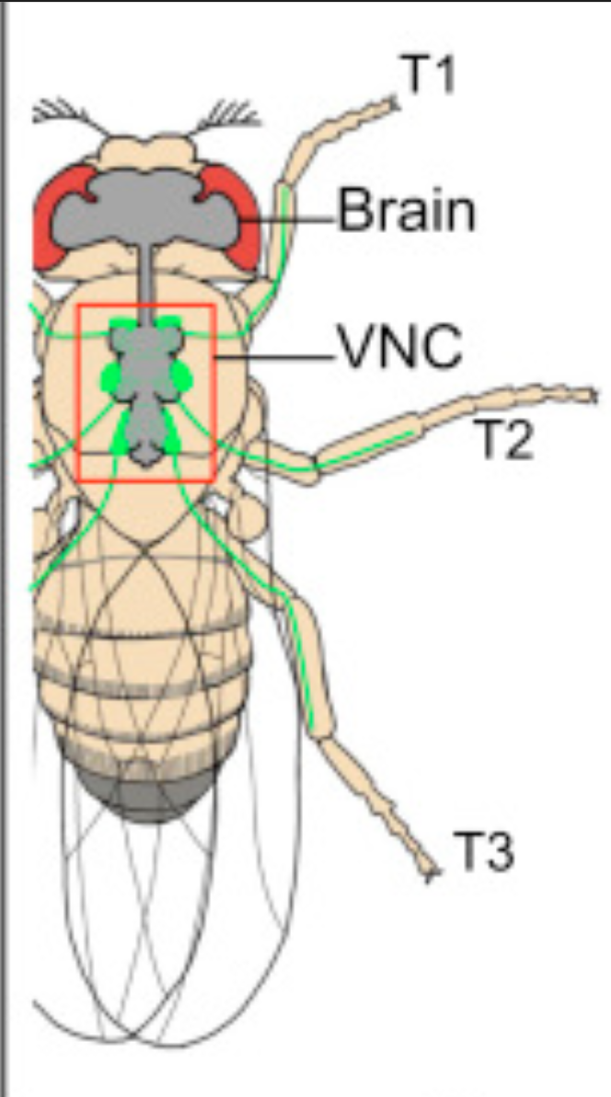
Overlay of the CNS/VNC anatomy on top of a fly. In green you can see MN clusters projecting their axons to the leg.

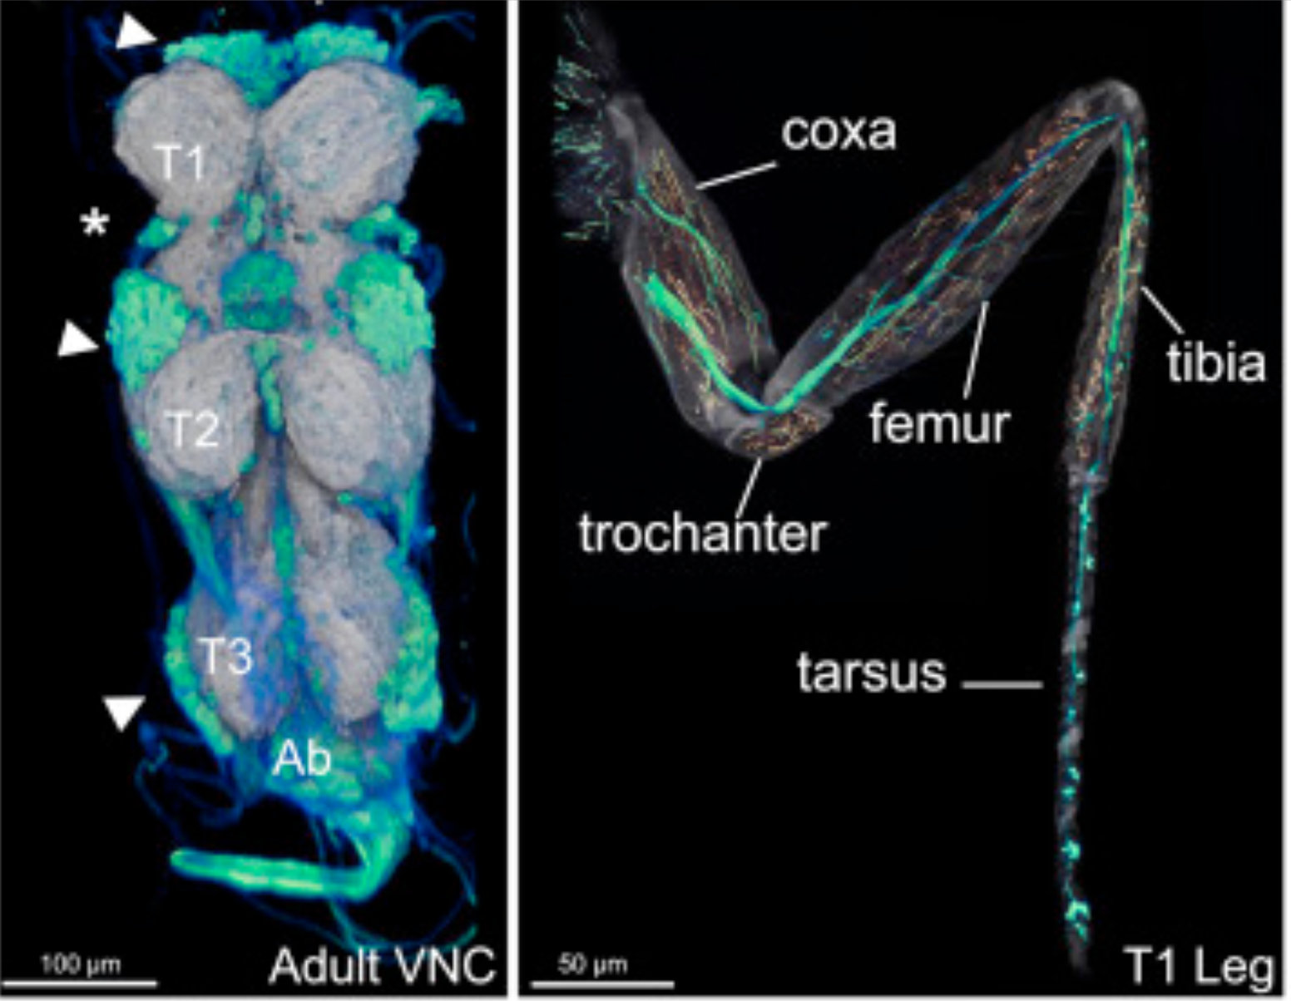
The leg MN clusters in the VNC (green) and in the leg itself. MN cluster might be too dense for the drawing, so I might it might be good to show a small subset of cell bodies in the VNC that bundles axons towards the leg. You can see the MN axon neurite along the central bundle through the leg as well as branching in coxa and femur. For the student demo simulation, we should focus on femur.

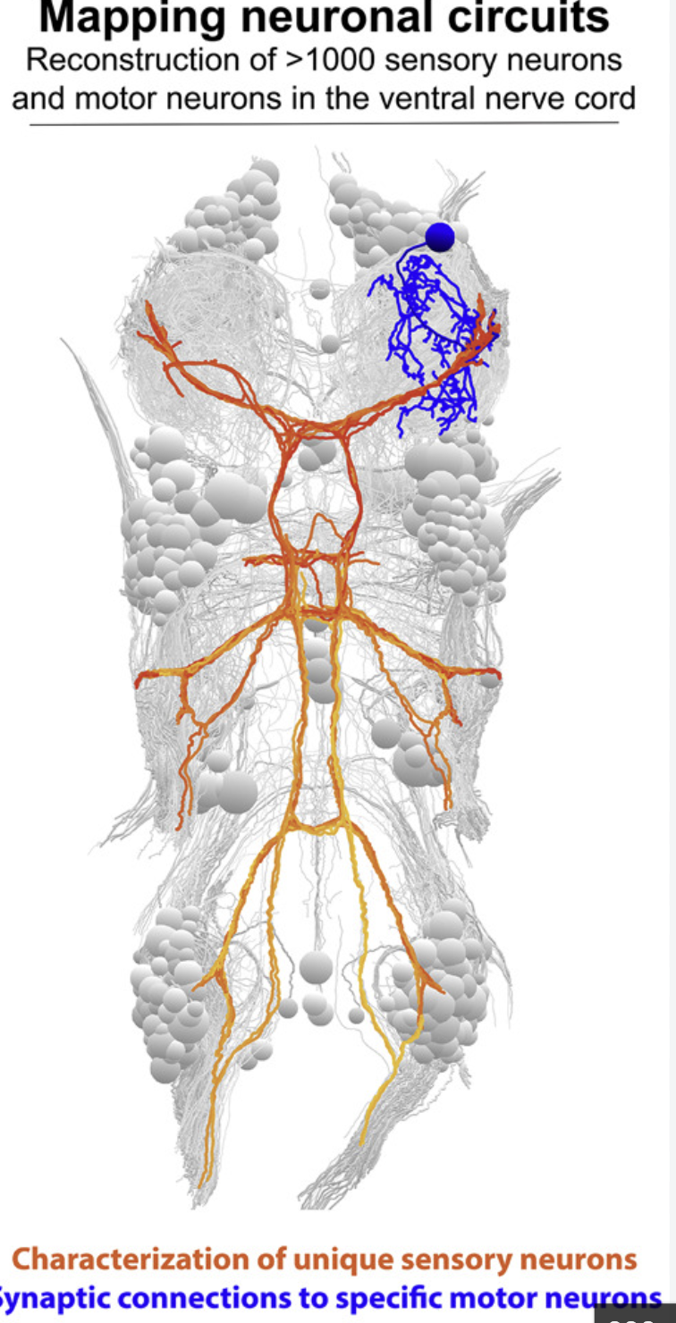
Nice illustration of how a single MN cell body (blue) is located. There are dendritic connections shown here, which can be drawn in the anatomy section, but will mostly be omitted and ignored for simulated microscopy image.

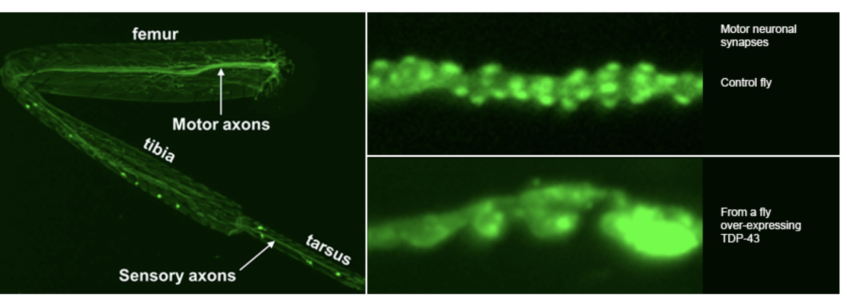
High resolution image of synapses and boutons of femur MNs.

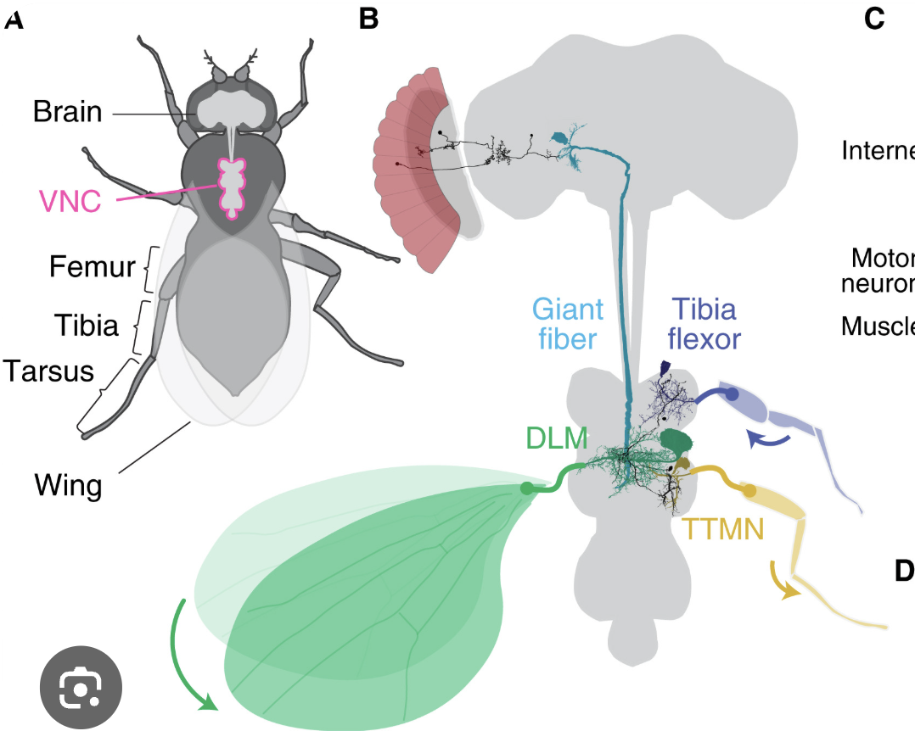
Simple illustration of VNC and different MN types. We are only focusing on the leg MNs (blue).

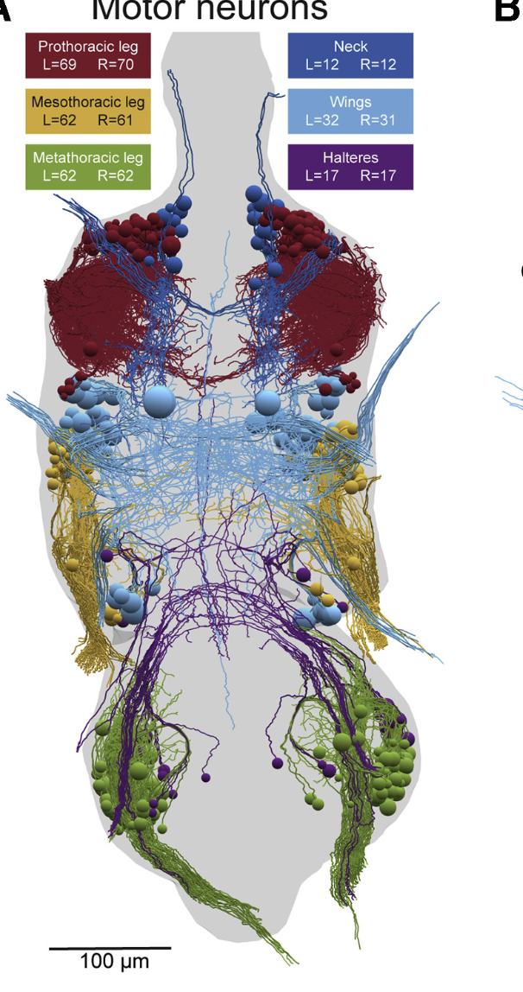
How leg MN cell bodies and projecting neurites are arranged. Obviously this is way too complicated for the microscopy simulation, so it will need to be a simplification.

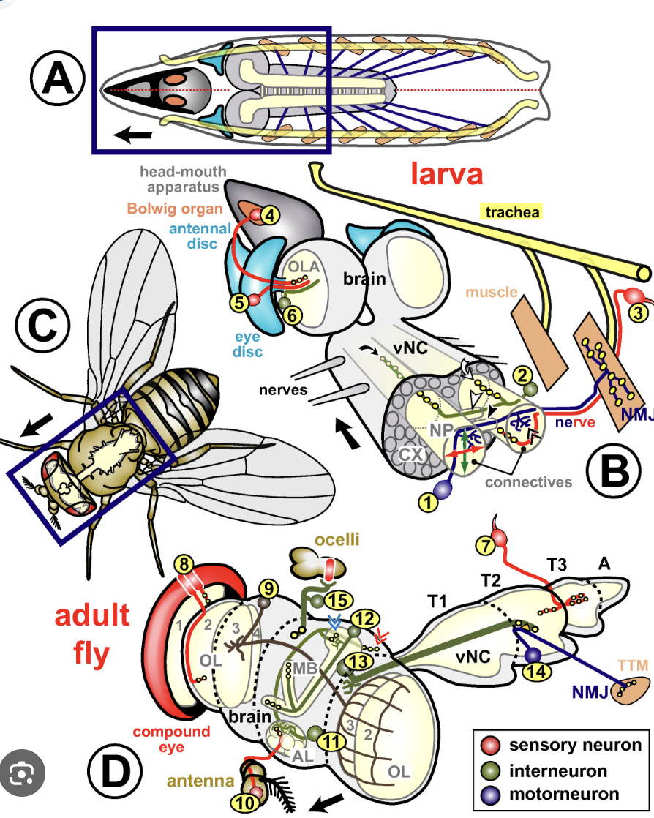
Another illustration of simplified leg MN in larvae and adult.

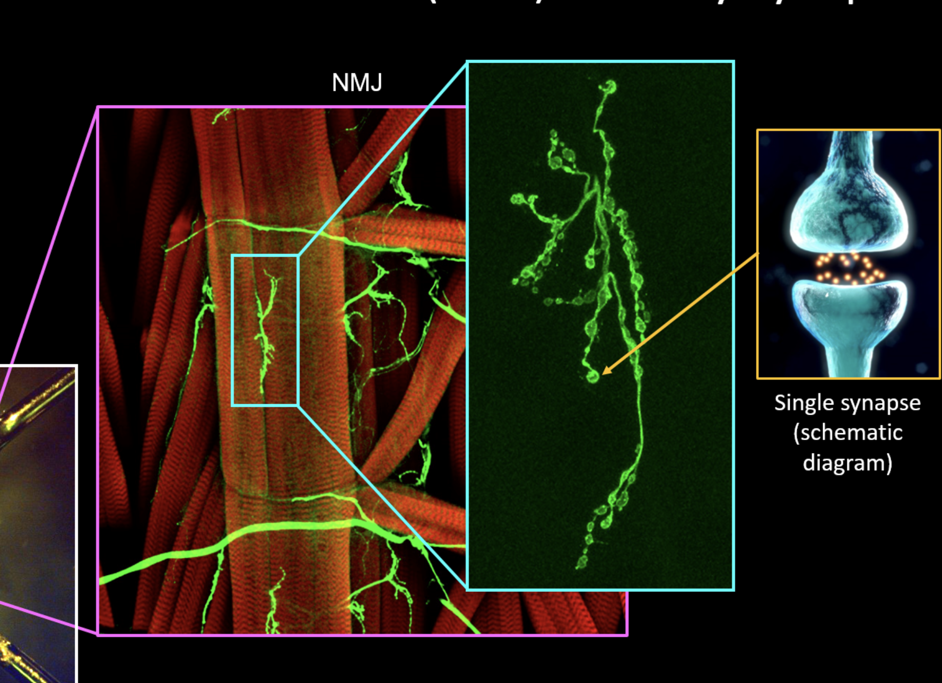
How the NMJ looks like in higher magnification. This is larval, but adult NMJ looks very similar. Muscle fibres (red), MN membrane (green).

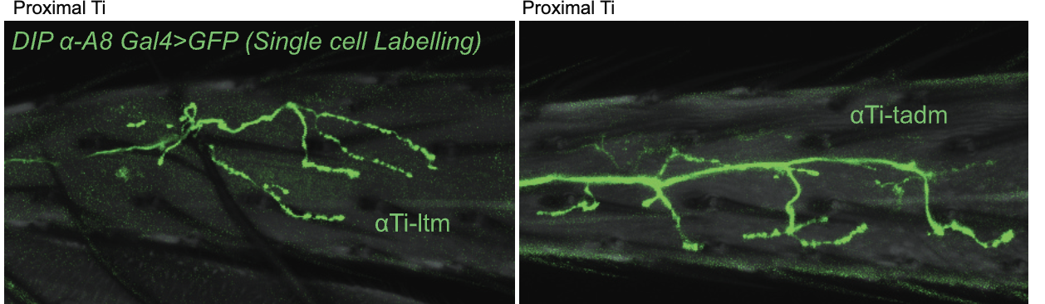
High resolution of adult leg MN neurite (single cell labelled), showing synaptic terminals. This is very similar to larval NMJ MNs.

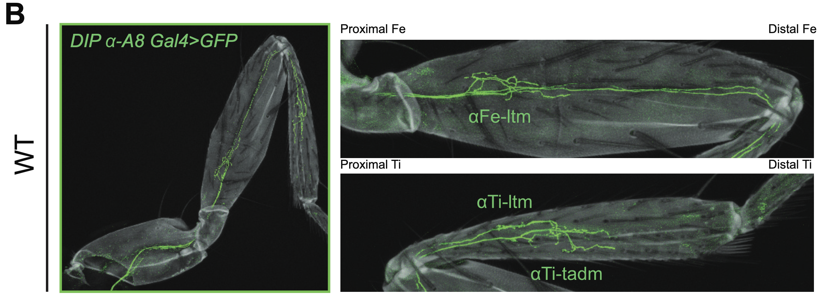
Confocal image showing how a single leg MN might be arranged across the leg, and also zoomed into Femur, showing synapses.

