_ZClientTemplate_.sln is now obsolete.

This functionality has been moved to Solution Launch.

1. In Visual Studio, do a Specific Get Latest of $/dev/common/tools/standalone/solutionlaunch.
2. Open the $/dev/common/tools/standalone/solutionlaunch/SolutionLaunch.sln
3. Build.
4. Run (Optionally create a short cut to the executable and run that).
5. Select the current Alpha ring and appropriate workspace, then right click, New, Client Specific Solution.

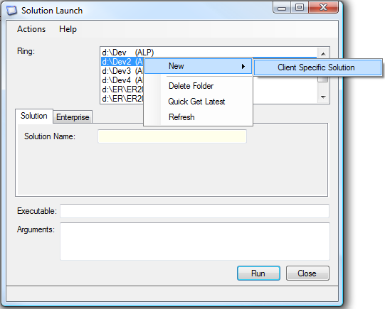

Screen clipping taken: 3/06/2009, 12:33 PM

