CSC254 Assignment#4

Junfei Liu(jliu137), Pinxin Liu(pliu23)

### Speedup Analysis for Parallelization

We use the following threads counts to test parallelization efficiency:

0,1,2,3,4,6,8,12,16,24,32,48

The diagram below is generated with 500000 vertices:

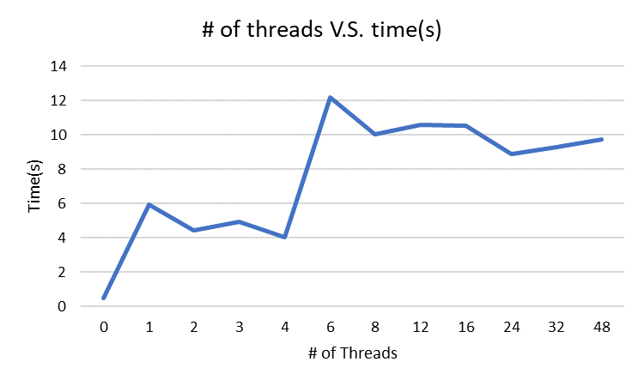

With raw data:

|  |  |
| --- | --- |
| # of threads | Time(s) |
| 0 | 0.471 |
| 1 | 5.951 |
| 2 | 4.453 |
| 3 | 4.956 |
| 4 | 4.024 |
| 6 | 12.155 |
| 8 | 10.052 |
| 12 | 10.599 |
| 16 | 10.51 |
| 24 | 8.877 |
| 32 | 9.286 |
| 48 | 9.728 |