# Week4: Deployment on Flask

### Data Glacier Virtual Internship

Name: Junfei Liu

Batch Code: LISUM16

Submission Date: Dec 28 2022

Submitted to: Data Glacier

1. Introduction
   1. Data

The dataset I used to train the model is a csv file containing 50 pairs of randomly generated x, y values, which can be found in Week4/dataset/A.

* 1. Model

I imported the linear regression model in Scikit-learn and trained the model on the data in csv file introduced above. The model is saved to model.pkl using Pickle. This part is in model.py.

* 1. Deployment

The ML model is deployed through Flask. This part is mainly implemented in app.py.

1. Snapshots

First, start running the app in command line:

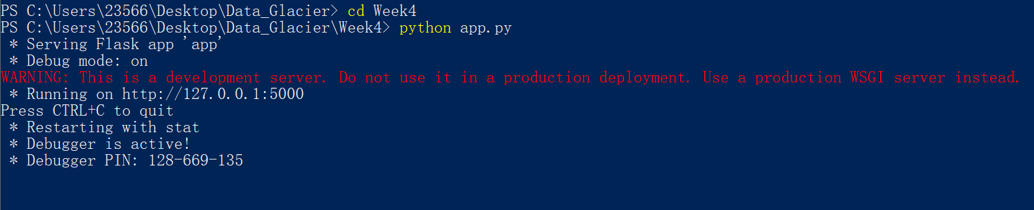

Now it is successfully running. The web page can be accessed on local host at <https://127.0.0.1:5000/>. The page is functioning like below:

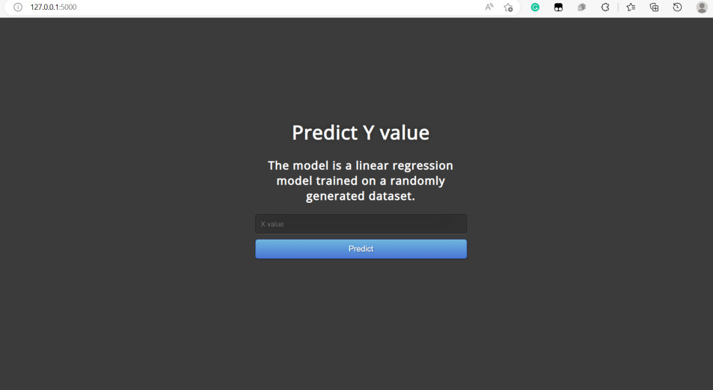

By entering 1 in the input line, the model will successfully predict the result and present the result to users as below:

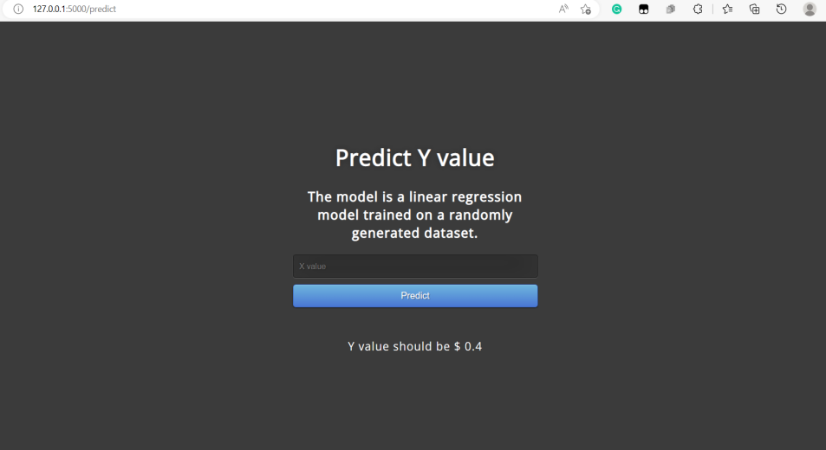

1. Summary

The deployment of model using Flask is successful in general as the web page can normally function to take inputs and the model can yield predictions.