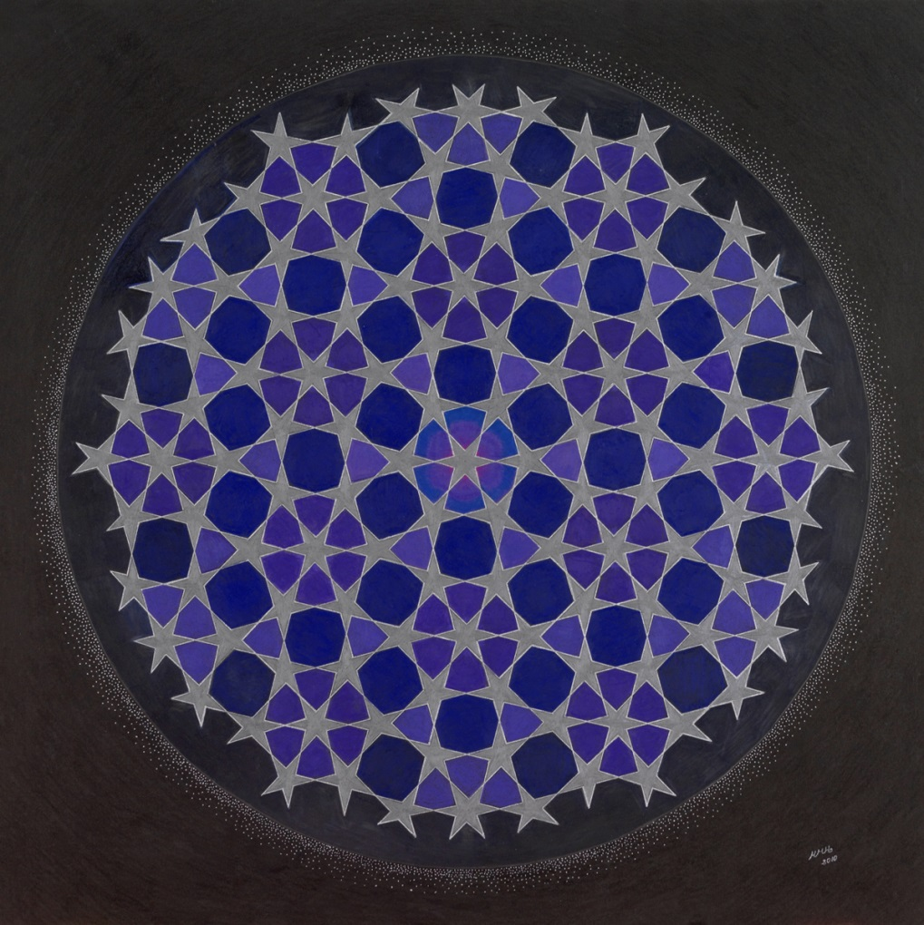

SACRED GEOMETRY

Mandala Art by Heide Mueller-Haas

*Proposal to Display at Enterprise Square Galleries*

May 2014

**Contents**

Overview and Description of Exhibition 3

Artist’s Statement 7

Curriculum Vitae 8

List of Images 9

Exhibition Information 10

A. Exhibition Requirements 10

B. Proposed Exhibition Budget 10

C. Space Required 10

D. Preferred Exhibition Dates and Duration 10

# Overview and Description of Exhibition

A mandala has a still point around which a circle is present. The still point represents peace, around which my mandalas revolve and also our lives unfold. When we are in the centre of our true self, and communicate from that, we are at peace. We could also call this point pure love that needs or wants nothing, but gives everything. I like to express this in my artwork.

Mandalas represent what is not always immediately seen in nature, but can be seen easily in the seeds of a sunflower, an apple cut through the middle, a shell, and flowers. They reveal to us that there is more to us, and everything, than meets the eye or is seen at first glance. They open us to the bigger and greater picture of our universe and how everything is connected, from the smallest particle to the largest galaxy.

My exhibition includes ten mandalas of various sizes. I use soft Prismacolor pencils to create the mandalas, usually on a black backdrop. When looking at my mandalas you will always see a circle and sometimes smaller circles within it, or many circles overlapping forming what is called “The Flower of Life”, a square or triangles forming a star. Usually an image is contained within a circle, but sometimes I go beyond the circle, just to show that one can, and I love to.

What you may experience when looking at my mandalas is joy and happiness, peace, protection, quiet, inspiration, love, or as one observer confided, that he felt the mandala gave him protection. You may be absorbed into them, and see more the longer you look.

***The Artwork***

**Note:** Please visit my website to view these images in greater detail: <http://sacredpatternmandelas.com/enterpriseproposal>.

|  |  |  |
| --- | --- | --- |
| C:\Users\Matthews\AppData\Local\Microsoft\Windows\Temporary Internet Files\Content.Word\1-Islamic-Design.jpg | ***Infinity***  This pattern speaks of Infinity and the ever-present centre. There is a beautiful underlying structure, the subgrid, out of which the stars are being born. | |
| C:\Users\Matthews\AppData\Local\Microsoft\Windows\Temporary Internet Files\Content.Word\2-GoldenTouch.jpg | | ***The Golden Touch***  Michelangelo depiction of two fingers touching, representing to me the coming together of Heaven and this Planet Earth. The Square depicts Earth and the circle infinity in sacred geometry. |
| C:\Users\Matthews\AppData\Local\Microsoft\Windows\Temporary Internet Files\Content.Word\3-Pearl-in-the-Eye.jpg | | ***Pearl in the Eye***  One circle is drawn over another so that they intersect through each other’s centers. This overlapping of the two equal circles creates a figure of profound and universal symbolism. It represents the union of heaven and earth, spirit and matter, conscious and unconscious. It is associated with Christ and the early symbol of fish in Christianity, and can be seen as bringing spirit or the unseen, into our material world. |
| C:\Users\Matthews\AppData\Local\Microsoft\Windows\Temporary Internet Files\Content.Word\4-Unveiled.jpg | | ***Unveiled***  The underlying structure of this creation is called "The Egg of Life" and has 19 equal circles that can't be seen. |
| C:\Users\Matthews\AppData\Local\Microsoft\Windows\Temporary Internet Files\Content.Word\5-Revealing-the-Unseen.jpg | | ***Revealing the Unseen***  The Golden Mean spiral is paramount in creation. It is based on a subgrid of squares and rectangles (which cannot be seen in this image), the rectangle determining how large the following square is, and then another larger rectangle, as seen in the picture, and it can go on forever. Nature does this without any effort. |
| C:\Users\Matthews\AppData\Local\Microsoft\Windows\Temporary Internet Files\Content.Word\6-Of-Water-and-Wind.jpg | | ***Of Water and Wind***  This mandala is based on the "Seed of Life", with the tree in the centre symbolizing life. |
| C:\Users\Matthews\AppData\Local\Microsoft\Windows\Temporary Internet Files\Content.Word\8-RaysofLight.jpg | | ***Rays of Light***  Created out of the Egg of Life, this mandala has 19 equal circles overlapping each other. |
| C:\Users\Matthews\AppData\Local\Microsoft\Windows\Temporary Internet Files\Content.Word\7-NewnessOutoftheAncient.jpg | | ***Newness Out of the Ancient***  This is a watercolour painting of an ancient tree in England that I did before turning more to Sacred pattern mandalas. |
| C:\Users\Matthews\Desktop\Adoration.jpg | | ***Adoration***  This mandala depicts a mother and her two older children admiring a baby. The circle around them represents a connection to the whole of creation, and I see it also as protection. The squares represent Planet Earth. |
| *This is an image I created in 2009, but I hope to create a new image based on this pattern in time for the exhibition.* | | ***The Flower of Life***  The flower of life has been found all over the world. It is a geometrical shape made up of 37 overlapping circles of the same size, and is the primary generator of all physical form. The oldest depiction of the Flower of Life known to man is at the temple of Osiris in Abydod, Egypt. Leonardo DaVinci studied its form and mathematical properties and was interested in how it connected to physical reality as well as consciousness. The Golden Ratio of Phi can also be derived from the flower of life pattern. |

# Artist’s Statement

Mandala is a Sanskrit word, loosely translated to mean Circle. There is a profound relationship between the stable and lasting nature of a mandala’s centre and the vital swing of its circle. The circle represents the cosmos, the universe, and shows us our relation to the infinite, a world extending beyond and within us. Working with mandalas shows us to come from our own constant centre, the sacred space of the heart.

The Mandala contains the origin of beginnings. Every cell and atom has a nucleus surrounded by a circle. It is unity around one point. A baby grows from a seed, the egg and sperm, with the sperm also changing into the exact shape of the egg. An apple cut diagonally in half reveals the seeds, and radiating out from there, a star shape surrounded by a circle, the outer shell.

In traditions and cultures all over the world we see circles, such as in circle dancing, the drawing of a medicine wheel, or the "Flower of Life" pattern found in all major religions of the world. Leonardo da Vinci, artist, engineer and mathematician, created works of art according to this pattern.

Creating Mandalas is an inner and outer journey for me. What I love about it is that it connects me to the tiniest life forms and I create something with shapes and colours that may speak of something more to people than our everyday lives.

What I aim to express in my mandalas is the coming together of spirit and matter, that there is more inside and outside than what is first perceived.

Where I would like to go next with my mandala creation is to create larger images on canvas may be with oil paints, creating a greater impact on the viewer.

# Curriculum Vitae

Heide Mueller-Haas

[Heide.mueller-haas@hotmail.com](mailto:Heide.mueller-haas@hotmail.com)

(587) 520-1171

9723 71 Ave., Edmonton, Alberta, T6E 0W5

Website: www.sacredpatternmandalas.com

I started painting in Germany in 1964. I am mainly self-taught, but attended art classes and was particularly drawn to Life drawing classes.

While living in Jamaica in the 1970s I was inspired to paint the beautiful landscapes and people of that country. The media I used were oil and watercolours, and much of my work was sold privately. I also learned the beautiful art form of Batik.

I returned to England in 1976, where many of my paintings were inspired by the ancient trees and the landscape around them. I mainly worked in oil at that time.

My love of Geometry took me to exploring mandalas, starting in 1994, when a friend introduced me to this unique art form.

It is since moving to Edmonton in 2003 that I have become more intensely involved in the creation of mandalas, the darker and colder winters having the positive effect of drawing me more indoors and inward. I have led workshops, teaching others the art of mandala creation.

**Exhibition History**

1975 Art Gallery and Library, Kingston Jamaica, oil and watercolour paintings

1977 Bristol Art Centre, England, oil and watercolour paintings and batik

1978 Arnolfini Gallery, Bristol, England, Juried Exhibition, oil paintings

1979 Art Gallery, Oxford, England, Jamaican oil paintings

2008 The Carrot Community Cafe, Edmonton, Mandalas

# List of Images

The required information is also included on my website: <http://sacredpatternmandelas.com/enterpriseproposal>

|  |  |  |  |
| --- | --- | --- | --- |
| Title | Date | Medium | Size (inches) |
| Infinity | 2012 | Prismacolor pencils on black paper | 21x21 |
| The Golden Touch | 2009 | Mixed media on black paper | 23x23 |
| Pearl in the Eye | 2013 | Mixed media on white paper | 23x23 |
| Unveiled | 2007 | Prismacolor pencils on black paper | 21x21 |
| Revealing the Unseen | 2008 | Mixed media on black paper | 13x13 |
| Of Water and Wind | 2008 | Mixed media on black paper | 11x11 |
| Rays of Light | 2013 | Mixed media on white paper | 12x12 |
| Newness Out of the Ancient | 1998 | Watercolour | 21x23 |
| Adoration | 2013 | Mixed media on white paper | 20x20 |
| The Flower of Life | 2014 | Oil on canvas | 30x30 |

# Exhibition Information

1. Exhibition Requirements

Wall hangers

1. Proposed Exhibition Budget

|  |  |  |
| --- | --- | --- |
| Category | Budget Item | Estimated Cost |
| Artwork Display | Labels | $200 |
|  | Framing | $500 |
| Opening Reception | Food and drink | $250 |
|  | Plates/glasses rental | $150 |

1. Space Required

In order to accommodate all of the artwork I am proposing to submit, 28 feet of wall space would be required.

1. Preferred Exhibition Dates and Duration

Preferred dates: Late April, May, June 2014

Preferred duration: One month