Automated Sprinkler Irrigation System
Parts Identification Guide, based on the 15 photos of your components
Each section below shows one of your photos, names the component, explains what it does in this project, and lists what to watch out for. Everything is read from the labels printed on the parts. Where something could not be read, it is marked "check".

1. Parts at a glance
Green = needed as is · Amber = needed, but a wiring or setup point applies · Blue = optional upgrade you already own.
# | Component | Used for | Verdict
1 | 12 V Solenoid Valve (KING SHENG, normally closed, pressure type) | Opens and closes the water line to the sprinklers | Required
2 | Current / Voltage Monitor Module (INA226-type, I2C): extra part | Reads battery voltage and pump current | Optional upgrade
3 | 2-Pole DC Circuit Breaker (PEMZZ WY47-63DC, B16) | Sits between the battery and everything else | Required (replaces the fuse)
4 | Capacitive Soil Moisture Sensor (DFRobot V1.0, analog) | Three of these feed the controller | Required
5 | ADS1115 16-bit I2C ADC Module (front): extra part | An optional upgrade for the soil sensors | Optional upgrade
6 | 12 V 25 Ah Gel Deep-Cycle Battery (YOQU E-bike type) | Powers the pump, valve, relay and ESP32 at night and on cloudy days | Required
7 | Water Flow Sensor (Sea ZJ-S201) | Measures flow and delivered volume, and detects dry-run, a blocked line or leaks | Required (needs voltage divider)
8 | microSD Card (SanDisk 16 GB microSDHC with adapter) | Goes into the serial data logger and stores the CSV history of sensor readings and events | Required
9 | ADS1115 ADC Module (back side) | Shows the supply range and input limit of the ADS1115 from photo 5 | Optional upgrade
10 | FireBeetle 2 ESP32-E (N16R2), DFRobot: the main controller | Runs the control loop, the web server for the app and all sensor reading | Required
11 | IO Expansion Shield for FireBeetle 2 (DFRobot) | Lets you plug in the soil sensors, relay, RTC, INA226 and ADS1115 neatly without soldering each pin | Required
12 | 2-Channel 5 V Relay Module (SRD-05VDC-SL-C, opto-isolated) | Channel 1 switches the pump and channel 2 switches the solenoid valve | Required (check wiring)
13 | Micro-Sprinkler with Rotating Head and Stake (on thin tubing) | The final outlets that water the plants | Required
14 | 12 V Diaphragm Water Pump (GOOD PUMPS, 72 W, 6 L/min, 0.9 MPa) | Pressurises the water line for the valve and micro-sprinklers | Required
15 | Water Inlet Suction Mesh Filter (Stainless steel strainer) | Filters water at reservoir suction line to protect pump and nozzles | Required

2. Photo-by-photo guide

Photo 1: 12 V Solenoid Valve (KING SHENG, normally closed, pressure type)
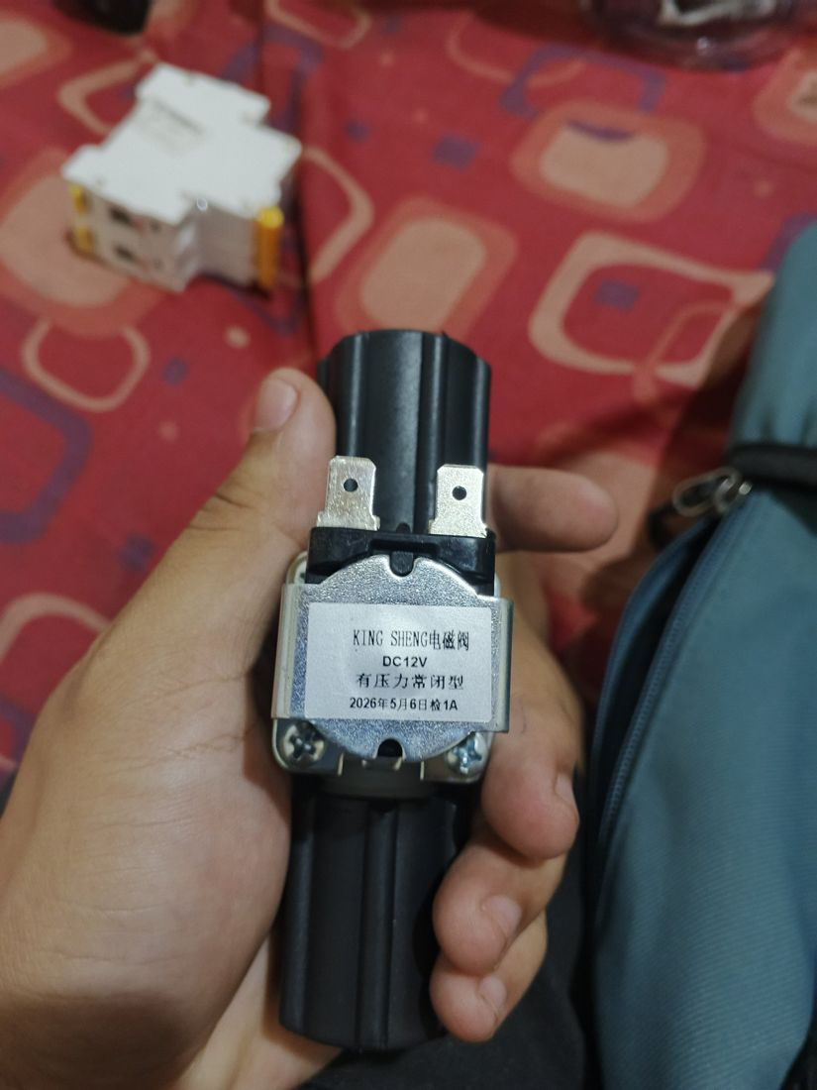 | What it is: A water valve opened by a 12 V electromagnet.  On the label: KING SHENG 电磁阀 · DC12V · 有压力常闭型 (pressure-type, normally closed) · stamped "1A" (probably an inspection mark, so measure the coil current yourself).  Role in this project: Opens and closes the water line to the sprinklers. Normally closed means a power failure shuts the water off.  Connect it / watch out:  - Pressure-type valves need line pressure to open, so they will not open from gravity alone. The pump creates that pressure. The firmware energises the valve, then starts the pump 1 s later, and that sequence still works.  - Wire it through relay channel 2 using COM and NO. It has two spade tabs; a plain DC coil has no polarity.  - Put a flyback diode (1N5408 or 1N4007) across the two tabs, stripe to +12 V, unless the coil already has one.  - Buy female spade connectors that match the tab width.  Verdict: Required

Photo 2: Current / Voltage Monitor Module (INA226-type, I2C): extra part
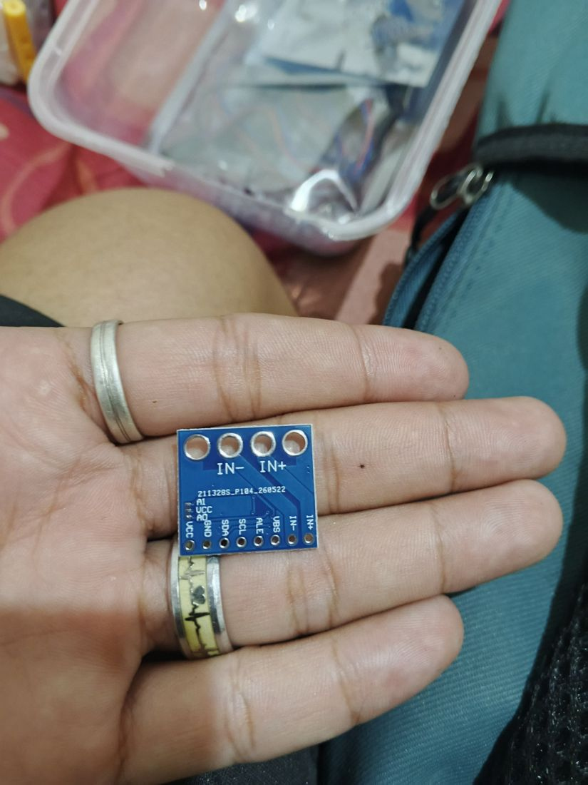 | What it is: A small I2C module that measures voltage and current at the same time.  On the label: Pins: VCC, GND, SDA, SCL, ALE (alert), VBS, IN+, IN− and A0/A1 address pads. This matches an INA226; confirm with the chip marking on the other side.  Role in this project: Reads battery voltage and pump current. Pump current falling to near zero means dry-run; a spike means a stalled pump. It also replaces the battery-voltage divider suggested in the guide.  Connect it / watch out:  - Wire VCC to 3.3 V, GND, SDA to GPIO21, SCL to GPIO22 (the shield I2C port). Default address 0x40, so no clash with the RTC (0x32) or ADS1115 (0x48).  - Put IN+ / IN− in series with the +12 V line you want to measure, and connect VBS to that same 12 V rail.  - Check the small shunt resistor on the component side: R100 (0.1 Ω) handles only about 0.8 A, R010 about 8 A, R002 about 40 A. A 0.1 Ω shunt is too small for the pump.  - The header pins do not look soldered yet; you will need a soldering iron.  Verdict: Optional upgrade

Photo 3: 2-Pole DC Circuit Breaker (PEMZZ WY47-63DC, B16)
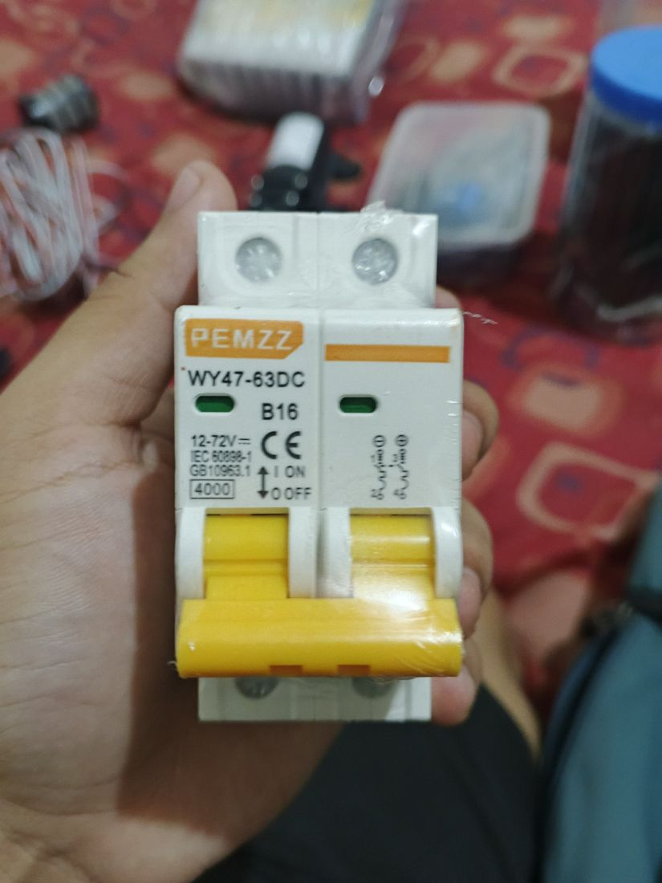 | What it is: A resettable DC breaker.  On the label: 12–72 V DC · B16 (16 A, B-curve) · IEC 60898-1 · 4000 A breaking capacity · 2 poles.  Role in this project: Sits between the battery and everything else. It cuts power on overload or short circuit and doubles as the main ON/OFF switch.  Connect it / watch out:  - Follow the polarity symbols printed on the side; many DC breakers only work correctly one way round.  - 16 A is higher than the 10 A fuse in the guide, so use at least 14 AWG (2.5 mm²) wire from the battery through the breaker.  - Add a small fuse (about 3 A) on the buck-converter input, because a 16 A breaker will not protect thin wires.  - Use one pole on battery +. The second pole can switch battery − so the system is fully isolated when it is off.  Verdict: Required (replaces the fuse)

Photo 4: Capacitive Soil Moisture Sensor (DFRobot V1.0, analog)
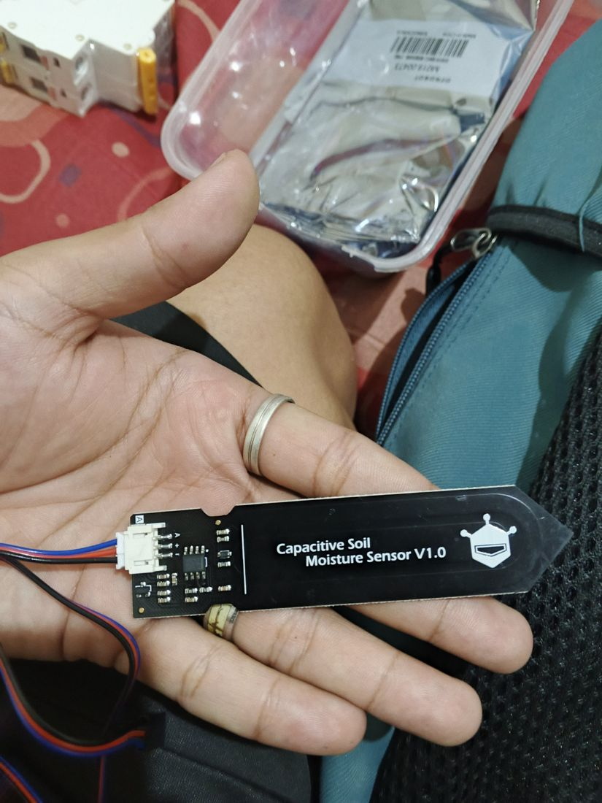 | What it is: Measures how wet the soil is without exposed metal electrodes, so it does not corrode like cheap resistive probes.  On the label: Capacitive Soil Moisture Sensor V1.0 · connector pins A (signal), + (power), − (ground).  Role in this project: Three of these feed the controller. The firmware takes the median, so one bad sensor does not trigger watering.  Connect it / watch out:  - Plug each into the shield Analog ports A0, A1, A2 (GPIO36, 39, 34). These are ADC1 pins, which is what the firmware expects.  - The output voltage drops as the soil gets wetter (about 0–3 V). Calibrate in the app: dry air = Set DRY, a glass of water = Set WET.  - Insert only up to the printed line. The chips on the upper part must stay dry; seal the cable joint with heat shrink or epoxy for outdoor use.  Verdict: Required

Photo 5: ADS1115 16-bit I2C ADC Module (front): extra part
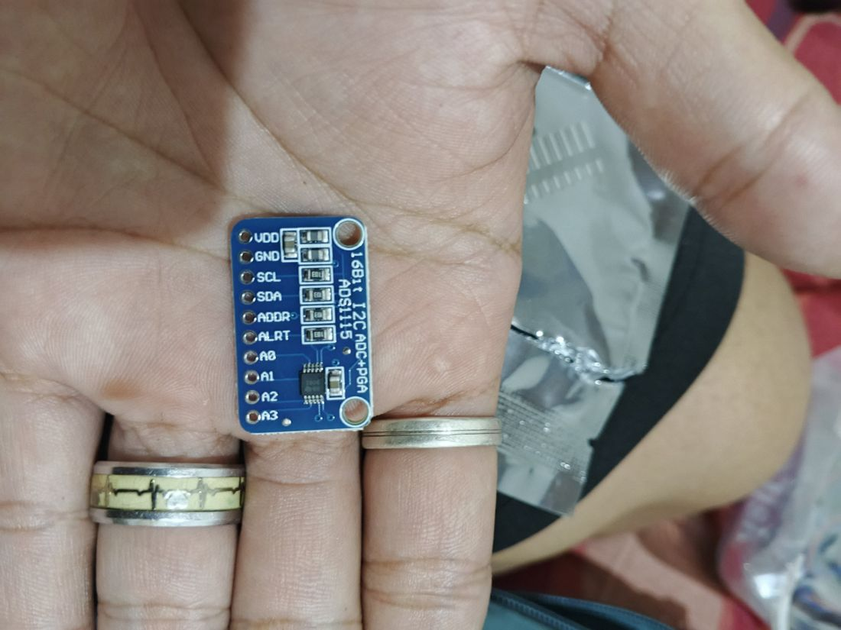 | What it is: An external analog-to-digital converter with 4 input channels.  On the label: Pins: VDD, GND, SCL, SDA, ADDR, ALRT, A0–A3 · printed "16Bit I2C ADC+PGA".  Role in this project: An optional upgrade for the soil sensors. The ESP32 built-in ADC is noisy and slightly non-linear; the ADS1115 reads much more cleanly. Use A0–A2 for the soil sensors and keep A3 spare.  Connect it / watch out:  - Wire VDD to 3.3 V, GND, SCL to GPIO22, SDA to GPIO21 and ADDR to GND (address 0x48).  - Keep inputs under VDD + 0.3 V. The soil sensors (about 3 V max) are fine at 3.3 V.  - Arduino library: Adafruit ADS1X15 (Library Manager). Start with the ESP32 ADC and switch to this if readings jump around.  - The header pins do not look soldered yet.  Verdict: Optional upgrade

Photo 6: 12 V 25 Ah Gel Deep-Cycle Battery (YOQU E-bike type)
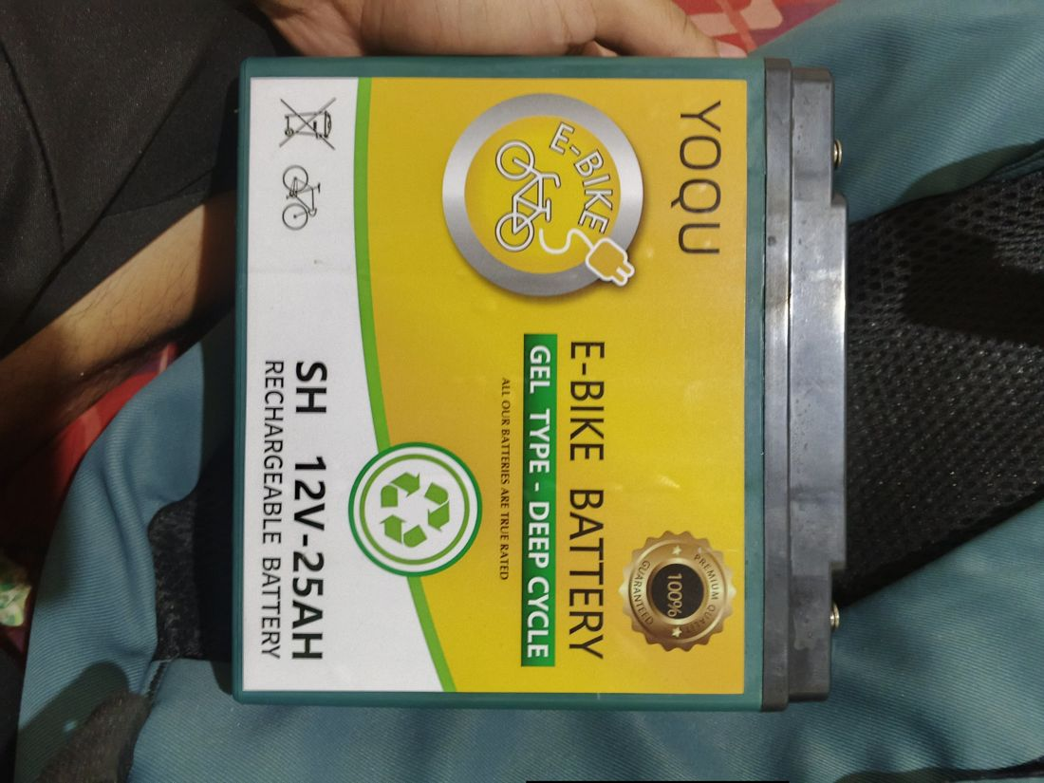 | What it is: A sealed gel lead-acid battery that stores the solar energy.  On the label: YOQU · E-BIKE BATTERY · GEL TYPE – DEEP CYCLE · SH 12V-25AH · rechargeable.  Role in this project: Powers the pump, valve, relay and ESP32 at night and on cloudy days. About 300 Wh nominal, roughly 150 Wh usable at 50% depth of discharge.  Connect it / watch out:  - The solar charge controller must have a GEL (or sealed lead-acid) charge setting. Do not use a lithium profile.  - Do not let it drop below about 11.5 V under load; repeated deep discharge shortens its life.  - Check the terminal type on top (screw, bolt or tab) and buy matching ring lugs.  Verdict: Required

Photo 7: Water Flow Sensor (Sea ZJ-S201)
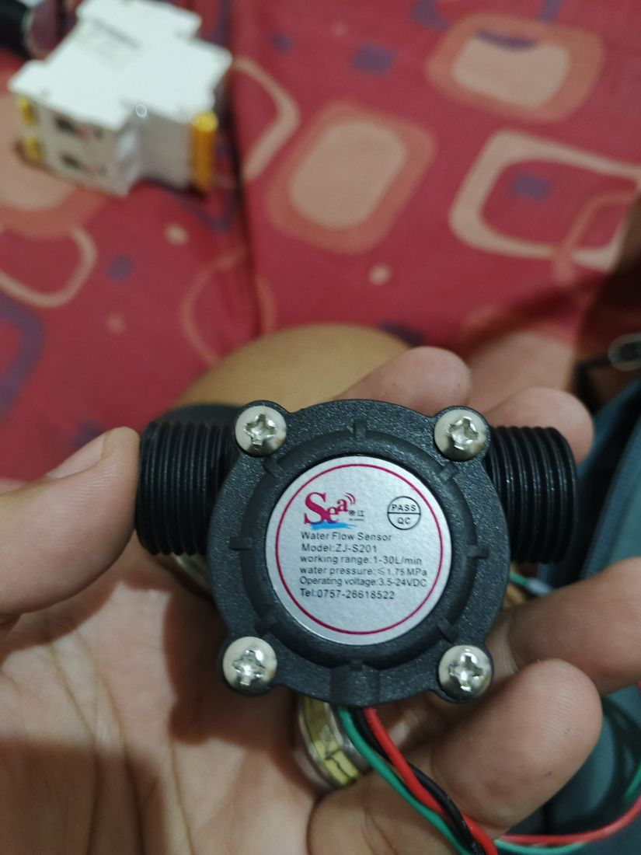 | What it is: A small turbine in the pipe that sends electrical pulses as water passes.  On the label: Model ZJ-S201 · working range 1–30 L/min · max pressure 1.75 MPa · operating voltage 3.5–24 VDC · red, black and green wires.  Role in this project: Measures flow and delivered volume, and detects dry-run, a blocked line or leaks.  Connect it / watch out:  - Typically red = +V, black = GND, green = signal. Verify before connecting.  - It needs at least 3.5 V, so power it from 5 V, not the 3.3 V port. Its signal is then 5 V, so use the 10 kΩ + 20 kΩ divider before GPIO27.  - Pulses per litre is not printed. The firmware assumes 450 (typical for this sensor family); calibrate with a bucket test.  - Readings are inaccurate below 1 L/min, so make sure enough nozzles are connected.  Verdict: Required (needs voltage divider)

Photo 8: microSD Card (SanDisk 16 GB microSDHC with adapter)
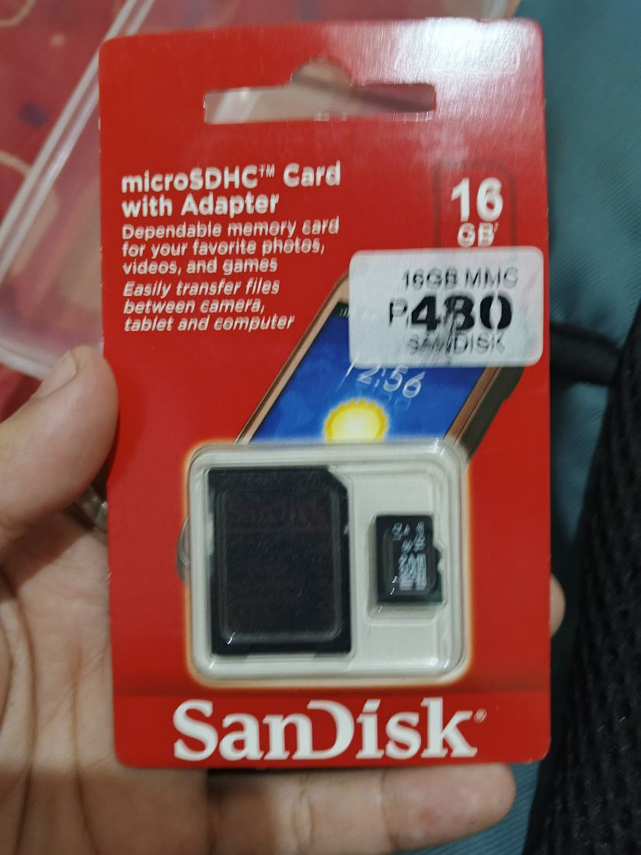 | What it is: The memory card that holds the logs.  On the label: SanDisk microSDHC 16 GB with SD adapter. The sticker "16GB MMC" is just the shop label.  Role in this project: Goes into the serial data logger and stores the CSV history of sensor readings and events.  Connect it / watch out:  - 16 GB SDHC is within the logger limit of 32 GB or less. Make sure it is formatted FAT32.  - Check the real capacity with H2testw (Windows) or f3 (Mac/Linux), because fake cards are common.  - Keep a spare card and swap it when you collect the data.  Verdict: Required

Photo 9: ADS1115 ADC Module (back side)
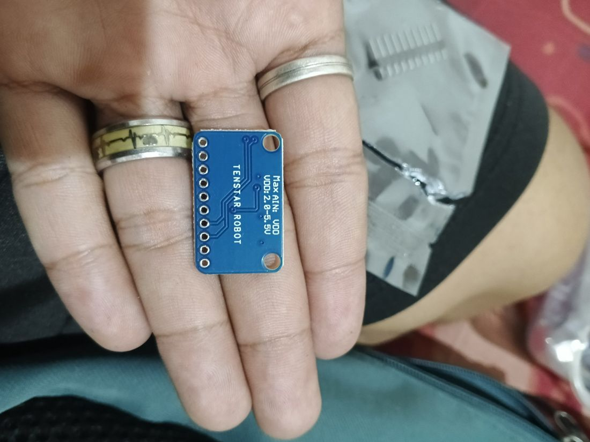 | What it is: The back of the same ADS1115 module.  On the label: Printed: TENSTAR ROBOT · Max AIN: VDD · VDD: 2.0–5.5V.  Role in this project: Shows the supply range and input limit of the ADS1115 from photo 5.  Connect it / watch out:  - Power it at 3.3 V so the I2C lines stay at 3.3 V, which is safe for the ESP32.  - An input signal must never exceed VDD.  Verdict: Optional upgrade

Photo 10: FireBeetle 2 ESP32-E (N16R2), DFRobot: the main controller
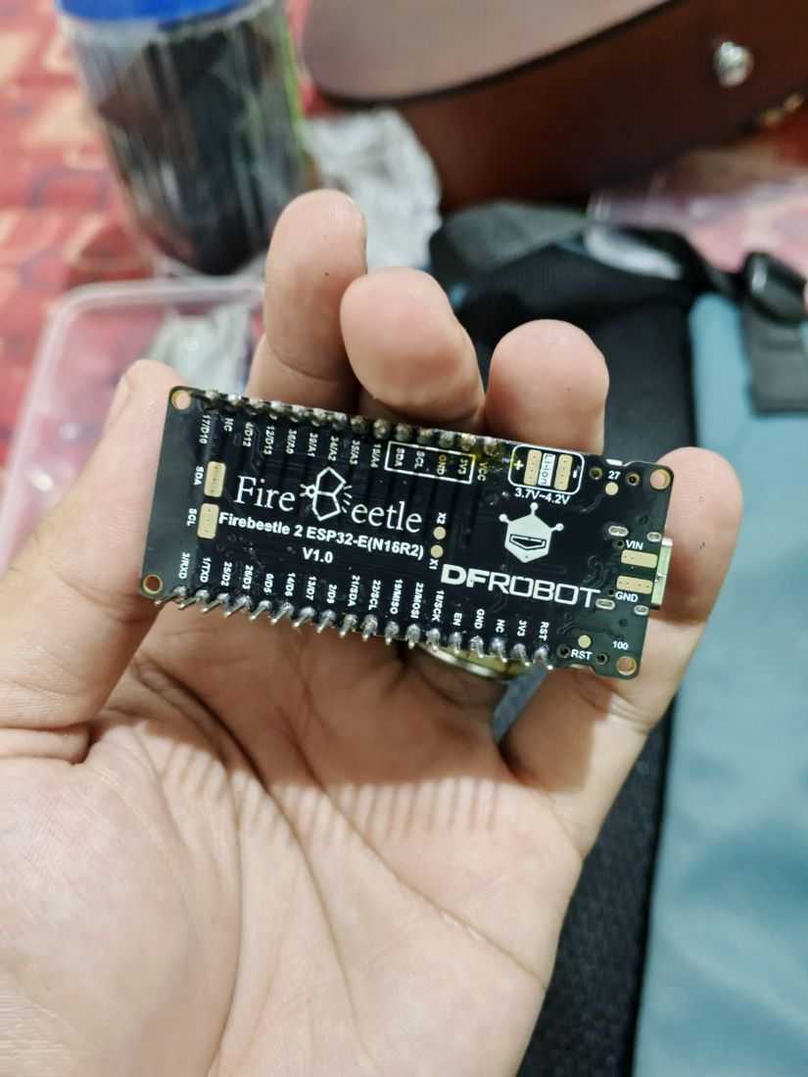 | What it is: The ESP32 board with Wi-Fi and Bluetooth. N16R2 means 16 MB flash and 2 MB PSRAM. The photo shows the underside with pin labels.  On the label: Firebeetle 2 ESP32-E (N16R2) V1.0 · A0=36, A1=39, A2=34, A3=35, A4=15 · D2=25, D3=26, D5=0, D6=14, D7=13, D9=2, D10=17, D12=4, D13=12 · SDA 21, SCL 22 · RX 3, TX 1 · MISO 19, MOSI 23, SCK 18 · a pad marked 27.  Role in this project: Runs the control loop, the web server for the app and all sensor reading.  Connect it / watch out:  - This matches your IO shield. In Arduino IDE choose DFRobot Firebeetle 2 ESP32-E (ESP32 Dev Module also works).  - Use ADC1 pins only for analog (A0–A3). A4 (GPIO15) is ADC2 and unreliable while Wi-Fi is on.  - Avoid boot-strapping pins for outputs: GPIO0, 2, 12 and 15 (D5, D9, D13, A4).  - GPIO16/17 are normally used by the PSRAM on this variant, so the data logger pins in the guide (16/17) must change to GPIO14 (TX) and GPIO13 (RX).  - Power it through USB-C or 5 V at VIN. Leave the Li-ion pads unused.  Verdict: Required

Photo 11: IO Expansion Shield for FireBeetle 2 (DFRobot)
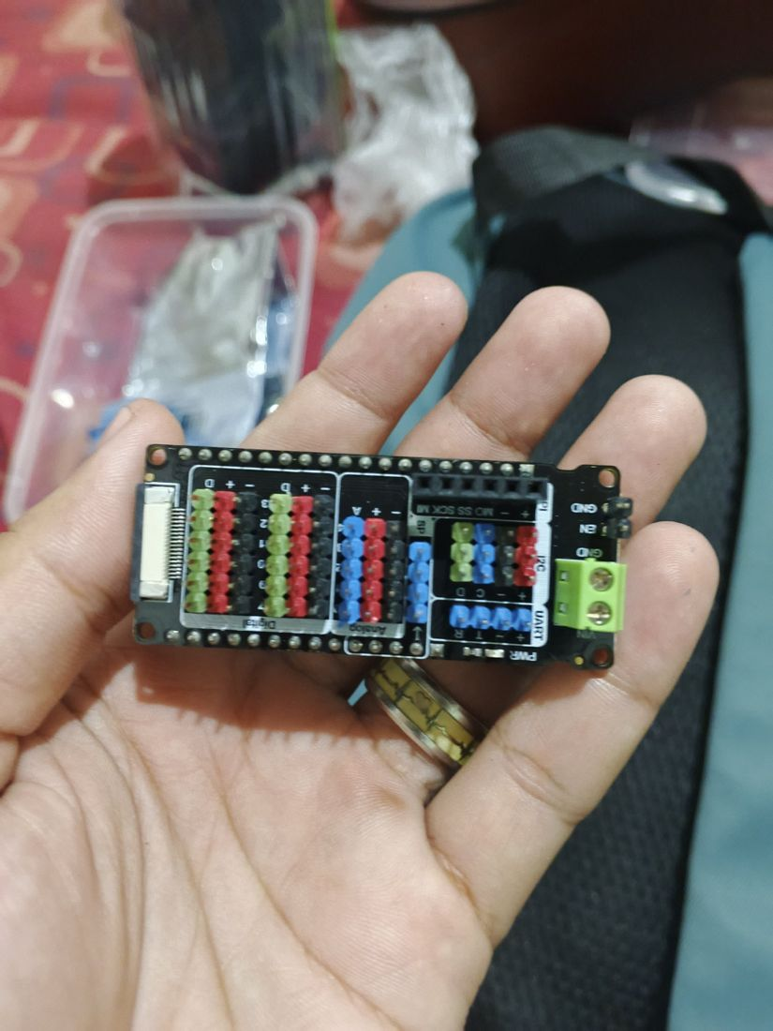 | What it is: A plug-on board that turns the ESP32 pins into 3-wire sensor ports.  On the label: Digital ports (D, +, −), Analog ports (A, +, −), I2C (D, C, −, +), UART (R, T, −, +), SPI, green VIN/GND screw terminal, EN/GND header.  Role in this project: Lets you plug in the soil sensors, relay, RTC, INA226 and ADS1115 neatly without soldering each pin.  Connect it / watch out:  - Soil sensors go to Analog A0, A1, A2. Relay IN1 goes to D2 (GPIO25) and IN2 to D3 (GPIO26). The flow signal goes to GPIO27 (the pad marked 27 on the board) through the divider.  - The RTC, INA226 and ADS1115 can all share the I2C port.  - The UART port most likely uses GPIO1/3, the same pins as the USB serial used for uploading. Do not use it for the data logger; use D6/D7 (GPIO14/13).  - Check the DFRobot wiki for the allowed VIN range of the green screw terminal and which voltage the + pins carry. I recommend feeding 5 V from the buck converter.  Verdict: Required

Photo 12: 2-Channel 5 V Relay Module (SRD-05VDC-SL-C, opto-isolated)
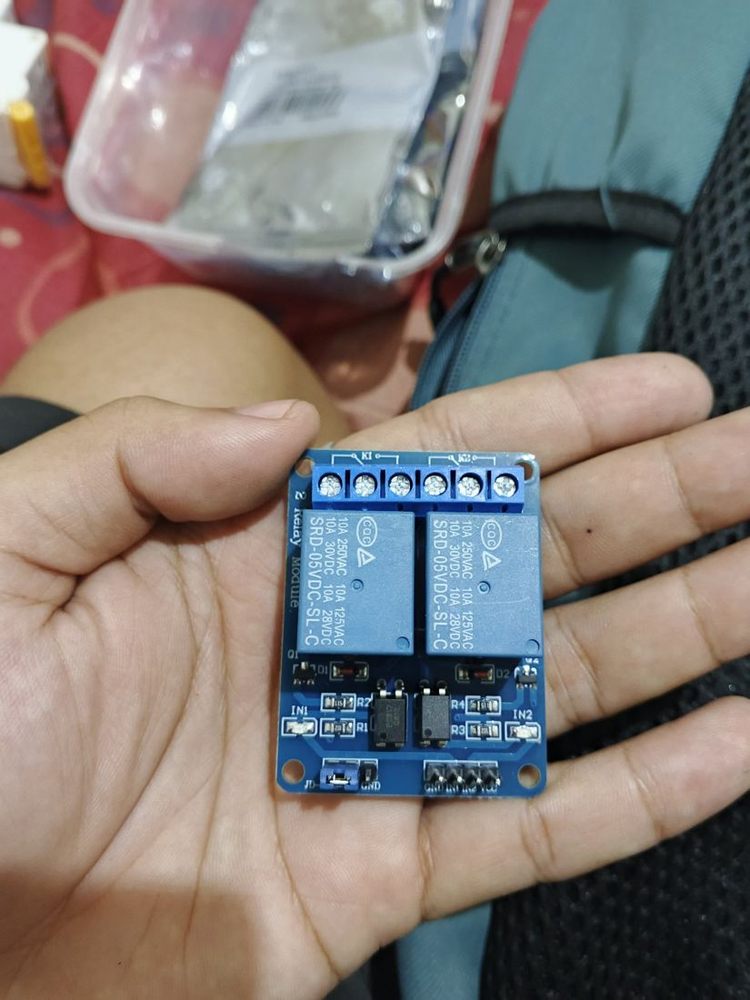 | What it is: Two electromagnetic switches controlled by logic pins, so the ESP32 can switch 12 V loads.  On the label: SRD-05VDC-SL-C relays, 10 A 250 VAC / 10 A 28 VDC · header pins GND, IN1, IN2, VCC · JD-VCC jumper · LEDs for IN1/IN2 · 3 screw terminals per relay.  Role in this project: Channel 1 switches the pump and channel 2 switches the solenoid valve.  Connect it / watch out:  - The coils are 5 V, not 12 V as in the original list. Power the relay side from the 5 V rail; the contacts switch the 12 V loads fine (rated 28 VDC).  - For 3.3 V logic: remove the JD-VCC jumper, feed VCC with 3.3 V and JD-VCC with 5 V (grounds common). If you keep the jumper, a relay may stay on when the pin is HIGH at 3.3 V.  - Use COM and NO on each relay so the load is off when unpowered. The module is active LOW: pin LOW = relay on.  - The board diodes protect only the relay coils; still add a flyback diode across the pump and the valve.  Verdict: Required (check wiring)

Photo 13: Micro-Sprinkler with Rotating Head and Stake (on thin tubing)
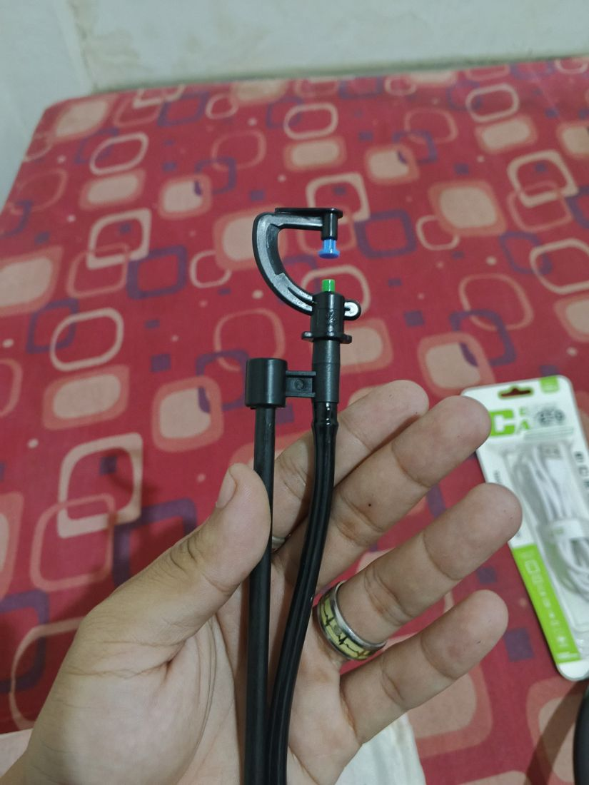 | What it is: A small spray nozzle on thin tubing; the C-shaped arm rotates to spread the water.  On the label: Black rotating arm with interchangeable coloured nozzle tips (blue and green), on black micro-tubing with a support clip.  Role in this project: The final outlets that water the plants.  Connect it / watch out:  - Connect to the ½ in main line with barbed connectors or a punch tool. Check the tubing size on your packaging (often 4/7 mm).  - The nozzle colour sets flow and spray pattern; check the packaging for litres per hour. Add up the nozzles so total flow is at least about 1 L/min for the flow sensor.  - The tiny orifices clog easily, so install a mesh or disc filter (120 mesh or finer) before the pump.  - These need some line pressure, which the pump provides.  Verdict: Required

Photo 14: 12 V Diaphragm Water Pump (GOOD PUMPS, 12 V 72 W, 6 L/min, 0.9 MPa)
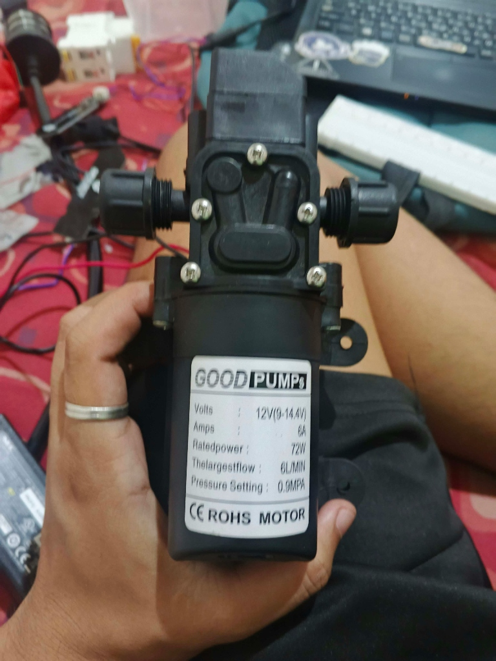 | What it is: A self-priming 12 V DC diaphragm water pump with an integrated automatic pressure switch.  On the label: GOOD PUMPS · Volts: 12V (9-14.4V) · Amps: 6A · Rated power: 72W · The largest flow: 6L/MIN · Pressure Setting: 0.9MPA (9 bar / 130 psi) · CE ROHS MOTOR.  Role in this project: Draws water from the 200 L reservoir drum through the suction filter and pressurises the line to open the solenoid valve and spin the micro-sprinklers.  Connect it / watch out:  • Rated 6 A at 12 V (72 W) with an operating voltage range of 9–14.4 V (well matched to the 12 V gel battery). Inrush starting current can reach 8–10 A.  • Wire Relay Channel 1 using COM and NO to switch the pump positive (+). The relay (SRD-05VDC-SL-C) is rated for 10 A at 28 VDC, which safely handles the pump’s 6 A load.  • Wire through the 16 A DC circuit breaker using at least 14–16 AWG wire to minimise voltage drop under the 6 A load.  • Install a heavy-duty flyback diode (1N5408, 3 A rated) directly across the motor leads (cathode with silver stripe to +12 V, anode to GND) to clamp inductive turn-off spikes.  • 0.9 MPa (9 bar) provides ample line pressure to open the normally closed pressure-type solenoid valve and drive all micro-sprinkler rotating heads.  • The built-in pressure switch automatically shuts off the motor if the line is closed or dead-headed, protecting the pump from overpressure.  • Observe the embossed flow direction arrow on the pump head when attaching the inlet and outlet hoses.  Verdict: Required

Photo 15: Water Inlet Suction Mesh Filter (Stainless Steel Strainer)
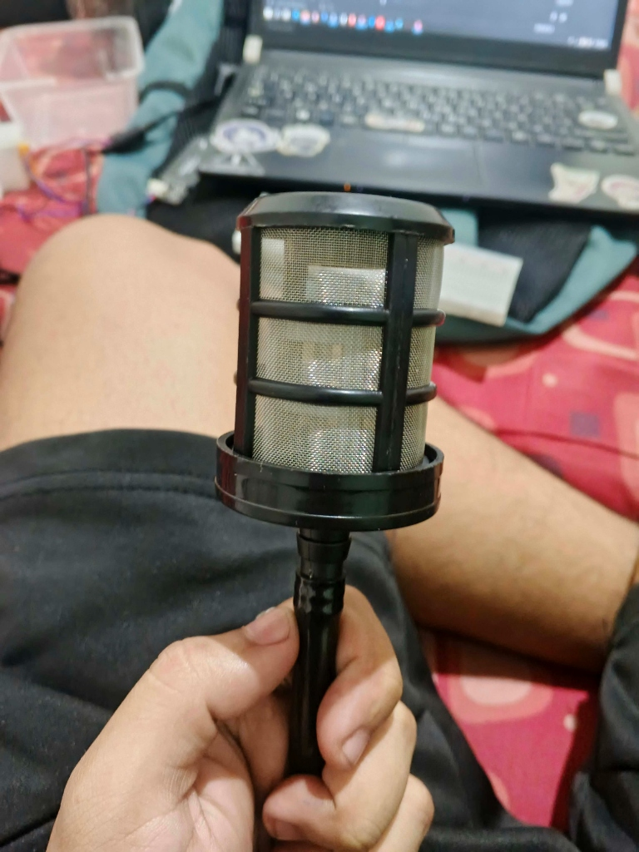 | What it is: A weighted submerged suction line foot strainer filter with a fine stainless steel mesh screen and hose barb.  On the label: Cylindrical stainless steel wire mesh screen housed in a black plastic frame with a ribbed hose barb connector.  Role in this project: Submerged inside the 200 L reservoir drum at the very beginning of the pump suction intake line. Filters out sediment, rust, algae, insects, and particulate matter before water reaches the pump or sprinkler nozzles.  Connect it / watch out:  • Push the pump intake hose firmly over the ribbed barb and secure tightly with a stainless steel hose clamp to prevent suction air leaks (air leaks cause loss of prime).  • Suspend the filter 5–10 cm above the bottom of the drum so it does not draw settled sludge or silt from the tank floor.  • Inspect and rinse the stainless steel mesh periodically to prevent suction restriction and pump cavitation.  Verdict: Required

3. In the project list but not in your photos
Please confirm you have these. They are needed for the system to work.
- SD2405 RTC module (keeps the time)
- Fermion Serial Data Logger V2.0 (the board the microSD card goes into)
- 12 V solar charge controller (must have a GEL battery setting)
- 100 W solar panel
- 200 L water drum with float (level control) valve
- Pipe, hose, and fittings (½ in suction & pressure hose, 4/7 mm micro-tubing, hose clamps)

4. What is important to get or prepare
Item | Why it matters | Priority
12 V → 5 V buck converter, 2 A or more | Powers the ESP32 and the relay coils from the 12 V battery. The ESP32 board cannot take 12 V. | Must buy
Flyback diodes ×2 (1N5408 or 1N4007) | Across the pump and the valve. They stop voltage spikes from welding relay contacts or resetting the ESP32. | Must buy
Resistors 10 kΩ + 20 kΩ | Flow-sensor divider: brings the 5 V pulses down to 3.3 V so the ESP32 pin is not damaged. | Must buy
Charge controller with GEL setting | Charges the gel battery correctly. A wrong profile shortens its life. | Must have
Wire, lugs and connectors | 14 AWG for battery to breaker, 16–18 AWG for loads, ring lugs for the battery, female spade connectors for the valve, terminal blocks. | Must buy
Jumper Wires (male to male and male to female) | The esp32 has a limited pins so we need a breadboard to connet them but the problem is we don’t have enough jumper wire to connect them, I’ll give you a free breadboard nalang because i have a spare breadboard. | Must buy
Multimeter | Set the buck converter to 5.0 V before connecting the ESP32, verify wire colours, and check battery voltage. | Strongly advised
IP65 box, cable glands, heat shrink | Most outdoor failures are moisture and loose connections, not the electronics. | Recommended
3 A fuse on the buck converter input | The 16 A breaker will not protect the thin wires to the electronics. | Recommended

5. Changes needed to the implementation guide
Your actual parts differ from the original list in a few places. These are the corrections to apply to Auto-Sprinkler-Implementation.md and the firmware.
Topic | In the guide now | Change to
Relay coil voltage | Guide says 12 V coil. | Parts are 5 V coil (SRD-05VDC). Power the relay side from 5 V. Remove the JD-VCC jumper and use 3.3 V on VCC with 5 V on JD-VCC.
Data logger UART pins | GPIO16 (RX) and GPIO17 (TX). | Change to GPIO13 (RX) and GPIO14 (TX). GPIO16/17 are normally taken by PSRAM on the N16R2 board.
Valve behaviour | Valve opens first to avoid dead-heading the pump. | The valve is pressure-type, so it opens only once the pump builds pressure. The existing order (valve on, pump 1 s later) still works.
Battery protection | 10 A inline fuse. | Use the 16 A DC breaker with at least 14 AWG wire, plus a small fuse (about 3 A) on the electronics branch.
Battery voltage | Optional resistor divider on an ADC pin. | Use the INA226 instead. It also gives pump current for a second dry-run check.
Soil sensor ADC | ESP32 internal ADC1. | Works as is. The ADS1115 is an optional accuracy upgrade over I2C (address 0x48).
Arduino IDE board | FireBeetle-ESP32 or ESP32 Dev Module. | Choose DFRobot Firebeetle 2 ESP32-E (the board in photo 10).
Pump specifications & protection | Generic 12 V pump without current rating. | GOOD PUMPS 12 V, 6 A rated, 72 W, 6 L/min, 0.9 MPa. Use a 1N5408 flyback diode (3 A rated) instead of 1N4007. Use 14–16 AWG power wiring. Flow rating (6 L/min) matches the ZJ-S201 flow sensor (1–30 L/min) sweet spot.

