**Clearing Browser Cache (Windows)**

When you use a browser, like Chrome, it saves some information from websites in its cache and cookies. Clearing them fixes certain problems, like loading or formatting issues on sites

**Chrome**



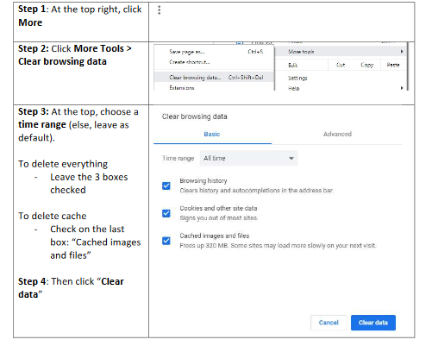

**IE 11**



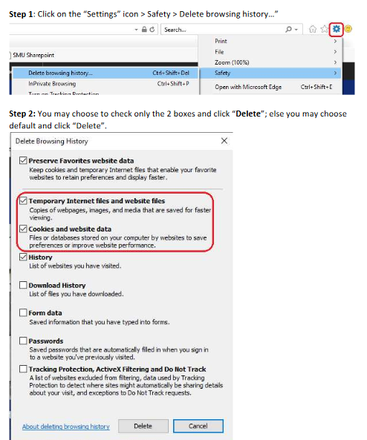

**Edge**



