BookIt Database Design Package
Milestone 02 – Database Design
Project: BookIt – Service Booking Platform
Database: PostgreSQL / Supabase

1. Introduction
BookIt is a service booking platform that allows customers to browse and book services, while service providers can create listings, manage availability, and track appointments. The database is designed to support user accounts, service categories, service listings, available time slots, bookings, and customer reviews.
The schema uses a relational structure to reduce repeated data and clearly define relationships between users, services, bookings, and reviews.

2. Table Descriptions
Users - Stores registered users for both customers and service providers. The role field identifies whether the user is a customer or provider.
Categories - Stores predefined service categories such as plumbing, cleaning, tutoring, photography, and personal training.
Services - Stores service listings created by providers. Each service belongs to one provider and one category.
time_slots - Stores available appointment times for each service. A time slot can be available or booked.
Bookings - Stores appointments made by customers. Each booking connects a customer, service, and time slot.
Reviews - Stores ratings and comments left by customers after completed bookings.

3. ER Diagram 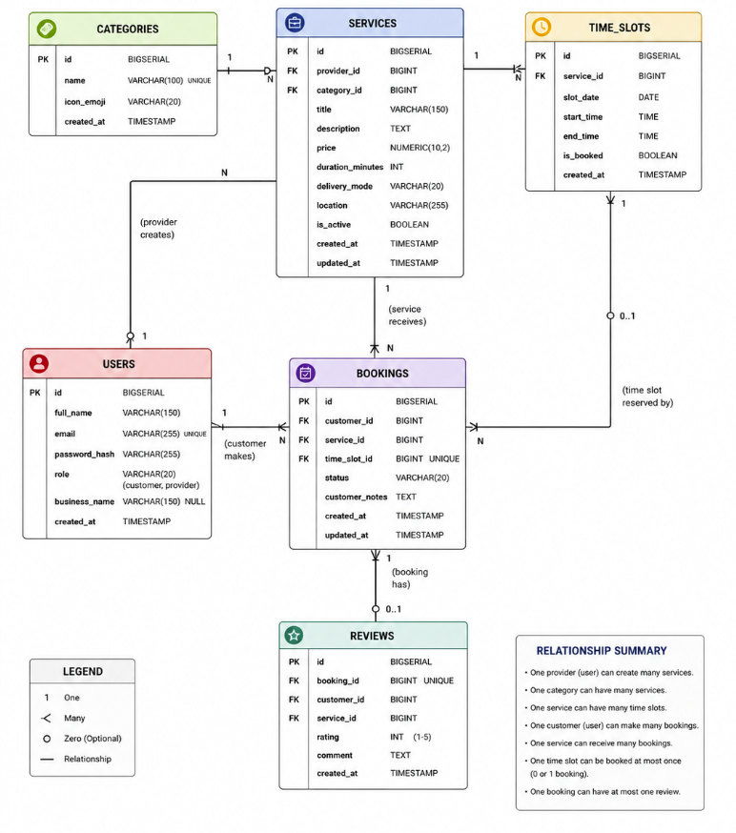

4. Relationship Summary
A provider can create many services, but each service belongs to one provider.
A category can contain many services, but each service belongs to one category.
A service can have many available time slots.
A customer can make many bookings.
Each booking is linked to one service and one time slot.
Each time slot can only be booked once.
Each completed booking can have at most one review.

5. Normalization Explanation
The database is normalized to reduce duplicate data. User information is stored once in the users table. Categories are stored separately instead of repeating category names in every service. Bookings are stored separately from services and time slots so appointment history can be tracked clearly. Reviews are also separated so each review is connected to a specific completed booking.
This structure avoids unnecessary repetition and keeps the database organized, flexible, and easier to maintain.

6. SQL CREATE TABLE Statements
CREATE TABLE categories (
id BIGSERIAL PRIMARY KEY,
name VARCHAR(100) NOT NULL UNIQUE,
icon_emoji VARCHAR(20),
created_at TIMESTAMP DEFAULT CURRENT_TIMESTAMP
);

CREATE TABLE users (
id BIGSERIAL PRIMARY KEY,
full_name VARCHAR(150) NOT NULL,
email VARCHAR(255) NOT NULL UNIQUE,
password_hash VARCHAR(255) NOT NULL,
role VARCHAR(20) NOT NULL CHECK (role IN ('customer', 'provider')),
business_name VARCHAR(150),
created_at TIMESTAMP DEFAULT CURRENT_TIMESTAMP,

CHECK (
role = 'customer'
OR business_name IS NOT NULL
)
);

CREATE TABLE services (
id BIGSERIAL PRIMARY KEY,
provider_id BIGINT NOT NULL,
category_id BIGINT NOT NULL,
title VARCHAR(150) NOT NULL,
description TEXT NOT NULL,
price NUMERIC(10,2) NOT NULL CHECK (price >= 0),
duration_minutes INT NOT NULL CHECK (duration_minutes > 0),
delivery_mode VARCHAR(20) NOT NULL CHECK (delivery_mode IN ('in-person', 'online')),
location VARCHAR(255),
is_active BOOLEAN NOT NULL DEFAULT TRUE,
created_at TIMESTAMP DEFAULT CURRENT_TIMESTAMP,
updated_at TIMESTAMP DEFAULT CURRENT_TIMESTAMP,

CONSTRAINT fk_services_provider
FOREIGN KEY (provider_id)
REFERENCES users(id)
ON DELETE CASCADE,

CONSTRAINT fk_services_category
FOREIGN KEY (category_id)
REFERENCES categories(id)
ON DELETE RESTRICT
);
CREATE TABLE time_slots (
id BIGSERIAL PRIMARY KEY,
service_id BIGINT NOT NULL,
slot_date DATE NOT NULL,
start_time TIME NOT NULL,
end_time TIME NOT NULL,
is_booked BOOLEAN NOT NULL DEFAULT FALSE,
created_at TIMESTAMP DEFAULT CURRENT_TIMESTAMP,

CONSTRAINT fk_time_slots_service
FOREIGN KEY (service_id)
REFERENCES services(id)
ON DELETE CASCADE,

CONSTRAINT chk_time_order
CHECK (end_time > start_time),

CONSTRAINT unique_service_slot
UNIQUE (service_id, slot_date, start_time)
);

CREATE TABLE bookings (
id BIGSERIAL PRIMARY KEY,
customer_id BIGINT NOT NULL,
service_id BIGINT NOT NULL,
time_slot_id BIGINT NOT NULL UNIQUE,
status VARCHAR(20) NOT NULL DEFAULT 'pending'
CHECK (status IN ('pending', 'confirmed', 'completed', 'cancelled')),
customer_notes TEXT,
created_at TIMESTAMP DEFAULT CURRENT_TIMESTAMP,
updated_at TIMESTAMP DEFAULT CURRENT_TIMESTAMP,

CONSTRAINT fk_bookings_customer
FOREIGN KEY (customer_id)
REFERENCES users(id)
ON DELETE CASCADE,

CONSTRAINT fk_bookings_service
FOREIGN KEY (service_id)
REFERENCES services(id)
ON DELETE CASCADE,

CONSTRAINT fk_bookings_time_slot
FOREIGN KEY (time_slot_id)
REFERENCES time_slots(id)
ON DELETE RESTRICT
);

CREATE TABLE reviews (
id BIGSERIAL PRIMARY KEY,
booking_id BIGINT NOT NULL UNIQUE,
customer_id BIGINT NOT NULL,
service_id BIGINT NOT NULL,
rating INT NOT NULL CHECK (rating BETWEEN 1 AND 5),
comment TEXT,
created_at TIMESTAMP DEFAULT CURRENT_TIMESTAMP,

CONSTRAINT fk_reviews_booking
FOREIGN KEY (booking_id)
REFERENCES bookings(id)
ON DELETE CASCADE,

CONSTRAINT fk_reviews_customer
FOREIGN KEY (customer_id)
REFERENCES users(id)
ON DELETE CASCADE,

CONSTRAINT fk_reviews_service
FOREIGN KEY (service_id)
REFERENCES services(id)
ON DELETE CASCADE
);

7. Design Justification
This database design supports the main BookIt workflow. Customers can register, browse categories, view services, select available time slots, create bookings, and leave reviews. Providers can register, create service listings, manage availability, and update booking statuses.
The schema uses primary keys, foreign keys, unique constraints, and check constraints to protect data accuracy. It also separates major entities into different tables, which makes the database easier to maintain and expand in later milestones.

