BookIt.
The Service Booking Platform

Course: CP476B – Internet Computing | Spring 2026
Milestone: 01 – Project Planning and Design
Team Size: 10 Students
Submitted: (Date of Submission)

Team Members
Zulqarnayeen Sadid – [169075017]
Fatma Mohamed Yasin – [169075296]
Moosa Ahmed – [169046796]
Dawood Ahmed – [169046795]
Pushti Nakum – [169053401]
Gurnivaj Tiwana – [169033176]
Harshaan Rehal – [169057121]
Jeff Vu – [169058539]
Hamza Mohammed – [169061024]
Arren Haroutunian – [210603250]

Section 1: Project Proposal
1.1 Problem Statement and Motivation
Have you ever found yourself needing your hair done, your plumbing fixed, and your lawn mowed all on the same day? Now imagine going to five different business websites just to book all these appointments. Sounds like a nightmare!
Customers typically search across multiple websites, make phone calls, and check availability manually. Then it's rinse and repeat for every different type of service they need. At the same time, small and independent service providers lack an easy and efficient way to manage their availability online and accept bookings. There is no single, consistent platform where someone can discover, compare, and book any local or online service in one place.
So, what kind of platform exists that can accommodate all these needs?
BookIt has all the solutions by providing a unified booking platform that works for any service category. The platform acts as a central hub where business owners can list their services, manage availability, and receive bookings, while customers can discover services based on either a specific problem they need solved or by browsing service categories.
This project was born out of a desire to simplify the process of connecting customers with service providers, regardless of industry. Existing solutions such as Yelp, Booksy, or Calendly each serve narrow use cases or specific verticals.
BookIt is designed with the goals of centralizing scheduling, availability, and booking management for both customers and service providers.
1.2 Target Users
- Customers: Individuals looking to discover and book services quickly, either by browsing categories or by describing their problem in natural language.
- Service Providers (Business Owners): Small business owners or independent professionals who want to list their services, set availability, and manage incoming bookings from a single dashboard.
- Administrators (optional, stretch): Platform administrators who can moderate service listings and manage user accounts.
1.3 Application Concept and Scope
BookIt is a full-stack web application that acts as a central hub connecting customers with local and online service providers. The platform supports two complementary discovery modes: a natural-language problem description (e.g., 'My lawn is very dry and I want to make it look better') that suggests relevant services, and a traditional category-based browsing system (Hair Styling, Lawn Care, Graphic Design, Tutoring, Home Repair, Cleaning, Fitness Training, Photography, Consulting, and more).
Once a customer identifies a service, they can view its details, select a date, browse available time slots, and book the appointment directly on the platform. Service providers manage their listings and see incoming bookings through a dedicated dashboard.
IN SCOPE:
- User registration and login for both customers and providers
- Service listing creation, editing, and deletion by providers
- Category-based service browsing by customers
- Natural-language service search / suggestion feature
- Service detail page with date and time-slot selection
- Appointment booking, viewing, and cancellation (CRUD on bookings)
- Provider dashboard: view and manage received bookings
- Customer dashboard: view upcoming and past bookings
- Input validation on all forms (client-side and server-side)
- Basic security: prepared statements, password hashing, XSS prevention
OUT OF SCOPE:
- Payment processing or financial transactions
- Real-time messaging between customer and provider
- Email/SMS notifications
- Advanced AI/ML for natural-language search (simplified keyword matching instead)
- Mobile native app

1.4 Feature List
Priority | Feature
Must Have | - User registration and login (customer and provider roles)  - Service listing management: create, view, edit, delete (CRUD) by provider  - Service category browsing for customers  - Service detail page (description, category, pricing, provider info)  - Time-slot availability management by provider  - Appointment booking by customer (create, view, cancel)  - Provider dashboard: view and manage incoming bookings  - Customer dashboard: view upcoming bookings  - Server-side input validation on all forms  - Secure password storage (bcrypt hashing)  - SQL injection prevention via prepared statements
Should Have | - Natural-language problem description → service suggestion feature  - Booking status management (pending, confirmed, completed, cancelled) by provider  - Search/filter services by category, keyword, or price range  - Review and rating system for completed bookings  - Customer profile edit page  - Provider profile edit page
Could Have | - Admin panel to moderate service listings  - Starred / Favorited services list for customers  - Printable booking confirmation page  - Service image upload  - Pagination on service listing results

Section 2: Requirements – Product Backlog (User Stories)
The following product backlog contains 15 user stories covering the end-to-end workflow of ServiceHub. Each story follows the exact format required: Story ID, Title, User Story, Story Points (Fibonacci), Priority, Sprint Assignment, Status, Conversation/Clarifications, and Confirmation/Acceptance Criteria.

AUTH-1 | Customer Registration
User Story | As a customer, I want to register for an account so that I can book services and manage my appointments.
Story Points | 3 (Fibonacci scale)
Priority | High
Sprint | Sprint 1
Status | Not Started
Conversation /  Clarifications | Registration requires name, email, password, and role selection (customer/provider). Email must be unique.
Confirmation /  Acceptance Criteria | ✓ A registration form is accessible from the homepage and displays fields for full name, email address, password, and confirm password.  ✓ Submitting the form with valid data creates a new customer account in the database and redirects to the customer dashboard.  ✓ If the email is already registered, an error message 'Email already in use' is displayed and no duplicate account is created.  ✓ Passwords are stored as bcrypt hashes, never plain text.  ✓ Leaving any required field empty displays a specific inline error message identifying the missing field.

AUTH-2 | User Login
User Story | As a registered user (customer or provider), I want to log in with my email and password so that I can access my account and dashboard.
Story Points | 3 (Fibonacci scale)
Priority | High
Sprint | Sprint 1
Status | Not Started
Conversation /  Clarifications | Login must work for both roles. After login, redirect to the correct dashboard based on role.
Confirmation /  Acceptance Criteria | ✓ A login form accepts email and password.  ✓ Valid credentials redirect the user to their role-specific dashboard (customer or provider).  ✓ Invalid credentials display 'Invalid email or password' without revealing which field is wrong.  ✓ After login, a session is created server-side and the user remains authenticated until they log out.  ✓ Accessing a protected route without being logged in redirects to the login page.

PROV-1 | Provider Registration
User Story | As a service provider, I want to register a provider account so that I can list my services and receive bookings.
Story Points | 3 (Fibonacci scale)
Priority | High
Sprint | Sprint 1
Status | Not Started
Conversation /  Clarifications | Provider registration shares the same form as customer but with role=provider. Business name is an additional field.
Confirmation /  Acceptance Criteria | ✓ The registration form includes a role selector (Customer / Service Provider).  ✓ Selecting 'Service Provider' reveals an additional 'Business Name' field.  ✓ Submitting with valid data creates a provider account and redirects to the provider dashboard.  ✓ Provider accounts are stored with role='provider' in the users table.

PROV-2 | Create Service Listing
User Story | As a service provider, I want to create a new service listing so that customers can discover and book my service.
Story Points | 5 (Fibonacci scale)
Priority | High
Sprint | Sprint 1
Status | Not Started
Conversation /  Clarifications | A service listing includes: title, description, category, price, duration (in minutes), and location/mode (in-person/online).
Confirmation /  Acceptance Criteria | ✓ A 'Create New Service' button on the provider dashboard opens a service creation form.  ✓ The form includes: title (required), description (required), category (dropdown, required), price (numeric, required), duration in minutes (required), and delivery mode (in-person/online, required).  ✓ On valid submission, the service is saved to the database linked to the logged-in provider and appears in the provider's service list.  ✓ If any required field is missing or invalid (e.g., negative price), a specific error message is shown and the record is NOT saved.  ✓ Server-side validation is performed — client-side alone is not sufficient.

PROV-3 | Edit Service Listing
User Story | As a service provider, I want to edit an existing service listing so that I can keep my information accurate and up to date.
Story Points | 3 (Fibonacci scale)
Priority | High
Sprint | Sprint 2
Status | Not Started
Conversation /  Clarifications | Only the provider who created the listing can edit it. Prevent other users from editing via URL manipulation.
Confirmation /  Acceptance Criteria | ✓ An 'Edit' button is visible on each service card in the provider's dashboard.  ✓ Clicking Edit pre-populates the form with the current values.  ✓ Saving valid changes updates the record in the database and shows a success message.  ✓ A provider cannot edit another provider's listing, a 403 response is returned if attempted.  ✓ Invalid input (e.g., empty title) displays an error and does not update the database.

PROV-4 | Manage Availability (Time Slots)
User Story | As a service provider, I want to add and remove available time slots for my services so that customers can only book valid appointment times.
Story Points | 5 (Fibonacci scale)
Priority | High
Sprint | Sprint 2
Status | Not Started
Conversation /  Clarifications | Time slots are linked to a specific service. Each slot has a date, start time, and is either available or booked.
Confirmation /  Acceptance Criteria | ✓ The provider can navigate to a 'Manage Availability' page for each service.  ✓ The provider can add new time slots by selecting a date and start time.  ✓ The provider cannot add a time slot with a date/time in the past.  ✓ A time slot already booked by a customer is displayed as 'Booked' and cannot be deleted while the booking is active.  ✓ Removing an available time slot deletes it from the database.

CUST-1 | Browse Services by Category
User Story | As a customer, I want to browse services by category so that I can quickly find service providers relevant to my needs.
Story Points | 3 (Fibonacci scale)
Priority | High
Sprint | Sprint 1
Status | Not Started
Conversation /  Clarifications | Categories are predefined (Hair Styling, Lawn Care, Graphic Design, Tutoring, Home Repair, Cleaning, Fitness Training, Photography, Consulting). Displayed as a grid of category cards on the homepage.
Confirmation /  Acceptance Criteria | ✓ The homepage displays a grid of service category cards with a name and icon.  ✓ Clicking a category displays a filtered list of all active services in that category.  ✓ Each service card shows: title, provider name, price, delivery mode, and a 'View Details' link.  ✓ If no services exist in a category, the message 'No services available in this category yet' is shown.  ✓ The page loads within a reasonable time and all listings are fetched from the database (not hardcoded).

CUST-2 | Natural-Language Service Search
User Story | As a customer, I want to describe my problem in plain language so that the platform can suggest relevant services without me needing to know the exact service name.
Story Points | 8 (Fibonacci scale)
Priority | Medium
Sprint | Sprint 2
Status | Not Started
Conversation /  Clarifications | Implemented as keyword-matching against service titles, descriptions, and categories. Full AI/NLP is out of scope.
Confirmation /  Acceptance Criteria | ✓ A text input search bar is prominent on the homepage with a placeholder like 'Describe your problem or need…'  ✓ Submitting a query returns a list of services whose title, description, or category contains any of the query keywords.  ✓ Results are ranked so that services matching more keywords appear first.  ✓ If no services match, a message 'No services found for your search. Try browsing by category.' is shown.  ✓ The search is case-insensitive.

CUST-3 | Book an Appointment
User Story | As a customer, I want to select a date and available time slot and confirm a booking so that I have a confirmed appointment with the service provider.
Story Points | 8 (Fibonacci scale)
Priority | High
Sprint | Sprint 2
Status | Not Started
Conversation /  Clarifications | The booking form shows a date picker and then dynamically loads available slots for that date. Booking marks the slot as unavailable.
Confirmation /  Acceptance Criteria | ✓ The booking form displays a date picker populated with dates that have at least one available slot.  ✓ Selecting a date dynamically updates the list of available time slots for that date.  ✓ Submitting the form with a selected slot creates a booking record linked to the customer, service, and time slot.  ✓ The selected time slot is marked as 'booked' so no other customer can select it.  ✓ A booking confirmation message (including date, time, and service name) is displayed after successful booking.  ✓ Attempting to book a slot that has just been taken by another user returns an error message.

CUST-4 | View and Cancel Bookings
User Story | As a customer, I want to view all my upcoming and past bookings and cancel upcoming ones so that I can manage my schedule.
Story Points | 5 (Fibonacci scale)
Priority | High
Sprint | Sprint 2
Status | Not Started
Conversation /  Clarifications | Cancellation should free the time slot. Past bookings are read-only.
Confirmation /  Acceptance Criteria | ✓ The customer dashboard shows two tabs or sections: 'Upcoming Bookings' and 'Past Bookings'.  ✓ Each booking shows: service name, provider name, date, time, and status.  ✓ A 'Cancel' button is available for upcoming bookings only.  ✓ Cancelling a booking updates its status to 'cancelled' in the database and marks the time slot as available again.  ✓ Past bookings (dates in the past) show no cancel button.

PROV-5 | Provider Booking Management
User Story | As a service provider, I want to view all bookings for my services and update their status so that I can manage my appointments professionally.
Story Points | 5 (Fibonacci scale)
Priority | High
Sprint | Sprint 3
Status | Not Started
Conversation /  Clarifications | Provider can mark bookings as confirmed, completed, or cancelled. Cancellation by provider should notify via status change.
Confirmation /  Acceptance Criteria | ✓ The provider dashboard shows a list of all bookings across all their services.  ✓ Each booking entry shows: customer name, service name, date, time, and current status.  ✓ The provider can update the booking status to: Confirmed, Completed, or Cancelled via a dropdown or buttons.  ✓ Marking a booking as 'Cancelled' returns the associated time slot to available status.  ✓ Status changes are immediately reflected in the customer's booking view.

Section 3: Wireframes
The following wireframes describe all key screens in ServiceHub's primary workflow. Each wireframe is presented as a labelled ASCII/structural layout to document screen content, element placement, and navigation paths. Navigation between screens is shown via arrows.

Navigation Flow Overview
- Homepage → Register / Login → Customer Dashboard → Browse by Category → Service List → Service Detail → Book Appointment → Booking Confirmation → My Bookings
- Homepage → Login → Provider Dashboard → My Services → Create / Edit Service → Manage Availability

WF-01: Homepage
Referenced User Stories: CUST-1, CUST-2
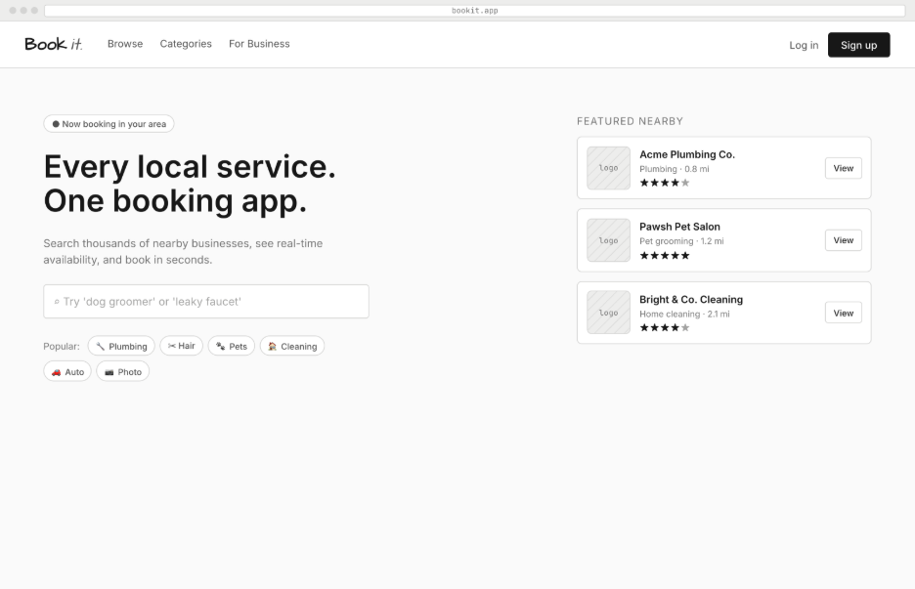
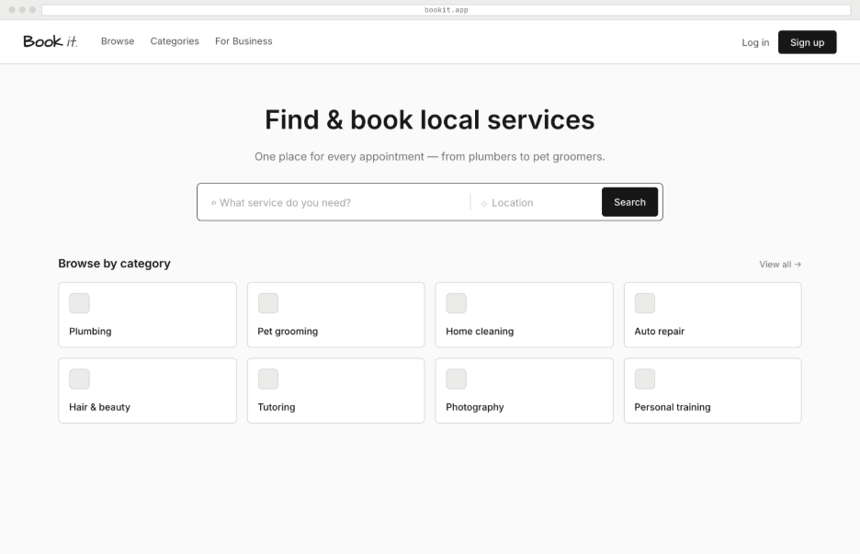

WF-02: Registration & Login
Referenced User Stories: AUTH-1, AUTH-2, PROV-1
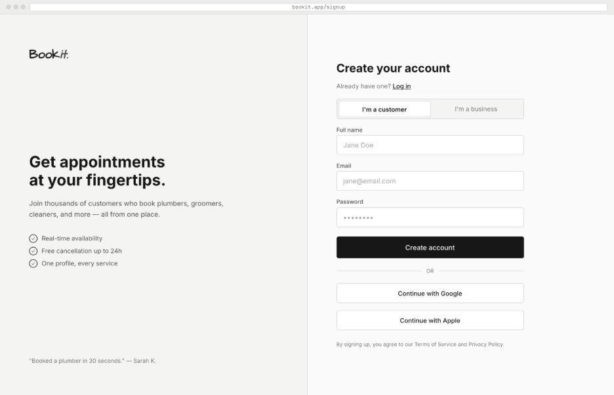
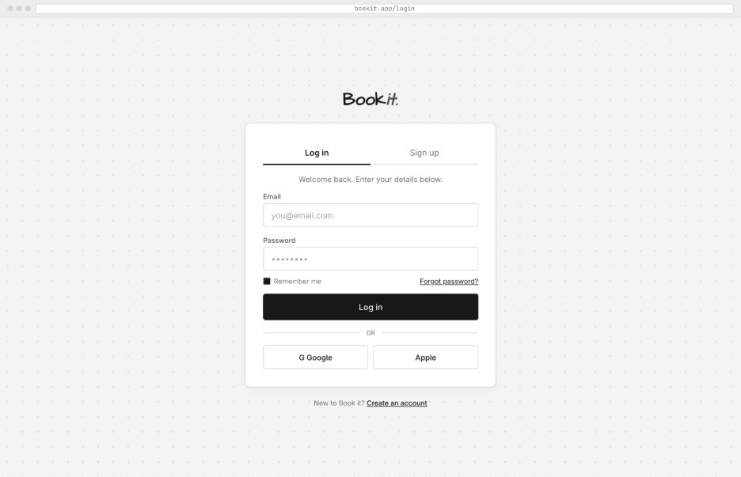

WF-03: Service Listing / Search Results
Referenced User Stories: CUST-1, CUST-2
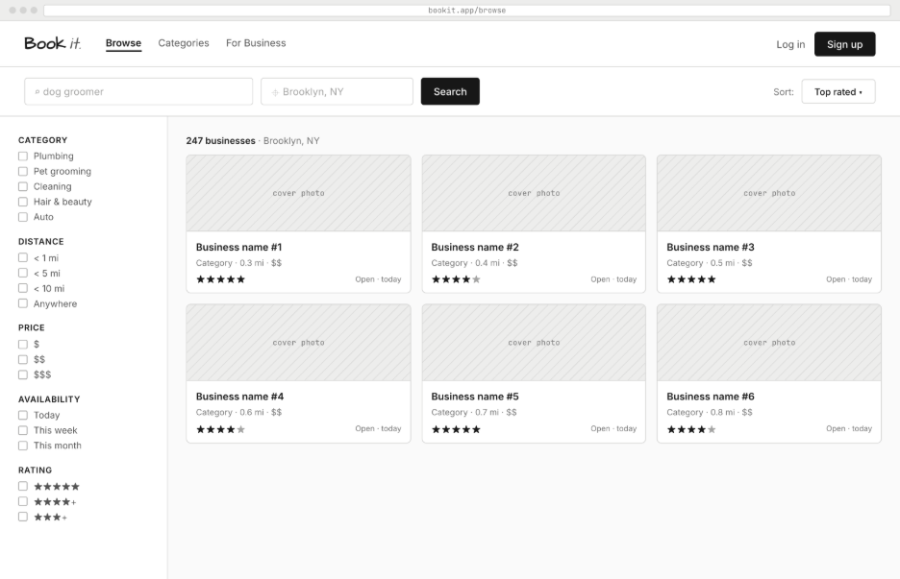
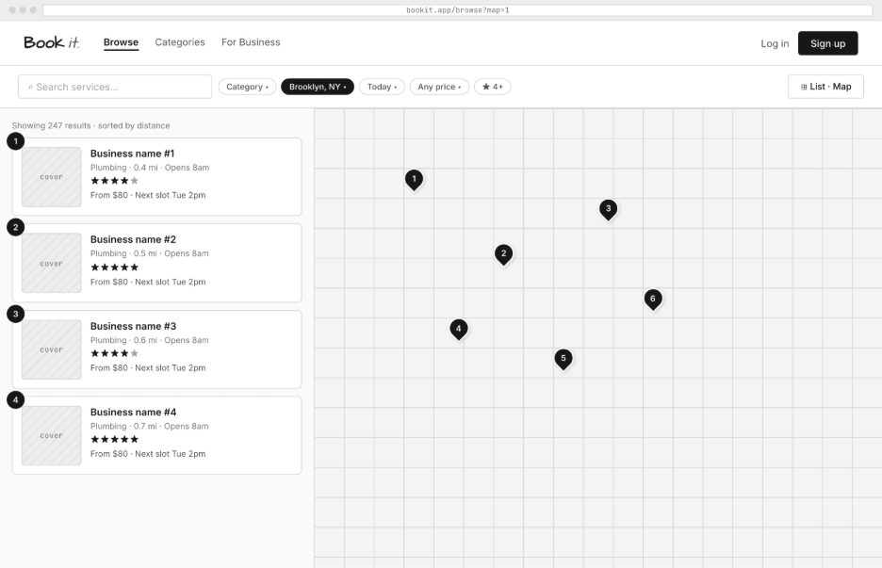

WF-04: Service Detail Page
Referenced User Stories: CUST-3, CUST-4
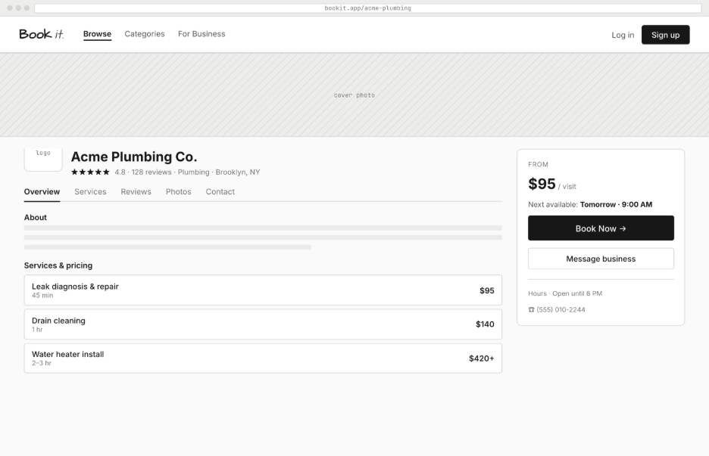
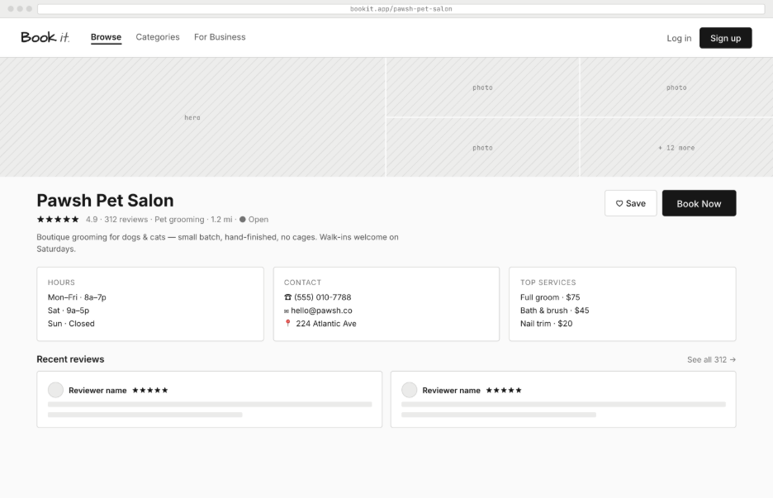

WF-05: Book Appointment
Referenced User Stories: CUST-4
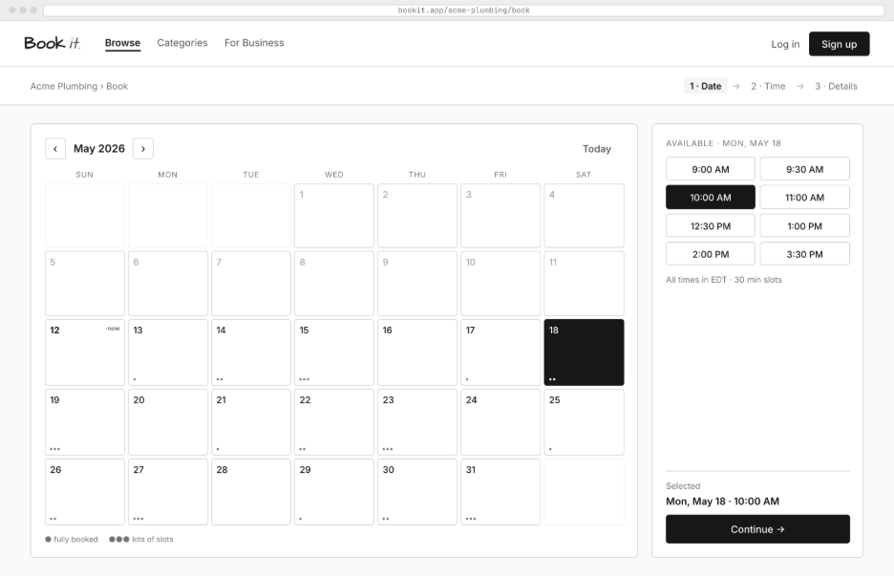
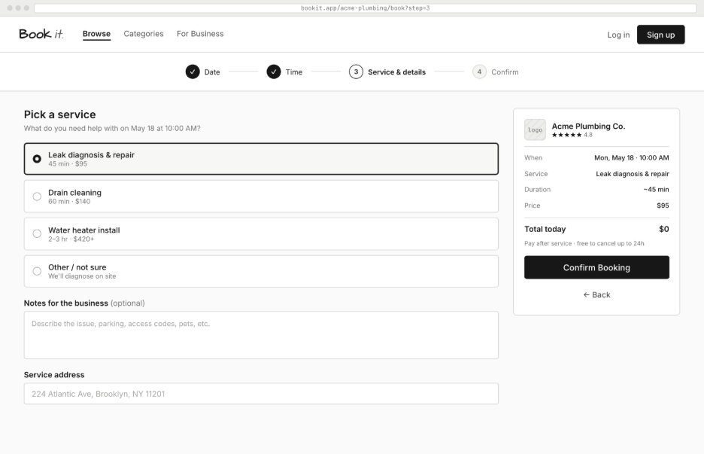
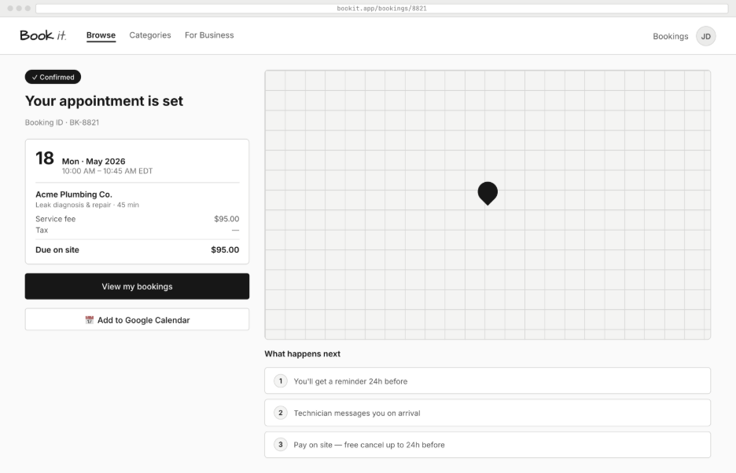

WF-06: Booking Confirmation
Referenced User Stories: CUST-4
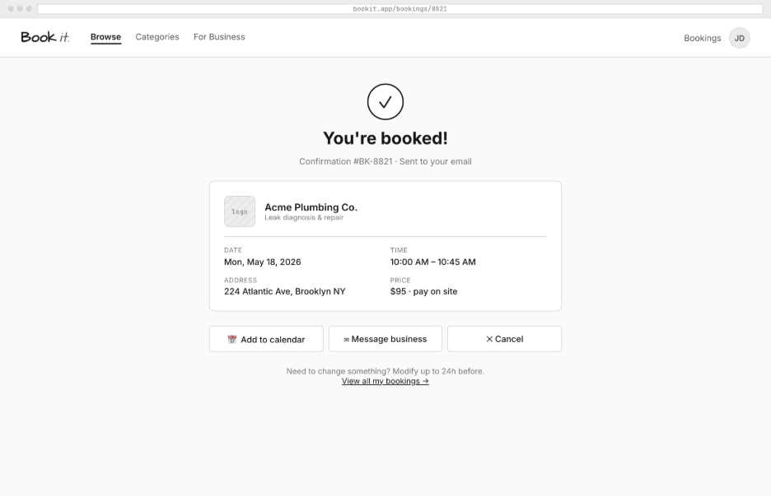

WF-07: Customer Dashboard (My Bookings)
Referenced User Stories: CUST-5, REV-1
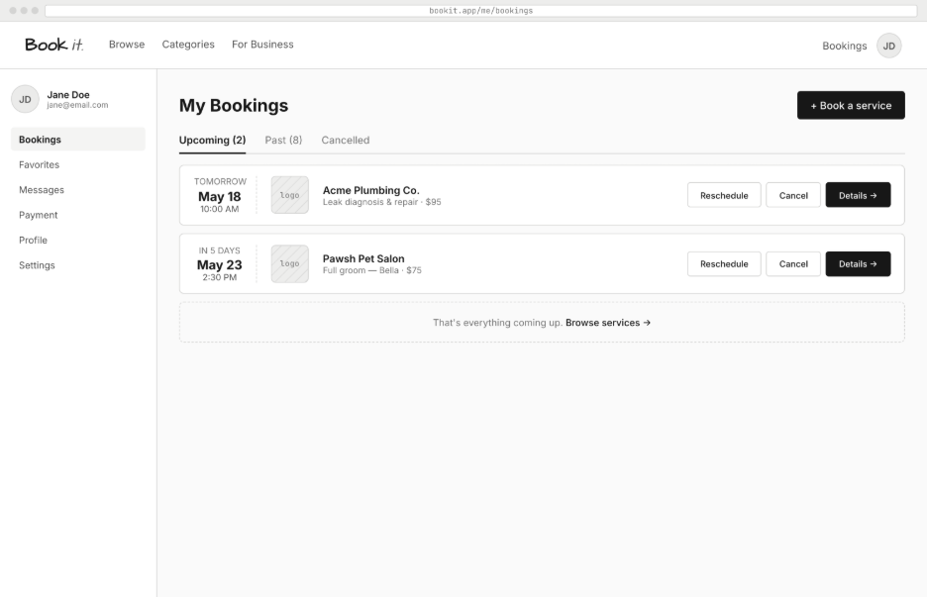
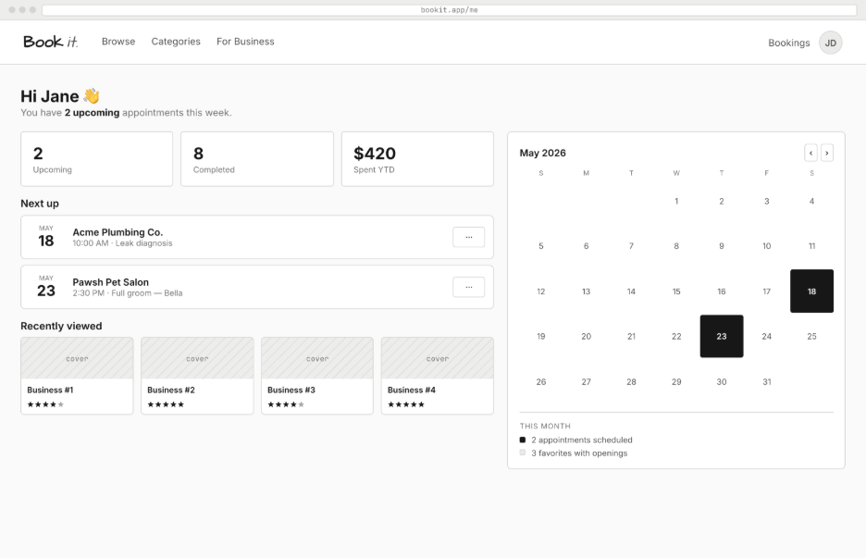

WF-08: Provider Dashboard
Referenced User Stories: PROV-2, PROV-3, PROV-4, PROV-6
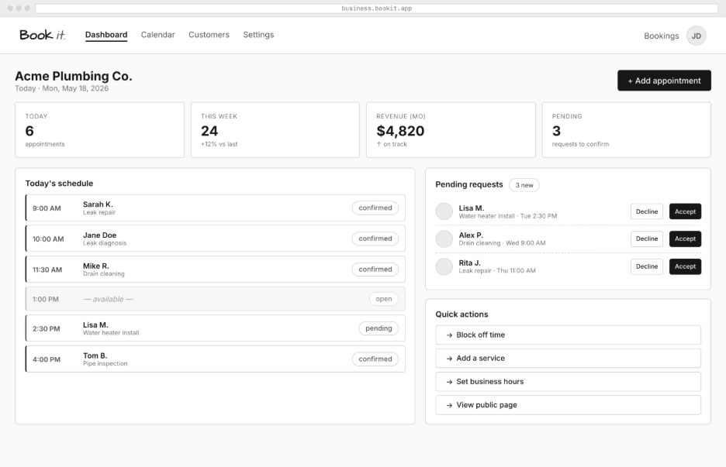

WF-09: Create / Edit Service Form
Referenced User Stories: PROV-2, PROV-3
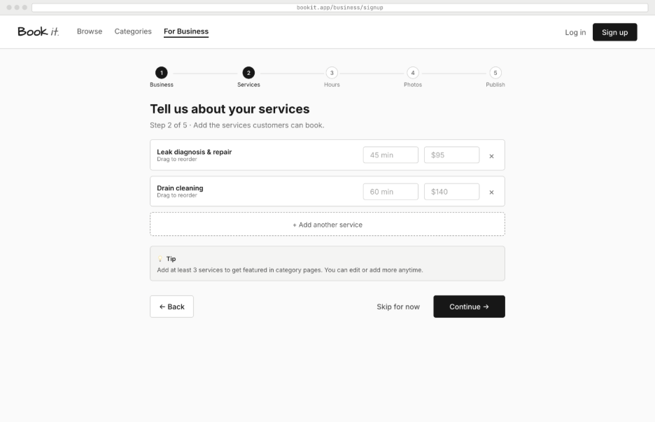
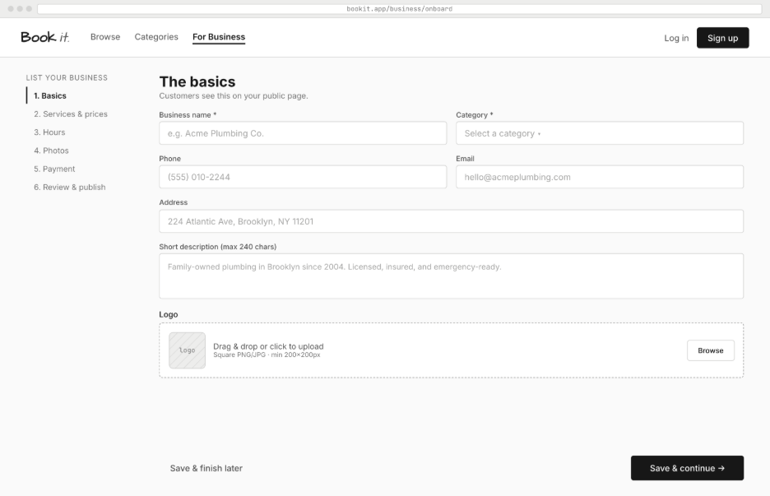

WF-10: Manage Availability (Time Slots)
Referenced User Stories: PROV-5
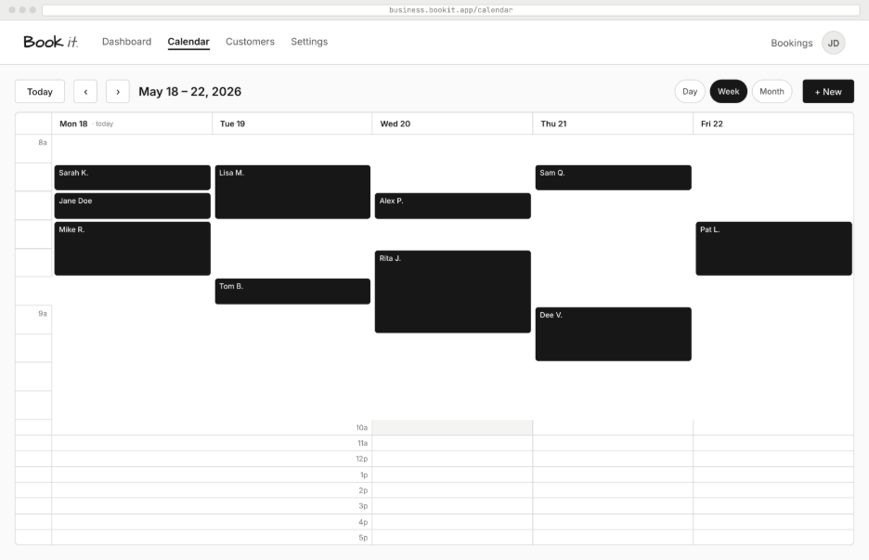

Section 4: Data Planning
This section identifies the core data entities required by ServiceHub and describes the key relationships between them. A full Entity-Relationship Diagram (ERD) will be produced in Milestone 02. Six tables are planned, exceeding the required minimum of four.

4.1 Key Data Entities
Table: users
Stores all registered users (both customers and providers). Role field distinguishes between the two. Providers have an additional business_name field.
- id (PK)
- full_name
- email (UNIQUE)
- password_hash
- role (ENUM: customer | provider)
- business_name (nullable, providers only)
- created_at

Table: services
Represents a service listing created by a provider. Each service belongs to one provider and one category.
- id (PK)
- provider_id (FK → users.id)
- title
- description
- category
- price (DECIMAL)
- duration_minutes (INT)
- delivery_mode (ENUM: in-person | online)
- created_at

Table: time_slots
Represents a specific available date/time window for a service. Linked to both the service and the booking (nullable FK, null if not booked yet).
- id (PK)
- service_id (FK → services.id)
- slot_date (DATE)
- start_time (TIME)
- is_booked (BOOLEAN, DEFAULT FALSE)

Table: bookings
A confirmed appointment between a customer and a service provider for a specific time slot. Status tracks the lifecycle of the booking.
- id (PK)
- customer_id (FK → users.id)
- service_id (FK → services.id)
- time_slot_id (FK → time_slots.id, UNIQUE)
- status (ENUM: pending | confirmed | completed | cancelled)
- created_at

Table: reviews
A post-service rating and comment left by a customer for a completed booking. One review per booking is enforced via a UNIQUE constraint.
- id (PK)
- booking_id (FK → bookings.id, UNIQUE)
- customer_id (FK → users.id)
- service_id (FK → services.id)
- rating (INT 1–5)
- comment (TEXT, nullable)
- created_at

Table: categories
A lookup table for the predefined service categories shown on the homepage. Allows future extensibility without code changes.
- id (PK)
- name (UNIQUE)
- icon_emoji (VARCHAR)

4.2 Key Relationships
From Table | To Table | Type | Description
users (provider) | services | One-to-Many | One provider can list many services; each service belongs to exactly one provider.
services | time_slots | One-to-Many | One service can have many available time slots; each slot belongs to exactly one service.
users (customer) | bookings | One-to-Many | One customer can have many bookings; each booking belongs to one customer.
services | bookings | One-to-Many | One service can have many bookings across different time slots.
time_slots | bookings | One-to-One | Each time slot can appear in at most one booking (enforced by UNIQUE on time_slot_id in bookings).
bookings | reviews | One-to-One | Each completed booking can have at most one review (enforced by UNIQUE on booking_id in reviews).
categories | services | One-to-Many | One category can contain many services; each service belongs to one category.

The data model supports the full CRUD workflow: providers create/update/delete services and time slots; customers create/view/cancel bookings; reviews are created once per completed booking. All foreign keys will be enforced with ON DELETE CASCADE where appropriate (e.g., deleting a service cascades to its time slots and bookings).

Section 5: Team Plan
5.1 Team Roles
Roles are designed to be rotated across milestones to ensure every team member gains experience across different parts of the stack. Role assignments will be confirmed and recorded in the GitHub Wiki after team discussion.

Role | Responsibilities | Assigned Member(s)
Project Manager | Coordinates milestones, manages GitHub Kanban, ensures deadlines are met, runs meetings, records minutes. | Zulqarnayeen Sadid
Front-End Lead | Leads HTML/CSS/JS implementation, enforces UI consistency, reviews front-end pull requests. | Jeff Vu
Front-End Developer(s) | Implements screens as per wireframes, client-side form validation, DOM interaction. | Hamza Mohammed, Arren Haroutunian
Back-End Lead | Leads Node.js/Express server architecture, route design, middleware, session management. | Gurnivaj Tiwana
Back-End Developer(s) | Implements server routes, request handling, server-side validation, business logic. | Harshaan Rahal, Dawood Ahmed
Database Architect | Designs relational schema, writes SQL CREATE TABLE statements, manages migrations. | Moosa Ahmed
Security & Testing Lead | Ensures prepared statements, XSS prevention, input sanitisation; writes and runs test cases. | Pushti Nakum
Documentation Lead | Maintains GitHub Wiki/activity blog, README, testing report, and demo script. | Fatmah Mohamed Yasin

5.2 Communication Method
- Primary channel: [WhatsApp / Zoom Meetings] — for daily async communication
- Weekly meetings: [Zoom Call / in-person] — every Thursday at 2:30pm
- Urgent issues: Direct message on WhatsApp/Zoom
- Formal decisions and outcomes logged in GitHub Wiki after every meeting
- GitHub Issues used for technical bugs and blockers

5.3 Meeting Cadence
- Weekly full-team meeting: Thursday & 2:30pm — review progress, assign new tasks, resolve blockers
- Sub-team check-ins: front-end and back-end sub-teams meet as needed (minimum once per week during active sprints)
- Pre-milestone review: dedicated meeting 3 days before each milestone deadline for final QA

5.4 Sprint Plan
Sprint | Focus | Key Deliverables
Sprint 1 | Foundation — Auth, Core UI, DB Schema | User registration/login, role-based routing, homepage with category grid, service listing page, database schema finalized, server entry point running, Kanban populated.
Sprint 2 | Core Features — Booking Workflow | Service CRUD by provider, time-slot management, service detail page, booking form with dynamic slots, customer dashboard with upcoming bookings, provider booking management dashboard.
Sprint 3 | Integration, Polish & Testing | Reviews/ratings, natural-language search, full end-to-end testing, server-side validation hardened, security audit (XSS, SQLi), demo video, testing report, README finalised.

5.5 Definition of Done (DoD)
A task is considered DONE only when ALL of the following conditions are satisfied:
- The feature or fix is fully implemented and matches the acceptance criteria defined in the user story.
- Server-side validation is in place for all user inputs associated with the feature.
- The code has been committed to the GitHub repository with a meaningful commit message.
- The associated Kanban card has been moved to the 'In Review' column and reviewed by at least one other team member.
- No known bugs exist in the feature's primary workflow.
- The code follows consistent naming conventions and contains no commented-out dead code.
- The activity blog/wiki has been updated with the task completion if it represents a significant milestone.
- The Kanban card is moved to 'Done' only after the review is approved.

Section 6: GitHub Setup Evidence
6.1 Repository Structure
The team's GitHub repository has been created and is accessible at the link provided in links.txt. The repository includes a README.md with a project skeleton, the team's GitHub Projects Kanban board with all required columns, and initial tasks assigned to team members.

Planned Repository Directory Structure:
servicehub/
├── README.md
├── links.txt
├── docs/
│ ├── milestone-01/ ← Milestone 01 PDFs
│ └── wireframes/
├── frontend/
│ ├── index.html ← Homepage
│ ├── css/
│ │ └── style.css
│ ├── js/
│ │ └── main.js
│ └── pages/
│ ├── login.html
│ ├── register.html
│ ├── services.html
│ ├── service-detail.html
│ ├── book.html
│ ├── dashboard-customer.html
│ └── dashboard-provider.html
├── backend/
│ ├── server.js ← Express entry point
│ ├── routes/
│ │ ├── auth.js
│ │ ├── services.js
│ │ ├── bookings.js
│ │ └── reviews.js
│ ├── controllers/
│ │ ├── authController.js
│ │ ├── serviceController.js
│ │ ├── bookingController.js
│ │ └── reviewController.js
│ ├── db/
│ │ ├── connection.js ← DB connection module
│ │ └── schema.sql ← CREATE TABLE statements
│ └── middleware/
│ └── auth.js ← Session authentication middleware
└── .gitignore

6.2 GitHub Projects Kanban Board
The GitHub Projects Kanban board is set up with the five required columns as specified in the project outline. Initial tasks for Sprint 1 have been created and assigned.
Column | Purpose
Backlog | All planned user stories not yet started — full product backlog lives here initially.
Ready | Stories approved for the current sprint — acceptance criteria confirmed, dependencies clear.
In Progress | Tasks currently being worked on. Maximum 2–3 per person at any time.
In Review | Implementation done; awaiting peer review / testing before being marked Done.
Done | Fully complete per the Definition of Done — all criteria met, reviewed, merged.

6.3 Initial Kanban Tasks Created (Sprint 1)
ID | Task | Sprint | Status | Assigned To
AUTH-1 | Customer Registration | Sprint 1 | Backlog | [Member]
AUTH-2 | User Login | Sprint 1 | Backlog | [Member]
PROV-1 | Provider Registration | Sprint 1 | Backlog | [Member]
PROV-2 | Create Service Listing | Sprint 1 | Backlog | [Member]
CUST-1 | Browse Services by Category | Sprint 1 | Backlog | [Member]
CUST-3 | View Service Details | Sprint 1 | Backlog | [Member]
DB-SETUP | Database Schema – CREATE TABLE statements | Sprint 1 | Backlog | [Member]
REPO-SETUP | Repository structure + README skeleton | Sprint 1 | Done | [Member]
WIKI-INIT | Initialize Activity Blog / Wiki | Sprint 1 | Done | [Member]

Section 7: Activity Blog / Wiki – Initial Entry

The GitHub Wiki has been initialized. The entry below is the first planning meeting record as required by Milestone 01. Subsequent entries will be added after each weekly team meeting.

Wiki Entry 01 — Kickoff / Planning Meeting
Date: May 21, 2026
Attendees: All 10 team members — [List names]
Meeting Type: Kickoff / Planning — Milestone 01
Platform: In-person
Duration: 120 minutes

Agenda & Discussion Points:
• Reviewed CP476 project requirements and milestone structure.
• Discussed and agreed on the BookIt (Service Booking Platform) as the project idea.
• Reviewed project scope: what is in-scope vs out-of-scope for the term timeline.
• Agreed on Node.js + Express as the back-end technology and MySQL as the database.
• Assigned initial team roles (see Section 5).
• Walked through the 11 user stories and reviewed acceptance criteria for each.
• Reviewed wireframes for all 10 primary screens.
• Discussed the 6-table relational database schema.
• Agreed on GitHub as the repository platform and set up the organization/repo.
• Created and configured GitHub Projects Kanban with all 5 required columns.
• Assigned Sprint 1 tasks to team members on the Kanban board.
• Agreed on weekly meeting day/time: Thursday at 2:30pm in-person.
• Agreed on Definition of Done criteria (see Section 5.5).

Key Decisions Made:
→ Project idea: BookIt – Service Booking Platform ✓
→ Tech stack: HTML/CSS/JavaScript (front-end) + Node.js/Express (back-end) + MySQL (database) ✓
→ No external libraries or CSS frameworks — course-covered technologies only ✓
→ Natural-language search will be implemented as keyword matching (no AI/ML) ✓
→ All team members must make meaningful commits to GitHub — individual accountability enforced ✓
→ Weekly meeting scheduled: [Day, Time, Platform] ✓

Task Assignments from this Meeting:
• Zulqarnayeen Sadid — Project Manager: Set up GitHub repo, create README skeleton, configure Kanban. | Due: [Date] | Status: Done
• Jeff Vu — Front-End Lead: Finalize homepage wireframe, create index.html skeleton. | Due: [Date] | Status: Not Started
• Hamza Mohamed, Arre Haroutunian — Front-End Dev: Create register.html and login.html pages. | Due: [Date] | Status: Not Started
• Gurnivaj Tiwana — Back-End Lead: Set up Node.js/Express server.js, define route structure. | Due: [Date] | Status: Not Started
• Harshaan Rehal, Dawood Ahmed — Back-End Dev: Implement AUTH routes (register, login, logout). | Due: [Date] | Status: Not Started
• Moosa Ahmed — Database Architect: Finalize schema.sql with all 6 CREATE TABLE statements. | Due: [Date] | Status: Not Started
• Pushti Nakum — Security Lead: Research bcrypt implementation for Node.js, draft security checklist. | Due: [Date] | Status: Not Started
• Fatmah Mohamed Yasin — Documentation Lead: Initialize GitHub Wiki, write this meeting entry. | Due: [Date] | Status: In Progress

Next Meeting: 28th May 2026.

End of Milestone 01 Submission — BookIt
CP476B – Internet Computing | Spring 2026

